Princeton Plasma Physics Laboratory
D-SITE Procedure
Procedure Title: Testing of the Twisted Racetrack Coil

Number: TBD |  | Revision: Initial issue |  |  | Effective Date:  (Ref. OP-AD-97)  Expiration Date:  (2 yrs. unless otherwise stipulated)
Procedure Approval

Author: B. E. Nelson |  |  |  |  |  | Date
ATI: James H. Chrzanowski |  |  |  |  |  | Date
RLM: L. Dudek |  |  |  |  |  | Date
Responsible Division: NCSX

Procedure Requirements
designated by RLM
x | NCSX Work Permit (TBD) |  | x | Lockout/Tagout (OP-AD-61)
 | TFTR Work Permit (OP-AD-09) |  | x | Door Permit (OP-G-93)
 | Tritium Work Permit (OP-AD-49) |  |  | T-MOD (OP-AD-03)
 | RWP (HP-OP-20) |  |  | Lift Procedure (ENG-021)
 | Confined Space Permit |  | x | DCA/DCN (OP-AD-104)
x | Pre-job brief (OP-AD-79) |  |  | ATI Walkdown
 | USQD (OP-AD-63) |  |  | Independant Review
 | Master Equip. List Mod (OP-AD-112) |  | x | ES&H Review (NEPA, IH, etc)
 | Flame Permit

REVISION SHEET

Revision | Description | Prepared by | Date

Table of Contents

1.0 Purpose 1
2.0 Scope 1
2.1 Geometric tests 1
2.2 Electrical tests 2
2.3 Hydraulic 3
2.4 Thermal 3
2.5 Structural 3
2.6 Instrumentation and Magnetic Loops 3
2.7 Performance of Power feed cables 3
3.0 Definitions 4
4.0 Precautions and Limitations 6
5.0 Prerequisites 7
5.1 Test Facility: 7
5.2 Buswork connections 8
5.3 Power supply connections 8
5.4 Instrumentation 8
5.5 Cooling connections 8
6.0 Pre-operational Testing Procedures 9
6.1 Geometric tests 9
6.2 Electrical tests 10
6.3 Cooling system operation 12
6.3.1 Hydraulic cooling lines – pressurize the inlet manifold and check flow rate in each circuit by sequentially letting the flow from each circuit empty into a container. Measure the total volume flow for 10 seconds and compute the flow rate. 12
6.3.2 Record flow rates 12
6.3.3 Check that there is gas flow through the lead cooling lines. 13
7.0 Operational Tests 13
8.0 Post Operational tests 13
8.1.1 Geometric tests 13
9.0 Completion and Sign-off 14

1.0 Purpose

The purpose of this procedure is to test the NCSX Twisted Racetrack Coil to compare actual performance with predicted performance.

2.0 Scope

Testing will be performed to verify performance in the following areas:
    - Geometric
    - Electrical
    - Hydraulic
    - Thermal
    - Structural
    - Instrumentation and magnetic loops
    - Power feeds

  - Geometric tests
    - Winding form shape will be measured before winding the coil and compared to the theoretical shape

    - Gross winding pack shape will be measured before application of ground wrap and chill plates and compared to theoretical shape

    - A Low Current Field check will be performed by flowing a maximum 1000 amperes through the coil in order to measure the magnetic field of the windings and characterize the field errors compared to a theoretically perfect coil.

Acceptance Criteria: The magnetic field measurements will be used to calculate the actual winding pack positions, and the predicted winding pack locations will be verified by sectioning the coil after the completion of all other tests. The intent is to demonstrate that the magnetic field measurement can predict the winding location within 0.2 mm of its actual position .

  - Electrical tests
    - Resistance measurements will be made for each winding pack, for the flexible power feed, and for the pair of winding packs in series to determine the DC resistance. The resistance measurements will be taken at room temperature, at liquid nitrogen temperature, and over the full range of operating temperatures.
Acceptance Criteria: The resistance measurements shall be within 10% of calculated value. The calculated resistance values are noted in each coil section of this procedure.

    - Meggar Tests will be performed to measure the resistance to ground of the windings before testing begins and at the conclusion of testing.

    - Hi Pot tests will be performed to measure the high voltage electrical integrity of the ground wall system by measuring the leakage current. This will be accomplished by applying high voltage to the complete coil and flexible lead assembly. The coil and lead assembly shall be tested at 6 kV prior to further coil testing and to failure at the end of all other testing. The initial Hi-pot voltage levels are based upon using 2/3 of the maximum allowable test voltage of the coil system according to the following formula:
PTP Hi-Pot Voltage Level = (2* 4kV (Operating voltage)e + 1 kV) * 2/3

    - Time Constant / Inductance performance will be evaluated by measuring the current ramp rate and decay behavior as a function of the applied voltage at the terminals.

  - Hydraulic
    - Flow rate The flow rate of liquid nitrogen will be measured for each hydraulic circuit.
    - Pressure drop The inlet and outlet pressure for each hydraulic circuit will be measured.

  - Thermal
    - Cooldown from room temperature to LN2 temperature
    - Heating during current pulse
    - Cooldown after pulse

  - Structural
    - Strain in winding form from cooldown to operational temperature
    - Strain in winding form from electromagnetic loading during current pulse
    - Gaps between winding pack and winding form before, during, and after cooldown and electromagnetic loading
    - Global deflection during cooldown and from magnetic loading

  - Instrumentation and Magnetic Loops
    - Temperature measurement instrumentation is accurate, reliable and repeatable
    - Strain gages are accurate and repeatable
    - Voltage taps work properly

  - Performance of Power feed cables
    - Routing flexibility of power feed cables
    - Operation at LN2 temperature
    - Heat leak into coils is negligible
    - Frost at warm end of power feed can be controlled
    - Loads from power feeds into coil leads are minimal under electromagnetic loading
    - Error field is within limits

- Definitions

  - Twisted Racetrack Coil – The twisted racetrack coil is a prototype demonstration for the NCSX modular coil design and fabrication. The basic TRC parameters are shown in Figure 1

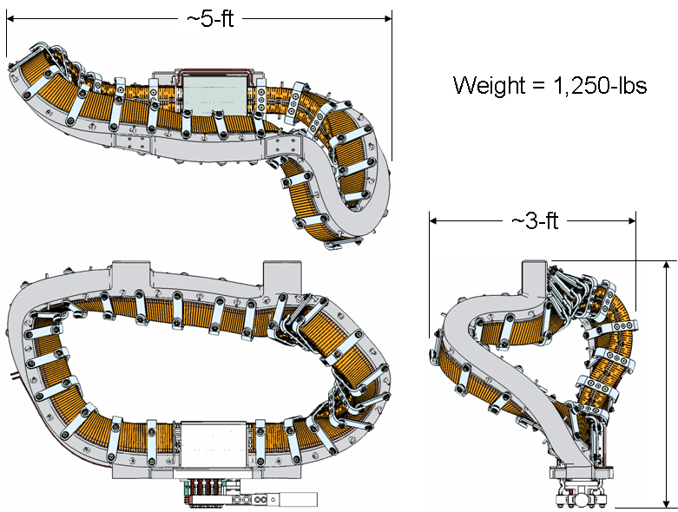
Figure 1 Twisted Racetrack Coil Configuration

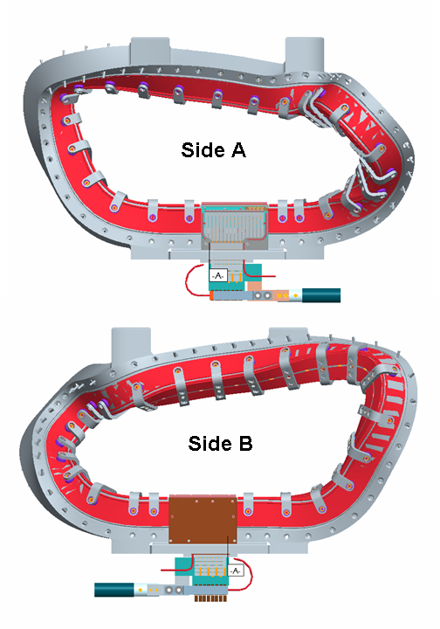
  - TRC side A and side B refers to the two sides of the coil and the associated two winding packs. The nomenclature is illustrated in Figure 2.

Figure 2 Side A and Side B references

  - Winding form studs are numbered from 1 through 50 as a means to reference locations around the two winding packs The numbering scheme is shown in
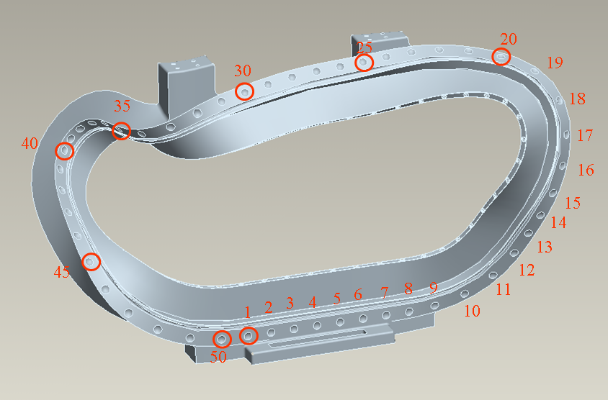

Figure 3 Stud numbering convention for TRC winding form

- Precautions and Limitations

  - During the testing of the TRC coil, there will be No Access, to the NCSX Coil Test Cell area except for the test crew.

  - The area shall be properly posted with suitable “Danger High Voltage” signs and flashing lights, until all of the electrical tests have been completed. Door guards will be posted at both the North and South access doors.

Test Director verify: ____________________

  - Technicians and engineers performing these tests shall be familiar with electrical safety and potential hazards for this procedure to avoid personnel danger.

  - There shall be a second person, “safety watch” monitoring the operator, and capable of removing the power incase of an accident. This person shall be CPR qualified.

Qualified CPR Member: _____________________________ Recertification Date: _______

  - The test operator shall stand on a PPPL safety approved electrical safety mat during the high voltage test operation.

  - PPPL safety approved rubber electrical safety gloves shall be worn by test members during grounding operations, which occur once the test has been completed, and the test equipment has been turned off.

  - Upon the completion of a test and before the TRC system is declared safe to touch, the system being tested shall be properly discharged using a “Ground Stick”. After a minimum period of 10 seconds, while the ground hook is still in place, attach a ground cable to the tested coil. The ground hook shall be removed once the ground cable is in place.

  - Prior to starting the electrical tests, the Test Director shall verify that the TRC coil has been grounded. Both the power supply side and the machine side of the bus systems shall be grounded.

  - Prior to starting the electrical tests, the Test Director shall verify that the TRC coil system has been disconnected at the “Coil/Bus Connection” area (copper bus to water-cooled Flex-cable), which is located in the south-west corner of the NSTX Test Cell.

Test Director verify: ____________________

- Prerequisites

  - Test Facility:
The TRC will be located in the Coil Test Facility. The TRC will be positioned inside the test facility cryostat for all tests except the magnetic field measurement tests.

  - Buswork connections
The TRC will be connected via cold buswork (anti-kick cable) inside the cryostat, which in turn is connected to warm buswork that extends outside the cryostat.

  - Power supply connections
    - The TRC will be energized by a high current (1kA) , low voltage (6V) power supply for field measurements and resistance measurements.

    - The TRC will be connected to a high current (>10kA), high voltage (4kV) power supply for all tests except the field measurements and resistance measurement tests.

  - Instrumentation
    - Strain gages will be installed on the TRC in locations as shown in Figure 4. There will be two types of strain gages, fiber optic gages and standard resistance strain gages
    - Temperature sensors will be installed as shown in Figure 5. Both standard thermocouples and fiber optic temperature sensors will be used.
    - Voltage taps will be installed on the two TRC lug terminals in the form of lead wires attaches to terminal lugs under the bolt heads.
    - Voltage loops that were co-wound with the TRC windings will be connected to suitable signal conditioning

  - Cooling connections
    - The 8 chill plate cooling circuits will be connected to the Coil Test Facility liquid nitrogen system
    - The two lead cooling circuits will be connected to the Coil Test Facility gaseous nitrogen feed.
    - The cooling system valves will allow isolation and flow testing of each of the 8 liquid nitrogen circuits.

Figure 4 TRC strain gage locations

Figure 5 TRC temperature sensor locations

- Pre-operational Testing Procedures

  - Geometric tests
    - Winding form shape The winding form shape was measured prior to winding the coil. It must be measured again after testing and disassembly of the winding from the winding form
    - Winding pack shape The winding pack shape was measured prior to installing the ground wrap, chill plates, and bag mold. This shape must be measured after testing by destructively sectioning the windings. The windings and winding form must be carefully match-marked prior to section the windings to provide a way to register the winding cross section measurements to the winding form.
    - Field measurement to determine winding pack shape The field measurements may be taken before or after testing, but must be made prior to sectioning the coil The coil will be operated at a DC current between 300 and 1000 A, and the field measured with a 3 axis hall probe connected to a Romer arm. The Romer arm will provide the geometric location and vector orientation of the hall probe, and the hall probe will measure the magnetic field vector at that location. The current in the coil must also be known for each measured point. The temperature of the coil will be inferred from the voltage drop through the coil, and the measurements will stop when the coil temperature rises 10C. The measurements will be made at room temperature.

  - Electrical tests

    - Resistance Measurement
      - The coil circuit resistance will be inferred by measuring the voltage drop across the coil leads while the coil is energized with a low voltage power supply..

      - Energize the coil at 100 A for 10 seconds

      - Record the voltage, current, and temperature readings on the test sheet. Calculate the system resistance at 20C or 77K according to the formula below and compare to the predicted system resistance at 20C or 77K.

Rc = (1.553E-6+6.91E-9x Tc) x Rmeas / 1.69E-6

where: Rc = measured resistance of the conductor (milliohms)
Tc = temperature of coil when resistance measurement is made

TRC Circuit Resistance

Test ID | Nominal temp of TRC during test | Measured Voltage Drop  (V) | Measured Current  (A) | Measured Temp, Tc  (C) | Calculcated System Resistance (Rc)  m-ohms at Tc | System Resistance corrected for temp  (ohms) | Predicted System Resistance  (ohms)
1 | RT |  |  |  |  |  | 4.73e-3
2 | RT |  |  |  |  |  | 4.73e-3
3 | LN2 temp |  |  |  |  |  | 5.55e-4
4 | LN2 temp |  |  |  |  |  | 5.55e-4

Resistance Results: Acceptable: _______________ Unacceptable: ____________

ATI Signoff: _____________________________ Date: ______________

    - Meggar Test

    - TRC Hi-Pot Test
      - See section 4.0 for safety precautions and conditions.
      - Test director for this test is: _________________________
      - Place the test set on a firm, stable surface.
      - Attach the ground cable to the test set by tightening the wingnut securely. Securely connect the ground lead to ground.
      - The Test Voltage Level for the TRC is 9.0 kV. Set the over-voltage limit 100 volts above the Test Voltage Level. Verify that it trips when checking calibration. To calibrate, run the Hi-pot tester into a calibrated voltmeter to verify trip setting.
      - Energize the test set.
      - Raise the DC potential, slowly, stopping at 25% (test voltage) intervals. Record the voltage and leakage current at 0, 30 and 60 seconds on the test sheet, after the test voltage has stabilized.

TRC System Hi-pot Test Results
Test temp | Voltage Level Volts | Leakage Current  @ 0 seconds | Leakage Current  @ 30 seconds | Leakage Current  @ 60 seconds | Remarks
RT | 500
 | 2500
 | 5000
 | 7500
 | 9000
LN2 temp | 500
 | 2500
 | 5000
 | 7500
 | 9000

Leakage current shall not exceed: __________________

Equipment ID No. _____________________________ Calibration Date: _____________

Hi-Pot Results: Acceptable: _______________ Unacceptable: ____________

ATI Signoff: _____________________________ Date: ______________

      - Reduce the test voltage to zero, and de-energize the equipment.
      - Connect the ground hook to the system under test and de-energize the system using high voltage gloves. The ground hook shall remain in place for a minimum period of 10 seconds (per section 4.7).
      - When the system is de-energized, apply grounds to safe the system. Grounds shall go back to building steel.
      - Remove all test leads from coil

    - Low Current Time Constant / Inductance tests
      - Energize the coil with the low current power supply by applying the maximum voltage
      - Record the current rise vs time in the coil and estimate the time constant
      - Using the resistance measurement of section 2.2.1, calculate the coil inductance and compare to the predicted value
      - Repeat the test 4 times

TRC Circuit Inductance

Test ID | Nominal temp of TRC during test | Measured Temp of TRC  (C) | Applied Voltage  (V) | Maximum Measured Current  (A) | 0.632 x Imax  (A) |  | Tau = Time to reach 0.632*Imax  (s) | System Inductance (H)  =tau x R | Predicted System Inductance  (H)
1 | RT |  |  |  |  |  |  |  | 6.13e-4
2 | RT |  |  |  |  |  |  |  | 6.13e-4
3 | LN2 temp |  |  |  |  |  |  |  | 6.13e-4
4 | LN2 temp |  |  |  |  |  |  |  | 6.13e-4

Resistance Results: Acceptable: _______________ Unacceptable: ____________

ATI Signoff: _____________________________ Date: ______________

  - Cooling system operation
    - Hydraulic cooling lines – pressurize the inlet manifold and check flow rate in each circuit by sequentially letting the flow from each circuit empty into a container. Measure the total volume flow for 10 seconds and compute the flow rate.
    - Record flow rates

TRC Cooling Circuit Flow

Circuit ID | Measured volume flow  (liters) | Measured time interval  (s) | Calculated flow rate  (l/s) | Predicted flow rate  (l/s) | Remarks
1
2
3
4
5
6
7
8

Resistance Results: Acceptable: _______________ Unacceptable: ____________

ATI Signoff: _____________________________ Date: ______________

    - Check that there is gas flow through the lead cooling lines.

- Operational Tests
    - Coil Energization
    - Current and Voltage waveforms
    - Temperature measurements
    - Strain Measurements

- Post Operational tests
    - Geometric tests
      - Winding form shape The winding form shape was measured prior to winding the coil. It must be measured again after testing and disassembly of the winding from the winding form
      - Winding pack shape The winding pack shape was measured prior to installing the ground wrap, chill plates, and bag mold. This shape must be measured after testing by destructively sectioning the windings. The windings and winding form must be carefully match-marked prior to section the windings to provide a way to register the winding cross section measurements to the winding form.
      - Field measurement to determine winding pack shape The field measurements may be taken before or after testing, but must be made prior to sectioning the coil The coil will be operated at a DC current between 300 and 1000 A, and the field measured with a 3 axis hall probe connected to a Romer arm. The Romer arm will provide the geometric location and vector orientation of the hall probe, and the hall probe will measure the magnetic field vector at that location. The current in the coil must also be known for each measured point. The temperature of the coil will be inferred from the voltage drop through the coil, and the measurements will stop when the coil temperature rises 10C. The measurements will be made at room temperature.

- Completion and Sign-off

  - The NSTX Coil System Pre-Ops tests have been satisfactorily completed..

Cognizant Engineer: _______________________ Date: ___________

Comments:

- Appendices

Current waveforms and temperature response

