Modeling and Experimental Verification of Welding Process

Introduction

The problems associated with the welding process required in the containment of the conductor prior to the imposition of vacuum polymer impregnation are briefly discussed here. There are four issues associated with the thermal modeling of the welding that need to be addressed:

- Damage to the conductor or its insulation wrapping during the welding process,
- The transient temperature field during the welding process,
- Vacuum testing of the containment can, and
- Residual stress analysis of the structure based on the results in part (b)

The items (a) and (b) are addressed in this section. The other items are discussed elsewhere.

To address these issues two steps were taken:

- An experiment was designed to (a) weld two flat steel sheets, and (b) weld a flat sheet with a small steel block. Visual assessment of the damage to the conductor and its wrappings were made. Experimental data on temperature and welding power input as function of time were collected. Then models for the thermal analysis of these test weldings were developed using FEMLAB. The models included the three steel pieces (two flat sheets and one small block) and incorporated the experimental results to verify the modeling procedure and parameters (most importantly, the way in which heat flux at the weld zone should be addressed).

- A FEMLAB model of the T section and the steel can containing the copper conductor was developed using features based on the verified model in the previous part. The results for temperature field and other information obtained from this calculation will be used to calculate thermal residual stress during and after the welding process elsewhere.

- Test Model and Experiment

Two separate TIG welding tests were conducted at the Mechanical, Aerospace, and Biomedical Engineering Department at the University of Tennessee. The data were collected and used in two separate FEMLAB models for verification purposes (e.g., boundary condition, flux rates, surface heat losses, etc.).

(a) In the first test, two sheets of steel (0.06 in. thick) were welded with the copper conductor clamped to the corner on the opposite side of the weld. The copper conductor is wrapped with one layer of fiberglass, then another layer of fiberglass with Kapton, and finally with an additional layer of fiberglass. Thermocouples were used to measure temperature at three locations on the top surface of the conductor insulation wrappings.

Figure 1 shows the geometry and dimensions of the steel sheets, the location of the clamped conductor, and the location of the thermocouples on the copper conductor. Figure 2 shows the welding area. The two sheets were welded in the middle forming an L shape. Temperatures measured by the three thermocouples were displayed on digital thermocouples. Simultaneous DC voltage and current input to the weld electrode was displayed on a monitor. All displays were recorded on a video throughout the welding process. In this way all temperatures and input power could be recorded and later transcribed as a function of time (measured from the beginning of welding).
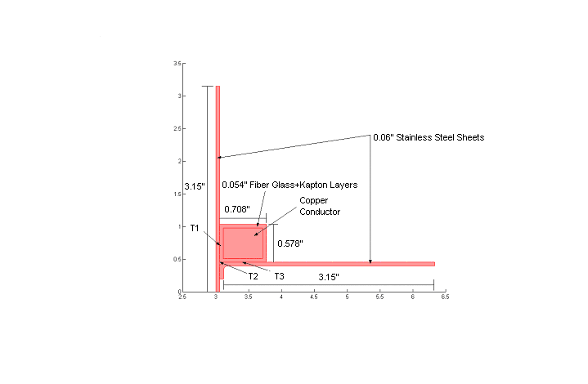
Fig 1. Geometry with location of thermocouples
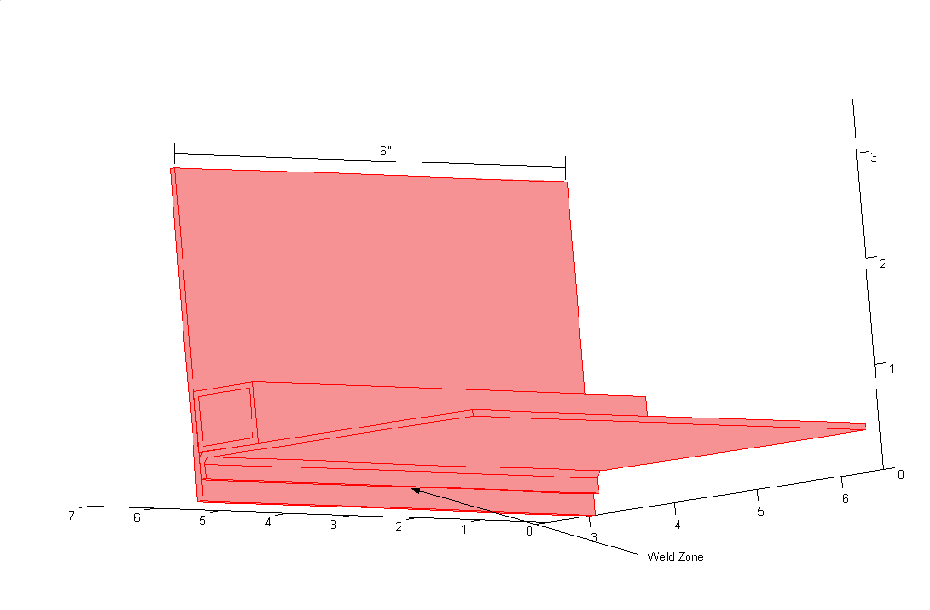
Fig 2. 3-D view showing weld area
The temperature data collected in the experiment are shown in Table 1.

T1  (ºC) | T2  (ºC) | T3  (ºC) | Time (sec.)
23 | 23 | 22.1 | 0
25 | 29 | 32 | 2
25 | 29 | 33 | 4
29 | 36 | 43 | 6
30 | 37 | 45 | 8
30 | 39 | 49 | 10
30 | 40 | 50 | 12
31 | 44 | 55 | 14
31 | 49 | 60 | 16
32 | 55 | 67 | 18
35 | 59 | 71 | 20
38 | 67 | 80 | 22
39 | 74 | 87 | 24
40 | 80 | 93 | 26
45 | 163 | 161 | 28
57 | 231 | 224 | 30
73 | 233 | 234 | 32
85 | 235 | 229 | 34
94 | 237 | 227 | 36
97 | 240 | 224 | 38
103 | 207 | 220 | 40
103 | 205 | 217 | 42
103 | 203 | 213 | 44
103 | 201 | 210 | 46
102 | 200 | 208 | 48
102 | 199 | 206 | 50

Table 1. Temperature measured as a function of time during the welding
by the 3 thermocouples shown in Fig 1.

The temperature data is also presented in graphical form in Fig. 3. As expected the highest temperature is recorded by the thermocouple in the corner of the L-shaped geometry (T2).

Several important conclusions can be made from the observations made:

- No damage was observed to the conductor or its insulation. The glass insulation did not discolor and remained white and soft to the touch.
- Maximum temperature reached anywhere on the insulation was 240 ˚ C (T2)
- It was observed that the welding of the two sheets could be accomplished with relative ease. The bead could be formed quickly and the welding moved rapidly, which allowed a short residence time for the arc at any location.
- Total welding time was 50 seconds and the total length of the weld area was 2.95 inch.

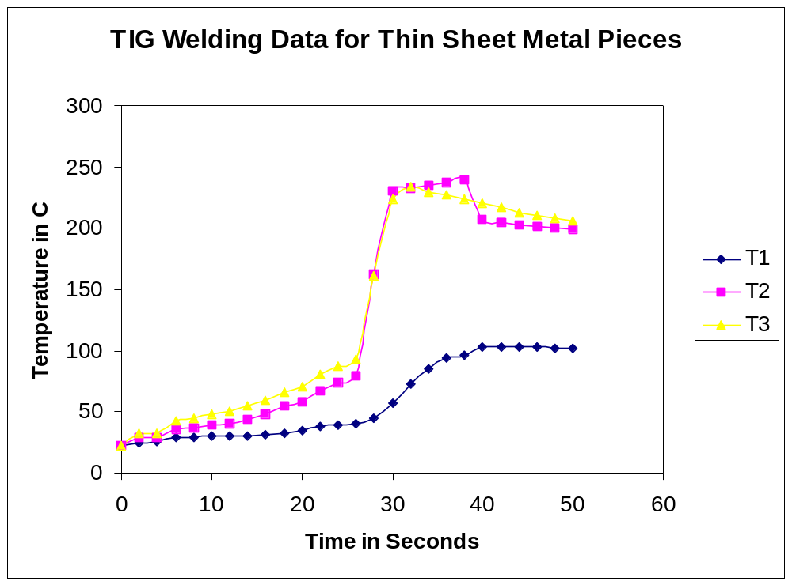

Fig 3. Plot of temperature vs. time as recorded by the thermocouples

  - In the second part of the experiment, a sheet of steel (0.06 in.) was welded to a small steel block as shown in Fig. 4. The copper conductor was clamped to the corner behind the welding area as in the previous case and as shown in Figs. 4 and 5.

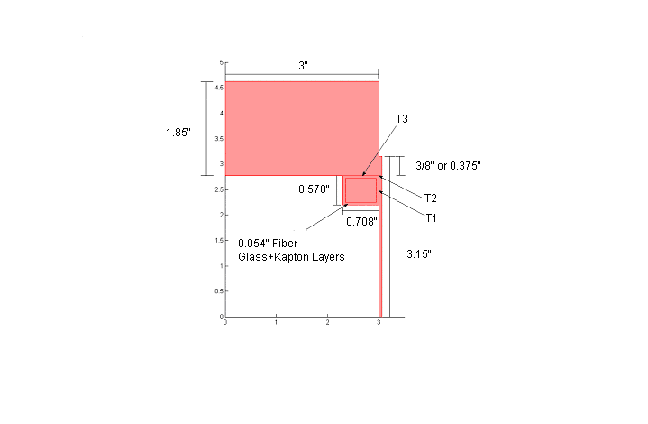
Fig 4. Geometry with location of thermocouples

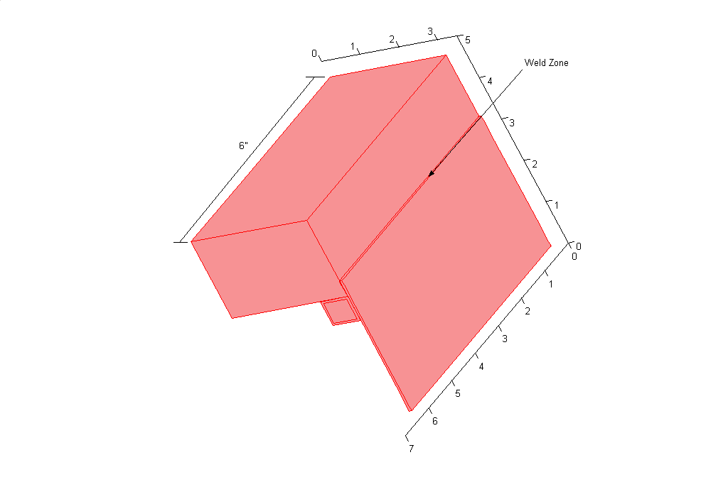
Fig 5. 3-D view showing weld area
The temperature data is presented in Table 2 and a graphical presentation is found in Fig. 6.

T1  (ºC) | T2  (ºC) | T3  (ºC) | Time (sec.)
23 | 25 | 25 | 0
27 | 29 | 25 | 3
27 | 30 | 26 | 6
27 | 33 | 29 | 9
25 | 36 | 32 | 12
26 | 38 | 38 | 15
27 | 41 | 41 | 18
28 | 45 | 45 | 21
30 | 48 | 49 | 24
30 | 54 | 51 | 27
32 | 64 | 58 | 30
34 | 66 | 65 | 33
35 | 75 | 68 | 36
38 | 85 | 75 | 39
43 | 103 | 87 | 42
47 | 111 | 92 | 45
48 | 120 | 92 | 48
53 | 135 | 106 | 51
57 | 140 | 112 | 54
61 | 150 | 117 | 57
69 | 170 | 130 | 60
72 | 190 | 137 | 63
77 | 220 | 142 | 66
88 | 282 | 154 | 69
100 | 300 | 167 | 72
107 | 340 | 176 | 75
118 | 390 | 188 | 78
126 | 400 | 188 | 81
132 | 370 | 185 | 84
133 | 360 | 183 | 87
135 | 332 | 178 | 90
135 | 300 | 174 | 93
133 | 286 | 169 | 96
134 | 286 | 166 | 99
133 | 272 | 165 | 102
132 | 250 | 161 | 105
127 | 220 | 153 | 108
124 | 202 | 148 | 111
119 | 197 | 141 | 114
113 | 179 | 130 | 117
110 | 175 | 125 | 120

Table 2. Temperature measured as a function of time during the welding
by the 3 thermocouples shown in Fig 4.
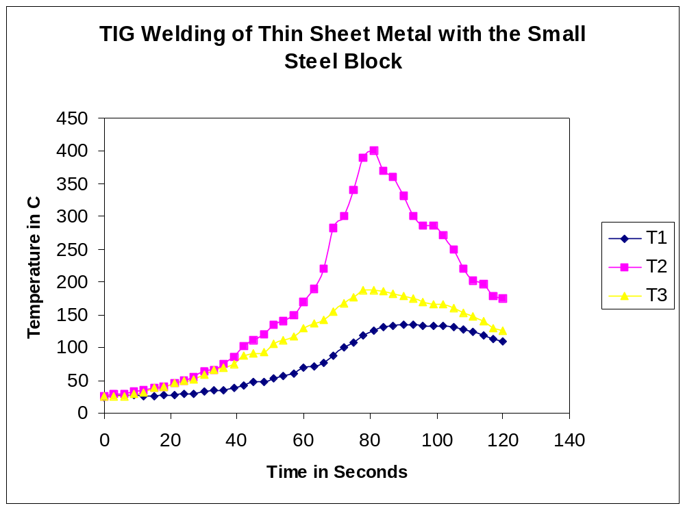
Fig 7. Plot of temperature vs. time as recorded by the thermocouples

In this test the process was slower and more power was needed to form the bead on the thicker block to weld with the thin sheet. As a result temperatures are observed to be higher. This case is therefore more important in so far as the analysis of the damage to the conductor or its wrapping is concerned. It is also the more important test case for residual stress analysis and the related issues.

Several important conclusions in the second test are:

    - Visual observations indicated no damage to either the conductor or the fiberglass wrapping,
    - Some discoloring was observed in the outer layer of the insulation. The insulation was slightly yellowed and seems less smooth to the touch.
    - More power was required to weld in this case and higher temperatures were observed. The maximum temperature measured was 400 ˚ C.
    - The temperature of the block, which acted as an effective heat sink, decreased very slowly and remained very warm to the touch long (5-10 minutes) after the completion of the test.
    - Total welding time was 120 sec. and the weld length was 4 inches.

( c) Finally several small tests were done to ascertain the melting and discoloring temperatures of the insulation, and the expected temperature drop across the fiberglass wrapping. One piece of fiberglass and one piece of fiberglass with Kapton were used for this purpose. An open Bunsen burner flame was used to heat the samples. A thermocouple was used to measure the surface of the fiber directly exposed to the flame and a second measured the temperature on the other side of the fiber sheet away from the flame.

The results are summarized below:

- Open Flame Temperature approx. 1800 ˚ F (980 ˚ C)

- Melting Point of Fiberglass approx. 1500 ˚ F (820 ˚ C)

- Melting Point of Kapton approx. 800 ˚ F (430 ˚ C)

- Fiberglass Insulation Flame side temp: approx. 870 ˚ F (460 ˚ C)
Side away from flame: approx. 830 ˚ F (440 ˚ C)

- Glass + Kapton Flame side temp: approx. 1000 ˚ F (540 ˚C)
Side away from flame: approx. 960 ˚ F (515 ˚C)

It is noted that across a single layer of fiberglass a temperature difference of 20 ˚C and across the glass and Kapton layer a temperature drop of 25 ˚C is observed.

- Development of a FEMLAB model for the two test cases and their verification

A FEMLAB model was developed for the welding in the two cases discussed above. The computation time and memory considerations suggested the use of a two-dimensional model for the welding process. This made it possible to quickly iterate on various input parameters and incorporate the experimental data in the verification of the modeling parameters and procedure. Various boundary conditions were used to model the flux at the welding zone and the resulting computed temperature results were compared with the experiment. It was found that the weld flux boundary condition needed to obtain desired output as compared with the observed values in the experiment is a combined transient heat flux and temperature boundary condition shown in Fig. 8. It is made up of a 0.1 sec. application of a Gaussian heat flux followed by a constant (melt) temperature boundary condition for 1.5 sec. The remainder of the imposed boundary condition is cooling by natural convection and radiation. The Gaussian heat flux distribution used is in the form of:
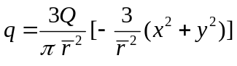

where Q = η VI, with V = voltage, I = current and η = fraction of power actually used for welding. In this case we selected η = 0.5 (based on other studies, e.g., Glickstein S.S., “Basic Studies of the Arc Welding Process”, Trends in Welding Research, Proceedings of a conference sponsored by Joining division of ASM, Louisiana, 16-18 Nov 2001.). r is the effective radius over which the heat flux is applied and it is assumed (from experimental observations) that r=3/16 inch. Also, x and y are the spatial coordinates away from the weld zone.

The results of the FEMLAB model are presented along with the experimental data in Fig. 8. There are several important features that need to be discussed in relation to the results.

- As observed, the computational model slightly overestimates (about 15%) the temperatures at T1 and T3. These differences are expected because the model is a two-dimensional model and the heat transfer in the third direction is absent. As a result an overestimate of temperatures in the 2D model is expected. Furthermore, the overestimate of the temperature increases with the distance away from the location of the application of the heat flux. This is the reason that T2 (at the corner of the conductor and closest location to the weld) is predicted much more accurately as compared to the other results (T1 and T3). Because the computed higher values of temperature and temperature gradient in the 2D model provide overestimates (more conservative estimates) of what is expected in similar 3D model of welding, they are safe to use as an upper limit for all 3D calculations and estimates.

- The time for the experimental data is measured from the location of maximum temperature observed for T2. This makes it possible to model a 2D heat transfer match as closely as possible to a 3D experimental test.

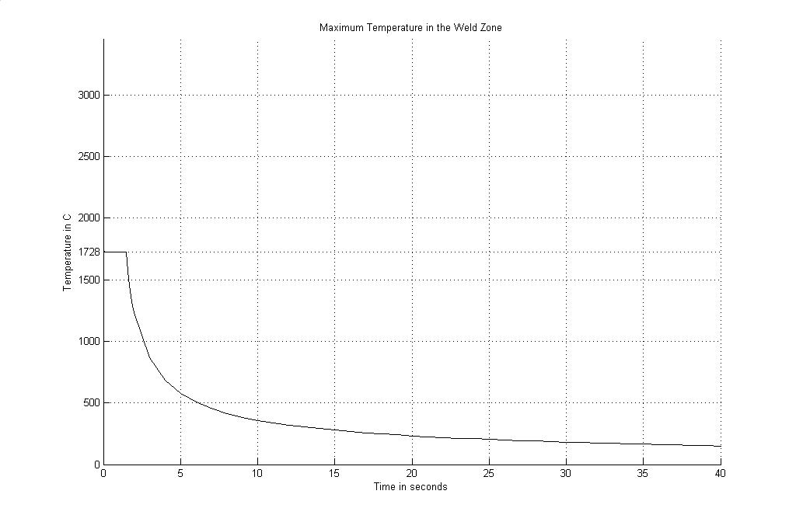

Pp

Fig. 8. Flux and temperature boundary conditions for the test cases

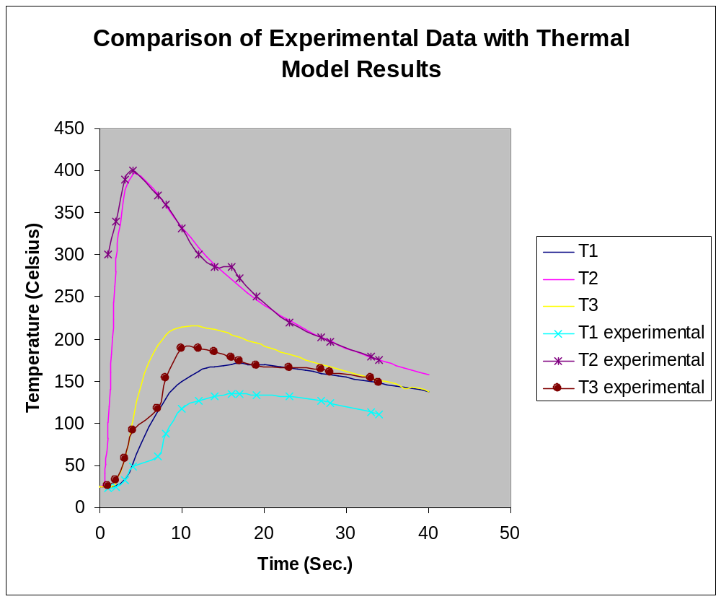

Fig. 9. Comparison of Experimental Data with Thermal Model Results

- Development of a FEMLAB model for the T section and welding of the containment can

The modeling features and welding parameters used and verified in the two test cases became the basis to develop a 2D model of the T section and its welding to a can made up of 0.04-inch-thick steel sheets. For this purpose, a FEMLAB model was developed for the T-section geometry shown in Fig.10. The copper conductor is wrapped individually and in combination with the other conductors as shown and described in the figure caption.

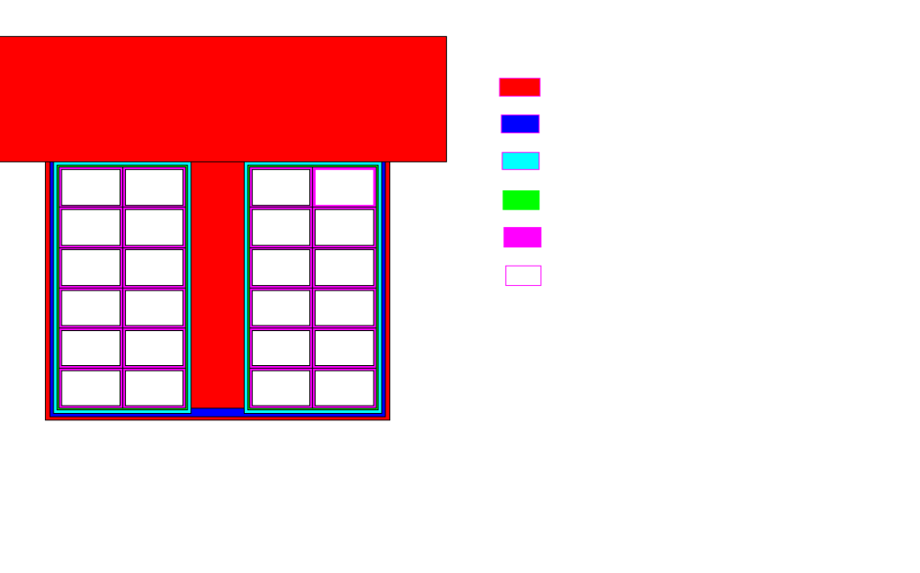

Fig. 10. Cross section of the T section with the copper conductor and various insulation layers
Red: Steel; Blue: Glass; Light blue: Copper cladding;
Green: Kapton; Purple: Kapton+glass; White: copper

As before, the Gaussian heat flux was used for the weld zone for 0.1 sec followed by a 1.5 second of constant melt temperature. After this time the weld area was allowed to cool up to 60 seconds by natural convection and radiation (Fig. 8).

The results are provided in a Power Point file named Welding Model for T section.ppt. The results indicate a growth and decay of temperature values at various locations. Five points are selected at the intersections of each insulation layer as shown in the file. It is of interest to note that maximum temperature encountered is directly below the edge of the steel block and the sheet with a value of about 750 ⁰C (fiber glass melt point is about 820 ⁰C). This is larger than the values obtained in the previous case in part because the steel sheet used here is 0.040 inch thick (compared with 0.06 inch. used in the experiments and their modeling discussed in previous sections). The surface temperatures for other layers remain below a maximum of
150 ⁰C as illustrated in the Welding Model for T section.ppt.

Finally, it is important to emphasize that the temperatures calculated here are upper limits for temperatures expected in a 3D model (based on the two tests performed, the temperatures in the 3D case will be probably as much as 15% smaller when compared with the 2D results)

