NCSX Engineering Design Document

Design Description
Electrical Power Systems (WBS 4)

NCSX PDR

October 7-9, 2003

Lead Author: Raki Ramakrishnan

Table of Contents
1 Introduction 3
2 Design Requirements and Constraints 3
3 Design Description and Performance 4
3.1 Power Loop Components 5
3.1.1 Power Converter 5
3.1.2 DC Current Limiting Reactors 6
3.1.3 Safety Disconnect and Ground Switches (DGS) 7
3.1.4 Power Cabling 7
3.1.5 Grounding 7
4 Design Basis 7
5 Design Implementation 7
6 Reliability, Maintainability, and Safety 8
7 Cost, Schedule, and Risk Management 8

Table of Figures
Figure 1 Transrex power supply schematic 5

Tables
Table 1 Transrex power supply section performance characteristics 4
Table 2 NCSX power supply requirements 6
Table 3 Work Breakdown Structure (WBS Level 3) 8
Table 4 Electrical Power Systems (WBS 4) cost summary by expense class (WBS Level 3) 9
Table 5 Electrical Power Systems (WBS 4) cost summary by year of expenditure (WBS Level 2) 9

Introduction
This document describes the design of the Electrical Power Systems (WBS 4) of the National Compact Stellarator Experiment (NCSX). The Electrical Power Systems WBS Element covers the supply and delivery of all AC and DC electrical power to all equipment associated with the NCSX experiment.

Design Requirements and Constraints
The main loads for the Electrical Power Systems come from:
- Stellarator Magnet Systems. The stellarator core has 2 modular coil circuits, 1 toroidal field (TF) coil circuit, and 3 poloidal field (PF) coil circuits in the initial configuration. These are: M1, M2/3, TF, PF1/2/3, PF4, PF6.
- Neutral Beam Injection (NBI) System.
The Electrical Power Systems requirements for the coil systems are derived from the performance requirements for the coils. NCSX is designed to be a flexible, experimental test bed. To ensure adequate dynamic flexibility, a series of reference scenarios has been established in the General Requirements Document (NCSX-ASPEC-GRD-01_dD). These scenarios include the:
- First Plasma Scenario
- Field Line Mapping Scenario
- 1.7T Ohmic Scenario
- 1.7T High Beta Scenario
- 2T High Beta Scenario
- 350kA Ohmic Scenario
- 1.2T Long Pulse Scenario
TF, PF, and modular coil systems and the vacuum vessel will be designed to meet the requirements of all the reference scenarios. The Electrical Power Systems will be designed and initially configured to meet the requirements of the First Plasma and Field Line Mapping Scenarios and designed to have an upgrade path to meet the requirements of all other reference scenarios.
Flexibility requirements have also been established. The dimensions in flexibility space include:
- Quasi-axisymmetry
- Internal and external iota
- Shear
- Beta
- Current profile
The coil systems shall be designed and the Electrical Power Systems will be upgradeable to accommodate flexibility requirements in each of these dimensions.
The NCSX Project has developed coil current waveforms for each reference scenario. These waveforms are documented in the Technical Data Sheet, which is an Appendix to the GRD and is provided as an appendix to this report (Appendix A). Plots of the waveforms and other parameters of interest are provided in Appendix B. Based on these waveforms, maximum circuit currents and voltages were calculated. Power supply requirements were calculated based on the Transrex supplies at D-site. These are the same power supplies that were used for TFTR, some of which are currently being used by NSTX. There are a total of 74 power supply sections located at D-site. The performance characteristics of these power supplies are tabulated in Table 1. A schematic of a Transrex power supply is provided in Figure 1.
When operating at full parameters (maximum I²t), the required repetition rate is once every 15 minutes. (The repetition rate is limited by the time required to cool down the modular coils.) The maximum CW current required in any circuit is 323 A during the first phase (First Plasma and Field Line Mapping). During subsequent phases including the final phase, the maximum CW current for the modular coils is increased to 1308 Amps. The maximum CW current for the TF and PF coils is less than 700 A.
Maximum active and apparent power requirements and stored energy requirements were calculated over the full range of reference scenarios. The maximum active power is 154 MW, with a maximum stored energy of 124 MJ, in the 2T High Beta Scenario. The maximum apparent power is 408 MVA, which occurred in the 1.7T Ohmic Scenario. These requirements are well within the capability of the D-site AC power system using the available line power and only a single MG set.
The remaining electrical loads should be comparable to electrical loads already handled by the C-site AC Power System during PBX-M operation.

Design Description and Performance
The NCSX machine will be installed in the NCSX Test Cell formerly occupied by the PLT and PBX-M tokamaks. The existing D-site DC power conversion equipment will be utilized for NCSX in order to meet the operational requirements of NCSX in a robust and cost-effective manner. The D-site power conversion equipment will be shared with NSTX, feeding at most one machine in operation at any one time. A one-line diagram of the NCSX Electrical Power Systems is provided in Appendix C, along with circuit schematics. Existing D-site power supplies will be used to power all the NCSX coils that are powered. Each of the a) six (6) NCSX circuits for the initial phase, and b) ten circuits (10) for the final phase, has been mapped into an existing or to-be-reconfigured NSTX coil circuit, as shown in Table 2.
Real time feedback control of the magnet power systems will be accomplished via digital computer algorithms performed in a processor provided as part of the Electrical Power Systems work scope. The same Electrical Power Systems computer presently controlling the NSTX system will be used for NCSX. However NCSX will be using a dedicated program. Input/output data for this purpose will be communicated using new and old data network (PC Link and HSDL) in the FCPC building and links from C-site as required. Wiring between power systems components and the existing CAMAC crates will remain as is.

Table 1 Transrex power supply section performance characteristics
Parameter | Value | Units
No Load Avg. DC Voltage | 1012.85 | volt
Nominal Pulse DC Current* | 24.0 | kA
Nominal Pulse ESW | 5.5 | sec
Nominal Pulse Repetition Period | 300.0 | sec
Maximum DC Current | 28.2 | kA
Maximum Continuous DC Current | 3.25 | kA

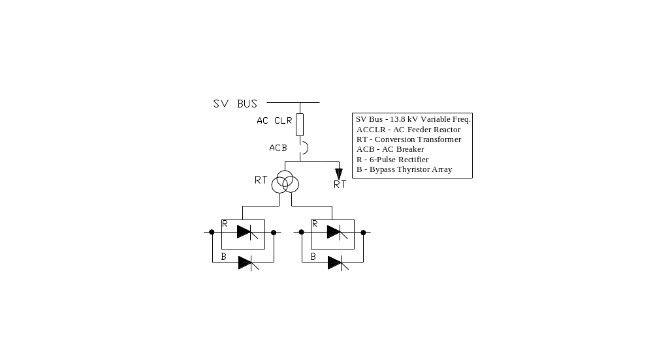
Figure 1 Transrex power supply schematic

The composite AC power demand imposed by NCSX may be supplied by a combination of power derived from the grid and one of the D-site MG sets. Available grid power for the pulsed loads through XST-1 is limited to approximately 120MVA. The total grid power availability depends on the power factor. Present contractual arrangements with PSE&G allow for instantaneous peak power demand up to 120MVA without mention of power factor.
AC power distribution to the D-site MG and power conversion rectifiers all exist and have been in service for several years at levels greater than those required for NCSX. The C-site NBI system was in operation for PBX-M. AC power distribution to NCSX auxiliary equipment will make use of existing equipment down to the 480V level under service conditions less than or equal to previous levels. Additional power panels will be purchased and installed in C-site NCSX Test Cell as required. Additional outlets and plug points will also be provided as needed. WBS 4 will provide power for all Diagnostics Systems equipment up to the power panels.

Power Loop Components

Power Converter
The power converter consists the rectifier transformer and associated thyristor power supply. Each rectifier transformer (manufactured by General Electric Co.) is a 3-winding 13.8kV/750V/750V unit. The 13.8kV primary of the transformer is a polygonal winding fed from the 13.8kV variable frequency (60 to 90Hz) bus supplied by the 470MVA Generator. One secondary is wye connected and the second is connected in delta.
Each conversion transformer feeds one thyristor Power Supply (manufactured by Transrex Co.). Each power supply consists of two sections rated at 1kV dc open circuit; the full load peak ESW (Equivalent Square Wave) pulsed current is 24kA for 5.5 seconds every 300 seconds. The pulsed rating was re-analyzed during the TFTR OH system upgrade and it was determined that the pulsed current can be raised to 28.4kA for 3 seconds every 300 seconds without overheating the thyristors. There are 37 power supplies installed in PPPL of this rating. Each power supply section consists of six rectifier bridges connected in parallel, and two bypass modules and associated firing generators, fault detectors and associated controls. In addition PPPL has two (2) power supplies rated at 4.5 kA ESW of 2 seconds every 300 seconds. The reduction in rating of these two supplies is due to the reduced size of the transformer. The thyristor units are same for all the 37 supplies.

Table 2 NCSX power supply requirements
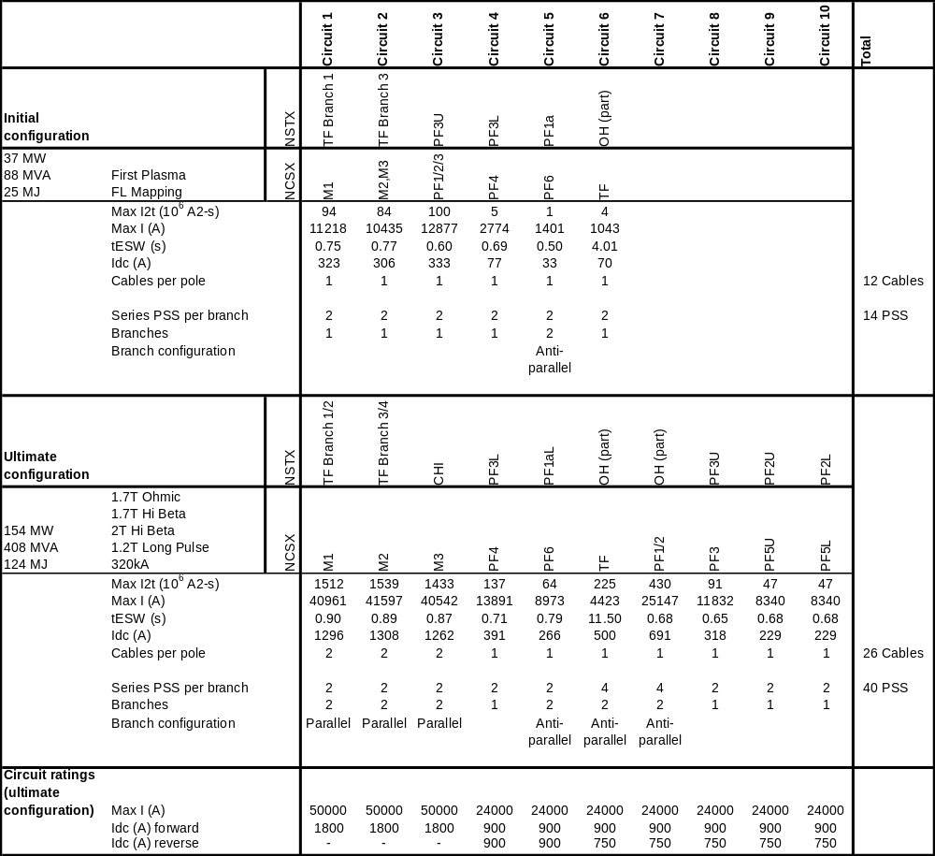

DC Current Limiting Reactors
The output of each string of the power supply is provided with a series current limiting reactor that has a value of 267 micro-henries. The reactors will limit the short circuit current to acceptable levels. Also when the branches operate in the anti-parallel configuration the reactors limit the circulating current.

Safety Disconnect and Ground Switches (DGS)
In the D-Site, each circuit will be provided with safety disconnect and ground switches (new purchase). The disconnect and ground switches are electrically and mechanically interlocked such that only one switch can be closed at a time. Both switches can be open at the same time.
In the C-Site also each circuit is provided with disconnect and ground switches. These are the switches originally used in each of the C-Site MG power loops.

Power Cabling
All the new cabling for the power loop will use 5kV shielded 1/c-1000mcm cable. The cables will be duplexed so that there is no resultant force from the pair of cables during pulsing.

Grounding
WBS4 scope includes all the grounding requirements for the machine. It is proposed to retain the copper ground pad/plate within the NCSX test Cell, which was originally used for earlier machines. How ever in order to reduce field errors due to eddy currents, radial cuts will be made in the copper pad/plate every 30 degrees under the foot print of the machine or beyond as determined to be necessary.
Diagnostics equipment will be provided with single point ground system to prevent ground loops. All grounding of equipment will be made per NEC taking care ground loops are avoided.

Design Basis
The bulk of work in this WBS element involves a) the reconfiguration of existing equipment that has been in use for several years at service levels equal to or greater than those required by NCSX and b) additional DC power cabling. All work activities will be performed in accordance with Princeton Plasma Physics Laboratory (PPPL) Engineering and Safety procedures and directives. New NCSX Electrical Power Systems components will be designed, constructed, and installed in compliance with the applicable provisions of the PPPL Health & Safety Manual (ES&H-5008) and other documents as listed in DOE Orders (e.g., ANSI/NFPA 70-(latest edition), National Electric Code, ANSI C20-(latest edition) National Electric Safety Code, etc.).

Design Implementation
The Field Coil Power Conversion (FCPC) Building houses all the power conversion equipment. Reconfiguring the coil power supplies so that they may be used for both NCSX and NSTX is a major activity that will have to be planned during the maintenance and shutdown periods of NSTX. The conversion transformers are located outside the building at the back of each of the rectifier units. The Safety Disconnect Switches (SDS) and the Hardwired Control System cabinet are also located in the FCPC building first floor.
Power cables will be installed from the D-site Safety Disconnect Switches (SDS) to the NCSX Disconnect & Ground Switches (DGS) to be located in the second floor of the FCPC building. Each leg of each circuit will be provided with 1/c-1000 mcm cable (5kV rated). A new overhead DC transmission system will be installed from D- to C-site to power the NCSX coils. Transmission will be via power cables from the NCSX Disconnect & Ground Switches (DGS) to the Power Cable Termination Box (PCTB) in the EF/OH building. Provision will be made to reverse the coil polarity with links inside the PCTB. Existing power cables from EF/OH building to the C-site MG basement will be reconnected for each circuit from the PCTB to the existing C-site Bus system at the Discharge Breaker Resistor Cubicles in C-site MG Basement.
The C-site Bus System/Local Disconnect & Grounding System (LDGS) is an existing system, which was installed for earlier fusion devices located in C-site. The C-site Bus System is also already provided with a set of Local Disconnect and Grounding Switches (LDGS). These will be used for each NCSX circuit. Thus, each NCSX coil can be isolated and grounded at the coil end at C-site. The LDGS is designed such that the coils get shorted and grounded when the switch is open. After the Bus System switches, power will be delivered to the coil terminals via power cables in the Test Cell.

Reliability, Maintainability, and Safety
There is a substantial experience in operating and maintaining the equipment in the Electrical Power Systems. On the basis of that experience, the equipment is expected to operate reliably and be readily maintainable. The equipment will be installed, tested, and maintained by experienced, trained personnel in accordance with Princeton Plasma Physics Laboratory (PPPL) Engineering and Safety procedures and directives.

Cost, Schedule, and Risk Management
Table 4 is a summary of the estimate for the Electrical Power Systems (WBS 4) in the NCSX Fabrication Project. The total cost is estimated to be 5094k$ in year of expenditure dollars. The dominant expense class is labor. DC Systems (WBS 43), which covers all of the cabling to bring DC power from D-site to C-site, is the largest cost element. The overall contingency was estimated to be 20%.
The schedule for implementing the Electrical Power Systems (WBS 4) may be seen in the project Master Schedule, provided as part of the Preliminary Design Report. Title II for Electrical Power Systems will generally be completed in FY05. Installation and testing will be generally completed by the end of FY06. The peak years of expenditure are FY05 and FY06, with expenditures of approximately $1.8M in each of those years.
Technical and cost risks should be minimal as this is primarily a reconfiguration activity of existing equipment being performed by experienced personnel. PPPL has extensive experience in all aspects of the job including power cable installation. Costs for power supply reconfiguration and cabling have been assessed based on recent experience on NSTX. Vendor quotes were obtained for constructing the towers between D-site and C-site. Careful planning will be required to mitigate schedule risk due to potential conflicts with the NSTX Project since part of the work can be performed only when NSTX is not operating. This has been carefully planned and has enough float to change depending on changes in the NSTX operational schedule. The jobs in C-Site do not depend on NSTX operations. How ever the C-Site tasks are coordinated with other WBS requirements and progress. Again, enough float has been retained to ensure that the tasks do not come in the critical path. The projected planning of all WBS4 tasks is such that there will not be any risk to the critical path schedule.

Table 3 Work Breakdown Structure (WBS Level 3)
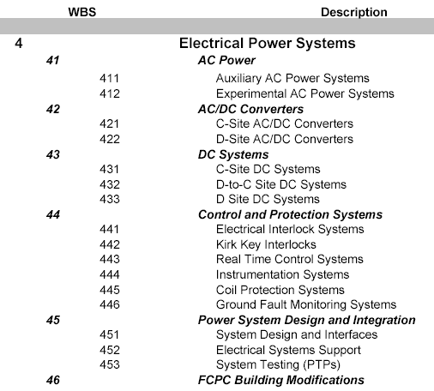
Table 4 Electrical Power Systems (WBS 4) cost summary by expense class (WBS Level 3)
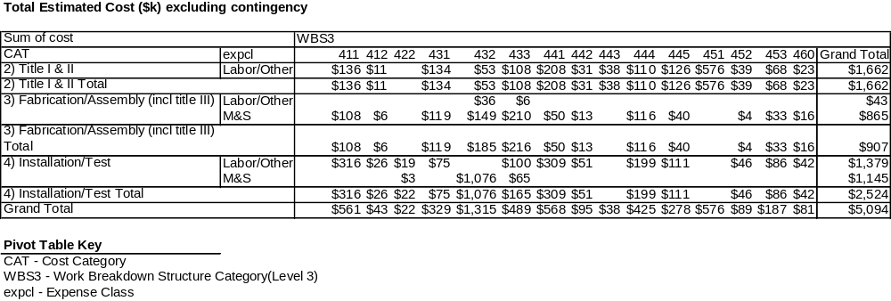

Table 5 Electrical Power Systems (WBS 4) cost summary by year of expenditure (WBS Level 2)
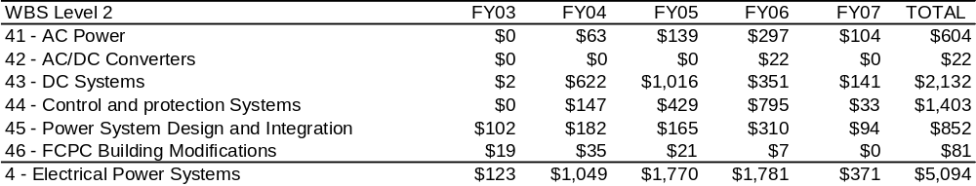

Appendix A – Excerpts from Technical Data Sheet
Appendix B – Plots of Electrical Power Systems Parameters
- First Plasma Scenario
  - Temperature
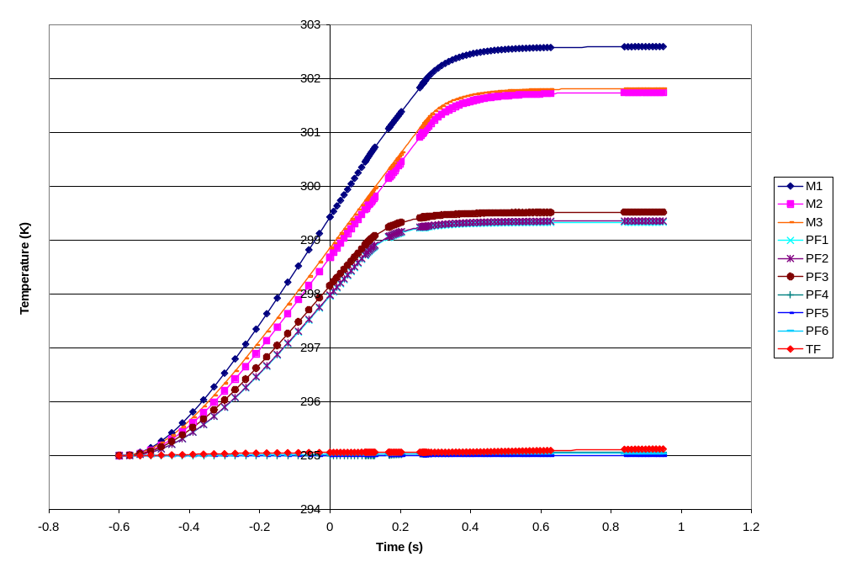
  - Current
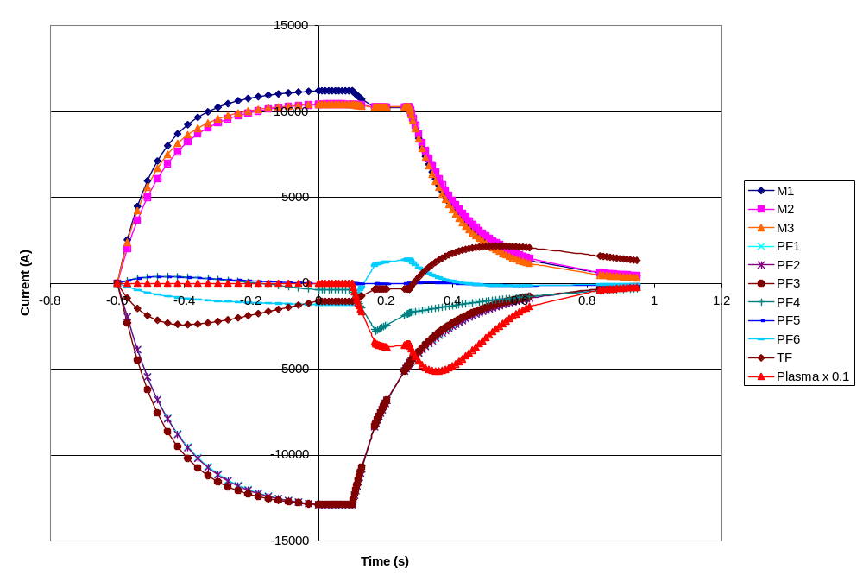
  - Power
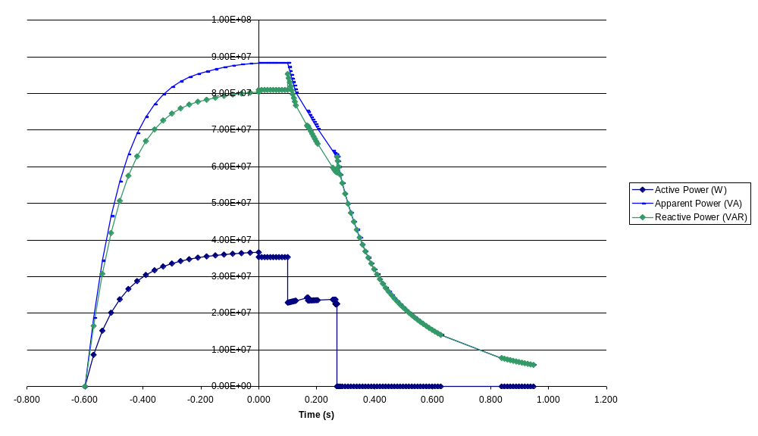
  - Energy
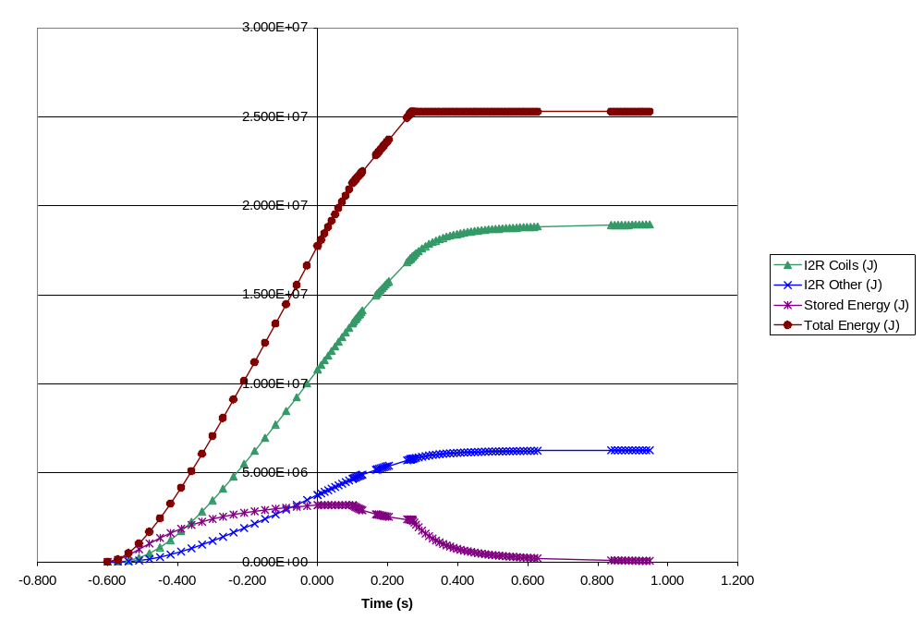
  - Power Supply Voltage
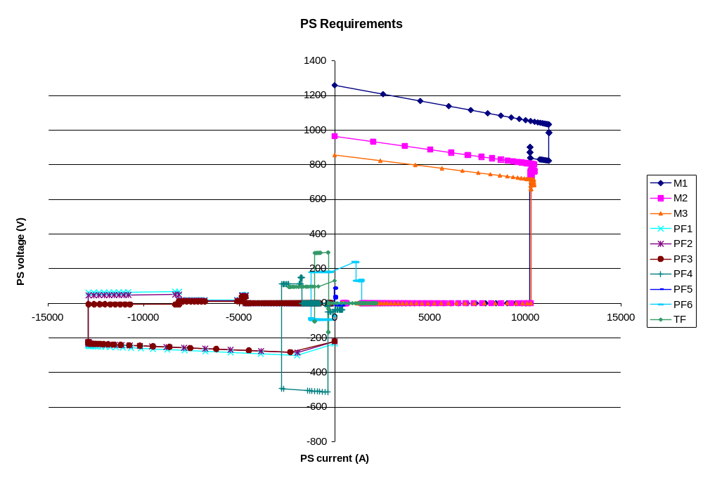

- Field Line Mapping Scenario
  - Temperature
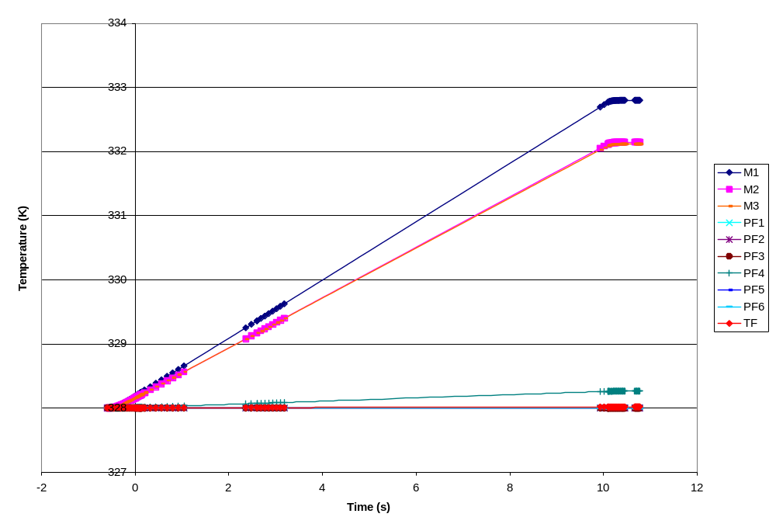
  - Current
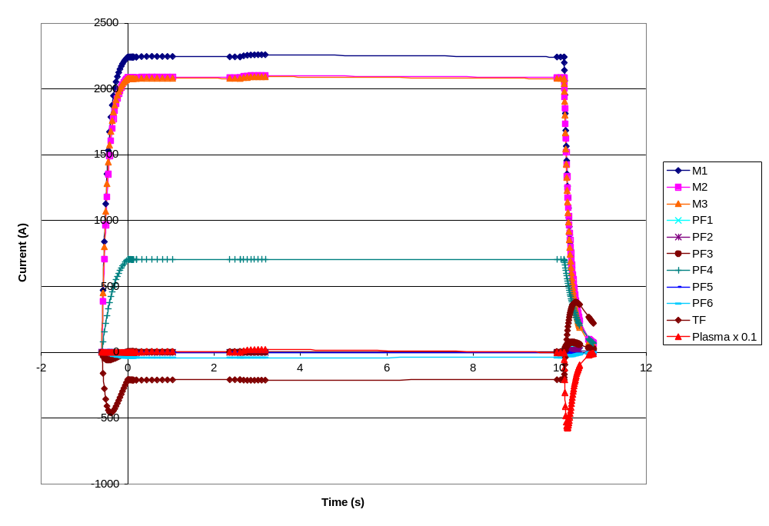
  - Power
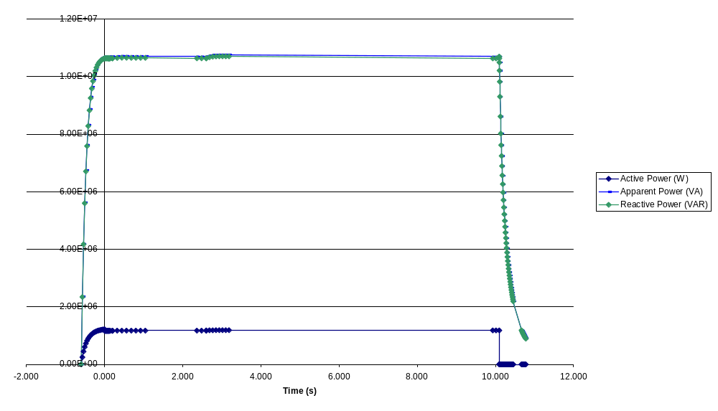
  - Energy
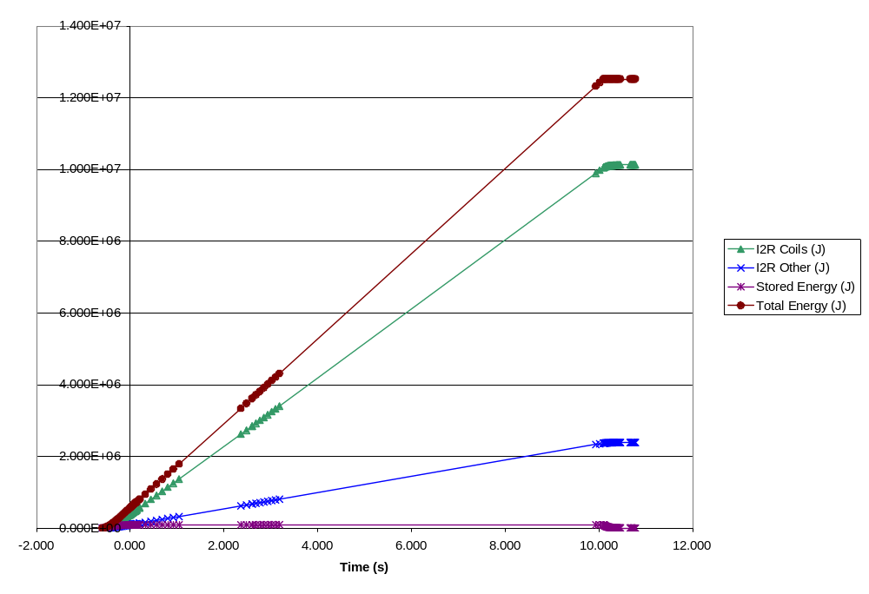
  - Power Supply Voltage
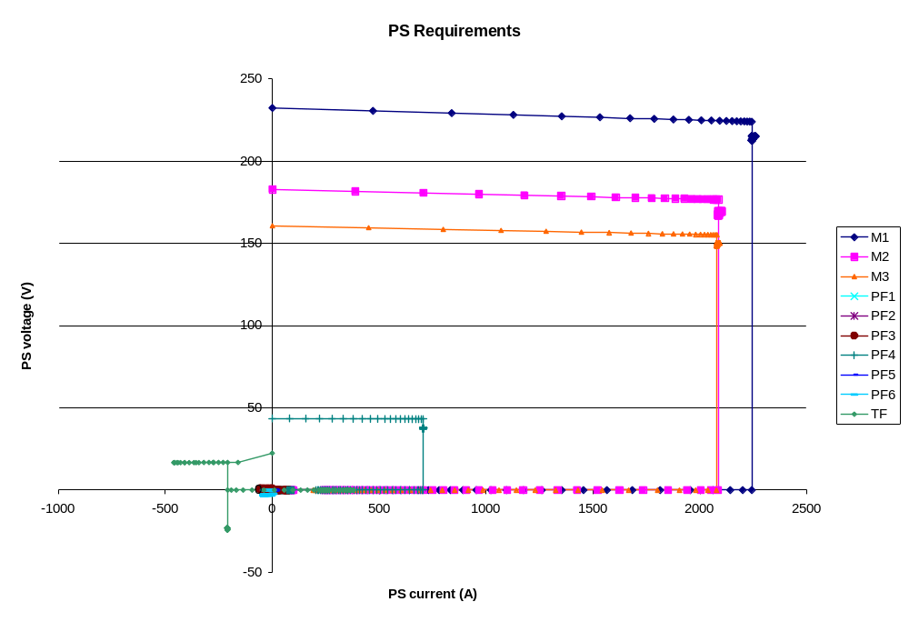

- 1.7T Ohmic Scenario
  - Temperature
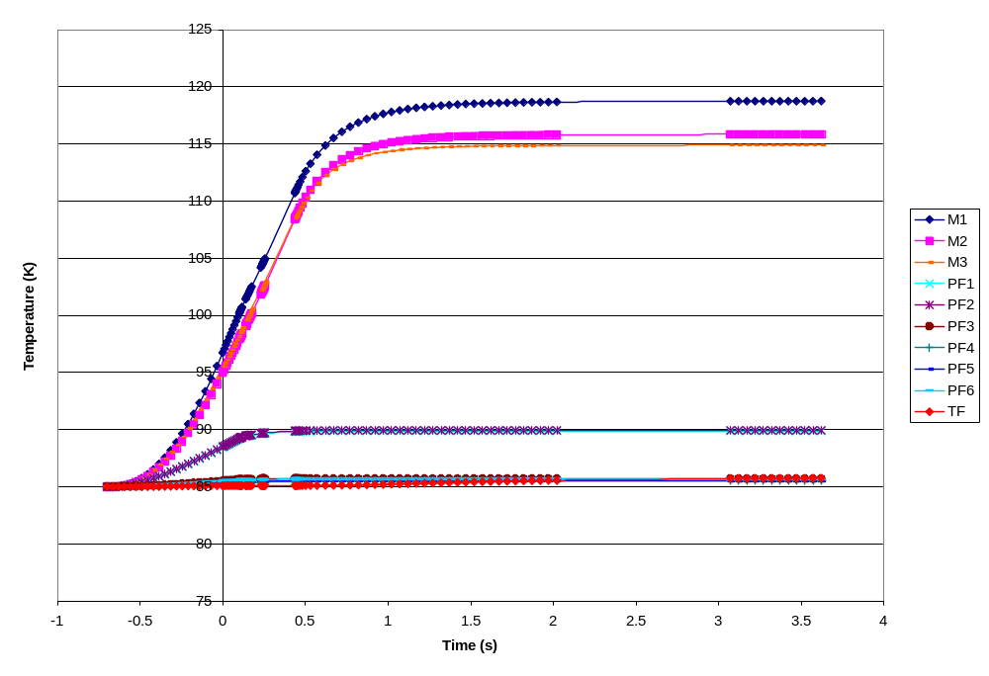
  - Current
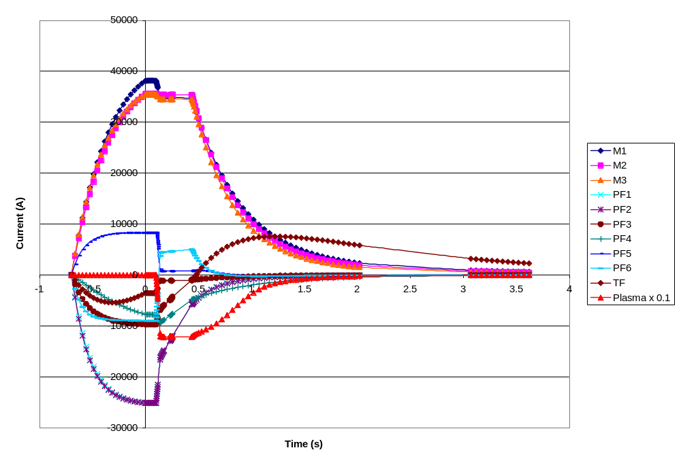
  - Power
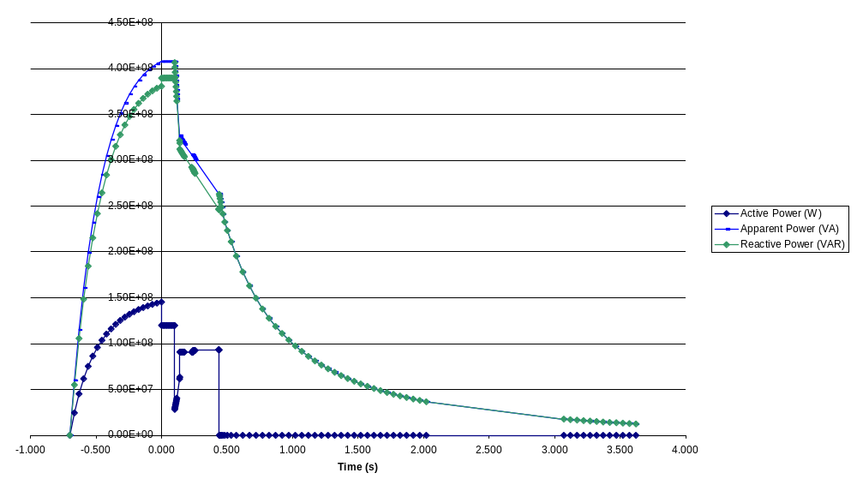
  - Energy
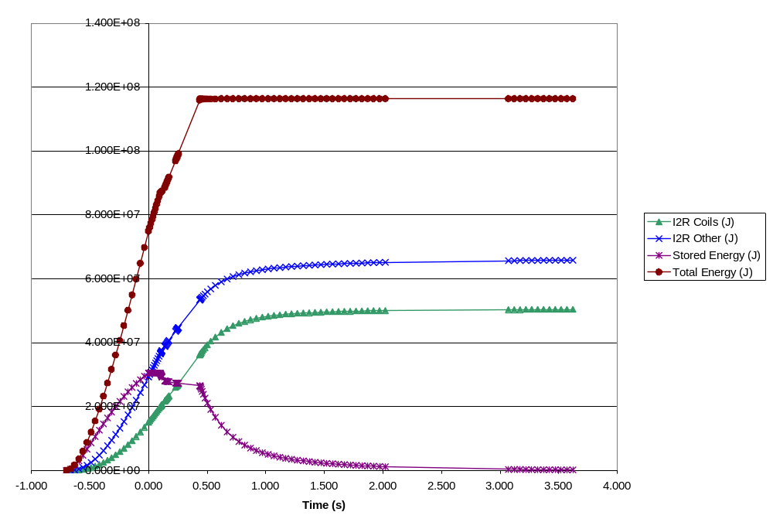
  - Power Supply Voltage
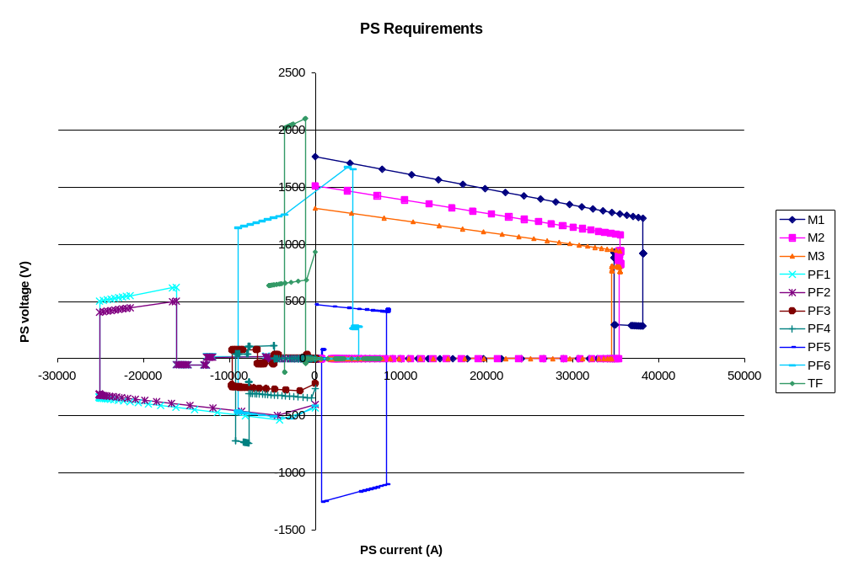

- 1.7T High Beta Scenario
  - Temperature
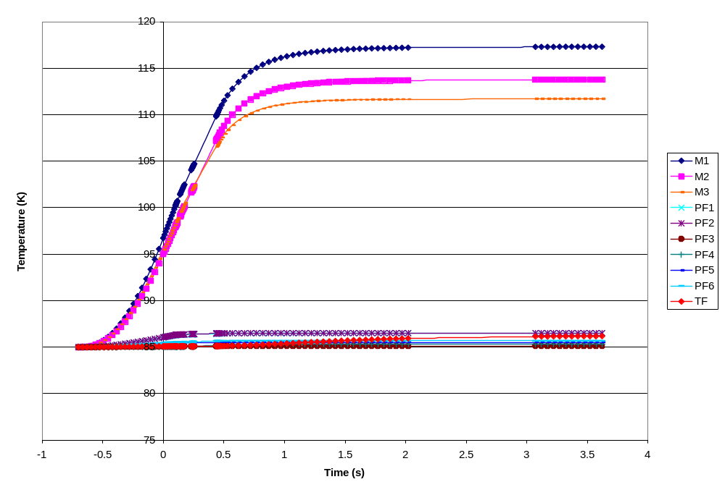
  - Current
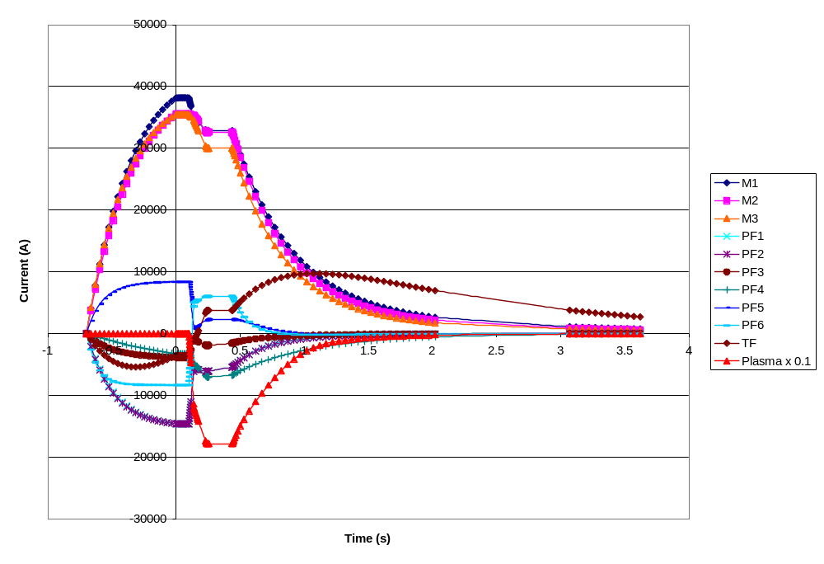
  - Power
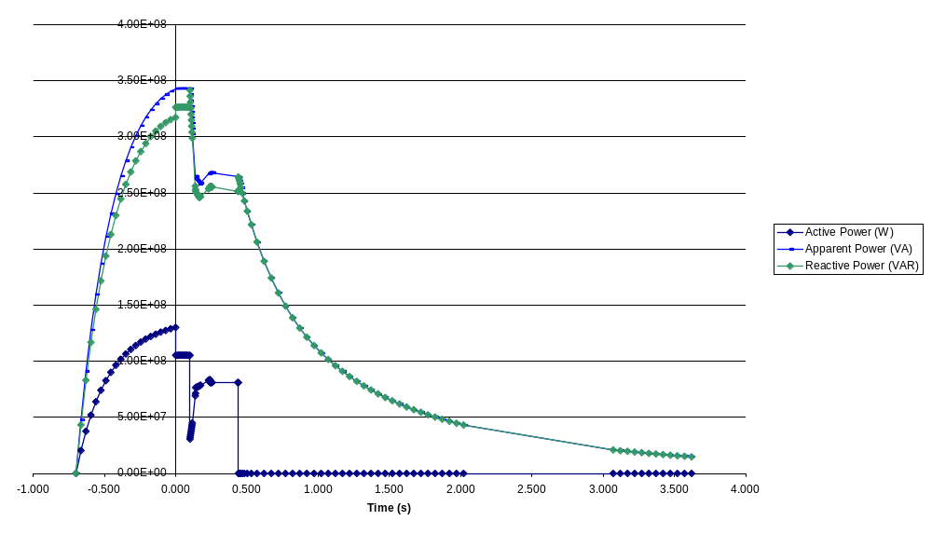
  - Energy
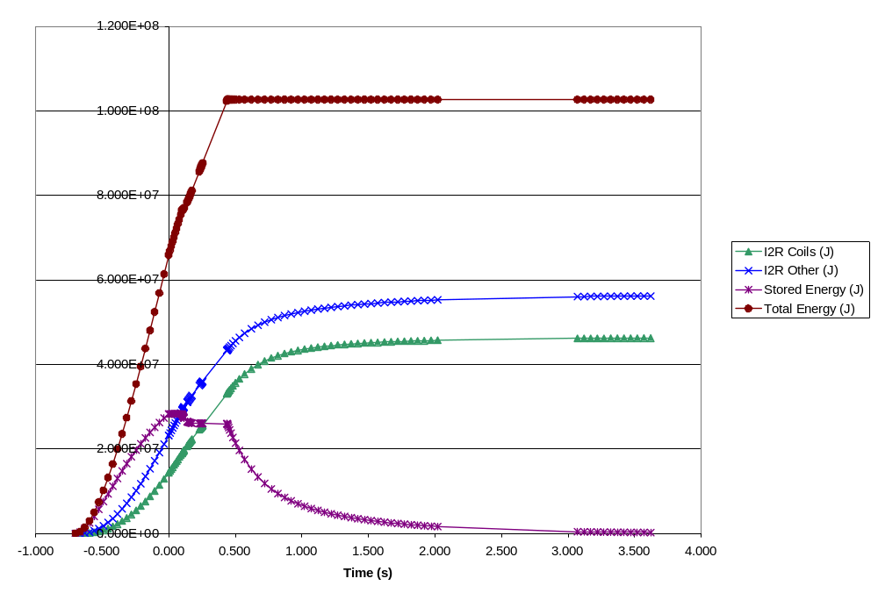
  - Power Supply Voltage
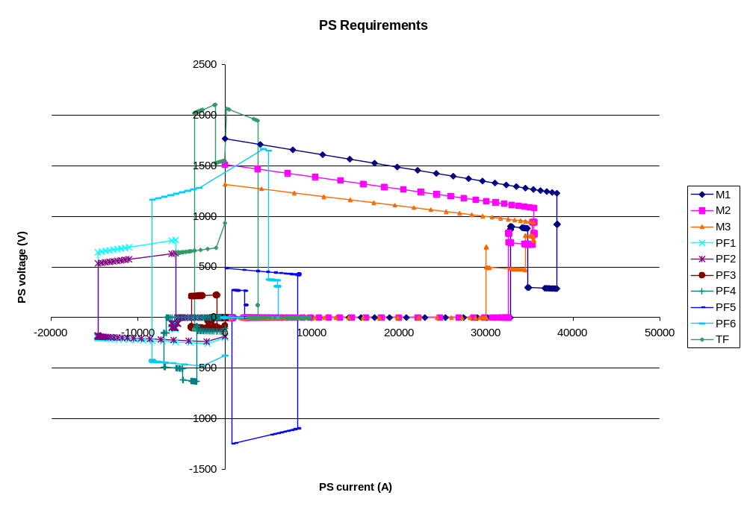

- 320kA Ohmic Scenario
  - Temperature
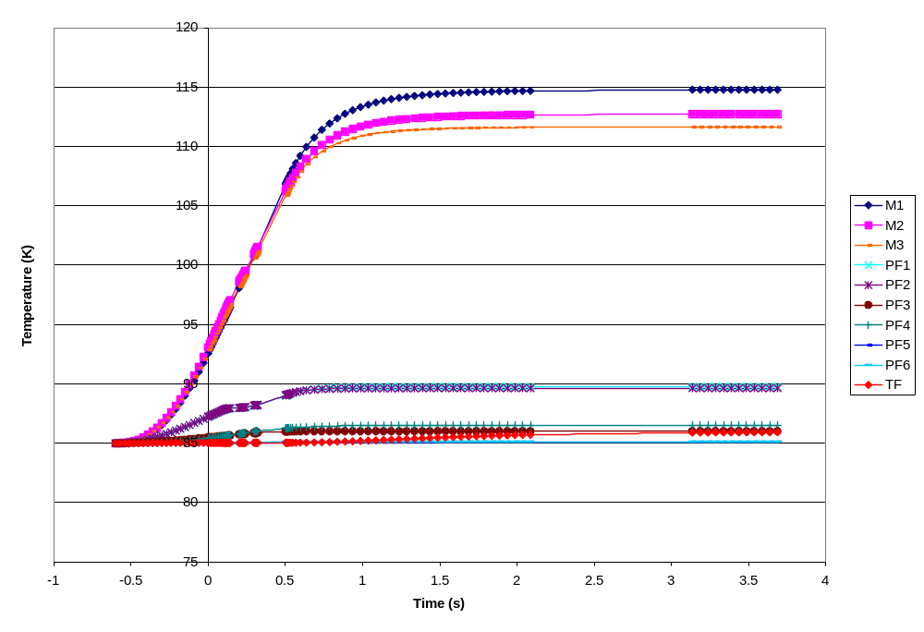
  - Current
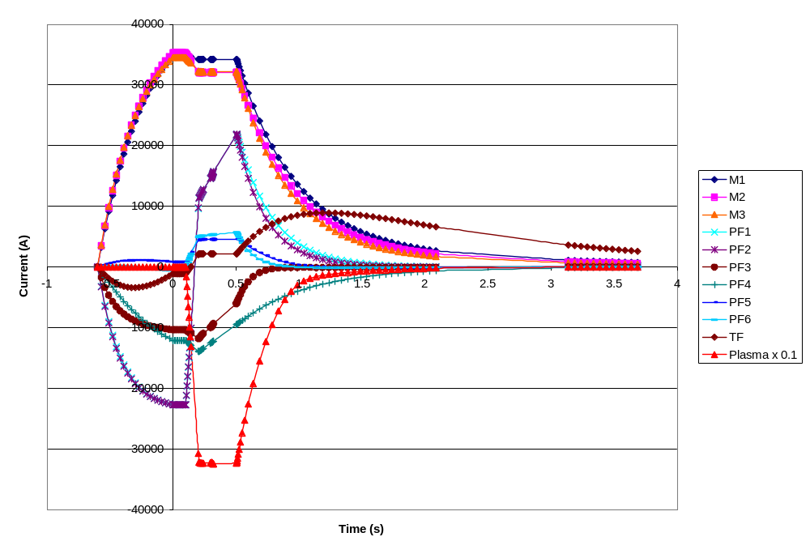
  - Power
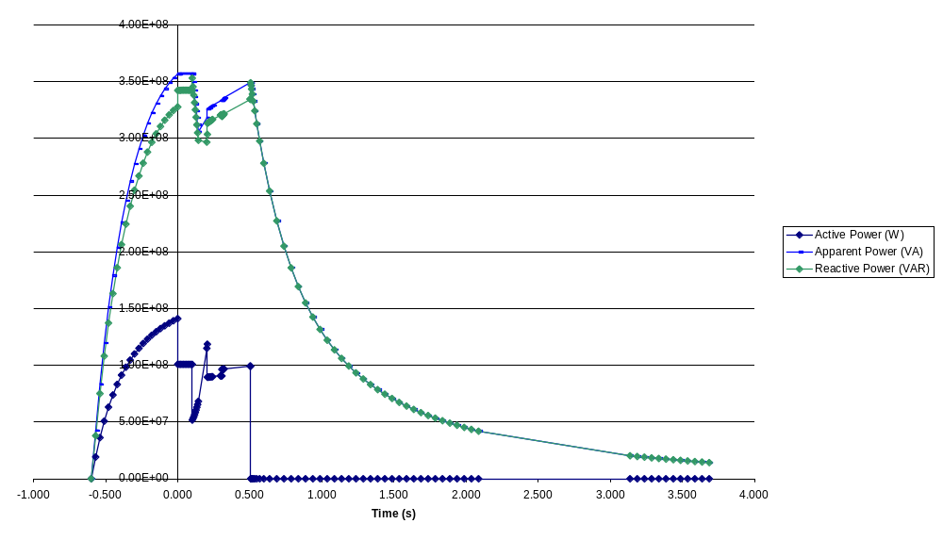
  - Energy
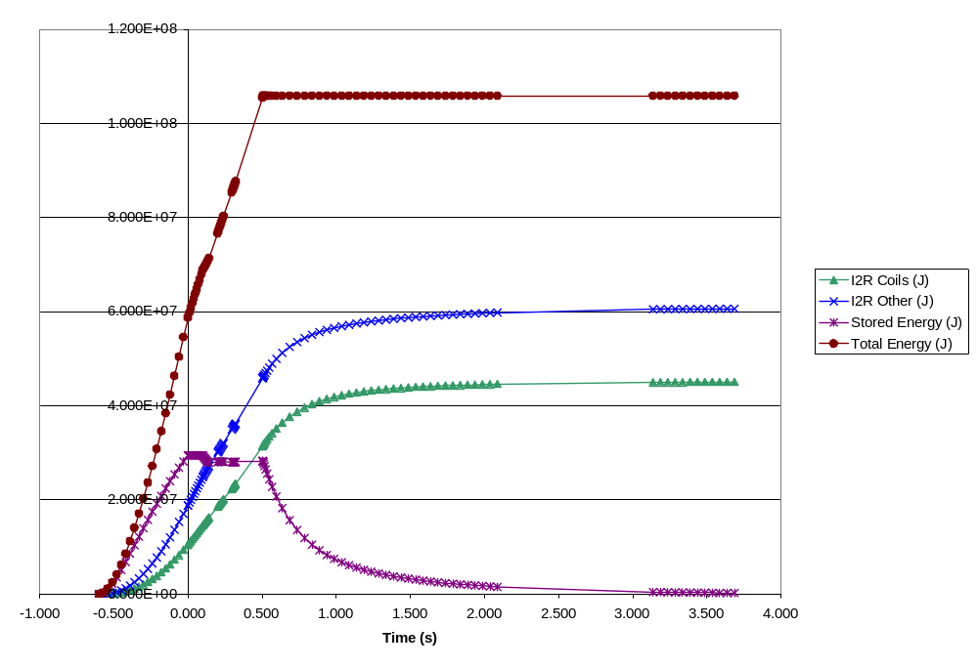
  - Power Supply Voltage
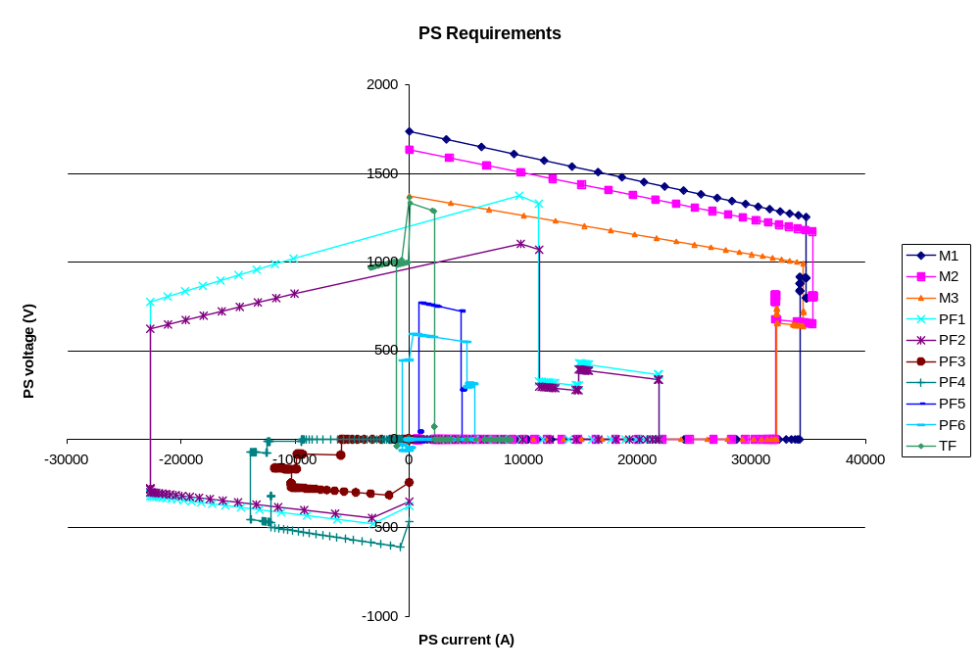

- 1.2T Long Pulse Scenario
  - Temperature
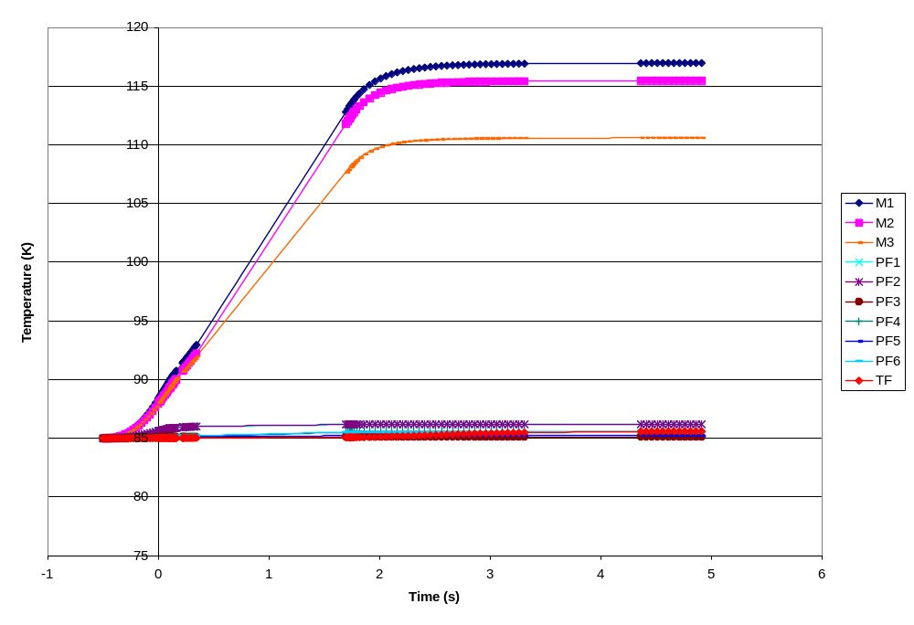
  - Current
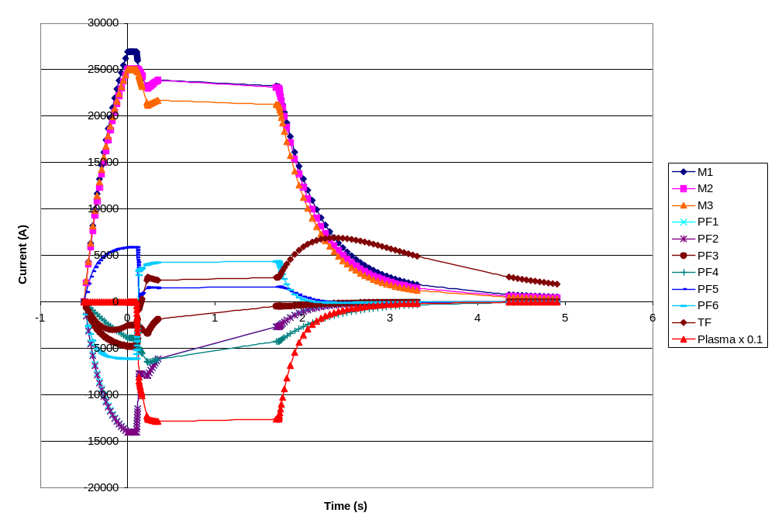
  - Power
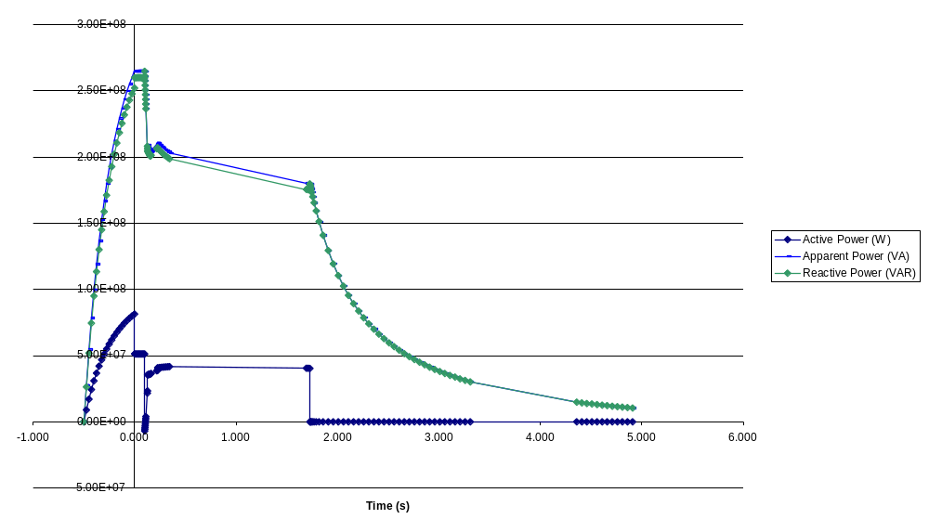
  - Energy
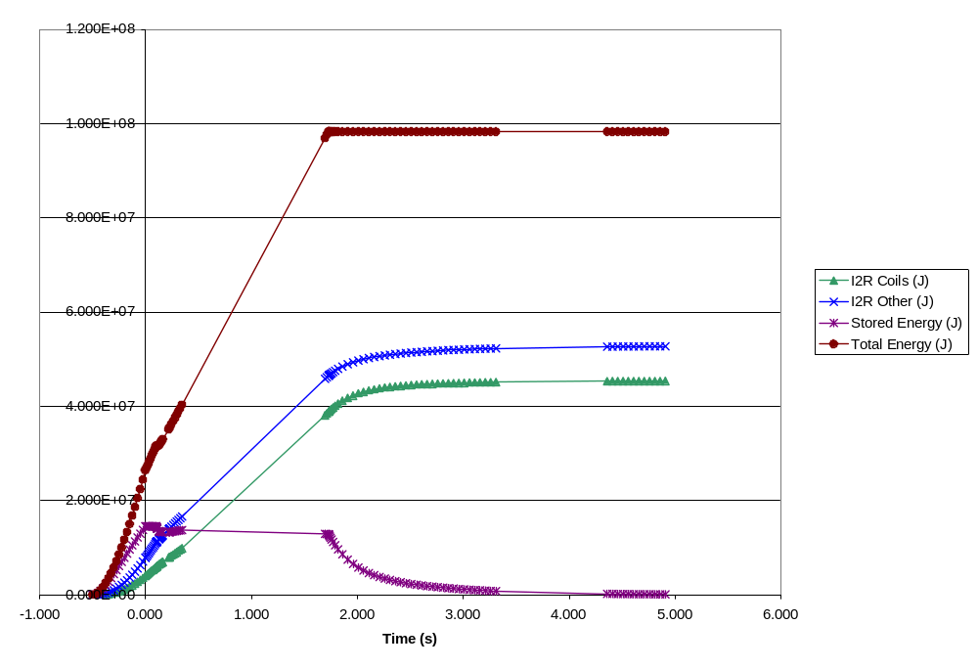
  - Power Supply Voltage
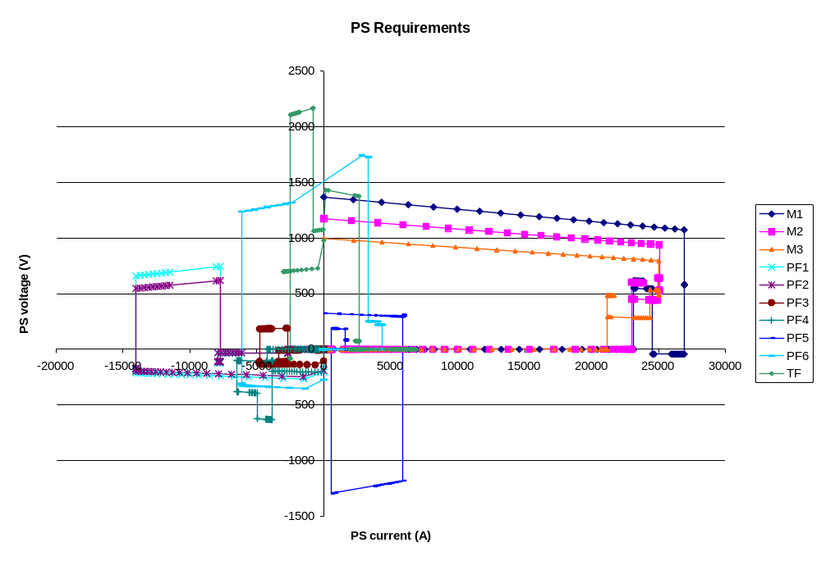

- 2T High Beta Scenario
  - Temperature
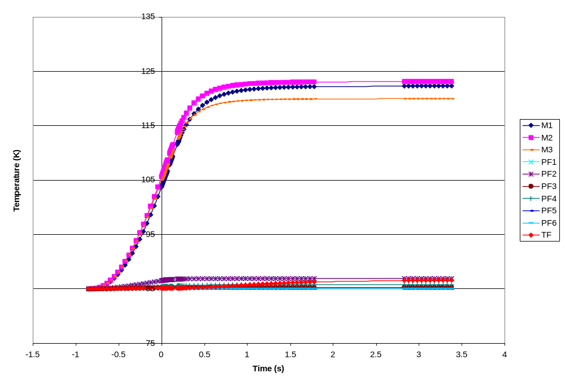
  - Current
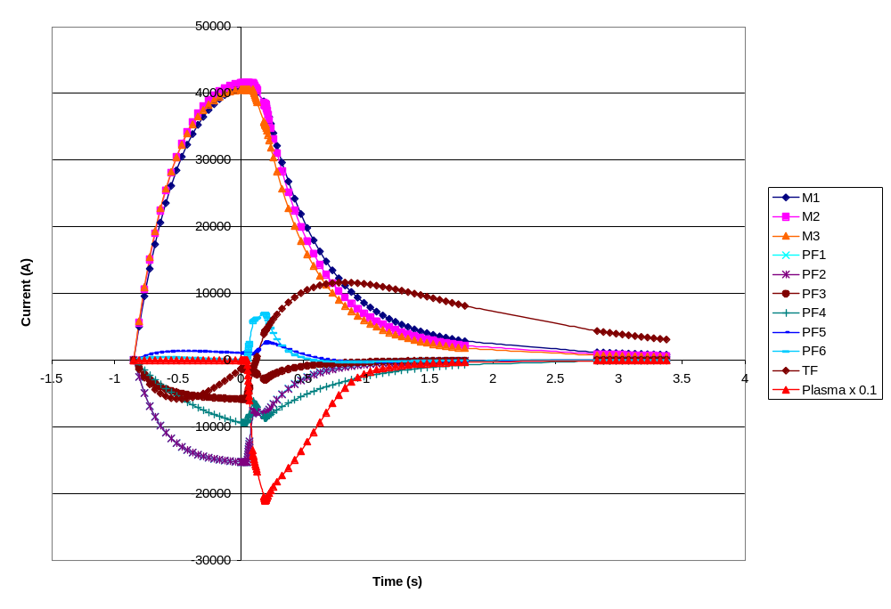
  - Power
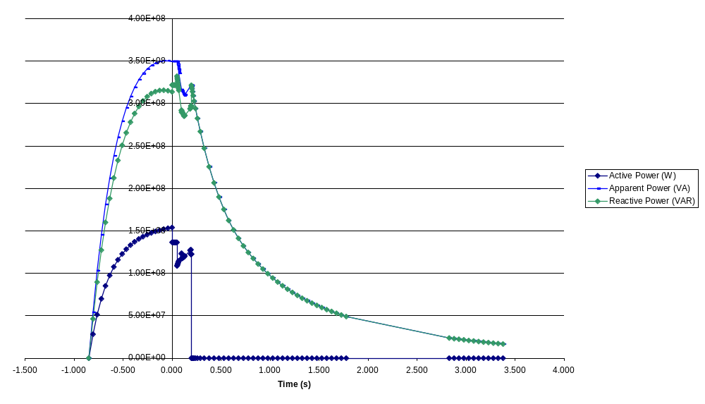
  - Energy
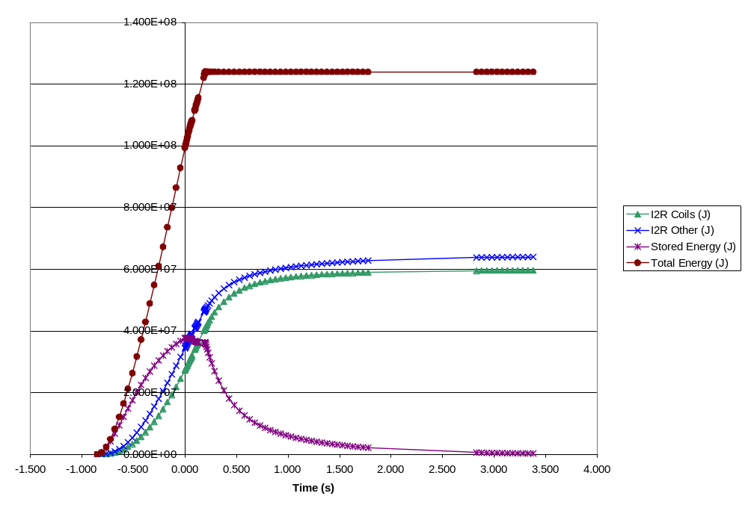
  - Power Supply Voltage
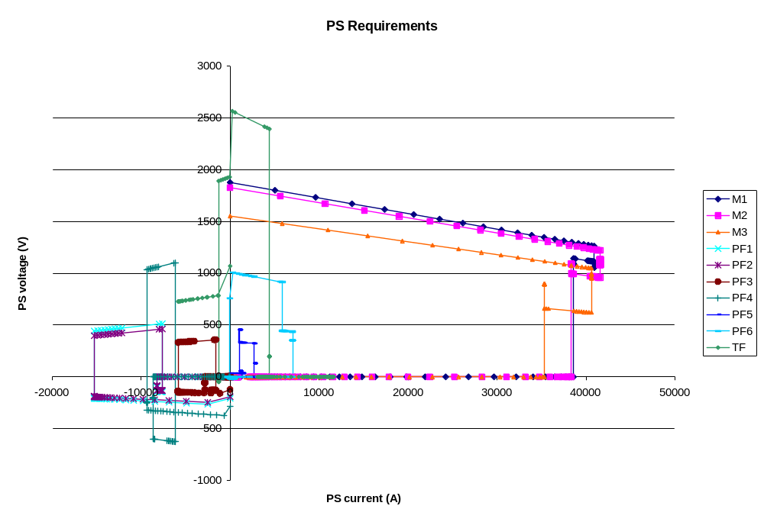
Appendix C – NCSX One-line Diagram and Circuit Schematics

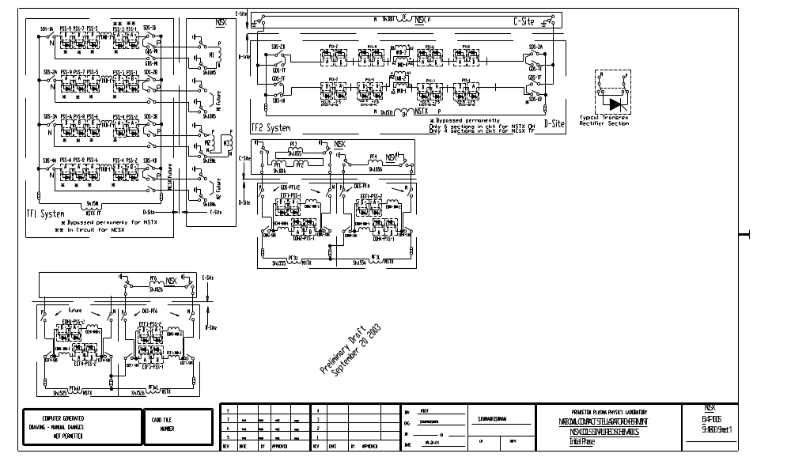

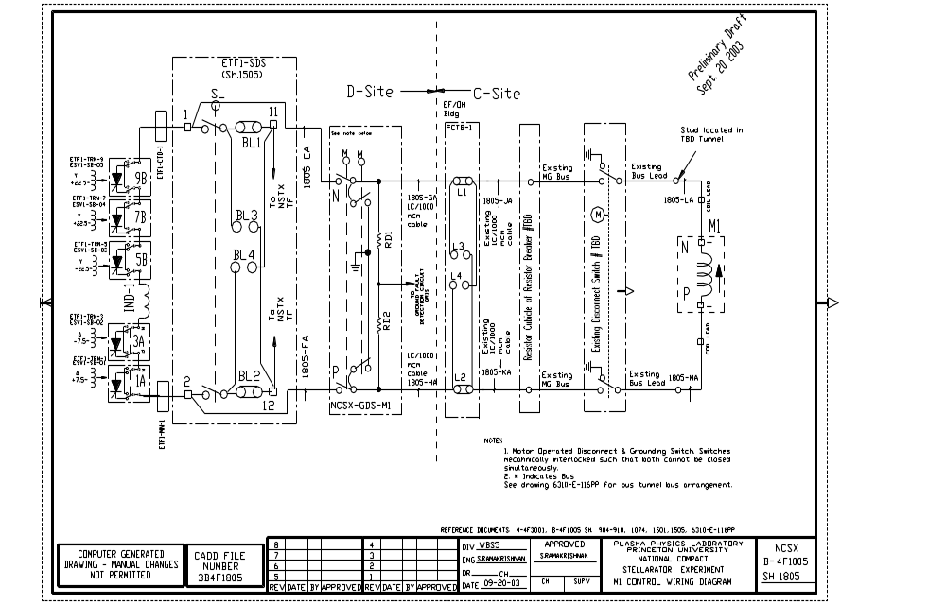
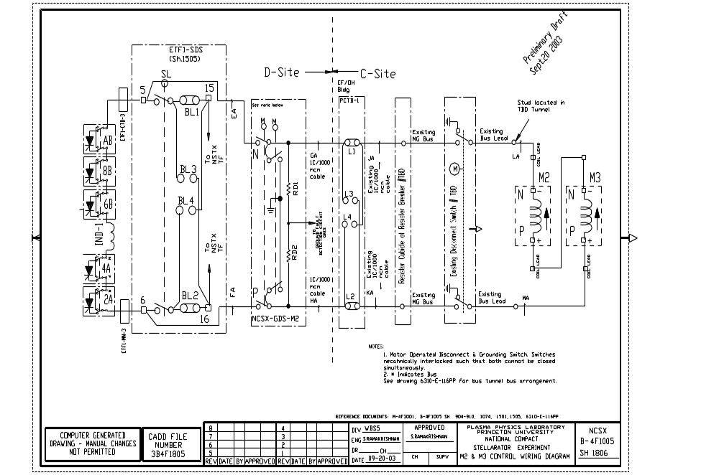
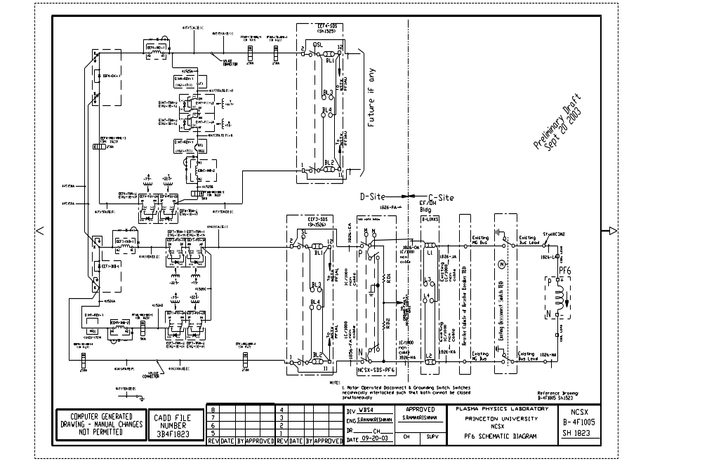
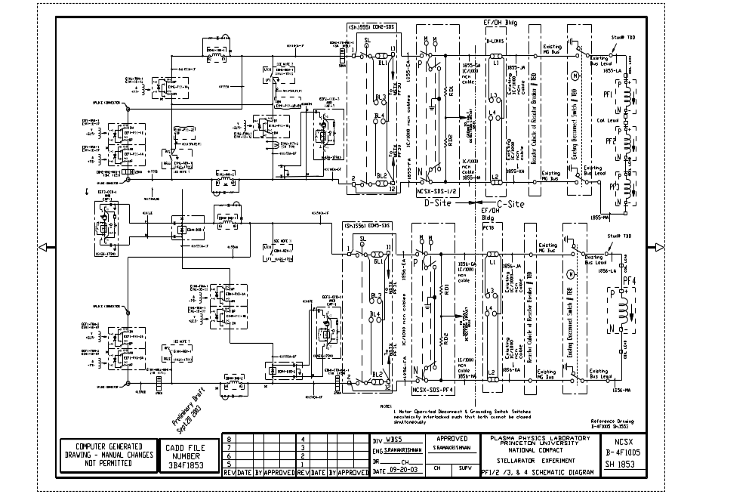
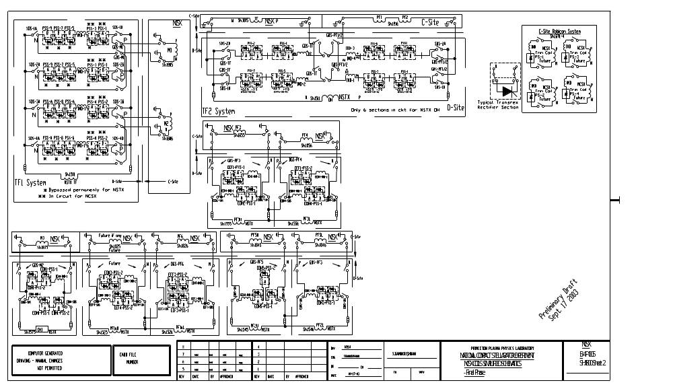

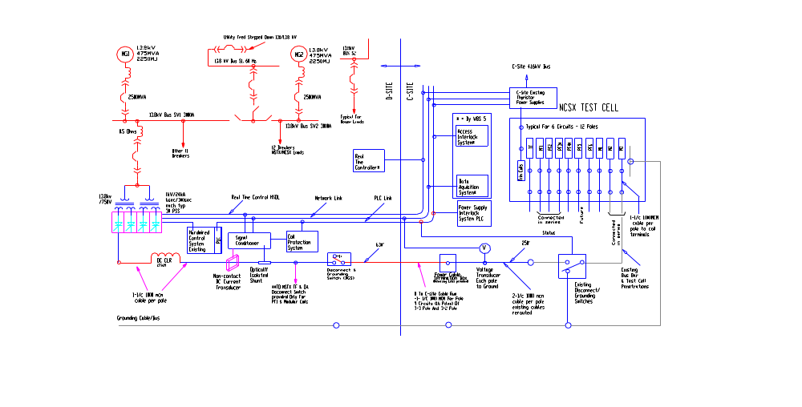

This draft version of the GRD was prepared for the October 2003 Preliminary Design Review (PDR). The changes proposed in it will be formally reviewed by the Project following the PDR.
TDS-C08R00_C.xls

