NCSX
Design Basis Analysis

Comparative Stress Analysis of the Reference and Narrow (3.47”) NCSX TF Coils

NCSX-CALC-131-002-00

Draft A
07 September 2004

Prepared by:

_______________________________________
L. Myatt, Engineering Analyst

I have reviewed this calculation and, to my professional satisfaction, it is properly performed and correct. I concur with analysis methodology and inputs and with the reasonableness of the results and their interpretation.

Reviewed by:

_______________________________________
- Brooks, Engineering Analyst

Controlled Document
THIS IS AN UNCONTROLLED DOCUMENT ONCE PRINTED.
Check the NCSX Engineering Web prior to use to assure that this document is current.

1.0 Executive Summary

This memo presents the results of an ANSYS stress analysis of the NCSX TF coil system. The model includes all conventional and modular coil field sources, but only focuses on the stresses in the TF winding pack (WP). The 3D model has been fully developed in an earlier memo, and so modeling details are omitted. The only difference between that configuration and the one analyzed here is a reduction in the toroidal width of the TF WP from 5.49” to 3.47”.

The analysis indicates that the reduction in WP width produces higher stresses and deflections of varying amounts, depending on the loading. Equilibrium ID 7 produces the highest stresses, and here the narrow WP has about a 20% impact on the maximum stress level.

The analysis also shows that Equilibrium ID7 is a very severe load condition, which results in stresses 65% to 75% higher than the 0.5T load case alone (depending on the TF WP build). Recall that the previous detailed TF stress analyses focus on this 0.5 T load case.
2.0 Assumptions and Notable Concerns

The analysis is based on a finite element model which is known to be inaccurate in the high stress region. There is also evidence that the inaccuracies lead to conservative results, which is discussed in the memo. Therefore, the model serves its intended function of evaluating this narrower WP design change relative to the reference design.

3.0 Analysis

This stress analysis of the NCSX Modular Coil system is based on the linear finite element ANSYS model shown in Fig. 3.0-1. The model is composed of the complex MC winding forms and coils, shell-to-shell insulated shims, conventional coil sources (CS, PF and TF) plus a simplistic representation of the plasma. The model employs 120˚ symmetry to minimize computational requirements.

The objective of this analysis is to evaluate a proposed change in the toroidal width of the TF WP from 5.49” to 3.47”. This change to the reference [Error: Reference source not found] model is handled very easily by simply modifying the toroidal position of the TF coil nodes away from the wedged region (see Fig. 3.0-2). A few of the most demanding operating conditions are used to benchmark the effects of this change: 0.5 T Only, Equilibrium ID #7, 1.7 T High-β and 2.0 T High-β. Maximum stresses and deflections are used to evaluate the effects of the reduction in WP width.
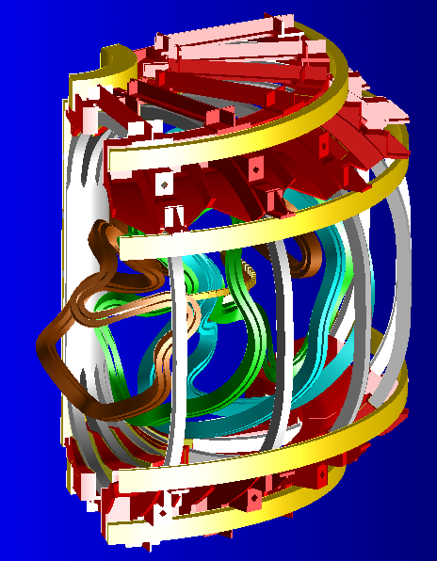
Fig. 3.0-1 NCSX Conventional & Modular Coils and Shell Structure, 3.47” Wide TF WP
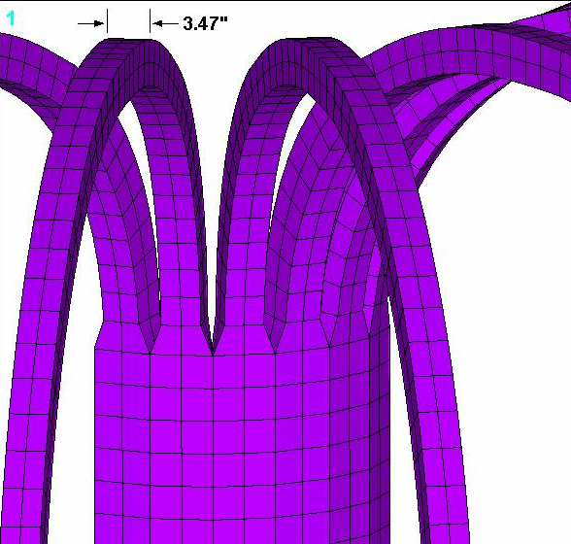
Fig. 3.0-2 TF Coils with Reduced Width WP away from Wedged Region

It should be clear by now that this model of the TF coil is less than perfect. The transition from the wedged to de-wedged region is too abrupt as illustrated in Fig. 3.0-3. On the left is a sketch of the TF inner leg and transition region. It shows that the wedging surface continues vertically well past the 57.57” length of the straight-leg. The model plot on the right shows that toroidal continuity ceases at the end of the straight section.

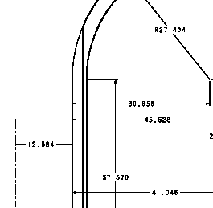
Fig. 3.0-3 Comparison of the Designed and Modeled Wedged Region
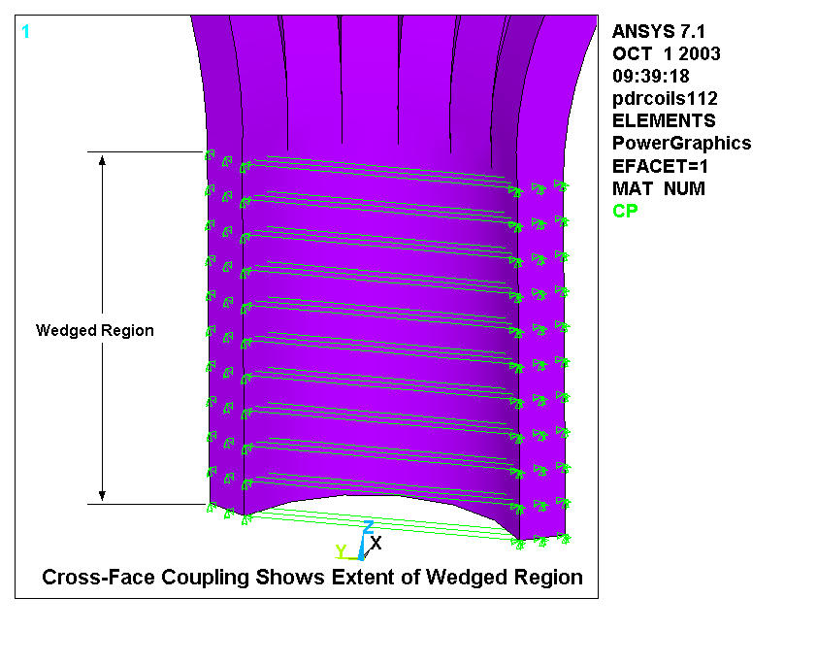

This detail was not lost as the analysis of the conventional coils evolved. In March of 2003 a far more detailed analysis of the TF coil system was presented. In addition to including a detailed portion of the WP conductor array, the model also got the transition region right (see Fig. 3.0-4). However, for the purposes of this comparative study, the simplistic representation of the TF coil will suffice.

Fig. 3.0-4 Model plot of Improved EM-ST model [Error: Reference source not found]

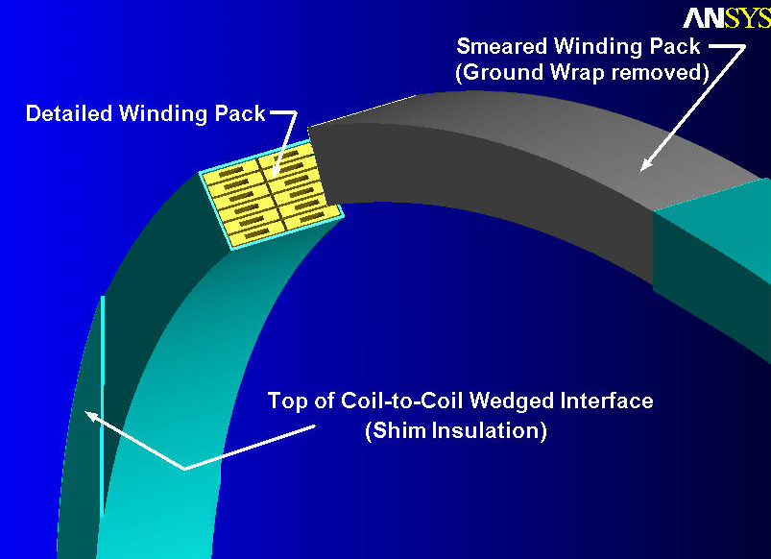
4.0 Results

The results of the analyses are summarized in Table 4.0-1 and illustrated by a series of stress intensity contour plots (Fig. 4.0-1 to 4.0-4) for the reference and narrow WP width configurations. All contour plots have are superimposed on deformed shapes which are scaled by 40x for visualization purposes. In addition to reporting the maximum stress intensity (SI) and deflection (U), the table also lists the peak field (B) in the WP. These values are included for reference purposes, and are not expected to be especially accurate based on the lack of detail in the TF model. The Run No. is listed in the table and the ANSYS plot titles (e.g., pdrcoils118 means that it’s a plot from run number 118).

Listed values indicate that the narrow WP produces larger stresses and deflections relative to the reference WP for all of these load cases. Although the percentage increase varies widely among the different load cases, the absolute effect is greatest for Equilibrium ID7 (LC6). The stresses increase from 233 MPa to 281 MPa (~20%), and the deflections increase from 19 mm to 24 mm (~30%).

Table 4.0-1 Max Stress & Deflection Comparison (and percentage increase WRT Reference WP)
Load Case | Parameter | Narrow (3.47”) WP | Reference WP
TF @ 0.5 T (LC1) | B [T] | 1.70 | 1.64
TF @ 0.5 T (LC1) | SI [MPa] | 162 (15%) | 141
TF @ 0.5 T (LC1) | U [mm] | 14.1 (16%) | 12.2
TF @ 0.5 T (LC1) | Run No. | 118 | 124
1.7 T High-β (LC2) | B [T] | 0.62 | 0.62
1.7 T High-β (LC2) | SI [MPa] | 31 (+35%) | 23
1.7 T High-β (LC2) | U [mm] | 9.0 (+5%) | 8.6
1.7 T High-β (LC2) | Run No. | 121 | 122
2.0 T High-β (LC3) | B [T] | 0.57 | 0.57
2.0 T High-β (LC3) | SI [MPa] | 12 (+50%) | 8
2.0 T High-β (LC3) | U [mm] | 8.4 (+2%) | 8.2
2.0 T High-β (LC3) | Run No. | 120 | 123
Equilibrium ID7 (LC6) | B [T] | 1.78 | 1.78
Equilibrium ID7 (LC6) | SI [MPa] | 281 (+21%) | 233
Equilibrium ID7 (LC6) | U [mm] | 23.9 (+28%) | 18.6
Equilibrium ID7 (LC6) | Run No. | 119 | 116
Fig. 4.0-1 Stress from LC1 (TF at 0.5 T), Reduced Width WP (top) and Ref. WP (bottom)
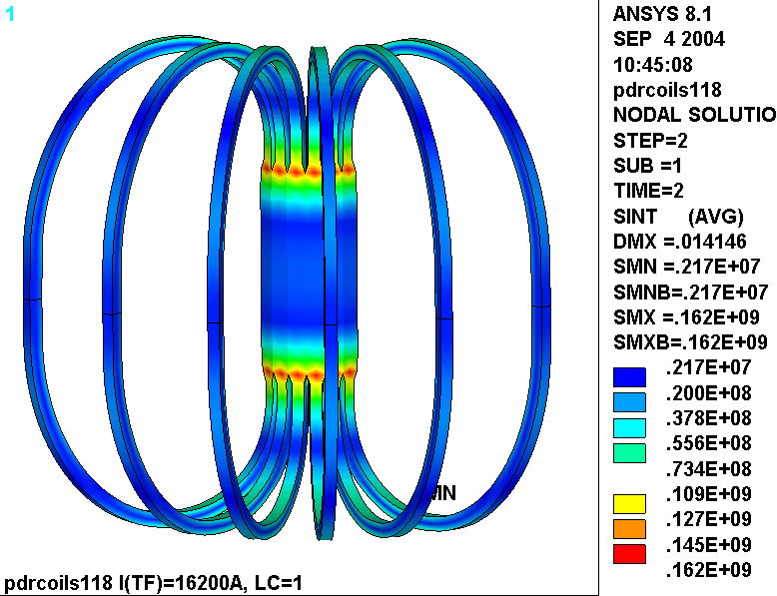

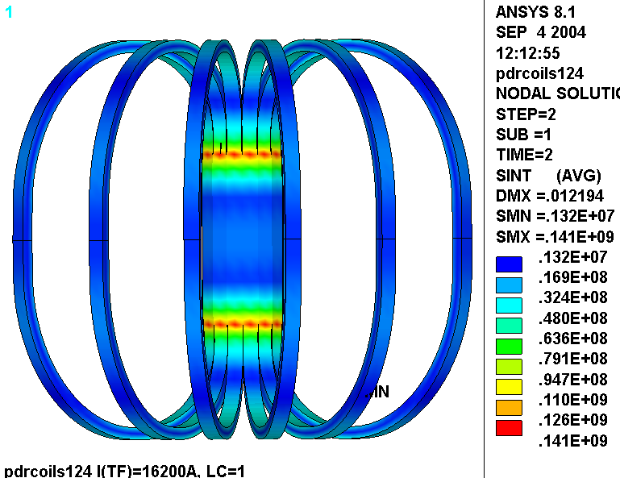
Fig. 4.0-2 Stress from LC2 (1.7T High-β), Reduced Width WP (top) and Ref. WP (bottom)
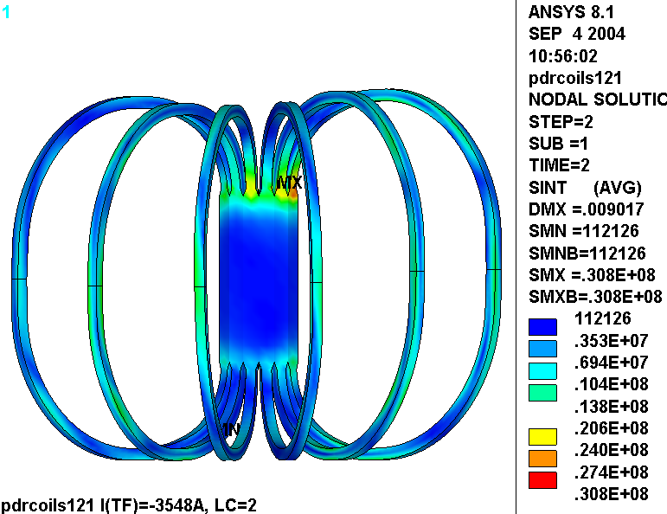

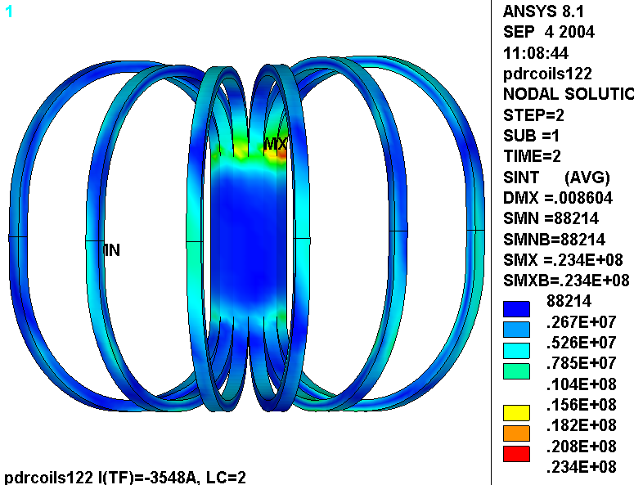
Fig. 4.0-3 Stress from LC3 (2.0T High-β), Reduced Width WP (top) and Ref. WP (bottom)
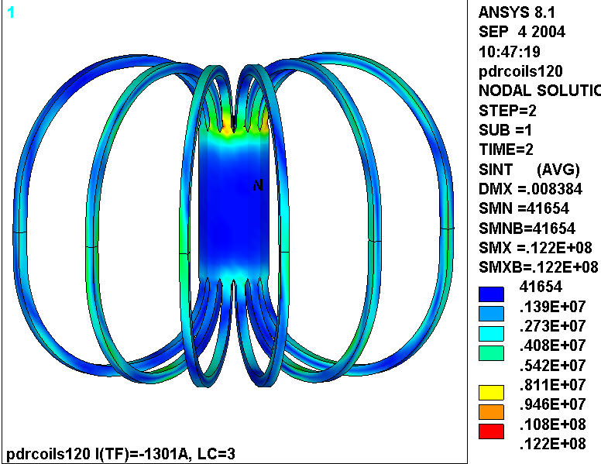

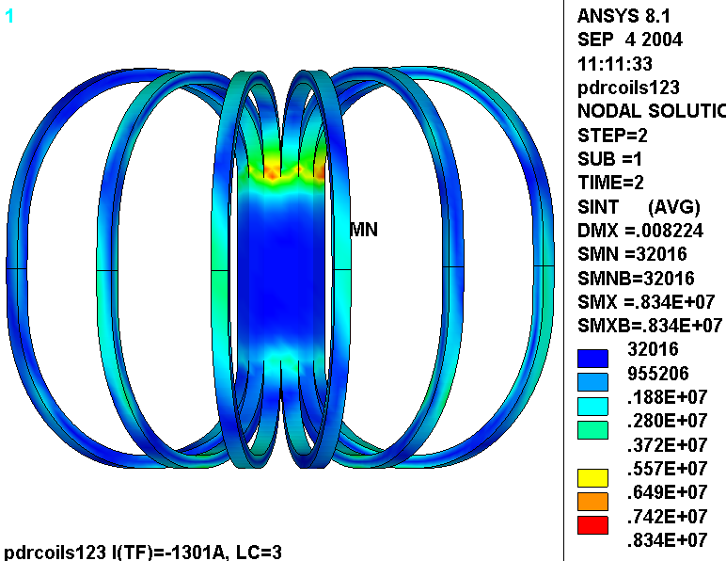
Fig. 4.0-4 Stress from LC6 (Equilibrium ID#7), Reduced Width WP (top) and Ref. WP (bottom)
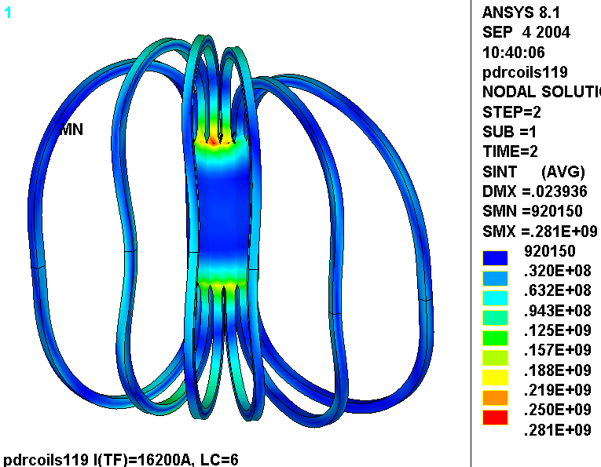
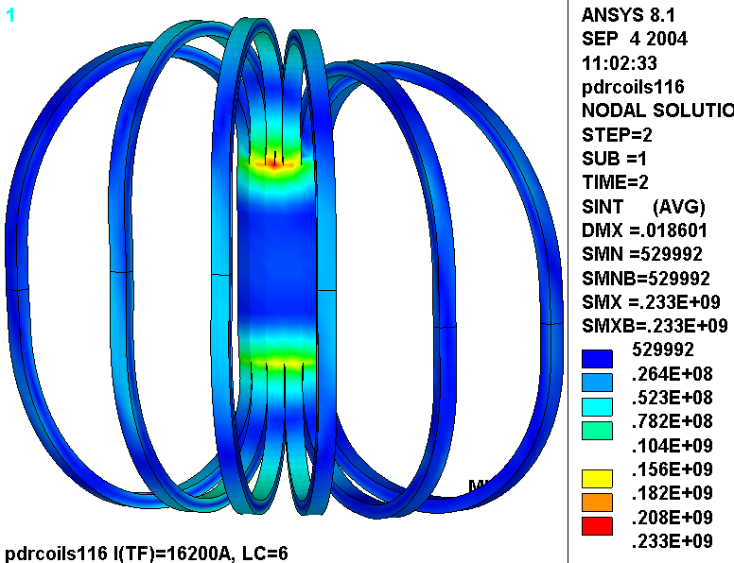
5.0 Summary & Commentary

It is difficult to assess the severity of this change in TF coil build since the model does not provide an extremely accurate representation of the coil in the reported high-stress region. However, the overall effect appears to be ~20% on stress and 30% on deformations. Also, it is clear that Equilibrium ID7 is a very severe load condition, which results in stresses 65% to 75% higher than the 0.5T load case alone, depending on the TF WP build. Recall that the previous detailed TF stress analyses [Error: Reference source not found] focus on this 0.5 T load case.

If we simply scale the 114 MPa Cu membrane + bending stresses from [Error: Reference source not found] by these ratios, one might expect an EQ ID7 stress level of ~190 MPa in the reference WP and 230 MPa in the narrow WP. These are both well above the 165 MPa stress allowable.

ANSYS Release 8.1, UP20040329, INTEL NT, ANSYS, Inc., Canonsburg, PA.
Leonard Myatt, “Electromagnetic Stress Analysis of the NCSX TF and PF Coil Systems,” 09/24/03.
Leonard Myatt, “Detailed Electromagnetic-Structural Analysis of the NCSX TF Coils,” 03/17/04.

