NCSX
Design Basis Analysis

Modular Coil Thermal Analysis

NCSX-CALC-14-002-00

Draft A

13 July 2004

Prepared by:

_______________________________________
K. Freudenberg, ORNL

I have reviewed this calculation and, to my professional satisfaction, it is properly performed and correct. I concur with analysis methodology and inputs and with the reasonableness of the results and their interpretation.

Reviewed by:

_______________________________________
B. Nelson, ORNL Engineer
Controlled Document
THIS IS AN UNCONTROLLED DOCUMENT ONCE PRINTED.
Check the NCSX Engineering Web prior to use to assure that this document is current.
Table Of Contents
I. Executive Summary 2
II. Assumptions 2
III. Analysis Methodology and Inputs 2
Software and data files 2
Drawings and models 2
Material properties 3
Model setup 3
Thermal analysis setup 5
IV. Results 6
Cladding configuration comparisons 6
Effect of tee heat sink 7
Ratcheting of nodal temperatures 10
Temperature variation along the length of the coil 12
Crimp/glue conductivity independence 12
V. Summary and Recommendations 14

I. Executive Summary

The purpose of this analysis is to examine the heat transfer characteristics of a local model of a 10 turn modular coil during and after an operational pulse. Each pulse generates a tremendous amount of heat in the winding coils that must be removed by cooling tubes such that the coil packs return to a baseline cryogenic temperature of about 85 K within 15 minutes. Also, the conduction path is varied by removing and/or adding copper cladding at several corners to determine the most financially and thermally economical option.

II. Assumptions
- Initially temperature of all components = 80 K (cryogenic)
- Heat from the pulse is imposed as a uniform volumetric heat generation (7.58E7 W/m³ for 1 sec) and is applied to the Cu/epoxy winding pack only.
- Cooling from the fluid in the tubing is imposed as constant temperature of 80 K throughout the 15 minute cycle.
- Radiation exchange with other surroundings is negligible.
- Material properties are temperature dependent (see table below in material property section)

III. Analysis Methodology and Inputs

For this study, the maximum temperature of the coil must return to approximately the same starting temperature of 80 K after 15 minutes. Although, there is no definitive temperature limit defined, it is generally accepted that the temperature should reach steady state equilibrium of less than 95 K when considering ratcheting temperatures after each successive pulse. This ensures that the liquid Nitrogen in the cooling tubes will not see a large delta T across its outer boundary and thus boiling will not occur. The model is a representative straight 3d section of the modulator coil pack and is not an actual section of a production coil form that has twists and turns.

Software and data files
The model is constructed in Ansys 8.0 and all of the preprocessing and post processing is done within the Ansys environment.

Drawings and models
No drawings have been referenced in this study. All models have been created as Ansys files.

Material properties
The temperature dependent material properties are listed in Table 1. For clarification, the insulation is the material that surrounds the winding cable and the glue is the material that is used to connect the copper cladding layers together and used in the “crimp” joints. Also, for modeling and meshing purposes it is necessary to model the glue as thicker than it is in reality, otherwise an extremely large mesh will result. The glue is 0.2” thick in the model and is approximately 0.05” in reality, thus the conductivity has been multiplied by 4 to account for this scaling factor.

Table 1: Material property data

Model setup

The model has been meshed with Solid 90 elements for the thermal analysis. Only half of the coil is measured as it is symmetric about its central axis. A detailed view of the elements and model are shown below in Figure 1, with the corresponding material color guide. Several cladding connecting scenarios were examined and detailed in Figure 2 and in Table 2. In addition, the effect of thermal conductivity and the presence of the tee (which acts as a heat sink) are also studied to determine a range of plausible temperature values. The connections between the cladding pieces and the crimp joints have been modeled using blocks of material with conductivity values documented above in material properties. These blocks conventionally represent contact resistance in heat transfer.
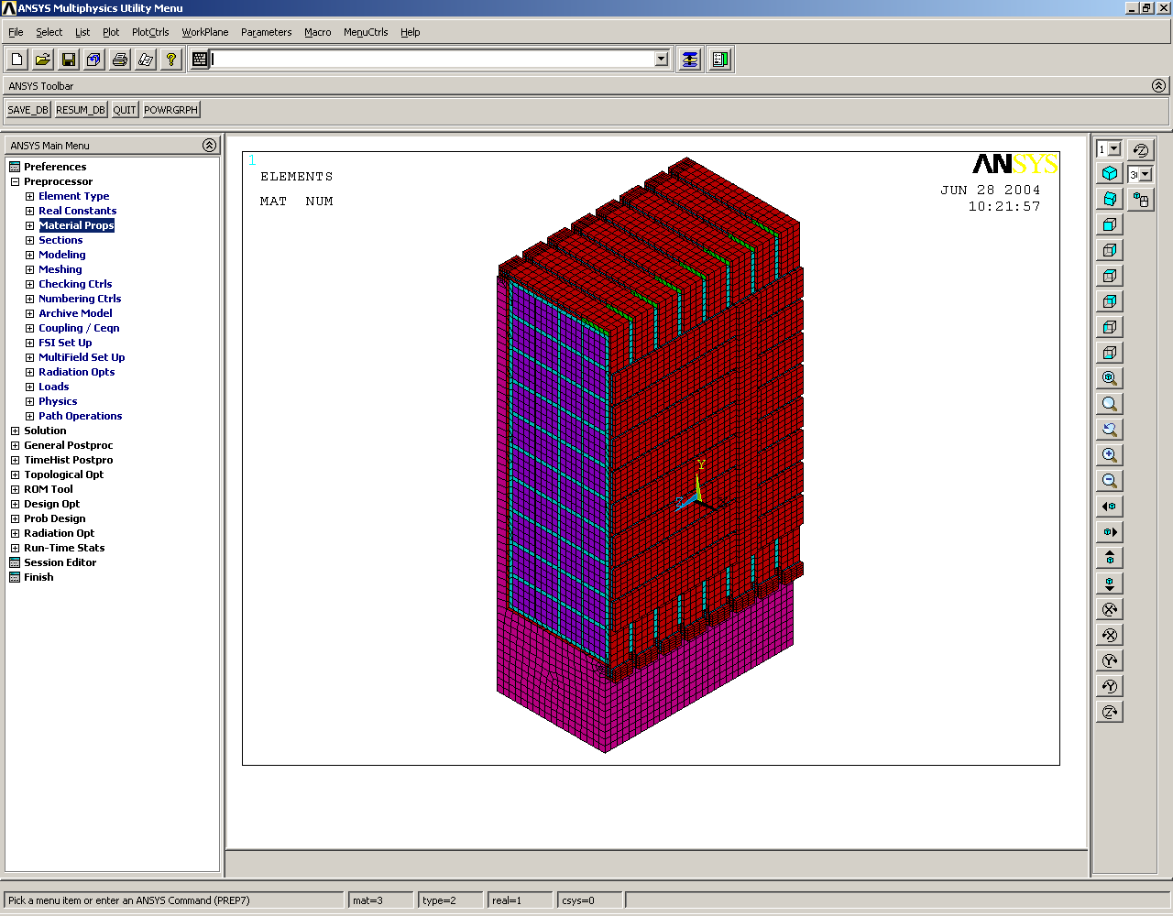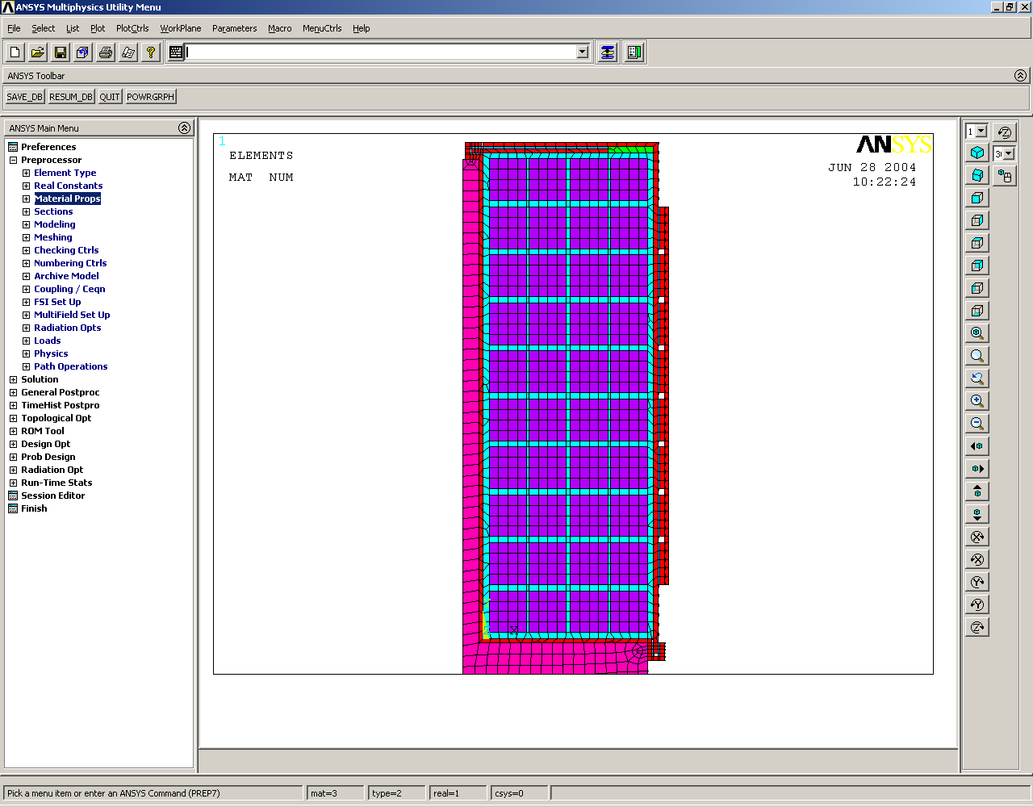
Cooling tube pad
Color Scheme
Purple = winding cable
Red = Cu
Cyan = winding insulation
Blue = glue/insulation
Magenta = Stainless steel
Green = insulation
Figure 1: Mesh used to model winding pack section

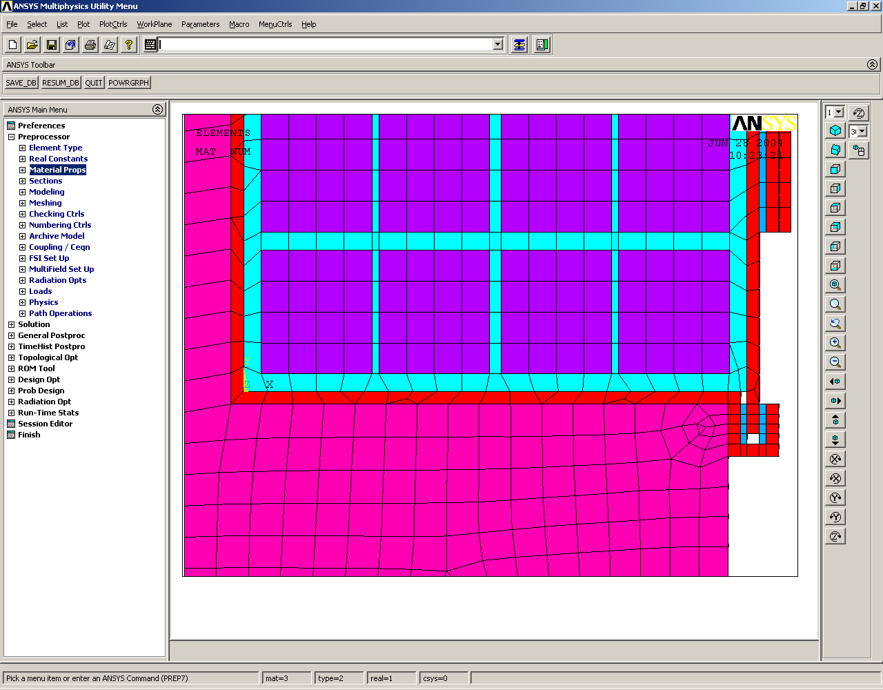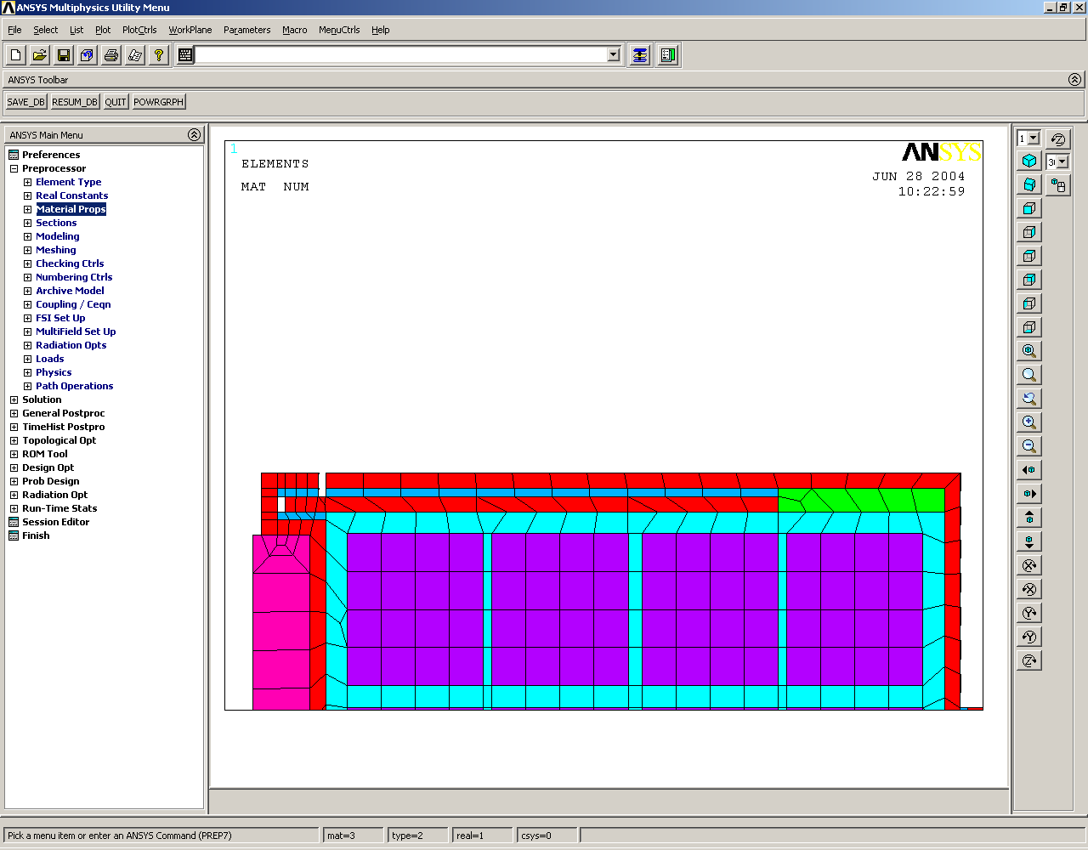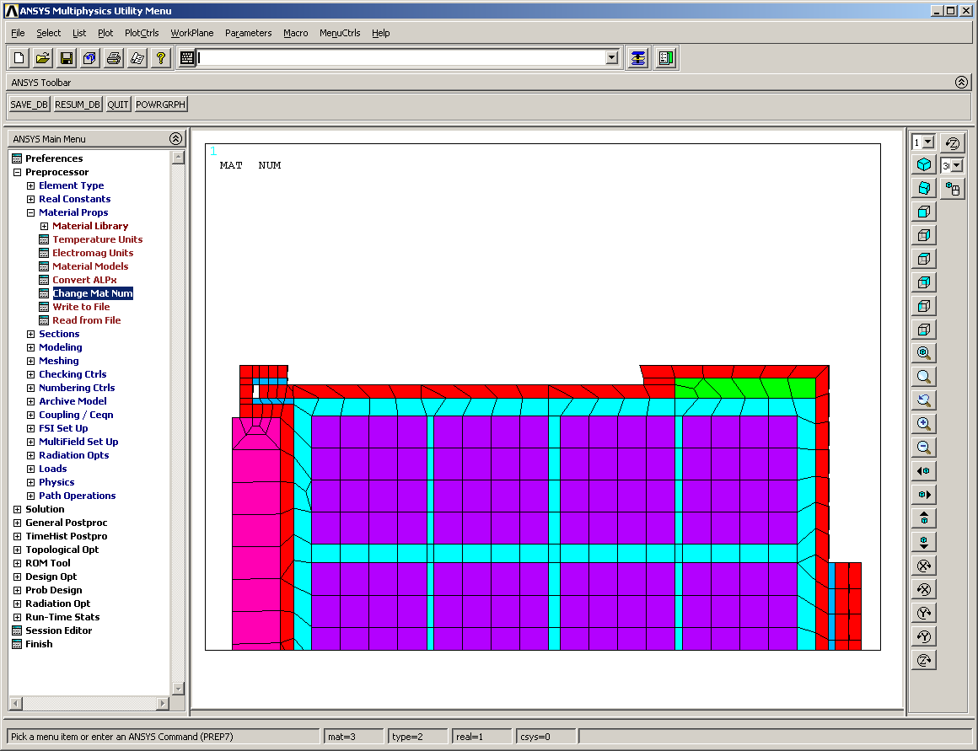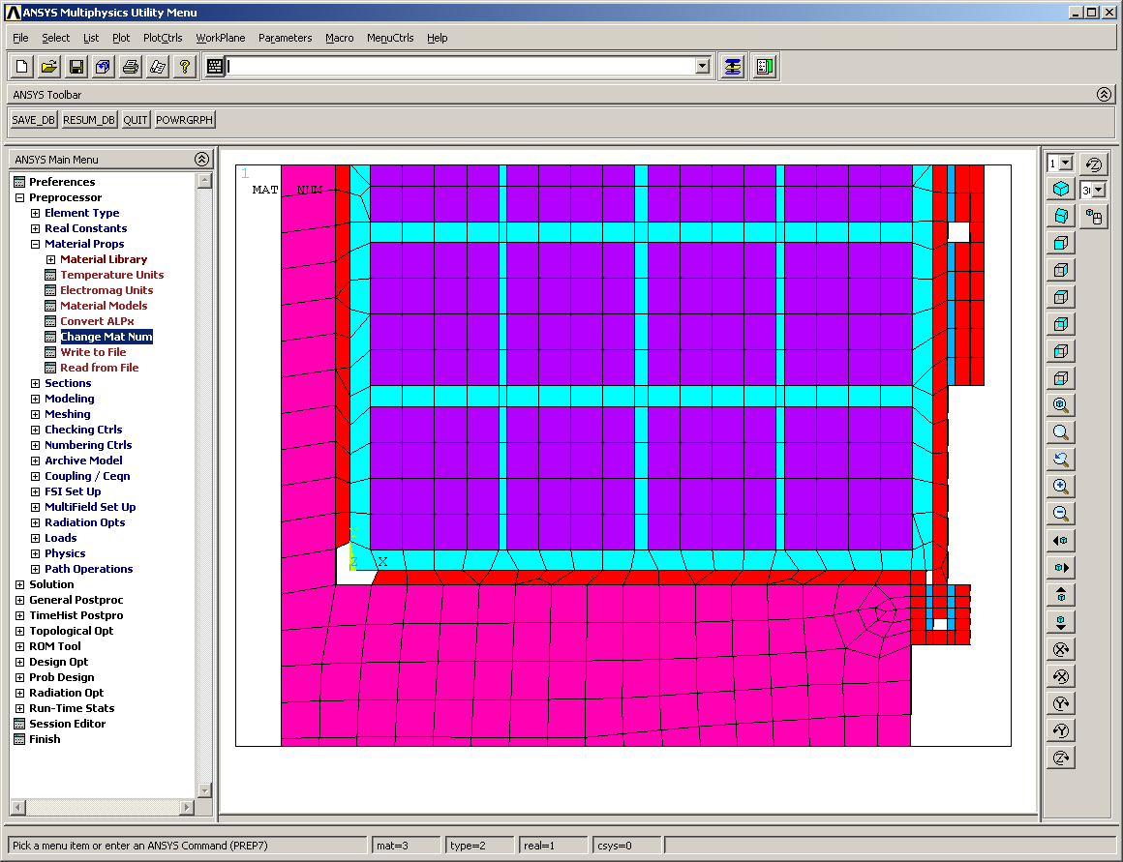
Top Connection
Bottom Connection
Break at inner tee comer (cases B,C)
Direct copper connectivity across top (cases B,C)
Copper connection at inner tee comer (cases A,D)
Electrical Insulation/glue across top (cases A,D)
Figure 2: Cladding connection configurations, upper insulation alternatives.

Placing a break at the inner corner of the tee cladding connection (top image in Figure 2) will allow the removal of a piece of electrical insulation from the top connection and provide an easier construction method to ensure electrical isolation. The lower image in Figure 2 is the default baseline from which all comparisons in this document are based.

Table 2: Description of cases considered in Ansys

The chosen glue conductivity values in this study are intended to illustrate a range of plausible maximum temperature values as the minimum conductivity value is perhaps too conservative and the maximum value of 100 W/m-K is most likely unachievable.

Thermal analysis setup

A transient thermal analysis was run on the representative modular coil shown above. Initially, all temperatures are set to 80 K, cryogenic conditions. The heat generation term of 7.58E7 W/m³ is applied to the winding cables for one second and then the model is allowed to cool by means of a constant temperature of 80 K applied to the cooling tube pad, indicted in Figure 1, for 15 minutes. The process is then repeated with the final nodal set temperature from the previous 15 minute cycle used as the beginning temperature set of the next cycle. This process is generally carried out at least 5 cycles so that a steady state equilibrium can be reached and the effect of ratcheting is known.

IV. Results

Cladding configuration comparisons

The contour plots after the first 15 minute cycle are shown below in Figure 3 for cases A and D. These two cases are grouped together to show the effect of changing the glue/crimp conductivity form 0.91 W/mK to 100 W/mK. The max temperature for the baseline case is 88.452 K where as the max temperature for the higher conductivity case is 85.251 a difference of about 3.2 degrees. Thus for geometric situation where a direct cladding connection is used at the inner tee corner and an insulation pad is placed at the top connection to ensure electrical isolation the max temperature after 15 minutes will fall between 85.2 K and 88.5 K.
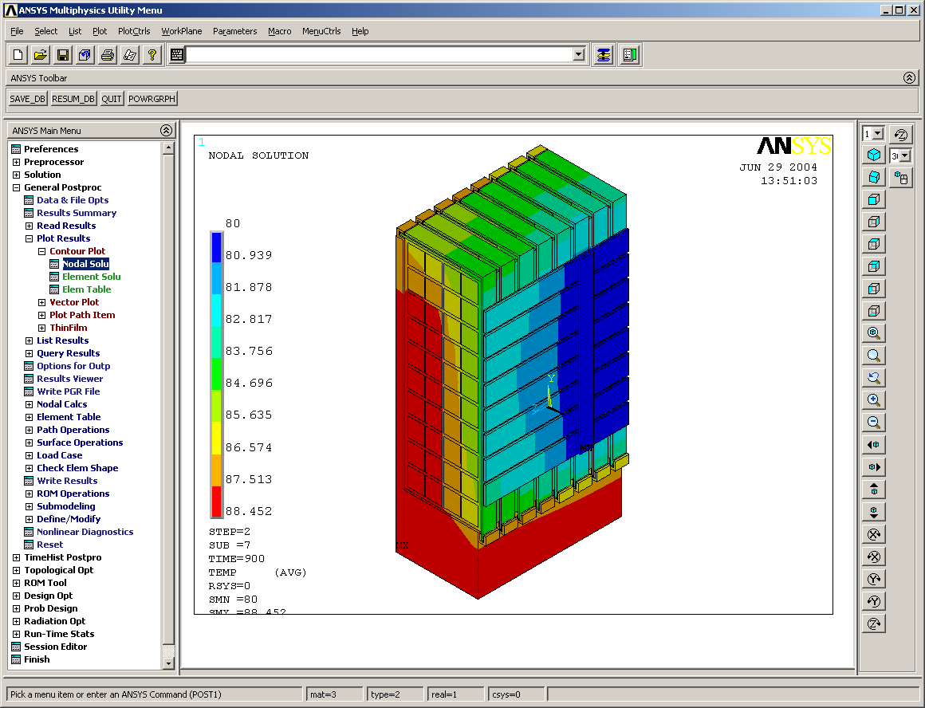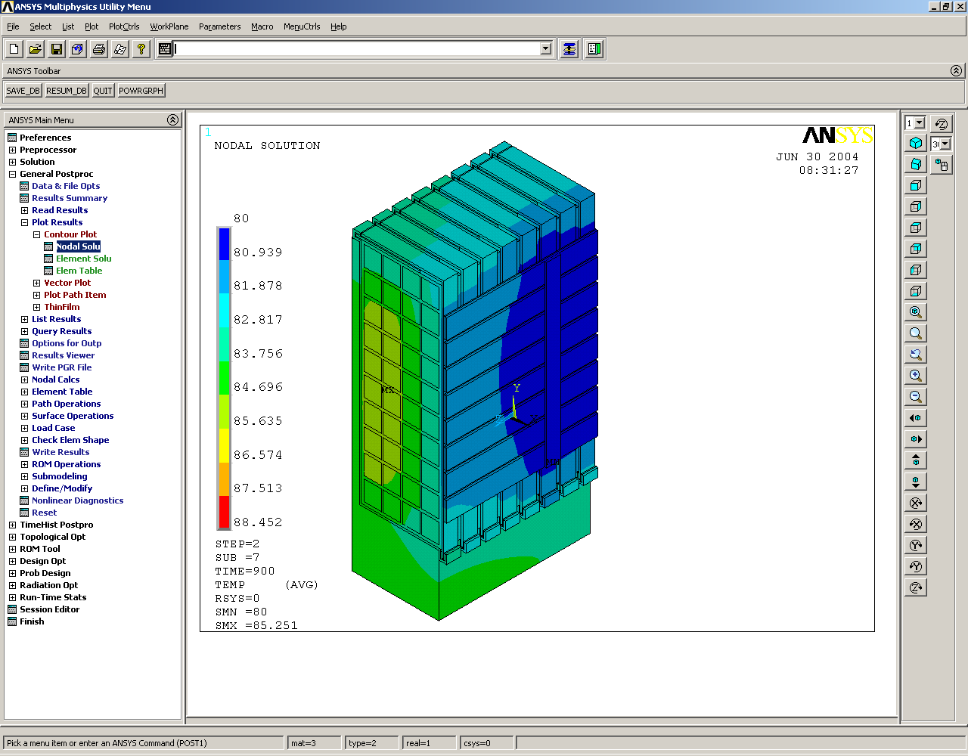
Baseline (Case A )
(Case D )
Note: contours have the same scale
Figure 4: Temperature distribution after the first pulse (Different glue/crimp conductivities)

Figure 5 illustrates the second geometric case where the cladding junction corner with the tee has been split into two pieces and the top cladding connection no longer requires electrical insulation. Case B has the lower conductivity value of 0.91 W/m-K and case C has the upper conductivity of 100 W/m-K. The maximum temperatures for both cases are 88.79 and 86.074 respectively.

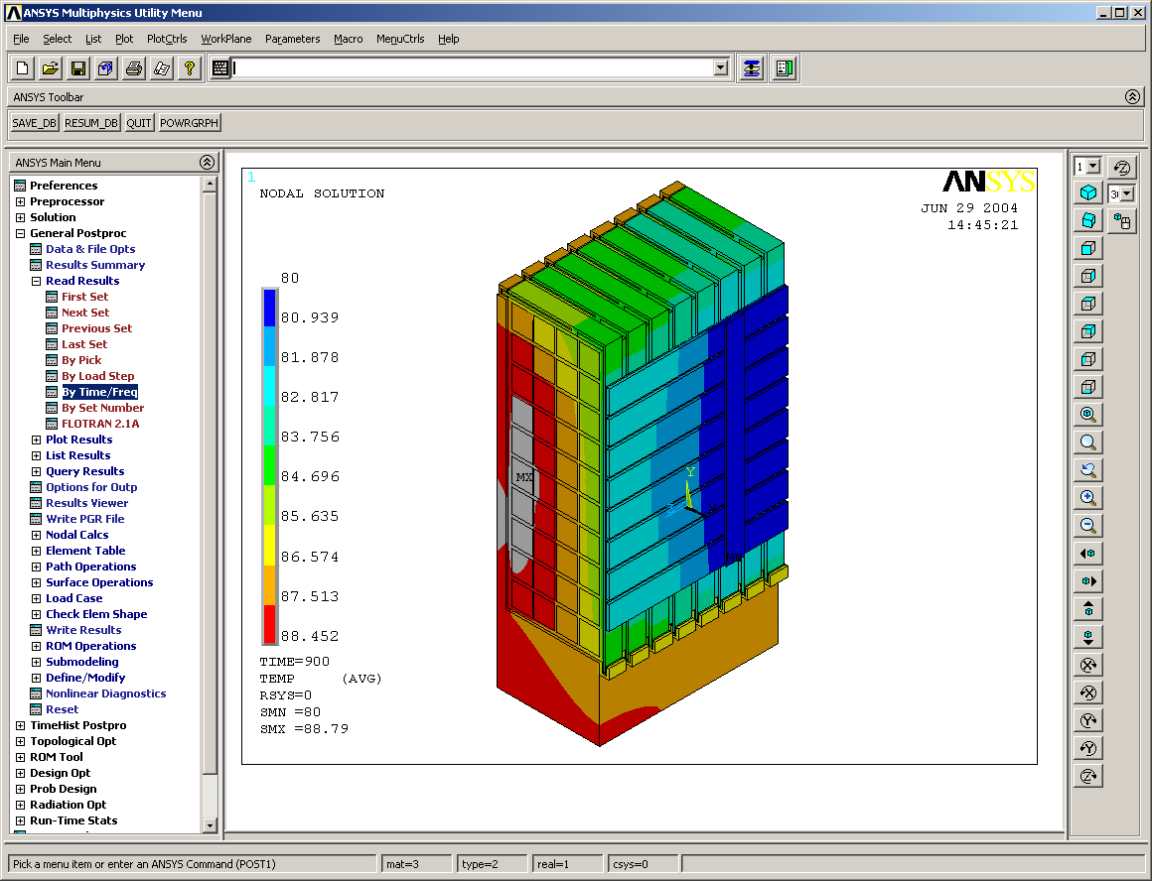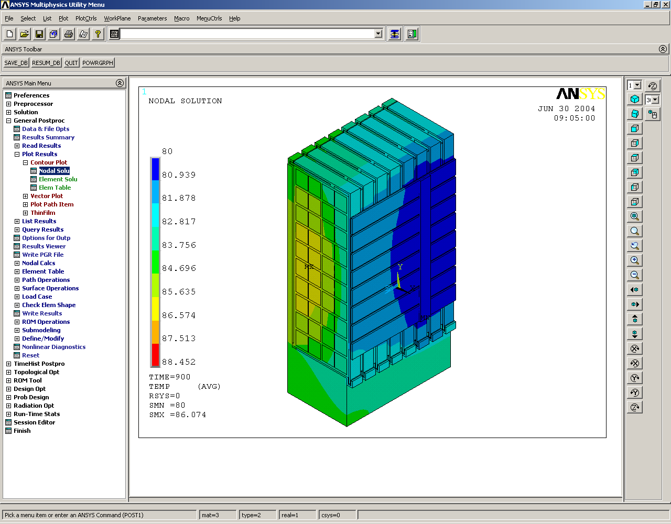
(Case B )
(Case C )
Note: contours have the same scale, gray areas are higher than 88.452 K.
Figure 5: Temperature distribution after the first pulse (Different glue/crimp conductivities, cladding tee corner connection broken)

Effect of tee heat sink

The effect of the tee as a heat sink has also been considered and is shown below in Figures 6 and 7. Figure 6 compares the baseline case to the situation where the tee has been removed from the analysis. The removal of the tee would correspond to a case where there is sufficient insulation between the tee and the winding pack that no heat crosses the boundary. This may also be the case if the winding shrinks away from the tee as it is heated up doing an operational pulse. The max temperature for the case without the tee is only marginally higher than the baseline case at 88.623 K as opposed to 88.452 K.

Figure 7 displays a similar comparison between the second geometric configuration where there is a break in the cladding at the inner tee corner and the identical case except with the tee removed. The max temperature for case without the tee is only slightly higher than that without at 89.644 K as opposed to 88.79 K. The comparison of the tee without the heat sink demonstrates that its removal only marginally increases the max temperature of the coil by generally less than a degree. However, an important observation is that if the tee is in intimate contact with the winding pack, it will absorb some of the heat from the pulse and thus will experience a temperature rise. The max temperature of the tee and the winding pack are within in a degree for all of the cases where the tee acts as a heat sink. Table 4 shows all of the max temperatures for both the tee and the inner winding pack.

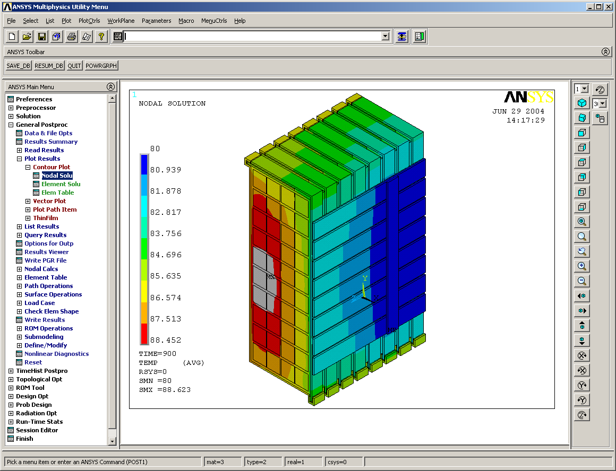
(Case E )
Baseline (Case A )
Figure 6: Temperature distribution after the first pulse (with and without tee)
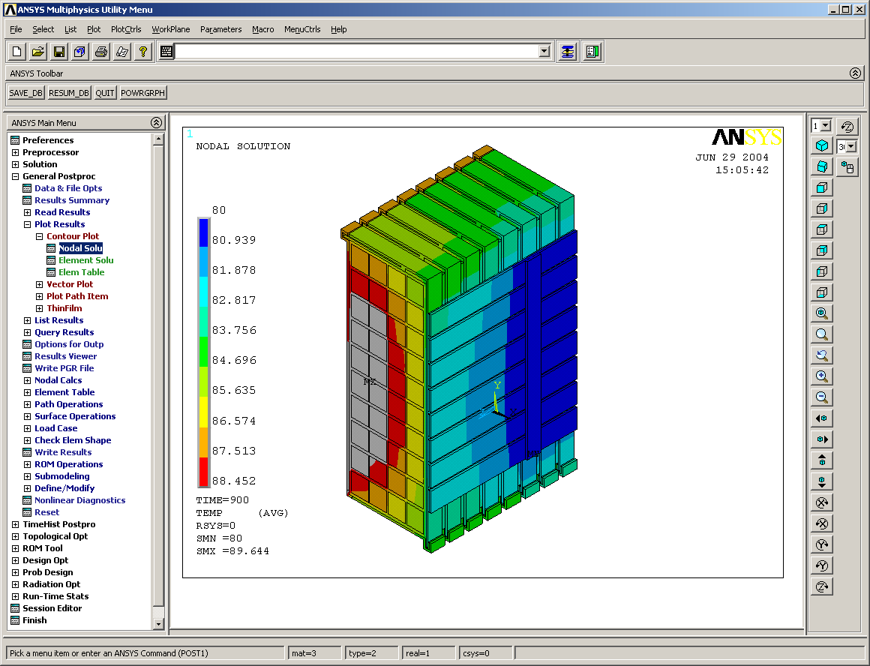
Case F (Tee Removed)
Case B
Note: contours have the same scale, gray areas are higher than 88.452 K.
Figure 7: Temperature distribution after the first pulse (with and without tee, cladding tee corner connection broken)

Table 4: Summary of max temperature results

Ratcheting of nodal temperatures

Figures 8 and 9 illustrate the effect of ratcheting temperatures over time. Case A was run out over ten cycles and reached a steady state equilibrium temperature of around 94 K after the third cycle. Case B was run out only 5 cycles but managed to reach equilibrium at 93.3 K after the third cycle also. Thus, the maximum steady state temperature is only marginally affected by the cladding connection scenarios studied in this report as there is less than a degree difference between the two cases.

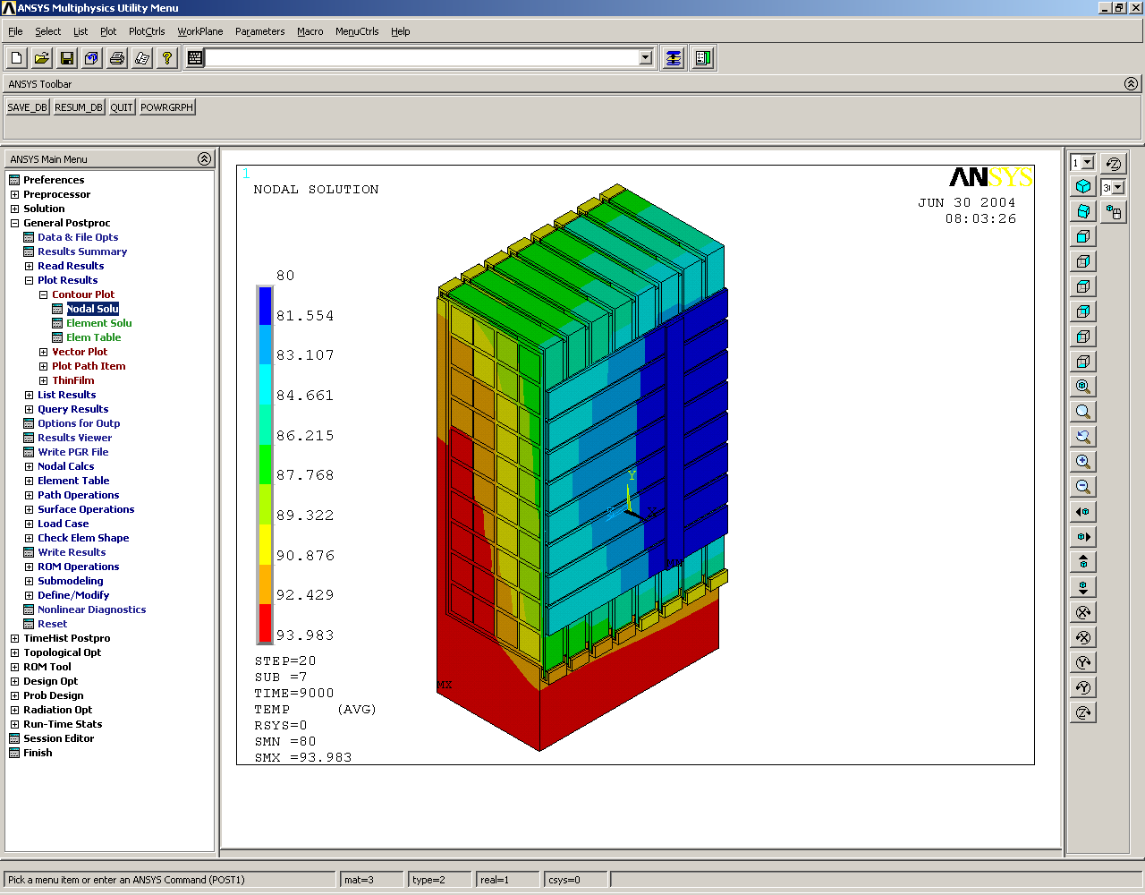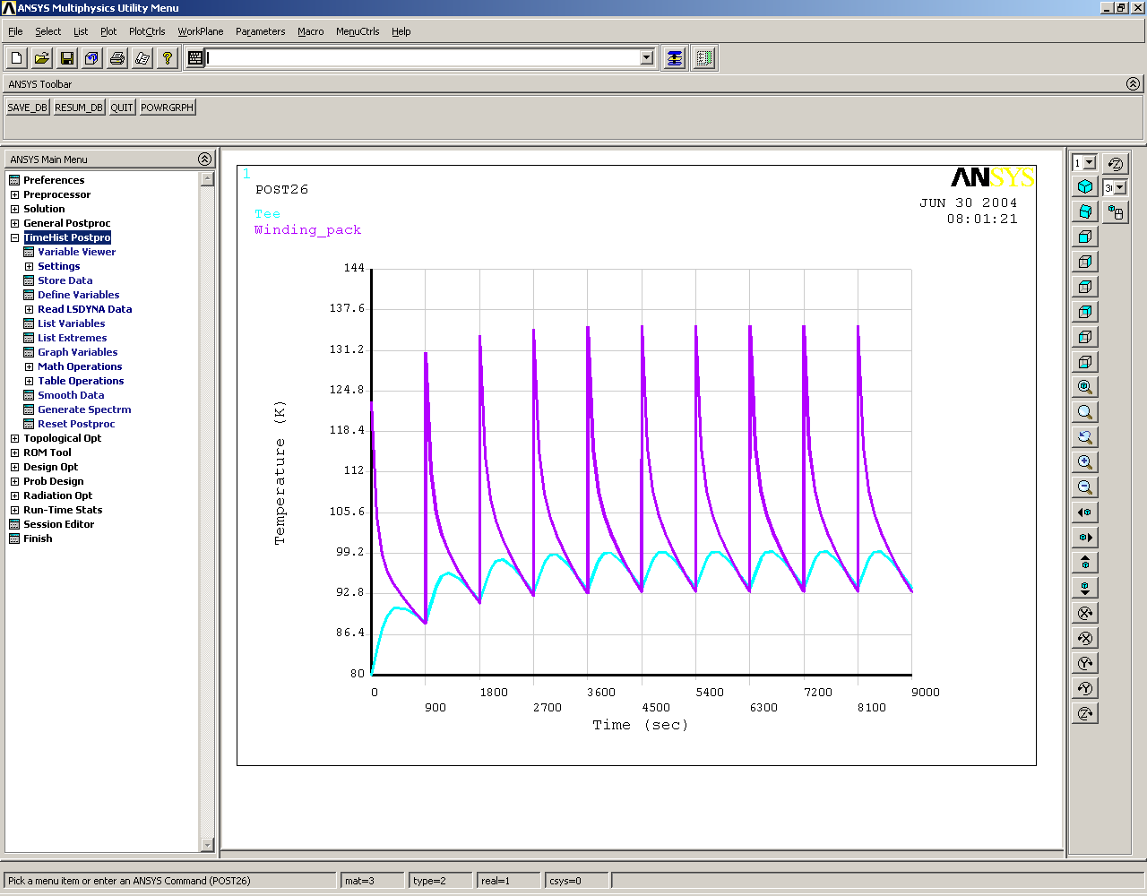
Nodal Temperature for Winding Pack
Nodal Temperature for Tee
Figure 8: Ratcheting node temperature for tee and winding pack (case A).
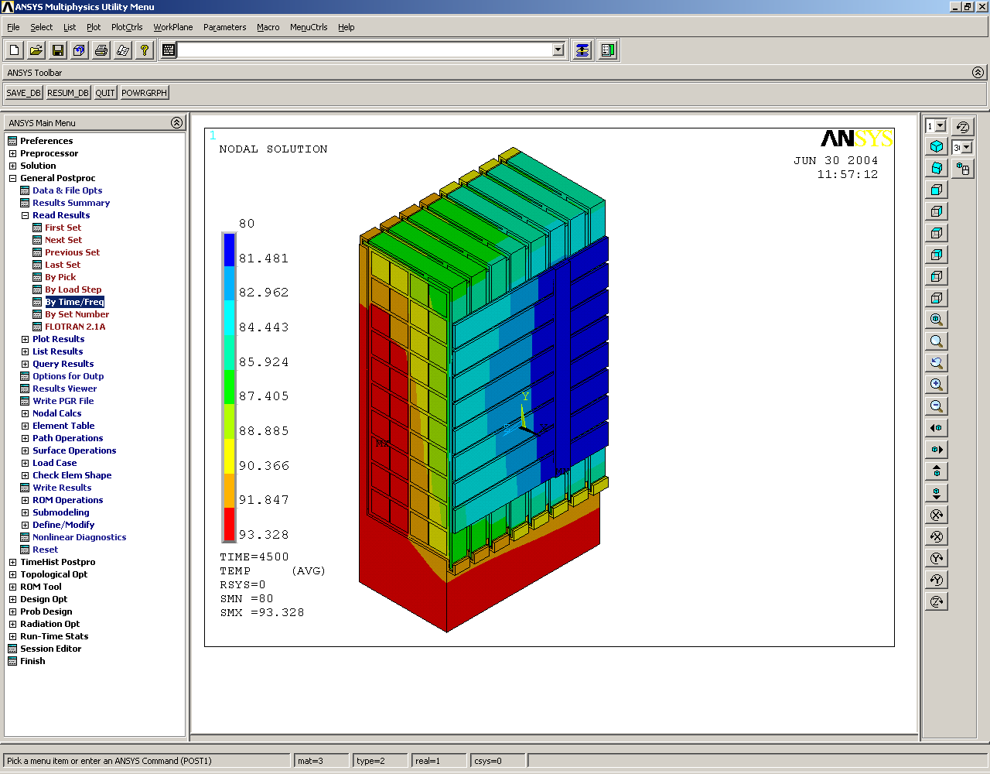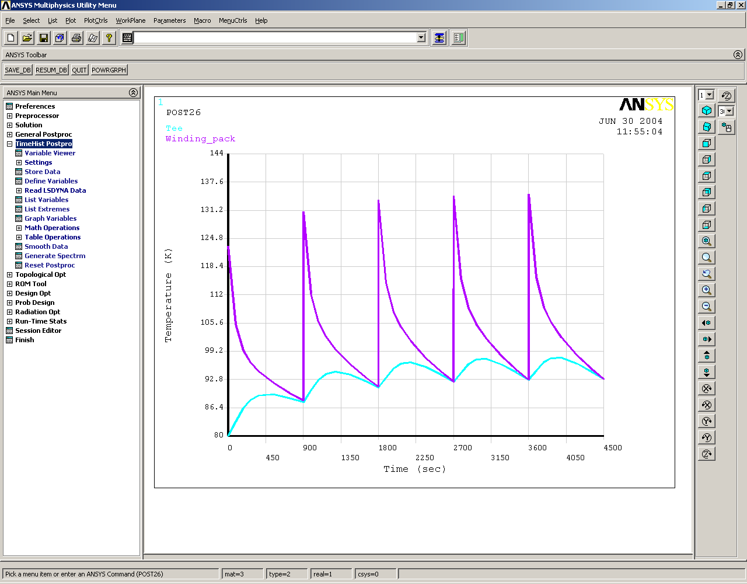
Nodal Temperature for Winding Pack
Nodal Temperature for Tee
Figure 9: Ratcheting node temperature for tee and winding pack (case B).
The ratcheting profile is affected by changing the conductivity of the glue as shown in Figure 10. Not surprisingly, the higher conductivity produces a lower steady state temperature of 87 K. Also, the nodal temperatures approach steady state more quickly (after the second cycle) than the lower conductivity cases (A and B). This suggests that a realistic expectation for the max temperature of the winding pack is for it to fall somewhere in the range of 87 K and 94 K, depending on the glue conductivity and the contact resistance (conductivity) of the crimp connection.

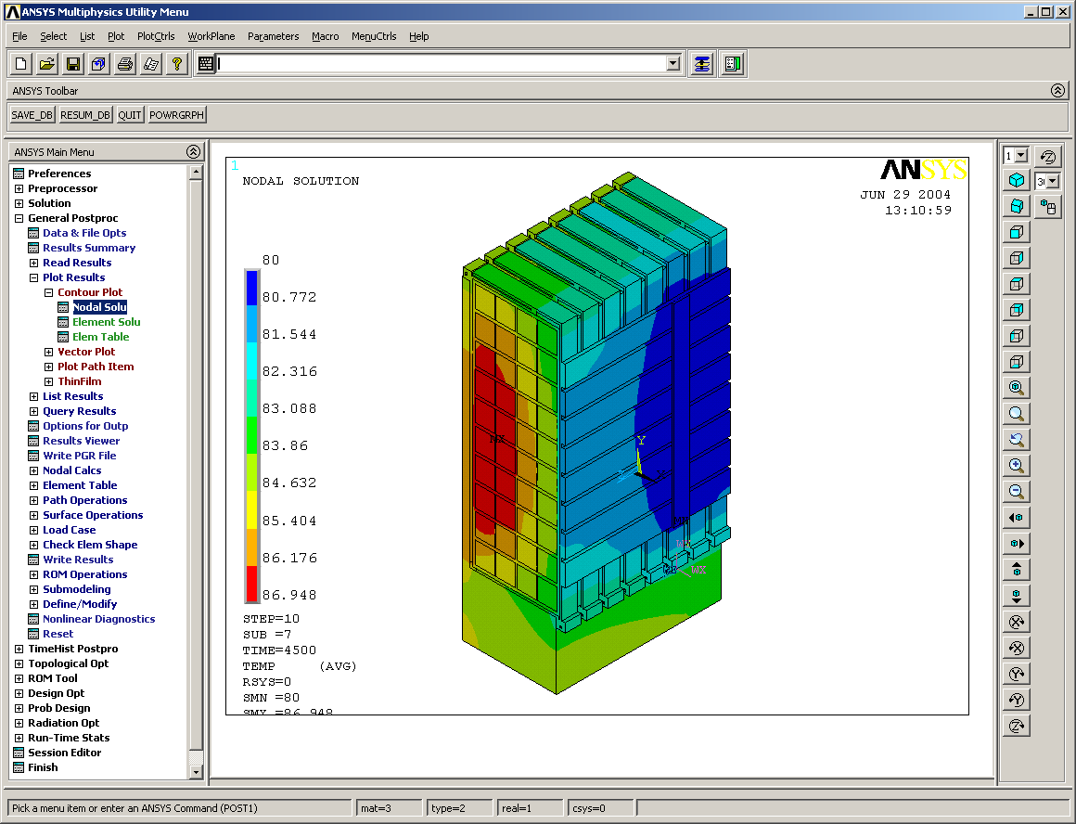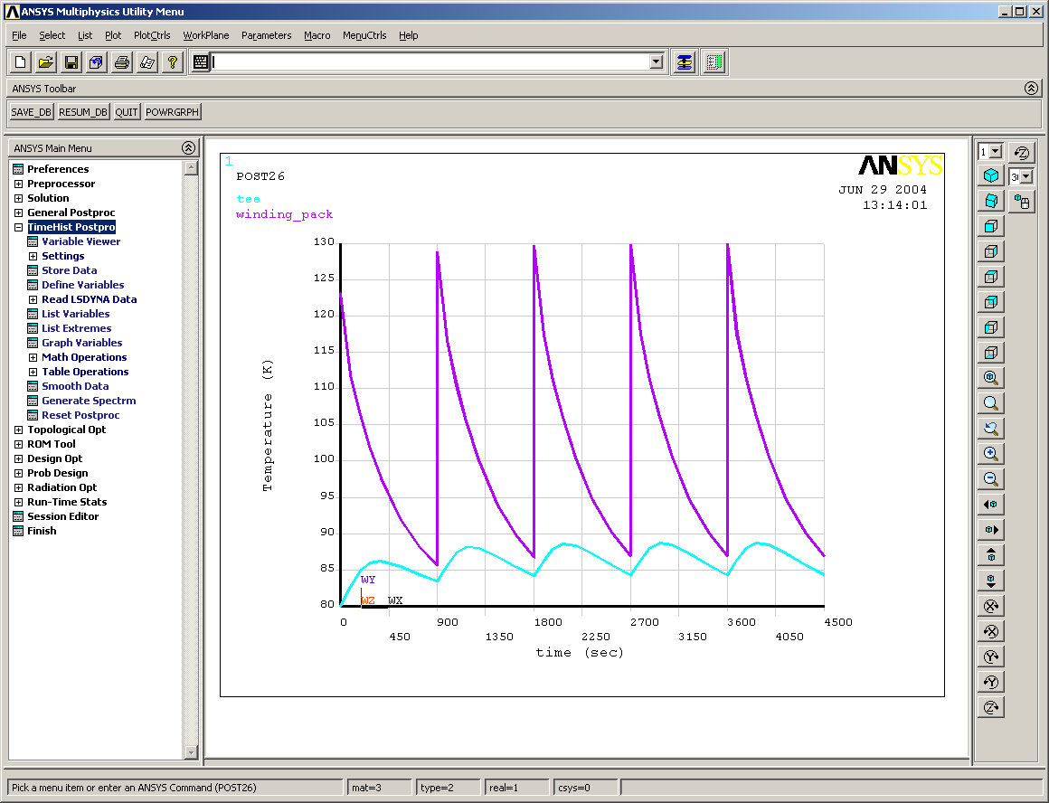
Nodal Temperature for Winding Pack
Nodal Temperature for Tee
Model approaches steady state after 2 cycles
Figure 10: Ratcheting node temperature for tee and winding pack (case C, higher glue/crimp conductivity).

Temperature variation along the length of the coil

Due to the relatively high conductivity of the winding pack along the length of the coil (300 W/m-K), there is little variation in the temperature of the winding pack even at locations far from the cooling tube. This is shown in Figure 11 where the image on the right depicts the temperature distribution of the cross section of the pack at the location of the cooling tube connection. The two temperature distributions of the coil pack are almost identical and this as typical for all cases studied. There is some variation in the tee and the cladding along the length of the coil but the winding pack temperature distribution appears independent of location along its length.

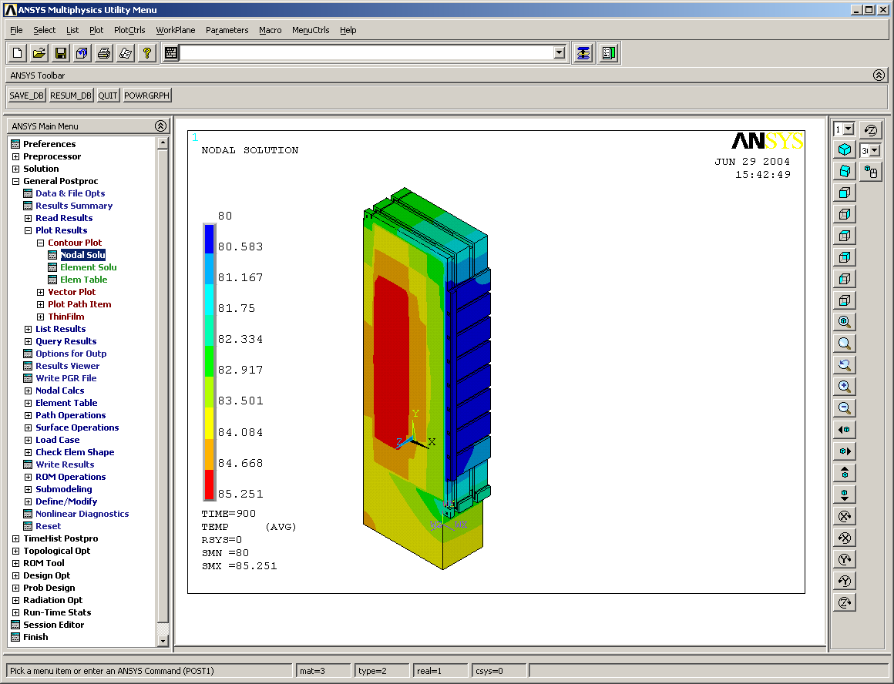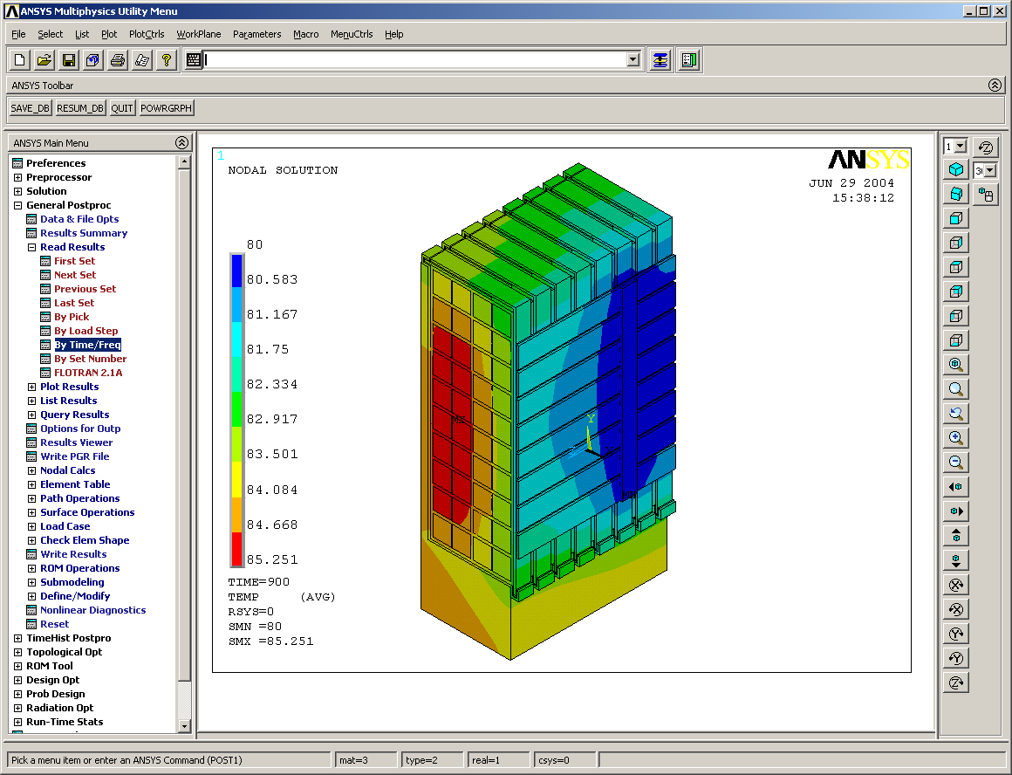
Figure 11: thermal variation along length of conductor (case D, typical for all cases)

Crimp/glue conductivity independence

Until now both the glue that holds the cladding vertical and horizontal pieces together and the crimp joints have had the same value of conductivity (contact resistance) applied to them in each case studied. The dependency was broken to determine which value (crimp or glue) was the dominant factor in determining the overall temperature distribution. Figure 12 illustrates the effect that the glue/crimp conductivity values have on the max temperature of the coil. The blue curve is indicative of the case where the glue and crimp conductivities are equal, the red curve is indicative of the case where the glue conductivity is set to its maximum (best achievable) value of 100 W/m-K and the crimp conductivity is allowed to vary and finally, the green curve is for when the crimp conductivity is set to its maximum (best achievable) value of 100 W/m-K and the glue conductivity is allowed to vary. The blue curve can be considered a worst case boundary as it is not possible to obtain values to the right or above that curve.

Figure 12 illustrates that crimp conductivity has less an effect than does the glue conductivity. That is, when the glue conductivity is set to 100 W/m-K and the crimp conductivity is allowed to vary, the resulting max temperatures are a few degrees lower from the default case where the conductivity values are equal. In contrast, the green line shown on the graph, where the crimp conductivity is set to its max value, indicates that the temperature is only slightly lower than the default case. This suggests that care should be taken to ensure that the most conductive glue is chosen for adhering the cladding pieces to each other.
Figure 12: Crimp/glue conductivity dependency on log scale

V. Summary and Recommendations

- For low conductivity glue/insulation, expect steady state at around 93-94 K. If glue/crimp joints can be more conductive (i.e. less contact resistance) the value can be dropped to around 84-85 K.
- Breaking the cladding at the lower corner of the tee does not have an appreciable effect on the temperature profile as shown by cases B and C. It raised the winding pack temperature slightly (1 degree).
- Removing the tee (i.e. floating winding pack) tends to cause slightly (1 degree or so) higher winding pack temperatures at least during the first pulse/cool down.
- All cases studied thus far achieve a steady state within 4 cycles.
- Due to the relatively high conductivity of the coil in the winding direction, the temperature profile of the winding pack remains relatively constant along its length.
- The glue (connecting the cladding plates together) conductivity is a more dominate factor in reducing the max temperature of the winding pack than the crimp conductivity.

Based on these findings, it is recommended that case B should be selected as the target configuration for the cladding. This case breaks the cladding connection at the inner corner of the tee and allows for the removal of the electrical insulation at the top of the winding pack. This method of construction is a little easier to assemble as the cladding no longer has to be bent into the relief groove in the tee doing assembly and the connection at the top of the tee becomes more straight forward when removing the extra piece of insulation. It was found that this geometric case experienced only a slight (less than a degree) increase in the max temperature and thus, it is considered a robust and viable option for assembling the cladding.

Additionally, care should be taken to ensure that the cladding is held together by highly conductive glue. This analysis has shown that depending on how mush loss there is across the glue and crimp joints the max temperature will fall in the range of 85-94 K. The upper value of 94 K is associated with using an epoxy/insulator conductor value of 0.91 W/m-K. Conductive glue conductivity vales are usually approximately ten times better than a straight insulator (although in certain cases, they can be significantly be better than that) which would put the max temperature around 86-87 K according to Figure 12. The crimping connections are also important in terms of ensuring a good conductive path but they are less of a factor than the glue.

