NCSX MODULAR COILS

Failure Mode and Effect Analysis (FMEA)

NCSX-FMEA-140-02-00

Prepared by: __________________________________________________________________________
D. Williamson, NCSX WBS 14 Manager

Checked by: __________________________________________________________________________
M. Cole, NCSX WBS 1 / Design Integration Manager

Approved by: _________________________________________________________________________
P. Heitzenroeder, NCSX Engineering Manager

Record of Revisions

Revision | Date | Description
0 | 2/11/2008 | Initial Issue

Table of Contents

1 Introduction and Scope 3
2 Applicable Documents 3
3 System Description and Functions 3
4 FMECA Worksheets 7
5 Risk Mitigation 10

1 Introduction and Scope

The National Compact Stellarator Experiment (NCSX) is an experimental research facility that is to be constructed at the Department of Energy’s Princeton Plasma Physics Laboratory (PPPL). Its mission is to acquire the physics knowledge needed to evaluate compact stellarators as a fusion concept, and to advance the understanding of three-dimensional plasma physics for fusion and basic science.

A primary component of the facility is the stellarator core, an assembly of four magnet systems that surround a highly shaped plasma and vacuum chamber. The coils provide the magnetic field required for plasma shaping and position control, inductive current drive, and error field correction.

This document, the Modular Coil (MC) Failure Mode and Effect Analysis (FMEA), is used to identify possible failure modes, their causes, and the effects of these failures on coil performance. It is hoped that the process of identifying potential failures will lead to design solutions that increase the overall reliability and safety of the modular coil system.

2 Applicable Documents

PPPL Procedure ENG-008, “Failure Modes and Effects Analysis”

3 System Description and Functions

The modular coil set consists of three field periods with 6 coils per period, for a total of 18 coils. Due to symmetry, only three different coil shapes are needed to make up the complete assembly. The coils are connected electrically with three circuits in groups of six coils, according to type. Figure 1 show the general arrangement of the coils and structure.

The primary function of the modular coil system is to provide a quasi-axisymmetric magnetic field configuration with up to 2-T on axis for 1-s with a 15-min repetition rate. Additional functions may be categorized according to coil subsystem:

Winding Forms –
- Provide an accurate means of positioning the conductor during the winding and vacuum-pressure impregnation (VPI) process.
- Support the windings during operation with symmetric and minimal deflection.
- Provide segmentation for assembly purposes and to prevent circulation of eddy currents.
- Support the vacuum vessel and internals.

Coil Winding Assembly –
- Provide up to 2-T magnetic field configuration for reference scenarios.
- Maintain current center within 1.5-mm (0.060-in) of theoretical position during operation.
- Incorporate independent control of each coil type for flexibility.
- Provide capability to monitor field, current, voltage, and temperature.
- Cool the windings back to operating temperature (80K) between pulses

Bag Mold and Structural Clamps –
- Provide a mold structure that supports VPI process requirements
- Provide clamping system that is generic in design, but capable of adapting to coil curvature
- Provide clamping force sufficient to pre-load windings against the winding form.

The level of resolution of this FMEA is indicated in Figure 2, a block diagram of the modular coil system.

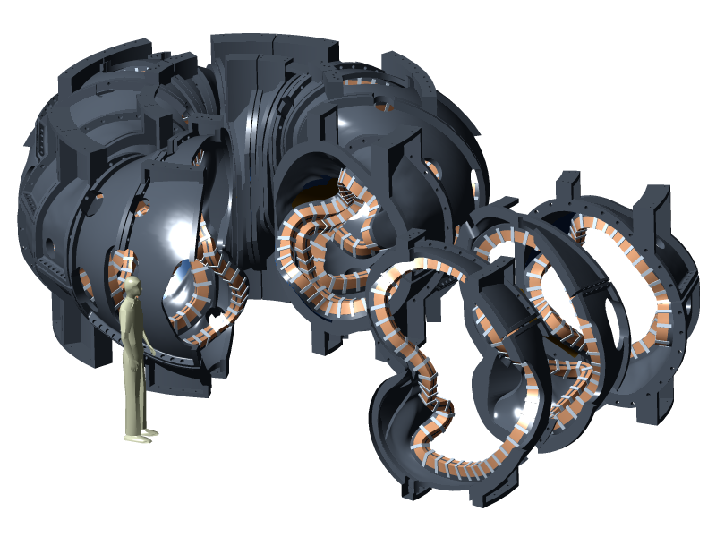

Figure 1 - Modular Coil General Arrangement

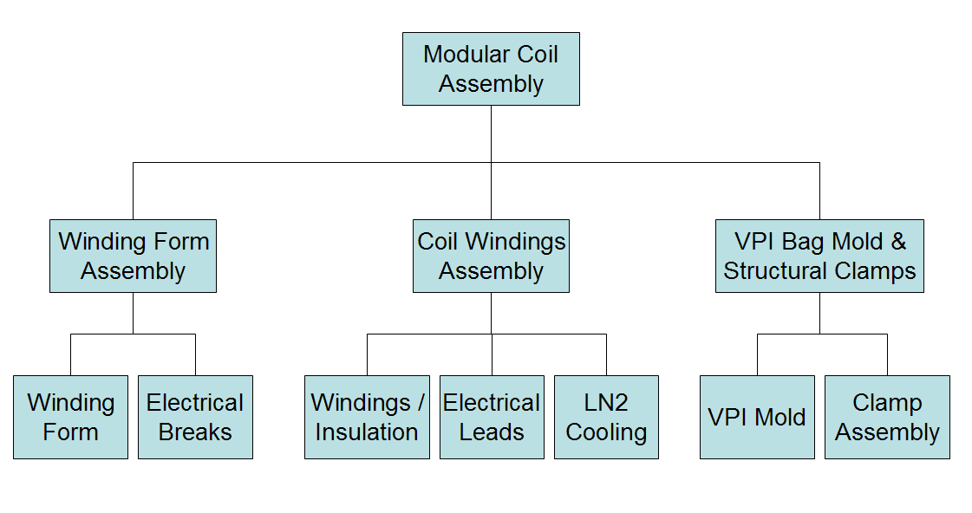
Figure 2 - Modular Coil System Block Diagram

4 FMEA Worksheets

Project: | NCSX |  | FAILURE MODE AND EFFECT ANALYSIS |  |  | Page: | 1 | of
WBS Element: |  | 14 Modular Coils |  | Performed By: | D. Williamson | Date: | 4/28/04
Component: |  | Winding Forms |  | Reviewed By: |  | Date:
Function: |  | - Provide an accurate means of positioning the conductor during the winding and vacuum-pressure impregnation (VPI) process.  - Support the windings during operation with symmetric and minimal deflection.  - Provide segmentation for assembly purposes and to prevent circulation of eddy currents.  - Support the vacuum vessel and internals.

 | Operating Mode |  |  | Failure Mode /Cause |  | System Effect |  | Fault Detection /Isolation |  | Compensating Provisions |  | Remarks
 | Fabrication |  |  | Components do not meet specification for casting / machining. |  | Limited coil performance, field errors, etc. |  | QA provisions of specification, vendor surveillance. |  | Re-work components if necessary.
 | Field period assembly |  |  | Incorrect alignment of coils to each other. |  | Magnetic field errors, loss of field symmetry. |  | Independent metrology assessment during all phases of assembly. |  | Re-assemble.
 | Field period assembly |  |  | Coils do not fit over vacuum vessel. |  | Delay in schedule, increased costs. |  | Simulate assembly using metrology of as-fabricated components. |  | Modify components during construction or prior to field period assembly.
 | Cool-down |  |  | Structure does not behave as expected structurally. |  | Magnetic field errors, loss of field symmetry. |  | Manufacturing and assembly QA.
 | Operation |  |  | Structure does not behave as expected electrically. |  | Induced currents, field errors. |  | None. |  | None.
 | Operation |  |  | Structure experiences excessive or non-symmetric deformation. |  | Magnetic field errors, loss of field symmetry. |  | None. |  | None.
Project: |  | NCSX |  |  | FAILURE MODE AND EFFECT ANALYSIS |  |  |  |  |  | Page: |  | 1 | of
WBS Element: |  |  | 14 Modular Coils |  |  |  | Performed By: |  | D. Williamson |  | Date: |  | 4/28/04
Component: |  |  | Coil Windings Assembly |  |  |  | Reviewed By: |  |  |  | Date:
Function: |  |  | - Provide up to 2-T magnetic field configuration for reference scenarios.  - Maintain current center within 1.5-mm (0.060-in) of theoretical position during operation.  - Incorporate independent control of each coil type for flexibility.  - Provide capability to monitor field, current, voltage, and temperature.  - Cool the windings back to operating temperature (80K) between pulses

Operating Mode | Failure Mode /Cause | System Effect | Fault Detection /Isolation | Compensating Provisions | Remarks
Fabrication | Windings have incorrect geometry due to fabrication errors, tolerance build-up. | Magnetic field errors, loss of field symmetry. | In-process measurement of winding pack to identify deviation. | Adjust thickness and placement of winding pack shims.
Operation | Failure of turn-to-turn insulation. | Possible motion of conductors under load, abrasion, electrical failure. | Magnetic diagnostics, electrical impedance. | Shutdown, repair if accessible.
Operation | Local failure of ground insulation. | Leakage current to ground, electrical failure. | Power supply system ground fault detector. | Shutdown, repair if accessible.
Operation | Excessive motion of electrical leads under load. | Abrasion, shorts, electrical failure. | Power supply response, visual inspection. | Shutdown and repair.
Operation | Local heating due to failure of vessel insulation during bakeout. | Possible damage to coil insulation. | None. | Shutdown, repair if accessible.
Operation | Local heating due to contact resistance between chill plate and winding pack. | Change in coil resistance, possible damage to coil insulation. | None. | Shutdown, repair if accessible.
Operation | Local heating due to blockage of cooling circuit. | Change in coil resistance, possible damage to coil insulation. | Flow switches. | Shutdown, repair if accessible.

Project: | NCSX |  | FAILURE MODES AND EFFECTS ANALYSIS |  |  | Page: | 1 | of
WBS Element: |  | 14 Modular Coils |  | Performed By: | D. Williamson | Date: | 4/28/04
Component: |  | Bag Mold and Structural Clamps |  | Reviewed By: |  | Date:
Function: |  | - Provide a mold structure that supports VPI process requirements  - Provide clamping system that is generic in design, but capable of adapting to coil curvature  - Provide clamping force sufficient to pre-load windings against the winding form.

Operating Mode | Failure Mode /Cause | System Effect | Fault Detection /Isolation | Compensating Provisions | Remarks
Fabrication | Voids due to failure of bag mold / VPI process. | Coil electrical, thermal, structural performance is limited. | None. | Remove windings and re-install.
Fabrication | Improper installation of structural clamps. | Excessive coil deflection under load, field errors. | Magnetic diagnostics. | Shutdown, repair if accessible.
Operation | Loss of clamp pre-load. | Excessive coil deflection under load, field errors. | Magnetic diagnostics. | Shutdown, repair if accessible.
Operation | Relative motion between clamps and windings. | Possible wear, failure of coil insulation. | None. | None.

5 Risk Mitigation

The analysis indicates that the most serious potential failures involve misalignment and/or excessive motion of winding pack during operation. This is being addressed in the design phase through design, analysis, R&D, and fabrication and assembly planning:

Design: The coils are designed around a cast and machined winding form that is very accurate, with the winding surfaces and mounting features integrated into a single unit. The coils are wound directly onto this form and vacuum pressure impregnated with epoxy. The casting is massive (just like the frame of a high precision machine tool) and deflections due to the winding and assembly process should be negligible. Since the windings are not removed from the winding form, the distortions that would normally occur during this operation are avoided.

Analysis: Nonlinear structural analysis has been performed to determine the behavior of the winding and clamps during cool-down and operation. Using conservative material properties assumptions, coil deflection due to thermal and electromagnetic loads has been determined and found not to have a significant impact on the magnetic field configuration. The analysis will continue to be refined as material tests and prototype fabrication and testing is completed.

R&D: Significant R&D is being performed in order to determine the material properties of the composite winding pack. This includes the tensile, compressive, and flexural modulus at operating temperature, orthotropic effects, and the fatigue characteristics of the material.

Fabrication and Assembly: The coil forms are wound at PPPL with total control over all processes by NCSX personnel. The use of a laser tracker or multi-link coordinate measuring system will allow the conductor placement to be continuously measured and corrections made throughout the winding process. Once the coils are completed, additional measurements of the as-built geometry can be entered into codes and the relative placement of each coil can be optimized, if necessary, for best control of error fields. Continuous measurements will be made during the assembly process to ensure that the coils are aligned correctly. Each coil will be located to a global reference frame that is continuously updated for the best fit to the coil array.

