NCSX
Design Basis Analysis

Analysis of Stray Magnetic Field
From Building Structure Steel

NCSX-CALC-82-002

Draft A

13 May 2004

Prepared by:

_______________________________________
Chang H. Jun, PPPL Engineer

I have reviewed this calculation and, to my professional satisfaction, it is properly performed and correct. I concur with analysis methodology and inputs and with the reasonableness of the results and their interpretation.

Reviewed by:

_______________________________________
Art Brooks, PPPL Engineer
Controlled Document
THIS IS AN UNCONTROLLED DOCUMENT ONCE PRINTED.
Check the NCSX Engineering Web prior to use to assure that this document is current.
I. Executive Summary

The purpose of this analysis is to examine the stray magnetic field caused by the magnetization of building structure steel beams. The NCSX machine will be installed in a room supported by structural steel beams. The concern is that the steel beams will be magnetized and affects on the plasma. It is possible that this stray magnetic field cause some deformation of the plasma shape which is controlled by its own magnetic fields. The goal of this analysis is to quantify the magnitude and the direction of stray magnetic fields on the plasma surface by FEA with ANSYS. If the stray magnetic field is too high to be neglected, some compensating coils could be used. The obtained results show that maximum magnetic field is around 13gauss and z directional (upward) field is dominant over radial directional one. This field level is not very serious, but not negligible either.

II. Assumptions
- The electric current sources to magnetize the building structure steels are PF coils only. (The TF and modular coils form self-closed magnetic field lines, therefore the influence on the building steels are very small comparing PF’s one.)
- All steel material properties are magnetically saturated structural steels.
- Solution domain is taken only a quarter of space. It contains all up and down PF coils, but only 90 degree pieces of PF coils. (Nevertheless, the whole PF coils have to be used for the analysis. ANSYS requires whole source conductors to perform Biot-Savart calculations.)
- The boundary condition on the two sectional areas (12 hour and 3 hour section) is parallel flux condition. It means that the PF coils and magnetized steels do not generate angular directional magnetic field. They generate only radial and up-down magnetic fields.
- The boundary condition on the four enveloping areas (top, bottom and two outer surfaces) is also parallel flux condition. It means there is no leakage flux on the enveloping boundary surfaces.
- The beams are modeled with a real I shape section because the magnetization of steel is quite sensitive with not only its volume, but also the shape itself.
- Only the floor building structure steels and supporter steels of the floor are modeled. The side wall steels on the first floor are far from the machine and the influence will be negligible.

III. Analysis Methodology and Inputs

The model contains all 8 PF coils and all building structure steels below the machine and surrounded air.
Software and data files
The model is constructed in Ansys 8.0 and all of the preprocessing and post processing is done within the Ansys environment. After finishing Ansys analysis, the magnetic field data are interpolated on the plasma surfaces. The plasma shape is too complicate to model in the Ansys analysis, so at first the magnetic field data with simple brick-shaped elements are obtained. As second step, the interpolation is performed by coding with Fortran to obtain the magnetic field value exactly on the three layers of plasma surfaces. For third step, the result of magnetic field on the plasma surfaces is drawn using Ansys post processing.

Drawings
To verify exact dimensions and spaces of building steel beams, three old construction drawings in PPPL are referenced as follows:
- CS building-CS first floor slab plan #330-101-1-G284, Rev E, Sheet 1 (February 1959)
- CS building -CS first floor slab sections and details #330-101-1-G284, Rev D, Sheet 2 (Feb. 1959)
- CS building BSMT floor plan XYZ coordinates #5603-D-5004PP (July 1971)

Material Properties
The B-H curve used for structural steels is used as following table:

Table 1: B-H curve data for the Building Steel

----------------------------------------------------------------
Points H B
----------------------------------------------------------------

1 200 0.7299
2 300 0.9009
3 400 1.0204
4 500 1.1086
5 600 1.1765
6 700 1.2302
7 800 1.2739
8 900 1.3100
9 1000 1.3405
10 1400 1.4257
11 1800 1.4778
12 2200 1.5131
13 2600 1.5385
14 3000 1.5576
15 3400 1.5726
16 3800 1.5847
17 4200 1.5945
18 4600 1.6028
19 5000 1.6098
20 7000 1.6332
21 9000 1.6465
22 11000 1.6551
23 13000 1.6611
24 15000 1.6656

Model Setup
The model used in this analysis is shown below in Figure 1. It is first quadrant of whole interested domain. Because of symmetry, the solution domain is selected only a quarter of the interested volume. The building steel is embedded in the model below PF coils. Figure 2 shows only PF coils and building steel.
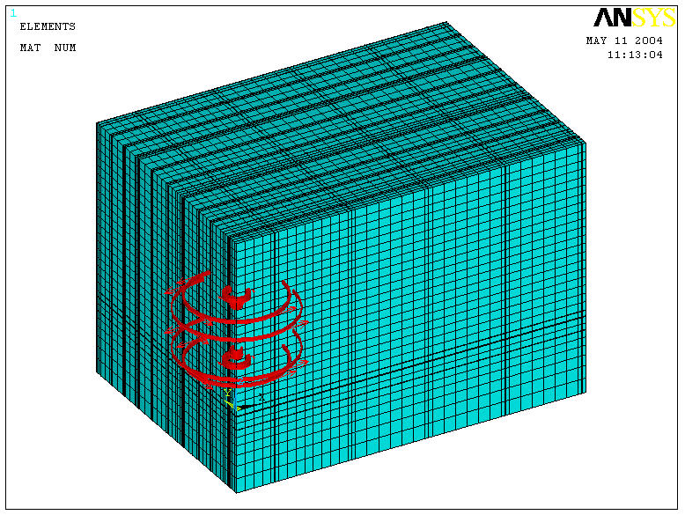
11.6m
16.8m
12.0m
Figure 1: The Ansys Model with PF Current Coils.

The model has been meshed with Solid 5 elements. The 8 PF coils are Source 36 elements.
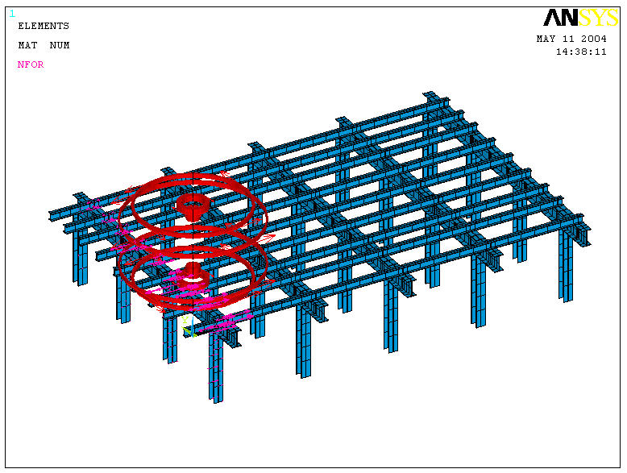
3.7m
3.2m
Figure 2: Building Steel Elements and PF Current Source Elements without Surrounded Air.

Input

Current input value of PF coils is as follows:
PF3 (most inner 2 coils: R=22cm, Z= ±120cm): +112,380A/coil
PF4 (second inner 2 coils: R=52cm, Z= ±158cm): -328,830A/coil
PF5 (second outer 2 coils: R=222cm, Z= ±153cm): +60,240A/coil
PF6 (most outer 2 coils: R=272cm, Z= ±120cm): +94,231A/coil
PF1 and PF2 is not energized and not involved in this analysis.

Procedure of Analysis

In this analysis, Ansys running is only a part of calculations. The whole procedure is explained as follows:
1) Model build and Ansys analysis in whole solution domain with building steels.
2) Ansys analysis in whole solution domain WITHOUT building steels.
3) Subtraction of nodal solution 2) from 1) (This subtracted magnetic flux density value is pure portion generated by the building steel magnification.)
4) Interpolation the nodal magnetic flux density values on the plasma surface nodes by Fortran coding.
5) Plotting these magnetic flux density values by Ansys post processing.

Interpolation Ansys Results

Because of resonance verification of the plasma, the B field value on the exact surfaces of the plasma is necessary. But to make Ansys elements along plasma surface is too hard. So we used the brick elements in Ansys and interpolate the field result on the plasma surface position. The plasma region is inside the PF coils. This is detailed explanation of the above Procedure of Analysis, 4):

- From Ansys result, the nodal points coordinates and nodal B field values have been extracted with element information.
- The extracted parts of elements include all plasma volume.
- The extracted elements have to be sorted for a proper order of node points.
- By several Fortran codes, the points on the plasma surface have to be judged in which element the plasma point are included.
- After deciding the including element, the plasma surface point is interpolated by 8 nodes of included element.
- The interpolation loops continue to evaluate all of the plasma surface points.
- The plasma surface and the result field are plotted in Ansys post processer by using DNSOL command.
- In the most outer surface and two inside surfaces of plasma are plotted for surface itself and B field results.

IV. Results

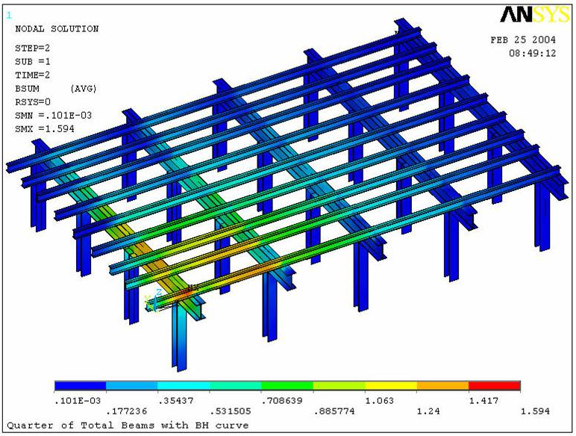
Figure 3: B Field (vector sum) in the Building Steel Beams (Maximum is 1.594 Tesla under PFs)

The steel beams under PF coils show saturated magnetic B field (more than 1Tesla) up to around 4m radius area. The maximum B field is around 1.6Tesla.

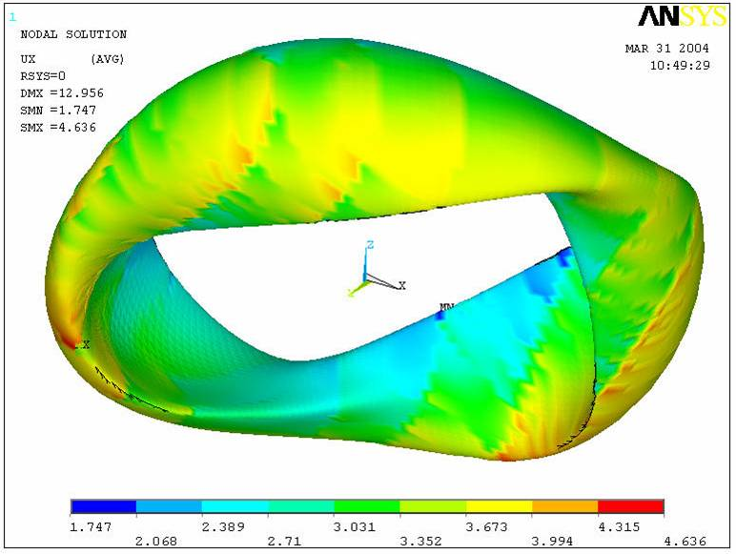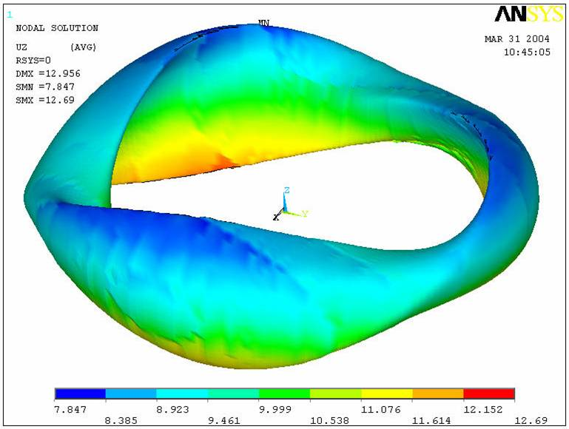

Figure 4: Radial B Field (left; maximum is 4.6 gauss) and
Longitudinal B Field (right; maximum is 12.7 gauss) on the Outmost Plasma Surface.

The B field in Z direction is dominant over radial direction.

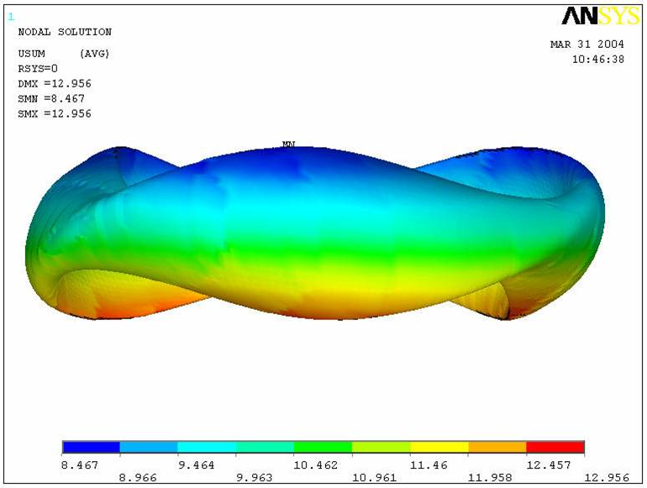

Figure 5: Vector Summed B Field on Outermost Plasma Surface.
(Front view; Maximum is 13gauss)
The maximum magnetic field on the plasma surface is around 13gausses. The bottom surfaces suffer higher magnetic field than top surfaces. The reason is that the bottom part is closer to steel beams than the top part.

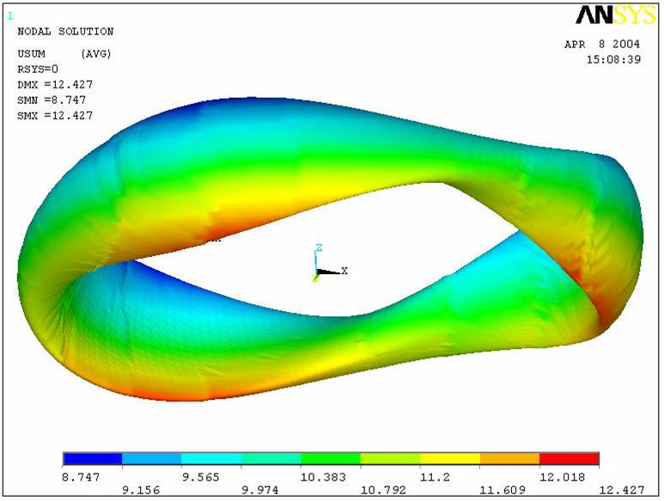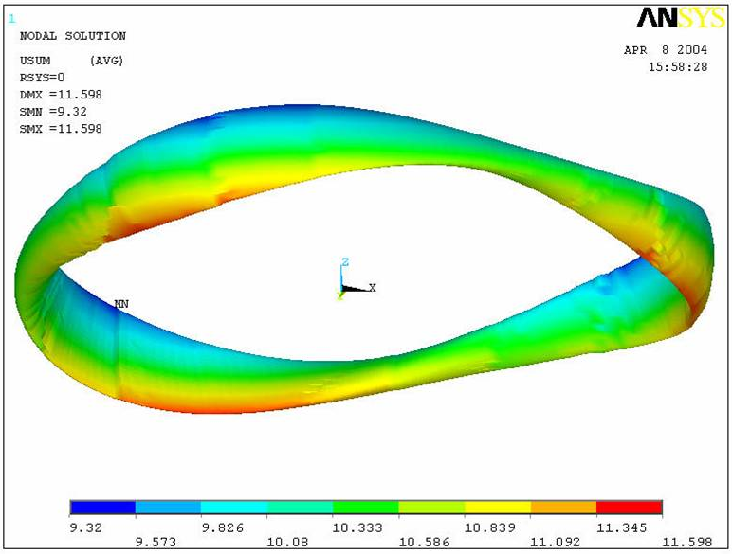

Figure 6: Vector Summed B Field on Middle Plasma Surface (Left; Maximum is 12.4gauss)
And On Most Inner Plasma Surface (Right; Maximum is 11.6gauss)

V. Summary and Recommendations

The maximum magnetic field generated by the building structural steels is around 13gauss. The dominant field component is longitudinal one (upward). The field is quite symmetric shape, so correction by some compensating coils will not be complicate.

Ansys Model, Fortran Codes & Plasma Surface Nodes Data

Ansys model used and Fortran source codes are in below directory:

P:/public/anonymous ftp public/cjun/NCSX01

The Ansys Model: Total_0224.db
Fortran codes: B_*.f90 (6 files)
Plasma surface data: Li383* (3 files)
{End}

