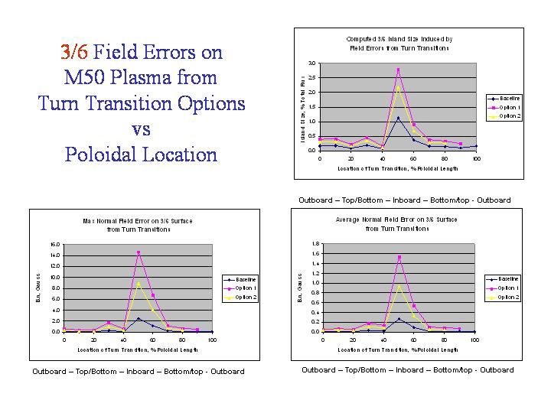

Modular Leads
One option under consideration for returning the modular coil leads was to spread the windings apart on either side of the T support structure, leaving room for a hole in the structure to route the leads. This perturbation to the winding geometry produces current loops with respect to the original geometry. That is to say the difference in the winding geometry of the perturbed on unperturbed coil can be modeled as two equivalent loops with opposite current direction as shown in the sketches below. Field errors from these loops were evaluated as described in Section Error: Reference source not found.
The poloidal location of the aneurysm on the modular coils was varied. The results, plotted below, show the field errors and the predicted island size for each location. The unacceptably high field errors and large islands led to the abandoning this approach.
