General Requirements Document (NCSX-ASPEC-GRD-01)

Description of Methods
The impact of field errors are traditionally investigated for vacuum field configurations by examining Poincare plots from field line tracing for any source and observing induced islands or changes in islands with respect to a Poincare plot for an ideal configuration. For NCSX, operating with significant plasma current and beta, the field from the plasma must be included to achieve the iota profiles expected which cross the resonances of concern. The PIES code can be used to produce Poincare plots which are self-consistent and indeed is being used for necessarily limited investigations within the NCSX Physics Group. The long run times required for convergence and limitations regarding symmetry-breaking perturbations make PIES a difficult design tool to employ for general engineering use.
A simpler approach was taken to provide a first cut at field error source assessment. It is based on the analytic expression for magnetic island width, in flux coordinates, by magnetic field perturbations in a general toroidal stellarator geometry. It presumes the underlying (perturbation free) field contains nested magnetic surfaces and is valid for rational surfaces (where the rotational transform ι = n/m). The VMEC equilibrium provides such a field. (Alternately, a vacuum configuration with the same rotational transform profile as the LI383 full current, full beta configuration could be used. However, attempts to define such a configuration were not successful.) Use of the VMEC equilibrium simplifies the evaluation of the island width which depends on B^{s}/B^{φ} expressed in straight line (magnetic) coordinates. Figure 1 presents the method used.
A computer program called VACISLD was written to evaluate the island width using the VMEC field and a perturbation field generated by coil filaments or alternately supplied as a field map from other sources. A field line tracing routine called TraceBrtp, capable of tracing the perturbation field with the VMEC field in VMEC coordinates, was developed to examine both symmetric and symmetry breaking field perturbations. VACISLD and TraceBrtp were benchmarked against PIES* for symmetry preserving field perturbations (*PIES was modified by Don Monticello to allow adding a perturbation field from coils to the background VMEC field). Figure 2 shows the resonances targeted.
The Field Error Source Assessment Methodology is similar for each of the sources identified. For each field error source, a field map is generated on resonant surfaces in the reference plasma using methods appropriate for the source. For coils which provide the sustaining field to form and support the plasma, the field error map is the difference between the ideal coil configuration and the perturbed or actual coil configuration, and the field is calculated using direct Biot-Savart integration of line filaments. For eddy currents, the total field is used and it is calculated by the SPARK code as field at remote points. For ferromagnetic sources, the ANSYS code is used to both determine the magnetization of the ferromagnetic source from other participating field sources and calculate the field at the plasma from the magnetizes ferromagnetic material.
Initial studies used the VMEC LI383 fixed boundary plasma configuration as the reference plasma. Subsequent work has used the latest VMEC free boundary plasma configurations (m45, m50, …).
Figure 1 Evaluation of Island Size in the VACISLD Code using VMEC Field
Figure 2 VMEC Resonant Surfaces in LI383 Fixed Boundary Plasma
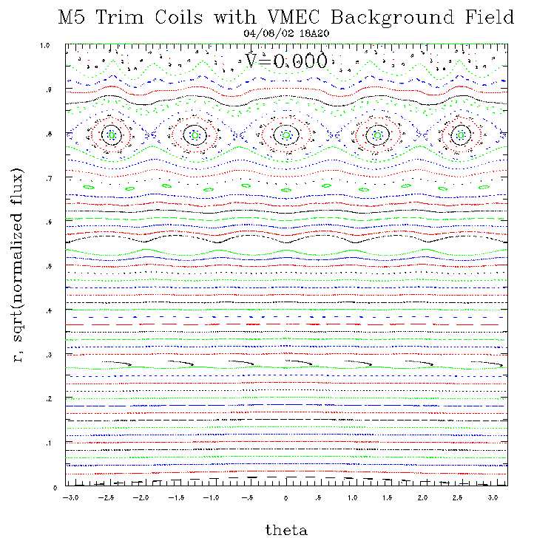
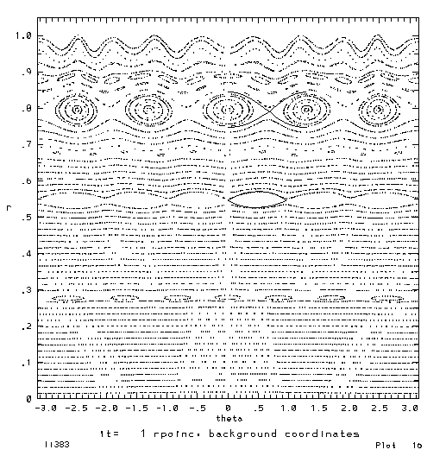
Benchmark of Field Line Tracing of Perturbation Field* from Coils on VMEC Field
PIES
TraceBrtp
*From 1 KA M5 Trim Coils
Figure 3 Benchmark of VACISLD and TraceBrtp Codes with PIES

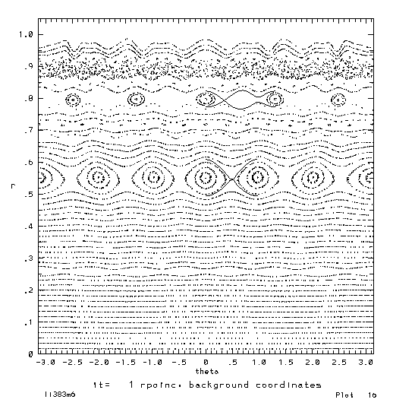
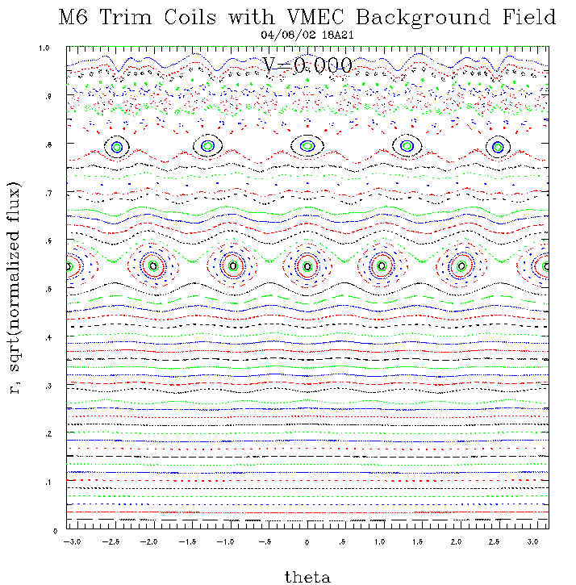
Benchmark of Field Line Tracing of Perturbation Field* from Coils on VMEC Field
PIES
TraceBrtp
*From 1 KA M6 Trim Coils

Figure 4 Benchmark of VACISLD and TraceBrtp Codes with PIES

D.K. Lee, J.H. Harris, G.S. Lee, Nuclear Fusion, Vol. 30, No. 10 (1990) $$d(s)=4{\left|\frac{c_{\text{mn}}(s)}{mι^{'}(s)}\right|}^{1/2}$$

