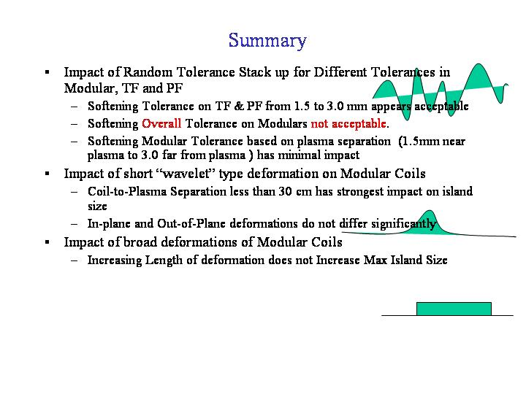

Leads and Turn Transitions
A number of winding options have been considered for the modular coils. These include conventional (one-in-hand) where the conductor winds up one layer and down the adjacent, and multiple-in-hand (2, 3 or the most recent 4) where the multiple turns are treated as a single conductor (ie at the same potential) and all turns raise or fall layer to layer together. The multiple-in-hand options were motivated by the need to reduce keystoning in the conductor during winding around tight bends by reducing the size of individual conductor turns. However, whereas the one-in-hand option has turn transitions that produce field errors that tend to cancel each other and form smaller current loops, the multiple-in-hand options require an external lead along the side of the bundle to close an effectively larger current loop with potential larger field errors.
Field errors from each configuration option were compared by calculating the differential field from each configuration and an idealized, no transition (i.e. parallel, nested turns) configuration. By subtracting the configurations themselves as opposed the field from each configuration separately, results in computationally a smaller, identical problem. Several different approaches were taken to model these equivalent configurations. Initially, the length of transition was ignored and the options were compared based on equivalent planar loops normal to the winding direction. A refinement to this inclined the loops to try and account the length of the transition. Finally, a detailed model of the individual turn transitions was made (ie the ‘basket’ model) which reflected the difference between the actually winding of each configuration, and a multifilament winding of parallel conductors.
The poloidal location of the turn transition and accompanying lead stems was varied as we looked at field errors and induced islands from each configuration. The figures that follow further describe the configurations and the results obtained. Results indicate preferred locations for the turn transition to minimize field errors and island sizes.

