PPPL ENGINEERING CHANGE NOTICE (ECN) ECN # 5128R1

COGNIZANT INDIVIDUAL: D. Williamson

ECN TITLE: MCWF Type-A and -B Modifications

ASSOCIATED ECP: None

CC/WP/Job:9450-1***-1403 AREA OR PROJECT: NCSX

LIMITATION OF SCOPE - NOTE: A Work Planning Form is NOT required if the total change to be accomplished (ENG-032):
- Is not large or complex or does not represent a new installation into a usable space
- Does not have a significant ES&H impact
- Does not involve tritium or other radioactive contaminated or activated equipment
- Does not impact multiple projects, systems, or groups
OR does not change the scope or intent of the original design.

Responsible Line Manager CONCURRENCE: __________________________________
(Signature indicates that no Work Planning form is required.)

If non-concurrence or associated with a work planning form, enter the WP Number:

DRAWING(S) AFFECTED NUMBER: | NEW  Revision | TITLE
SE141-114 | 7 | Production Winding Form Type-A
SE141-115 | 8 | Production Winding Form Type-B
Continued on Back

DESCRIPTION OF CHANGE: (State Drawing No., Zone/Group, or List Attachments)
Revise Type-A flange holes from clearance to tapped holes per RFD-14-018. Ref drawings SE141-114, sheets 4, 5.
Revise Type-B flange holes per notes and discussion with MTM during visit to PPPL. Reference meeting notes, 5/18/06. Ref drawing SE141-115, sheets 4,5.
Revise Type-A T/C hole size and location per RFD-14-017. Ref SE141-114, sheet 9.
Revise Type-B T/C hole size and location per discussion. Ref SE141-115, sheet 9.
Revise Type-B leads interface features, SE141-115, sheet7, quad B-4.
Revise Type-B port geom to match NC programming. Ref Se141-115, sheet 8, quad C-1.
Revise .25-20UNC hole chamfer on -114, sht4, B4, -115, sht4,E1, -115, sht5, F7

PPPL ENGINEERING CHANGE NOTICE (ECN) ECN # 5128R1

REASON FOR CHANGE:

Major Tool noted casting interference at the bolt locations as shown in the attached figures for the Type A castings The interference is similar to what was noted on the Type-C winding forms, but more severe. NCSX reviewed the layout for Type-A and -B coils and changed some holes from clearance holes to tapped holes as shown in the attached figure.

In order to facilitate the drilling of the thermocouple holes, MTM proposed to increase the diameter of the hole for all except the last inch of depth. In addition, the location of the inboard thermocouple was changed to eliminate a setup.

Port geometry was changed very slightly in order to use a common setup for nearby external features on the part.

A Project-initiated modification to improve the lead block positioning resulted in a
slight reorientation (2.2° horizontal change at the top and 0.114” vertical change) of the Type-B lead slots as shown in the figure (Ref RFD-14-022).

Tapped holes in the flanges (.25-20UNC) have an incorrect chamfer callout on the drawing, though the model is correct.

ENGINEERING CHANGE PROPOSAL: DATE:

COGNIZANT INDIVIDUAL MAKING THE CHANGE: D. Williamson

RESONSIBLE LINE MANAGER:

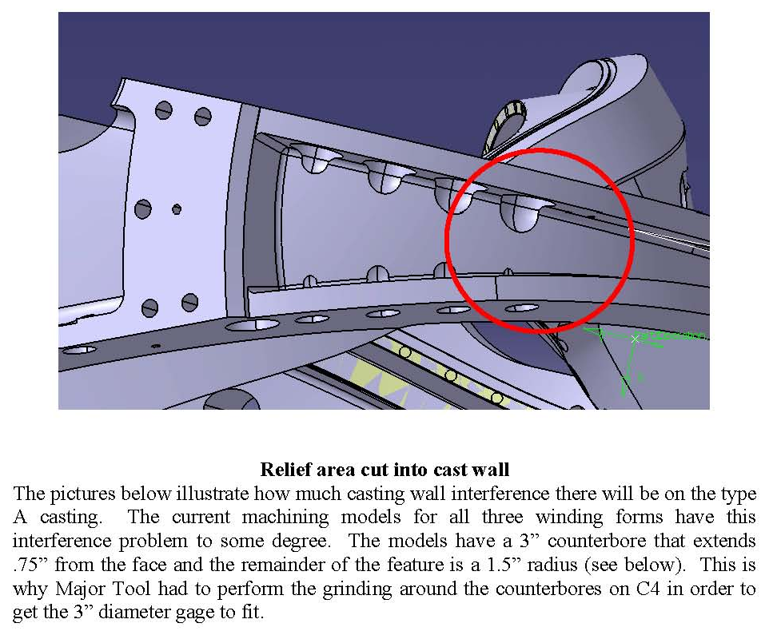

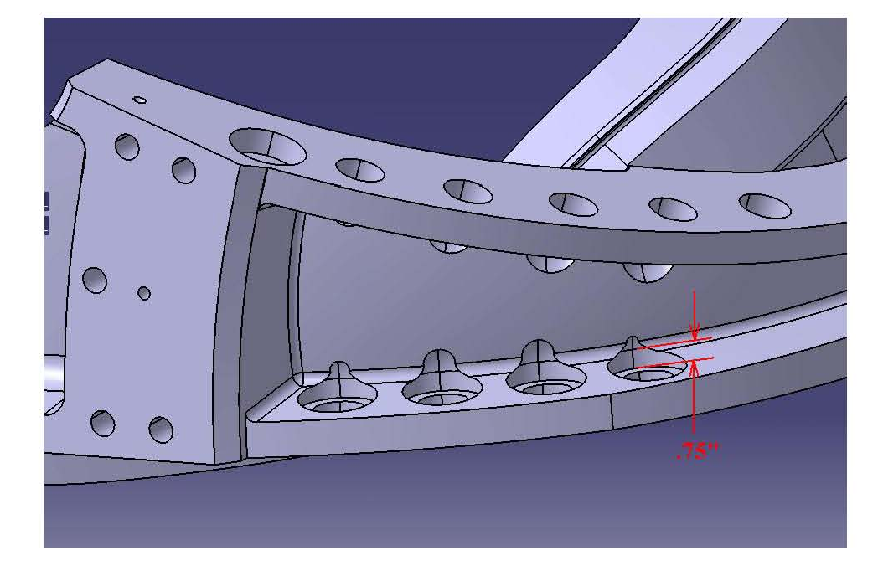
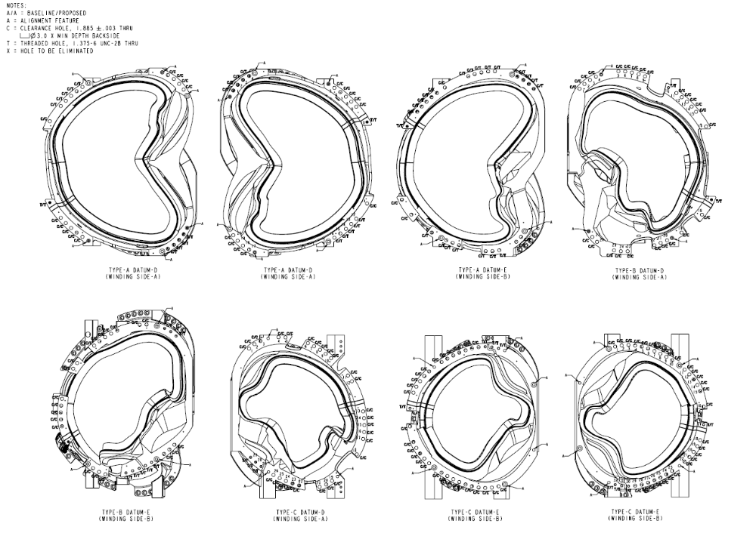
Ref drawing SE140-129 (to be released)
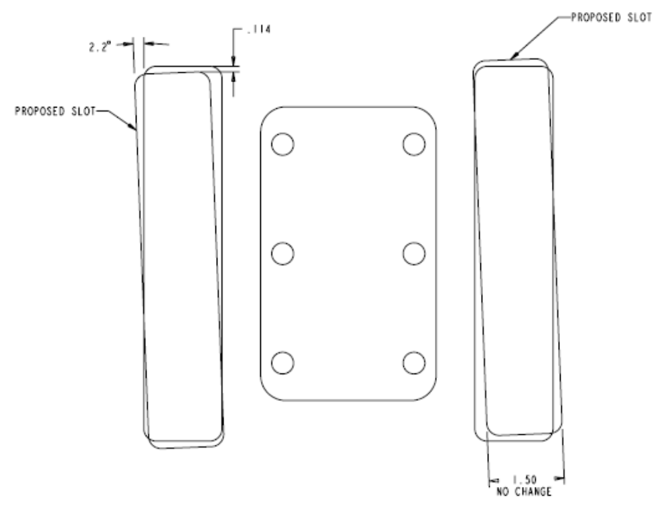
Type-B leads area (Ref SE141-115, sht7, B4)

