PPPL ENGINEERING CHANGE NOTICE (ECN) ECN # 5140

COGNIZANT INDIVIDUAL: Dave Williamson

ECN TITLE: Changes to Modular Coil Lead Area Design

ASSOCIATED ECP: None

CC/WP/Job: 9450-1***-1451 AREA OR PROJECT: NCSX

LIMITATION OF SCOPE - NOTE: A Work Planning Form is NOT required if the total change to be accomplished (ENG-032):
- Is not large or complex or does not represent a new installation into a usable space
- Does not have a significant ES&H impact
- Does not involve tritium or other radioactive contaminated or activated equipment
- Does not impact multiple projects, systems, or groups
OR does not change the scope or intent of the original design.

Responsible Line Manager CONCURRENCE: __________________________________
(Signature indicates that no Work Planning form is required.)

If non-concurrence or associated with a work planning form, enter the WP Number:

DRAWING(S) AFFECTED NUMBER: | NEW  Revision | TITLE
SE142C-203 | 1 | TYPE-C SPECIAL CHILL PLATE DETAILS
SE142A-242 | 1 | TYPE-A SIDE-B CLAD/CHILL PLATE ASM
SE142A-252 | 1 | TYPE-A SIDE-A CLAD/CHILL PLATE ASM
SE142B-252 | 2 | TYPE-B SIDE-A CLAD/CHILL PLATE ASM
SE142C-382 | 1 | TYPE-C SIDE-A UPPER CLADDING
SE142C-384 | 1 | TYPE-C SIDE-A LOWER CLADDING
SE142C-482 | 1 | TYPE-C SIDE-B UPPER CLADDING
SE142C-484 | 1 | TYPE-C SIDE-B LOWER CLADDING
SE142C-050 | 1 | TYPE-ABC LEADS TERMINAL ASM
SE142C-047 | 1 | TYPE-ABC JUMPERS BASE BLOCK
SE142C-080 | 1 | TYPE-C LEAD BLOCK PRE-FIT ASM
SE141-121 | 1 | TYPE-A MCWF WINDING PREP
SE141-123 | 2 | TYPE-C MCWF WINDING PREP
SE142C-138 | 0 | TYPE-ABC JUMPER GRND STRAP

PPPL ENGINEERING CHANGE NOTICE (ECN) ECN # 5140

DESCRIPTION OF CHANGES: (State Drawing No., Zone/Group, or List Attachments)

The purpose of these lead area design changes is to mitigate technical risks that have come to light in the course of testing the C1 Modular Coil. The following changes are proposed:

- On the top chill plate (the one with the long fingers that extend parallel to the coil) – cut off the fingers and eliminate the chill plate. (See Figure 1). This change will be implemented for the C3 and follow-on coils.
- Isolated copper cladding pieces (located on the base of the tee underneath the winding pack in the lead area, the vertical cladding pieces in the same area, and the cladding in the poloidal break area) – change the material to G-11cr. (See Figure 2). This change will be implemented starting with the C5 and follow-on coils. Note: The G-11 pieces should be made to look like the cladding (with slots) so that forming to the shape and wicking of epoxy will be that same as for other areas.
- For the power bus tie-in area, cap the attachment bolt with an epoxy seal to mitigate a potentially short tracking path.. (See Figure 3L). This should be implemented on all coils.
- Presently the four bolts that connect the power bus are floating which is an undesirable condition (See Figure 3R ) - connect them to one side by eliminating the insulating washers on the other side. This should be implemented on all coils.
- The bolts that attach the G-11 base plate underneath the jumper stack – put a cover (Kapton or thin G-11 sheet) to increase the tracking distance. (See Figure 4). This should be implemented on all coils.
- For the three studs that bolt the stack of jumper plates together that are isolated – electrically tie them to one of the jumpers. (See Figure 5). Also add an insulating “plug” at the base of the hole in the G-11 base plate to reduce the risk of the studs penetrating the G-11 backing sheet to the winding form. This should be implemented on all coils.
- Entire lead assembly – manufacture a cover/box over the entire lead assembly or spray the exposed surfaces with a cryogenically compatible electrical varnish (e.g., Glyptol if cryogenically compatible) in order to prevent shorting due to metal chips, bolts, washers, etc. from falling in these areas during operation. This should be implemented on all coils.
- Improve the insulation between the cladding and the tee, especially at the tip of the tee where there is a risk of penetrating the kapton during staking – additionally use a metal backing tool (e.g., a putty knife) between the copper and kapton during the staking operation. This will serve to spread the impact load and protect the kapton. This should be implemented on the C3 and follow-on coils. This should be implemented on all coils.
- Tie the poloidal break shims and bolts electrically to the winding form. Implement for all coils.

PPPL ENGINEERING CHANGE NOTICE (ECN) ECN # 5140

REASON FOR CHANGES:

During the testing of the C1 coil, several design improvement issues were identified. These changes will serve to mitigate the technical risks identified.

ENGINEERING CHANGE PROPOSAL: N/A DATE: June 13, 2006

COGNIZANT INDIVIDUAL MAKING THE CHANGE:

RESONSIBLE LINE MANAGER:

RLM Comments:

Figure 1

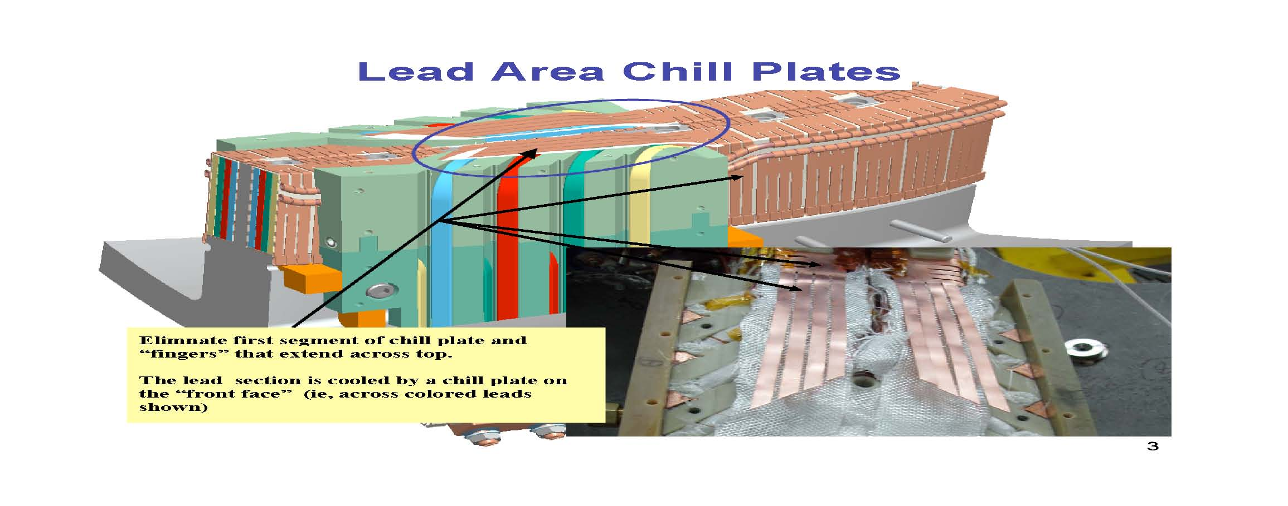
PPPL ENGINEERING CHANGE NOTICE (ECN) ECN # 5140

Figure 2

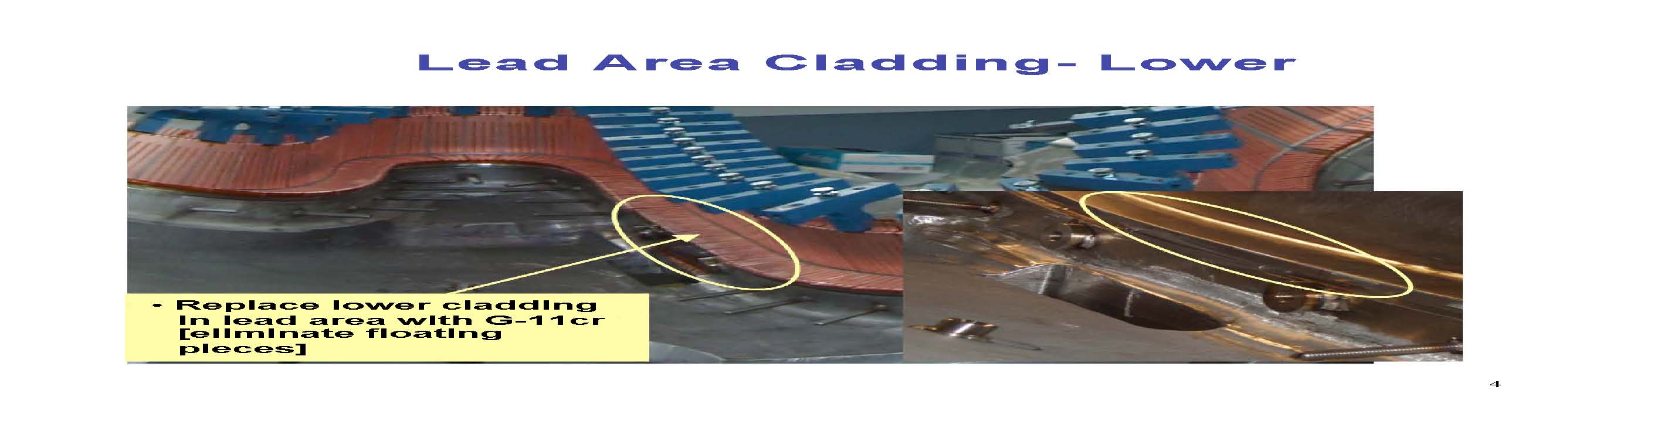

Figure 3

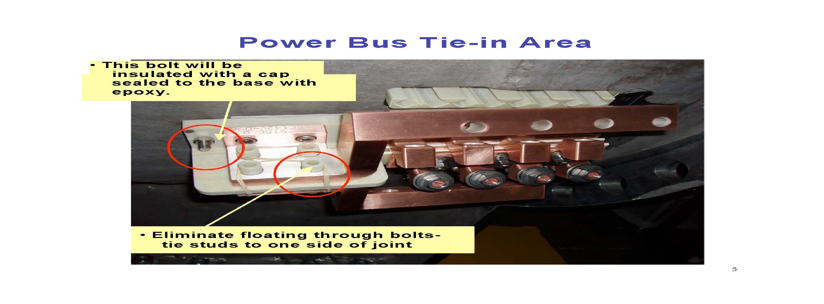
PPPL ENGINEERING CHANGE NOTICE (ECN) ECN # 5140

Figure 4
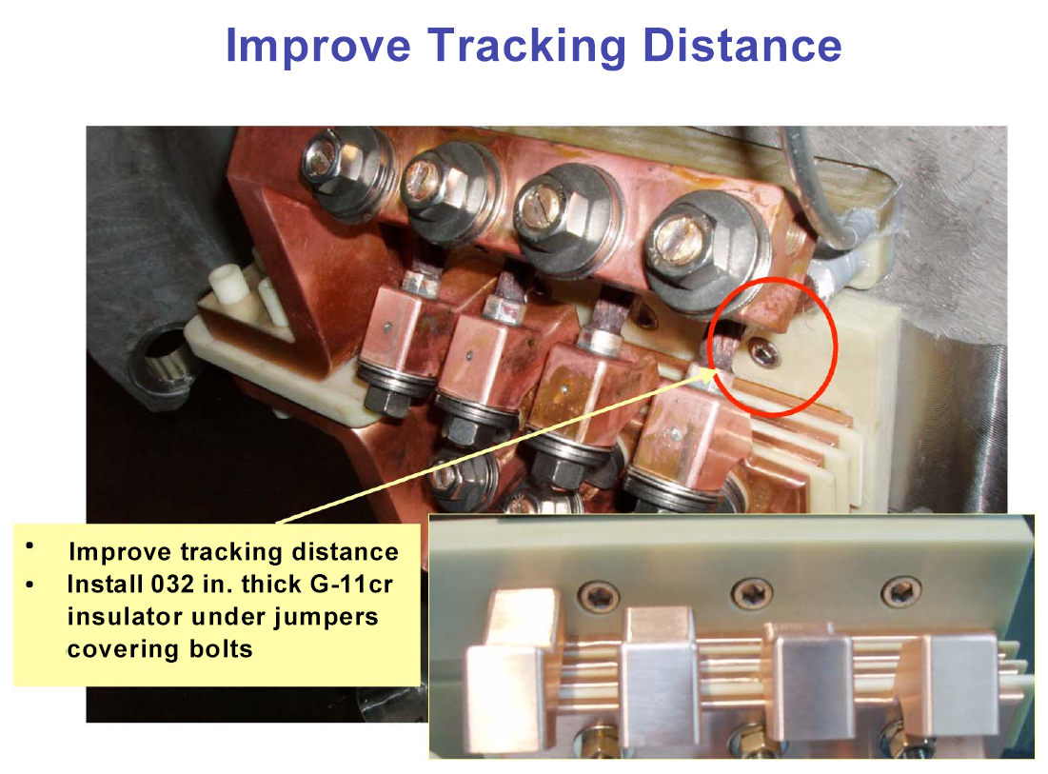
Improve tracking distance to attachment bolt heads by inserting G-11 CR or Kapton sheets under jumpers which would cover the bolt heads.

Figure 5


