- Adobe Acrobat 7.0 (or later version) works the best.

- Use the word template below for each and every ECN. This permits you to change the ECN number and to provide any description you desire –m at a minimum, you should include the ECN number. This template merely states: “ECN-XXXX Pending”

ECN XXXX Pending.

- Suggest you set up a Separate “Pending ECN Folder” on your desktop with subfolders for each and every ECN.

- Convert the Word version of the stamp for ECN-XXXX (where XXXX is a specific ECN number) to pdf using the print as “Adobe PDF” on the print menu and save in the same subfolder as the source Word stamp.

- In order to set the affected drawing up to accept a stamp, the following steps need to be done:
  - Copy drawing to your desktop:

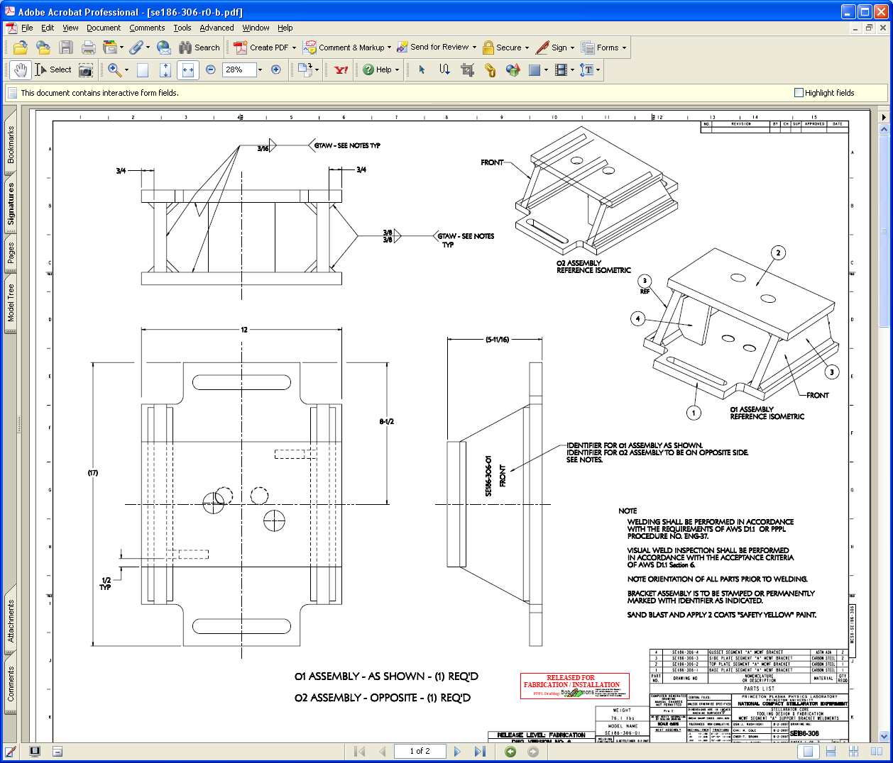
  - Clear signature fields by:
    - Select Signature tab
    - Select Options on tab and then “Clear All Signature Fields”

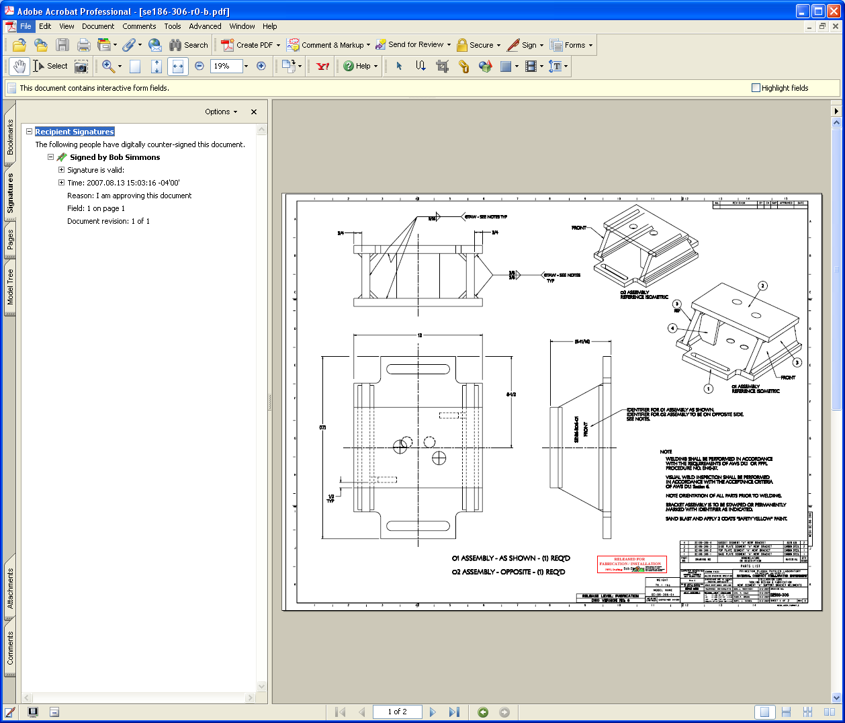
Clear All Signature Fields

  - Once signature field cleared, go to Security and select “No Security” – this will permit adding stamp.

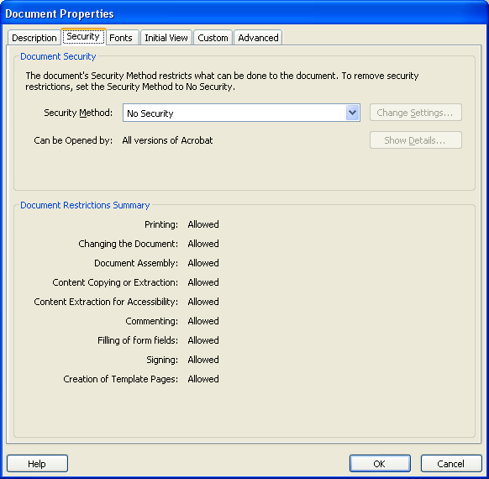
- Set up the stamp as part of the stamp tool by:

- Select Comments Menu =>Commenting Tools => Stamps => Create Custom Stamp:

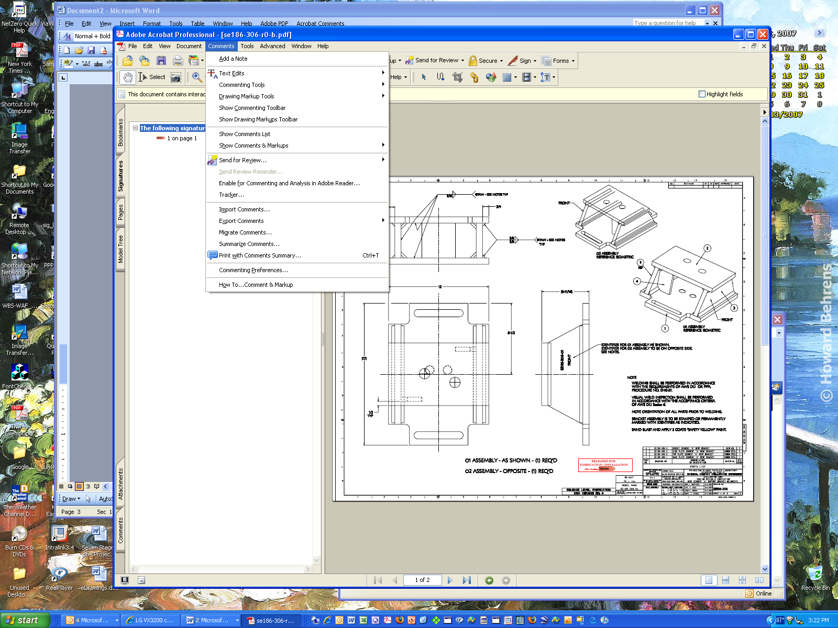

- In the “Select Image for Custom Stamp” box, select “Browse” to select specific ECN-XXXX stamp location and the check OK:

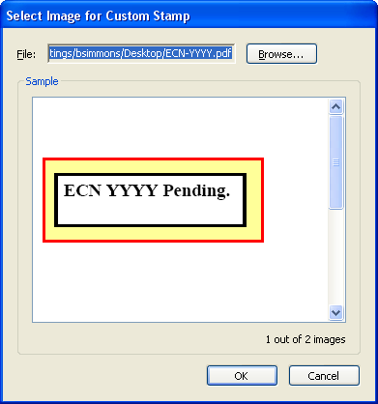
- In Create Custom Stamp box, assign category “Pending ECN Stamps and assign name (suggest you use the ECN number). Note that this is different from where you store the stamp on your desktop – this sets up your ability to drag and drop a stamp to your drawing.
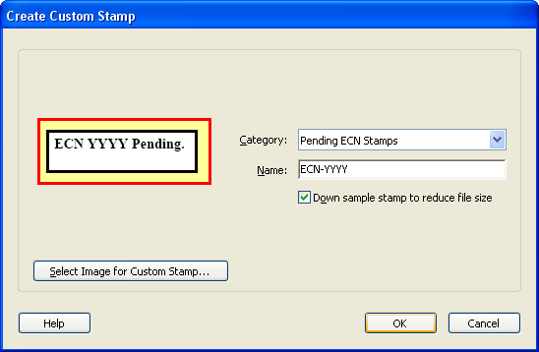

- Select Comments Menu => Commenting Tools => Stamps => Select “Pending ECN Stamps” => ECN stamp desired and then drag to your drawing. You can resize stamp size as desired.

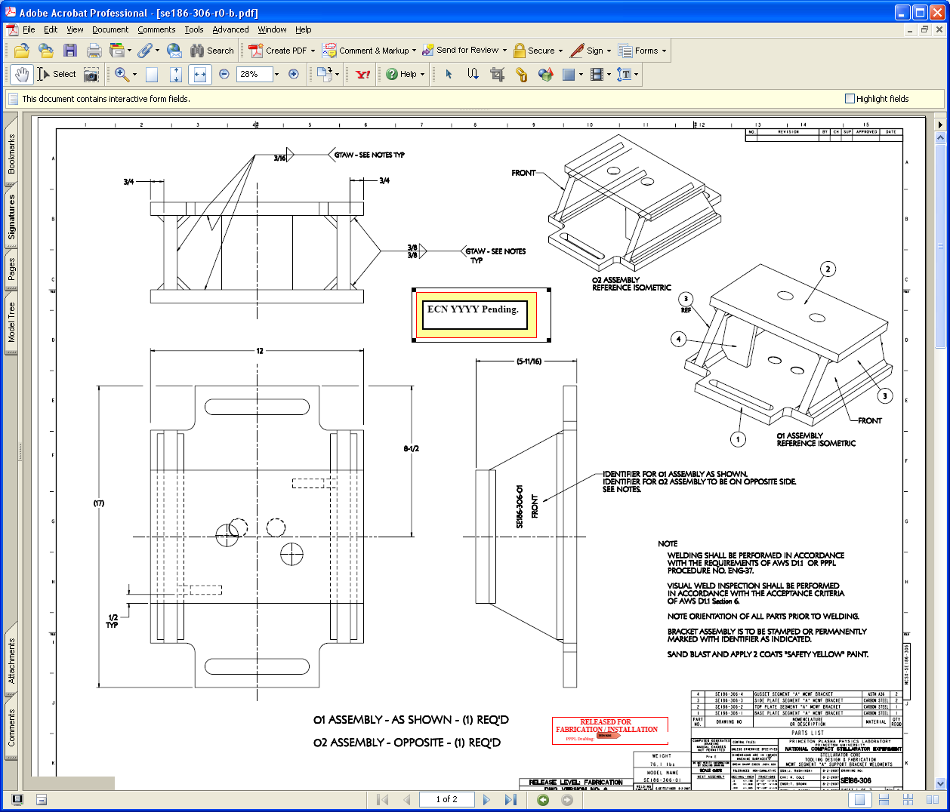

- Restore Security to Password Security and complete necessary password and printing and signing options. You select the password in the “Change Permissions Passwords” section, select “High Resolution” printing option, and “Filling in form fields and signing existing signature fields” option, and check “Enable copying of text, images, and other content” => this will permit copying and permit signing.

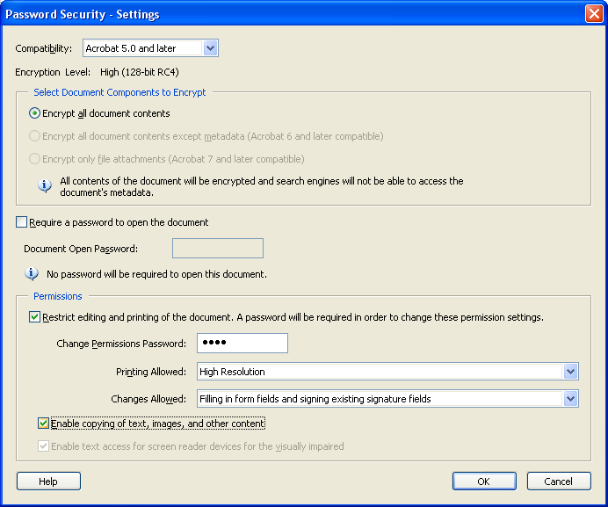

- Confirm Permissions Password and check “OK” => select “OK” again, and the again

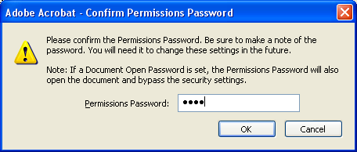
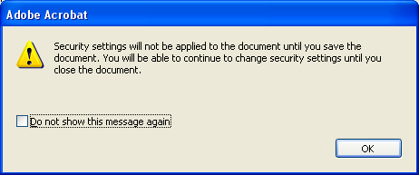

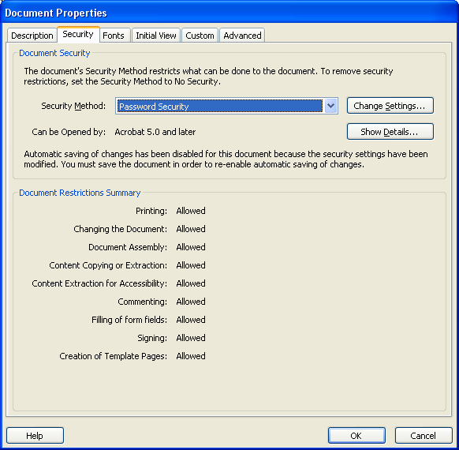

- Save drawing, assigning a letter revision (e.g., “SE186-306-r0-b” where “b” is the letter revision.

- Post drawing on PPPL Engineering Department Web that lists all the drawings.

- Repeat process for next ECN

