- Adobe Acrobat 7.0 (or later version) works the best.

- Use the pdf template below for each drawing. Note that the pdf version has provided the capability (see Addendum) to permit entering text. Two type of ECN stamps exist:
- Case 1 - There is an approved ECN not yet incorporated into a drawing => this notifies the user that the drawing has an outstanding ECN(s). “XXXX” is the ECN number which will be added once the stamp is on the drawing. (Note: Pending ECN stamp template is maintained by the PPPL Drafting Supervisor who will enter the particular ECN number as he places the stamp on the drawing(s) impacted).
Revision Pending.
ECN # (XXXX)

  - Case 2 - Where the NCSX Project has made the decision to utilize an ECN stamp in lieu of updating the drawing (done on a case by case basis). This stamp notifies users that there is an approved ECN, but that the NCSX Project has authorized the use of an ECN stamp in lieu of updating the drawing. PPPL and NCSX procedures require that a drawing cannot have more than 3 ECN stamps unless specifically authorized by the NCSX Engineering Manager. “XXXX” is the ECN Number, “Y” is the Revision Number of the impacted drawing, and z is the letter revision of the drawing with this stamp (e.g., “a”, “b”, or “c”) – these will be added once the stamp is on the drawing.
ECN Approved & Use of Stamp Authorized in Lieu of Updating Drawing:
ECN-(XXXX Rev Y-z)

- It is recommended that a Separate “ECNs Not Yet Incorporated” and/or “ECN Stamps” folder be established on the desktop to track these stamps.

- Convert the Word version of the stamp for ECN-XXXX (where XXXX is a specific ECN number) to pdf using the print as “Adobe PDF” on the print menu and save in the same subfolder as the source Word stamp.

- In order to set the affected drawing up to accept a stamp, the following steps need to be done:
  - Copy drawing to your desktop:

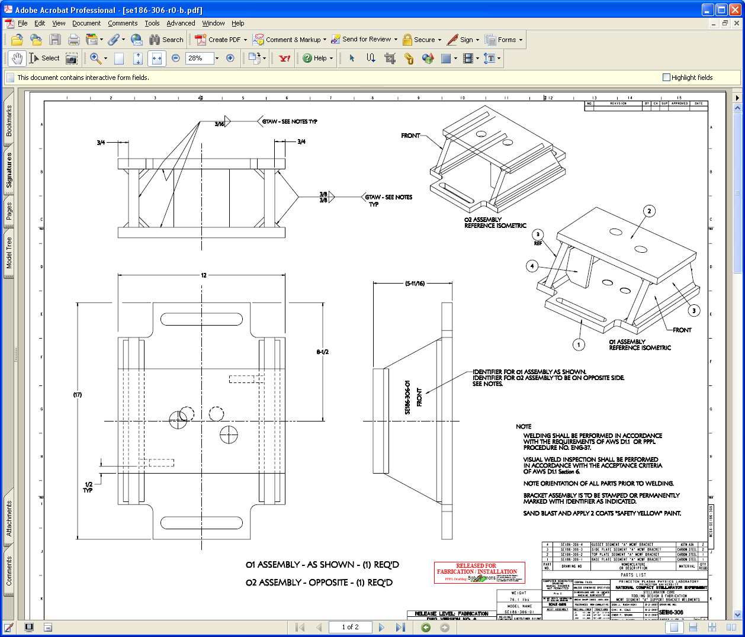
  - Clear signature fields by:
    - Select Signature tab
    - Select Options on tab and then “Clear All Signature Fields”

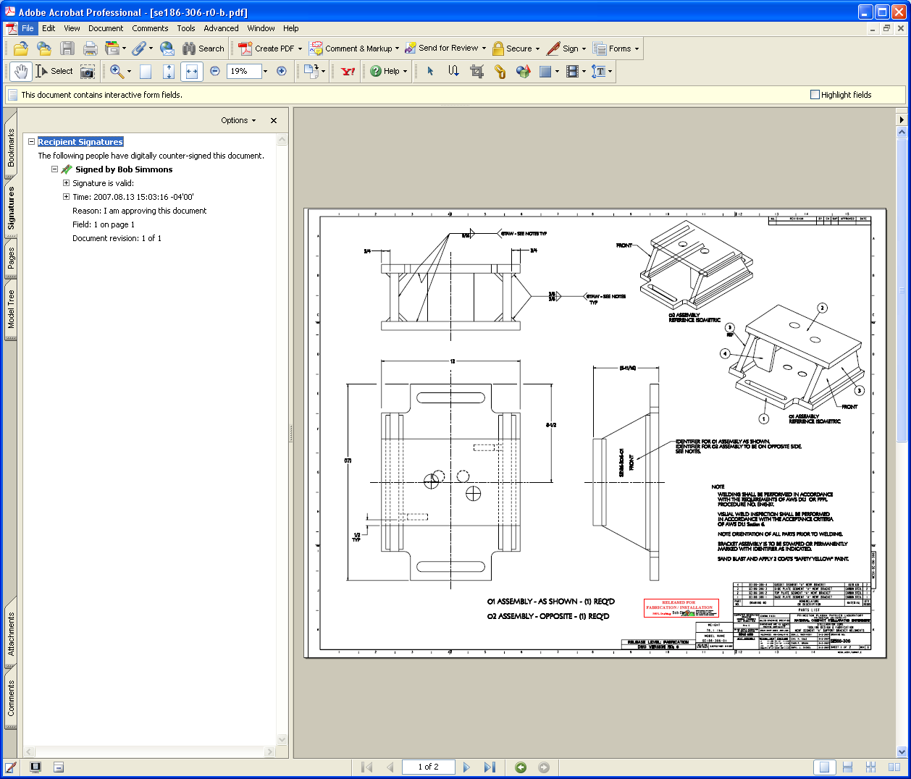
Clear All Signature Fields

  - Once signature field cleared, go to Security and select “No Security” – this will permit adding stamp.

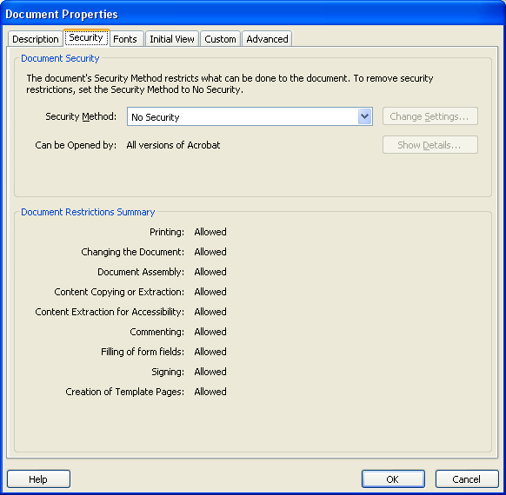
- Set up the stamp as part of the stamp tool by:

- Select Comments Menu =>Commenting Tools => Stamps => Create Custom Stamp:

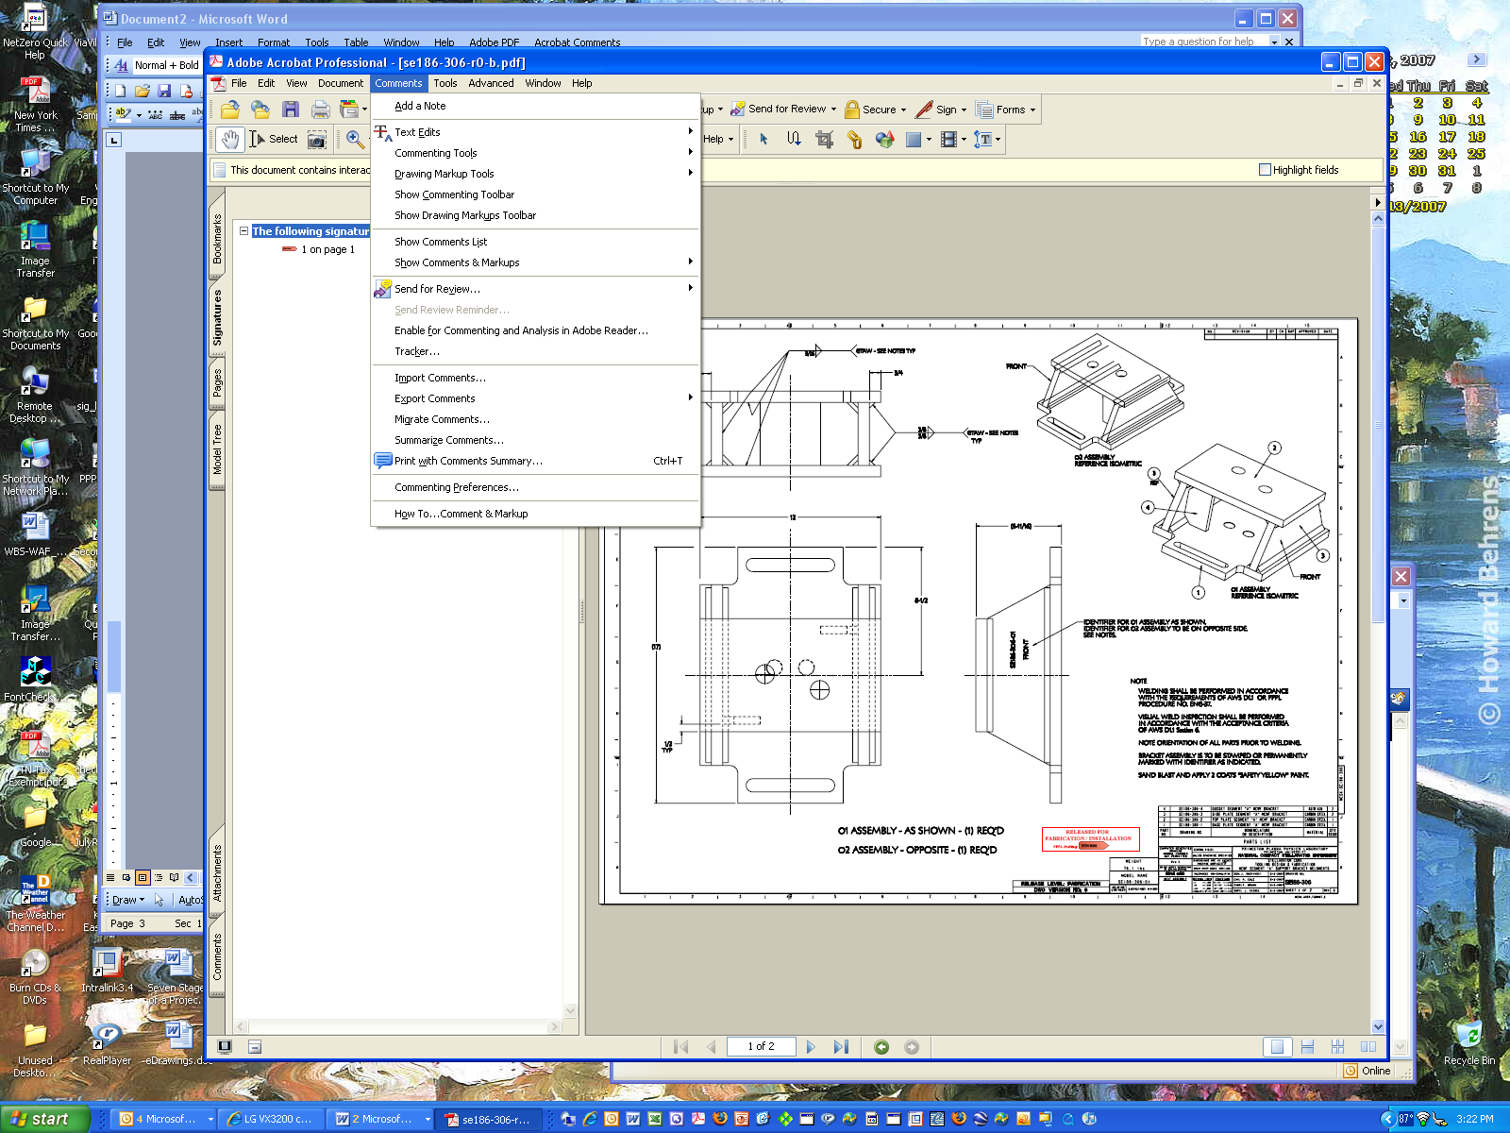

- Or if stamp already created, select “Manage Custom Stamps” and select “Template” stamp location and the check OK:

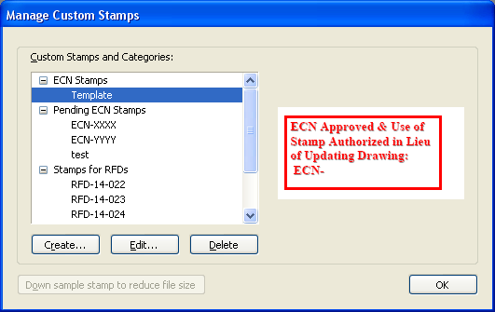

- Assuming stamp already created, now select Comments Menu => Commenting Tools => Stamps => Select “ECN Stamps” => “Template” and then drag to your drawing. You can resize stamp size as desired.

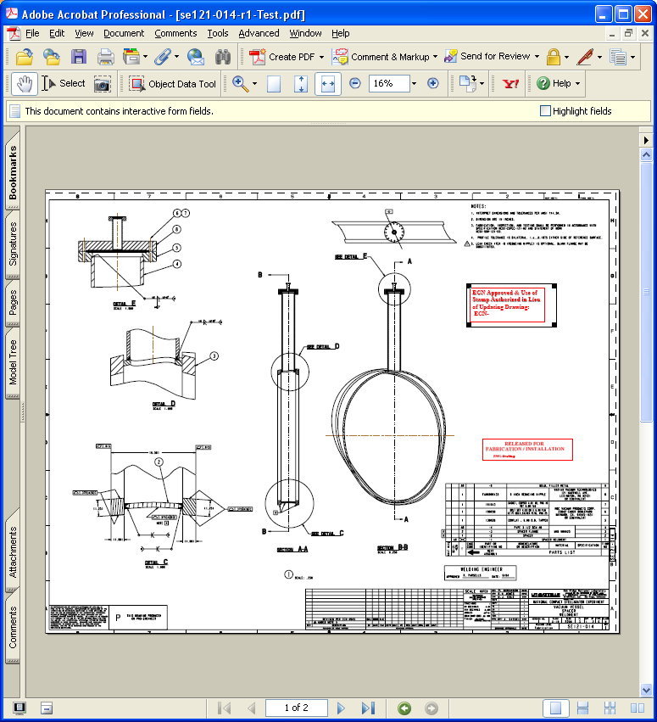

- Place the necessary text (e.g., ECN Number, and drawing Rev and stamp revision number/letter) by selecting: Tools => Advanced Editing => Text Field Tool and place text block where desired at size desired. Next select “Hand Tool” and click within the text field block and type the information desired – note that size of text is usually set to Auto to maximize readability.

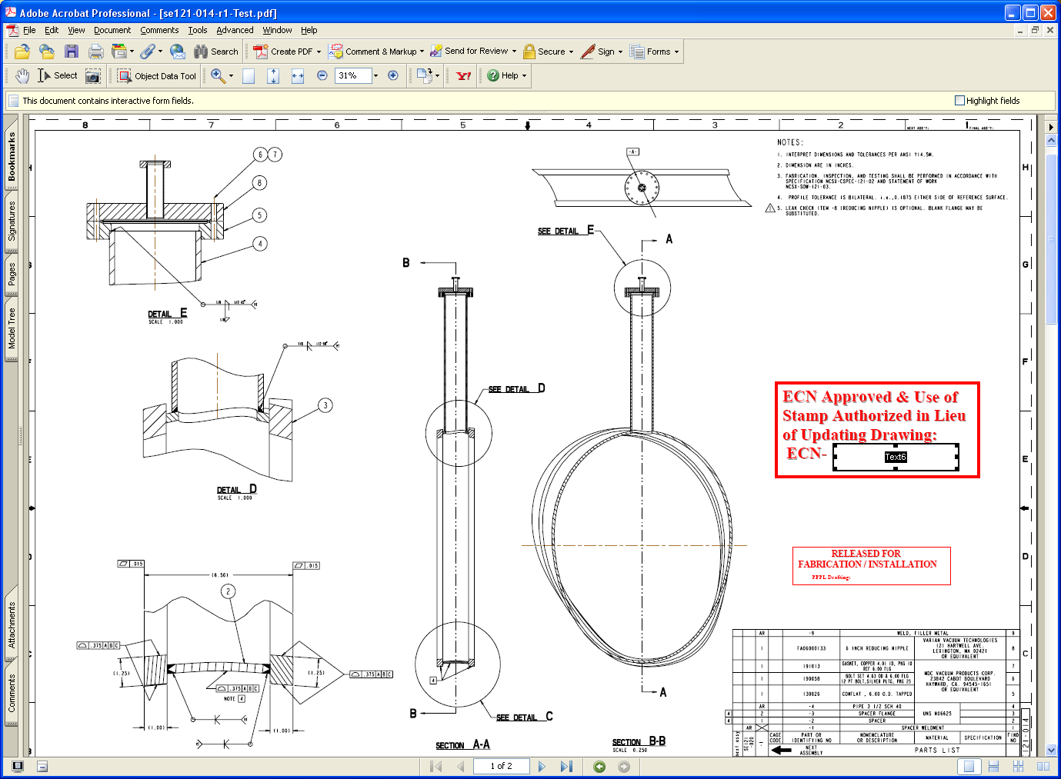

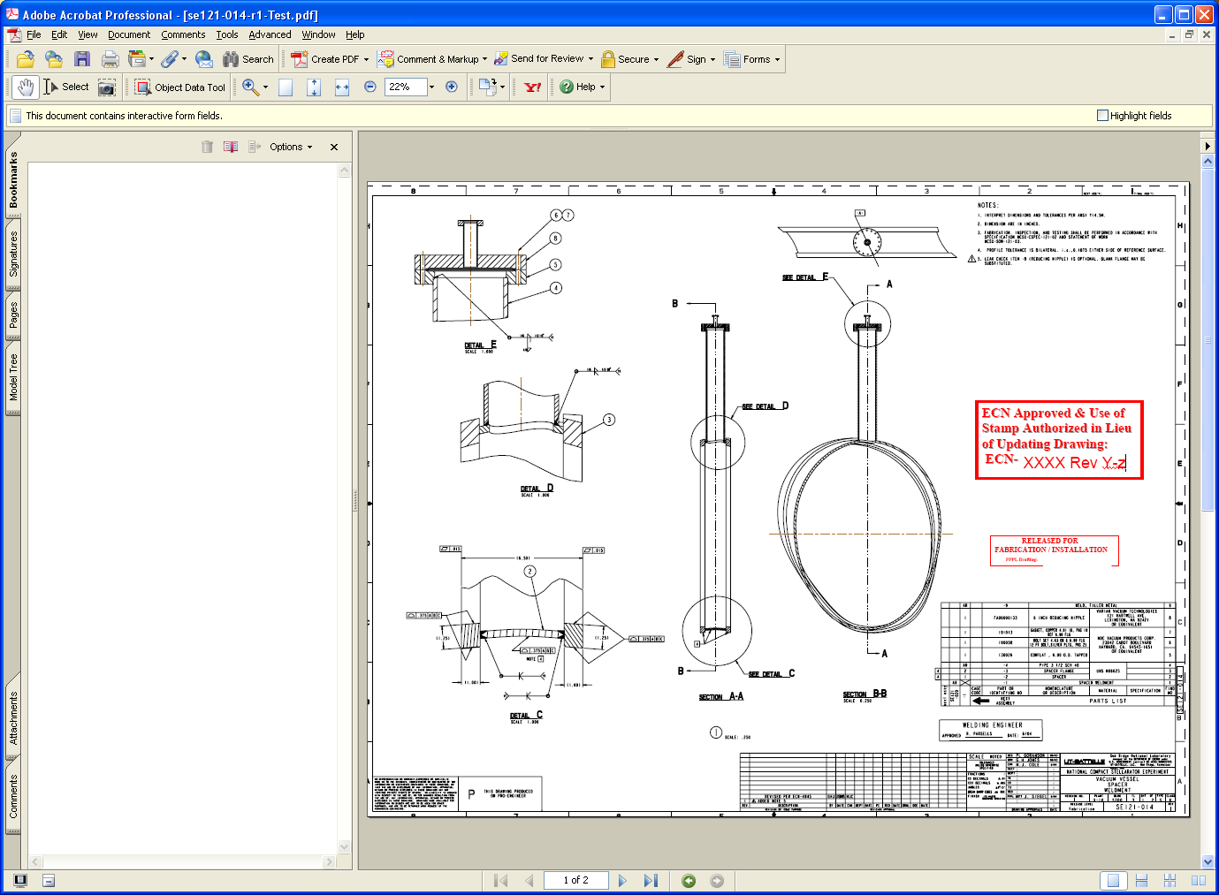

- Save drawing with Rev and stamp letter shown in title.

- Restore Security to Password Security and complete necessary password and printing and signing options. You select the password in the “Change Permissions Passwords” section, select “High Resolution” printing option, and “Filling in form fields and signing existing signature fields” option, and check “Enable copying of text, images, and other content” => this will permit copying and permit signing.

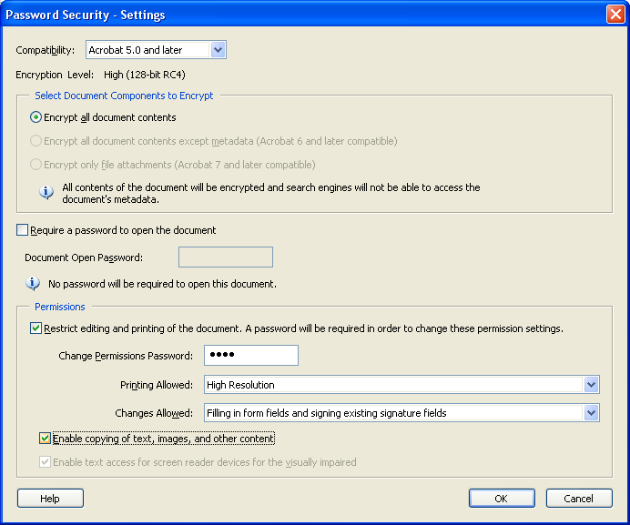

- Confirm Permissions Password and check “OK” => select “OK” again, and the again

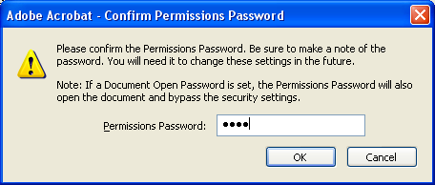
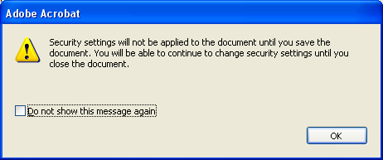

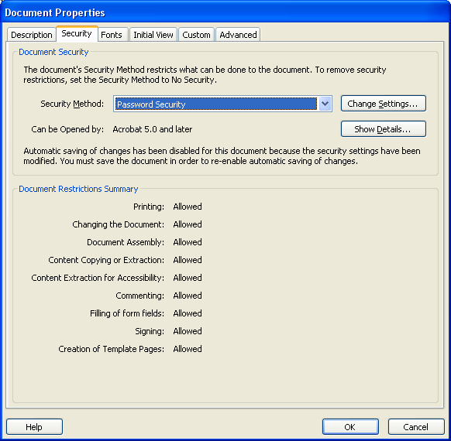

- Save drawing, assigning a letter revision (e.g., “SE186-306-r0-b” where “b” is the letter revision.

- Post drawing on PPPL Engineering Department Web that lists all the drawings.

- Repeat process for next ECN

