PPPL ENGINEERING CHANGE NOTICE (ECN) ECN # 5140R1

COGNIZANT INDIVIDUAL: Dave Williamson

ECN TITLE: Changes to Modular Coil Lead Area Design

ASSOCIATED ECP: None

CC/WP/Job: 9450-1***-1451 AREA OR PROJECT: NCSX

LIMITATION OF SCOPE - NOTE: A Work Planning Form is NOT required if the total change to be accomplished (ENG-032):
- Is not large or complex or does not represent a new installation into a usable space
- Does not have a significant ES&H impact
- Does not involve tritium or other radioactive contaminated or activated equipment
- Does not impact multiple projects, systems, or groups
OR does not change the scope or intent of the original design.

Responsible Line Manager CONCURRENCE: __________________________________
(Signature indicates that no Work Planning form is required.)

If non-concurrence or associated with a work planning form, enter the WP Number:

Description of Changes

No. | Drawing | Rev | Sht | Zone | Change Description
1 | SE140-101 | 0 | 1 | G2 | Add a general note that leads area shall be covered or sprayed with an insulating material to prevent debris from causing an electrical short during operation
2 | SE140-101 | 0 | 2 | E5 | Studs for busbar connection shall be electrically connected to one pole by eliminating the insulating washers
3 | SE140-102 | 0 | 1 | G2 | Add a general note that leads area shall be covered or sprayed with an insulating material to prevent debris from causing an electrical short during operation
4 | SE140-102 | 0 | 2 | E5 | Studs for busbar connection shall be electrically connected to one pole by eliminating the insulating washers
5 | SE140-103 | 0 | 1 | G2 | Add a general note that leads area shall be covered or sprayed with an insulating material to prevent debris from causing an electrical short during operation
6 | SE140-103 | 0 | 2 | E5 | Studs for busbar connection shall be electrically connected to one pole by eliminating the insulating washers
PPPL ENGINEERING CHANGE NOTICE (ECN) ECN # 5140R1

No. | Drawing | Rev | Sht | Zone | Change Description
7 | SE141-101 | 4 | 2 | D5 | Make poloidal break shim and studs electrically connected to winding form
8 | SE141-102 | 4 | 2 | D5 | Make poloidal break shim and studs electrically connected to winding form
9 | SE141-103 | 4 | 2 | D5 | Make poloidal break shim and studs electrically connected to winding form
10 | SE142A-080 | 0 | 1 | F4 | Modify long-fingered chill plate
11 | SE142A-242 | 1 | 1 | B1 | Add UNS C11000 ETP material per RFD-14-021
12 | SE142A-242 | 1 | 1 | G2 | Add general note that indicated parts are to be made of NEMA Grade G-11CR
13 | SE142A-242 | 1 | 2 | E2 | Remove long fingers to prevent possible insulation damage
14 | SE142A-242 | 1 | 2 | E2 | Change material to G11 to avoid conductive parts that are electrically floating
15 | SE142A-252 | 1 | 1 | B1 | Add UNS C11000 ETP material per RFD-14-021
16 | SE142A-252 | 1 | 1 | G2 | Add general note that indicated parts are to be made of NEMA Grade G-11CR
17 | SE142A-252 | 1 | 2 | E7 | Remove long fingers to prevent possible insulation damage
18 | SE142A-252 | 1 | 2 | E7 | Change material to G11 to avoid conductive parts that are electrically floating
19 | SE142B-080 | 0 | 1 | F4 | Modify long-fingered chill plate
20 | SE142B-184 | 0 | 1 | E4 | Remove center rib to prevent possible insulation damage during assembly
21 | SE142B-242 | 1 | 1 | G2 | Add general note that indicated parts are to be made of NEMA Grade G-11CR
22 | SE142B-242 | 1 | 2 | E2 | Remove long fingers to prevent possible insulation damage
23 | SE142B-242 | 1 | 2 | D2 | Change material to G11 to avoid conductive parts that are electrically floating
24 | SE142B-252 | 2 | 1 | G2 | Add general note that indicated parts are to be made of NEMA Grade G-11CR
25 | SE142B-252 | 2 | 2 | E7 | Remove long fingers to prevent possible insulation damage
26 | SE142B-252 | 2 | 2 | D7 | Change material to G11 to avoid conductive parts that are electrically floating
27 | SE142C-047 | 1 | 1 | D8 | Change model to match Keensert hole callout
28 | SE142C-050 | 1 | 1 | F2 | Add note- use minimal force during asm
PPPL ENGINEERING CHANGE NOTICE (ECN) ECN # 5140R1
No. | Drawing | Rev | Sht | Zone | Change Description
29 | SE142C-050 | 1 | 1 | F5 | Add kapton strip to cover head of block mounting fasteners (6X)
30 | SE142C-050 | 1 | 1 | G4 | Add insulator and stud electrical connector (new part) to the jumpers assembly
31 | SE142C-050 | 1 | 1 | G4 | Add insulating plug to bottom of stud holes in part SE142C-047
32 | SE142C-050 | 1 | 1 | F5 | Add Kapton barrier between busbar connection and studs attachment to winding form
33 | SE142C-050 | 1 | 2 | D5 | Reverse flat/belleville washers to give more room for protruding shoulder on -059
34 | SE142C-051 | 1 | 1 | C6 | Add 5/32 thru hole for solder bleed out
35 | SE142C-051 | 1 | 1 | B1 | Add UNS C10100 material per RFD 14-007
36 | SE142C-052 | 1 | 1 | C6 | Add 5/32 thru hole for solder bleed out
37 | SE142C-052 | 1 | 1 | B1 | Add UNS C10100 material per RFD 14-007
38 | SE142C-053 | 1 | 1 | C6 | Add 5/32 thru hole for solder bleed out
39 | SE142C-053 | 1 | 1 | B1 | Add UNS C10100 material per RFD 14-007
40 | SE142C-054 | 1 | 1 | C6 | Add 5/32 thru hole for solder bleed out
41 | SE142C-054 | 1 | 1 | B1 | Add UNS C10100 material per RFD 14-007
42 | SE142C-055 | 1 | 1 | C4 | Add 5/32 thru hole for solder bleed out (4X)
43 | SE142C-055 | 1 | 1 | F4 | Add perpendicularity between tapered hole and nut mating surface
44 | SE142C-056 | 1 | 1 | C7 | Add 5/32 thru hole for solder bleed out (4X)
45 | SE142C-056 | 1 | 1 | F7 | Add perpendicularity between tapered hole and nut mating surface
46 | SE142C-059 | 2 | 1 | C5 | Cut taper back 1/8-in to prevent nut from bearing on shoulder
47 | SE142C-059 | 2 | 1 | C5 | Add note- lap tapered surface
48 | SE142C-059 | 2 | 1 | C7 | Add note- use minimal force during asm
49 | SE142C-080 | 1 | 1 | F4 | Modify long-fingered chill plate
50 | SE142C-184 | 1 | 1 | E4 | Reduce size of center rib and chamfer edges to prevent possible insulation pinch
51 | SE142C-203 | 1 | 1 | B1 | Add UNS C11000 ETP material per RFD-14-021
PPPL ENGINEERING CHANGE NOTICE (ECN) ECN # 5140R1
No. | Drawing | Rev | Sht | Zone | Change Description
52 | SE142C-203 | 1 | 1 | F6 | Remove long fingers to prevent possible insulation damage
53 | SE142C-382 | 1 | 1 | B1 | Add UNS C11000 ETP material per RFD-14-021
54 | SE142C-382 | 1 | 1 | G2 | Add general note that indicated parts are to be made of NEMA Grade G-11CR
55 | SE142C-382 | 1 | 2 | G7 | Change material to G11 to avoid conductive parts that are electrically floating
56 | SE142C-384 | 1 | 1 | B1 | Add UNS C11000 ETP material per RFD-14-021
57 | SE142C-384 | 1 | 1 | G2 | Add general note that indicated parts are to be made of NEMA Grade G-11CR
58 | SE142C-384 | 1 | 2 | G7 | Change material to G11 to avoid conductive parts that are electrically floating
59 | SE142C-386 | 1 | 1 | B1 | Add UNS C11000 ETP material per RFD-14-021
60 | SE142C-386 | 1 | 1 | G2 | Add general note that indicated parts are to be made of NEMA Grade G-11CR
61 | SE142C-386 | 1 | 2 | G7 | Change material to G11 to avoid conductive parts that are electrically floating
62 | SE142C-388 | 2 | 1 | B1 | Add UNS C11000 ETP material per RFD-14-021
63 | SE142C-388 | 2 | 1 | G2 | Add general note that indicated parts are to be made of NEMA Grade G-11CR
64 | SE142C-388 | 2 | 2 | G7 | Change material to G11 to avoid conductive parts that are electrically floating
65 | SE142C-482 | 1 | 1 | B1 | Add UNS C11000 ETP material per RFD-14-021
66 | SE142C-482 | 1 | 1 | G2 | Add general note that indicated parts are to be made of NEMA Grade G-11CR
67 | SE142C-482 | 1 | 2 | G7 | Change material to G11 to avoid conductive parts that are electrically floating
68 | SE142C-484 | 1 | 1 | B1 | Add UNS C11000 ETP material per RFD-14-021
69 | SE142C-484 | 1 | 1 | G2 | Add general note that indicated parts are to be made of NEMA Grade G-11CR
70 | SE142C-484 | 1 | 2 | G7 | Change material to G11 to avoid conductive parts that are electrically floating
71 | SE142C-486 | 1 | 1 | B1 | Add UNS C11000 ETP material per RFD-14-021
72 | SE142C-486 | 1 | 1 | G2 | Add general note that indicated parts are to be made of NEMA Grade G-11CR
73 | SE142C-486 | 1 | 2 | G7 | Change material to G11 to avoid conductive parts that are electrically floating
PPPL ENGINEERING CHANGE NOTICE (ECN) ECN # 5140R1
No. | Drawing | Rev | Sht | Zone | Change Description
74 | SE142C-488 | 1 | 1 | B1 | Add UNS C11000 ETP material per RFD-14-021
75 | SE142C-488 | 1 | 1 | G2 | Add general note that indicated parts are to be made of NEMA Grade G-11CR
76 | SE142C-488 | 1 | 2 | G7 | Change material to G11 to avoid conductive parts that are electrically floating

DESCRIPTION OF CHANGES: (State Drawing No., Zone/Group, or List Attachments)

The purpose of these lead area design changes is to mitigate technical risks that have come to light in the course of testing the C1 Modular Coil. The following changes are proposed:

- On the top chill plate (the one with the long fingers that extend parallel to the coil) – cut off the fingers and eliminate the chill plate. (See Figure 1). This change will be implemented for the C3 and follow-on coils.
- Isolated copper cladding pieces (located on the base of the tee underneath the winding pack in the lead area, the vertical cladding pieces in the same area, and the cladding in the poloidal break area) – change the material to G-11cr. (See Figure 2). This change will be implemented starting with the C5 and follow-on coils. Note: The G-11 pieces should be made to look like the cladding (with slots) so that forming to the shape and wicking of epoxy will be that same as for other areas.
- For the power bus tie-in area, cap the attachment bolt with an epoxy seal to mitigate a potentially short tracking path.. (See Figure 3L). Thiswill be implemented on all coils.
- Presently the four bolts that connect the power bus are floating which is an undesirable condition (See Figure 3R ) - connect them to one side by eliminating the insulating washers on the other side. This will be implemented on all coils.
- The bolts that attach the G-11 base plate underneath the jumper stack – put a cover (Kapton or thin G-11 sheet) to increase the tracking distance. (See Figure 4). This will be implemented on all coils.
- For the three studs that bolt the stack of jumper plates together that are isolated – electrically tie them to one of the jumpers. (See Figure 5). Also add an insulating “plug” at the base of the hole in the G-11 base plate to reduce the risk of the studs penetrating the G-11 backing sheet to the winding form. This will be implemented on all coils.
- Entire lead assembly – manufacture a cover/box over the entire lead assembly or spray the exposed surfaces with a cryogenically compatible electrical varnish (e.g., Glyptol if cryogenically compatible) in order to prevent shorting due to metal chips, bolts, washers, etc. from falling in these areas during operation. This will be implemented on all coils.
- Improve the insulation between the cladding and the tee, especially at the tip of the tee where there is a risk of penetrating the kapton during staking – additionally use a metal backing tool (e.g., a putty knife) between the copper and kapton during the staking operation. This will serve to spread the impact load and protect the kapton. This should be implemented on the C3 and follow-on coils. This will be implemented on all coils.

PPPL ENGINEERING CHANGE NOTICE (ECN) ECN # 5140R1

DESCRIPTION OF CHANGES: (Continued)
- Tie the poloidal break shims and bolts electrically to the winding form. This will be implemented on all coils.

Revision 1 to this ECN reflects the additional design change that has come to light during the C1 repair processes. The current list of impact drawings is inclusive of both Revision 0 and Revision 1 changes and descriptions. In addition, Revision 1 to this ECN now also identifies the impacted and/or new procedures needed to implement the changes described in this ECN:
- The NCSX Procedure on Modular Coil Fabrication-Winding Station Activities (D-NCSX-MCF-002) will be revised to reflect the following changes:
  - That only hand pressure is to be used to assemble lead block and to line up bolt holes. Spring camps can be used to hold components in position but extreme care must be used to maintain light pressure only. Slotting bolt holes (up to 1/32”) on top plate can be used if necessary.
  - The requirement to remove the top plate following installation to verify condition inside lead area. A check will then be made to ensure that the chill plates are not bowed and that the chill plate tabs are not pushed together.
  - Addition of a note of caution that sealing of the lead area is extremely important for complete epoxy penetration.
  - The improved technique for bending chill plate tabs following C1 – this should pay dividends on subsequent coils.
- A new NCSX Modular Coil repair procedure (D-NCSX-RP-STEL-058) will be written for these repairs to address the following elements:
  - Rotate coils on end so that box is facing upward;
  - New lift procedure required.
  - Machine lead box lid to remove rib. (Dry fit lid)
  - The C3 lid will require machining to provide adequate space for the copper lead conductor which is known to be oversized.
  - Paint epoxy on torn glass and resin starved areas. Do a wet lay up of glass and epoxy. (CTD 540 Rm Temperature Cure)
  - Perform bench tests prior to writing procedure to determine if preheating is necessary and if wetting is OK.
  - Megger – requirement is for Insulation Resistance = (15K Meg @ 7.5KV).
- The NCSX Modular Coil Winding Form Lift Procedure (D-L-NCSX-983) will be revised to rotate the C1 and C3 coils to the correct position (i.e., so that the lead box is facing upwards)

PPPL ENGINEERING CHANGE NOTICE (ECN) ECN # 5140R1

ENGINEERING CHANGE PROPOSAL: N/A DATE: July 24, 2006

COGNIZANT INDIVIDUAL MAKING THE CHANGE:

RESONSIBLE LINE MANAGER (Design):

RESONSIBLE LINE MANAGER (Fabrication):

Figure 1

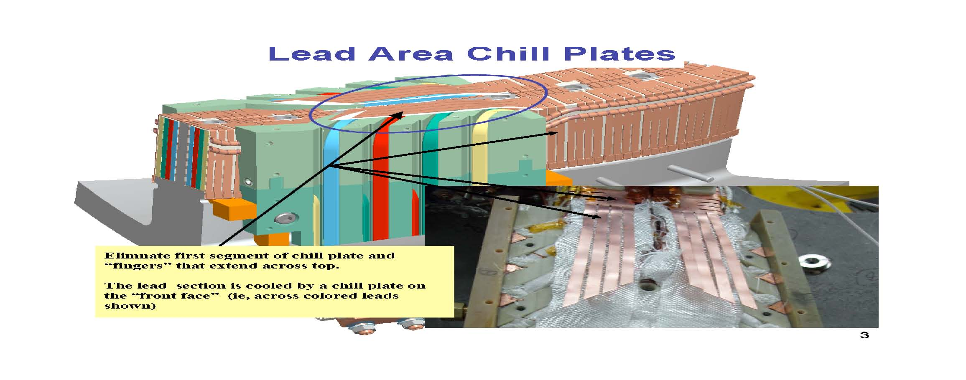

PPPL ENGINEERING CHANGE NOTICE (ECN) ECN # 5140R1

Figure 2

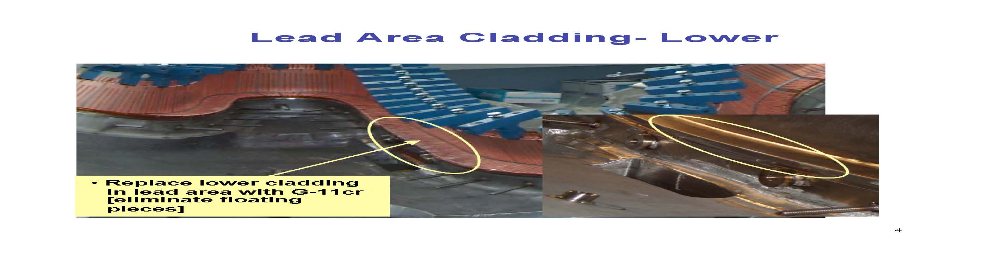

Figure 3

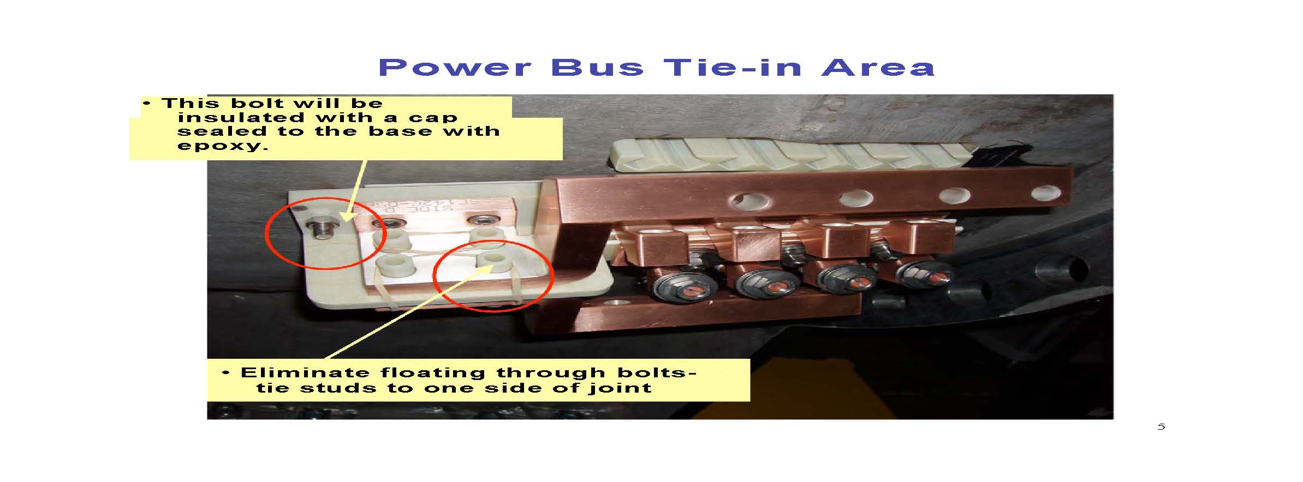

PPPL ENGINEERING CHANGE NOTICE (ECN) ECN # 5140R1

Figure 4
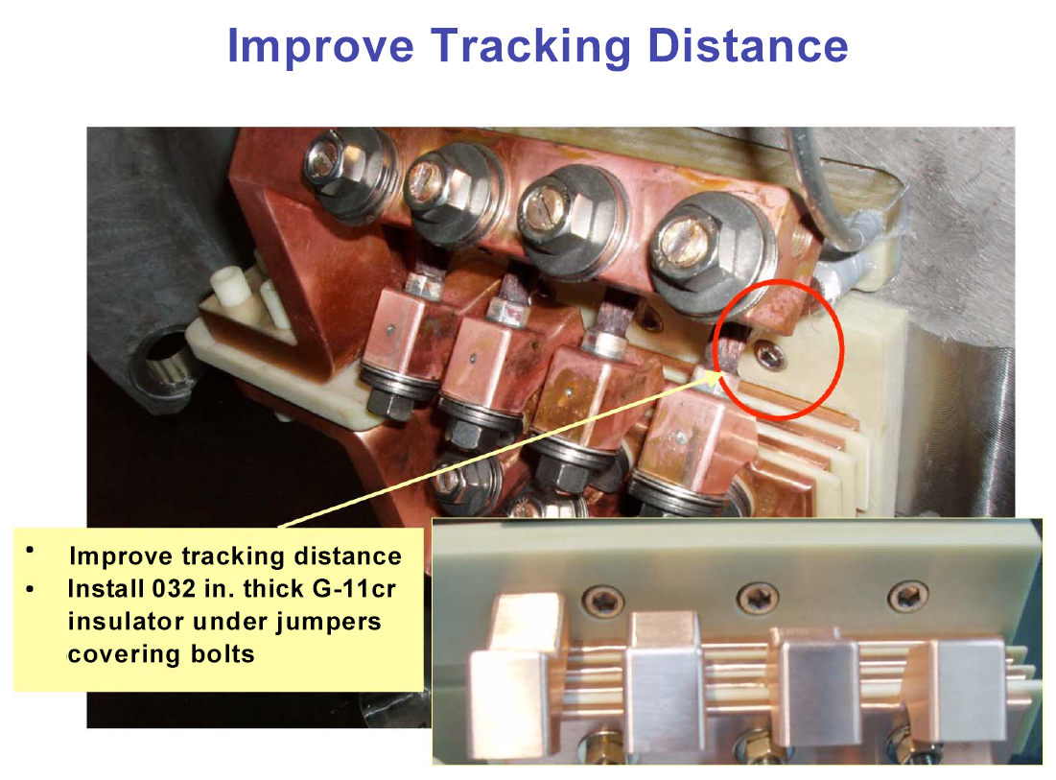
Improve tracking distance to attachment bolt heads by inserting G-11 CR or Kapton sheets under jumpers which would cover the bolt heads.

Figure 5


