Attachment [1] – Detailed Description of Change

Modular Coil Winding Form (MCWF) Procurement (WBS 141)
The NCSX project recently received two fixed-price and-schedule proposals for fabricating the production winding forms. The scope of work included casting seventeen winding forms and machining eighteen. A pre-production casting being fabricated under the current manufacturing development and prototype fabrication contract will be machined under the production contract and used as the first winding form.
We are in final negotiations with the successful offerer. The price for the production winding forms is $8.0M. Assuming a contract start date of 15 September 2004, the first winding form would be delivered on or before 13 May 2005, with subsequent winding forms being delivered every 4 weeks thereafter. The last winding form would be received on or before 14 September 2006. Payments would be made monthly between 15 October 2004 and 15 September 2006.
Work on the prototype winding forms has been stopped by both suppliers, saving $118K and $196K respectively.
Pre-production casting activities (added scope per ECP-04-008) were initiated by the two MCWF suppliers, but have now been stopped by the supplier which was unsuccessful in the production procurement. The initial cost estimates for the pre-production castings were based on using the same pattern process that was used for the prototype. The successful supplier has identified the need to change the pattern design, moving from foam patterns to hard (wood) patterns because of the heavier than anticipated weight of the casting. The wood patterns are re-usable, which is advantageous, but they cost more and require more time to fabricate. The fixed price proposal was predicated on using a hard Type C pattern produced as part of the pre-production casting activities. It is estimated that an additional $329K will be required to complete the pre-production casting activities with the successful supplier and an additional $20K will be required to close out pre-production casting activities with the other supplier.
The budgeted contract cost for the MCWF fabrication procurement was $4.8M. The budgeted cost and schedule were derived from input from both suppliers participating in the Manufacturing Development and Prototype Fabrication phase. The contract was scheduled to run from 01 October 2004 through 24 April 2006. The first winding form would arrive on 20 January 2005. The last winding form would be received by 24 April 2006.
The impacts of the actual proposal which has been accepted are clear:
- Cost increase. A contract cost increase of $3.2M.
- Schedule delays. A delay in receiving the first winding form of 16 weeks. A delay in receiving the last winding form of 20 weeks. These delays impact the critical path of the project.
- Funding constraints. The increase in the required BA for the winding forms requires that other activities be postponed to make funding available for these critical path activities.
Vacuum Vessel Sub-assembly Procurement (WBS 121)
The NCSX project also received two fixed-price and -schedule proposals for fabricating the vacuum vessel sub-assemblies (VVSAs). We are in final negotiations with the successful offerer. The price for the production VVSAs is $4.5M. Assuming a contract start date of 15 September 2004, the three VVSAs would be delivered in the period from 20 September 2005 through 10 November 2005. Payments would be made as major steps in the work are completed. All but perhaps fabrication and receipt of the 3rd VVSA and receipt of the tooling would be billed in FY05 with the balance being billed in the very first part of FY06.
The budgeted direct cost for this procurement was $3.0M, including a budget for additional ports added in ECP-04-008. The budgeted cost and schedule was derived from input from both suppliers participating in the Manufacturing Development and Prototype Fabrication phase. The proposed schedule was consistent with the baseline schedule. However, the required BA is significantly higher than the planned BA.
The impacts of this proposal are clear:
- Cost increase. A contract cost increase of $1.5M.
- Funding constraints. The increase in the required BA for the VVSAs requires accommodation.
The project has developed offsets to mitigate the cost increase in both the MCWF and VVSA fabrication, and to accommodate the schedule stretchout in the MCWF fabrication.

Modular Coil Winding (WBS 142)
One of the recognized schedule risks in winding the modular coils is that the application of the chill plates and cooling tubes might take longer than the schedule would allow. This risk has been mitigated by changing Station 4 into a winding station. Station 4 previously was used to apply the chill plates, cooling tubes, and to prepare the winding for VPI. Now that work will be done on the three winding stations, improving efficiency and schedule robustness. Winding of the last six coils will be done on a two-shift basis to mitigate the schedule impact of the delayed production of the winding forms. The figure below illustrates the new flow with three winding stations. The net cost increase in WBS 142 is $99K.
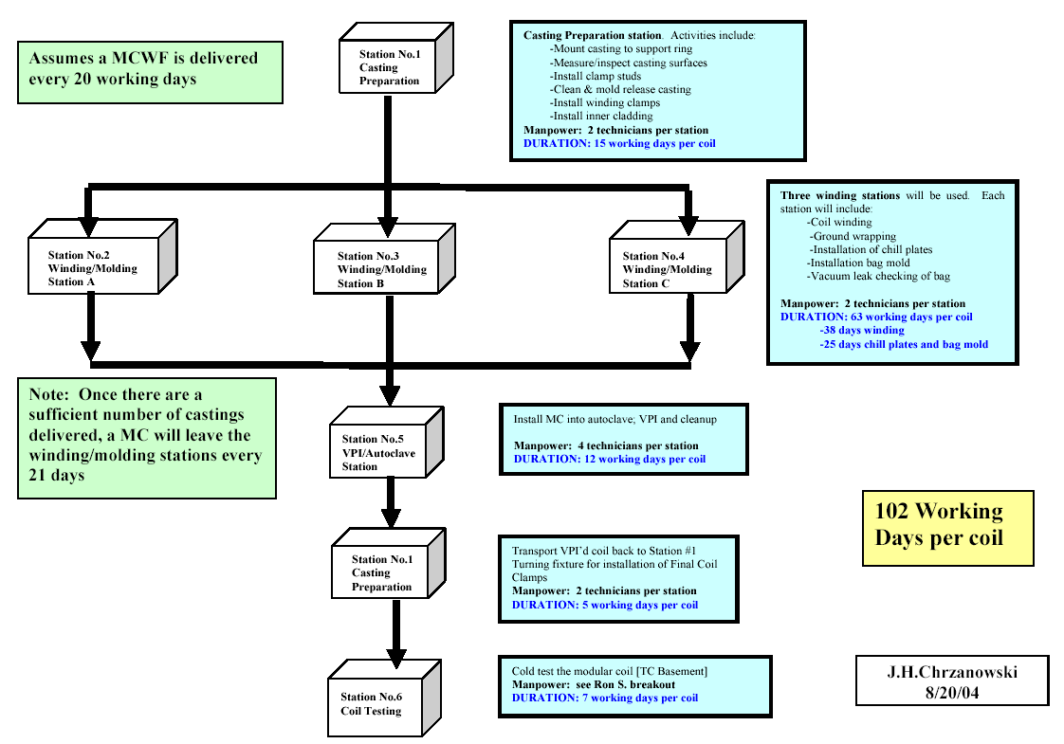

VV Outer Port Extensions and NB Transition Ducts (WBS 121)
The VVSA design features an Inconel shell with Inconel port extensions that are welded on during field period assembly. The port extensions extend through the modular coil shell and have vacuum flanges at the ends. Outer port extensions, made of stainless steel, will be attached at these flanges to extend the ports through the cryostat. For initial operation, there are no diagnostics which use these outer port extensions so they were removed from the MIE project scope. Likewise, the three NB transition ducts are not required for initial operation and were removed from the MIE project scope. The vacuum pumping system, which will ultimately be connected to a NB transition duct, can be connected to one of the vertical ports or to the large port adjacent to the NB transition duct for initial operation. Elimination of the outer port extensions and NB transition ducts from the MIE project will save $250K.
Modular Coil Winding From Title III Engineering (WBS 141)
Title III Engineering costs were reduced to levels more in line with our experience during the Manufacturing Development and Prototype Fabrication phase saving an estimated $150K.
Laser-based GPS (WBS 187)
The laser-based GPS was eliminated saving $128K. Metrology needs can be satisfied using two multi-link coordinate measurement machines (Romer arms) and one Leica laser tracker.
Neutral Beams (WBS 25)
The NB equipment tests required for CD-4 will be satisfied by the end of FY-04. The equipment has been shown to be in good condition. Remaining project tasks would make progress toward full operation, but not provide any capability required for CD-4. These remaining tasks have been eliminated saving $860K.
Diagnostic Integration (WBS 39) and Project Physics (WBS 84)
Many ports were added prior to the VVSA FDR, satisfying the MIE diagnostic interface goals and ensuring that required upgrade diagnostics can be accommodated. The budget has been reduced by $481K in Diagnostics Integration (WBS 39) and by $96K in Project Physics (WBS 84).
Edge and Divertor Diagnostic Systems (WBS 36)
An existing camera required for First Plasma will be used, saving $56K.
Electrical Power System (WBS 4)
CD-4 coil power requirements will be satisfied using C-site equipment. All remaining work associated with the D-Site power supplies, including the DC transmission from D- to C-site, has been deleted from the MIE scope. Assignment of the power supplies for each coil and the available voltage and current are shown in the table below.

Coil | Max.Voltage (Volts) | Max. Current (kiloAmps) | Assigned Power Supply
M1, M2, M3 in series | 500 | 20 | R20
TF | 300 | 5 | R5-1
PF1, PF2 in series | 550 | 5 | R5-2 &3 in series
PF3 | 300 | 5 | R5-4
PF4 | 500 | 5 | UCLA
PF5 |  |  | Not required for First Plasma
PF6 | 100 | 10 | R10

Each of the above seven rectifier supplies presently installed in C-Site will be cabled up to the NCSX coils listed above. Protection for the coil system will be designed and installed in C-Site. A redundant PLC system will be designed and installed to provide hardwired controls for the rectifiers. Net saving in WBS 4 in changing to the C-site power supplies are estimated to be $1624K.
Plasma Control (WBS 5)
CD-4 control requirements can be satisfied with a more basic I&C system. This approach sacrifices convenience, but provides essential control and protection. Some savings were also realized as a result of NSTX developments. Net savings in WBS 5 from adopting this approach are estimated to be $391K.
Cryogenic Cooling Supply (WBS 622)
The baseline NCSX cryogenic cooling design provides liquid cryogen transfer lines from the existing 9200 gallon tank to the NCSX device. Also planned was a sub-cooled single phase (all liquid) cooling circuit for the NCSX field windings. A simplified representation of such a system is shown in the figure. Key points are that the expansion volume maintains the minimum system (pump suction) pressure above the saturation pressure (boiling point) associated with the warmest points in the windings: The system stays in the liquid phase. The single phase aspect of the system coupled with redundant pumps (less mechanical downtime) yields a design that supports the heat rejection rate requirements at full machine performance. A final notable feature is that the heat exchanger for the liquid circuit is cooled by boiling atmospheric pressure liquid nitrogen whose off-gas is used to cool the machine cryostat.

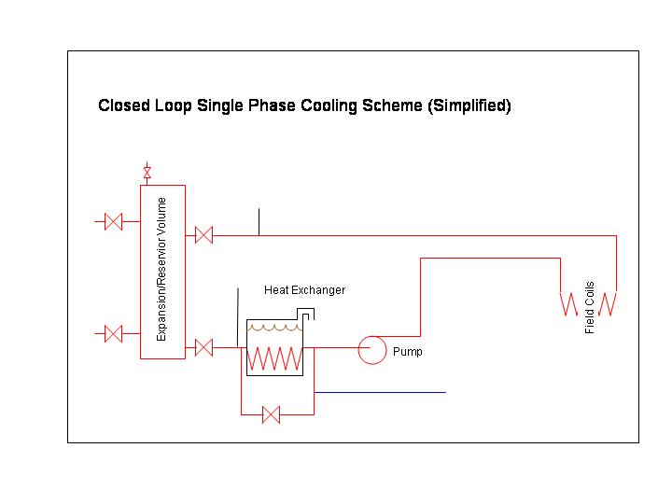

To meet CD-4 requirements, a simplified single phase approach is proposed that will cool the NCSX windings with liquid nitrogen that is prevented from boiling in the cooling circuits by an appropriate back-pressure valve and control scheme (see figure below). The back-pressure can be maintained at a useful level that remains less that the supply pressure from the 9200 gallon storage tank: The differential pressure between the tank and the back-pressure control drives flow through the winding’s coolant passages. This low-cost design will allow enough heat rejection capacity to support recently-issued first plasma and field line mapping scenarios. A further cost-saving measure in this proposal is the substitution of less-thermally efficient urethane foam-insulated lines for the vacuum insulated lines mentioned above.
These changes will provide a net cost savings of $274K in WBS 622.

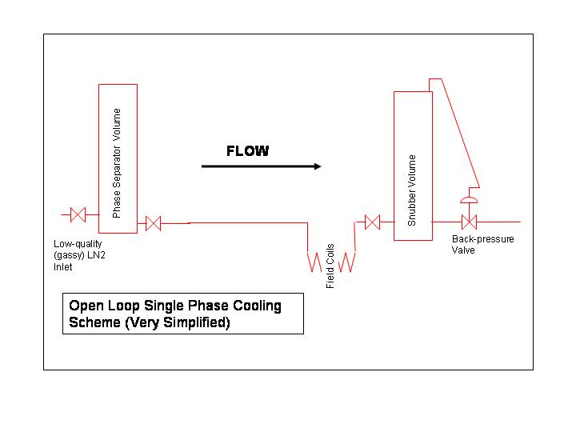
Vacuum Vessel Heating/Cooling System (WBS 64)
The VV heating/cooling system has been eliminated from the MIE project. Eddy current heating techniques that have been used in the past on tokamaks, will be used to heat the vacuum vessel to 150C for bakeout. Eliminating the VV heating/cooling system should save $629K.
Project Management (WBS 81) and Project Engineering (WBS 82)
Management costs were reviewed and adjusted based on past experience and projected needs. Hours were added for project control functions. Hours were reduced for project management, engineering management, and systems engineering to reflect reduced MIE scope in systems outside the stellarator core. The result of these changes was a net cost reduction of $507K.
Startup (WBS 85)
The revised startup testing schedule completes the final CD-4 tests in two months, recouping most of the schedule impact from the late delivery of the modular coil winding forms. E-beam mapping will be limited to confirming that the basic magnet system produces magnetic surfaces. Coil and power supply tests and First Plasma will be performed at cryogenic temperature. The startup period was reduced by moving tasks (e.g., cryostat installation, close out “punch list” of construction items, and the ACC safety assessment) formerly in the startup phase forward into the construction phase and revising the logic such that some tasks were taken off the critical path and will instead be performed in parallel with critical-path tasks. Cryostat installation will occur during the construction phase. E-beam mapping will be performed only at cryogenic temperature. Although there are substantial schedule benefits with this approach, the required budget for WBS 85 went down by only $5K.

