NATIONAL COMPACT STELLARATOR PROJECT
Engineering Change Proposal (ECP)
COVER PAGE
(TO BE COMPLETED BY SYSTEMS ENGINEERING SUPPORT MANAGER)
Originator: Bob Simmons |  |  | Date: January 25, 2005
ECP No: 019 |  | ECP Title: VVSA Contract Addenda 3-1, 3-2, and 3-3
Required Reviewers
Required Reviewers for this ECP:
W. Reiersen
ECP Approval Level
Expedited ECP? Yes No
Change Level:
Approving Official:
Actions
Revise Specification (NCSX-CSPEC-121-02) and identified drawings and models as per the attached VVSA Subcontract S005243-F Addenda Number 3-1 (December 3, 2004), Number 3-2 (December 21, 2004), and Number 3-3 (January 25, 2005) and ECN-4945.

These items should be revised by March 1, 2005.
APPROVALS
(TO BE COMPLETED BY APPROVING OFFICIALS)
Change Level | Approving Official |  | Approval? | Signature
3 | NCSX Project Manager |  | Yes No
3a  (Expedited ECP) | NCSX Engineering Manager |  | Yes No
2 | NCSX Federal Project Director |  | Yes No
1 | Associate Director OFES |  | Yes No
0 | Under Secretary of Energy |  | Yes No

NATIONAL COMPACT STELLARATOR PROJECT
Engineering Change Proposal (ECP)
PART I
(TO BE COMPLETED BY ORIGINATOR)
Originator: | Date:
Overview of Change

Type of of ECP: EXPEDITED STANDARD

Type of Change: TECHNICAL COST SCHEDULE EDITORIAL

(Check all that Apply)

Reason for Change: Supplier and PPPL identified several issues requiring clarification and/or revision to expeditiously change the contract documentation to preclude unnecessary delays and cost/schedule growth. These changes were processed in accordance with the NCSX Procedure 002 (NCSX-PROC-002-01) on Configuration Control. This expedited ECP captures those “rapid response” changes.

Impacted WBS Elements: WBS 121

Impacts of Change (Briefly Describe): Subcontract Addenda 3-1, 3-2, and 3-3 (attached) provide the details. ECN 4945 details the changes to the models and drawings. Specification NCSX-CSPEC-121-02 will have to be revised also.

Assessment of Other Options: None. Processing a normal ECP had the potential to adversely impact the technical, cost, and schedule performance of this subcontract.

Attachments:

- VVSA Contract Addendum 3-1
- VVSA Contract Addendum 3-2
- VVSA Contract Addendum 3-3
- ECN-4945

VVSA Contract Addendum 3-1
\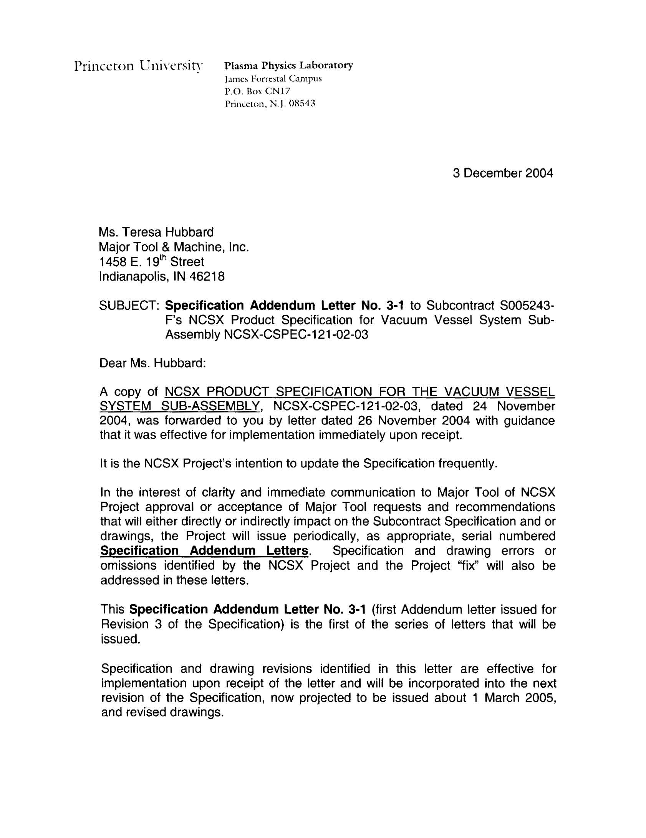
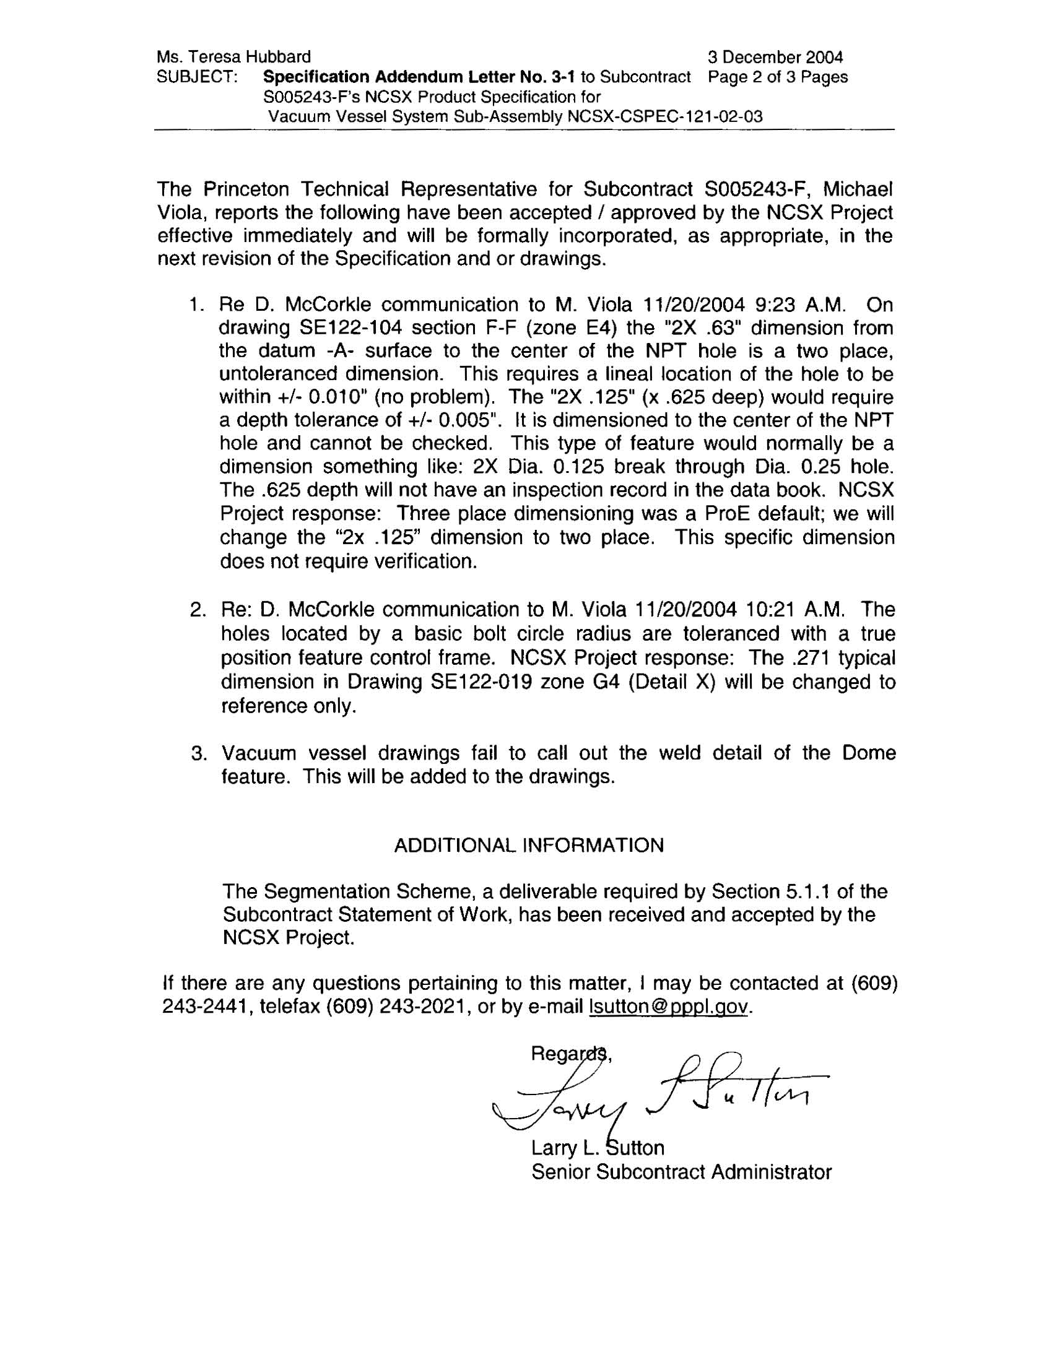

VVSA Contract Addendum 3-2
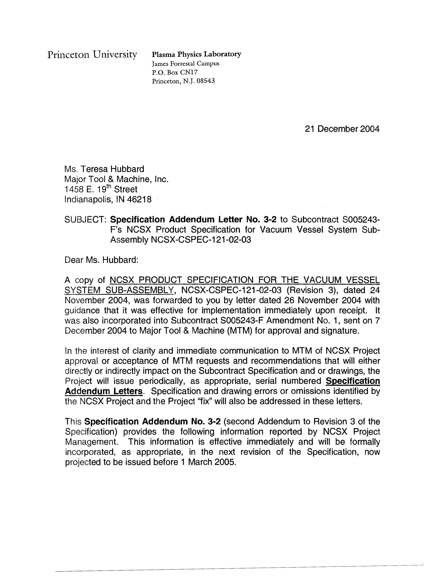

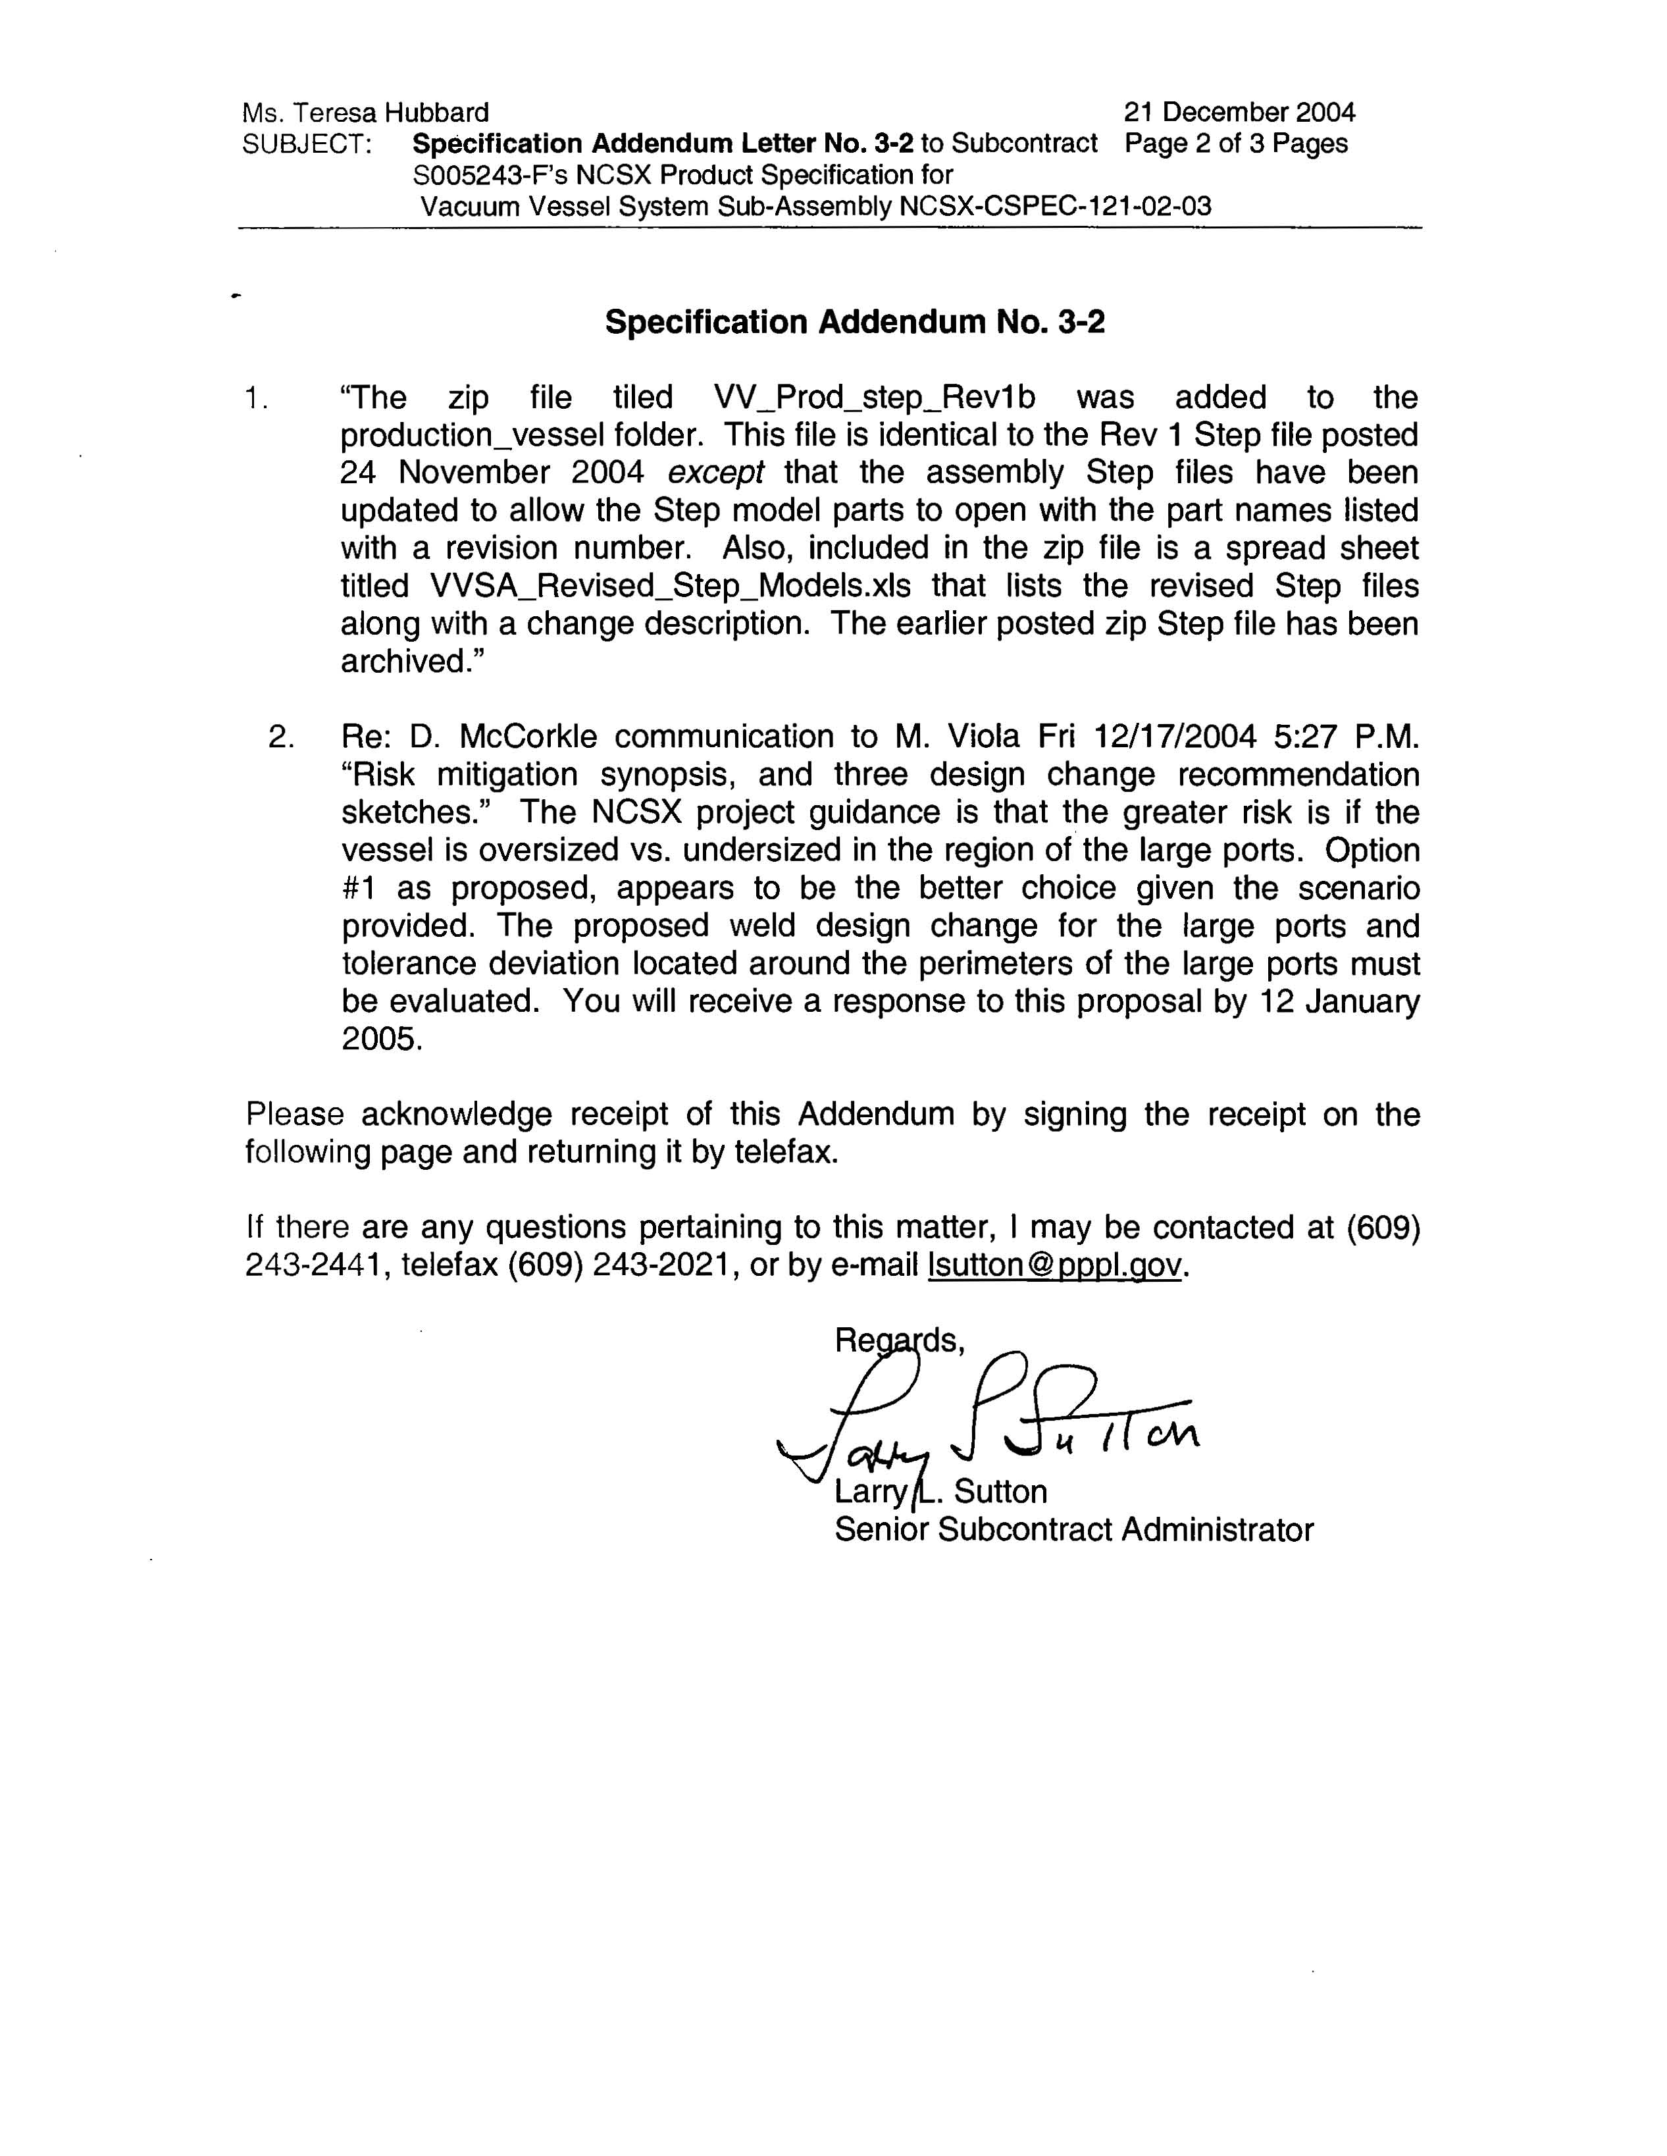

VVSA Contract Addendum 3-3



