NCSX
Specification

System Requirements Document (SRD)
For the
Modular Coil System (WBS 14)

NCSX-BSPEC-14-01

Revision 1

17 November 2005

Prepared by: __________________________________________________________________________
D. Williamson, Modular Coil System (WBS 14) Manager

Concur: ______________________________________________________________________________
P. Heitzenroeder, Technical Representative for MCWF (WBS 141) Procurement

Concur: ______________________________________________________________________________
J. Chrzanowski, Coil Manufacturing Facility Manager

Concur: ______________________________________________________________________________
B. Nelson, RLM for Stellarator Core Systems (WBS 1) Design and Procurement

Concur: ______________________________________________________________________________
L. Dudek, RLM for On-site Fabrication

Concur: ______________________________________________________________________________
M. Zarnstorff, Head, Project Physics

Concur: ______________________________________________________________________________
J. Levine, ES&H

Concur: ______________________________________________________________________________
J. Malsbury, Quality Assurance

Concur: ______________________________________________________________________________
W. Reiersen, Engineering Manager

Approved by: _________________________________________________________________________
G. H. Neilson, NCSX Project Manager

Controlled Document
This is a controlled document. Check the NCSX Engineering Web prior to use to assure that this document is current.
Record of Revisions

Revision | Date | ECP | Description of Change
Rev. 0 | 5/27/2005 | - | Initial issue.
Rev. 1 | 11/17/2005 |  | Revised Appendix A _ Quality Conformance Matrix to identify how and when verification would take place  Changed the applied voltage for the toroidal break from 6V to 150V to withstand instantaneous disruptions should they occur (ref. Section 3.2.1.2.5.1.1)

Table of Contents
1 Scope 1
1.1 Document Overview 1
1.2 Incomplete and Tentative Requirements 1
2 Applicable Documents 2
2.1 NCSX Documents 2
3 Subsystem Requirements 3
3.1 Subsystem Definition 3
3.1.1 Subsystem Diagrams 3
3.1.1.1 Functional Relationships 3
3.1.1.2 Functional Flow Block Diagram 5
3.1.2 Interface definition 5
3.1.2.1 Vacuum Vessel (WBS 12) 5
3.1.2.2 Conventional Coils (WBS 13) 6
3.1.2.3 Modular Coil Winding Facility and Fixtures (WBS 144) 6
3.1.2.4 Coil Support Structures (WBS 15) 6
3.1.2.5 LN2 Distribution System (WBS 161) 6
3.1.2.6 Electrical Leads (WBS 162) 6
3.1.2.7 Coil Protection System (WBS 163) 6
3.1.2.8 Cryostat (WBS 171) 6
3.1.2.9 Field Period Assembly (WBS 18) 6
3.1.2.10 Magnetic Diagnostics (WBS 31) 7
3.1.2.11 Electrical Power Systems (WBS 4) 7
3.1.2.12 Central I&C (WBS 5) 7
3.1.2.13 Cryogenic Systems (WBS 62) 7
3.1.2.14 Test Cell Preparations and Machine Assembly (WBS 7) 7
3.1.3 Major Component List 7
3.2 Characteristics 7
3.2.1 Performance 7
3.2.1.1 Perform Initial and Pre-run Verification 7
3.2.1.1.1 Initial Facility Startup 7
3.2.1.1.1.1 Initial Verification of Operability 8
3.2.1.1.1.2 Field Line Mapping 8
3.2.1.1.1.3 Design Verification 8
3.2.1.1.2 Pre-Run Facility Startup 8
3.2.1.2 Prepare for and Support Experimental Operations 8
3.2.1.2.1 Subsystem Verification and Monitoring 8
3.2.1.2.2 Coil Cool-down 9
3.2.1.2.2.1 Timeline for Coil Cool-down to Cryogenic Temperature 9
3.2.1.2.2.2 Cool-down and Warm-up Cycles 9
3.2.1.2.3 Bakeout 9
3.2.1.2.3.1 Coil Temperatures during Bakeout 9
3.2.1.2.3.2 Bakeout Cycles 9
3.2.1.2.4 Pre-Pulse Temperature 10
3.2.1.2.5 Field Error Requirements 10
3.2.1.2.5.1 Electrical Breaks 10
3.2.1.2.5.1.1 Toroidal Electrical Breaks 10
3.2.1.2.5.1.2 Poloidal Electrical Breaks 10
3.2.1.2.5.2 Eddy Current Time Constants 10
3.2.1.2.5.3 Stellarator Symmetry 10
3.2.1.2.5.4 Winding Tolerance 10
3.2.1.2.5.5 Deflections under Load 11
3.2.1.2.6 Plasma Magnetic Field Requirements 11
3.2.1.2.6.1 Magnetic Field Polarity 11
3.2.1.2.6.2 Reference Scenario Requirements 12
3.2.1.2.6.3 Flexibility Requirements 12
3.2.1.2.7 Pulse Repetition Rate 12
3.2.1.2.8 Discharge Termination 12
3.2.1.2.8.1 Normal Termination 12
3.2.1.2.8.2 Abnormal Termination 13
3.2.1.3 Shut Down Facility 13
3.2.1.3.1 Coil Warm-up Timeline 13
3.2.2 Physical Characteristics 13
3.2.2.1 Configuration Requirements and Essential Features 13
3.2.2.1.1 Modular Coil Winding Forms (WBS 141) 13
3.2.2.1.2 Coil Windings and Assembly (WBS 142) 13
3.2.2.1.3 Local Instrumentation and Control (WBS 143) 14
3.2.3 System Quality Factors 14
3.2.3.1 Reliability, Availability, and Maintainability 14
3.2.3.2 Design Life 15
3.2.3.3 Seismic Criteria 15
3.2.4 Transportability 15
3.3 Design and Construction 15
3.3.1 Materials, Processes, and Parts 15
3.3.1.1 Magnetic Permeability 15
3.3.1.2 Corrosion Prevention and Control 15
3.3.1.3 Metrology 16
3.3.2 Electrical Requirements 16
3.3.2.1 Electrical Grounding 16
3.3.2.2 Voltage Standoff Capability 16
3.3.3 Nameplates and Product Marking 16
3.3.3.1 Labels 16
3.3.4 Workmanship 16
3.3.5 Interchangeability 16
3.3.6 Environmental, Safety, and Health (ES&H) Requirements 17
3.3.6.1 General Safety 17
3.3.6.2 Personnel Safety 17
3.3.6.3 Flammability 17
3.4 Documentation 17
3.4.1 Specifications 17
3.5 Logistics 17
3.5.1 Maintenance 17
4 Quality Assurance Provisions 18
4.1 General 18
4.2 Verification Methods 18
4.3 Quality Conformance 18
Appendix A – Quality Conformance Matrix 19

Table of Figures
Figure 3-1 General arrangement of the modular coil system 3
Figure 3-2 Modular coil system functional relationships 4
Figure 3-3 Functional flow block diagram 5
Figure 3-4 NCSX coordinate system 11

Table of Tables
Table 3-1 Modular coil specifications 17

Scope
The National Compact Stellarator Experiment (NCSX) is an experimental research facility that is to be constructed at the Department of Energy’s Princeton Plasma Physics Laboratory (PPPL). Its mission is to acquire the physics knowledge needed to evaluate compact stellarators as a fusion concept, and to advance the understanding of 3D plasma physics for fusion and basic science.
A primary component of the facility is the stellarator core, an assembly of four coil systems that surround a highly shaped plasma and vacuum chamber. The four coil systems include the modular coils, the poloidal field (PF) coils, the toroidal field (TF) coils, and the external trim coils. These coils provide the magnetic field required for plasma shaping and position control, inductive current drive, and error field correction.

Document Overview
This document, the System Requirements Document (SRD) for the Modular Coil System (WBS 14), is the complete development specification for this subsystem excluding the Modular Coil Winding Facility and Fixtures (WBS 144), which does not include experimental systems. (Requirements for the Modular Coil Winding Facility and Fixtures (WBS 144) will be separately derived.) Performance requirements allocated to this subsystem in the system specification, the General Requirements Document (NCSX-ASPEC-GRD-01), have been incorporated in this document. In this document, the term “the system” refers to the overall device and facility and the terms “the subsystem” and “modular coils” refer to the Modular Coil System (WBS 14) excluding the Modular Coil Winding Facility and Fixtures (WBS 144).
The specification approach being used on NCSX provides for a clear distinction between performance requirements and design constraints. Performance requirements state what functions a system has to perform and how well that function has to be performed. Design constraints, on the other hand, are a set of limiting or boundary requirements that must be adhered to while allocating requirements or designing the system. They are drawn from externally imposed sources (e.g., statutory regulations, DOE Orders, and PPPL ES&H Directives) as well as from internally imposed sources as a result of prior decisions, which limit subsequent design alternatives.

Incomplete and Tentative Requirements
Within this document, the term “TBD” (to be determined) indicates that additional effort (analysis, trade studies, etc) is required to define the particular requirement. The term “TBR” (to be revised) indicates that the value given is subject to change.

Applicable Documents
The following documents form a part of this specification to the extent specified herein. In the event of a conflict, the contents of this specification shall be considered a superceding requirement.

NCSX Documents
Project Execution Plan (NCSX-PLAN-PEP-01)
General Requirements Document (NCSX-ASPEC-GRD-02)
Stellarator Core Systems (WBS 1) WBS Dictionary (NCSX-WBS1-02)
Structural and Cryogenic Design Criteria (NCSX-CRIT-CRYO-00)
Seismic Design Criteria (NCSX-CRIT-SEIS-00)
Reliability, Availability, and Maintainability (RAM) Plan (NCSX-PLAN-RAM-00)

Subsystem Requirements

Subsystem Definition
The modular coil set consists of three field periods with 6 coils per period, for a total of 18 coils. Due to symmetry, only three different coil shapes are needed to make up the complete assembly. The coils are connected electrically with three circuits in groups of six coils, according to type. Figure 3-1 shows the general arrangement of the coils and structure.
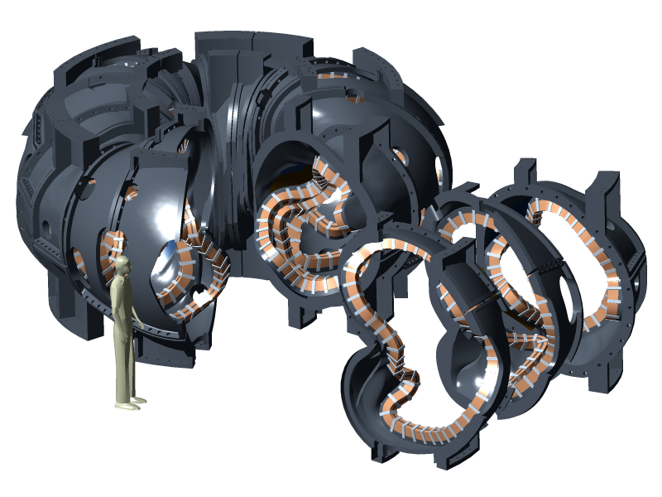
Figure 3-1 General arrangement of the modular coil system

Each coil has a structural shell known as the modular coil winding form (MCWF), to which it is attached. Each coil has associated with it local instrumentation and control (I&C), liquid nitrogen (LN₂) cooling tubes, and clamps which hold the coils to the MCWF. Poloidal electrical breaks are provided in each MCWF. Within a field period, toroidal electrical breaks are provided between adjacent coils.

Subsystem Diagrams

Functional Relationships
A block diagram of the Modular Coil System and its environment is depicted in Figure 3-2.

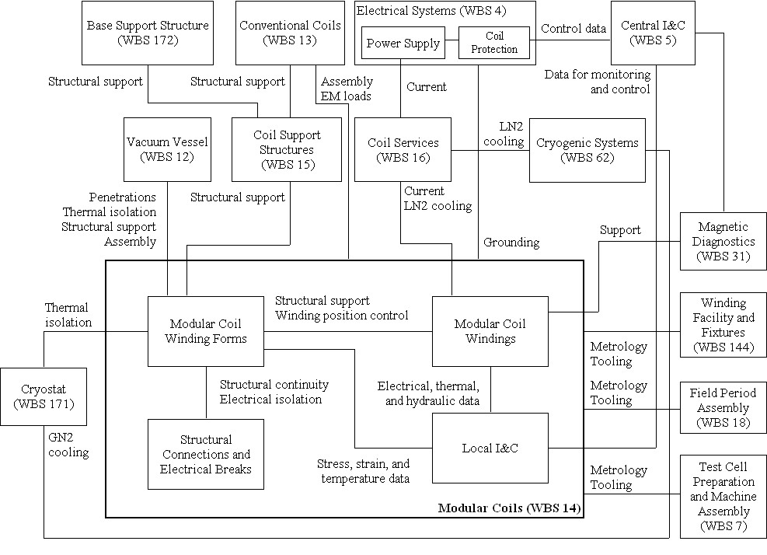

Figure 3-2 Modular coil system functional relationships

Functional Flow Block Diagram
A functional flow block diagram (FFBD) is provided in Figure 3-3.

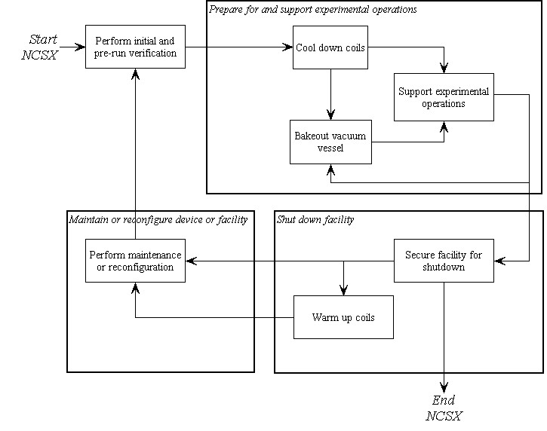
Figure 3-3 Functional flow block diagram

Interface definition

Vacuum Vessel (WBS 12)
- There are several physical and functional interfaces between these elements. The vacuum vessel is physically supported from the modular coil shell for vertical (gravity and net electromagnetic loads) and lateral loads. The vacuum vessel is thermally insulated to reduce heat leakage from the vacuum vessel to the modular coils. The vacuum vessel port extensions penetrate the modular coil shell.
- During field period assembly, the modular coils must be able to be assembled over the vacuum vessel.

Conventional Coils (WBS 13)
- Conventional coils include the TF coils, PF coils, and external trim coils. The coils are attached to the Coil Support Structures (WBS 15), which are in turn attached to the Modular Coils (WBS 14) as noted in Section 3.1.2.4.
- The conventional coils introduce electromagnetic loads on the modular coils and vice versa.
- During field period assembly, the TF coils must be able to be assembled over the modular coils.

Modular Coil Winding Facility and Fixtures (WBS 144)
This WBS element does not include any experimental hardware but rather the winding fixtures, autoclave, and coil test facility that will be used to wind, mold, impregnate, cure, and test the modular coils.

Coil Support Structures (WBS 15)
The Coil Support Structures (WBS 15) include a group of elements that form structural plates above and below the modular coils. These elements are attached to the modular coil winding forms. The upper plate supports the gravity and net electromagnetic loads from the upper PF ring coils, upper external trim coils, central solenoid assembly, and cryostat. The upper plate also provides out-of-plane support for the TF coils. These loads are transmitted through the modular coil shell to the lower plate along with gravity loads from the modular coils, vacuum vessel, and in-vessel components. Gravity loads from the stellarator core are transmitted through the lower plate to the Base Support Structure (WBS 172).

LN2 Distribution System (WBS 161)
Liquid nitrogen for coil cooling is supplied from the Cryogenic Systems (WBS 62) to the LN2 Distribution System (WBS 161), which in turn supplies the liquid nitrogen to the individual modular coils.

Electrical Leads (WBS 162)
The current and voltage required to drive the modular coils is supplied from the Electrical Power Systems (WBS 4) to the Electrical Leads (WBS 162), which in turn supplies the direct current (DC) power to the individual modular coils.

Coil Protection System (WBS 163)
The Coil Protection System (WBS 163) includes all the activities required to develop the coil protection logic and specification of coil protection parameters, including modular coils. The Coil Protection System (WBS 163) does not include any hardware or software.

Cryostat (WBS 171)
Although there is no physical contact between the Cryostat (WBS 171) and the Modular Coils (WBS 14), the cryostat does provide thermal isolation from the environment outside the cryostat and containment for the cold, dry nitrogen environment inside the cryostat, which is required for cooling and maintaining the temperature of the modular coil shell. The nitrogen environment inside the cryostat is maintained by the Cryogenic Systems (WBS 62).

Field Period Assembly (WBS 18)
The modular coils will have interfaces with the tooling and metrology equipment required for field period assembly, including lifting points and monuments to facilitate position measurements.

Magnetic Diagnostics (WBS 31)
Magnetic loops will be incorporated into the modular coil windings.

Electrical Power Systems (WBS 4)
- The current and voltage required to drive the modular coils is supplied from the Electrical Power Systems (WBS 4) to the Electrical Leads (WBS 162), which in turn supplies the direct current (DC) power to the individual modular coils.
- Electrical Power Systems (WBS 4) provide coil protection via parameters measured in the power supply circuitry based on parameters provided by Coil Protection System (WBS 163) activities. Electrical Power Systems (WBS 4) also provides coil protection via permissives and trip signals provided by Central I&C (WBS 5) in response to the output from sensors included in the local I&C within the Modular Coil System (WBS 14).
- Electrical Power Systems (WBS 4) are responsible for providing single point grounds for the modular coil winding forms.

Central I&C (WBS 5)
Central I&C (WBS 5) is responsible for taking the output from the sensors (e.g. strain gauges, resistance temperature detectors, and thermocouples) provided in the local I&C in the Modular Coil System (WBS 14), processing those signals, displaying and storing the data, and providing permissives and trip signals for coil protection to Electrical Power Systems (WBS 4) in accordance with the coil protection logic and parameters specified by the Coil Protection Systems (WBS 163).

Cryogenic Systems (WBS 62)
- Cryogenic Systems (WBS 62) are responsible for providing liquid nitrogen cooling for the modular coils via the LN2 Distribution System (WBS 161) as discussed in Section 3.1.2.5.
- Cryogenic Systems (WBS 62) are responsible for providing the gaseous nitrogen cooling within the cryostat required to cool and maintain the temperature of the modular coil shell.

Test Cell Preparations and Machine Assembly (WBS 7)
The modular coils will have interfaces with the tooling and metrology equipment required for field period assembly.

Major Component List
There are no major components for which additional development specifications are planned.

Characteristics

Performance

Perform Initial and Pre-run Verification

Initial Facility Startup
Background
Initial facility startup includes all activities required to verify safe operation of NCSX systems after their initial assembly and installation, or after a major facility reconfiguration, and before plasma operations. Initial facility startup activities would be performed prior to First Plasma and will include subsystem pre-operational test procedures (PTPs) and an Integrated System Test Program (ISTP) to verify that the system operates safely and as expected prior to plasma operation. For example, the ISTP will include verification of proper coil polarities and power supply connections. The ISTP will also include verification that, at First Plasma, the system demonstrates a level of system performance sufficient for the start of research operations, as specified in the Project Execution Plan (NCSX-PLAN-PEP-01). A subset of the ISTP will be conducted before the start of a run.

Initial Verification of Operability
The subsystem shall provide the capability to perform subsystem PTPs and support a comprehensive ISTP, to verify, prior to plasma operation that the system is properly configured, functioning correctly, and can be operated safely. [Ref. GRD Section 3.2.1.1]

Field Line Mapping
- The subsystem shall perform the capability to perform field line mapping with current waveforms as specified in the Field Line Mapping Scenario (GRD Appendix A, Section A.3.2) with the modular coils starting at room temperature prior to completely installing the cryostat.
- The subsystem shall perform the capability to perform field line mapping with current waveforms as specified in the Field Line Mapping Scenario (GRD Appendix A, Section A.3.2) with the modular coils starting at cryogenic temperature (nominally 80K) after completely installing the cryostat. [Ref. GRD Section 3.1.2a]

Design Verification
The subsystem shall be instrumented such that key modular coil performance parameters (stresses, deflections, temperatures, pressures, etc.) can be measured and compared to calculated values to assure that the subsystem is performing consistent with the design intent prior to First Plasma.

Pre-Run Facility Startup
Background
Pre-run facility startup includes all activities required to verify safe operation of the NCSX subsystems after a major maintenance outage or a minor facility reconfiguration (one affecting a small number of subsystems). Pre-run facility startup activities would typically be performed prior to the start of a run period and would include a subset of the full PTP and ISTP activities referred to in Section 3.2.1.1.1.
Requirement
The subsystem shall support the capability to perform a controlled startup of the facility, and verify that the subsystem is properly configured, functioning correctly, and can be operated safely. [Ref. GRD Section 3.2.1.2]

Prepare for and Support Experimental Operations

Subsystem Verification and Monitoring
Background
Pre-operational initialization and verification activities would generally cover those activities required prior to the start of an operating day following an overnight or weekend shutdown. Pre-pulse initialization and verification activities cover those activities required prior to the start of each pulse (plasma discharge). The Modular Coil System (WBS 14) should be verified and monitored that the subsystem is functioning correctly and configured properly at the start of an operating day and prior to the start of each pulse.
Requirement
The subsystem shall provide the capability to verify that the subsystem is properly configured, functioning correctly, and can be operated safely prior to the start of an operating day and prior to the start of each pulse (plasma discharge). [Ref. GRD 3.2.1.3 and GRD 3.2.1.4]

Coil Cool-down
Background
The Integrated System Test Program (ISTP) will include coil testing and initial field line mapping with the coils around room temperature to facilitate engineering shakedown and testing with portions of the cryostat removed. The coils will be cooled to cryogenic temperatures for First Plasma. (In this context, cryogenic temperatures are around 80K (the saturation temperature of liquid nitrogen at slightly above 1 atmosphere).
Prior to experimental operations, the cryo-resistive coils must be cooled down from room temperature to a pre-pulse operating temperature of about 80K. The coils are located in a dry nitrogen environment that is provided by the cryostat, which surrounds the coils. In order to gain access to the interior of cryostat, the coils must be warmed up from operating temperature to room temperature. The anticipated operational plans are expected to result in no more than 150 cool-down and warm-up cycles between room temperature and operating temperature over the lifetime of the machine.

Timeline for Coil Cool-down to Cryogenic Temperature
The modular coils shall be capable of being cooled down from room temperature (293K) to their pre-pulse operating temperature within 96 hours with the vacuum vessel at room temperature (20°C). [Ref. GRD Sections 3.2.1.2.1.1 and 3.2.1.2.1.3]

Cool-down and Warm-up Cycles
The design of the modular coils shall allow for at least 150 cool-down and warm-up cycles between room temperature and cryogenic temperature. [Ref. GRD Section 3.2.1.2.1.2]

Bakeout
Background
The temperature of the vacuum vessel shell will be capable of being elevated to a nominal temperature of 150ºC for vacuum vessel bakeout operations and to a nominal temperature of 350ºC to support bakeout of an in-vessel carbon-based liner (to be installed as an upgrade) at that temperature. Initially, there will not be any limiters installed in the vacuum vessel for first plasma or field line mapping. However, later in the program, the liner will be installed inside the vacuum vessel with a surface area that is a substantial part of the vacuum vessel surface area to absorb the high heat loads and to protect the vacuum vessel and internal components.

Coil Temperatures during Bakeout
During bakeout of the vacuum vessel (up to 350ºC in the vacuum vessel shell and 150ºC at the ends of the port extensions), the temperature of the modular coils shall be capable of being kept below 90K and returned to their pre-pulse operating temperatures within the 24 hours following completion of bakeout. [Ref. GRD Section 3.2.1.2.3.3]

Bakeout Cycles
The device shall be designed for at least 1000 bakeout cycles over the life of the machine. [Ref. GRD 3.2.1.2.3.6]

Pre-Pulse Temperature
The modular coils shall return to a pre-pulse temperature of about 80K, so as to prevent overheating during repeated operation, with a vacuum vessel shell temperature in the range of 40ºC to 250 C. [Ref. GRD Section 3.2.1.4.2]

Field Error Requirements
Background
Field errors are a major concern in the design of the modular coils. The fundamental global requirement is that the toroidal flux in island regions due to fabrication errors, magnetic materials, and eddy currents shall not exceed 10% of the total toroidal flux in the plasma (including compensation). To implement this requirement, external trim coils have been provided for field error correction. Poloidal and toroidal electrical breaks are required in the modular coil structure to reduce the size of the eddy current loops and to reduce the longest eddy current time constant in the modular coils such that the calculated field errors are acceptably low. The electrical breaks also facilitate field penetration from the modular and conventional (PF, TF and external trim) coils. The modular coils will be fabricated and assembled to tight tolerances which are calculated to introduce acceptably low field errors (after correction).

Electrical Breaks

Toroidal Electrical Breaks
- Toroidal electrical breaks shall be provided between adjacent modular coils within a field period. Electrical breaks are not required between adjacent modular coils in adjacent field periods. [Ref. GRD Section 3.2.1.5.2b]
- Toroidal electrical breaks must be able to withstand an applied voltage of 150 V (ref. GRD Section 3.2.1.5.3.6).

Poloidal Electrical Breaks
- A poloidal electrical break shall be provided within each modular coil. The winding form and cooling components must both contain at least one poloidal break and also be isolated from each other.
- The resistance of the mid-plane insulation and of the bolt insulation shall be >500 k-ohms when tested at 100 VDC.

Eddy Current Time Constants
The time constant of the longest-lived eddy current eigenmode in the completed modular coil assembly (all eighteen coils excluding the conductor circuits) shall be less than 20 ms. [Ref. GRD Section 3.2.1.5.2c]

Stellarator Symmetry
Stellarator symmetry shall be preserved in the design of conducting structures in the modular coils and placement of electrical breaks. [Ref. GRD Section 3.2.1.5.2e]

Winding Tolerance
The local current centroid of each modular coil shall be located within 1.5 mm of the nominal location defined in Section A.1.1 Coil Centroids with the modular coils at the pre-pulse operating temperature with zero current.

Deflections under Load
- Modular coils shall be designed such that deflections due to thermal growth and due to electromagnetic loads preserve stellarator symmetry.
- Deflection of the nominal current centroid due to electromagnetic loads shall not exceed 3 mm.

Plasma Magnetic Field Requirements

Magnetic Field Polarity
Background
Figure 3-4 illustrates the right-handed coordinate system used for the stellarator and test cell on NCSX. The Z-axis of the coordinate system is vertical. The major axis of the stellarator is coincident with the Z-axis. The following conventions are followed:
- A positive toroidal (plasma) current or a positive toroidal magnetic field point in the φ-direction (counter-clockwise viewed from above).
- A positive vertical magnetic field points in the Z-direction (upward).
- A positive poloidal current (TF or modular coil current in the inner leg) flows in the Z-direction and provides a positive toroidal magnetic field.
- Positive radial magnetic fields and currents are in the R-direction, radially outward from the Z-axis, the major axis of the stellarator.
[Ref. GRD Section 3.2.1.5.3.1]
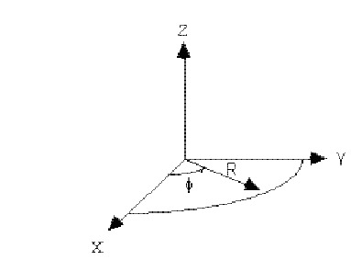
Figure 3-4 NCSX coordinate system

Requirements
- The modular coils shall be configured for the standard magnetic field polarity to have its toroidal field in the negative direction.
- The modular coils shall have the capability to be reconfigured, as a complete set, to operate with the magnetic field polarity reversed from its standard direction.
[Ref. GRD Section 3.2.1.5.3.2]

Reference Scenario Requirements
Background
NCSX is designed to be a flexible, experimental test bed. To ensure adequate dynamic flexibility, a series of reference scenarios has been established. TF, PF, and modular coil systems and the vacuum vessel will be designed for a plasma with a nominal major radius of 1.4 m and capability to meet the requirements of all the reference scenarios. Electrical power systems shall be designed and initially configured to meet the requirements of the First Plasma and Field Line Mapping Scenarios and shall be capable of being upgraded to meet the requirements of all other reference scenarios.
Reference scenario definitions are provided in Section 3.2.1.5.3.3.1 of the General Requirements Document. Reference waveforms of engineering parameters such as coil currents, voltages, power dissipation, etc. are derived from the scenario specifications and are documented in GRD Appendix A.
Requirement
The modular coils will be designed to meet the requirements of all the reference scenarios. [Ref. GRD Section 3.2.1.5.3.3.2]

Flexibility Requirements
Background
NCSX is designed to be a flexible, experimental test bed. To ensure that changes in equilibria can be accommodated, several dimensions have been identified over which changes in equilibria must be accommodated.
Flexibility requirements have been established for a toroidal magnetic field of 1.7T. Greater flexibility exists at lower field levels.
The NCSX Project has determined that the required flexibility can be achieved with the modular coil capabilities developed in response to the reference scenarios. Therefore, no additional requirements are placed on the modular coils to satisfy flexibility requirements for the overall device and facility.
Requirements
None

Pulse Repetition Rate
Modular coils shall be designed for pulses to be initiated at intervals not exceeding 15 minutes when constrained by coil cooldown and 5 minutes otherwise. [Ref. GRD Section 3.2.1.5.10]

Discharge Termination

Normal Termination
Background
Normal termination includes all system actions necessary to shutdown the plasma and associated subsystems at the conclusion of a pulse in preparation for the next pulse.
Requirement
During a controlled shutdown, the modular coil currents will be driven to zero by the power supplies according to the pre-programmed current waveform. [Ref. GRD Section 3.2.1.5.11.1]

Abnormal Termination
Background
Abnormal termination consists of all system responses necessary to remove conditions that occur during experimental operations that could cause significant damage to the NCSX system or cause injury to personnel.
Requirement
During an abnormal termination, the modular coil power supplies will be bypassed and the modular coil currents will go to zero on the natural decay times of the coil circuits. [Ref. GRD Section 3.2.1.5.11.2]

Shut Down Facility
Background
Facility shutdown involves the shutdown of NCSX equipment following the termination of a discharge (per Section 3.2.1.2.8) in preparation for a brief (overnight or weekend) or extended (between run periods) shutdown.
Requirement
The NCSX system shall provide the capability to perform a controlled shutdown of the modular coils. [Ref. GRD Section 3.2.1.6]

Coil Warm-up Timeline
The modular coils shall be capable of being warmed up from operating temperature (80K) to room temperature (293K) within 96 hours. [Ref. GRD Section 3.2.1.6.1]

Physical Characteristics

Configuration Requirements and Essential Features

Modular Coil Winding Forms (WBS 141)
Background
The winding forms provide an accurate means of positioning the conductor during the winding and vacuum-pressure impregnation (VPI) process. The winding forms are permanent structures that also provide mechanical support for the windings during coil operation. The complete assembly of winding forms is referred to as the structural shell.
Requirements
- Eighteen winding forms of three different types (six of each type) are required to construct the modular coils.
- Each winding form shall include accurately machined surfaces for positioning the conductor during the winding and VPI process.

Coil Windings and Assembly (WBS 142)
Background
The function of the modular coil windings is to provide the basic quasi-axisymmetric magnetic configuration for the device. The windings can produce alternate magnetic configurations by varying the current for each coil type independently.
Requirements
- Each modular coil shall consist of two winding packs, wound on either side of a structural tee feature on the winding form. The two winding packs comprise a modular coil.
- The number of turns per coil is as specified in GRD Appendix A, Section A.1.2 Turns per Coil.
- The modular coils shall be connected electrically in 3 circuits, with coils of each type in series.
- The maximum weight of a completed Type A modular coil shall not exceed 6500 lbs. The maximum weight of a completed Type B modular coil shall not exceed 6000 lbs. The maximum weight of a completed Type C modular coil shall not exceed 6500 lbs.

Local Instrumentation and Control (WBS 143)
Background
The function of the modular coil windings is to provide the basic quasi-axisymmetric magnetic configuration for the device. The windings can produce alternate magnetic configurations by varying the current for each coil type independently.
Requirements
- Each modular coil assembly shall be equipped with multiple Resistance Temperature Detectors (RTDs) or thermocouples in order to provide pre- and post-pulse monitoring of conductor average temperature.
- Each modular coil shall be equipped with voltage taps at the leads.
- Each winding form shall be equipped with strain gages along the length the coil.

System Quality Factors

Reliability, Availability, and Maintainability
Background
The overall objective is to provide a device with high operational availability, meaning that the number of plasma discharges achieved in a run period is a large percentage (greater than 75%) of the number planned after the initial shakedown and commissioning phases of the facility. Bottoms-up reliability predictions are difficult to perform and have large uncertainties for first-of-a-kind experimental devices such as NCSX. Therefore, quantitative RAM requirements on NCSX will be few. Rather, NCSX will rather rely on sound engineering practice to assure high availability in NCSX, which has been the tried-and-true approach on similar scale fusion devices. Sound engineering practices include:
- Applying design principles that promote reliability (e.g., employing an adequate factor of safety on mechanical and electrical stresses, avoiding unnecessary complexity, using proven design approaches and well characterized materials, etc.)
- Optimizing designs for reliability and maintainability through systematic evaluation of design options,
- Performing failure modes, effects and criticality analysis (FMECAs) for RAM design improvement and verification, and
- Employing peer reviews as a mechanism to enhance the design process.
The NCSX RAM Plan defines the processes that will be used by the Project to achieve a device with high availability.
Requirements
- The modular coils shall incorporate reliability and maintainability features in the design that are consistent with achieving a high (greater than 95%) operational availability.
- Provisions for recovery shall be made for every credible failure mode.
- The modular coils shall be capable of being disassembled and reassembled to permit replacement of any part or machine reconfiguration that would require disassembly.
- Provisions for lifting, e.g. lifting eyes, other sling attachment provisions, or equivalent provisions, shall be made in the design of the modular coils.
[Ref. GRD Section 3.2.4.1]

Design Life
- The modular coils shall have a design life of >10 years when operated per the reference scenarios in Section 3.2.1.2.6.2.
- The modular coils shall be designed for the following maximum number of pulses when operated per the reference scenarios defined in Section 3.2.1.2.6.2 and based on the factors for fatigue life specified in the NCSX Structural and Cryogenic Design Criteria Document:
- 100 per day;
- 13,000 per year; and
- 130,000 lifetime.
[Ref. GRD Section 3.2.4.2]

Seismic Criteria
Background
NCSX systems shall be designed in accordance with seismic design and evaluation criteria for Performance Category 1 (PC1) facilities, per DOE-STD-1020-2002, “Natural Phenomena Hazards Design and Evaluation Criteria for Department of Energy Facilities.” The NCSX Seismic Design Criteria provides an NCSX-specific interpretation of those requirements
Requirement
The modular coils shall be design in accordance with the NCSX Seismic Design Criteria. [Ref. GRD Section 3.3.1.5]

Transportability
All modular coil assemblies and components shall be transportable by commercial carrier via highway, air, sea, or railway. [Ref. GRD Section 3.2.5]

Design and Construction

Materials, Processes, and Parts

Magnetic Permeability
All materials used in the modular coils must have a relative magnetic permeability less than 1.02 unless otherwise authorized by the Project. [Ref. GRD Section 3.3.1.1]

Corrosion Prevention and Control
Materials, processes, and protective surface treatments or finishes shall be provided to ensure that equipment capability during its service life is not degraded due to corrosion. Where possible, contact between dissimilar metals shall be avoided. [Ref. GRD Section 3.3.1.4]

Metrology
The modular coils shall provide features (e.g., fiducial markers) to facilitate accurately measuring and locating components relative to the magnetic field for the life of the machine. [Ref. GRD Section 3.3.1.6]

Electrical Requirements

Electrical Grounding
Background
The modular coil winding electrical circuits are connected to a single point ground by the Electrical Power Systems (WBS 4). In addition, the modular coil winding forms which are electrically isolated need to be connected to a single point ground.
Requirement
The modular coil winding forms shall be connected to a single point grounding system.

Voltage Standoff Capability
- Field Maintenance Test Voltage. The field maintenance test voltage shall be twice the maximum operating voltage to ground plus 1 kV.
- Manufacturing Test Voltage. The manufacturing test voltage shall be 1.5 times the field maintenance test voltage.
- Design Voltage Standoff. The design voltage standoff shall be twice the manufacturing test voltage.

Nameplates and Product Marking

Labels
Equipment and any parts of that equipment to be used by personnel shall be identified with appropriate labels. Labels shall indicate clearly and concisely the function and purpose of the item being labeled. Hierarchical labeling shall be used to facilitate component location on control panels. The terminology used for equipment, procedures, and training materials shall be the same for each case. Label design shall be consistent to promote simplicity and avoid clutter. The use of abbreviations and acronyms shall be minimized. Permanent labels shall be attached to the specific component or equipment in such a manner that environmental conditions or usage by personnel will not remove or destroy the label. Temporary labels shall be used only when necessary and shall not obscure other information or equipment. If a temporary label is to designate a device that is out of service, the label shall be applied so that it prevents the use of that device. Labeling shall be legible and conform to human visual capabilities and limitations in regard to physical characteristics. [Ref. GRD Section 3.3.2.1]

Workmanship
During modular coil fabrication and finishing, particular attention shall be given to freedom from blemishes, defects, burrs, and sharp edges; accuracy of dimensioning radii of weld fillets; making of parts; thoroughness of cleaning; quality of brazing, welding, riveting, painting, and wiring; alignment of parts; and tightness and torquing of fasteners. [Ref. GRD Section 3.3.3]

Interchangeability
Design tolerances shall permit parts and assemblies of the same part number to be used as replacement parts without degrading the specified performance of the parent item. [Ref. GRD Section 3.3.4]

Environmental, Safety, and Health (ES&H) Requirements

General Safety
- When utilized within its intended use and within specified environments, the safe operation, test, handling, maintenance and storage of the subsystem hardware and software shall be provided.
- The subsystem shall not present any uncontrolled safety or health hazard to user personnel.
- The subsystem shall detect abnormal operating conditions and safeguard the NCSX system and personnel.
[Ref. GRD Section 3.3.5.1]

Personnel Safety
The subsystem shall meet all applicable OSHA requirements in accordance with 29CFR1910. The system shall limit personnel exposure to hazardous materials to below their OSHA permissible exposure limit (PEL). [Ref. GRD Section 3.3.5.3]

Flammability
The use of flammable materials shall be minimized. [Ref. GRD Section 3.3.5.4]

Documentation

Specifications
Specifications shall be developed for each configuration item as shown in Table 3-1.

Table 3-1 Modular coil specifications
Configuration Item | Specification Identifier | Specification Type
Modular Coil Winding Form | NCSX-CSPEC-141-03-XX | Product specification – forms the basis of the MCWF procurement
Modular Coil Cable Conductor | NCSX-CSPEC-142-03-XX | Product specification – forms the basis of the conductor procurement
Modular Coil Winding Assembly | NCSX-CSPEC-142-05-XX | Product specification – forms the basis for fabricating and testing the modular coil winding assembly

Logistics

Maintenance
The modular coils shall be maintained using, to the extent possible, standard/common tools and existing multi-purpose test equipment. Use of new/special tools and the number of standard/common tools shall be minimized through maximum commonality of fasteners, clamps, adapters, and connectors.

Quality Assurance Provisions

General
This section identifies the methods to be used for verification of requirements in Section 3.2 of this specification. General definitions of basic verification methods are outlined in Section 4.2. Verification of subsystem requirements will require additional testing in operational or near-operational environments.

Verification Methods
Verification of qualification shall be by analysis, demonstration, inspection, or test. Definition of analysis, demonstration, inspection, and test is as follows:
Analysis: Verification of conformance with required characteristics by calculation or simulation, including computer modeling based on established material or component characteristics.
Inspection: Verification of conformance by measuring, examining, testing, and gauging one or more characteristics of a product or service and comparing the results with specified requirements.
Test: Verification by physically exercising a component or system under appropriate loads or simulated operating conditions, including measurement and analysis of performance data.

Quality Conformance
Background
This section establishes the specific evaluation criteria for verification of the subsystem characteristics in Section 3.2. In general, all requirements shall be verified under operational or near-operational conditions as possible given test constraints.
Requirements
Test methods for each of the performance characteristics in Section 3.2 are identified in Appendix A – Quality Conformance Matrix.

Appendix A – Quality Conformance Matrix
Section | Characteristic | Analysis | Inspection | Test | Comments
3.2 | Characteristics
3.2.1 | Performance
3.2.1.1 | Perform Initial and Pre-run Verification
3.2.1.1.1 | Initial Facility Startup
3.2.1.1.1.1 | Initial Verification of Operability | a |  | b | a. The adequacy of design features to verify operability shall be assessed during final design.  b. Functionality shall be tested during integrated system testing.
3.2.1.1.1.2 | Field Line Mapping |  |  | X | The coil currents are benign during field line mapping (relative to full field operation) so no detailed analysis is required. Functionality shall be tested during integrated system testing.
3.2.1.1.1.3 | Design Verification | a |  | b | The adequacy of instrumentation to verify the design shall be [a] assessed during final design and [b] tested during qualification testing of the first article.
3.2.1.1.2 | Pre-Run Facility Startup | a |  | b | a. The adequacy of the design to support controlled startup shall be assessed during final design.  b. Functionality shall be tested during integrated system testing.
3.2.1.2 | Prepare for and Support Experimental Operations
3.2.1.2.1 | Subsystem Verification and Monitoring | a |  | b | a. The adequacy of the design to support controlled startup shall be assessed during final design.  b. Functionality shall be tested during integrated system testing.
3.2.1.2.2 | Coil Cool-down
3.2.1.2.2.1 | Timeline for Coil Cool-down to Cryogenic Temperature | a |  | b | a. The adequacy of the design shall be assessed during final design.  b. Performance shall be tested during qualification testing of the first article.
3.2.1.2.2.2 | Cool-down and Warm-up Cycles | X |  |  | The adequacy of the design shall be established by analysis during final design.
3.2.1.2.3 | Bakeout
3.2.1.2.3.1 | Coil Temperatures during Bakeout | X |  |  | The adequacy of the design shall be established by analysis during final design.
3.2.1.2.3.2 | Bakeout Cycles | X |  |  | The adequacy of the design shall be established by analysis during final design.
3.2.1.2.4 | Pre-Pulse Temperature | a |  | b | a. The adequacy of the design shall be established by analysis during final design.  b. Performance shall be tested during qualification testing of the first article.
3.2.1.2.5 | Field Error Requirements
3.2.1.2.5.1 | Electrical Breaks
3.2.1.2.5.1.1 | Toroidal Electrical Breaks | a |  | b | a. The adequacy of the design shall be established by analysis during final design.  b. The integrity of the toroidal electrical breaks shall be tested upon completion of each 3-coil assembly, 6-coil assembly, and the complete 18-coil assembly.
3.2.1.2.5.1.2 | Poloidal Electrical Breaks | a |  | b | a. The adequacy of the design shall be established by analysis during final design.  b. The integrity of the poloidal electrical breaks shall be tested upon completion of each MCWF and each modular coil assembly.
3.2.1.2.5.2 | Eddy Current Time Constants | X |  |  | The adequacy of the design shall be established by analysis during final design.
3.2.1.2.5.3 | Stellarator Symmetry |  | a | b | a. Preservation of stellarator symmetry shall be determined by inspection of the design during final design.  b. Preservation of stellarator symmetry shall be determined by field line mapping after machine assembly
3.2.1.2.5.4 | Winding Tolerance |  | a | b | a. The winding tolerance will be apportioned appropriately. For each step in the fabrication and assembly of the modular coil system, measurements will be made to assure that specified tolerances are met.  b. Field line mapping will be performed following machine assembly to determine if excessive field errors exist.
3.2.1.2.5.5 | Deflections under Load | a |  | b | a. Analyses shall be performed to confirm that deflections are symmetry preserving and that max deflections under EM loads do not exceed prescribed limits.  b. Deflections under EM loads shall be measured during integrated system testing to confirm that the structural response matches predictions.
3.2.1.2.6 | Plasma Magnetic Field Requirements
3.2.1.2.6.1 | Magnetic Field Polarity |  | a | b | a. The design shall be inspected for reconfigurability during final design.  b. Magnetic field polarity will be tested during integrated system testing.
3.2.1.2.6.2 | Reference Scenario Requirements | X |  |  | The adequacy of the design to meet the reference scenario requirements shall be established by analysis during final design.
3.2.1.2.6.3 | Flexibility Requirements
3.2.1.2.7 | Pulse Repetition Rate | a |  | b | a. The adequacy of the design to meet pulse repetition rate requirements shall be established by analysis during final design.  b. The adequacy of the design to meet pulse repetition rate requirements shall be tested during qualification testing of the first article.
3.2.1.2.8 | Discharge Termination
3.2.1.2.8.1 | Normal Termination |  |  | X | Normal termination shall be tested during integrated systems testing.
3.2.1.2.8.2 | Abnormal Termination |  |  | X | Abnormal termination shall be tested during integrated system testing.
3.2.1.3 | Shut Down Facility |  |  | X | Controlled shutdown of the modular coils shall be demonstrated during integrated system testing.
3.2.1.3.1 | Coil Warm-up Timeline | a |  | b | a. The adequacy of the design shall be established by analysis during final design.  b. The adequacy of the design shall be tested during qualification testing of the first article.
3.2.2 | Physical Characteristics
3.2.2.1 | Configuration Requirements and Essential Features
3.2.2.1.1 | Modular Coil Winding Forms (WBS 141) | X |  |  | Verified by inspection of the final design
3.2.2.1.2 | Coil Windings and Assembly (WBS 142) | a | b |  | a. Configuration requirements and essential features verified by inspection of the final design.  b. Weight verified by inspection of each completed coil assembly.
3.2.2.1.3 | Local Instrumentation and Control (WBS 143) | a | b |  | a. Verified by inspection of the final design.  b. Verified by inspection of each coil assembly.
3.2.3 | System Quality Factors
3.2.3.1 | Reliability, Availability, and Maintainability | a | b |  | Verified by analysis (e.g. FMECAs) and design inspection during final design.
3.2.3.2 | Design Life | X |  |  | Verified by analysis during final design.
3.2.3.3 | Seismic Criteria | X |  |  | Verified by analysis during final design.
3.2.4 | Transportability |  |  | X | Verified by inspection during final design.
3.3 | Design and Construction
3.3.1 | Materials, Processes, and Parts
3.3.1.1 | Magnetic Permeability |  | a | b | a. Verified by design inspection during final design.  b. Verified by magnetic permeability measurements on each MCWF and each coil assembly
3.3.1.2 | Corrosion Prevention and Control |  | X |  | Verified by design inspection during final design.
3.3.1.3 | Metrology |  | X |  | Verified by design inspection during final design.
3.3.2 | Electrical Requirements
3.3.2.1 | Electrical Grounding |  | a | b | a. Verified by design inspection during final design.  b. Verified by test during field period and machine assembly.
3.3.2.2 | Voltage Standoff Capability | a |  | b | a. Verified by analysis during final design for design voltage standoff.  b. Verified by electrical testing of each completed coil assembly for the manufacturing test voltage. Verified by electrical testing during integrated system testing for the field test voltage.
3.3.3 | Nameplates and Product Marking
3.3.3.1 | Labels |  | X |  | Verified by inspection of completed components and assemblies.
3.3.4 | Workmanship |  | X |  | Verified by inspection of completed components and assemblies.
3.3.5 | Interchangeability | X |  |  | Verified by analysis during final design.
3.3.6 | Environmental, Safety, and Health (ES&H) Requirements
3.3.6.1 | General Safety |  | X |  | Verified by design inspection during final design.
3.3.6.2 | Personnel Safety |  | X |  | Verified by design inspection during final design.
3.3.6.3 | Flammability |  | X |  | Verified by design inspection during final design.

