NCSX
Product Specification
Modular Coil Winding Forms
NCSX-CSPEC-141-03-11-dB
January 11, 2006

Prepared By: ___________________________________________________________
P. Heitzenroeder, Technical Representative for Modular Coil (WBS 14) Procurements

Concurred By: __________________________________________________________
D. Williamson, WBS Manager for Modular Coils (WBS 14)

Concurred By: __________________________________________________________
F. Malinowski, PPPL Procurement QA Representative

Approved by: __________________________________________________________
B. Nelson, Responsible Line Manager for Stellarator Core Systems (WBS 1)
Controlled Document
THIS IS AN UNCONTROLLED DOCUMENT ONCE PRINTED.
Check the NCSX Engineering Web prior to use to assure that this document is current.
Record of Revisions

Revision | Date | Description of Changes
Rev. 0 | 7/1/2004 | Initial issue
Rev 1. | 7/5/2004 | Revised Table 6-1
Rev 2 | 7/20/2004 | Updated Table 6-1 to Production Drawings
Rev 3 | 8/4/2004 | Updated Table 6-1 – Drawings se141-116 to se141-116r1 and Drawing se141-116-nf.stp to se141-116-NFr1.stp
Rev 4 | 9/17/2004 | Updated specification to reflect final negotiated configuration:  - Added vendor information on alloy in Sections 3.1.1.1 and  - Revised Sections 4.2.5 and 4.2.7.2.1; and  - Updated Table 6-1
Rev 5 | 9/23/2004 | Updated Table 6-1
Rev 6 | 1/14/2005 | Updated Table 6-9
Rev 7 | 04/19/2005 | Incorporated ECP-026 (MCWF Fast Response), ECP-028 (RFD-14-001), and RFD-14-002. Changes made include:  - Removed reference to a specific operation date in Section 1.1.  - Updated Table 3.2 to reflect correct units;  - Updated and/or revised Sections: 3.1.1.6.3; 3.1.1.7; 3.2.3.2.3; 4.2.1; 4.2.2; 4.2.2.5 (New); 4.2.8.1; 4.2.8.2; 6.1; and 6.2.  - Added Appendix A which identifies the high stress regions.
Rev 8 | 07/12/05 | Incorporated ECP-033. Changes include:  - Added ASTM A751-01, “Standard Test Methods, Practices, and Terminology for Chemical Analysis of Steel Products,” to Section 2.1.1.  - Revised Section 3.1.1.1: Added note about alloy composition ranges;  - Revised Table 3-1: Changed Si from 0.5 to 0.7% max.  - Added Table 3-2 for weld material composition;  - Revised Table 3-7 : Changed yield from 34 ksi (234.4 MPa) to 30 ksi (206.8 Mpa);  - Revised Section 3.1.1.4 to change surface finish requirements.  - Revised Section 3.1.1.6.1: Clarified visual inspection requirements;  - Revised Section 3.2.3.1 to clarify stress relieving processes.  - Revised Sections 3.2.3.2.2.2 and 3.2.3.2.2.3 concerning weld repair to address weld repairs due to machining errors;  - Revised Section 4.2.1: clarified requirements for chemical analysis for each ladle and weld wire lot;  - Revised Section 4.2.2: Deleted the requirement for both transverse and longitudinal test specimens and clarified test specimen details;  - Revised Sections 4.2.2.1, 4.2.2.2, 4.2.2.3:: Added “ for the three zones…” for emphasis;  - Revised Section 4.2.2.4: Revised additional testing material requirements; and  - Revised Section 4.2.2.5: Clarified wording for weld filler properties requirements.  - Revised Table 6-9 and Table 6-14 to reflect latest approved models and drawings and approved RFDs.
Rev 9 | 08/8/05 | Incorporated RFD-14-004 and ECP-035. Changes include:  - Updated drawings set per ECN#5009R1  - Revised Table 3-1 reflect the change in chemical composition requirements for phosphorus and sulfur.  - Updated Table 6-9 added reference to new Appendix B to provide complete listing of drawings and their applicable revisions.  - Added new Appendix B to provide complete listing of drawings and their applicable revisions.
Rev 10 | 11/15/05 | Incorporated RFD-14-005 RFD-14-006, RFD-14-008, and RFD-14-009R1; incorporated ECNs 5016 and 5026; and incorporated ECP-038. Changes include changes in requirements, clarifications and/or correction of omissions, and updated information on drawings and models and RFDs:  - Changes in Requirements:  - Revised Section 4.2.4 to add the requirement for separate reporting of surface finish inspections in the tee area.  - Revised Section 3.1.1.7 to clarify radiographic inspection requirements as per MSS SP 54.  - Restored Section 3.1.1.8 to clarify and simplify inspection requirements within the high stress areas; flaw size changed to 0.080” major dimension in the web region of the tee. The base of the flange radiographic inspection requirement was removed.  - Revised Section 3.2.3.2.2.3 to state that any defect (either surface or subsurface) that exceeds the defect size and depth, should be repaired. Eliminated any references to NCR requirement.  - Revised Section 4.2.6 to increase dimension inspection coverage of flange of the tee.  - Revised Sections 3.1.1.6.2, 4.2.7.2.1, and 4.2.7.2.2 to add Level I liquid penetrant inspections for post-machining acceptance criteria.  - Revised Section 4.2.8 to delete references to “pre-machining” and “post-machining” inspections for internal defects.  - Clarifications and/or Correction of Omissions:.  - Revised Section 3.1.1.5 on mag. permeability: now in two sub-sections, 3.1.1.5.1 which addresses the casting, including upgrades, and 3.1.1.5.2, which addresses fasteners and hardware. Also revised Section 4.2.4 accordingly.  - Updated Section 3.1.1.1, to modify or add Table 3-1, Table 3-3, Table 3-5, and Table 3-7 to clarify the chemical composition requirements for the casting alloy and weld wire.  - Revised Section 3.1.1.6.1 to delete the reference to SCRATA graded references for machined surfaces.  - Revised Sections 3.2.1 and 3.2.2.1 to clarify wording.  - Revised Section 4.2.3.1 and 4.2.3.2 concerning electrical testing.  - Revised Section 4.2.5 and expanded into four subparagraphs (Sections 4.2.5.1, 4.2.5.2, 4.2.5.3, and 4.2.5.4) added to clarify requirements.

Rev 10 | 11/15/05 | - Updated information on Drawings/Models and RFDs  - Updated Table 6-9 to provide updated listing of zip files for ProE, STEP, and pdf files. These drawings and models incorporate changes outlined in RFD-14-009R1 and ECNs 5016 and 5026. Appendix B and Read Me file on Supplier FTP Site provide most recent revision for all drawings.  - Added new updated Table 6-11 U to replace Appendix B which was deleted.  - Renumbered and updated Table 6-14 to list all approved Requests for Deviation. Added RFDs 14- 005, 14-006, 14-008, and 14-009R1.  - Updated Figure 7-6 to show high stress region.
Rev 11-dB | 1/10/2006 | Revised technical requirements to improve machining and inspection times as a result of technical meetings held at MTM the week of January 3, 2006. Changes were made to the following sections:  - 3.1.1.4 (Surface Finish) – Changed and clarified surface finish requirements in the “wing” area to permit “scalloping”. New Figure 3-2 added to shows “scalloping” permitted in the “wing” area.  - 3.1.1.5.2 (Relative Magnetic Permeability of Winding Form Fasteners and Miscellaneous Hardware) – incorporated RFD-14-011 to relax magnetic permeability requirement to 1.03.  - 3.2.2.1 (Measurement) – waived dimensional verification by CMM of poloidal break bushing holes and break flanges effective with the date of this revision. In lieu of this requirement, dimensional verification shall be accomplished using a 0.0002 inch “no-go” feeler gauge or pin gauge.  - 4.2.2.5 (Weld Filler Material) – provided alternate method (by supplier or material supplier) to verify weld filler material properties.  - 4.2.5.3 (Verification of Relative Magnetic Permeability for Machined Surfaces) – simplified verification requirements.  - 4.2.6 (Verification of Dimensions and Tolerances) – revised and clarified verifications for all cast and machined surfaces.  - Clarified the verification methods acceptable to perform dimensional and tolerances checks for cast surfaces.  - Permits castings C3-C6 to utilize the same machine surfaces verification methods used for the C2 castings. Machined surfaces shall be checked in a defined pattern provided by the NCSX Project for the Type A and B winding forms. Drawings will be updated and included in Table 6-9, Table 6-11, and Table 6-13 to reflect this guidance.  - The revised pattern to verify the ground clear space dimension in Figure 7-14 is acceptable.  - Table 6-9 and Table 6-11 have been updated to reflect the latest approved drawings.  - Table 6-13 has been added to show the list of revised STEP files since Revision 10 to this CSPEC.  - List of approved RFDs now shown in Table 6-14.

Table of Contents
1 Introduction and Scope 1
1.1 Introduction 1
1.2 Scope 2
2 Applicable Documents 2
2.1 Codes and Standards 2
2.1.1 American Society for Testing and Materials (ASTM) Documents 2
2.1.2 Manufacturers Standardization Society (MSS) of the Valve and Fittings Industry, Inc. Documents 2
3 Requirements Item Definition 2
3.1 Characteristics 3
3.1.1 Performance 3
3.1.1.1 Chemical Composition of the Casting Alloy and Weld Wire 3
3.1.1.2 Mechanical Properties of the Casting Alloy and Welding Material 3
3.1.1.3 Electrical Requirements for the Poloidal Electrical Break 4
3.1.1.4 Surface Finish 4
3.1.1.5 Relative Magnetic Permeability 4
3.1.1.5.1 Relative Magnetic Permeability of Winding Form 4
3.1.1.5.2 Relative Magnetic Permeability of Winding Form Fasteners and Miscellaneous Hardware 5
3.1.1.6 External Defects 5
3.1.1.6.1 Visual Examination 5
3.1.1.6.2 Liquid Penetrant Examination of Casting 5
3.1.1.6.3 Liquid Penetrant Inspection of High Stress Regions 5
3.1.1.7 Radiographic Inspection 5
3.1.1.8 Inspection for Internal Defects in the High Stress Areas 5
3.2 Design and Construction 6
3.2.1 Production Drawings 6
3.2.2 Dimensions and Tolerances 6
3.2.2.1 Measurement 6
3.2.2.2 Fiducials 6
3.2.3 Standards of Manufacture 6
3.2.3.1 Heat Treatment 6
3.2.3.2 Repairs 6
3.2.3.2.1 Non-Weld Repairs 6
3.2.3.2.2 Weld Repairs 7
3.2.3.2.2.1 Minor Weld Repairs 7
3.2.3.2.2.2 Major Weld Repairs 7
3.2.3.2.2.3 Repairs in High Stress Areas 7
4 QUALITY ASSURANCE PROVISIONS 7
4.1 Responsibility for Inspection 7
4.2 Quality Conformance Inspections / VERIFICATIONS 7
4.2.1 Verification of Chemical Composition 8
4.2.2 Verification of Mechanical Properties of the Casting Alloy and Weld Material 8
4.2.2.1 Verification of Yield Strength and Elastic Modulus 9
4.2.2.2 Verification of Ultimate Tensile Strength and Elongation 9
4.2.2.3 Verification of Charpy V-Notch Energy 9
4.2.2.4 Additional Test Material 10
4.2.2.5 Weld Filler Material 10
4.2.3 Verification of the Electrical Properties of the Poloidal Break 10
4.2.3.1 Mid-Plane Insulation 10
4.2.3.2 Bolt Insulation 10
4.2.4 Verification of Surface Finish 10
4.2.5 Verification of Relative Magnetic Permeability 10
4.2.5.1 Weld Repairs 11
4.2.5.2 Cast Surfaces 11
4.2.5.3 Machined Surfaces 11
4.2.5.4 Fasteners and Hardware 11
4.2.6 Verification of Dimensions and Tolerances 11
4.2.7 Inspection for External Defects 12
4.2.7.1 Visual Inspection 12
4.2.7.2 Liquid Penetrant Inspections. 12
4.2.7.2.1 General Liquid Penetrant Inspection 12
4.2.7.2.2 Post Machining Liquid Penetrant Inspection 12
4.2.8 Inspection for Internal Defects 12
5 Preparation for delivery 12
5.1 Marking 12
5.2 Cleaning 12
5.3 Crating 13
5.4 Shipping 13
6 Tables of Approved Models/drawings and deviations 13
6.1 TableS of Models and Drawings 13
6.2 Table of approved deviations 15
7 APPENDICES 15
7.1 Appendix A: Identification Of High Stress Regions For Production MCWF 15

List of Figures
Figure 1-1 Typical Machined Modular Coil Winding Form 1
Figure 4-1 Definition of Zones for Test Specimens 9
Figure 7-1 – Identification of High Stress Zones 16
Figure 7-2 – High Stress Region Identification for Type-C MCWF 17
Figure 7-3 – High Stress Region Identification for Type-B MCWF 18
Figure 7-4– High Stress Region Identification for Type-A MCWF 19
List of Tables
Table 3-1 Weight % of Chemical Constituents in Casting Alloy 3
Table 3-2 Weight % of Chemical Constituents of Bare Weld Wire 3
Table 3-3 Weight % of Chemical Constituents of Covered Welding Electrodes 3
Table 3-4 Minimum Mechanical Properties 4
Table 6-1 Production Modular Coil Winding Form Models and Drawings 13
Table 6-2 Updated Drawings List 13
Table 6-3 Approved Deviations 15
Table 7-1 Definition of High Stress Region Based on Flange Hole Numbers 16

Introduction and Scope

Introduction
Stellarators are a class of magnetic fusion confinement devices characterized by three dimensional magnetic fields and plasma shapes and are the best-developed class of magnetic fusion devices after the tokamak. The stellarator concept has greatly advanced since its invention by Dr. Lyman Spitzer, the founding director of the Princeton Plasma Physics Laboratory (PPPL), during the 1950’s. A traditional stellarator uses only external magnetic fields to shape and confine the plasma. The National Compact Stellarator Experiment (NCSX) is the first of a new class of stellarators known as “compact stellarators.” The differentiating feature of a compact stellarator is the use of plasma current in combination with external fields to accomplish shaping and confinement. This combination permits a more compact device. The NCSX project is managed by PPPL in partnership with the Oak Ridge National Laboratory. This Subcontract will be administered by PPPL.
The winding forms are austenitic (non-magnetic) stainless steel structures that are one of the most important components of the modular coils and the NCSX device. The winding forms perform two very important functions: (1) the conductors are wound on the winding forms, and are located in precise position by these forms; (2) the winding forms serve as their structural support during assembly and operation. There are three (3) distinct shapes of winding forms. Six (6) of each are required for a total of eighteen (18). The winding forms shall be manufactured by casting followed by machining. A machined winding form is illustrated in Figure 1-1. This figure is intended to be illustrative only and not to be used for manufacture; specific models and drawings shall provide the technical details needed for manufacturing.
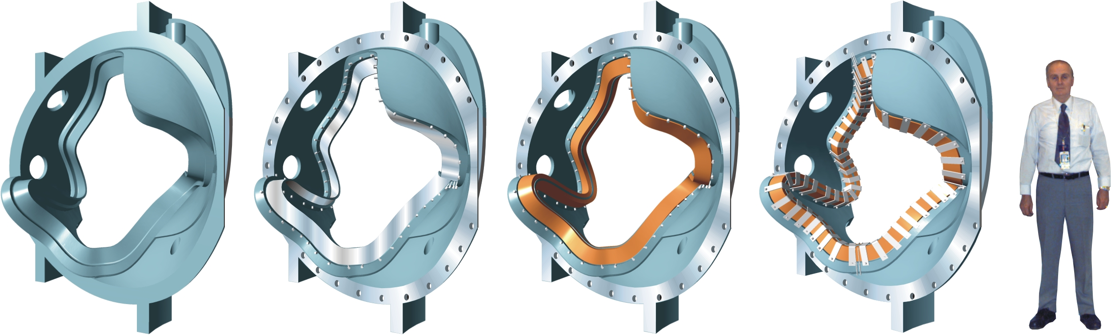
Figure 1-1 Typical Machined Modular Coil Winding Form

Scope
This specification establishes the manufacturing and acceptance requirements for the National Compact Stellarator Experiment (NCSX) Modular Coil Winding Forms. There are three different types of Winding Forms, identified as type A, B, and C.

Applicable Documents

Codes and Standards

American Society for Testing and Materials (ASTM) Documents
- A703/A703M-03 “Standard Specification for Steel Castings, General Requirements for Pressure Containing Parts”.
- A751-01 “Standards Test Methods, Practices, and Terminology for Chemical Analysis of Steel Products”.
- A800/A800M-01 “Standard Practice for Steel Casting, Austenitic Alloy, Estimating Ferrite Content Thereof”.
- A802/A802M–95 “Standard Practice for Steel Castings, Surface Acceptance Standards, Visual Examination”.
- A903/A903/M–99 “Standard Specification for Steel Castings, Surface Acceptance Standards, Magnetic Particle, and Liquid Penetrant Inspection”.

Manufacturers Standardization Society (MSS) of the Valve and Fittings Industry, Inc. Documents
- MSS SP-54-2001: “Quality Standard for Steel Castings for Valves, Flanges, Fittings, and Other Piping Components; Radiographic Inspection Method”.

Requirements Item Definition
The items covered by this Specification are Type A, Type B, and Type C winding forms. This includes the castings, all associated machining, all poloidal break hardware, and all associated processing, testing, quality control, documentation, packaging, and shipping.

Characteristics

Performance

Chemical Composition of the Casting Alloy and Weld Wire
The winding forms are to be cast from an alloy with its chemical composition being in accordance with Table 3-1. The chemical composition of the weld material shall comply with Table 3-3 for bare wire electrodes or Table 3-5 for covered electrodes.
 | C | Mn | Si | Cr | Ni | Mo | P | S | N
Min. % | .040 | 2.3 | -- | 18.0 | 13.0 | 2.1 | -- | -- | .24
Max. % | .070 | 2.8 | 0.7 | 18.5 | 13.5 | 2.5 | 0.035 | 0.025 | .28
Table 3-1 Weight % of Chemical Constituents in Casting Alloy
 | C | Mn | Si | Cr | Ni | Mo | P | S | Cu | N
Min. % | -- | 5.0 | -- | 19.0 | 15.0 | 2.5 | -- | -- | -- | --
Max. % | 0.03 | 9.0 | 1.0 | 22.0 | 18.0 | 4.5 | 0.03 | 0.02 | 0.3 | 0.3
Table 3-3 Weight % of Chemical Constituents of Bare Weld Wire

 | C | Mn | Si | Cr | Ni | Mo | P | S | Cu | N
Min. % | -- | 2.5 | -- | 16.5 | 14.0 | 2.5 | -- | -- | -- | 0.1
Max. % | 0.04 | 4.0 | 0.9 | 19.5 | 17.0 | 3.5 | 0.03 | 0.025 | 0.5 | 0.2
Table 3-5 Weight % of Chemical Constituents of Covered Welding Electrodes

Mechanical Properties of the Casting Alloy and Welding Material
The properties of the winding form casting alloy and welding material for each casting shall meet or exceed the mechanical properties requirements stated in Table 3-7. Note that the properties required are identical for casting alloy and weld material except for elongation.
Temperature | 77K | 293K
Elastic Modulus | 21 Msi (144.8 Gpa) | 20 Msi (137.9 Gpa)
0.2% Yield Strength | 72 ksi (496.4 Mpa) | 30 ksi (206.8 Mpa)
Tensile Strength | 95 ksi (655 Mpa) | 78 ksi (537.8 Mpa)
Elongation (Casting) | 32% | 36%
Elongation (Weld Material) | 25% | 28%
Charpy V – notch Energy | 35 ft. lbs. (47.4 J) | 50 ft-lbs (67.8 J)
Table 3-7 Minimum Mechanical Properties

Electrical Requirements for the Poloidal Electrical Break
The resistance of the mid-plane insulation and of the bolt insulation shall be >500 kohms when tested at 100 VDC.

Surface Finish
The two “L” machined surfaces of the tee must have a RMS (root mean square) surface finish <125 μ-inches. “Wing” areas will be finished by machining “guide grooves” and then grinding the peaks between the guide grooves to attain the required profile tolerance. In these locations, “scalloping” as shown in 1 shall be acceptable. All other machined surfaces must have a RMS (root mean square) surface finish <250 μ-inches. The finished part shall be free of sharp edges and burrs.

Grind line at something under high side of tolerance
To be within Minimum Tolerances
Figure 3-3 Wing Surface Finish Requirements

Relative Magnetic Permeability

Relative Magnetic Permeability of Winding Form
The local relative magnetic permeability of any point in the winding form (including the base metal and weld repairs) shall not exceed 1.02.

Relative Magnetic Permeability of Winding Form Fasteners and Miscellaneous Hardware
The local relative magnetic permeability of any modular coil fasteners and hardware shall not exceed 1.03.

External Defects

Visual Examination
Cast surfaces shall be free of visual external defects as defined in ASTM A802/A802M (using SCRATA graded reference comparators) Level III. Discontinuities not meeting the evaluation criteria shall be repaired per Section 3.2.3.2. (Repairs).

Liquid Penetrant Examination of Casting
Each casting shall be free of external defects as defined in ASTM A903/A903M Level II for as-cast areas and Level I for machined surfaces. Discontinuities not meeting the evaluation criteria shall be repaired per Section 3.2.3.2 (Repairs).

Liquid Penetrant Inspection of High Stress Regions
High stress areas, as defined in Appendix A (7.1), shall be free of external defects as defined in ASTM A903/A903M Level I when checked by liquid penetrant inspection. Discontinuities not meeting the evaluation criteria shall be repaired per Section 3.2.3.2.2.3 (Repairs in High Stress Areas).

Radiographic Inspection
Each casting shall be free of internal radiographic indications of defects as defined in MSS SP 54 for radiography. Defects exceeding these limits shall be repaired per Section 3.2.3.2 (Repairs).

Inspection for Internal Defects in the High Stress Areas
Each casting shall be free of internal defects exceeding 0.080” (major dimension) in the web region of the Tee in the High Stress Areas (as defined in Appendix A - 7.1 ) . Radiographic inspection or radiographic inspection in combination with ultrasonic (UT) inspections shall be used. Radiographic inspections shall be performed as defined in MSS SP 54. UT inspections shall be performed in accordance with procedures and personnel qualifications submitted to PPPL for approval prior to use. Defects exceeding these limits shall be repaired per Section 3.2.3.2 (Repairs) if performed prior to any significant amount of machining has been accomplished. Defects exceeding those limits which are identified after the winding form is significantly machined (i.e., within 0.25” of final dimensions) shall be reported on an NCR for evaluation. Repairs at that stage shall only be made if formally approved in the disposition of the NCR, and as defined in the NCR disposition.

Design and Construction

Production Drawings
These items shall be fabricated in accordance with the Pro/Engineer CAD files listed in Table 6-1. These files are located at the production winding form ftp site:
ftp://ftp.pppl.gov/pub/ncsx/manuf/production_winding_form

Dimensions and Tolerances

Measurement
Strict adherence to the dimensions and tolerances defined in the production drawings referenced in Section 3.2.1 is required. All dimensions are for 20 C; actual measurements shall be temperature compensated for 20 C. It should be noted that dimensional verification by CMM of the poloidal break bushing holes and break flanges is waived with Rev. 11 of this document. In lieu of this, a 0.002 inch “no-go” feeler gauge or pin gauge shall be used to verify that the fit-up of the polodial break flanges and bushings do not exceed this dimension.

Fiducials
The Supplier shall provide eighteen (18) or more permanent targets that are in known relationship to the CAD model of the winding form. Three (3) fiducials (spherical seats) shall be provided on each flange surface; four (4) targets shall be visible for each setup of machined features, and four (4) targets shall be visible from any exterior view of the winding form.

Standards of Manufacture

Heat Treatment
The casting shall be heat treated prior to final measurements of mechanical properties and relative magnetic permeability. In addition, stress relieving shall be performed after all major weld repairs (as defined in Section 3.2.3.2.2.2) and radiography (as defined in Section 3.1.1.7) is completed at the foundry. Minor weld repairs, as defined in Section 3.2.3.2.2.1, will be allowed without subsequent stress relief. The temperature and duration of the stress relieving process shall be reviewed and approved by PPPL. Heat treatment records shall be prepared and maintained as defined in S21 of ASTM Specification A703/A703M, and supplied to PPPL.

Repairs

Non-Weld Repairs
When defects are removed by grinding without violating minimum wall thickness requirements, the ground area shall be re-inspected by the original inspection method to verify complete defect removal. Discontinuities which are/will be completely removed during machining operations do not need to be weld repaired.

Weld Repairs
Weld repairs may be necessitated to (1) repair casting defects when defect removal involves excavation beyond wall thickness limitations or (2) to repair gouges or other machining errors. Welding procedure qualification tests shall include evidence of compliance with the magnetic permeability requirements of Section 3.1.1.5, as well as compliance with the mechanical properties listed in Table 3-7. Weld preparation shall be per Section S10 of ASTM Specification A703/A703M. Weld repairs must meet the inspection criteria of Sections 3.1.1.6 and 3.1.1.7.

Minor Weld Repairs
Weld repairs smaller than those defined in 3.2.3.2.2.2 below, as Major Weld Repairs, shall be welded in accordance with Section 3.2.3.2.2.

Major Weld Repairs
Repairs shall be considered major when the depth of the cavity prepared for welding exceeds 20 % of the actual wall thickness or 1 inch, whichever is smaller, or when the extent of the cavity exceeds approximately 10 in². Weld Maps (showing size and location as required by ASTM A703/A703M S20) shall be prepared for each major weld repair cycle. The weld map shall be delivered to PPPL no later than 24 hours after the start of welding. Major weld repairs during machining operations shall necessitate the issuance of a Non-Conformance Report to address the conditions that led to the need for welding. The weld repairs may proceed while the NCR is being dispositioned.

Repairs in High Stress Areas
Rejectable surface defects which are less than 0.125” in depth shall be eliminated by grinding. Rejectable surface defects which exceed this depth, as well as any rejectable subsurface defects shall be repaired per Section 3.2.3.2.2(Weld Repairs). The High Stress Areas are defined in Appendix A (7.1).

QUALITY ASSURANCE PROVISIONS

Responsibility for Inspection
The responsibility for performing all tests and verifications rests with the supplier. PPPL reserves the right to witness or separately perform all tests specified or otherwise inspect any or all tests and inspections.

Quality Conformance Inspections / VERIFICATIONS
The winding form shall be subject to all Quality Conformance Inspections listed below. However, the poloidal break shims shall only be subject to Section 4.2.1 (Verification of Chemical Composition), 4.2.4 (Verification of Surface Finish), 4.2.5 (Verification of Relative Magnetic Permeability), 4.2.6 (Verification of Dimensions and Tolerances), 4.2.7.1 (Visual Inspection), 4.2.7.2.2 (Post Machining Liquid Penetrant Inspection), and 4.2.8 (Inspection for Internal Defect).

Verification of Chemical Composition
The chemical composition of the casting alloy shall be measured for compliance with the requirements stated in Section 3.1.1.1 and shall be provided for each ladle used in each casting. The weighted average, per ASTM A751, is required to meet the chemistry of Table 3-1. The chemical composition for each lot of welding material shall also be reported to ensure compliance with the requirements in Section 3.1.1.1. If any of the ladles used deviates from the chemistry given in Table 3-1, a product analysis from the attached test specimens from each of the three zones may be required at PPPL’s discretion.

Verification of Mechanical Properties of the Casting Alloy and Weld Material
The mechanical properties of the casting alloy for each winding form must be verified by testing. The test specimens shall be fabricated from “attached specimens” which are located as near as possible to the winding form casting (or from a substitute approved in writing by PPPL). Properties must be verified for each of the 3 zones identified in Figure 4-4 below. The specimen material shall be heat treated simultaneously with the winding form; during the heat treatment this material shall be located adjacent to the zone from which it was derived in order to represent as closely as possible the properties of that material. Each specimen shall be engraved or cast with the casting number and zone to permit traceability. This data shall be supplied to PPPL within 30 days of the casting date. Test specimens are to be retained, with identification traceable to the test results, and provided to PPPL with the corresponding casting.

Zone 1
Zone 3
Zone 2

Figure 4-4 Definition of Zones for Test Specimens

Verification of Yield Strength and Elastic Modulus
The yield strength at 0.2% offset strain and the elastic (Young’s) modulus shall be verified for the cast stainless steel in the as heat-treated condition at room temperature and 77K for the three zones specified in Section 4.2.2 for each casting. Test specimen coupons shall be tested in accordance with ASTM A703/A703M-03, Paragraphs 6 and 7.

Verification of Ultimate Tensile Strength and Elongation
The ultimate tensile strength and elongation for the cast stainless steel in the as heat-treated condition at room temperature and 77K shall be verified for the three zones specified in Section 4.2.2 for each casting. Tensile test specimen coupons shall be tested in accordance with ASTM A703/A703M-03, Paragraphs 6 and 7.

Verification of Charpy V-Notch Energy
The Charpy V-Notch energy of the casting alloy at room temperature and 77K shall be measured for the three zones specified in Section 4.2.2 for each casting. Specimen coupons shall be cast and heat treated with each winding form and tested in accordance with ASTM A703/A703M-03, Paragraph 6.

Additional Test Material
Three samples at least 3” x 3” x 1” shall be provided for each zone of the casting. These test plates shall be attached to or part of the casting and shall be heat treated simultaneously with the casting. The test samples shall be located next to their corresponding zones of the casting so the heat treatment they receive are as near as possible to that of the casting. All supplied material shall be engraved or stamped with low stress stamps with the casting and zone as described in Section 4.2.2. These samples shall be shipped to PPPL where they will be archived for possible use in materials testing.

Weld Filler Material
The properties of Section 3.1.1.2 shall also be verified for each lot of the weld material at RT and 77K. Alternatively, measured properties (either provided by the material supplier or measured by the Subcontractor) can be provided as verification if material certifications for the weld wire can be provided which confirms that the material meets the weld wire manufacturer’s specified requirements.

Verification of the Electrical Properties of the Poloidal Break

Mid-Plane Insulation
The resistance of the mid-plane electrical insulation shall be measured for compliance with the requirements stated in Section 3.1.1.3. The insulation resistance between the mid-plane poloidal break shim and winding form shall be measured. During this test, the bolts should be in their normal state (i.e., electrically “floating”). The mid-plane shim shall be connected to one side of the megger, and the casting shall be connected to the other.

Bolt Insulation
All of the bolts shall be electrically connected (jumpered) together in one group. The mid-plane casting (shim) and the winding form shall be electrically connected together in a second group. The insulation resistance between the jumpered bolts (group 1) and the jumpered winding form and mid-plane (group 2) shall be measured for compliance with the requirements stated in Section 3.1.1.3

Verification of Surface Finish
All machined surfaces shall be inspected for compliance with surface finish requirements specified in Section 3.1.1.4. Either a surface profilometer or comparator can be used. Location and actual results shall be reported areas that do not comply with Section 3.1.1.4.

Verification of Relative Magnetic Permeability
All cast surfaces, features, fasteners, and hardware shall be checked with a calibrated Severn Permeability Indicator for compliance with Sections 3.1.1.5.1 and 3.1.1.5.2. Relative magnetic permeability that exceeds 1.02 must be documented on a nonconformance report and will require approval on a case-by-case basis. Permeability measurements shall be per Supplementary Requirements S24 of ASTM Spec. A703/A703M and S1 of ASTM A800/A800M, except that the results shall be expressed as relative permeability, μ, Mu, rather than ferrite content (FN).

Weld Repairs
Accessible weld repairs shall be checked at a minimum of 1 point per every 2 sq. in. of surface area or 3 points per repair, whichever is smaller.

Cast Surfaces
Relative magnetic permeability measurements shall be made on all surfaces of the final casting at locations approximately 6 inches apart (to approximate a 6 inch x 6 inch grid).

Machined Surfaces
To verify that cold work due to machining did not result in unacceptable levels of magnetic permeability, permeability checks shall be performed at 3 locations (2 on the vertical web; 1 on the base) along the machined “T” in alignment with every 5th hole along the top of the T.

      - Fasteners and Hardware
Fasteners and hardware shall be inspected at a minimum of 3 points per item.

Verification of Dimensions and Tolerances
All cast surfaces, machined surfaces and features such as holes, ports, supports, etc. shall be dimensionally checked to assure compliance with Section 3.2.2. Cast surfaces shall be checked at 50 locations on the outer cast surfaces and 50 locations on the inner cast surfaces of the shell at locations roughly equally spaced to permit the generation of an “as built” model. Machined surfaces shall be checked.in a defined pattern provided in revised drawings included in Table 6-9, Table 6-11, and Table 6-13 to reflect this guidanX
For C3-C6, the measurements shall be made in the same manner they were made for C2: i.e. with measurements taken to approximate a 2” x 2” grid; features such as holes, ports, supports, etc. shall be verified per standard machine shop practices. On the winding tee flange, where a 2” x 2” grid would result in a single line of measurements, a minimum of 2 readings (two lines of measurements) shall be recorded.
The adequacy of the ground clear space dimension at the base of the T shall be verified using the pattern shown in Figure 7-14 of Appendix B (Section 7.2).

Inspection for External Defects

Visual Inspection
All of the casting features shall be inspected to assure compliance with Section 3.1.1.6.1 (Visual Inspection).

Liquid Penetrant Inspections.

General Liquid Penetrant Inspection
All surfaces of the casting shall be liquid penetrant inspected to assure compliance with Section 3.1.1.6.2 (Liquid Penetrant Examination of Casting) (ASTM A903 Level II). Certified test reports shall be per ASTM A903, Supplementary Requirement S1. Surfaces shall be prepared by abrasive blast per standard foundry procedures.

Post Machining Liquid Penetrant Inspection
All machined surfaces shall be liquid Penetrant inspected to assure to assure compliance with Section 3.1.1.6.2 (Liquid Penetrant Examination of Casting) (ASTM A903 Level I). Certified test reports shall be per ASTM A903, Supplementary Requirement S1.

Inspection for Internal Defects
Each casting shall be examined for internal defects as defined in ASTM Spec. A703/A703M using radiographic inspection per Supplementary Requirement S5. Penetrameters shall be used to demonstrate a sensitivity of at least 2% of the thickness being measured. Acceptance criteria shall be as defined in Section3.1.1.7.
.

Preparation for delivery

Marking
Each winding form shall have the supplier's name, a serial number (drawing number and a unique identifier), and the part weight engraved or stamped with characters ¼ inches high. The marking shall be located as shown in the part drawing.

Cleaning
The winding forms shall be degreased/cleaned using a solvent which must be able to dissolve grease, oils and other soils, and leave the casting residue free. No chips, burrs, oil, etc. shall remain in any of the tapped holes.

Crating
The crate shall protect the winding form from shock and weather conditions, including precipitation. The crate shall be built for moving on rollers, handling with slings from overhead cranes, and transport by forklifts. The part shall be totally wrapped with a plastic protective film.

Shipping
Supplier is responsible for arranging shipment, and for the safe arrival of each winding form at PPPL in Princeton, New Jersey, USA. Subcontractor’s name, shipper, purchase order number, contents and gross weight shall be marked on the shipping container.

Tables of Approved Models/drawings and deviations

TableS of Models and Drawings
e provides the complete listing of zip files which includes all the approved drawings, ProE models, and STEP files. They can be found on the Supplier FTP site at:
ftp://ftp.pppl.gov/pub/ncsx/manuf/production_winding_form
Table 6-9 Production Modular Coil Winding Form Models and Drawings
ZIP File | Model Description (from Pro/Intralink database, edited)
production_mcwf_proe Rev6.zip | ZIP file containing all ProE models for the winding forms.
production_mcwf_stp_ Rev6.zip | ZIP file containing all STEP files for the winding forms.
production_mcwf_pdf_ Rev6.zip | ZIP file containing all pdf drawing files.
Note: Filename indicates revision of Zip File only. Revision numbers of drawings/files within the Zip File are indicated by the individual filename of each drawing/file. 2 lists all the drawings and their applicable revision number.
Table 6-11 Updated Drawings List
DRAWING NO. | REV | REL DATE | MODEL NO. | DESCRIPTION
SE141-101 | 2 | 8/5/05 | SE141-101 | MOD COIL WINDING FORM ASM TYPE-A
SE141-102 | 2 | 8/5/05 | SE141-102 | MOD COIL WINDING FORM ASM TYPE-B
SE141-103 | 3 | 11/18/05 | SE141-103 | MOD COIL WINDING FORM ASM TYPE-C
SE141-048 | 1 | 9/23/04 | SE141-048 | POL BREAK SHIM ASM TYPE-A
SE141-058 | 1 | 9/23/04 | SE141-058 | POL BREAK SHIM ASM TYPE-B
SE141-078 | 2 | 11/18/05 | SE141-078 | POL BREAK SHIM ASM TYPE-C
DS141-036 | 2 | 11/18/05 | SE141-036 | STUD, 1.375-6UNC-2A X 9.5 LG
DS141-038 | 0 | 7/20/04 | SE141-038 | INSULATING WASHER - OBSOLETE
DS141-060 | 1 | 11/18/05 | SE141-060 | NUT, 12PT HEX 1.375-6UNC-2B
DS141-079 | Deleted | N/A | SE141-079 | WASHER, 2.75 OD X 1.66 ID X 0.5 THK
SE141-114 | 5 | 8/5/05 | SE141-114 | PRODUCTION WINDING FORM TYPE-A
SE141-115 | 5 | 8/5/05 | SE141-115 | PRODUCTION WINDING FORM TYPE-B
SE141-116 | 7 | 11/18/05 | SE141-116 | PRODUCTION WINDING FORM TYPE-C
SE141-137 | 0 | 11/18/05 | SE141-137 | MCWF POL BREAK BEARING PLATE
SE141-138 | 0 | 11/18/05 | SE141-138 | MCWF POL BREAK BEARING PLATE
Table 6-13 List of Updated Step Files
DRAWING NO. | REV | REL DATE | MODEL NO. | DESCRIPTION
SE141-101 | 2 | 8/5/05 | SE141-101 | MOD COIL WINDING FORM ASM TYPE-A
SE141-102 | 2 | 8/5/05 | SE141-102 | MOD COIL WINDING FORM ASM TYPE-B
SE141-103 | 3 | 11/18/05 | SE141-103 | MOD COIL WINDING FORM ASM TYPE-C
SE141-048 | 1 | 9/23/04 | SE141-048 | POL BREAK SHIM ASM TYPE-A
SE141-058 | 1 | 9/23/04 | SE141-058 | POL BREAK SHIM ASM TYPE-B
SE141-078 | 2 | 11/18/05 | SE141-078 | POL BREAK SHIM ASM TYPE-C
DS141-036 | 2 | 11/18/05 | SE141-036 | STUD, 1.375-6UNC-2A X 9.5 LG
DS141-038 | 0 | 7/20/04 | SE141-038 | INSULATING WASHER - OBSOLETE
DS141-060 | 1 | 11/18/05 | SE141-060 | NUT, 12PT HEX 1.375-6UNC-2B
DS141-079 | Deleted | N/A | SE141-079 | WASHER, 2.75 OD X 1.66 ID X 0.5 THK
SE141-114 | 5 | 8/5/05 | SE141-114 | PRODUCTION WINDING FORM TYPE-A
SE141-115 | 5 | 8/5/05 | SE141-115 | PRODUCTION WINDING FORM TYPE-B
SE141-116 | 7 | 11/18/05 | SE141-116 | PRODUCTION WINDING FORM TYPE-C
SE141-137 | 0 | 11/18/05 | SE141-137 | MCWF POL BREAK BEARING PLATE
SE141-138 | 0 | 11/18/05 | SE141-138 | MCWF POL BREAK BEARING PLATE

Table of approved deviations
Table 6-14 Approved Deviations
Deviation Number | Description | Date Approved | Impacted Documents
NCSX-RFD-14-001 | RFD-14-001, Revised Location of Part Number in MCWF Casting | 3/30/2005 | Drawing SE-141-114 shows the reference location of the pattern/casting identification number for Type A coils. No change in that drawing is planned, at least not until all of the Type A coils are fabricated.
NCSX-RFD-14-002 | RFD-14-002, Change in dimensional inspection for C1 casting. | 4/15/2005 | Deleted MIT/QA Plan second dimensional inspection – deemed redundant.
NCSX-RFD-14-003 | RFD-14-003, Relaxation of material testing requirements | 6/8/2005 | Deleted requirement in CSPEC to test material in the transverse and longitudinal direction.
NCSX-RFD-14-005 | RFD-14-005, For C1 only -Waiver of Post Machining Inspection for Internal Defects in High Stress Area & Radiography on Weld Repair | 9/15/2005 | Approved for C1 Casting Only.
NCSX-RFD-14-006 | RFD-14-006, Deletion of Erroneous Requirement in Section 3.1.1.6.1 of the Modular Coil CSPEC (NCSX-CSPEC-141-03) | 9/15/2005 | Approved. Revision 10 to CSPEC incorporated this change.
NCSX-RFD-14-008 | RFD-14-008, C! Casting - Add Additional G11CR Shim Pieces for the Poloidal Break | 9/22/2005 | Approved for C1 Only. Revision 10 to CSPEC incorporated this change for rest of castings.
NCSX-RFD-14-009R1 | RFD-14-009R1, Proposed Drawing Changes Resulting from Inspection of C1 Casting at PPPL | 10/24/2005 | Approved. Revision 10 to CSPEC incorporated this change.
NCSX-RFD-14-010 | RFD-14-010, Material Change for Terminal Lugs for MCWF | 12/14/2005 | Approved. Drawings updated to reflect this change.
NCSX-RFD-14-011 | RFD-14-011, Change in Magnetic Permeability for MCWF Fasteners and Miscellaneous Hardware | 12/20/2005 | Approved. Revision 11 to CSPEC incorporates this change

APPENDICES

Appendix A: Identification Of High Stress Regions For Production MCWF
Figure 7-6, Figure 7-8 , Figure 7-10, F, and Table 7-16 of this appendix identify the high stress areas and show a numbering scheme for the 3/8-16UNC tapped holes in the tee. Per the proposal of Major Tool, every tenth hole shall be identified by etching. The high stress region shall be identified as the web of the “tee” cross-section.
The base of the “tee” cross-section in all regions where the minimum machined thickness is < 2” between profile points “P” and “Q” on Detail A, Sheet 2 of drawings SE141-114 (shown below for illustrative purposes) , SE141-115, and SE141-116, that is located in between the hole numbers shown in Table 7-16 or be or between the coordinates shown in Figure 7-6 (for type C for illustration only) and Table 7-16.

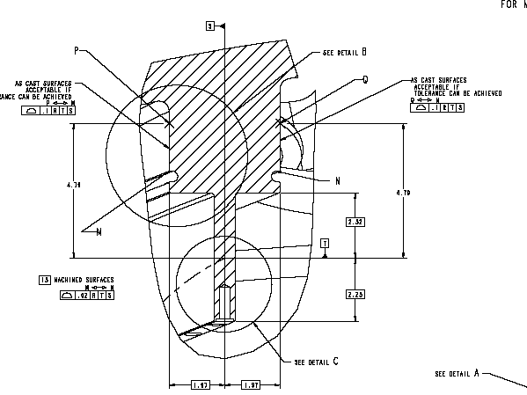
The profile of the high stress region is shown in red. (Type C shown in illustration).

Figure 7-6 – Identification of High Stress Zones

MCWF Type | Hole No. (Start) | Hole No. (End)
C (Fig. 1) | 45 | 65
B (Fig. 2) | 55 | 75
A (Fig. 3) | 20 | 35
Table 7-16 Definition of High Stress Region Based on Flange Hole Numbers

The figures also show approximate dimensions, including ½-in. stock material allowance, from the flat surfaces of the casting to the start and end locations. These dimensions shall be used to identify the high stress regions prior to machining. Figure 7-8 (Type C), Figure 7-10 (Type B), and F (Type A) depict the high stress region identification for each type casting.

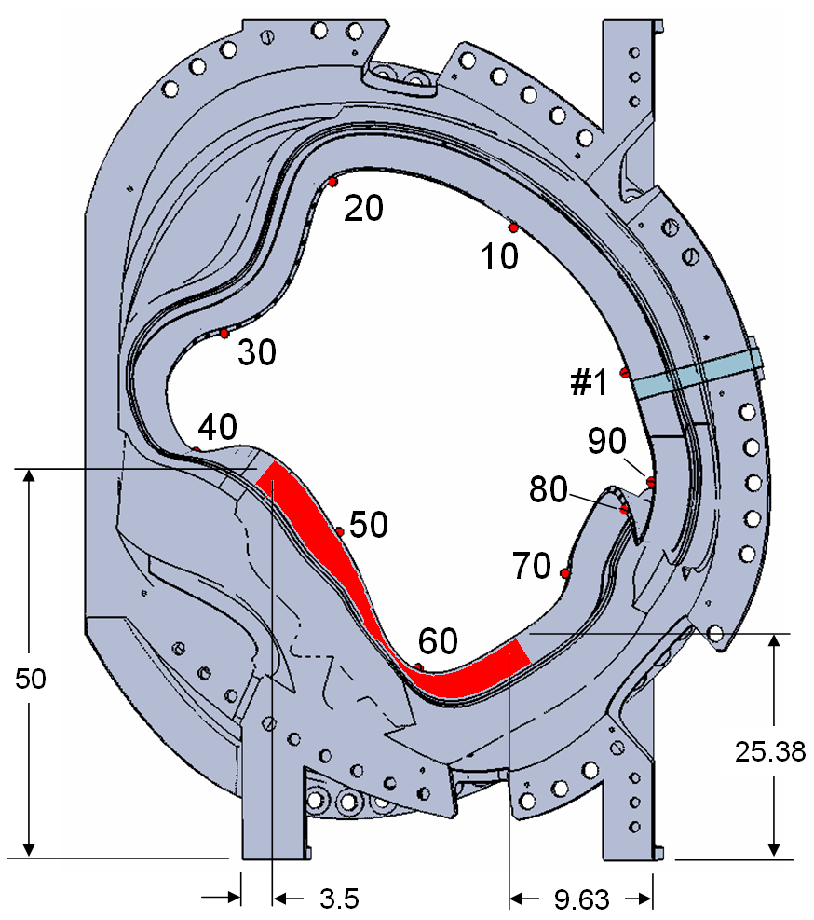
Figure 7-8 – High Stress Region Identification for Type-C MCWF

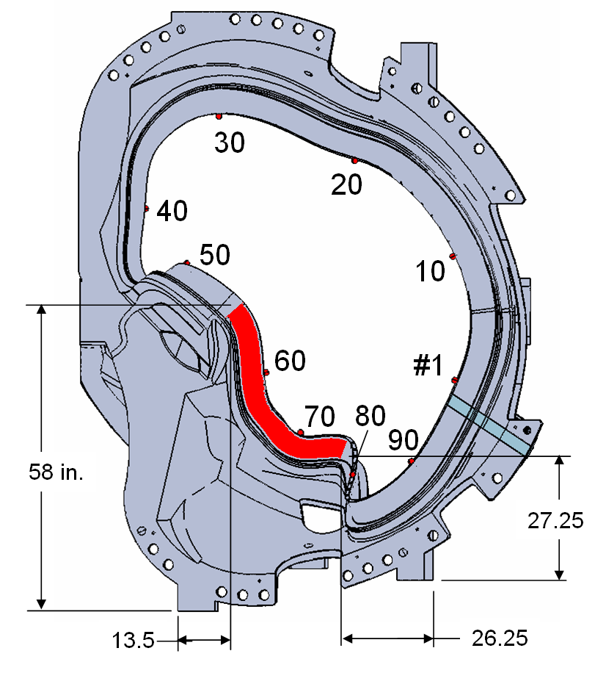
Figure 7-10 – High Stress Region Identification for Type-B MCWF

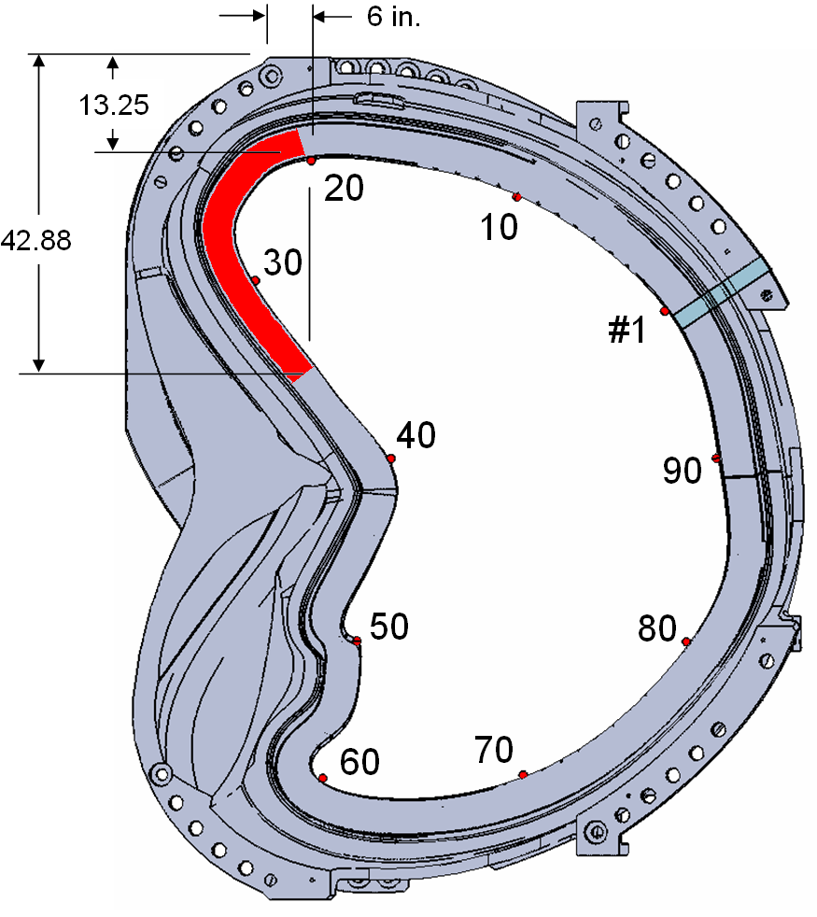

F

igure 7-13 High Stress Region Identification for Type-A MCWF

Appendix B: Verification Of The Ground Clear Space Dimension

Figure 7-14 below shows the revised T-Base Grinding Template to be used for verifying the ground clear space dimension of the Type A and Type B winding forms. The template shall be used along the entire length of the T.
Figure 7-14 T-Base Grinding Template
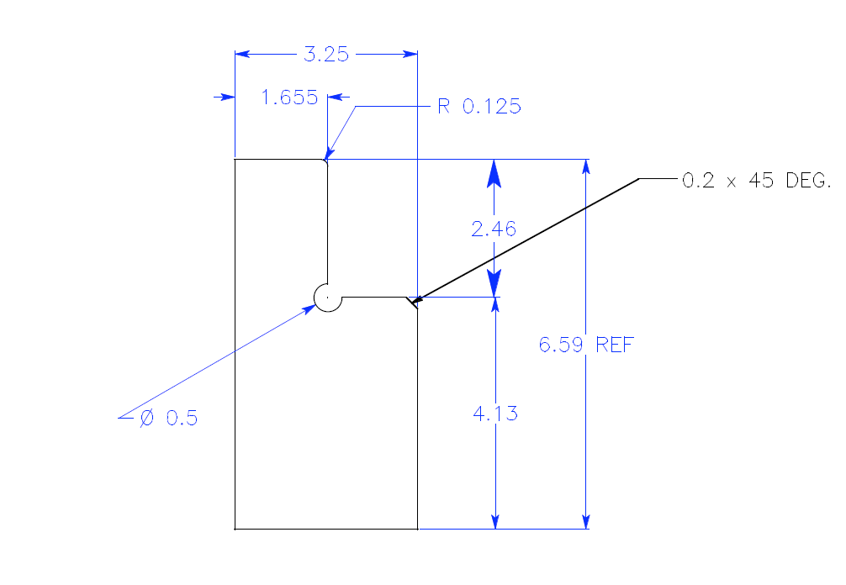

Publications are available from http://www.astm.org/cgi-bin/SoftCart.exe/index.shtml?E+mystore.
Publications are available from Manufacturers Standardization Society of the Valve and Fittings Industry, Inc., 127 Park Street, NE, Vienna, Virginia 22180p, Tel. (703)-281-6613.

