NATIONAL COMPACT STELLARATOR PROJECT
Engineering Change Proposal (ECP)
COVER PAGE
(TO BE COMPLETED BY SYSTEMS ENGINEERING SUPPORT MANAGER)
Originator: Ron Strykowsky |  |  | Date: June 8, 2006
ECP No: 045 |  | ECP Title: May 2006 PMB Update
Required Reviewers
Required Reviewers for this ECP: Hutch Neilson, Wayne Reiersen, Brad Nelson, Larry Dudek, Mike Williams

ECP Approval Level
Expedited ECP? Yes No
Change Level:
Approving Official:
Actions
Update PMB by June 9, 2006 (see Greg’s comments of 6/8) – do use this ECP to status May or ECP-043?
APPROVALS
(TO BE COMPLETED BY APPROVING OFFICIALS)
Change Level | Approving Official |  | Approval? | Signature
3 | NCSX Project Manager |  | Yes No
3a  (Expedited ECP) | NCSX Engineering Manager |  | Yes No
2 | NCSX Federal Project Director |  | Yes No
1 | Associate Director OFES |  | Yes No
0 | Deputy Secretary of Energy |  | Yes No

NATIONAL COMPACT STELLARATOR PROJECT
Engineering Change Proposal (ECP)
ECP-045
PART I
(TO BE COMPLETED BY ORIGINATOR)
Originator: Ron Strykowsky | Date: June 8, 2006
Overview of Change

Type of ECP: EXPEDITED STANDARD

Type of Change: TECHNICAL COST SCHEDULE EDITORIAL

(Check all that Apply)

Reason for Change: Update of costs to date plus update of estimate to complete.

Impacted WBS Elements: ALL WBS Elements

Impacts of Change (Briefly Describe): Re-align the project PMB (BCWS) by recognizing;
- The additional cost incurred for retired risk ($510k);
- Re-evaluated scope requirements including estimates for future scope (net +$39k); and
- Realigning the project schedule consistent with estimated cost to complete.

This change requires the drawdown of $549k of contingency from $8,720k to $8,171k. It should be noted that while the Project expects a credit for FY2006 end-of-year rate changes, this has not been taken into account in this ECP.

This change does not impact Level I or II milestones. The project total float has increased from 5 to 6 month as a result of schedule optimizations.

Much of the cost increases documented in this ECP were offset by non-CD-4 scope reductions primarily in the I&C and electrical power systems. To ensure that the required safeguards and vigilance to the CD-4 deliverables is met the project has drafted a "Safe startup and Control" plan. This plan depicts those controls, actions, documents, sub-system procedures, ES&H requirements necessary to meet the CD-4 requirements for the Stellarator Acceptance Testing and Magnetic Configuration Studies phase of the NCSX Project.

Does this Change Impact Material Already Procured or Parts/Assemblies Already Assembled/Manufactured using this Material: Yes No

NATIONAL COMPACT STELLARATOR PROJECT
Engineering Change Proposal (ECP)
ECP-045
PART I
(TO BE COMPLETED BY ORIGINATOR)
Originator: Ron Strykowsky | Date: June 8, 2006
Detailed Description of the Change:
(Use Continuation Sheets and/or Attach Information/Sketches, As Needed)

List Attachments, Impacted Documents, etc.
1) Detailed resource loaded schedule
2) ECP-43 vs ECP-45 budget comparison table

Description of Change:
WBS Total Change
Unrecoverable Cost Variances Estimate to Complete Change
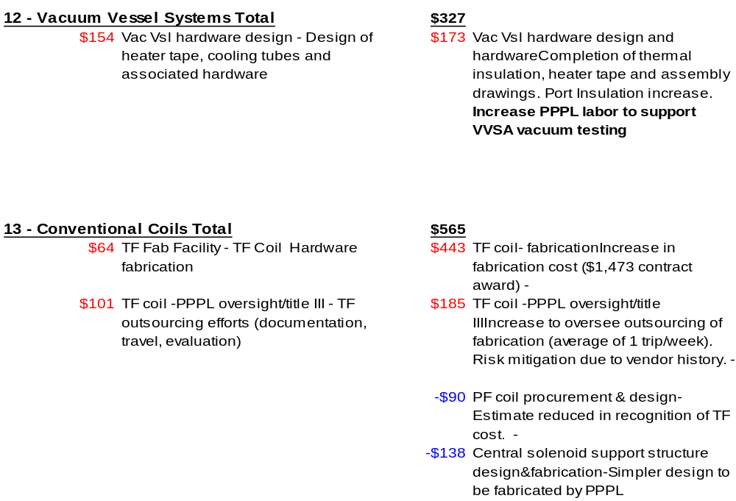

NATIONAL COMPACT STELLARATOR PROJECT
Engineering Change Proposal (ECP)
ECP-045
PART I
(TO BE COMPLETED BY ORIGINATOR)
Originator: Ron Strykowsky | Date: June 8, 2006
Continuation Sheet:

Description of Change:
WBS Total Change
Unrecoverable Cost Variances Estimate to Complete Change

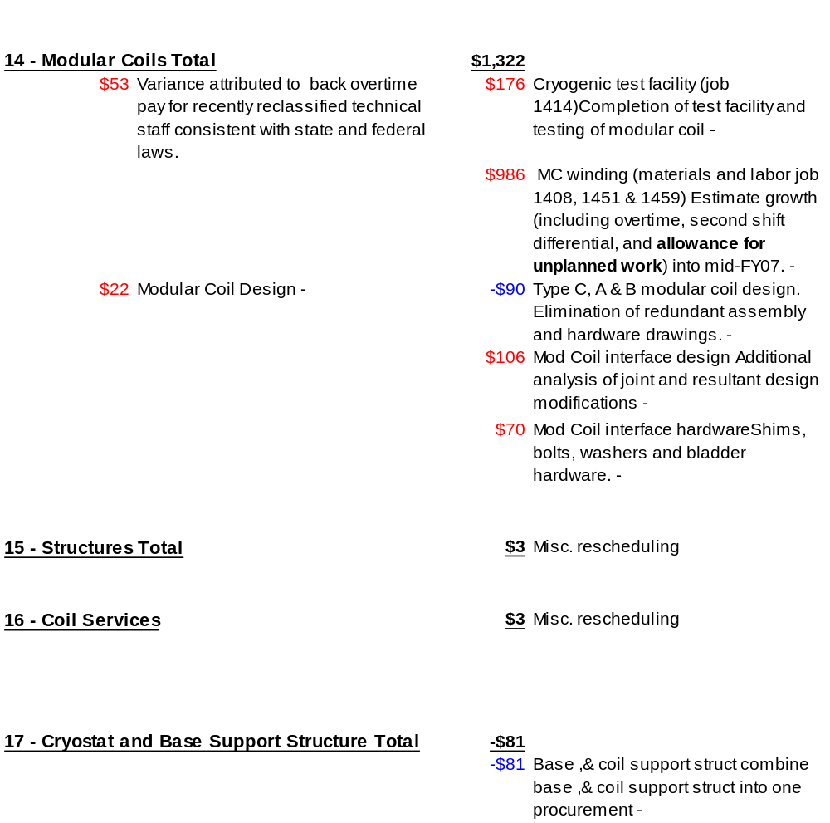

NATIONAL COMPACT STELLARATOR PROJECT
Engineering Change Proposal (ECP)
ECP-045
PART I
(TO BE COMPLETED BY ORIGINATOR)
Originator: Ron Strykowsky | Date: June 8, 2006
Continuation Sheet:

Description of Change:
WBS Total Change
Unrecoverable Cost Variances Estimate to Complete Change

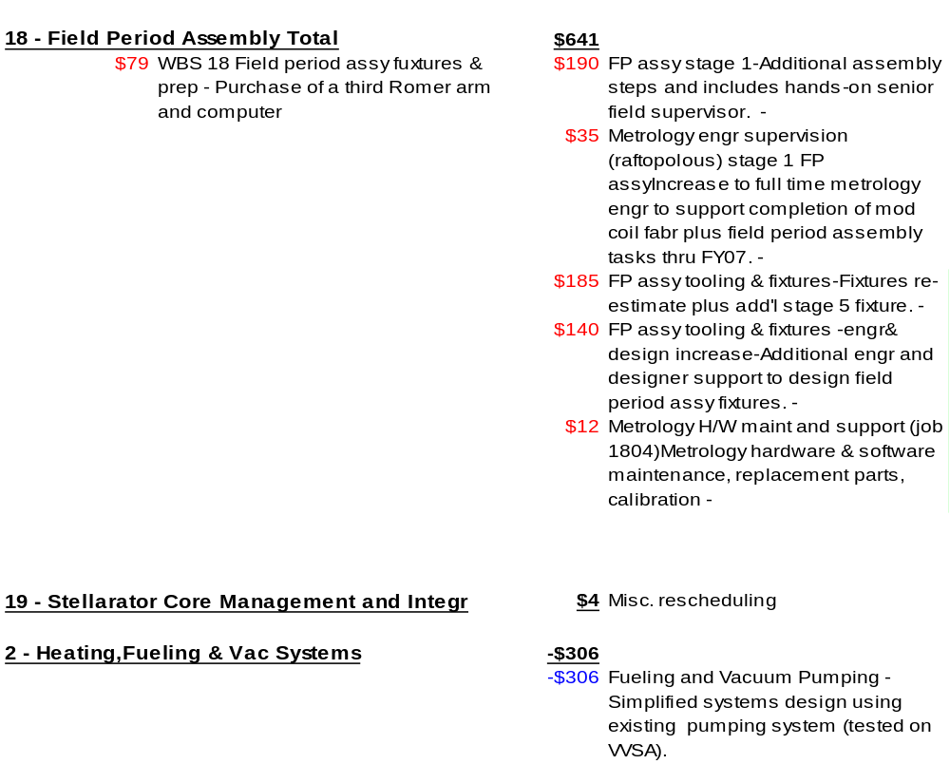

NATIONAL COMPACT STELLARATOR PROJECT
Engineering Change Proposal (ECP)
ECP-045
PART I
(TO BE COMPLETED BY ORIGINATOR)
Originator: Ron Strykowsky | Date: June 8, 2006
Continuation Sheet:
Description of Change:
WBS Total Change
Unrecoverable Cost Variances Estimate to Complete Change

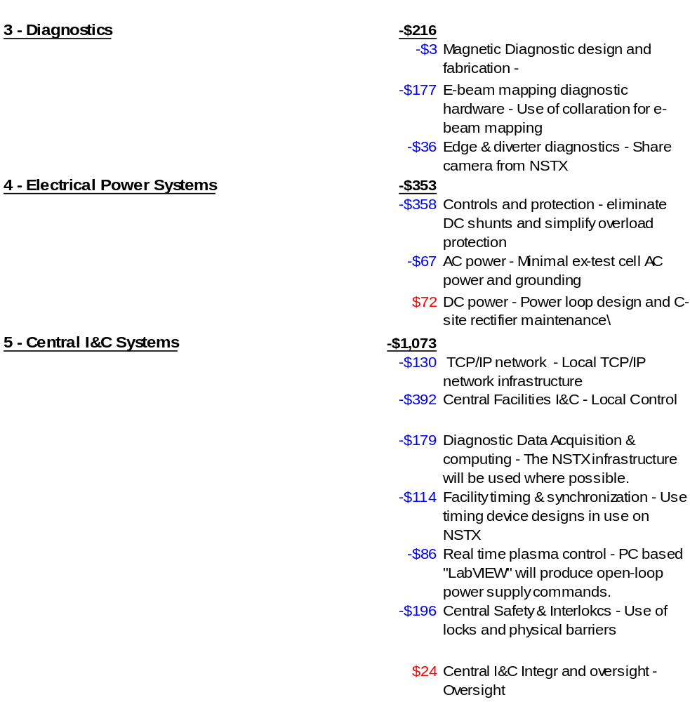

NATIONAL COMPACT STELLARATOR PROJECT
Engineering Change Proposal (ECP)
ECP-045
PART I
(TO BE COMPLETED BY ORIGINATOR)
Originator: Ron Strykowsky | Date: June 8, 2006
Continuation Sheet:

Description of Change:
WBS Total Change
Unrecoverable Cost Variances Estimate to Complete Change


