NATIONAL COMPACT STELLARATOR PROJECT
Engineering Change Proposal (ECP)
COVER PAGE
(TO BE COMPLETED BY SYSTEMS ENGINEERING SUPPORT MANAGER)
Originator: Ron Strykowsky |  |  | Date: June 13, 2006
ECP No: 045 |  | ECP Title: May 2006 PMB Update
Required Reviewers
Required Reviewers for this ECP: Hutch Neilson, Wayne Reiersen, Brad Nelson, Larry Dudek, Mike Williams

ECP Approval Level
Expedited ECP? Yes No
Change Level:
Approving Official:
Actions
Update PMB
APPROVALS
(TO BE COMPLETED BY APPROVING OFFICIALS)
Change Level | Approving Official |  | Approval? | Signature
3 | NCSX Project Manager |  | Yes No
3a  (Expedited ECP) | NCSX Engineering Manager |  | Yes No
2 | NCSX Federal Project Director |  | Yes No
1 | Associate Director OFES |  | Yes No
0 | Deputy Secretary of Energy |  | Yes No

NATIONAL COMPACT STELLARATOR PROJECT
Engineering Change Proposal (ECP)
ECP-045
PART I
(TO BE COMPLETED BY ORIGINATOR)
Originator: Ron Strykowsky | Date: June 13, 2006
Overview of Change

Type of ECP: EXPEDITED STANDARD

Type of Change: TECHNICAL COST SCHEDULE EDITORIAL

(Check all that Apply)

Reason for Change: Update of costs to date plus update of estimate to complete.

Impacted WBS Elements: ALL WBS Elements

Impacts of Change (Briefly Describe): Re-align the project PMB (BCWS) by recognizing;
- The additional cost incurred for retired risk ($510k);
- Re-evaluated scope requirements including estimates for future scope (net +$39k); and
- Realigning the project schedule consistent with estimated cost to complete.

This change requires the drawdown of $549k of contingency from $8,720k to $8,171k. It should be noted that while the Project expects a credit for FY2006 end-of-year rate changes, this has not been taken into account in this ECP.

This change does not impact Level I or II milestones. The project total float has increased from 5 to 6 month as a result of schedule optimizations.

Much of the cost increases documented in this ECP were offset by non-CD-4 scope reductions primarily in the I&C and electrical power systems. To ensure that the required safeguards and vigilance to the CD-4 deliverables is met the project has drafted a "Safe startup and Control" plan. This plan depicts those controls, actions, documents, sub-system procedures, ES&H requirements necessary to meet the CD-4 requirements for the Stellarator Acceptance Testing and Magnetic Configuration Studies phase of the NCSX Project.

Additionally, safety implications for both personnel and machine operations (including subsystems protection) will be addressed in subsequent design reviews for all subsystems. These reviews will include ES&H professionals as well as experienced PPPL machine operators to ensure the reliable and safe operability of the NCSX device.

NATIONAL COMPACT STELLARATOR PROJECT
Engineering Change Proposal (ECP)
ECP-045
PART I
(TO BE COMPLETED BY ORIGINATOR)
Originator: Ron Strykowsky | Date: June 13, 2006
Detailed Description of the Change:
(Use Continuation Sheets and/or Attach Information/Sketches, As Needed)

Does this Change Impact Material Already Procured or Parts/Assemblies Already Assembled/Manufactured using this Material: Yes No

List Attachments, Impacted Documents, etc.
1) Detailed resource loaded schedule
2) ECP-43 vs ECP-45 budget comparison table

Description of Change:
WBS Total Change
Unrecoverable Cost Variances Estimate to Complete Change
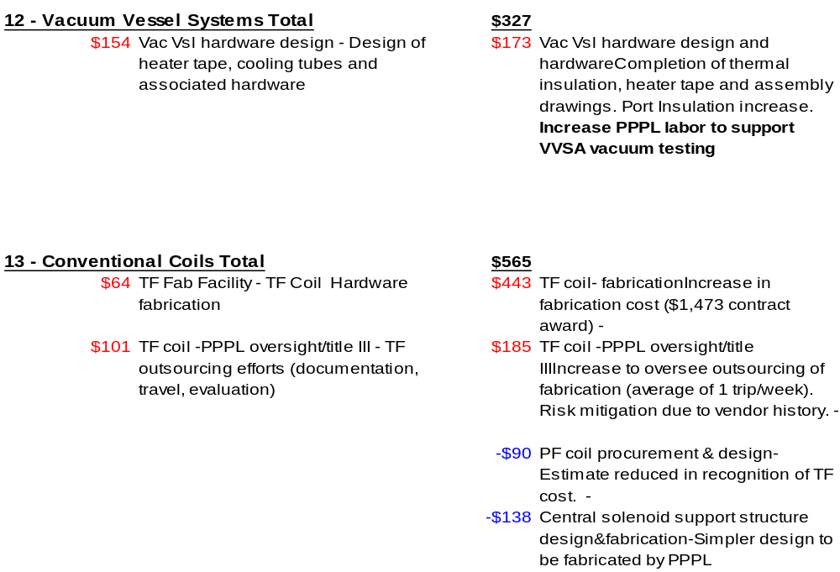

NATIONAL COMPACT STELLARATOR PROJECT
Engineering Change Proposal (ECP)
ECP-045
PART I
(TO BE COMPLETED BY ORIGINATOR)
Originator: Ron Strykowsky | Date: June 13, 2006
Continuation Sheet:

Description of Change:
WBS Total Change
Unrecoverable Cost Variances Estimate to Complete Change

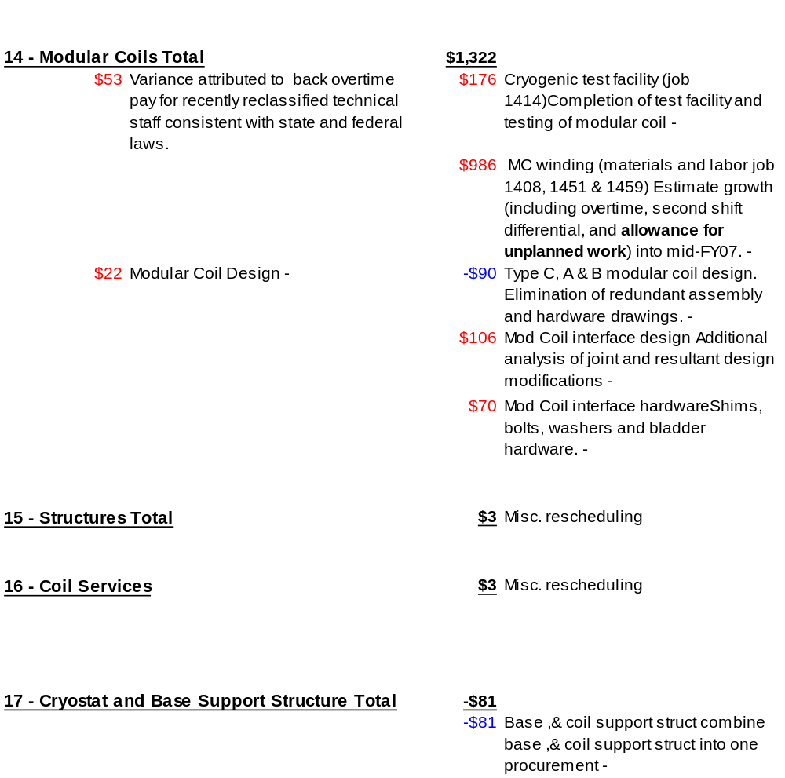

NATIONAL COMPACT STELLARATOR PROJECT
Engineering Change Proposal (ECP)
ECP-045
PART I
(TO BE COMPLETED BY ORIGINATOR)
Originator: Ron Strykowsky | Date: June 13, 2006
Continuation Sheet:

Description of Change:
WBS Total Change
Unrecoverable Cost Variances Estimate to Complete Change

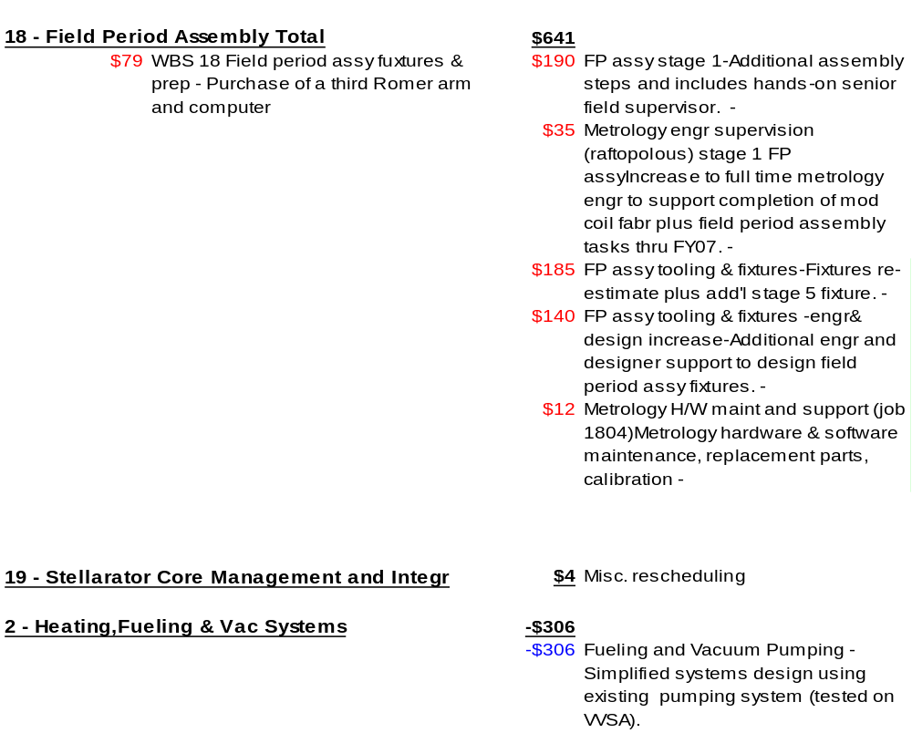

NATIONAL COMPACT STELLARATOR PROJECT
Engineering Change Proposal (ECP)
ECP-045
PART I
(TO BE COMPLETED BY ORIGINATOR)
Originator: Ron Strykowsky | Date: June 13, 2006
Continuation Sheet:
Description of Change:
WBS Total Change
Unrecoverable Cost Variances Estimate to Complete Change

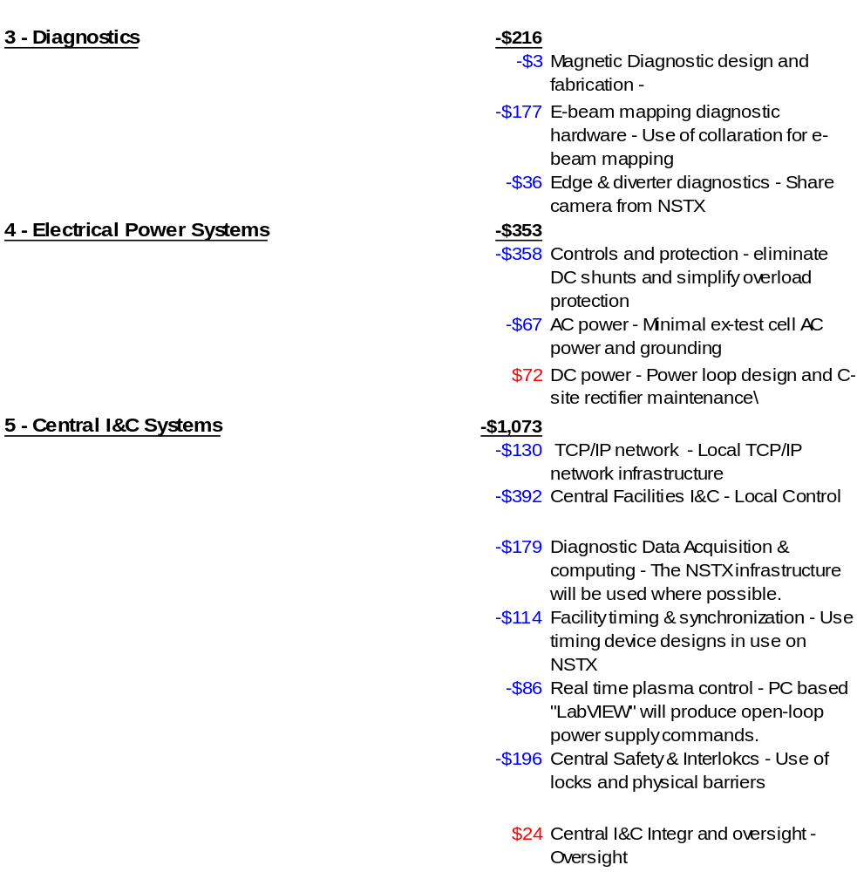

NATIONAL COMPACT STELLARATOR PROJECT
Engineering Change Proposal (ECP)
ECP-045
PART I
(TO BE COMPLETED BY ORIGINATOR)
Originator: Ron Strykowsky | Date: June 13, 2006
Continuation Sheet:

Description of Change:
WBS Total Change
Unrecoverable Cost Variances Estimate to Complete Change


