NATIONAL COMPACT STELLARATOR PROJECT
Engineering Change Proposal (ECP)
COVER PAGE
(TO BE COMPLETED BY SYSTEMS ENGINEERING SUPPORT MANAGER)
Originator: R.Strykowsky |  |  | Date: August 22,2008
ECP No: 60 |  | ECP Title: NCSX MIE Project Closeout
Required Reviewers
Required Reviewers for this ECP: D.Rej, H.Neilson, R.Simmons, P.Heitzenroeder, L.Dudek, J.Harris

ECP Approval Level
Expedited ECP? Yes No
Change Level: 0 - Deputy Secretary of Energy
Approving Official: Deputy Secretary of Energy
Actions
1. Accept proposed closeout plan as proposed (DOE)
2. Execute closeout plan (PPPL/ORNL)

APPROVALS
(TO BE COMPLETED BY APPROVING OFFICIALS)
Change Level | Approving Official |  | Approval? | Signature
3 | NCSX Project Manager |  | Yes No
3a  (Expedited ECP) | NCSX Engineering Manager |  | Yes No
2 | NCSX Federal Project Director |  | Yes No
1 | Associate Director OFES |  | Yes No
0 | Deputy Secretary of Energy |  | Yes No

NATIONAL COMPACT STELLARATOR PROJECT
Engineering Change Proposal (ECP)
PART I
(TO BE COMPLETED BY ORIGINATOR)
ECP-60
Originator: R.Strykowsky | Date: August 22,2008
Overview of Change

Type of ECP: EXPEDITED STANDARD

Type of Change: TECHNICAL COST SCHEDULE EDITORIAL

(Check all that Apply)

Reason for Change: Project Cancellation

Impacted WBS Elements: All

Impacts of Change (Briefly Describe):
NCSX MIE Project cancelled as directed by DOE. Remaining work (as defined in attached) required to bring work efforts to an orderly conclusion, which includes new scope of safeguarding acquired project assets and documentation closeout.

Project TEC reduced from $92.4M to $92.0M
Project OPC increased from $9.6M to $10.0M
Project TPC unchanged at $102.0M
CD-4 date unchanged at July, 2009. Scope changed as described herein.

Does this Change Impact Material Already Procured or Parts/Assemblies Already Assembled/Manufactured using this Material: Yes No

If “Yes”, what is the recommended disposition of this material/part/assembly? Fabricated and procured parts and hardware will be inventoried, collected and stored in a protected defined area.

Assessment of Other Options: Parts and fabricated hardware to be stored for future disposition and not sold for scrap value at this time.

NATIONAL COMPACT STELLARATOR PROJECT
Engineering Change Proposal (ECP)
PART I
(TO BE COMPLETED BY ORIGINATOR)
Originator: R.Strykowsky
Detailed Description of the Change:
(Use Continuation Sheets and/or Attach Information/Sketches, As Needed)
List Attachments, Impacted Documents, etc.

1) WBS Element Description & Status at Closeout
2) CD4 Deliverables
3) WBS financial comparison chart between previous baseline (ECP-53) and this Closeout ECP
4) Closeout plan resource loaded schedule
5) Revised list of milestones
6) Decision memo from SC-1 to S-2 announcing project cancellation
Description of Change:
- Scope:
– Document work performed relative to the ECP-53 baseline
– Inventory and store all materiel and fabricated components
– Complete fabrication of 18 modular coils
– Complete fabrication of 18 toroidal field coils
– Complete coil structures final design review
– Complete the LN2 distribution system PDR, trim coil , and base structure FDR
– Complete subassembly of two half field period assemblies (HFPAs) & one HFPA trial fit-up test over vacuum vessel subassembly
- Document final status of CAD models, finite-element analyses, and all work packages, including open issues needing to be resolved in order to complete construction.
– Archive key project documents for long-term storage electronically, and make those documents readily accessible to the research community
– Prepare journal manuscripts on physics, engineering design, integration, R&D, fabrication, assembly, management, and lessons learned (OPC)
  - Closeout costs, e.g., subcontract claims, indirect changes
  - Organizational restructuring
- Costs & Budgets:
  - TEC
Costs through 5/31/08 ……....…...$82.7M
Estimate to Complete…..…………$9.4M
Current Baseline …….…..……...$92.4M
Revised Baseline…………………$92.0M
  - OPC
Current Baseline: ………….………$9.6M
Revised ……………………..……$10.0M
- Schedule: See attached resource-loaded schedule for early finish dates

ATTACHMENT 1 page 1/12

WBS ELEMENT DESCRIPTION & STATUS AT CLOSEOUT

1 Stellarator Core

Vacuum Vessel System (WBS 12)
The vacuum vessel was to have provided the vacuum boundary around the plasma suitable for high vacuum conditions; structural support for all internal hardware and access for auxiliary systems such as neutral beam injection and plasma diagnostics. The vacuum vessel was a highly shaped, three-period Inconel structure which approximately conforms to the plasma. Work included engineering design, R&D in support of design and fabrication, component procurement, and fabrication. Project scope and construction status at the end of the project are listed in Table 1.
Table 1: Vacuum Vessel System Scope
MIE Project Scope | Status at Closeout
Three vacuum vessel sub-assemblies, each consisting of a 120-degree shell sector, spacer, and associated ports | Complete
Heating and cooling hoses, with attachment hardware | Complete, except for following exceptions due to replacement of 11 reworked hoses (NCR3758) and connections loosened to correct instrumentation which needed troubleshooting. The following activities would need to be done if the Project were to be restarted.  VVSA-1: 2 connections (1hose) will need brazing + leak check; 5 lines will need leak check only  VVSA-2: 14 connections (7 hoses) will need brazing + leak check; 12 lines will need leak check only.  VVSA-3: 8 connections (4 hoses) will need brazing + leak check; 13 lines will need leak check only
Heating and cooling manifolds | Complete
Cryostat interface flanges | Preliminary design complete. Detail drawings not started. Scope cancelled.
Heater tapes | Complete
Supports | Design: 100% complete  100% of parts delivered  Not installed
Thermocouples and other instrumentation | Complete
Thermal insulation | Title-I & II design complete  100% of materials delivered  Some further design changes likely needed
ATTACHMENT 1 page 2/12

Conventional Coils (WBS 13)
The conventional coil systems scope included the fabrication of eighteen toroidal field (TF) coils, six poloidal field (PF) coils, forty-eight trim coils for control of low-order helical field harmonics, local instrumentation, and certain support structures. The TF coils are identical, and were to be installed equally spaced, providing flexibility in the magnetic configuration. TF coils were wound from copper conductor, assembled to steel support wedges, and vacuum impregnated with epoxy. They were designed to operate at the liquid nitrogen (LN2) cryogenic temperatures. The PF magnets produce the poloidal magnetic field within the NCSX device. These coils were to provide inductive current drive and plasma shape and position control. The coils were to be wound from copper conductor and vacuum impregnated with epoxy, and also designed to operate at the LN2 temperatures. Existing PF solenoids from the National Spherical Torus Experiment (NSTX) were to be utilized as the initial central solenoid for NCSX. Project scope and construction status at the end of the project are listed in Table 2.
Table 2: Conventional Coils Scope
MIE Project Scope | Status at Closeout
Design and fabrication of eighteen TF coil assemblies consisting of D-shaped coils assembled to wedge support pieces | Complete.
Design and fabrication of three pairs of PF ring coils. Central Solenoid will utilize existing PF-1a solenoid from NSTX | Final design complete; fabrication contract award was pending at time of Project cancellation.
Design and fabrication or procurement of trim coils required for MIE project. | Final design complete.
Fabrication and installation of local instrumentation for the conventional coils, e.g., thermocouples, strain gauges, RTDs, and voltage taps | Scope cancelled. Not started.
Fabrication and installation of the support structure for existing central solenoid coils, and procurement and installation of I&C for those coils | Final design of structure complete. Design of PF 1 interconnecting bus not done.

Modular Coils (WBS 14)
The modular coils consisted of eighteen complex-shaped coils supported on the interior surface of a toroidal shell structure. The coils were fabricated on 2700 kg castings made from a specially developed modified CF8M alloy named Stellalloy. There were three types of coils differing primarily in their shapes. The coils were fabricated from flexible copper cable conductor wound on the inner diameter of a support structure called a modular coil winding form (MCWF), and vacuum impregnated with epoxy. In the finished assembly, the modular coils were arranged in three identical field periods, each containing six coils, two of each type. The winding forms were joined together at their mating flanges to form a stiff toroidal structure when completed. The flange interfaces between the modular coils utilize a combination of electrically insulated custom-fitted friction shims, insulated bolts, and specially designed low distortion welded connections in some regions to provide strong, stable structural connections

ATTACHMENT 1 page 3/12

between the winding forms along with accurate coil positioning and an adequate electrical time constant to facilitate magnetic field penetration. The coils were designed to operate at LN2 cryogenic temperatures. Work included engineering design, R&D in support of design and fabrication, component procurement, tooling and fixtures, fabrication, and sub-assembly. Project scope and construction status at the end of the project are listed in Table 3. There were many challenges that were overcome during the coil winding process, one of the most significant was the metrology. In order to minimize islands in the toroidal flux to less than 10%, a tolerance in the positioning of the modular coil winding pack ± < 0.5 mm was required. Through careful assembly and after-winding shaping techniques the tolerance was achieved on almost all points on the winding path.
Table 3: Modular Coils Scope
MIE Project Scope | Status at Closeout
Delivery of eighteen winding forms to modular coil fabrication operations | Complete
Delivery of eighteen instrumented coils and assembly hardware to assembly operations | Coil winding, VPI, and post-VPI activities: Complete.  Thermocouple installation: 50% Complete  Strain gage installation: 0% Complete
Delivery of drawings, specifications, and models to fabrication and assembly operations; and documentation of coil protection limits. | All models, drawings, and specifications for the modular coil assemblies (SE104-10X) issued for fabrication/assembly.  Station-3 models, drawings, and spec issued for comment.  Station-5 assembly drawings issued for comment.  Coil protection limits guidance complete
Delivery and installation (as appropriate) of tooling for the modular coil fabrication facility. | Complete
Delivery of modular coil interface parts to assembly operations | Detailed fabrication, assembly, and some as-built drawings issued.

Conventional Coil Structures (WBS 15)
The coil support structures were to have provided the mechanical supports connecting TF, PF ring coils (PF 4, 5, and 6) to the modular coil toroidal shell and the base support structure. Work included engineering design, procurement, and fabrication of structures and associated instruments and controls. The coil supports interfaced with the MCWF shell which provided the load path to react all coil electromagnetic and gravity loads. It also interfaced with mounting hardware for supporting coil buswork, cryogen lines & cryostat. Project scope and construction status at the end of the project are listed in Table 4.

Table 4: Conventional Coil Structures Scope
MIE Project Scope | Status at Closeout
Design, fabrication, and delivery of coil support structure components to machine assembly operations. | Final design complete. Final design review judged successful pending resolution of open chits. 2 chits from the FDR and 4 remaining from PDR will be left open, pending re-start of NCSX since their resolution is dependent on work stopped due to NCSX closeout.
ATTACHMENT 1 page 4/12

Coil Services (WBS 16)
The coil services consisted of the LN2 distribution system and electrical leads inside the cryostat, serving all of the coils. It also included the specification of requirements for the coil protection system. Project scope and construction status at the end of the project are listed in Table 5.
Table 5: Coil Services Scope
MIE Project Scope | Status at Closeout
Engineering design, procurement, and fabrication of manifolds, cooling pipes, and associated supports and I&C, and delivery of components to machine assembly operations. | Preliminary design for LN2 System (WBS1601) complete.  R&D, procurement, fabrication & assembly work had not started.
Engineering design, procurement, and fabrication of leads and associated supports, and delivery of components to machine assembly operations. | Preliminary design on lead system (WBS1602) approximately 75% complete.
Design, fabrication, and delivery of delivery of coil protection requirements to the coil protection system design activity | Scope cancelled. Not started.

Cryostat & Base Structure (WBS 17)
A cryostat was to have enclosed the NCSX device to provide a suitable thermal environment for the magnets, and provides thermal insulation and a tight seal to isolate the cold gaseous nitrogen atmosphere surrounding the coils and cold structure from the ambient atmosphere. It would also provide a means for circulating dry nitrogen inside the cold volume to cool down and maintain the temperature of the interior structures. The base support system would have provided the gravity support for the core device (vacuum vessel and coils) and also thermal isolation of the cold structure from the floor. Project scope and construction status at the end of the project are listed in Table 6.Table 6: Cryostat & Base Structure Scope
MIE Project Scope | Status at Closeout
Engineering design, procurement, and fabrication of the cryostat shell and structure components, insulation, attachments for the structural support of internal components, and penetrations for electrical, cooling, and mechanical support services. Delivery of components to machine assembly operations. | A Peer Review of the cryostat involving experts from other laboratories and industry was held on April 23, 2008. A cryostat and cryosystem development plan was formulated based on input from the review. The targeted completion dates for Final Designs were in the 2nd quarter of CY 09. At the time of closeout, a cryostat shell design compatible with the structures, internal components, and penetrations was well underway. A subcontract that was being negotiated for expert support to guide the completion of the shell design, insulation, and integration was terminated.
Engineering design, procurement, and fabrication of the permanent base support structure for the machine. Delivery of components to machine assembly operations. | Final design complete.  Only the spherical bearings were procured; no fabrication was begun.
ATTACHMENT 1 page 5/12

Field Period Assembly (WBS 18)
This activity included the assembly of the vacuum vessel, modular coils, and toroidal field coils and trim coils into three identical modules known as field periods. Each field period would contain one vacuum vessel sub-assembly (120-degree shell sector, toroidal spacer, and ports), six modular coils (two each of the three types), six toroidal field coils, sixteen trim coils, and associated coil support structures. Work included engineering design, R&D in support of design and fabrication, component procurement, tooling and fixtures, and assembly. The three different modular coils were aligned, bolted and welded together to form a half period assembly. Alignments were measured to a precision of 0.08 mm and maintained to position requirements of 0.50 mm or less. Project scope and construction status at the end of the project are listed in Table 7.
Table 7: Field Period Assembly Scope
MIE Project Scope | Status at Closeout
Delivery of drawings, specifications, and models to field period assembly and machine operations. | Station 2: 100% complete  Station 3: 100% complete  Station 5: 50% complete (drawings 90% complete; specifications not started)  Station 6: 40% complete (drawings 60% complete; specifications not started)
Delivery and receiving inspections of 3 vacuum vessel assemblies (plus port extensions), to Station 1 | Complete
Delivery of three field period modules to machine assembly operations. | Two half periods assembled.
Delivery and installation (as appropriate) of tooling for field period assembly | Station 1: 80% complete  Station 2: 50% complete  Station 3: Complete  Station 5: Complete  Station 6: Complete
Design, procure and fabricate additional metrology equipment needed for field period assembly. | Complete

ATTACHMENT 1 page 6/12

2 Auxiliary Systems (WBS 2)
MIE Project scope included gas fueling, vacuum pumping, and an evaluation of an existing PPPL neutral beam system for potential future use after the planned completion of the Project. Work included design, R&D to support the design effort, component fabrication, assembly, installation, system level commissioning and testing. Project scope and construction status at the end of the project are listed in Table 8.
Table 8: Vacuum Vessel System Scope
MIE Project Scope | Status at Closeout
Design, fabrication, refurbishment, installation, and system testing of gas fueling equipment capable of injecting H2, D2, or He gas into the plasma. Components include a gas delivery line, and pulse valve control. | Design ~25% complete.  No parts were procured, fabricated or refurbished.  Neither installation nor testing of the system had been started.
Design, fabrication, installation, and system testing of turbomolecular pumps backed by existing mechanical vacuum pump systems. | Design ~30% complete.  No parts were procured, or fabricated.  Installation of the system had not been started.  System testing ~30% complete (offline tests of legacy TMPs and mechanical pumps).
Evaluate, for future use, a neutral beam injection including one beamline, power systems, ac power, & controls system, based on existing C-site NBI system. | Complete

ATTACHMENT 1 page 7/12

3 Diagnostics (WBS 3)
Diagnostic systems would have provided measurements of first plasma parameters. The NCSX MIE Project included the following diagnostics: (1) magnetic field probes and flux loops; (2) an existing fast visible TV camera to measure edge and divertor plasma; (3) an electron beam mapping apparatus to measure properties of the magnetic surfaces including shape and topology. Project scope and construction status at the end of the project are listed in Table 9.
Table 9: Diagnostics Scope
MIE Project Scope | Status at Closeout
Co-wound magnetic flux loops installed on the modular coils, TF coils, and PF coils. Saddle loops installed on the vacuum vessel. Rogowski loops. Integrator, digitizer, and data acquisition for one Rogowski loop. | Design: 95% complete  95% of parts delivered  Loops installed on vaccum vessel, modular & TF coils
Delivery of one Fast visible TV camera system (based on existing equipment). | Design: Scope cancelled. Not started.  No components delivered
Installation of electron-beam mapping equipment including probe drive with an electron gun at its tip, fluorescent detector which intercepts the electron beam, and a high-resolution CCD camera to detect the light from the detector. Existing components will be used to the extent possible | Design: Scope cancelled. Not started.  No components delivered or installed

4 Electrical Power Systems (WBS 4)
This system consisted of the supply and delivery of AC and DC electrical power to NCSX equipment, and equipment control and protection systems. The MIE scope dealt with all electrical power system capabilities required for initial operation, including design, component fabrication, assembly, and installation activities, system level commissioning, and testing.
Table 10: Electric Power System Scope
MIE Project & GPP Scope | Status at Closeout
Provide auxiliary AC power systems and experimental AC Power Systems. | Design 80% complete  Fabrication 45% complete (GPP work)  Installation 45% complete (GPP work)
Provide refurbished AC/DC Convertors required for initial operation. | Design 70% complete  Procurement 0% complete  Refurbishment 0% complete
Provide, refurbishing as needed, cabling and other DC components required to feed the NCSX machine from the existing C-Site rectifiers. | Design 35% complete  Fabrication 0% complete  Installation 0% complete
Provide control and protection systems including electrical interlocks, Kirk key interlocks; real time Control systems, instrumentation systems | Design 15% complete  Fabrication 0% complete  Installation 0% complete
ATTACHMENT 1 page 8/12

5 Central Instrumentation, Controls, & Data Acquisition (WBS 5)
This system consisted of equipment and software that would have provided central computing, control, and synchronization for NCSX. Components interfaced with the subsystem’s local instrumentation and controls (I&C) systems and allowed for control and monitoring of NCSX experiments from the control room and includes analysis and display of the data. Subsystems included: network & fiber infrastructure; central I&C; data acquisition and facility computing; facility timing and synchronization; real time control; central safety & interlocks; and control room. Project scope and construction status at the end of the project are listed in Table 11.

Table 11 Central Instrumentation, Controls, and Data Acquisition Scope
MIE Project Scope | Status at Closeout
Provide and install network & fiber infrastructure systems with common backbone for all data acquisition, and I&C communications. | Design 10% complete  Fabrication 0% complete  Installation 0% complete
Provide and install integrated control of NCSX through supervisory control and a common user interface to selected engineering subsystems and diagnostics instruments. It will provide process control and monitoring functions, inter-process synchronization, operator displays, alarm management, and historical trending. It will be designed using the Experimental Physics and Industrial Control System (EPICS). | Design 5% complete  Fabrication 0% complete  Installation 0% complete
Provide and install a software structure to collect, catalog, and manage experimental results for analysis and subsequent retrieval. The design will use the MIT-developed MDSplus software for data acquisition, data archiving and display. | Design 5% complete  Fabrication 0% complete  Installation 0% complete
Provide and install a timing & synchronization system sufficient to synchronize the equipment and computers used for achieving the MIE Project requirements. | Design 10% complete  Fabrication 0% complete  Installation 0% complete
Provide and install a PC-oriented, LabVIEW-like system to produce synchronized, open-loop power supply commands and gas injection commands. The system will also control a few gas delivery valves. | Design 5% complete  Fabrication 0% complete  Installation 0% complete
Provide and install a central safety and interlock system Provide a limited CSIS, sufficient to achieve safe operation of the NCSX device. | Design 3% complete  Fabrication 0% complete  Installation 0% complete

ATTACHMENT 1 page 9/12

6 Facility Systems (WBS 6)
Facility Systems consisted of the following subsystems which support operation: water cooling; cryogens; air system utilities; vacuum vessel heating and cooling. Project scope and construction status at the end of the project are listed in Table 12.
Table 12: Facility Systems Scope
MIE Project Scope | Status at Closeout
Provide required cooling water for vacuum pumping system | Design 5% complete  Fabrication 0% complete
Provide liquid nitrogen supply for coil and cryostat cooling consistent with CD-4 requirements | Design 10% complete  Fabrication 0% complete  Contract with Bagley Assoc for LN2 delivery system (WBS-621) and cooling of structures within cryostat (WBS-623) was underway in May 2008. Contract was terminated prior to completion of any design reviews.
Establish requirements and system architecture for entire LN2 feed system including in-cryostat LN2 distribution system (WBS 161). | Design 70% complete  Fabrication 0% complete  Design of the in-cryostat LN2 distribution (WBS-161) for cooling of coils was well under way (successful PDR on 6/5/08).
Provide LN2 cooling system based on that constructed for the coil test facility (CTF). | Design 5% complete  Fabrication 0% complete  Engineering studies of the LN2 cooling system (WBS 622) was underway by ORNL and Bagley Associates. Contract was terminated prior to completion of any design reviews.
Provide a vent for the vacuum vessel pumping system. | Design 5% complete  Fabrication 0% complete
Provide a system to force 150-deg-C heated air through the vacuum vessel heating and cooling tubes. | Design 5% complete  Fabrication 0% complete

ATTACHMENT 1 page 10/12

7 Test Cell Preparation & Machine Assembly (WBS 7)
This work consisted of engineering and field labor to prepare the test cell and install the stellarator core systems, including trial machine assembly in which the three field period assemblies would be joined together to form the torus, followed by installation of PF coils, remaining trim coils, coil services, and cryostat. Design and fabrication of special machine assembly tools and equipment were included in this work. Project scope and construction status at the end of the project are listed in Table 13.

Table 13: Test Cell Preparation and Machine Assembly Scope
MIE Project Scope | Status at Closeout
Design and fabricate a platform around the NCSX device, in support of various diagnostics and systems required for operation. | Design: 80% complete  Materials: 50% ordered & received  Fabrication: 10% complete
Perform final assembly of the stellarator core, specifically: installation and leveling of machine base plate; installation and leveling of the machine support columns; installation of the machine platform; installation of lighting and fire detection/suppression systems under the platform; installation of the lower cryostat floor; installation of the lower PF-3 & 4 coils in preliminary positions; installation of the three field periods; support pump down and vacuum leak testing; placement of the lower PF-3 & 4 into their final position; installation of the upper PF-3 & 4 coils; installation of the PF-1 & PF-2 solenoid; installation of external cryostat walls and ceiling; and cold power test PTP. | Scope cancelled. Not started.
Design and fabricate tooling and fixtures for machine assembly including the base support structure used during assembly and constructability analyses. | Design: Models 75% complete; Drawings not started  Analyses : Scope cancelled. Not started.  Fabrication: Scope cancelled. Not started.

8 Technical Management & Support
81-Project Management & Integration\
This work included of all the activities necessary to manage the NCSX Project and carry out system-level engineering tasks such as project management, project control, systems engineering, design integration, technical assurance, and project physics. It also includes planning and performing Project closeout.

84- Project Physics
This work included the definition of the project physics requirements and documenting them in the NCSX Project General Requirements Document (GRD).
ATTACHMENT 1 page 11/12

82-Project Engineering
This work included risk management, project planning, including implementing the PPPL work planning program, safety, including implementing the PPPL Integrated Safety Management (ISM) program. Responsible Line Managers (RLMs) were responsible for managing on-site fabrication and assembly work and the design, fabrication, and assembly of ancillary, facility, and electrical systems.

8202-System Engineering
This work included requirements management, design verification, including a program for systematic design reviews, configuration management and change control, including processing of Requests for Deviations (RFDs), Engineering Change Proposals (ECPs), Risk registry maintenance, Risk management, and Engineering Change Notices (ECNs), and interface control, document control, and training project personnel in project plans, procedures, and practices.

8203-Design Integration
This work included configuration development and integration support for all design and construction activities, design reviews, the computer aided design (CAD) database of project models and drawings, reviewing and promoting CAD models and drawings, establishing Intralink procedures and privileges, and providing support to the metrology and dimensional control efforts by analyzing metrology data in conjunction with CAD models of the parts and assemblies.

8204-System analysis / Technical Assurance
This work included establishing structural and cryogenic design criteria, establishing dimensional accuracy requirements for coil systems based on field error considerations, analyzing field errors and managing field error budgets for as-designed conditions, out-of-tolerance conditions, eddy currents, and magnetic materials. It also included the disposition of nonconformance reports (NCRs), providing analysis support to the metrology and dimensional control efforts for troubleshooting problems as well as production activities, analyzing options for optimally aligning modular coils based on physical and magnetic measurements, performing global analyses which are outside the scope of individual subsystems, and independently assessing design adequacy and risks for critical systems and design feature. Analyses included electromagnetic analyses to determine coil inductances, fields, forces; global structural modeling to determine overall structural behavior, mechanical interface loads, and operating limits.

8205-Dimensional Control Coordination
This work included support of design and construction activities in the realization of dimensional accuracy requirements by developing strategies and procedures for dimensional control and supporting their implementation.

ATTACHMENT 1 page 12/12

8215-Plant Design
This work included allocating space within the NCSX Test Cell and adjacent areas, and developing models and drawings to define the routing and location of equipment in the Test Cell.

8501-Integrated System Testing
This work covered the planning, document preparation, and execution of the NCSX integrated system testing and startup activities, through the generation of the first plasma. Program was documented in a draft NCSX Safe Startup & Control Plan. Costs for the development and completion of the sub-system preoperational tests procedures were the responsibility of the individual (sub-system) WBS managers and were detailed in the specific WBS work elements.

8221-Closeout Documentation
This task includes documentation of all work, both performed and remaining at the time of termination. This information will be of critical value if NCSX construction is restarted, or if another device of this type is undertaken in the future. A Closeout Note will be prepared for each job that was in process at the time of NCSX cancellation or was completed as part of the Project closeout. Closeout Notes for jobs already completed and/or closed prior to cancellation, will be generated on a case-by-case basis to document information that was not captured in other Project documents, e.g., lessons learned and engineering solutions to problems that were encountered. Each closeout note includes the following elements: job scope; status of work completed at the time of closeout; definition of key interfaces and any changes anticipated at time of closeout; specifications, schematics, process & instrumentation diagrams, models, drawings, analyses; testing summaries; costs; narratives of remaining work; lessons learned; and a conclusion. Manuscripts for archival journal publication are also being prepared.

8220-Equipment Disposition
This job includes the safe and orderly disassembly of NCSX construction facilities at PPPL and the disposition of equipment. The major components of the NCSX – the vacuum vessel, modular coils, TF coils, diagnostics, and their associated ancillary components, assembly fixtures, rigging, and tooling – will stored in and under the test cell that had been prepared for NCSX. The modular coil autoclave will also be stored at PPPL. The modular coil winding rooms and test cryostat will be salvaged.

Project Termination
This includes additional costs incurred from cancellation of the Project. These costs include claims resulting from contract termination, and severance associated with workforce restructuring.

ATTACHMENT 2

ATTACHMENT 3

ATTACHMENT 4 page 1/9
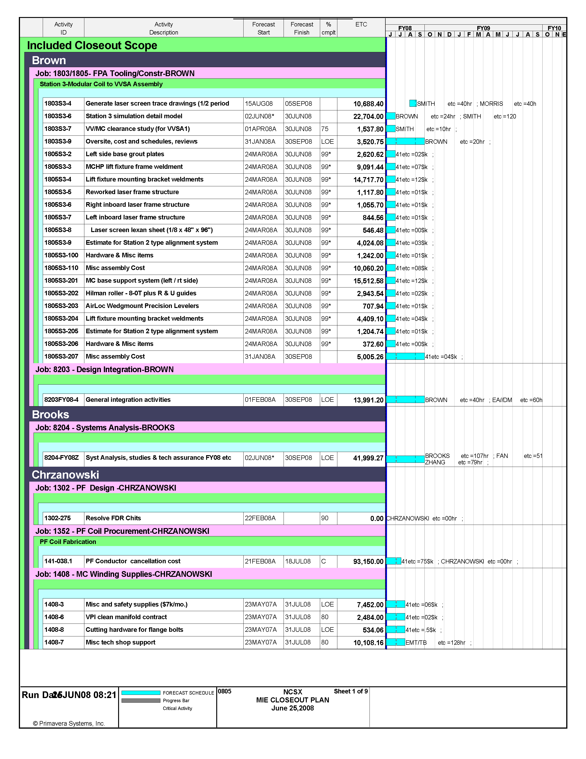
ATTACHMENT 4 page 2/9
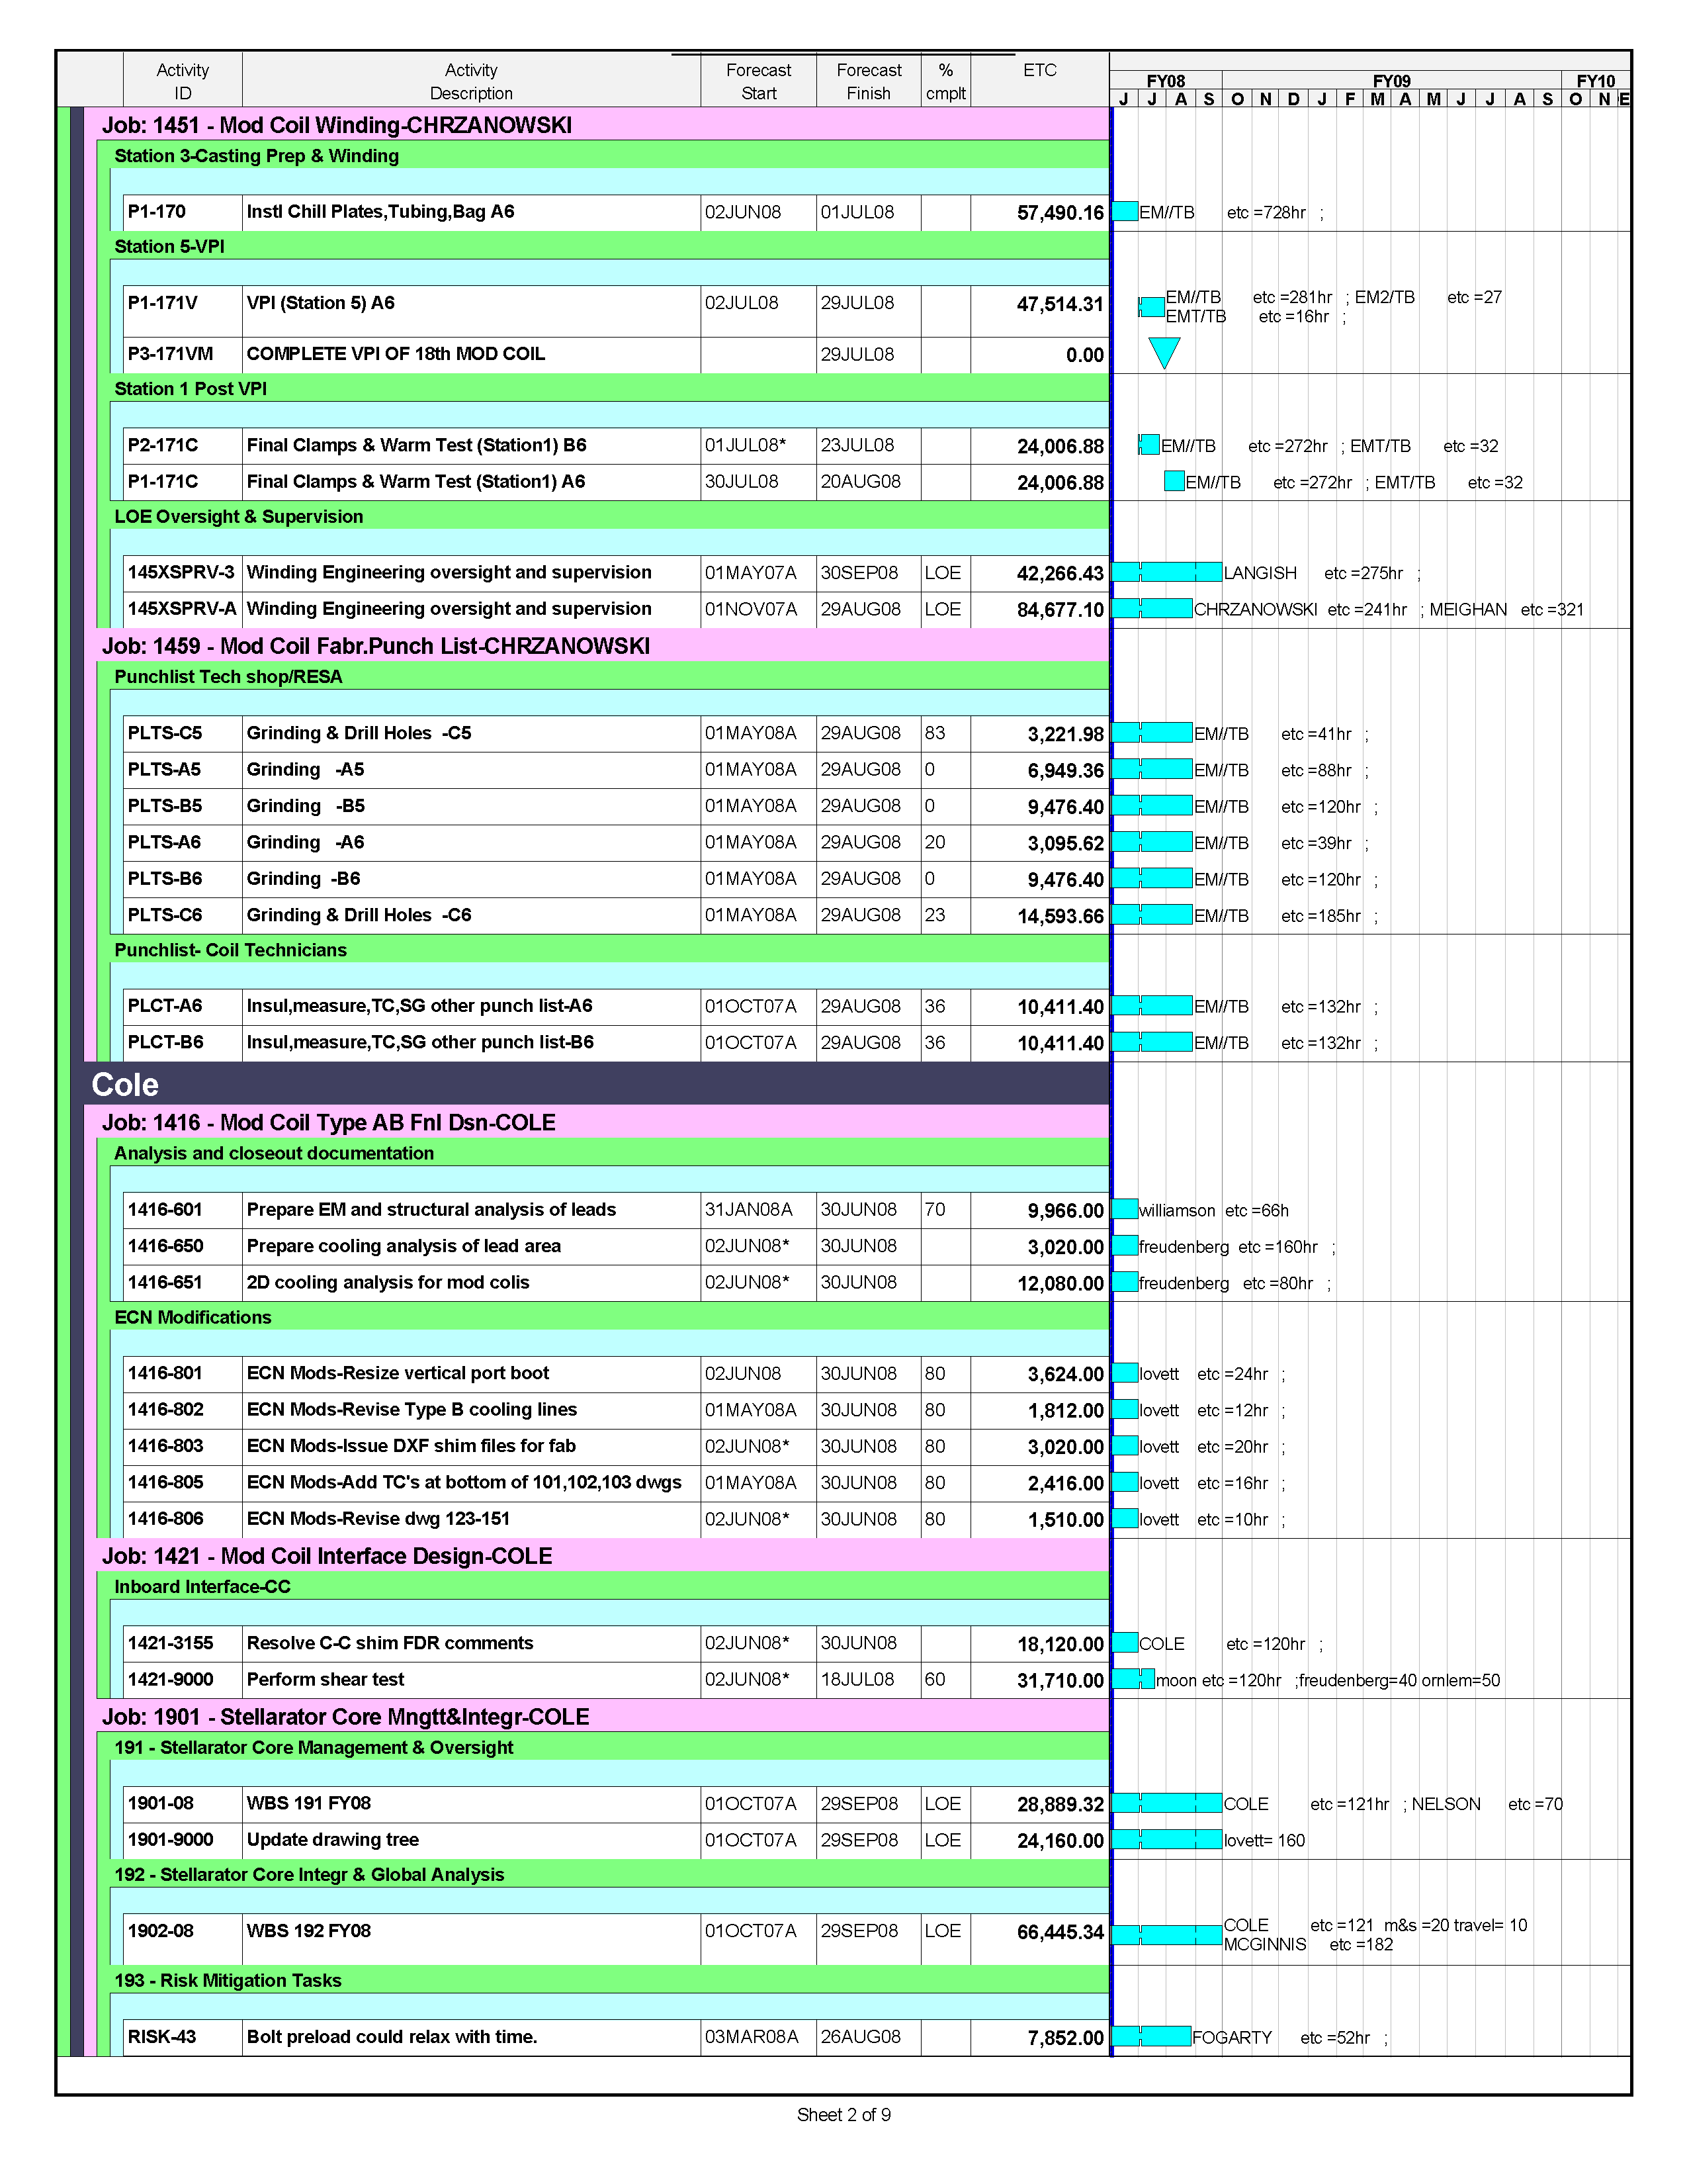
ATTACHMENT 4 page 3/9
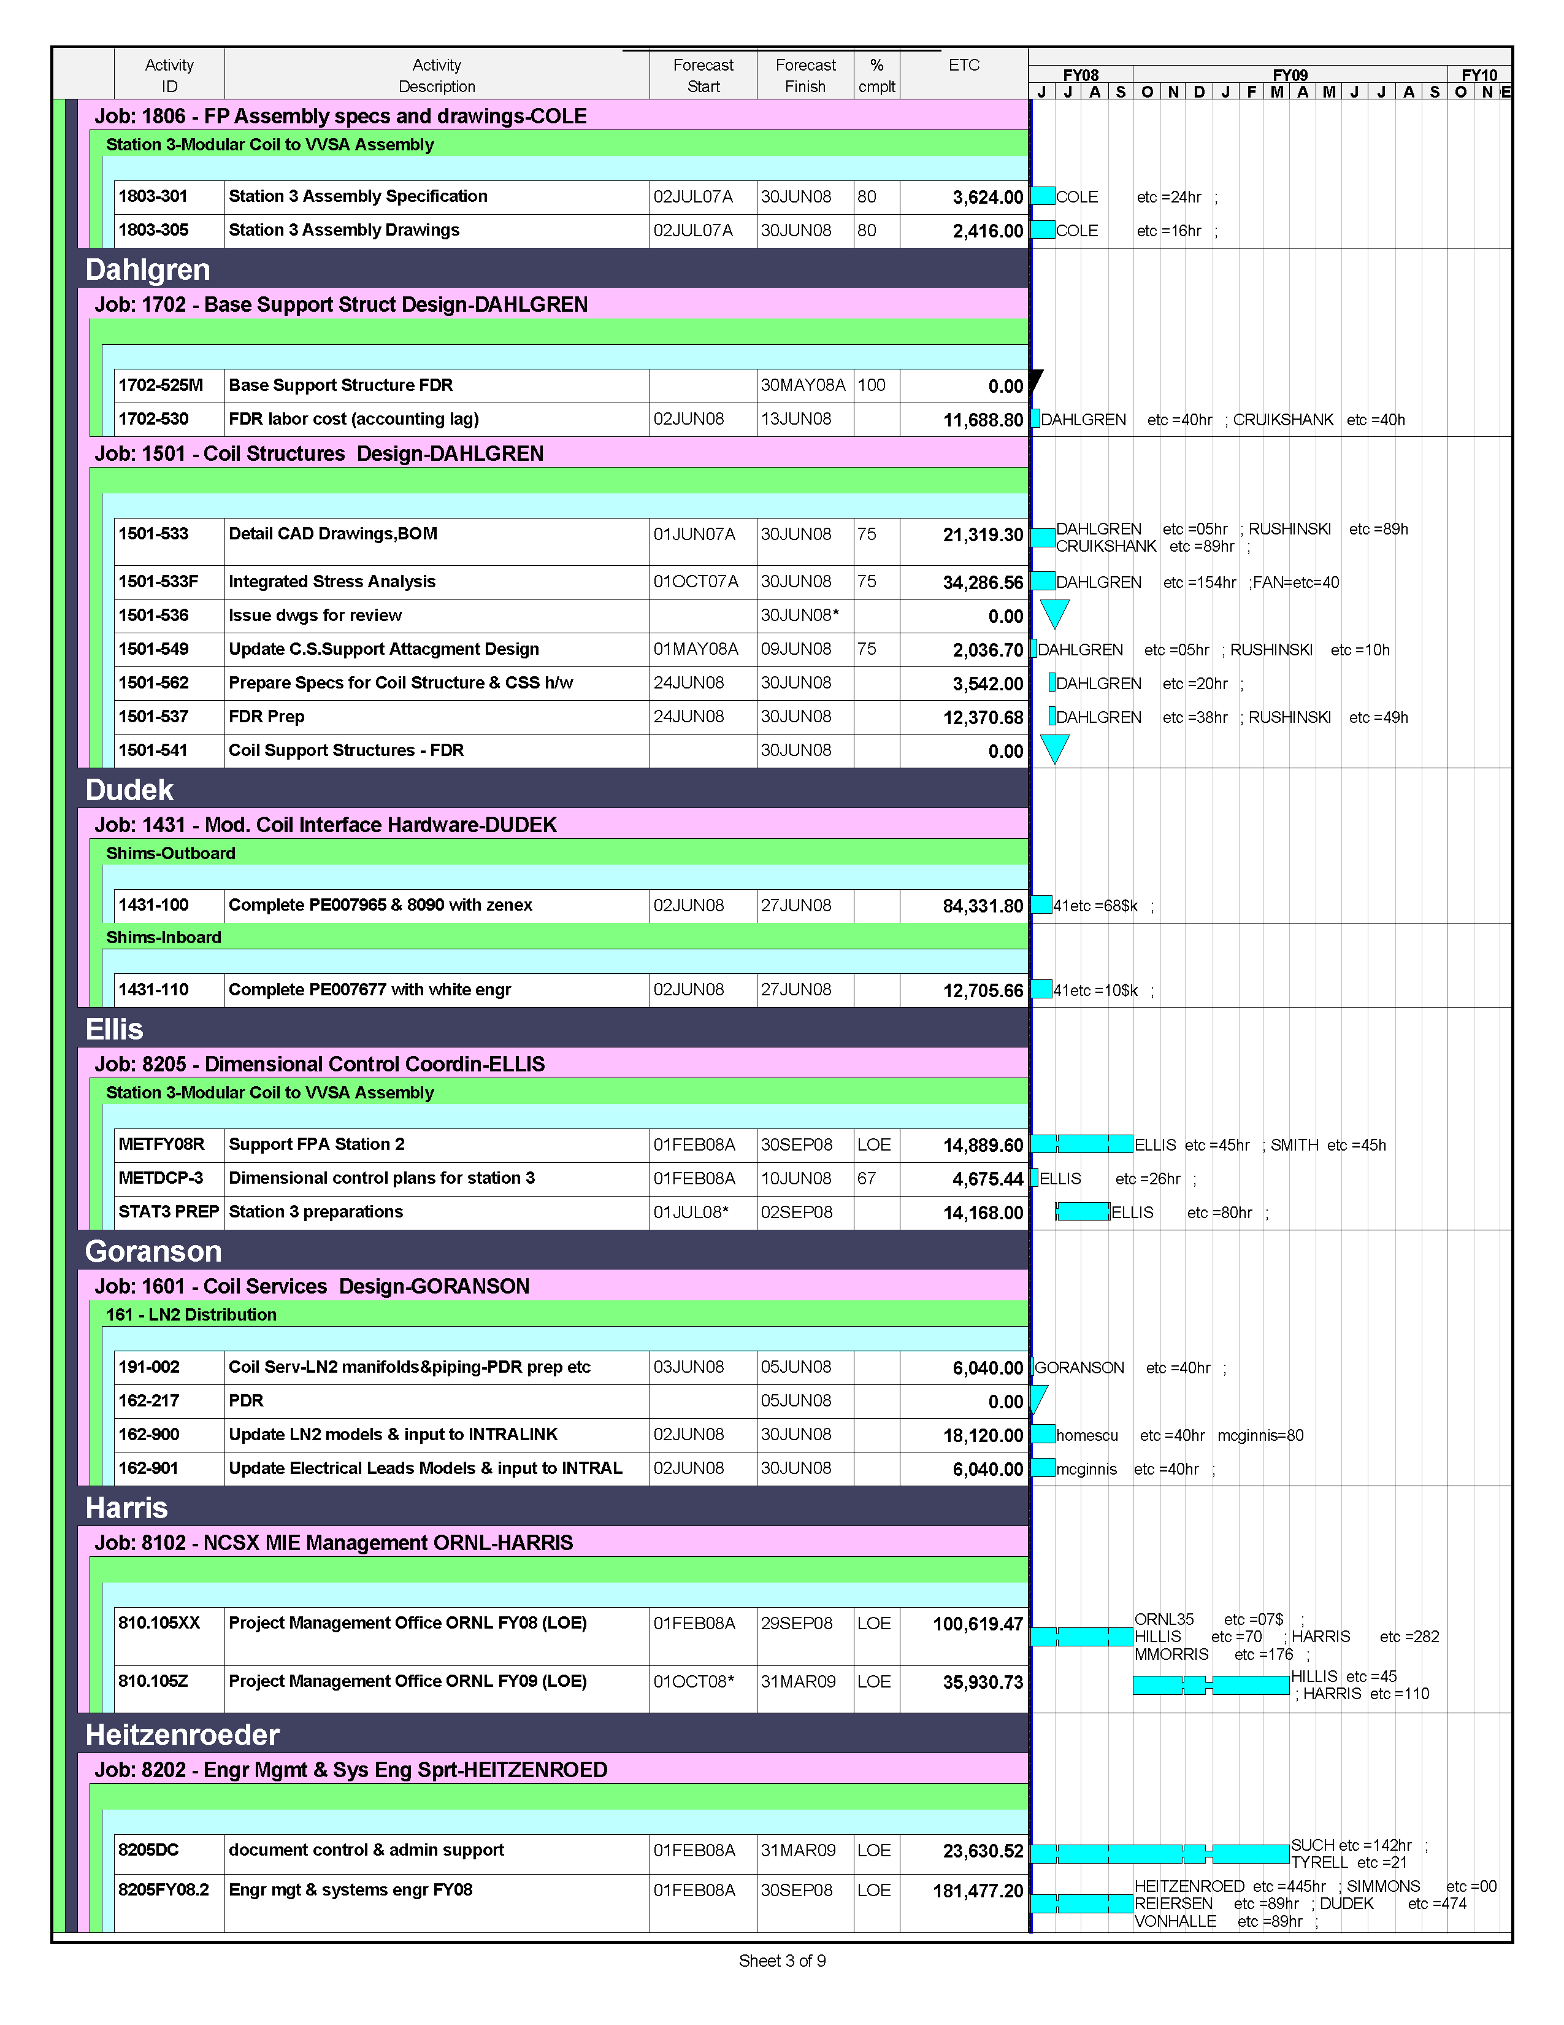

ATTACHMENT 4 page 4/9
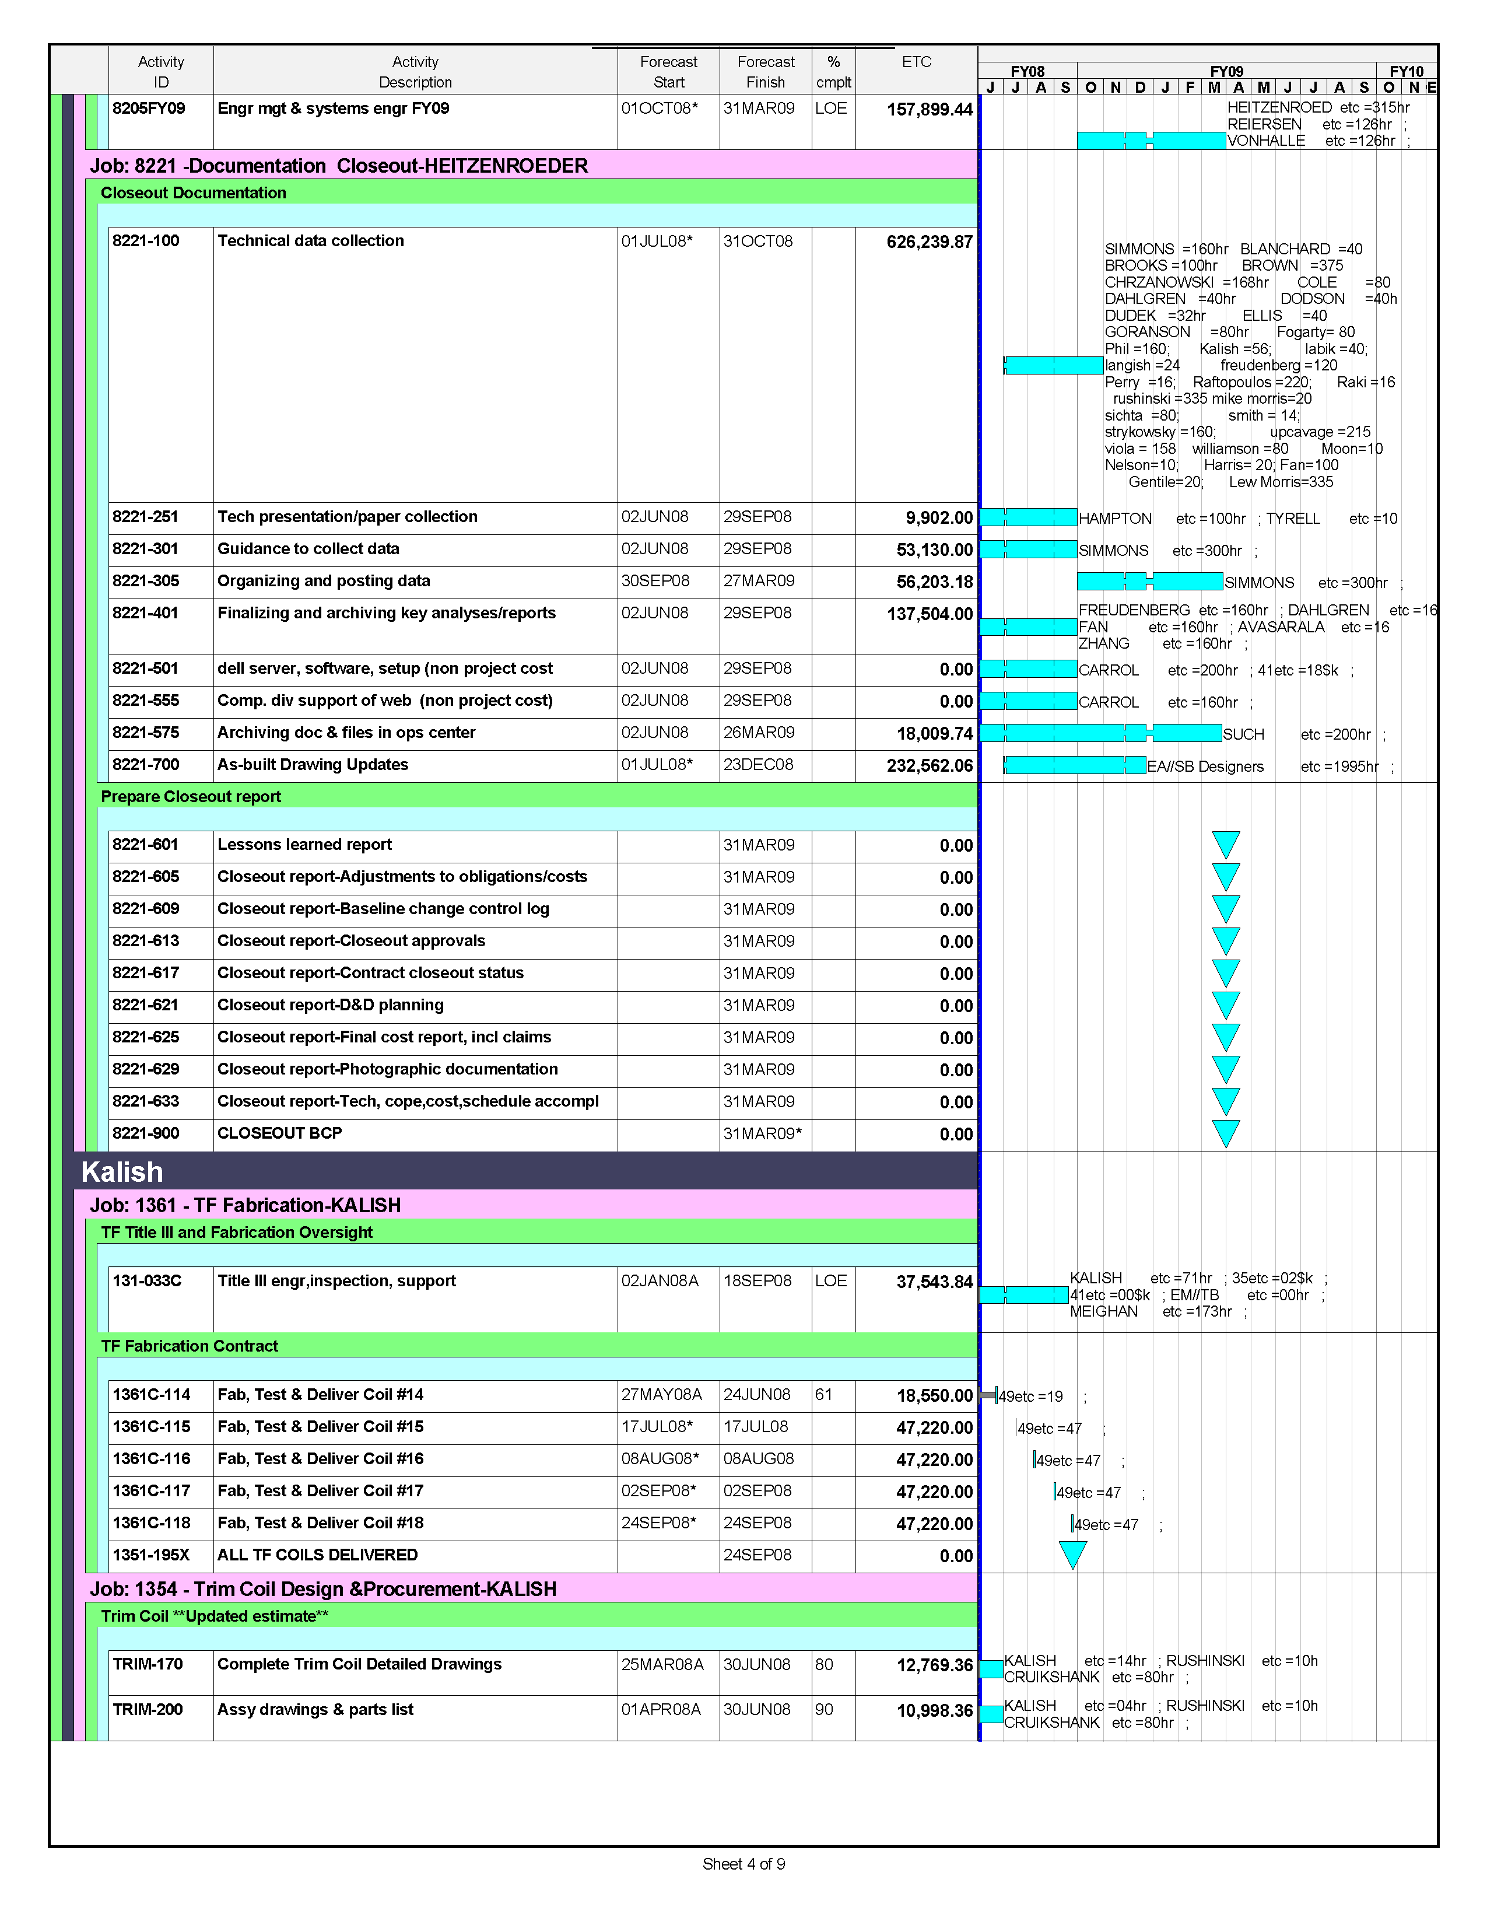
ATTACHMENT 4 page 5//9
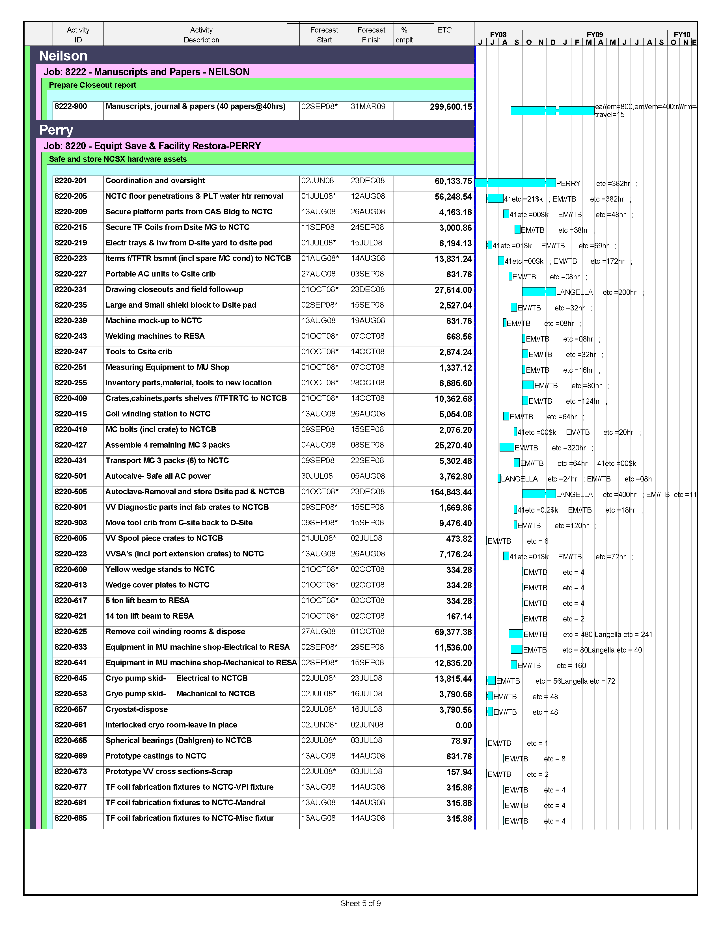
ATTACHMENT 4 page 6/9
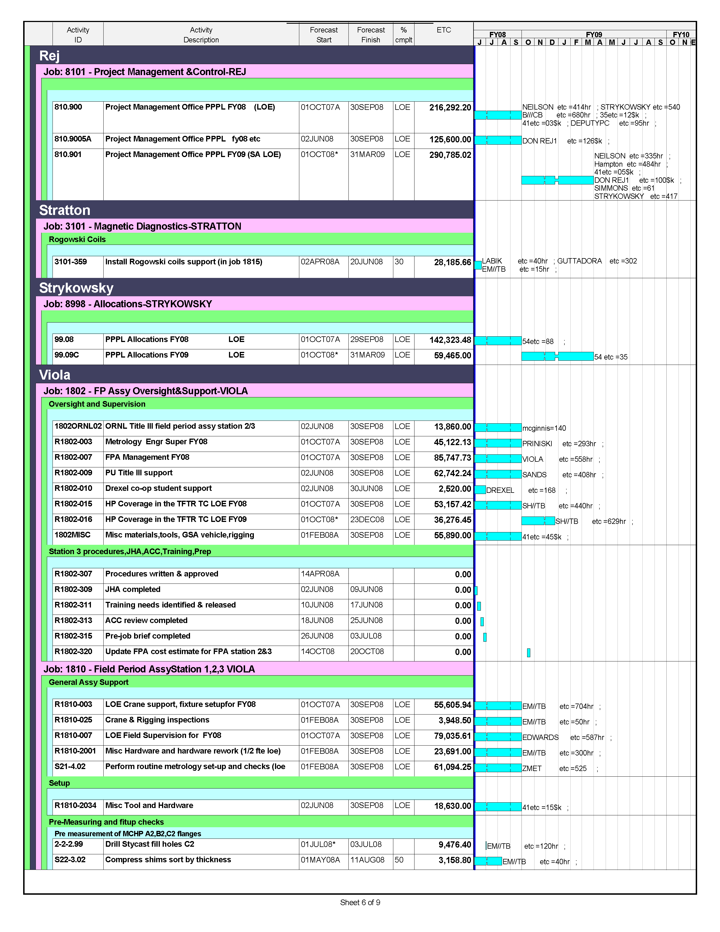
ATTACHMENT 4 page 7/9
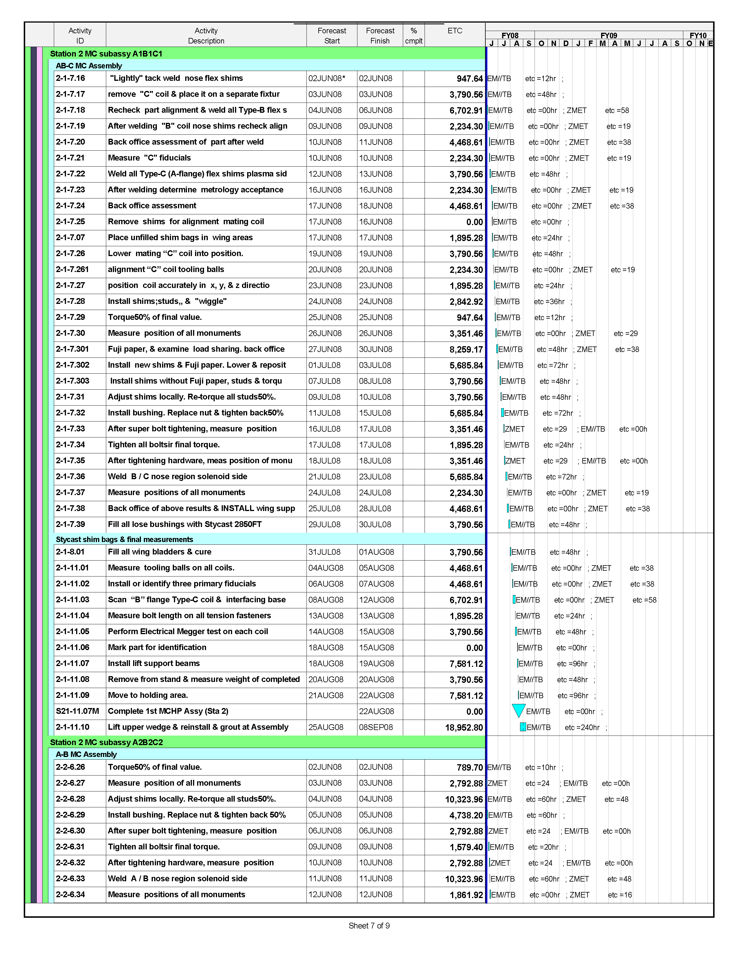
ATTACHMENT 4 page 8/9

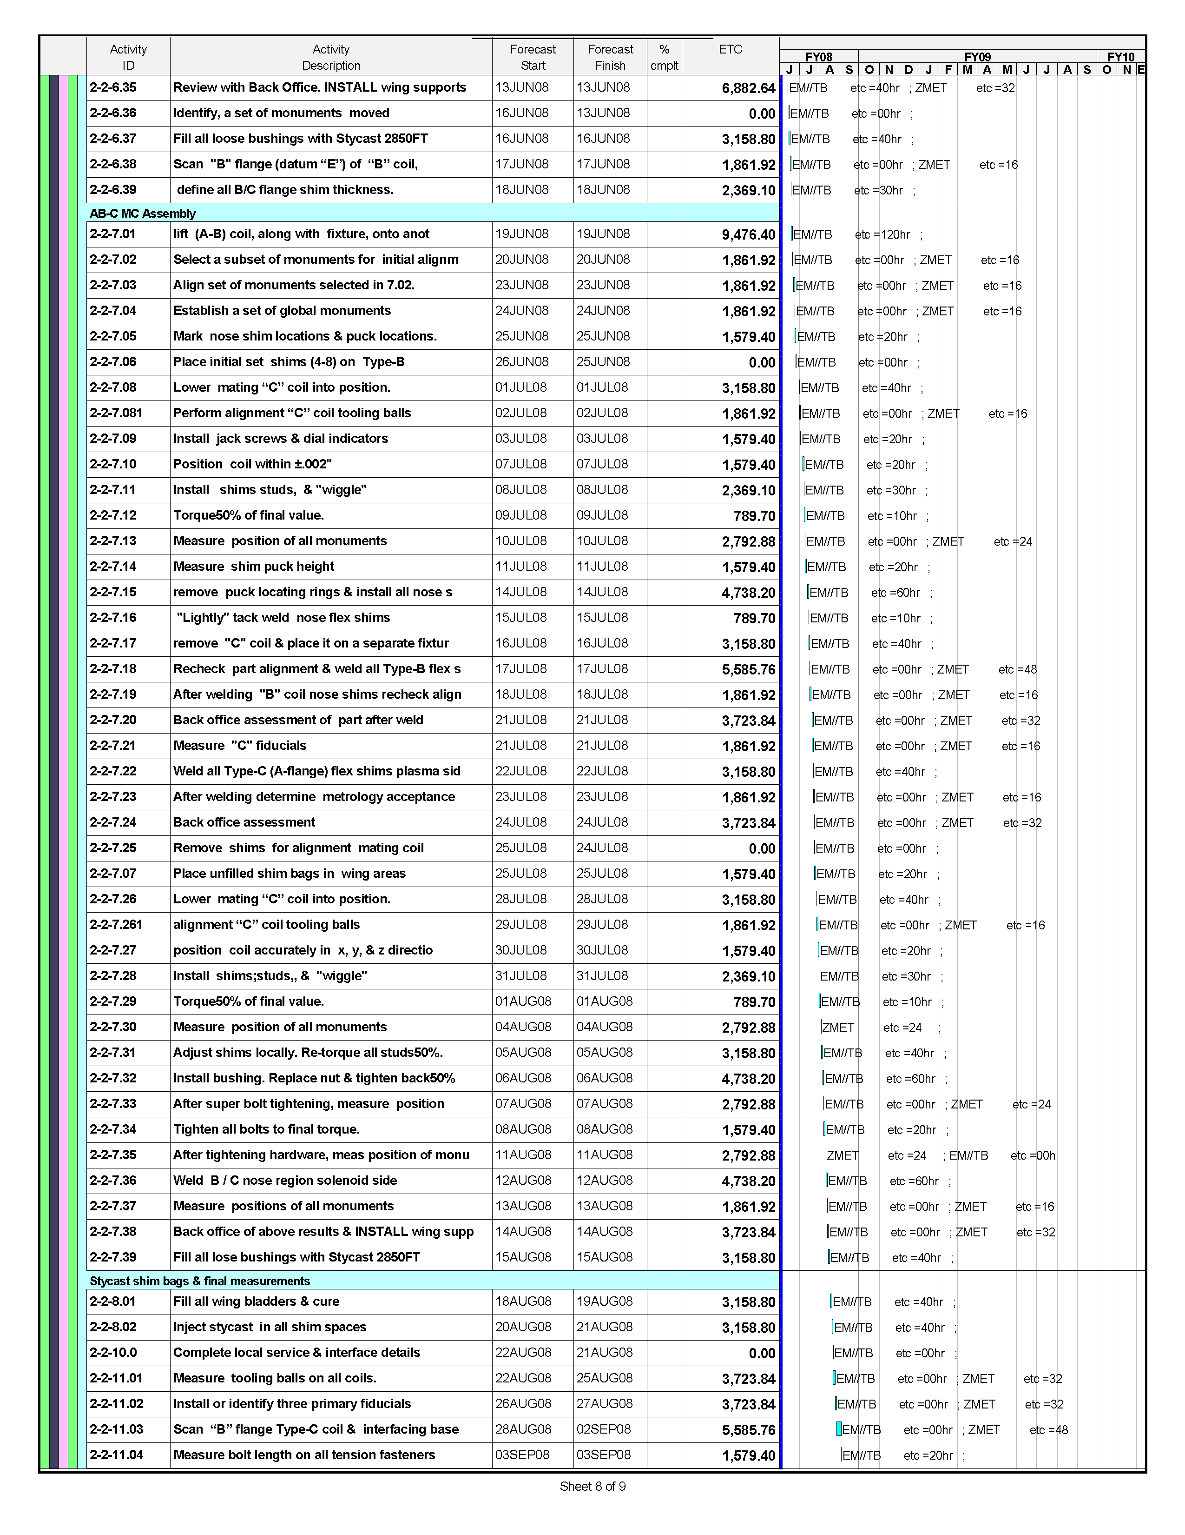
ATTACHMENT 4 page 9/9
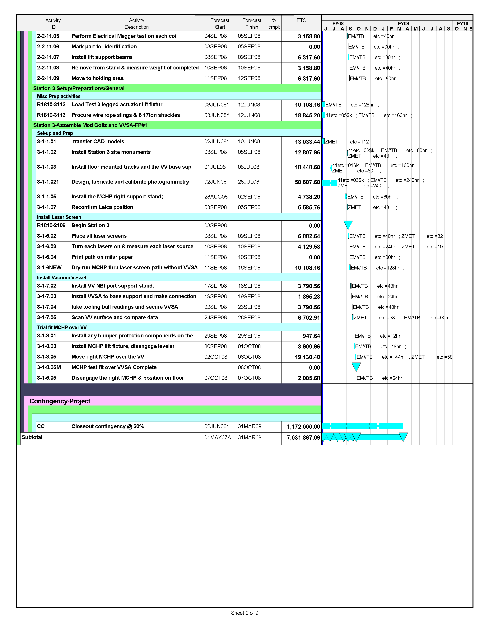
ATTACHMENT 5

ATTACHMENT 6 page 1/2

ATTACHMENT 6 page 2/2

