Step #1: Authenticate through PPPL Firewall via VPN authentication process (vpn.pppl.gov)

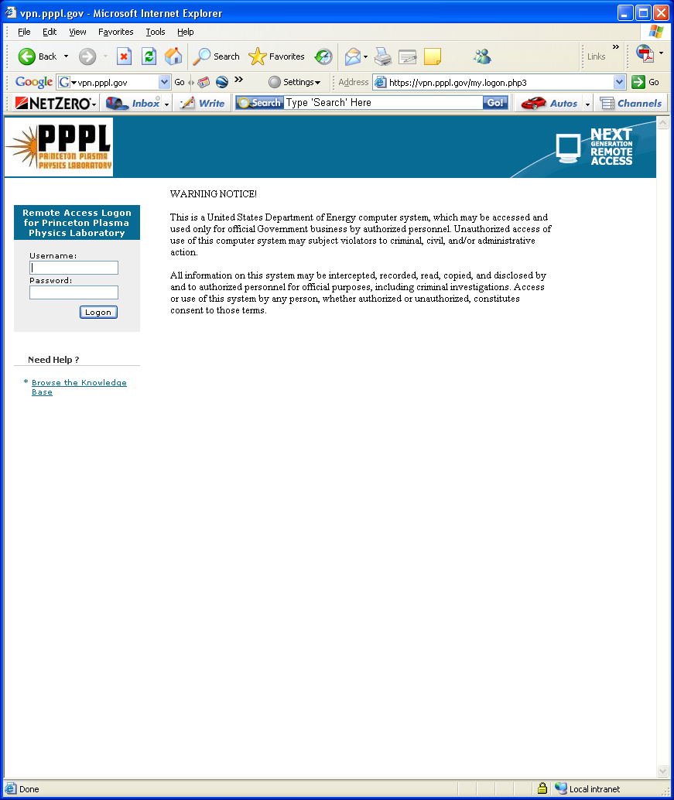
Username: Use your PPPL user name

Password: Use your PIN & Secure ID token 6 digit code

Step #2: Open Remote Desktop – Use Pulldown menu to select “termserv” or type in “termserv.pppl.gov”

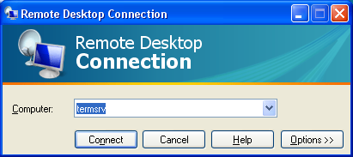

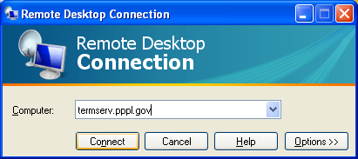

Step #3: Enter User name and Password.

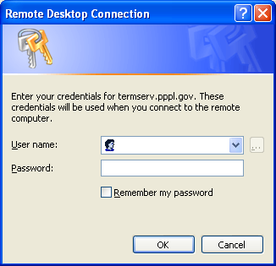
User name: Enter User Name for your PPPL user account.

Password: Enter Password for your PPPL user account

Step #4: If desired by the User, one can save the document to their local hard drive to preclude having to go through the entire setup as follows:

- Select “Options” tab:

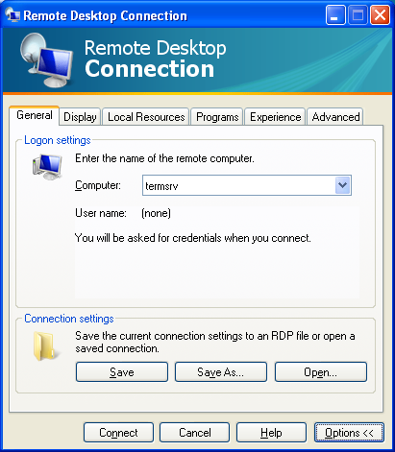

- Select “Local Resources” tab and then “More” tab to get to drivers.

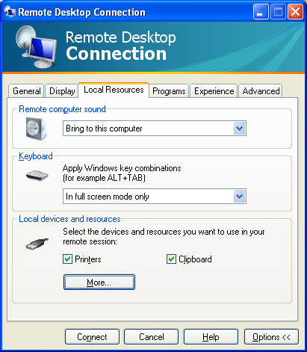

- Select your drive that you desire to load Terserv on and click “OK”. For a MAC, select “Local Drives” and select “Disc Drives” and then click “OK”.

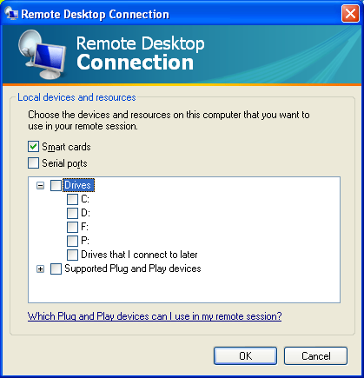

- Return to Remote Desktop screen and Select “General” tab and click “Save” => won’t have to go through the entire setup again! Then click “Connect” to connect to termserv.

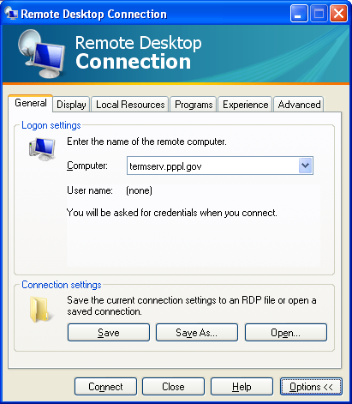

- Step # 5: Once on “termserv”, you can connect directly to the NCSX Drawings page by typing in the following URL:
http://cadd-web.pppl.gov/NCSX/Menu00.htm

You can also ave this page as a favorite or your home page to facilitate access.

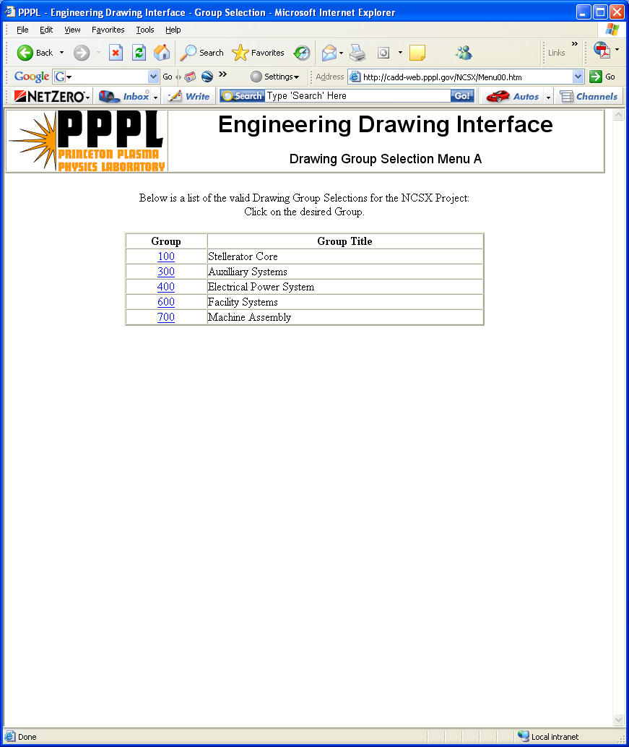
Select desired “grouping” of drawings

Step #6: Select the WBS level and then the desired drawing within that WBS element and download and save to their local hard drive.



