NCSX RFD  Part I | Number:  RFD-12-017 |  | RFD Description:  Port Attachment Weld Deviation Request
Initiator: Doug McCorkle |  | Organization: Major Tool & Machine, Inc.
List of Impacted Documents: (Specification, MIT/QA Plan, SOW, drawing, etc.)
NCSX-CSPEC-121-02-06; SE120-004;
Cost Impact: (If none, so state): NONE
Schedule Impact: (If none, so state): NONE

Quality Impact: (If none, so state) : Quality improvement and improved welding distortion control.
State Requirement Deviation is Requested For: (Specification, MIT/QA Plan, SOW, drawing, etc.): Ref: Drawing SE120-004, Sht 4, 5, 6, 7, 8, 9, 10, 11, 12, 13, 14, 15, 16, 17, 18, & 19. The drawing weld symbol for joining the port extension to the vessel.
Full Description of the Deviation Requested:

Background: NCR 19464 (attached) identified that MTM had used a different method for welding the port extensions to the vessel for VVSA segments #1 and #2. As indicated in the NCR, rather than following the design on the respective drawings, MTM elected to utilize and alternate methods by:
- Round ports - cutting the hole in the vessel to the o.d. size of the tube and welding full penetration from the vessel interior (ground flush) with a continuous fillet weld around the tube exterior.
- Ports 4, 12, NB - welded the exterior fillet as a continuous fillet opposed to the specified intermittent weld.
- Clevis bosses - added a 3/16 fillet to the exterior side of the joint.

The attached sketch visually provides the type of welding performed by MTM.

MTM justified this deviation from design by claiming that their alternate methods resulted in an improvement in quality and provided better welding distortion control.

Deviation Requested: Permit this alternate welding method for VVSA Segment #3.

Attachments:
(1) Sketch of MTM Weld Concept
(2) Copy of NCR 19464

Initiator Signature: Mike Viola Date: March 23, 2006

Sketch of MTM Weld Concept

This sketch better defines the weld prep for the joint that attach the port stubs to the vessel wall on the first two units. The majority of the joint is filled in from the inside vessel surface, then we grind the outside (root side) until all irregularities are removed, and apply a fill pass and a cover pass (which creates the 3/16 fillet) on the exterior side.

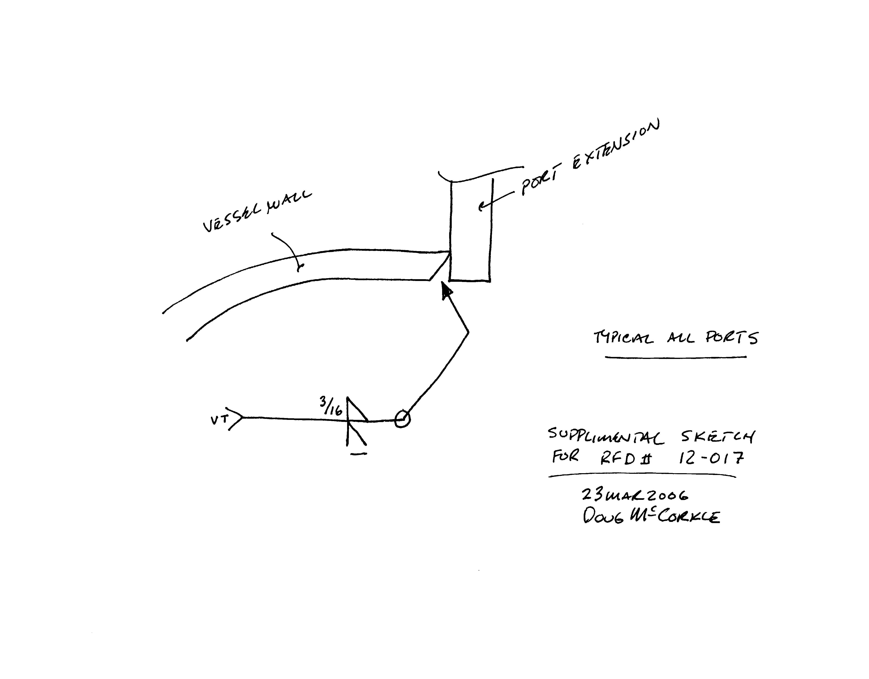
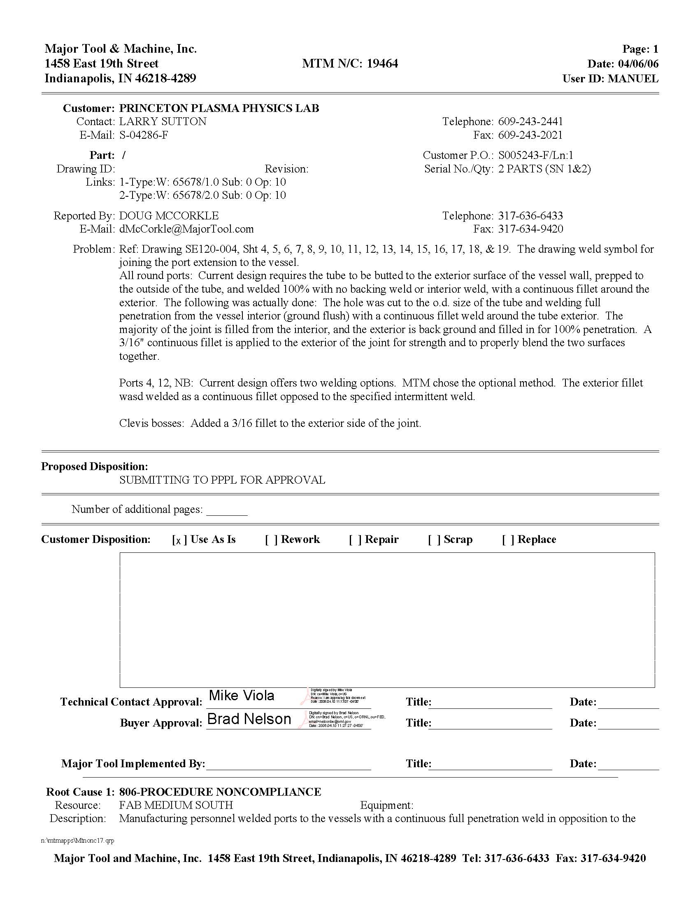

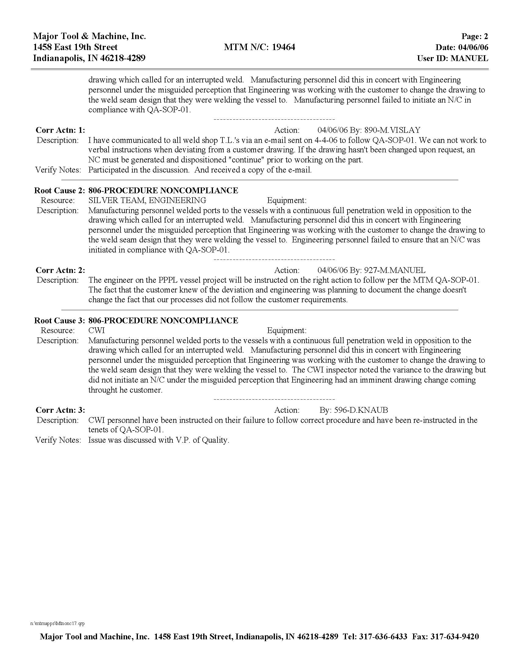

NCSX RFD  Part II | Number: RFD-12-017 |  | RFD Description: Port Attachment Weld Deviation Reques
RLM: Brad Nelson |  | Organization: ORNL
Impact on Interfaces with Other WBS Elements/Items: (If none, so state): NONE
RLM Recommendation:

Approve Do Not Approve

Additional remarks:

Approved for use on the VVSA Segment #3. Drawings will not be revised to reflect revised welding method – however a note will be placed on the drawings to note this change.

MTM NCR caused when MTM manufacturing and engineering personnel assumed that PPPL was advised of the change prior to the non-conforming action. This has been thoroughly discussed with MTM management and engineering and manufacturing personnel as indicated in the three (3) corrective actions included with the NCR. This is acceptable to PPPL.

Does this Change Impact Material Already Procured or Parts/Assemblies Already Assembled/Manufactured using this Material: Yes No

If “Yes”, what is the recommended disposition of this material/part/assembly?

RLM Signature:

Project Disposition:

Approved. No ECP required. ECN will be prepared to note this NCR on the impacted drawings.

NCSX Systems Engineering Support Manager

Approved. ECP - assigned and processed.

Not Approved. Reason(s) for disapproval:

