NCSX RFD  Part I | Number:  14-004 |  | RFD Description:  Add fillets to Modular Coil Lower Lead Blocks to aid machining
Initiator:  John Puhl |  | Organization:  JP Pattern
List of Impacted Documents: (Specification, MIT/QA Plan, SOW, drawing, etc.)
Drawing: SE142C-134-r0
Drawing: SE142C-135-r0
Cost Impact: (If none, so state)
NONE
Schedule Impact: (If none, so state)
NONE
Quality Impact: (If none, so state)
NONE
State Requirement Deviation is Requested For: (Specification, MIT/QA Plan, SOW, drawing, etc.)
Drawing: SE142C-134-r0
Drawing: SE142C-135-r0
Full Description of the Deviation Requested: (Use continuation pages, e-mails, letter, sketches, etc. as needed and include amplifying information as appropriate to support deviation request.)
The following changes are requested to to aid in machining (see attached sketches).
- C02a_fillet-n-rnds_se142c-134-r0
  - 1/16 fillet added to posts due to surface not being planar. Is this acceptable? If not area could be filed out.(red)
  - 1/16 fillet added to inner rib.(red)
  - 1/64 round added due to area being extremely thin. (Cyan)
  - 1/32 round added to ribs due to area being thin also (yellow)
- C02a_fillet-n-rnds_se142c-135-r0
  - 1/16 fillet added to posts due to surface not being planar. Is this acceptable? If not area could be filed out.(red)
  - 1/64 round added due to area being extremely thin. (Cyan)
Attachments:
[1] C02a_fillet-n-rnds_se142c-134-r0.gif
[2] C02a_fillet-n-rnds_se142c-135-r0.gif
[3] E-mail dated July 12, 2005 from James Woznicki (JPP) to Dudek and Nelson

Initiator Signature: See Attachment [3] Date: July 20, 2005

NCSX RFD  Part II | Number: 14-004 |  | RFD Description: Add fillets to Modular Coil Lower Lead Blocks to aid machining
RLM: Brad Nelson |  | Organization: ORNL
Impact on Interfaces with Other WBS Elements/Items: (If none, so state)
None
RLM Recommended Disposition:

Approve Do Not Approve (If recommendation is to approve, ECP will be assigned)

Additional remarks:

WBS Manager (D. Williamson) –

PTR (L. Dudek) –

RLM Disposition: Approve with caveat that mating parts be chamfered to clear added fillets.

RLM Signature:

Project Disposition: (Include ECP Number): Approve with caveat that mating parts be chamfered to clear added fillets.

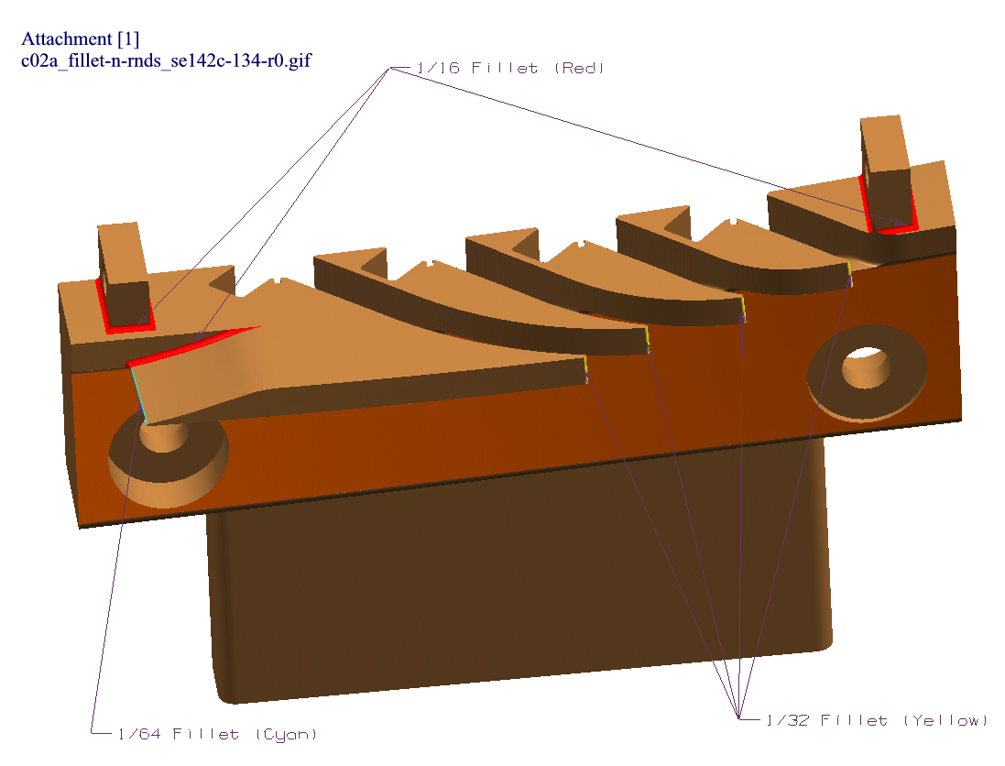
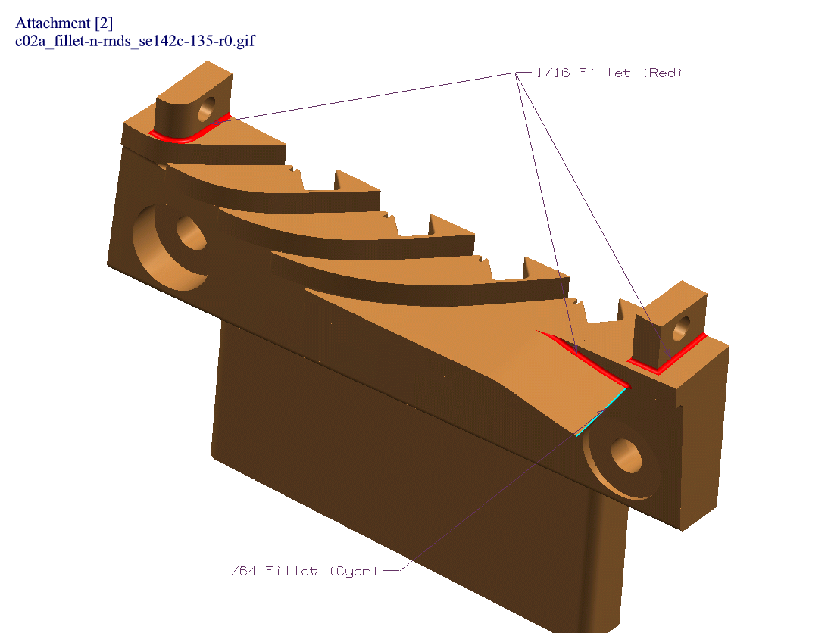
Attachment [3]

From: James Woznicki [mailto:jimw@jppattern.com]
Sent: Tuesday, July 12, 2005 8:00 AM
To: Nelson, Brad E.; ldudek@pppl.gov
Cc: Johnp@jppattern.com; Jobfile Notes
Subject: NcSX Lead Supports Fillets-n-Rnds (JP20051092)

Brad/Lawrence,

I have reviewed the lower lead support data for preparation
of machining. Attached are a few images with fillets and rounds added to
aid in machining.

* C02a_fillet-n-rnds_se142c-134-r0

* 1/16 fillet added to posts due to surface not being
planar. Is this acceptable? If not area could be filed out.(red)
* 1/16 fillet added to inner rib.(red)
* 1/64 round added due to area being extremely thin.
(Cyan)
* 1/32 round added to ribs due to area being thin also
(yellow)

* C02a_fillet-n-rnds_se142c-135-r0

* 1/16 fillet added to posts due to surface not being
planar. Is this acceptable? If not area could be filed out.(red)
* 1/64 round added due to area being extremely thin.
(Cyan)

Please review images and reply if these added fillets and rounds are
acceptable.

Thanks,

James C. Woznicki
J.P.Pattern Inc.
262-781-2040 Ext 19.

