NCSX RFD  Part I | Number: 14-009 |  | RFD Description: Deviations on C1 Casting that are Applicable to Downstream Castings
Initiator: Phil Heitzenroeder |  | Organization: PPPL
List of Impacted Documents: (Specification, MIT/QA Plan, SOW, drawing, etc.):
CSPEC (NCSX-CSPEC-141-03) and drawings SE141-103 (Item 1), SE141-078 (Item 2), DS11-036 (Item 3), and SE141-116 (Items 4-9).

Cost Impact: (If none, so state): TBD, but C2 casting changes anticipated to be <$2K. EIO/MTM to provide more detailed estimate within 30 days of receipt of this RFD.

Schedule Impact: (If none, so state) ): TBD, but C2 casting changes not anticipated to result in a delay. EIO/MTM to provide more detailed estimate within 30 days of receipt of this RFD.

Quality Impact: (If none, so state): NONE

State Requirement Deviation is Requested For: (Specification, MIT/QA Plan, SOW, drawing, etc.): CSPEC will be updated (Rev 10 in process) and will incorporate drawings and models that include these changes.

Full Description of the Deviation Requested: (Use continuation pages, e-mails, letter, sketches, etc. as needed and include amplifying information as appropriate to support deviation request.)

Deviation Requested: As a result of inspections of C1 casting, it was determined that the following changes shown on the attachment are necessary for all follow-on C castings to facilitate/correct errors and omissions:
- Item 1 – Washer shown on SE141-103 is not compatible with insulator sheet (see RFD-14-008). Replacement of washer with bearing plates on SE141-137 and SE141-138 (new drawings)
- Item 2 – Add instruction on drawing SE141-078 to chamfer all shim edges 1/16”.
- Item 3 – Revise material on DS141-036 to ASTM A453, Grade 660B.
- Item 4 - Change location of hole position shown on drawing SE141-116 Sheet 5 Zone E8
- Item 5 – Change spherical size tolerance to +0.002/-0.003. Pilot hole up to 3/8” is acceptable. Lap final size tolerance of +0.002/-0.000.
- Item 6 – Add 1/16” chamfer of all surfaces and edges of poloidal break shown on drawing SE141-116, Sheet 6, Zone D3.
- Item 7 – Revise location and diameter of the interfering hole (old hole location will be removed from updated model to be provided in CSPEC Rev 10) and the diameter of other seven holes. Two views shown.

NCSX RFD  Part I | Number: 14-007 |  | RFD Description: Deviations on C1 Casting that are Applicable to Downstream Castings
Initiator: Phil Heitzenroeder |  | Organization: PPPL
Full Description of the Deviation Requested: (continuation page)

Deviation Requested: As a result of inspections of C1 casting, it was determined that the following changes shown on the attachment are necessary for all follow-on C castings to ensure clearance for wings:
- Item 8 – Revised profile tolerance on drawing SE141-116, Sheet 10, Zone D2 to +0.05/-0.1 over area defined by the IGES surface.
- Item 9 – Added new drawing view to drawing SE141-116 to show instructions for area of casting.
Attachments:
- Drawing changes showing each item in detail per Meeting Notes, Review of MCWF at PPPL, dated 10/14/2005
- Power Point View of IGES File showing hole location

Initiator Signature: __________________________________________________

NCSX RFD  Part II | Number: 14-009 |  | RFD Description: Deviations on C1 Casting that are Applicable to Downstream Castings
RLM: Brad Nelson |  | Organization: ORNL
Impact on Interfaces with Other WBS Elements/Items: (If none, so state): WBS 14
RLM Recommendation:

Approve Do Not Approve

Additional remarks: Incorporate into next revision of CSPEC (including drawings). All changes will be reviewed again with MTM, PPPL, and ORNL to ensure mutual understanding.
RLM Signature:

Project Disposition:

Approved. No ECP required.

Approved. ECP -038 has been assigned and is in the process of being reviewed and dispositioned – this will be Revision 10 to CSPEC 141-03.

NCSX Systems Engineering Support Manager

Not Approved. Reason(s) for disapproval:

October 18, 2005

Reference: Meeting Notes, Review of MCWF C1 at PPPL, 10/14/05

The following drawing changes are proposed:

Item | Drawing | Sheet | Zone | Issue | Resolution
1 | SE141-103 | 1  2 | C2  D5 | Washer not suitable for thin flange, required bolt preload. | Replace washer with bearing plates, SE141-137 and SE141-138.
2 | SE141-078 | 1 | F7 | Shim edges are flush with insulator, making it difficult to seal for VPI. Also, potential for voltage breakdown. | Add instruction to chamfer all shim edges 1/16”.

Item | Drawing | Sheet | Zone | Issue | Resolution
3 | DS141-036 | 1 | N/A | Material specification is incorrect and length must match revised drawing to accommodate bearing plates. | Revise material to ASTM A453, Grade 660B.
4 | SE141-116 | 5 | E8 | Tapped and thru hole were not positioned according to latest model/drawing revision. | Adopt latest rev for hole position, change tapped hole from thru to 1.25” blind due to flange radius.

Item | Drawing | Sheet | Zone | Issue | Resolution
5 | SE141-116 | 5 | F7 | Spherical seat size tolerance +/- .01 is not suitable for intended use. | Change size tolerance to +.002/-.003. Pilot hole up to 3/8” is acceptable. Lap finish to final size tolerance of +.002/-.000.
6 | SE141-116 | 6 | D3 | Poloidal break edge is flush with insulator. | Add instruction for 1/16 chamfer all surfaces and edges of break.

Item | Drawing | Sheet | Zone | Issue | Resolution
7 | SE141-116 | 9 | C7  F3 | Cooling inlet/outlet thru hole diameter is too small, and one hole interferes with flange. | Revise location and diameter of the interfering hole and the diameter of the other seven holes.

Item | Drawing | Sheet | Zone | Issue | Resolution
8 | SE141-116 | 10 | D2 | As-cast tolerance is not suitable over a small area where wing of adjacent coil overlaps. | Revise profile tolerance to +0.05 / -0.1 over area defined by IGES surface.
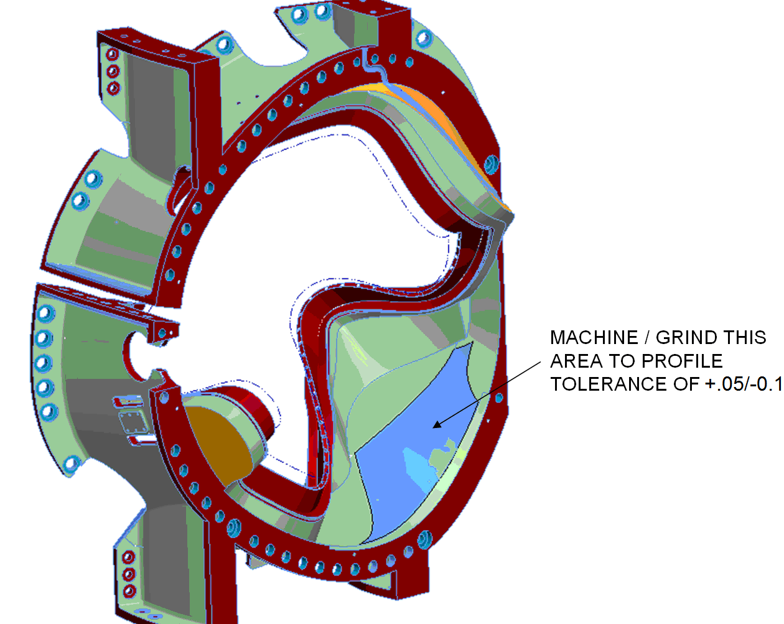

Item | Drawing | Sheet | Zone | Issue | Resolution
9 | SE141-116 | NEW | N/A | Four thru holes to be added for cooling line inlet/outlet at poloidal break. | Add drawing view.

