October 17, 2005

Reference: Meeting Notes, Review of MCWF C1 at PPPL, 10/14/05

The following drawing changes are proposed:

Item | Drawing | Sheet | Zone | Issue |  | Resolution
1 | SE141-103 | 1  2 | C2  D5 | Washer not suitable for thin flange, required bolt preload. |  | Replace washer with bearing plates, SE141-137 and SE141-138.
2 | SE141-078 | 1 | F7 | Shim edges are flush with insulator, making it difficult to seal for VPI. Also, potential for voltage breakdown. |  | Add instruction to chamfer all shim edges 1/16”.
3 | DS141-036 | 1 | N/A | Material specification is incorrect and length must match revised drawing to accommodate bearing plates. |  | Revise material to ASTM A453, Grade 660B.
4 | SE141-116 | 5 | E8 | Tapped and thru hole were not positioned according to latest model/drawing revision. |  | Adopt latest rev for hole position, change tapped hole from thru to 1.25” blind due to flange radius.
5 | SE141-116 | 5 | F7 | Spherical seat size tolerance +/- .01 is not suitable for intended use. |  | Change size tolerance to +.002/-.003. Pilot hole up to 3/8” is acceptable. Lap finish to final size tolerance of +.002/-.000.
6 | SE141-116 | 6 | D3 | Poloidal break edge is flush with insulator. |  | Add instruction for 1/16 chamfer all surfaces and edges of break.
7 | SE141-116 | 9 | C7  F3 | Cooling inlet/outlet thru hole diameter is too small, and one hole interferes with flange. |  | Revise location and diameter of the interfering hole and the diameter of the other seven holes.
8 | SE141-116 | 10 | D2 | As-cast tolerance is not suitable over a small area where wing of adjacent coil overlaps. |  | Revise profile tolerance to +0 / -.1 over area defined by IGES surface.
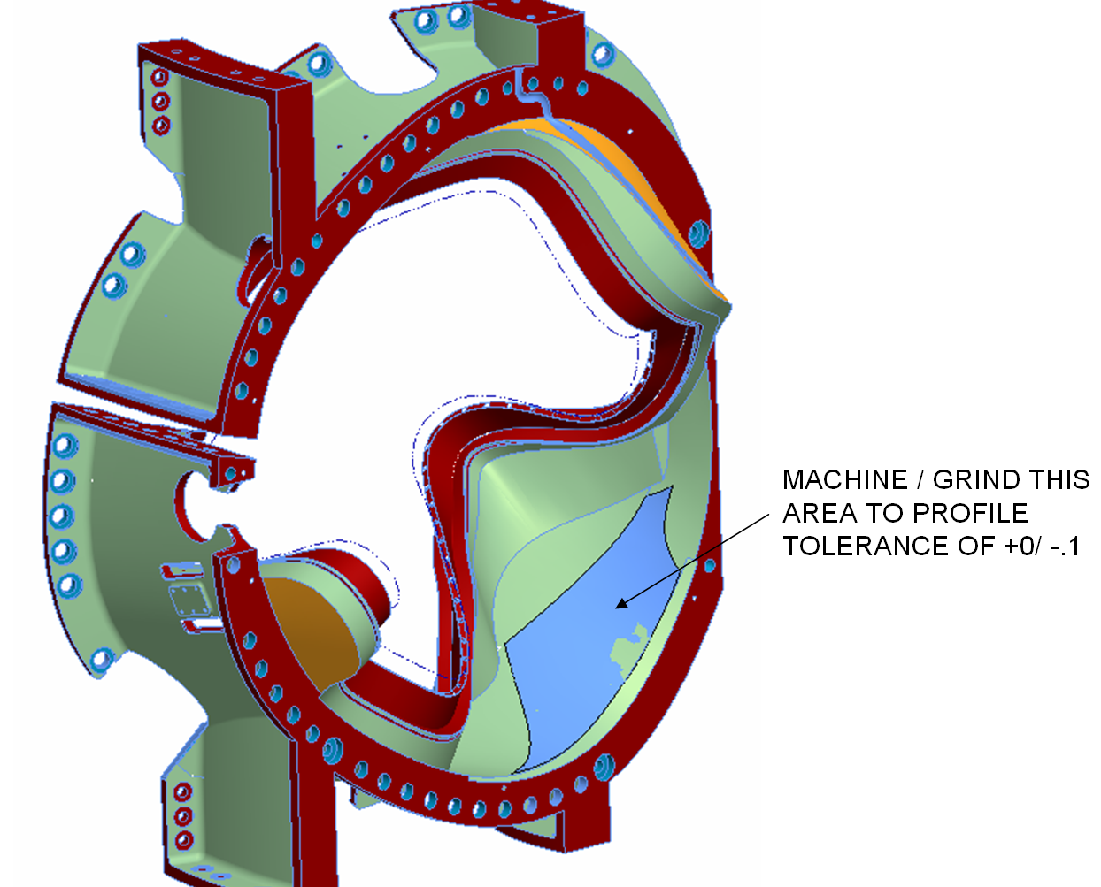
9 | SE141-116 | NEW | N/A | Four thru holes to be added for cooling line inlet/outlet at poloidal break. | Add drawing view.

