NCSX RFD  Part I | Number: 14-015 |  | RFD Description: MCWF Type C Port Openings
Initiator: Kevin Bowling/P. Heitzenroeder |  | Organization: MTM/PPPL
List of Impacted Documents: (Specification, MIT/QA Plan, SOW, drawing, etc.)
Drawing SE141-116
Cost Impact: (If none, so state) : NONE for MTM – may be some impact on PPPL.
Schedule Impact: (If none, so state: NONE
Quality Impact: (If none, so state): NONE
State Requirement Deviation is Requested For: (Specification, MIT/QA Plan, SOW, drawing, etc.): MTM determined that model and drawing required time-consuming setup time to machine each port opening.
Full Description of the Deviation Requested: (Use continuation pages, e-mails, letter, sketches, etc. as needed and include amplifying information as appropriate to support deviation request.): MTM, and PPPL concurred (after evaluation), that remainder of C Castings could permit the port openings to be machined at a common angle => will significantly reduce setup time.

Attachments:
- Kevin Bowling (MTM) RFD dated 2/16/2004

Initiator Signature: Kevin Bowling (See Attachment)/ Phil Heitzenroeder

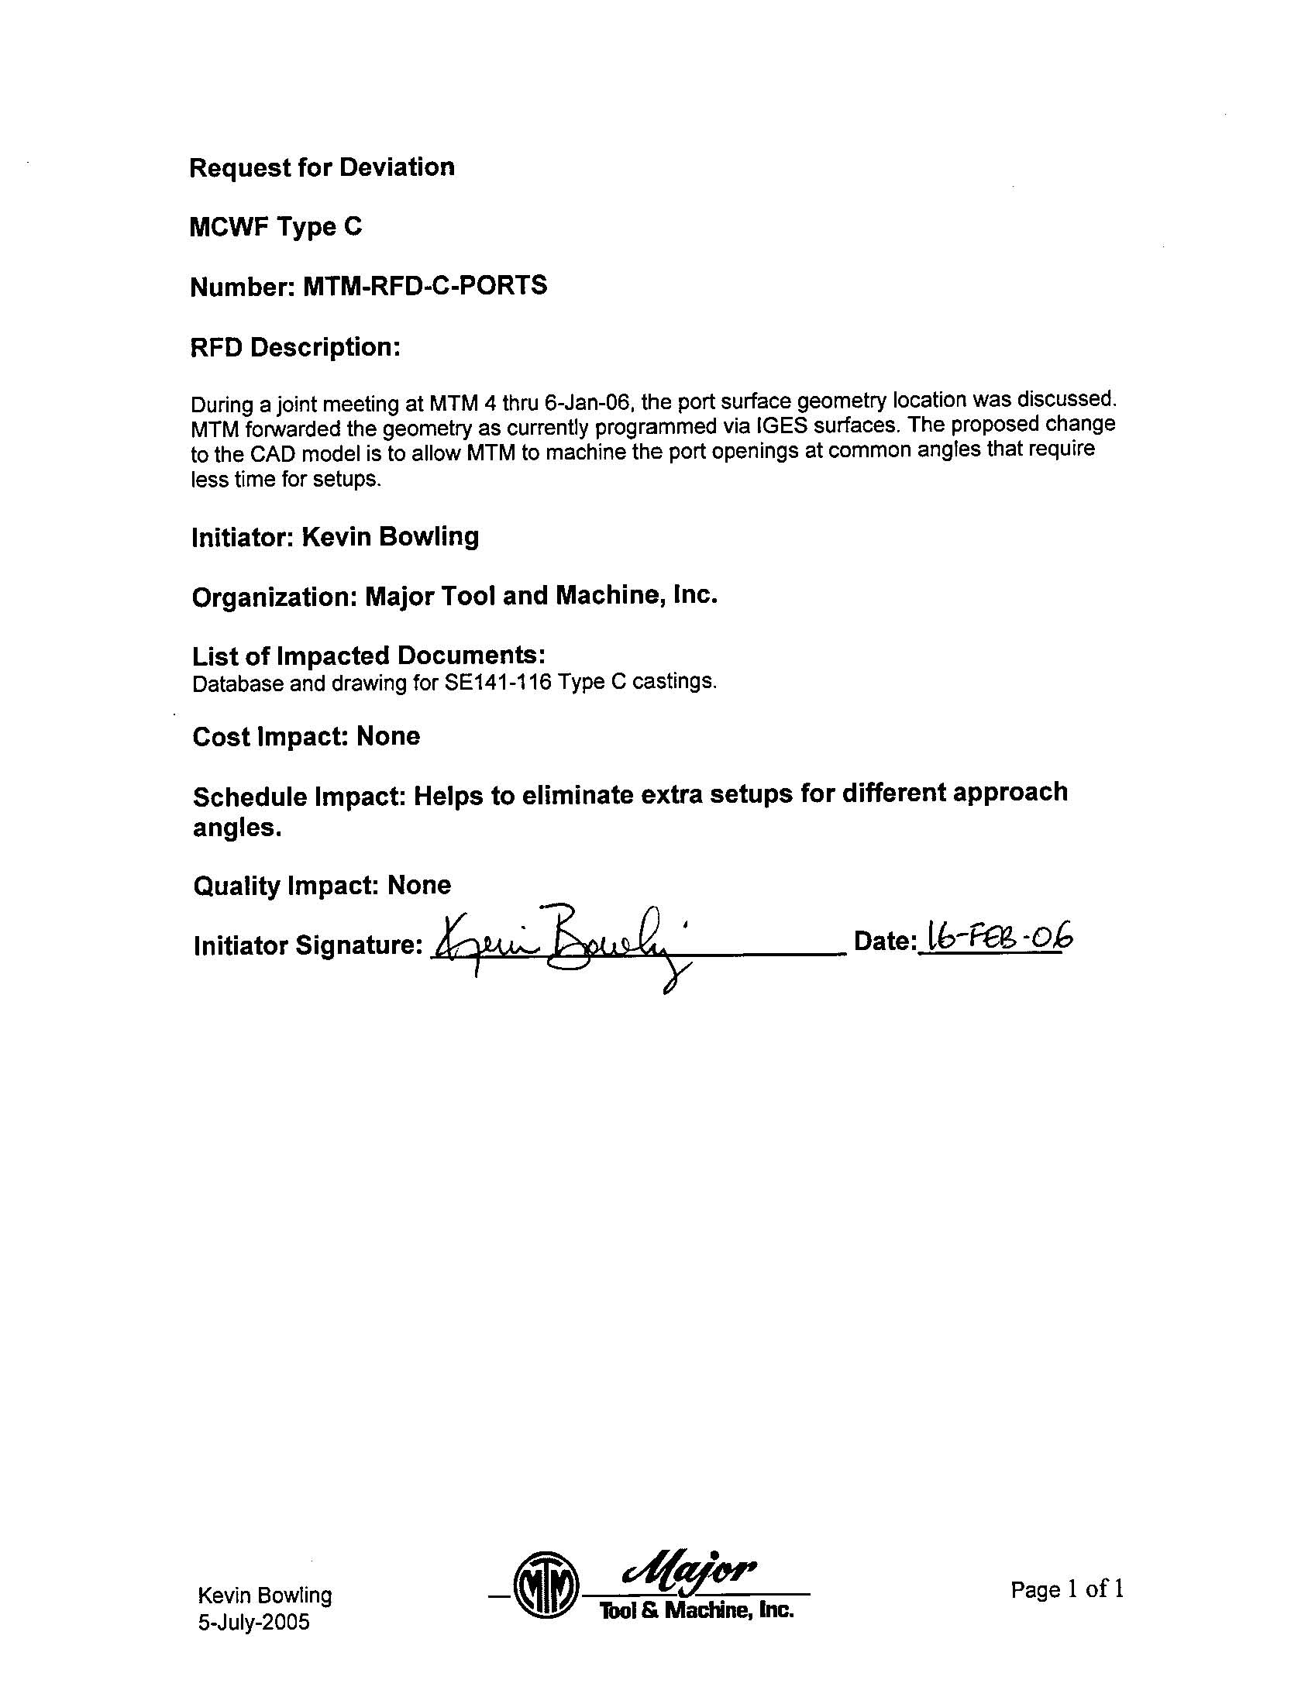

NCSX RFD  Part II | Number: 14-015 |  | RFD Description: MCWF Type C Port Openings
RLM: Brad Nelson |  | Organization: ORNL
Impact on Interfaces with Other WBS Elements/Items: (If none, so state): WBS 12 – cost of redesign of G10 boot retainers.
RLM Recommendation:

Approve Do Not Approve

Additional remarks:

Dave Williamson (WBS Manager): We received an IGES file for two port openings from MTM, which we incorporated into the model in the last revision (SE141-116 Rev 8 dated Feb 2, 2006). The geometry change was small and had no impact except for a minor design modification to the G10 port boot rings at those locations.

PPPL/ORNL will likely need to develop two designs of the G10 boot retainers, one for the C1 through C3 castings and one for the C4 through C6 castings => approximate cost impact to NCSX Project (PPPL/ORNL) will be ~$10K (WBS 12 impact).

Does this Change Impact Material Already Procured or Parts/Assemblies Already Assembled/Manufactured using this Material: Yes No

If “Yes”, what is the recommended disposition of this material/part/assembly? Use C-1 through C-3 castings “as is.” C-4 through C-6 castings will be modified as indicated .

RLM Signature:

Project Disposition:

Approved. No ECP required.

Approved. ECP -042 already processed which incorporated this design change in CSPEC (NCSX-CSPEC-141-03-11). ECP-045 will capture the cost impact of this change.

NCSX Systems Engineering Support Manager

Not Approved. Reason(s) for disapproval:

