NCSX RFD  Part I | Number: 14-018R2 |  | RFD Description: Type A2-A6 MCWFs Flange Hole Modifications
Initiator: Mike Griffith |  | Organization: Major Tool
List of Impacted Documents: (Specification, MIT/QA Plan, SOW, drawing, etc.):
SE141-114

Cost Impact: (If none, so state): NONE
Schedule Impact: (If none, so state: NONE
Quality Impact: (If none, so state): NONE
State Requirement Deviation is Requested For: (Specification, MIT/QA Plan, SOW, drawing, etc.): SE141-114
Full Description of the Deviation Requested: (Use continuation pages, e-mails, letter, sketches, etc. as needed and include amplifying information as appropriate to support deviation request.):
Revision 2 to this RFD corrected Attachment (2 ) to keep the Type-A, Datum-E, hole #10, as a clearance hole for winding forms A2-A6.

Revision 1 to this RFD removed the Type A1 MCWF– it will be the subject of RFD-14-020. This RFD now only addresses Type A2 through A6 MCWFs.

Major Tool noted casting interference at the bolt locations as shown in the attached figures for the Type A castings – see Attachment (1). This casting interference is similar to what was noted on the Type C winding forms, but more are severe in these areas for the Type A MCWFs. NCSX reviewed the remaining flange holes for the Type A2 though A6 castings and developed the concept shown on Attachment (2) in which a number of the clearance holes have been changed to tapped holes. The remaining A2 through A6 MCWFs shall be manufactured per this.

Attachments:
- Pictures showing interference details.
- Proposed changes to Type A2-A6 MCWFs (Revised May 18, 2006)

Initiator Signature: Mike Griffith/Phil Heitzenroeder

Attachment (1)
Type A MCWF Interferences

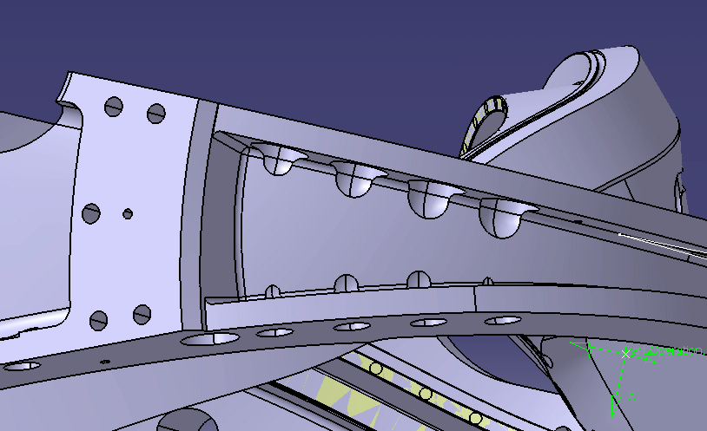

Relief area cut into cast wall
The pictures below illustrate how much casting wall interference there will be on the type A casting. The current machining models for all three winding forms have this interference problem to some degree. The models have a 3” counterbore that extends .75” from the face and the remainder of the feature is a 1.5” radius (see below). This is why Major Tool had to perform the grinding around the counterbores on C4 in order to get the 3” diameter gage to fit.

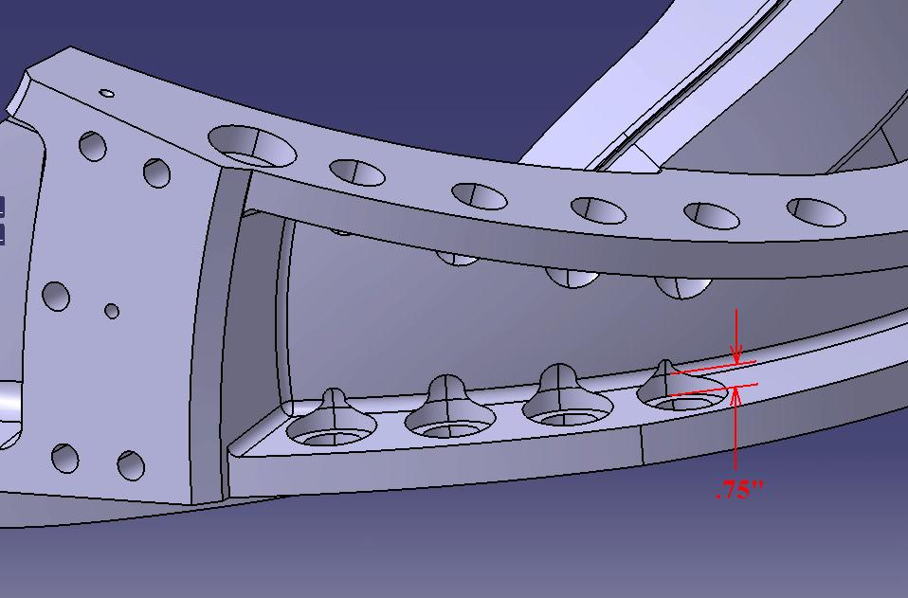

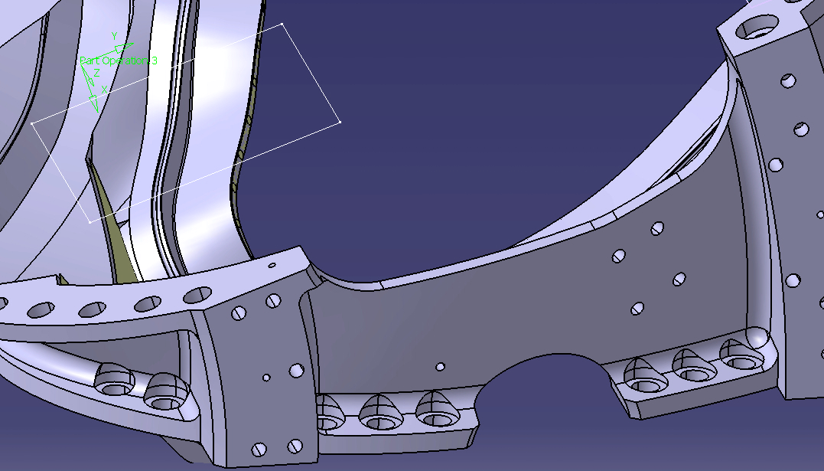

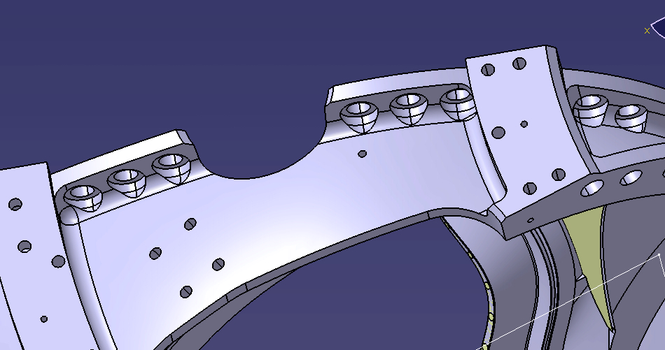

Attachment (2)

Definition of Holes to be Modified for Type A2 through A6 MCWFs
(Reference: D.Williamson e-mail of May 18, 2006)

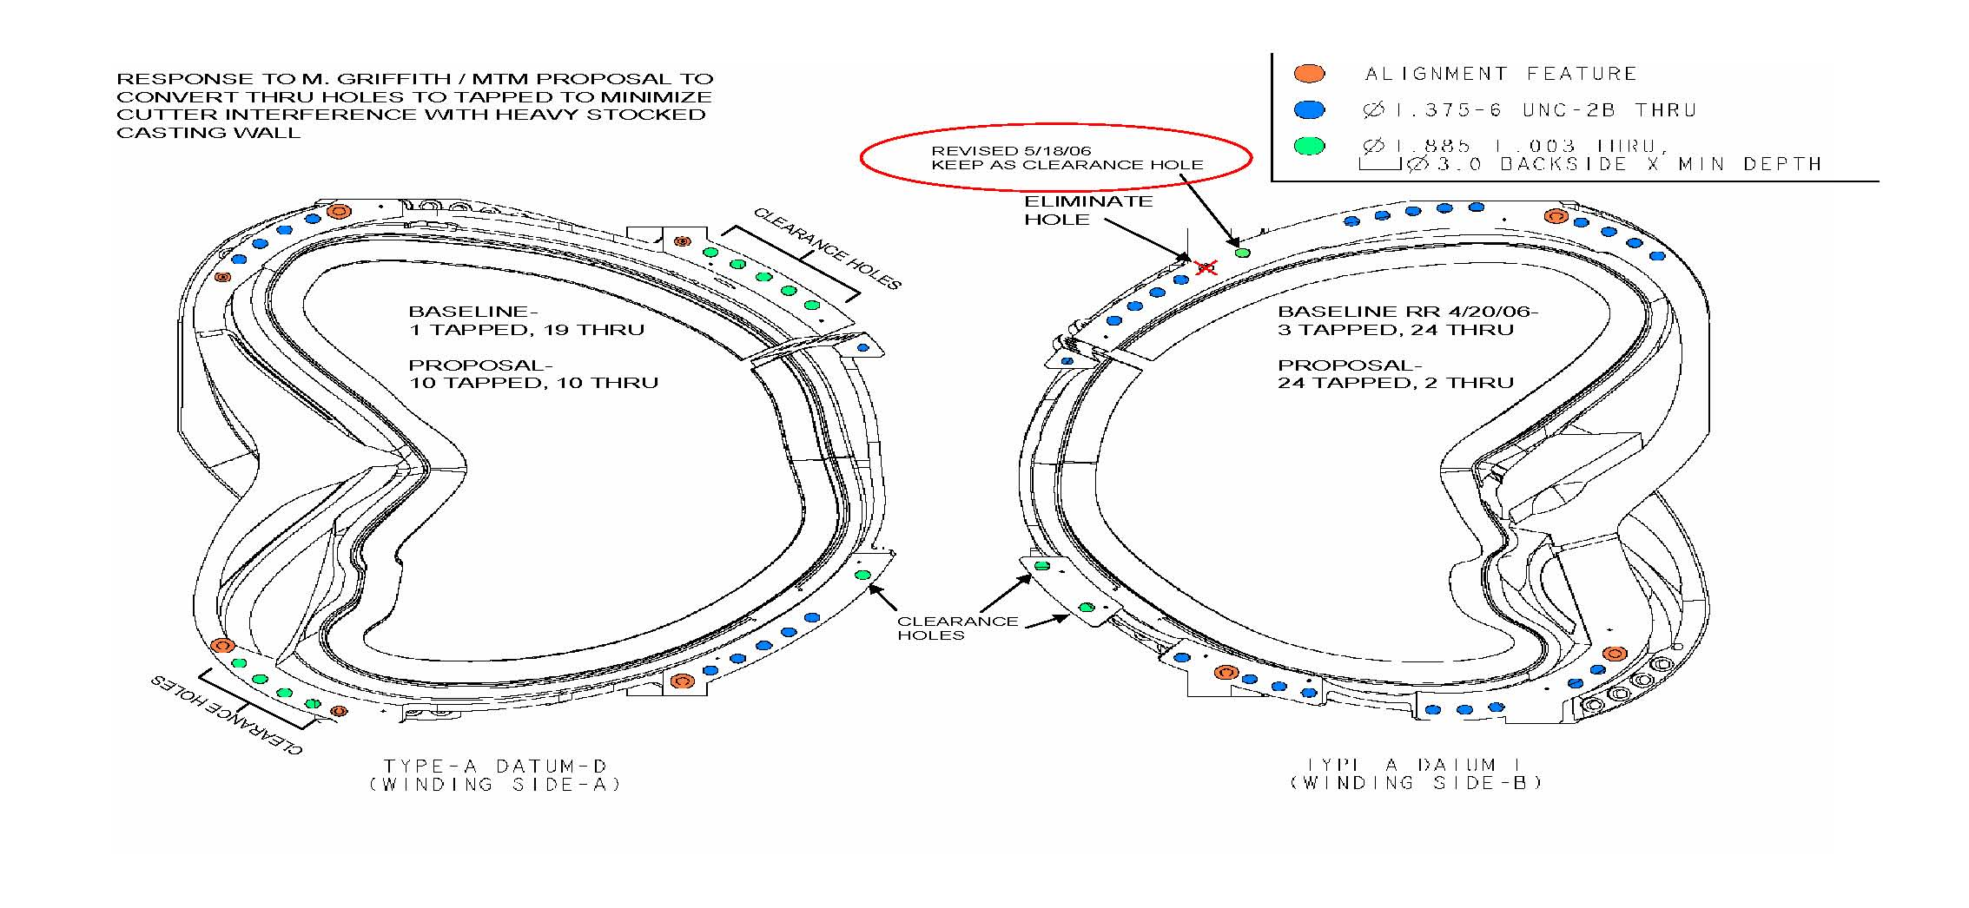
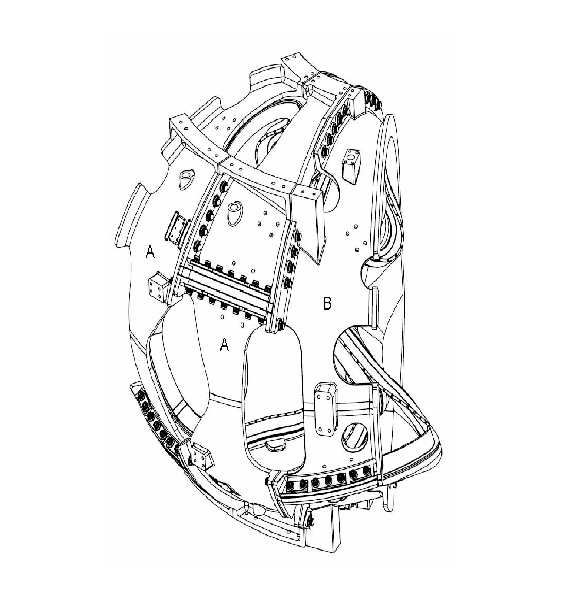
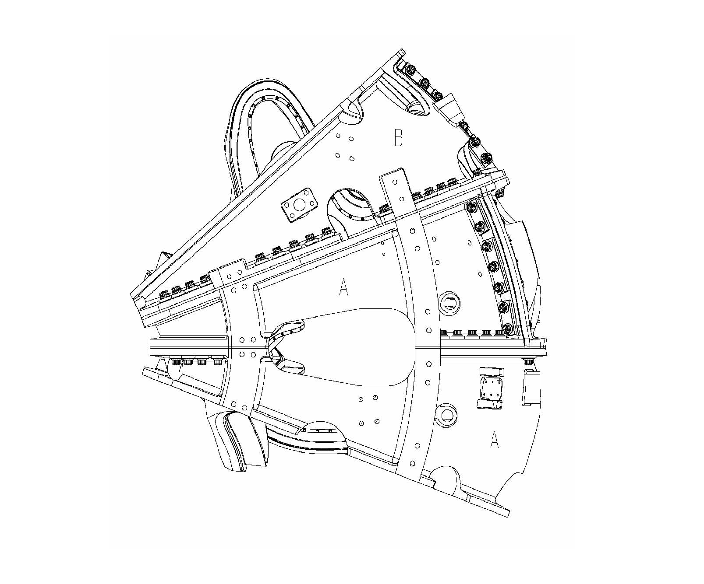\
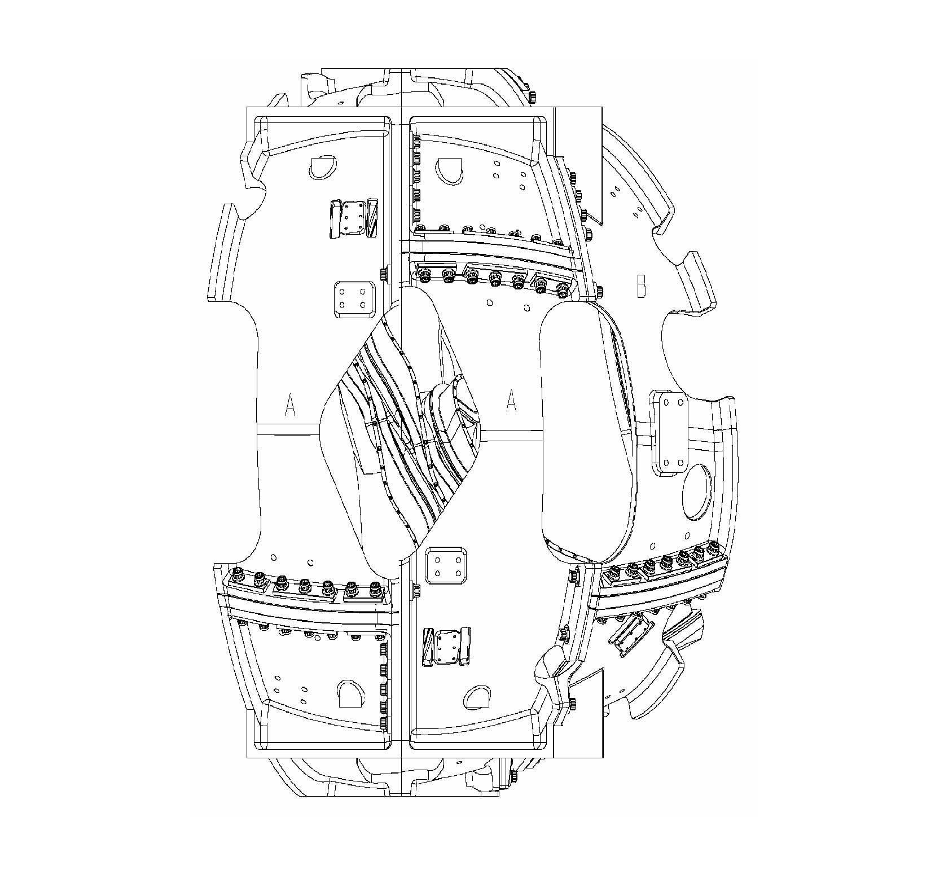

NCSX RFD  Part II | Number: 14-018R2 |  | RFD Description: Type A2-A6 MCWFs Flange Hole Modifications
RLM: Brad Nelson |  | Organization: ORNL
Impact on Interfaces with Other WBS Elements/Items: (If none, so state): NONE
RLM Recommendation:

Approve Do Not Approve

Additional remarks:

This RFD also includes a modification by the NCSX Project for the identified Type A2 through A6 MCWF flange holes - See Attachment (2). The milling machine should be programmed to tap to a depth of 1.5” from the front flange face ( recognizing that some flange areas may be less than 1.5” thick and therefore the thread length may be less than 1.5”
for some holes).

These modifications will be incorporated in a future revision to this drawing. In the interim that “stamp” process will be used to annotate SE141-114.

Does this Change Impact Material Already Procured or Parts/Assemblies Already Assembled/Manufactured using this Material: Yes No

If “Yes”, what is the recommended disposition of this material/part/assembly? A1 Casting will be accepted “as is” with the exception of the two holes shown.

RLM Signature:

Project Disposition:

Approved. No ECP required.

NCSX Systems Engineering Support Manager
Approved. ECP will be assigned and processed.

Not Approved. Reason(s) for disapproval:

