NCSX RFD  Part I | Number: 14-018 |  | RFD Description: Type A Casting Wall Interference
Initiator: Mike Griffith |  | Organization: Major Tool
List of Impacted Documents: (Specification, MIT/QA Plan, SOW, drawing, etc.):
SE141-114

Cost Impact: (If none, so state): NONE
Schedule Impact: (If none, so state: NONE
Quality Impact: (If none, so state): NONE
State Requirement Deviation is Requested For: (Specification, MIT/QA Plan, SOW, drawing, etc.): SE141-114 showing bolt hole interferences.
Full Description of the Deviation Requested: (Use continuation pages, e-mails, letter, sketches, etc. as needed and include amplifying information as appropriate to support deviation request.):

Major Tool noted casting interference at the bolt locations shown in the attached figures for the Type A castings. This casting interference is similar to what was noted on the type C winding forms, but more severe in these areas.

After some discussion (teleconference the evening of March 29th), it was decided that this interference condition will be accepted as is for these locations on A1 - NSTX will need to weld in threaded “pucks” and bolt through from the opposite side.

Attachments: Pictures showing interference details.

Initiator Signature: Mike Griffith/Phil Heitzenroeder

Type A MCWF Interferences

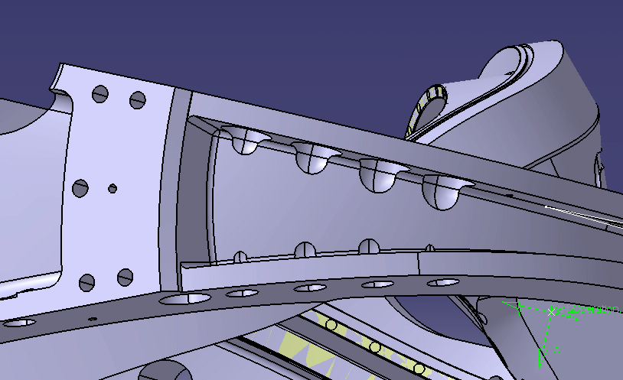

Relief area cut into cast wall
The pictures below illustrate how much casting wall interference there will be on the type A casting. The current machining models for all three winding forms have this interference problem to some degree. The models have a 3” counterbore that extends .75” from the face and the remainder of the feature is a 1.5” radius (see below). This is why Major Tool had to perform the grinding around the counterbores on C4 in order to get the 3” diameter gage to fit.

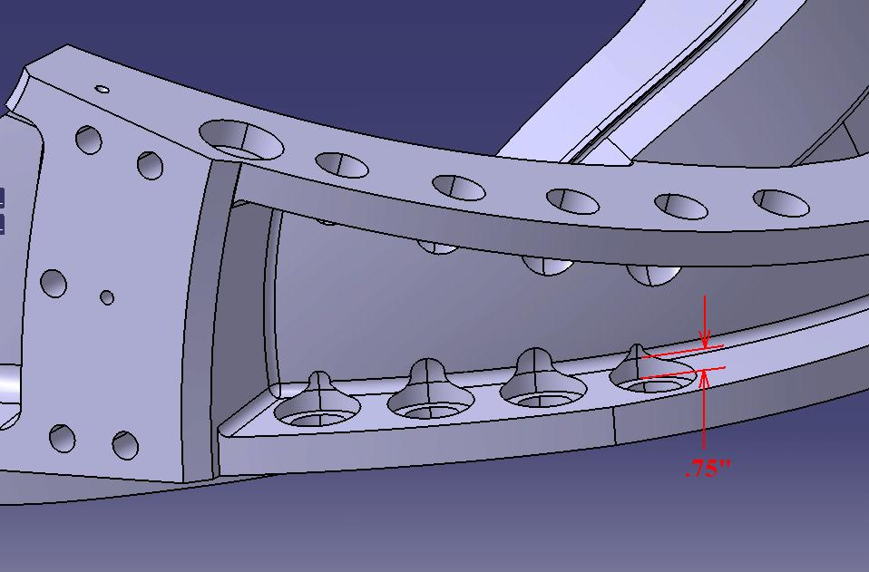
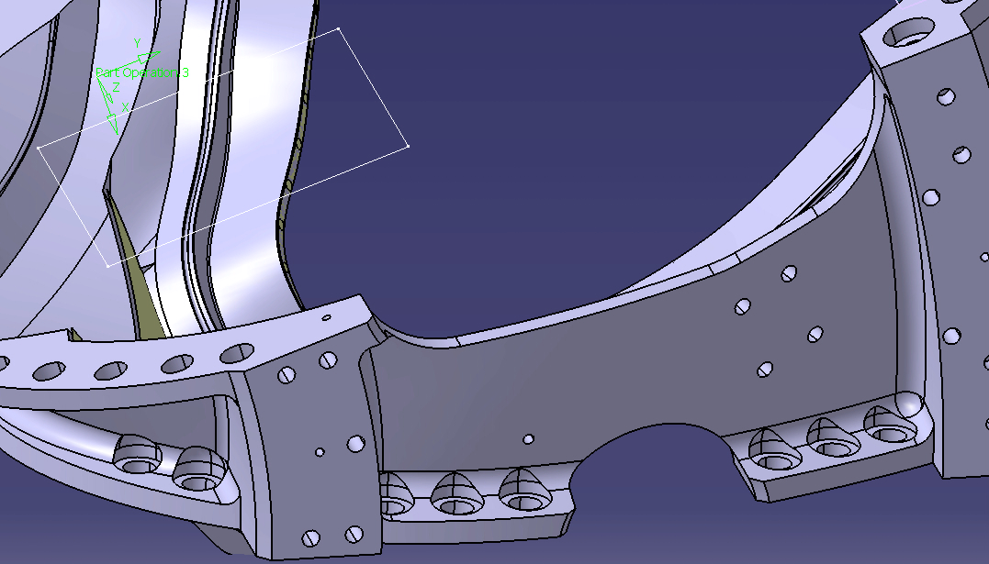

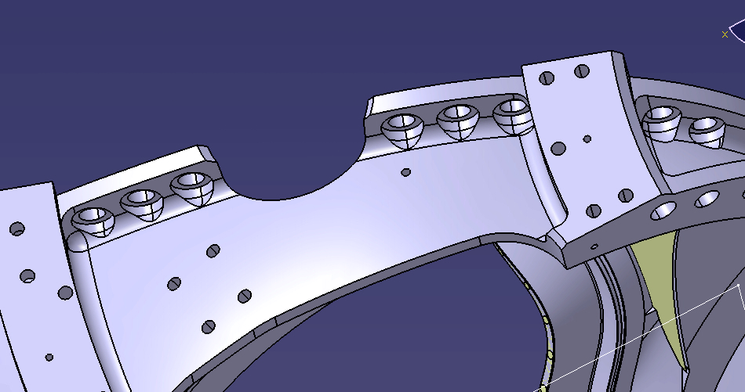

NCSX RFD  Part II | Number: 14-018 |  | RFD Description: Type A Casting Wall Interference
RLM: Brad Nelson |  | Organization: ORNL
Impact on Interfaces with Other WBS Elements/Items: (If none, so state): NONE
RLM Recommendation:

Approve Do Not Approve

Additional remarks:

In an e-mail (L. Sutton to N. Horton of March 29, 2006), PPPL approved this change. This RFD documents the official approval. While it is likely that other interferences will be identified, they will be addressed as either revisions to this RFD or as separate RFDs.

An ECN will be processed this week to capture these changes.

Does this Change Impact Material Already Procured or Parts/Assemblies Already Assembled/Manufactured using this Material: Yes No

If “Yes”, what is the recommended disposition of this material/part/assembly? A1 Casting will be accepted “as is”.

RLM Signature:

Project Disposition:

Approved. No ECP required.

Approved. ECP will be assigned and processed.

NCSX Systems Engineering Support Manager

Not Approved. Reason(s) for disapproval:

