NCSX RFD  Part I | Number: 14-019 |  | RFD Description: Adding Lifting Holes in Poloidal Break Shims
Initiator: Mike Giffith |  | Organization: MTM
List of Impacted Documents: (Specification, MIT/QA Plan, SOW, drawing, etc.)
- SE141-048 (MC Poloidal Break Shim Assembly Type-A)
- SE141-058 (MC Poloidal Break Shim Assembly Type-B)
- SE141-078 (MC Poloidal Break Shim Assembly Type-C)

Cost Impact: (If none, so state) : NONE
Schedule Impact: (If none, so state: NONE
Quality Impact: (If none, so state): Incorporation of these proposed changes will improve MTM manufacturing processing of remaining MCWFs not yet shipped.
State Requirement Deviation is Requested For: (Specification, MIT/QA Plan, SOW, drawing, etc.): Revise identified drawings to provide lifting holes in Poloidal Break Shims.
Full Description of the Deviation Requested: (Use continuation pages, e-mails, letter, sketches, etc. as needed and include amplifying information as appropriate to support deviation request.)
To add lifting holes in the poloidal shims as per the attached e-mail request from Mike Griffith. Will only impact MCWFs not yet shipped.

Attachments: E-mail (Griffiths to N.K. Flowers) dated April 5, 2006.

Initiator Signature: Mike Griffith Date: April 5, 2006

From: Griffith, Mike [mailto:mgriffith@majortool.com]
Sent: Wednesday, April 05, 2006 11:51 AM
To: NKHFlowen@aol.com; royjratc-aol-com-offsite
Cc: Bowling, Kevin
Subject: Request for Lifting holes in Poloidal Break Shims

In order to assist in the intermediate and final assembly of the poloidal break shims in the remaining C's and in all of the A and B shims, we are requesting the addition of a 3/8-16 hole in both ends of the shim to be used for lifting. The drawing below is a C shim showing the approximate location of the holes. Please review and forward this request to PPPL. Thanks.

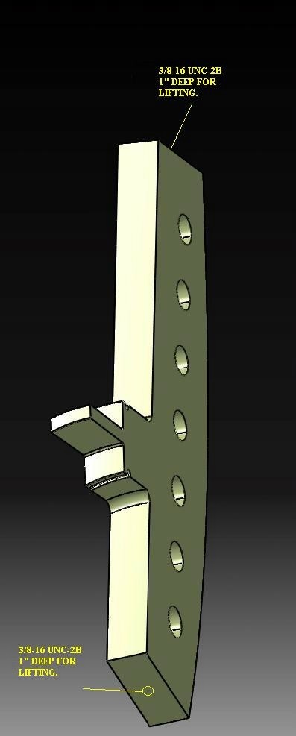

NCSX RFD  Part II | Number: 14-019 |  | RFD Description: Adding Lifting Holes in Poloidal Break Shims
RLM: Brad Nelson |  | Organization: ORNL
Impact on Interfaces with Other WBS Elements/Items: (If none, so state): NONE
RLM Recommendation:

Approve Do Not Approve

Additional remarks:

ECN-5107 being processed to reflect these changes.

Does this Change Impact Material Already Procured or Parts/Assemblies Already Assembled/Manufactured using this Material: Yes No

If “Yes”, what is the recommended disposition of this material/part/assembly? C Castings already shipped will not be changed (C1 through C4) and will be used as is. Remaining castings will reflect this change.

RLM Signature:

Project Disposition:

Approved. No ECP required.

Approved. ECP will be assigned and processed.

NCSX Systems Engineering Support Manager

Not Approved. Reason(s) for disapproval:

