NCSX RFD  Part I | Number: |  | RFD Description: Revised location of part number in MCWF casting
Initiator: P. Heitzenroeder |  | Organization: PPPL
List of Impacted Documents: Drawing SE-141-114 will eventually be updated to reflect as built new part number location on the Type A casting.
Cost Impact: (If none, so state)
Minimal – cost of processing RFD and eventual cost of revising drawing.
Schedule Impact: (If none, so state)
None
Impact on Interfaces with Other WBS Elements/Items: (If none, so state)
None
Full Description of the Deviation Requested: (Use continuation pages, e-mails, letter, sketches, etc. as needed and include amplifying information as appropriate to support deviation request.)

Ref.: P. Djordjevich’s e-mail of 29 March 05; Subject: Pattern Change deviation.
“EIO would like to formally request a deviation on A coil for a re-location of pattern/casting identification number.
Please review the attachment and advise.
Thanks
Peter”.

This change will simplify the pattern and mold design.
Attachments:
See att. 1 and 2: P. Djordjevich’s e-mail of 29 March 05 and the pdf drawing attached to this e-mail

Initiator Signature: Date:

NCSX RFD  Part II | Number: |  | RFD Description: Revised location of part number in MCWF casting
RLM: B. Nelson |  | Organization: ORNL
RLM Recommended Disposition:

Approve Do Not Approve (If recommendation is to approve, ECP will be assigned)

Additional remarks:

RLM Signature:

Project Disposition: (Include ECP Number):

Attachment I: E-mail request:

From: Peter Djordjevich [djord@earthlink.net]
Sent: Tuesday, March 29, 2005 2:09 PM
To: Phil Heitzenroeder; PQA
Cc: NKHFlowen; royjratc-aol-com-offsite
Subject: Pattern Change deviation

EIO would like to formally request a deviation on A coil for a re-location of pattern/casting identification number.
Please review the attachment and advise.
Thanks
Peter

Peter Djordjevich
djord@earthlink.net
EarthLink Revolves Around You.

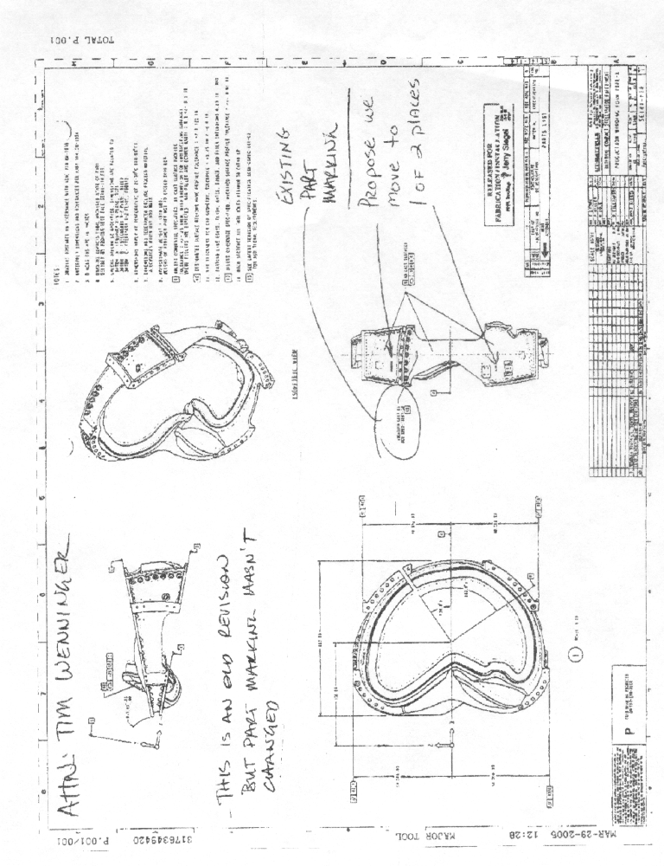
Attachment II. Proposed location change

