Princeton Plasma Physics Laboratory
Procedure
‘
Procedure Title: Field Period Assembly Station Three

Number: D-NCSX-FPA-003 |  | Revision: 0 |  |  | Effective Date: June 19, 2008  Expiration Date:  (2 yrs. unless otherwise stipulated)
Procedure Approvals:
Note: Abbreviated review authorized since Project cancelled and only limited Station 3 work to proceed (2 3-packs and mounting on three pack over VV for gross fit.
Author: Bill Sands / Mike Viola
ATI: Mike Viola
RLM: Larry Dudek
Responsible Division: NCSX Project
Procedure Requirements Designated by RLM - LAB-WIDE:
X | Work Planning Form (ENG-032) #1224 |  |  | Lockout/Tagout (ESH-016)
 | Confined Space Permit (5008,SEC.8 Chap 5) |  | X | Lift Procedure (ENG-021)
 | Master Equipment List Mod (GEN-005) |  | X | ES&H Review (NEPA, IH, etc.) NEPA 1261
 | RWP (HP-OP-20) |  |  | Independent Review
 | ATI Walkdown |  | X | Pre-Job Brief
X | Post-job Brief * |  | X | Hydrostatic and Pneumatic Testing. (ENG-014)
D-SITE SPECIFIC:
X | D-Site Work Permit (OP-AD-09) |  |  | Door Permit (OP-G-93)
 | Tritium Work Permit (OP-AD-49) |  |  | USQD (OP-AD-63)
X | Pre-Job Brief (OP-AD-79) |  |  | T-Mod (OP-AD-03)
 | **DCA/DCN (OP-AD-104) #

* Required for installations involving internal vacuum installations, critical lifts, and for the initial installation of repetitive work.
** OP-AD-104 was voided by procedure ENG-032. However, DCA’s that were open at the time of adoption of ENG-032 are still considered valid for work approval purposes.

REVIEWERS (designated by RLM)
Incorporated Comments
Accountable Technical Individual……………………………………
Test Director
Independent Reviewer
D-Site Shift Supervisor
Independent
NCSX Dimensional Control Coordinator…………………………… Bob Ellis |  |  |  | Yes
Vacuum Vessel Cognizant Engineer
PPPL Metrology Manager…………………………………… Tiana Dodson / Craig Prininski
NCSX Field Period Assembly Manager…………………………… Mike Viola |  |  |  | Yes
NCSX Field Supervisor……………………………………………… John Edwards
Project Engineer for Stellarator Systems (WBS 1) Manager…… P. Heitzenroeder
FPA Tooling and Constructability ………………………………… Tom Brown |  |  |  | Yes
Quality Assurance/Quality Control…………………………….…… J. Malsbury/C. Colin
Maintenance and Operations Division
Energy Conversion System/Motor Control Division
Engineering ………………………………………………………… Phil Heitzenroeder
Environmental Restoration & Waste Management Division
Environmental, Safety & Health…………………………………… Jerry Levine
Industrial Hygiene…………………………………………………… Bill Slavin
Health Physics……………………………………………………..… George Ascione
RLM………………………………………………………………….…. Larry Dudek
TRAINING (designated by RLM)
No training required ______________ | Instructor John Edwards
Personnel (group, job title or individual name) |  | Read Only | Instruction  Pre-Job Briefing |  | Hands On
Lead Tech. |  |  | X
Technicians performing task |  |  | X
Field Supervisors |  |  | X
Quality Control Representative |  |  | X
Training Rep.
RLM Larry Dudek

RECORD OF CHANGE

Revision | Date | Description of Change
00 | May 1, 2008 | Initial release

TABLE OF CONTENTS
1. Introduction and Scope 1
1.1 Introduction 1
1.2 Scope 1
1.3 Identification of Modular Coil Segments Being Assembled 1
2. Applicable Documents 1
2.1 Manufacturing Facility Operations Plan 1
2.2 Manufacturing, Test, and Quality Assurance Plan 1
2.3 Modular Coil Lift Procedures 1
2.4 Field Period Assembly Station 3 Dimensional Control Plan 2
2.5 Metrology data plan and area is in place 2
2.6 Weld qualifications and weld procedure 2
3. Safety Requirements 2
3.1 Job Hazard Analysis (JHA) 2
4. Prerequisites & Condition 3
4.1 Pre-Job Briefing 3
4.2 Training 3
5. Drawings Required for Station 3 3
6. Pre-Installation Set-Up 4
6.1 Metrology Procedure for Station 3 4
7. Pre-Assemble Left MCHP 4
7.1 Alignment and Metrology 4
8. Pre-Assemble Right MCHP 6
8.1 Alignment and Metrology 6
9. Pre-Assemble Left and Right MCHP 7
9.1 Install Nose Shims 7
Figure 2 Left and Right MCHP 8
10. Re-Assemble Left and Right MCHP 8
10.1 Re-Assemble and Metrology 8
11. Install Laser Screens 9
11.1 Place Screens 9
12. Install Vacuum Vessel 10
12.1 Installation Setup and Metrology 10
13. Install Right MCHP Over VV 11
13.1 Move Right MCHP onto VV and Metrology 11
14. Install Left MCHP Over VV 12
14.1 Move Left MCHP onto VV and Metrology 12
15. Weld All Inboard Shims and Fill Bushing Gaps 13
15.1 Welding, Metrology and Gap Fill 13
16. VVSA Attachment to MC 14
16.1 Move Prep 14
17. Transfer Period to NCSX Test Cell 14
17.1 Move to Station 5 14
Appendix A. Document Sign Off 16
Appendix B. Log Book Record 21

LIST of TABLES

Table 1 Reference Drawings 3

LIST OF FIGURES
Figure 1 Right MCHP……..…………………………………………………………6
Figure 2 Left and Right MCHP………..……………………………………………8
Figure 3 Laser Screen Placement………………………………………………..10
Figure 4 Vacuum Vessel Stand…………………………………………………..11

Introduction and Scope

Introduction
The Field Period and Machine Assembly are divided into 5 workstations. Stations 1, 2, 3, and 5 deal with Field Period Assembly and Station 6 deals with final machine assembly. Each workstation has a specific set of tasks that will be performed as part of the overall assembly process. This procedure addresses the manufacturing, inspection, test and QC inspection points for the Station No. 3 Full Period Assembly (HPA) Activities.

Scope
This procedure is used to describe the assembly sequence required for Station No. 3 Full Period Assembly and includes:
- Pre Assemblies of Left and Right MCHP
- Metrology measurements (all racking and interim measurements);
- Laser Guide Screen Placement
- Vacuum Vessel Installation Setup
- Transfer Period to NCSX Test Cell

Identification of Modular Coil Segments Being Assembled
Field Supervisor lists the Modular Coil Segments being assembled on Appendix A.
Field Supervisor See Appendix A – Document Sign-off Record

Applicable Documents

Manufacturing Facility Operations Plan
The purpose of the Manufacturing Facility Operations Plan (NCSX-PLAN-MFOP) is to describe how the activities within the NCSX Manufacturing Facility will meet PPPL Integrated Safety Management (ISM) requirements specified in laboratory policies, programs, and procedures. It will also provide an overview of the general processes that occur in the facility. More detailed descriptions and processes for each process will be described in specific Manufacturing, Inspection and Test/Qualify Assurance (MIT/QA) plans and detailed manufacturing/assembly procedures.

Manufacturing, Test, and Quality Assurance Plan
Manufacturing, Test, and Quality Assurance Plan (NCSX-MIT/QA-185) addresses the manufacturing, inspection, test and Quality Assurance (QA) plan to complete and deliver three (3) Field Period Assemblies for the NCSX Project to the NCSX test cell.

Modular Coil Lift Procedures
Wound Modular Coil Lift Procedure (D-L-NCSX-999) describes the necessary equipment and methods to follow in lifting and transporting each wound modular coil assembly. The Assembled Modular Coils Lift Procedure (D-L-NCSX-1000) is under development to lift the wedge with the joined A-B coil as well as a procedure to lift the completed 3 coil Modular Coil Half Period (MCHP).

Field Period Assembly Station 3 Dimensional Control Plan
Field Period Assembly Station 3 Dimensional Control Plan (D-NCSX-PLAN-FPA3DC) describes the dimensional control steps that will be taken to ensure adequate dimensional control of the Modular Coil Half Period (MCHP) that will occur at Station 3.

Metrology data plan and area is in place
All metrology record copy files shall be saved electronically per PPPL Metrology Procedure D-NCSX-FPA-010. The metrology Supervisor shall assure that the file area is set up, accessible by the field measurement technicians and back office engineers.
Metrology Supervisor See Appendix A – Document Sign-off Record

Weld qualifications and weld procedure
All welding of the NCSX modular Coils shall be performed per drawing MC Shim Plate Layout SE140-046 with an approved welding procedure and with qualified welders per PPPL ENG-037. The welding engineer shall record the weld procedure and list those individuals qualified to perform welding per this procedure in Appendix A.
Welding Engineer Supervisor See Appendix A – Document Sign-off Record

Safety Requirements
All work will be performed in a safe manner in accordance with PPPL Environmental Safety & Health Directives ES&H 5008 and the “Integrated Safety Management” (ISM) policy.

Job Hazard Analysis (JHA)
A JHA will be generated for each Vacuum Vessel Sub Assembly station, identifying existing or potential workplace hazards and to evaluate the risk of worker injury or illness associated with job tasks. (Reference document ESH-004 “Job Hazard Analysis”) The IH representative will review the JHA’s for accuracy as well as completeness. It will be reviewed with all activity participants at the Pre-Job briefings. These JHA’s will be regularly reviewed and updated as needed. Any changes to the JHA’s must be reviewed by all active participants

 | Refer to JHA for All Hazardous Activities!

Prerequisites & Condition

Pre-Job Briefing
A pre-job briefing will be held, describing the processes and safety issues prior to starting any part of this procedure. Attendance shall be documented via training sign-in sheet. A copy of the sign-in sheet will be maintained with the run copy of the procedure. The original will be delivered in person to Human Resources, as required by ENG-030
Field Supervisor See Appendix A – Document Sign-off Record

Training
Assure all individuals working on FPA 3 have been trained as per requirements of the Field Period Assembly Training Matrix located at:

http://ncsx.pppl.gov/SystemsEngineering/Training/Training_Matrices/FPA_Training_MatrixR0.pdf
Field Supervisor to verify all training has been performed
See Appendix A – Document Sign-off Record

Drawings Required for Station 3
Materials are listed in drawing bill of materials on the respective drawings in

Title | Drawing Number
VV SUPPORT FIXTURE ASSEM. | SE184-050
FIELD PERIOD ASSEM. FIXTURE | SE185-300
FLOOR MOUNTED ROLLER TRACKS & SCREEN | SE185-301
FLOOR MOUNTED ROLLER TRACKS W/ VV BASE SUPPORT | SE185-303
MCWF OVER VACUUM VESSEL | SE186-300

Table 1 Reference Drawings

Note: Procedural steps marked N/A! (non applicable) have been removed due to budget cuts and NCSX cancellation as of 5-22-2008. N/A! applies only to the metrology portion of the subsequent steps.

6. Pre-Installation Set-Up

6.1 Metrology Procedure for Station 3

6.1.1 Work with back office to transfer CAD models that establish a global coordinate system for Station 3 based on the Stellarator Core coordinate system.
Dimensional Control Coordinator Appendix A – Document Sign-off Record

6.1.2 Install Station 3 site monuments as needed to perform metrology measurements. Two coordinate systems must be established. One that defines the full period and one used for initial positioning and measuring the right MCHP when the support cart is moved to the far right.

6.1.3 Install floor mounted tracks and the VV base support. The alignment accuracy for these parts with respect to the Station 3 coordinate system is .050" RMS. N/A! Grout beneath floor tracks as required.

6.1.4 Install MCHP left support stand. Position to .060" RMS.

6.1.5 Install the MCHP right support stand; verify the cart motion and then move to the far right. Position the AirLoc Wedgemount in a lowered position. Monuments on the cart should be within .060" (true distance) of their desired position.

6.1.6 Install alignment brackets, jack screws and dial indicators for horizontal positioning on both support stands. Brackets are similar to the system used for alignment in Station 2

6.1.7 Reconfirm Leica position used for measuring each MCHP target alignment monuments. N/A!
Metrology Supervisor See Appendix A – Document Sign-off Record

7. Pre-Assemble Left MCHP

7.1 Alignment and Metrology

7.1.1 Using the SISSCO actuator and the base support lateral adjustment system (similar to approach used in Station 2), position left MCHP over the left support with respect to the period global coordinate system. All three monuments should be within .010" (actual distances) of the desired position.

Metrology Supervisor See Appendix A – Document Sign-off Record

 | Caution Lifting hazard -  Refer to JHA for All Hazardous Activities!

7.1.2 While held by the SISSCO actuator brings the AirLoc Wedgemount leveler up to take the load. Secure left MCHP at three locations to vertical support posts on support base.

7.1.3 Measure all chosen monuments (from Station 2) on left MCHP with respect to the period global coordinate system. All monuments should be within .010" (actual distances) of the desired position. If this criterion is not met, review with back office and if directed disengage Wedgemount and repeat Step 7.1.7.

Metrology Supervisor See Appendix A – Document Sign-off Record

7.1.4 Measure the Type-A and Type-C end flanges while standing in the vertical position.
Metrology Supervisor See Appendix A – Document Sign-off Record

7.1.5 Allow time for the back office to review the metrology data. N/A!
Dimensional Control Coordinator Appendix A – Document Sign-off Record

7.1.6 Using the Type-A (A-flange) inboard shim template mark the nose shim locations and puck locations. Remove the template. Use a thin equivalent washer of the puck diameter (or some other method) to provide a positional "feel" to allow measuring puck height in the A -B installed position. Attach the locating ring to the outside of the flange.

Field Supervisor See Appendix A – Document Sign-off Record

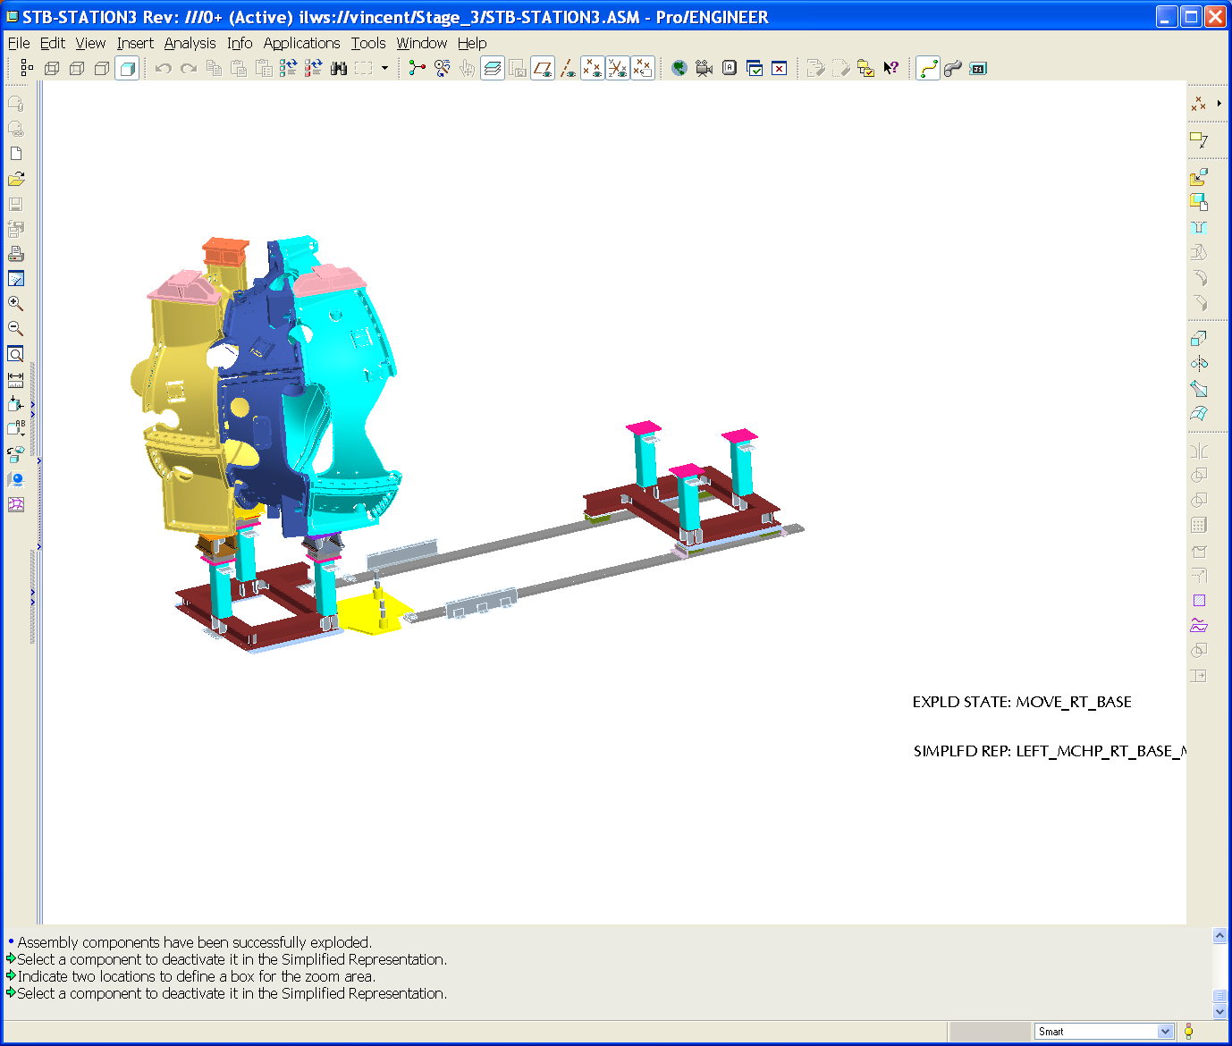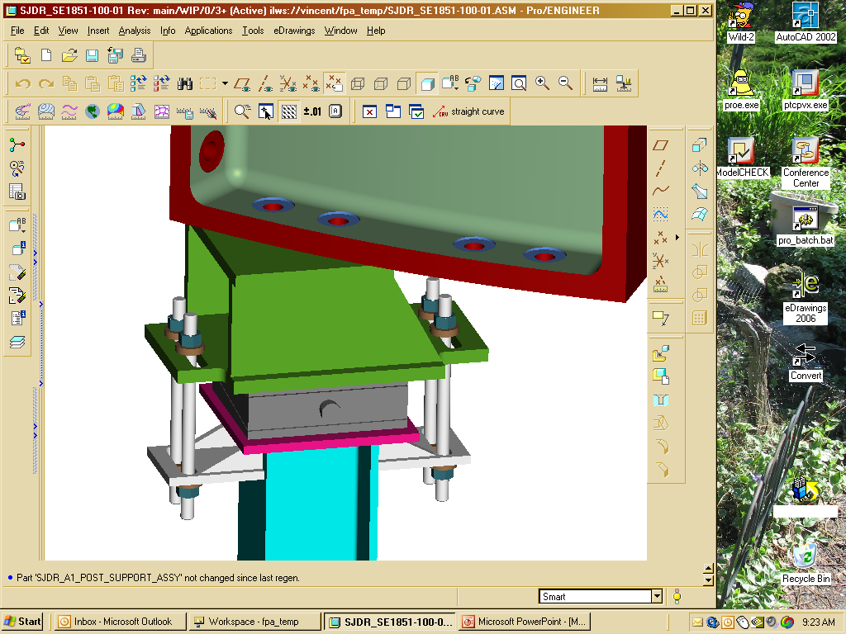
MCHP support cart assembly
MCHP Left side
AirLoc Wedgemount bolt on spherical seat precision leveler
Figure 1 Right MCHP

8. Pre-Assemble Right MCHP

8.1 Alignment and Metrology

8.1.1 Move the right support cart in the far right location, and position it with respect to the second global coordinate system. Secure support cart in place. Monuments on the cart should be within .060" (true distance) of their desired position.

8.1.2 Using the SISSCO crane and the base support lateral adjustment system (similar to approach used in Station 2), position right MCHP over the right support with respect to the right global coordinate system.

8.1.3 While held by the SISSCO rigging bring the AirLoc Wedgemount leveler up to take the load. Secure left MCHP to the support base.

8.1.4 Measure the target monuments on right MCHP with respect to the right global coordinate system. All three monuments should be within .010" (actual distances) of the desired position. If the criterion is not met, review with back office and if directed disengage Wedgemount and repeat Step 8.1.4.
Metrology Supervisor See Appendix A – Document Sign-off Record

8.1.5 Measure the Type-A and Type-C end flanges while standing in the vertical position. Check for any deformation (sag).

8.1.6 Allow time for the back office to review the metrology data. N/A!

8.1.7 Using the Type-A (A-flange) inboard shim template mark the nose shim locations. Remove the template.

8.1.8 Based on flange surface measurements of left and now right MCHP Type-A mating flanges define all outboard shim thickness. Hopefully this is a verification check of the "A" flanges measured at the end of Station 2.

8.1.9 If new shims are needed fabricate them and or compress alumina coated shims and sort by thickness the shim set that will be installed on the A/A interface.
Field Supervisor See Appendix A – Document Sign-off Record

9. Pre-Assemble Left and Right MCHP

9.1 Install Nose Shims

9.1.1 Place an initial set of shims (4-8) on the left side Type-A MCHP in designated locations for the initial alignment of the mating coil. Temporarily secure the shims in place. Local platforms will be needed to secure initial shim set on left MCHP.

9.1.2 Using the SISSCO rigging remove the right MCHP from the right support stand and move the support cart to the period installed position next to the Left MCHP. Secure in place.

9.1.3 Measure the target monuments on left MCHP with respect to the period global coordinate system. All monuments should be within .010" (actual distances) of the desired position. If the criterion is not met, review with back office to see how we proceed.
Metrology Supervisor See Appendix A – Document Sign-off Record

9.1.4 Install the remaining alumina coated shims; install studs and supernuts.

9.1.5 Tighten flange fasteners to 50%

9.1.6 Make a hand "wiggle" test (rotate on bolt) on all shims to make sure that they are tight. If a loose shim is found back off on sufficient adjacent bolts to allow a replacement shim to be inserted. Tighten bolt .
Field Supervisor See Appendix A – Document Sign-off Record

9.1.7 After tightening, measure the position of all monuments per the Dimensional Control Plan, following steps 2.3.3 through 2.3.7. All monuments should be within .010" (actual distances) of the desired position. If the criterion is not met, review with back office to see how we proceed.

9.1.8 Measure the shim puck height (at a number of points around the puck surface) at each of the nose shim puck locations. Use the data to define each puck height.

9.1.9 Unfasten all bolts, remove local platforms and roll the right MCHP to the far right position.

9.1.10 Recheck the part alignment of the left MCHP to make sure it is still within alignment, remove puck locating ring and then weld all left MCHP Type-A flex shims to the plasma side of the Type-A flange, following the weld sequence plan. Use the template markings of Step 7.1.6 to position nose shims.

9.1.11 After welding the left MCHP nose shims recheck alignment to determine if the part still meets the metrology acceptance criterion. The acceptance criterion is .005" RMS deviation in alignment to the set of tooling balls.

9.1.12 Time needs to be allocated for a back office assessment of the part after welding. If Control Plan acceptance criterion is not met project input is needed to determine how to proceed.
Metrology Supervisor See Appendix A – Document Sign-off Record

9.1.13 Measure the right MCHP fiducials to establish a reference coordinate system prior to welding the nose shims.

9.1.14 With the successful left MCHP weld operation, weld all the right MCHP Type-A, A-flange (datum D) flex shims to the plasma side, following the weld sequence plan.
Field Supervisor, Quality Control See Appendix A – Document Sign-off Record

9.1.15 After welding the right MCHP nose shims recheck the part to determine if it still meets the metrology acceptance criterion. The acceptance criterion is .004" RMS deviation in alignment to the set of tooling balls. Consult Dimensional Control if this criterion is not met.
Dimensional Control Coordinator Appendix A – Document Sign-off Record

9.1.16 Time needs to be allocated for a back office assessment of the part after welding. The acceptance criterion is .004" RMS deviation in alignment to the set of tooling balls. Consult Dimensional Control if this criterion is not met.

9.1.17 Time needs to be allocated for a back office assessment of the part after welding. If Control Plan acceptance criterion is not met project input is needed to determine how to proceed.
Local rigging interface structure
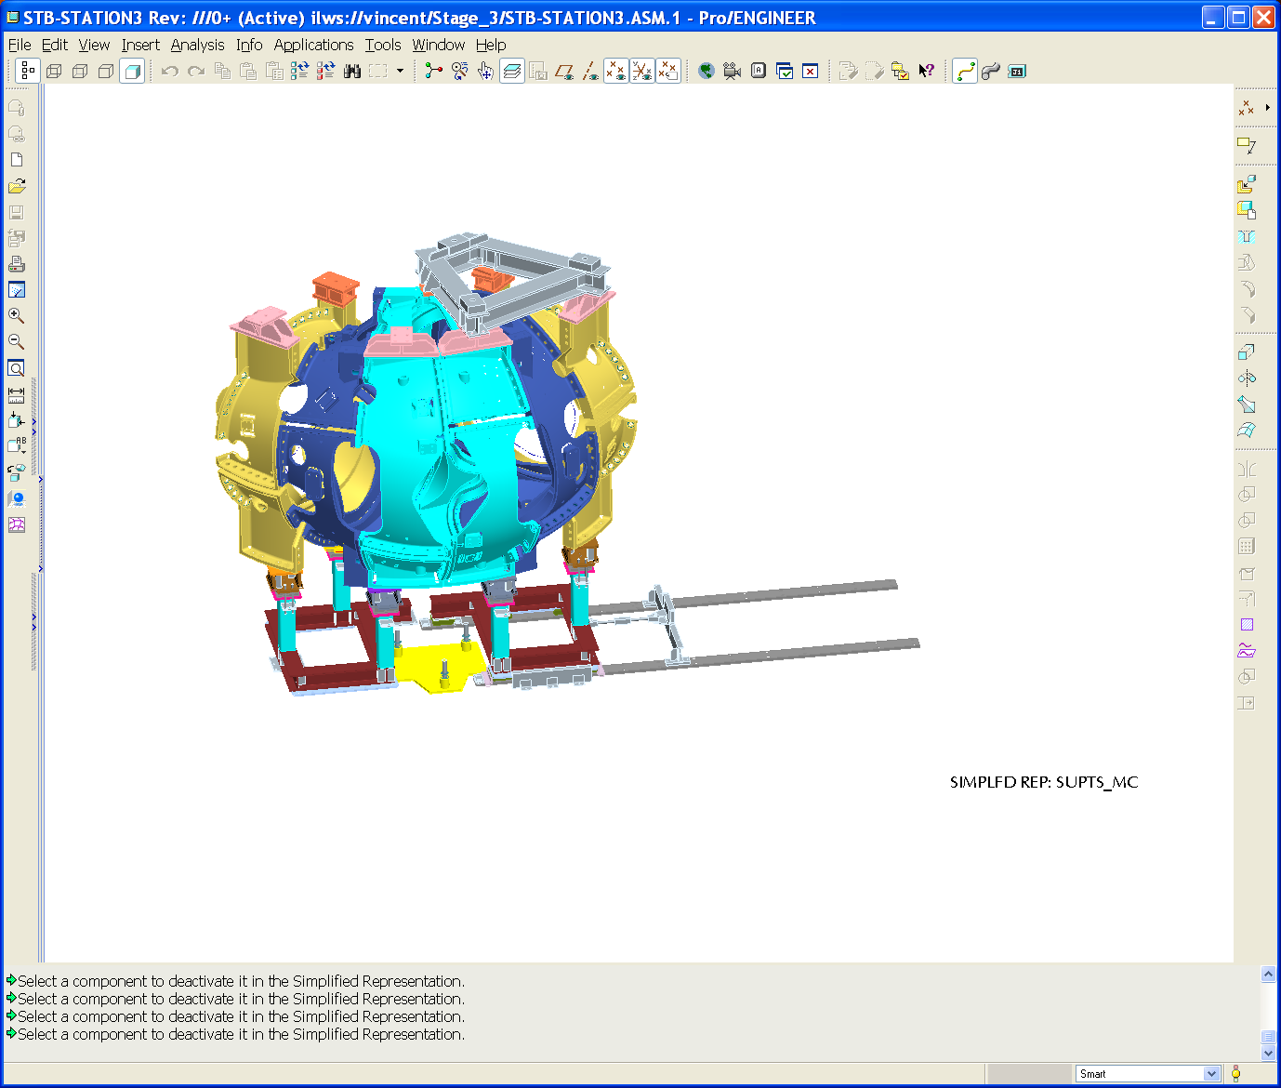
X
Y
Z
Station 3 Coordinate System
MCHP Left Side
VV support hanger locations
HP lift fixture
MCHP Right Side

Figure 2 Left and Right MCHP

10. Re-Assemble Left and Right MCHP

10.1 Re-Assemble and Metrology

10.1.1 Using the SISSCO rigging remove the right MCHP from the right support stand and move the support cart to the period installed position next to the Left MCHP. Secure in place.

10.1.2 Using the SISSCO rigging and the base support lateral adjustment system (similar to approach used in Station 2), position right MCHP over the right support with respect to the period global coordinate system. Using three selected monuments on the right MCHP, the positional alignment should be within .010" RMS. Measurements must be approved by the dimensional coordinator or his designee.

10.1.3 While held by the SISSCO rigging bring the AirLoc Wedgemount leveler up to take the load. Secure right MCHP to the support base.
Field Supervisor See Appendix A – Document Sign-off Record

10.1.4 Measure the target monuments on left MCHP with respect to the period global coordinate system. All three monuments should be within .010" (actual distances) of the desired position.

Metrology Supervisor See Appendix A – Document Sign-off Record

10.1.5 Bond all inboard shim pucks to the right MCHP Type-A, side A-flange (datum D).

11. Install Laser Screens

11.1 Place Screens

11.1.1 Using period global coordinate system place all of the laser screens as called out in the Stage 3 drawings. Position to .060" RMS. Record position of the laser screens from the metrology measurements.

11.1.2 Turn each laser on and measure each laser source and the end point on the screens. Measure fiducial points on each screen to identify their position.

11.1.3 Based on metrology measurements of the screens and lasers the screens path can be defined by the back office. Print the path on mylar paper and using metrology mount the mylar on the screens.

11.1.4 Disengage the right MCHP’s and move it to the far right (on its support stand) and secure in place.

11.1.5 Remove the left MCHP using the SISSCO rigging and follow the laser path to test that this can be done within assembly tolerances.

11.1.6 Place left MCHP in temporary location where crane can be detached.

11.1.7 Using the SISSCO rigging remove the right MCHP from the right support stand and move the support cart to the period installed position next to the Left MCHP. Secure in place.
Field Supervisor See Appendix A – Document Sign-off Record

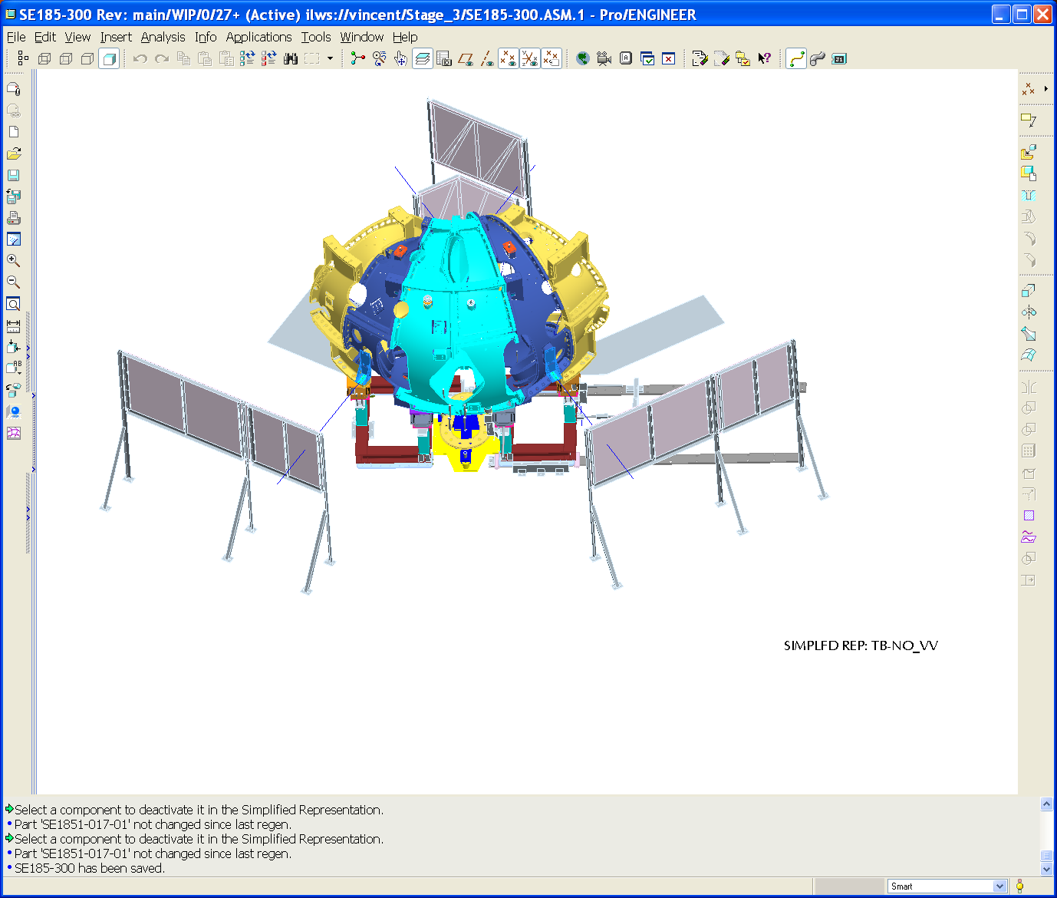
Floor mounted screen
Left screen
Right screen
Inboard screens
Floor mounted screen
Figure 3 Laser Screen Placement

12. Install Vacuum Vessel

12.1 Installation Setup and Metrology

12.1.1 Install VV NBI port support stand. Locate with respect to period coordinate system. Measurements should be based on positioning monuments on the assembled parts to be within .060" (actual distances) of the desired position.

12.1.2 Install VVSA to base support and make the connection to the NBI port attachment.

12.1.3 Using metrology take tooling ball readings off the VV shell to properly position the VVSA to the global coordinate system. Secure the VVSA to the base and at the NBI port support stand. Position three tooling balls on the VV to within .050" (actual distances) of the desired position.

12.1.4 Scan VV surface and compare data with earlier surface data scanned when VV was on Station 1 fixture. Back office input is involved here.
Dimensional Coordinator See Appendix A – Document Sign-off Record

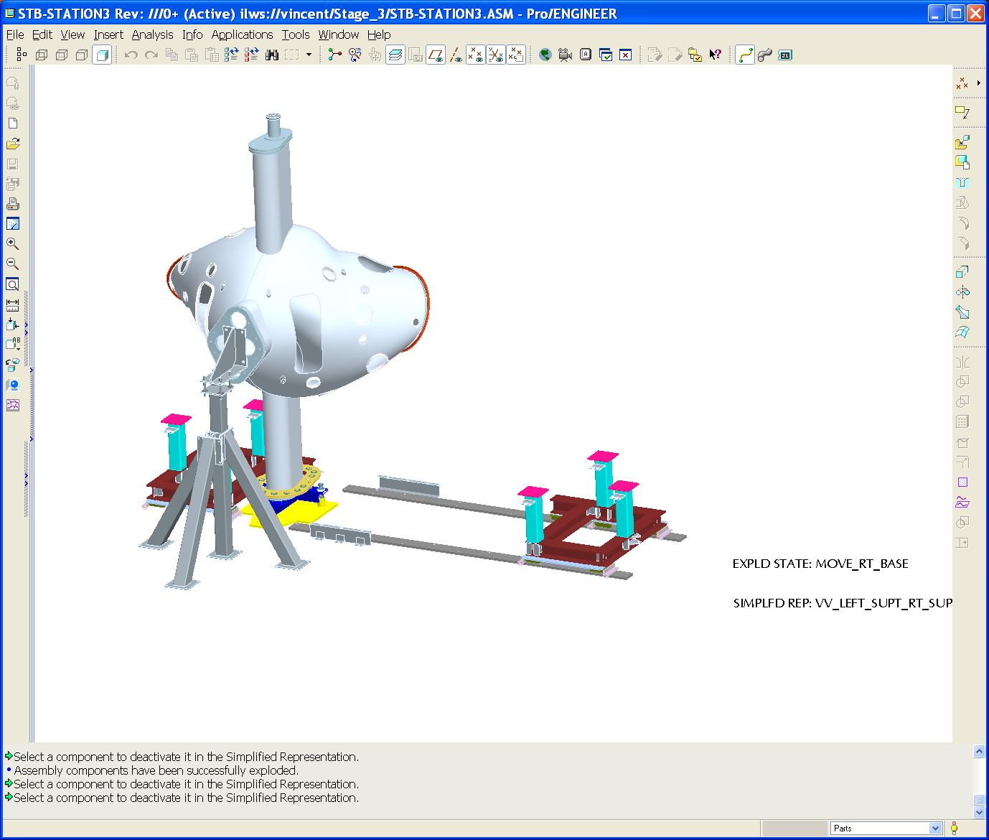
MCHP support cart assembly
MCHP fixed support
assembly
VV lateral support

VV base support
Figure 4 Vacuum Vessel Stand

13. Install Right MCHP Over VV

13.1 Move Right MCHP onto VV and Metrology

 | Caution Laser Light -  Refer to JHA for All Hazardous Activities!

13.1.1 Install any bumper protection components on the VV (left and right side) before manipulating right MCHP over the VV.
Field Supervisor See Appendix A – Document Sign-off Record

13.1.2 Install MCHP lift fixture, disengage leveler connections and lift the MCHP off the right support stand. Move the right support stand to its final position and secure in place.

13.1.3 Re-install the right adjustor bar.

13.1.4 Using the SISSCO actuators with laser guidance move the right MCHP over the VV.

13.1.5 Using the SISSCO rigging and the base support lateral adjustment system (similar to approach used in Station 2), position right MCHP over the right support with respect to the period global coordinate system. Using three selected monuments on the right MCHP, the positional alignment should be within .010" (actual distances) of the desired position. N/A!
Metrology Supervisor See Appendix A – Document Sign-off Record

13.1.6 While held by the SISSCO rigging bring the AirLoc Wedgemount leveler up to take the load. Secure right MCHP to the support base.
Field Supervisor See Appendix A – Document Sign-off Record

13.1.7 Measure the target monuments on right MCHP with respect to the period global coordinate system. If the positional alignment accuracy is greater than .010" (actual distances) of the desired position. N/A! Review with back office and if directed disengage Wedgemount and repeat Step 13.1.5.
Dimensional Coordinator See Appendix A – Document Sign-off Record

13.1.8 While held by the SISSCO rigging lower the AirLoc Wedgemount leveler up to release the load.

13.1.9 Using the SISSCO actuators with laser guidance move the right MCHP off of the VV.

13.1.8 Using the adjustor bar on the left side move the MCHP to the right 1/2". This will allow the right MCHP to be position without wing interferences.

STOP HERE

14. Install Left MCHP Over VV

14.1 Move Left MCHP onto VV and Metrology

14.1.1 Using the SISSCO actuators with laser guidance move the left MCHP over the VV TO WITHIN 1/2" OF ITS FINAL POSITION and pause. Go to the next step.

14.1.2 Using the adjustor bar on the right side move the right MCHP back to its installed position. Have a floor mounted system to act as an alignment stop for repositioning the right MCHP.

14.1.3 Bring together pre-fit-up Type-A MC's with alignment bushings installed.

14.1.4 Using the SISSCO rigging and the base support lateral adjustment system (similar to approach used in Station 2), position left MCHP over the left support with respect to the period global coordinate system. Using three selected monuments on the right MCHP, the positional alignment should be within .010" RMS
Metrology Supervisor See Appendix A – Document Sign-off Record

14.1.5 While held by the SISSCO rigging bring the AirLoc Wedgemount leveler up to take the load. Secure right MCHP to the support base.
Field Supervisor See Appendix A – Document Sign-off Record

14.1.6 Measure the target monuments on right MCHP with respect to the period global coordinate system. If the positional alignment accuracy is greater than .010" RMS review with back office and if directed disengage Wedgemount and repeat Step 8.06.

14.1.7 Remove the laser screens to provide more floor space for scaffolding.

14.1.8 Install temporary scaffolding to install flange hardware

14.1.9 Install bolts and all outboard alumina shims.

14.1.10 Tighten flange fasteners to 50%

14.1.11 Make a hand "wiggle" test (rotate on bolt) on all shims to make sure that they are tight. If a loose shim is found back off on sufficient adjacent bolts to allow a replacement shim to be inserted. Tighten bolt and recheck.

14.1.12 Perform metrology measurements of all alignment fiducials on both MCHP's. The maximum deviation from the reference points should be .015” or less. The maximum deviation from the “realigned” points should be .015” or less (true distance). If the deviation is greater that .015", Project input is needed to determine how to proceed.
Metrology Supervisor See Appendix A – Document Sign-off Record

14.1.13 Perform position adjustments on the left side MCHP if tolerance is not met. Loosen all studs, adjust AirLock Wedgemounts as needed; install alternate sized shims. Re-torque all studs to 50% and recheck. Back office support will be used in identifying revised shim thickness.

Remove SISSCO actuator from left MCHP.

14.1.14 One hole at a time, remove the supernut. Using the eccentric gage slid onto the stud define the hole eccentricity. Select bushing and machine to match required eccentricity. Install bushing. Replace nut and tighten back to 50% and recheck alignment.

14.1.15 Tighten nuts 100%. Re-verify adequate MCHP alignment.
Field Supervisor, Metrology Supervisor See Appendix A – Document Sign-off Record

15. Weld All Inboard Shims and Fill Bushing Gaps

15.1 Welding, Metrology and Gap Fill

15.1.1 Follow a predefined weld sequence at all MC's and weld the inboard shims, solenoid side, following weld procedures.

15.1.2 Measure the positions of all monuments per the process defined in the Metrology Plan, steps 2.3.3 through 2.3.7. The maximum deviation from the “realigned” points should be .020” or less (true distance). If the deviation is greater than .020", Project input is needed to determine how to proceed
Metrology Supervisor See Appendix A – Document Sign-off Record

15.1.3 Fill all lose bushings with Stycast 2850FT

15.1.4 Measure the monuments on all coils. Save the data file and back it up. Print reports of all alignments used, and nonconformance reports, and keep with run copies of the assembly procedure. The maximum deviation from the “realigned” points should be .020” or less (true distance). If the deviation is greater than .020", Project input is needed to determine how to proceed.
Dimensional Coordinator See Appendix A – Document Sign-off Record

16. VVSA Attachment to MC

16.1 Move Prep

16.1.1 Remove MCHP lift fixture and attach germinate VV supports to the MC at the two outboard connection points at the top and bottom of each Type-A MC.

16.1.2 Attach temporary VV vertical supports to the MC at the two connection points at the top and bottom of the Type-B MC.

16.1.3 Disconnect base support and transfer load to VV vertical supports.

16.1.4 Install VV lateral supports and align VVSA to modular coils This is a trial alignment to ensure there are no problems. Final alignment and scanning of the flanges will not be performed until after port welding on Station 5 is completed because of distortion concerns.

16.1.5 Prepare VVSA for transport. Install blocking as required to prevent any motion relative to the modular coils.
Field Supervisor See Appendix A – Document Sign-off Record

17. Transfer Period to NCSX Test Cell

17.1 Move to Station 5

17.1.1 Install crane rigging to MCWF and transfer the unit to the transfer support frame. Secure Period /support frame to the transporter.

17.1.2 Transfer completed Period to Station 5 located in NCSX test cell.
Field Supervisor See Appendix A – Document Sign-off Record

Appendix A. Document Sign Off
1.3 Modular Coil Segments Identification

Assembly Coils Involved: ______________; ______________; ______________

Verified by: _________________________ Date: __________________
Field Supervisor

2.5 Metrology data area is in place

Verified by: _________________________ Date: __________________
Metrology Supervisor

2.6 Welding procedure and qualified welders

Welding Procedure number: ____________________________

Qualified Welders: __________________________; _______________________

__________________________; _______________________

Verified by: _________________________ Date: __________________
Welding Engineer Supervisor

4.1 Pre Job Briefing

Pre Job Briefing Complete:

Verified by: _________________________ Date: __________________
Field Supervisor

4.2 Training

Individuals trained per training matrix:
_____________________________________________________________________
_____________________________________________________________________
_____________________________________________________________________

Verified by: _________________________ Date: __________________
Field Supervisor

6.1.1 Global Coordinates Established

Monuments Approved and Record achieved RMS: ___________

Verified by: _________________________ Date: __________________
Dimensional Control Coordinator

6.1.7 Laser Position Confirmed

Verified by: _________________________ Date: __________________
Metrology Supervisor

7.1.1 Monuments within Spec.

Verified by: _________________________ Date: __________________
Metrology Supervisor

7.1.3 Monuments Within Spec.

Verified by: _________________________ Date: __________________
Metrology Supervisor

7.1.4 A & C End Flanges Measured

Verified by: _________________________ Date: __________________
Metrology Supervisor

7.1.5 Metrology Coordinates Confirmed

Monuments Approved and Record achieved RMS: ___________

Verified by: _________________________ Date: __________________
Dimensional Control Coordinator

7.1.6 Shims Measured Locating Ring Attached

Verified by: _________________________ Date: __________________
Field Supervisor

8.1.4 Monuments within Spec.

Verified by: _________________________ Date: __________________
Metrology Supervisor

9.1.3 Monuments within Spec.

Verified by: _________________________ Date: __________________
Metrology Supervisor

9.1.14 Weld Inspection

Weld Inspection Acceptance and Permeability Acceptance (<1.02 mu)

Verified by: _________________________Date: _________________
Quality Control

Verified by: _________________________Date: _________________
Field Manager

9.1.15 Metrology Coordinates Confirmed

Monuments Approved and Record achieved RMS: ___________

Verified by: _________________________ Date: __________________
Dimensional Control Coordinator

10.1.3 MCHP Secured

Verified by: _________________________ Date: __________________
Field Supervisor

10.1.4 Monuments within Spec.

Verified by: _________________________ Date: __________________
Metrology Supervisor

11.1.7 MCHP Secured

Verified by: _________________________ Date: __________________
Field Supervisor

12.1.4 Metrology Coordinates Confirmed

Monuments Approved and Record achieved RMS: ___________

Verified by: _________________________ Date: __________________
Dimensional Control Coordinator

13.1.1 Bumper Protection Installed

Verified by: _________________________ Date: __________________
Field Supervisor

13.1.5 Monuments within Spec.

Verified by: _________________________ Date: __________________
Metrology Supervisor

13.1.6 MCHP Secured

Verified by: _________________________ Date: __________________
Field Supervisor

13.1.7 Monuments within Spec.

Verified by: _________________________ Date: __________________
Metrology Supervisor

14.1.4 Monuments within Spec.

Verified by: _________________________ Date: __________________
Metrology Supervisor

14.1.7 MCHP Secured

Verified by: _________________________ Date: __________________
Field Supervisor

14.1.12 Max. Deviation within Tolerance

Verified by: _________________________ Date: __________________
Metrology Supervisor

14.1.15 Bolt Torque and Alignment Confirmed

Verified by: _________________________ Date: __________________
Field Supervisor

Verified by: _________________________ Date: __________________
Metrology Supervisor

15.1.2 Monuments within Spec.

Verified by: _________________________ Date: __________________
Metrology Supervisor

15.1.4 All Monuments and within to Spec. to Proceed

Monuments Approved and Record achieved RMS: ___________

Verified by: _________________________ Date: __________________
Dimensional Control Coordinator

16.1.5 VVSA Prepared for Transport

Verified by: _________________________ Date: __________________
Field Supervisor

17.1.2 Completed Period Ready for Transfer

Verified by: _________________________ Date: __________________
Field Supervisor

Appendix B. Log Book Record

