NCSX Half Period Modular Coil Half Period Assembly (Station 2) Dimensional Control Plan
NCSX-PLAN-FPA2DC-00
November 7, 2007

Author: __________________________________________________
Robert Ellis, Dimensional Control Coordinator
Reviewed By:_____________________________________________
Steve Raftopoulos, Metrology Engineer
Reviewed By:_____________________________________________
Michael Zarnstorff, NCSX Project Physics Manager
Reviewed By:_____________________________________________
M. Viola, Field Period Assembly Manager
Approved By:_____________________________________________
Phil Heitzenroeder, NCSX Engineering Manager
Record of Changes
Revision | Date | Description
0 | 11/7/2007 | Initial Issue
Table of Contents

1 Introduction 1
1.1 Scope 1
1.2 Relevant Documents 1
1.3 Overview 1
2 HPA and Dimensional Control Steps 3
2.1 Monuments and Alignments 3
2.2 Racking of the Modular Coils 4
2.3 Pre-Measurement of Modular Coils 6
2.4 Type “A” to Type “B” Assembly 7
2.5 (A+B) to C Assembly 11
Appendix 1 – Derivation of Racking Calculations Appendix 1-1
Attachment 1 – Sample Alignment Report A1-1
Attachment 2 – Type “A” Modular Coil A2-1
Attachment 3 – Type “B” Modular Coil A3-1
Attachment 4 – Type “C” Modular Coil A4-1

Table of Figures

Figure 2.4-1 Type “A” to Type “B” Setup 7
Figure 2.4-2 Mating “B” Coil into Position 8
Figure 2.4-3 Jack Screws and Dial Indicator Installation 9

Introduction

Scope
This plan describes the dimensional control steps that will be taken to ensure adequate dimensional control of the Modular Coil Half Period (MCHP) assembly of the National Compact Stellarator Experiment (NCSX) at the Princeton Plasma Physics Laboratory. This activity shall occur at Station 2. Each half period assembly consists of three modular coils, one each of type A, B, and C. The three coils are joined together with bolts and shims. Two half periods are joined, in stellarator symmetry, to form a full period. Adequate dimensional control will ensure that the coil current centers are within the specified tolerance.

This document is not an assembly procedure. It is meant to provide an overview of the dimensional control strategy for half period assembly, and to provide input into the assembly procedures.

Relevant Documents

NCSX Plans
- Modular Coil Winding Dimensional Control Plan (NCSX-PLAN-MCWDC) – latest version

NCSX Drawings
- Modular Coil Winding Form Assembly Type A (SE141-101) – latest version
- Modular Coil Winding Form Assembly Type B (SE141-102) – latest version
- Modular Coil Winding Form Assembly Type C (SE141-103) – latest version

Overview
The dimensional control steps outlined in this document are the result of experience gained during coil-to-coil fitup trials, the modular coil weld tests, and development of the coil racking procedure.
A modular coil half period assembly consists of three modular coils: one each of type A, B, and C. Each coil subtends a 20deg toroidal angle. The coils are joined by bolts and shims at the hole locations in the flanges, and welded together in the nose region. The gap between flanges is nominally .500”. Two datum planes, defining the toroidal angular extent of the coils, are nominally .250” offset from the plane of each flange, and pass through the vertical centerline of NCSX. The datum planes are defined as datums “D” and “E”. Datum “D” corresponds to side “A” or flange “A” of the coil; datum “E” corresponds to flange “B”. See attachments 2, 3, and 4.
During assembly, the position of the coil current centers is not measured directly, as the winding surfaces are not accessible. Their position is inferred from the position of external monuments, or tooling balls, located on the outside of the flanges and bodies of the modular coils. The positions of these monuments are related to the special “conical seat” monuments that were used for coil winding through the coil pre-measurement process. Because of the flexibility of the coils, and the need to represent the positions of the current centers as accurately as possible, the coil is twisted slightly, or “racked” into its as-wound shape prior to pre-measurement. This step is a necessary precursor to the pre-measurement process.
Measurements during the modular coil half period assembly process are performed with a laser tracker, used in conjunction with Verisurf© measurement software. The measurement philosophy, generally, is to align the tracker to the part geometry in order to relate the measurements to the CAD model of the part. Once an alignment is successfully completed, a set of global monuments are established for the purpose of repositioning the tracker, and for periodic checks of the accuracy of the process. Before aligning to the part geometry, it is necessary for the part to be twisted into the proper shape; the racking process therefore must be a predecessor to the measurement process.
In the pre-measurement process, the laser tracker is aligned to the coordinate system of the CAD model of the coil with the coil in its as-wound configuration. All of the external monuments are measured, as well as the “A”, or datum “D” flange of the coil. The monument locations are used to position and track the coil during all subsequent assembly operations, and the measurements of the flange surface are used to predetermine shim thicknesses at all locations for the initial assembly. It is not possible to measure the full set of coil monuments from one laser position. Monuments are measured from two or three vantage points, as required. Each time the laser tracker is repositioned, an alignment using the global monuments is performed. Where possible, monuments that are accessible from both vantage points are measured from each location, as a check on the accuracy of the process.
The steps used for the pre-measurement process are the building blocks of the dimensional control steps for modular coil half period assembly. The first step is to set the first coil [type “A”] on a wedge fixture that is oriented so that the top, or datum “E” flange, of the coil, is pointing up. The racking procedure is used to twist the coil into the proper shape, and the laser tracker is aligned to the coil. A network of global monuments is immediately established. The surface of the datum “E” flange is scanned in order to calculate the required shim thicknesses. The shims, along with pressure sensitive “Fuji paper”, are placed on the top flange, and the mating coil [“B”] is lowered into position. [note: the steps involving the “Fuji paper” apply only to the first modular coil half period] Using jack screws, and measurements of three designated monuments, the top coil is positioned in the plane of the flanges. The bolts are partially torqued, and all of the monuments, on both coils, are measured. The top coil is raised, and the Fuji paper is inspected to verify proper load distribution among the shims. Monument positions are analyzed by the dimensional control team to verify proper coil placement. If necessary, some shim thicknesses are changed in order to achieve dimensional accuracy and adequate load sharing. The coils are brought back together with fresh Fuji paper installed, the bolts are partially torqued, and the monuments are measured. As before, the coils are separated, the results are checked, and if acceptable, the shims, without Fuji paper, are installed, along with the proper bushings, and the coils are brought together for the final time. At this point, the gap along the nose region is measured, the initial shims in that region are removed, and the special weld shims are final machined to the appropriate dimensions and installed. After welding the nose region and final tightening of the bolts, the full set of monuments is measured and the datum “E” flange of the top, or “B”, coil is scanned. Because the nose region is welded, there is no easy remedy if the deviations of the monuments from their nominal positions are not acceptable.
After this step, the coils, still attached to the fixture, are mounted on another wedge that has its top surface tilted at 20 degrees from horizontal, so that the top flange of the “B” coil is approximately horizontal. It is assumed that, when the monuments were measured after welding, that a suitable set of monuments, within an acceptable deviation from nominal position, were found, and the laser tracker can be aligned to them. A set of global monuments is immediately measured, and the same basic coil-to-coil joining sequence is performed between the “B” and “C” coils.

HPA and Dimensional Control Steps

Monuments and Alignments
The laser tracker measures point locations in a 3-dimensional Cartesian coordinate system that has its z-axis parallel to the vertical axis of the tracker. The purpose of an alignment is to relate this coordinate system to the coordinate system in which a part, or a set of monuments, is defined. Two types of monuments are used in the modular coil half period assembly: part monuments and global monuments. The fundamental difference between the two is that part monuments are physical points on the part that are defined in the CAD model of the part, while global monuments are physical locations, on a fixture or in the assembly area, that are measured by the laser tracker in order to establish their position, and thereafter used as references. Alignment is a means of defining the position of the laser tracker in terms of a set of monuments, and as such is less sensitive to small variations in the positions of monuments when a set of well chosen monuments, covering a large range of the azimuth of the tracker, are used. Alignment to the part geometry, while necessary at some point in the procedure, should only be used as a first step towards establishing a global network of monuments for a given step of the assembly sequence.
If the part is deformed from the state in which the part monuments were defined, the accuracy of the alignment will suffer. A process for correcting this deformation prior to initial alignment to the part geometry has been developed, and is the first step in the pre-measurement process and the assembly process.
A useful criterion for measuring the quality of an alignment is the rms deviation of the alignment. This quantity appears in the alignment report provided by Verisurf©. A sample report is shown in Attachment 1. Our criterion for alignments to pre-assembly part geometry is that the rms deviation be not greater than 0.005”. For alignments to global monuments, the rms deviation shall not be greater than 0.002”. Nonconformance reports shall be generated for each alignment that exceeds its relevant criterion, and must be resolved prior to use of that alignment. Additional requirements on selection of monuments appear in later sections of this document. Alignment reports for all alignments used in the process are to be saved and recorded with the run copy of the assembly procedure.
A variety of techniques can be used to measure the positions of monuments. During coil racking, the conical seats are measured by measuring a 10-point sphere around a 15mm ball placed in the seat. The sphericity measurement returned by Verisurf© is a useful and necessary check on the quality of the measurement. Our goal is a sphericity of 0.001” or better, but .002” on 25% or less of the monuments can be accepted.
Tooling balls can be measured directly by use of an angle reflector, or by placing a magnetic nest and 0.5” diameter ball reflector (corner cube) in the tooling ball holder. This will yield a more accurate result than the 10-point sphere. The 10-point sphere is required during the racking process because it enables a greater number of conical seats to be measured from a single laser tracker position. With the angle reflector or the corner cube method, averaging of repeated measurements can be used to increase the certainty of the measurement.
Accuracy, and certainty, of measurements is a function of several factors, including measurement technique, choice of reflector, layout of monuments, and position of laser tracker. An accuracy standard for measurement of tooling balls, and global monuments, is required for dimensional control and is defined as follows:
The measured position of a monument, relative to the laser tracker, shall be within a sphere of .003” of the actual position of that monument, relative to the tracker, with a confidence of 98%. This statement defines a 98% confidence interval about the measured position of the monument. It is the role of the metrology engineer to develop procedures, and specify techniques, that meet this requirement.

Racking of the Modular Coils

The following general steps are provided to rack the modular coils:
    - Set up a wedge fixture, with the top surface approximately level, with the appropriate top plate for the type of coil to be measured. Support the narrow edge at its corners and approximately midway along its length. The top plate shall have precisely drilled holes for monuments at its corners, or pucks to receive the 1.5” diameter reflecting ball shall be glued to the corners.
    - Place a set of wedge jacks, one roughly under the position where each conical seat will be, on the top surface.
    - Place the laser tracker in a position relative to the wedge, and at a height, where it will be able to measure at least 75% of the conical seats on the coil, and three of the corner monuments on the wedge. Note: this position, for each type of coil, is to be determined during pre-measurement of the first coil of each type.
    - Measure a plane [“measure plane” in Verisurf©] by measuring three arbitrary points on the top surface of the fixture. One point should be near each corner at the thick end of the wedge, and the third point should be approximately midway along the narrow edge. This plane will be referred to as plane “G”.
    - Measure the four corner monuments on the wedge, and a set of five or more global monuments attached to the building. These will be the global monuments used for subsequent global alignments. The set of monuments must be approved by the Dimensional Control Coordinator.
    - Using the laser tracker and the “Build to Surface” feature of Verisurf©, set the jacks to a constant height relative to plane “G”.
    - Lower the coil onto the jacks. For type “B” and type “C” coils datum “E” shall face down. For type “A” coils, datum “D” shall face down.
    - Re-check the measurements of global monuments on the fixture. If they have moved more than .002”, re-measure the full set of global monuments.
    - Measure the locations of all of the conical seats that are accessible, in sequence from lowest to highest number.
    - In Microsoft Excel, open the racking spreadsheet for the particular coil that has been prepared by Dimensional Control. In Verisurf©, select only the level in which plane “G” has been defined, do a point report on the three points, and transfer the results to the spreadsheet in the cells assigned to those points. This enables the spreadsheet to compute the unit normal vector and the scalar that define the plane in 3dimensional Cartesian space.
    - In Verisurf©, select only the level on which the conical seats are defined. Do a point report, transfer the results to the racking spreadsheet in the cells that are assigned to the conical seats. The “nominal”, or as-wound, positions of the conical seats, will have already been entered into the spreadsheet by Dimensional Control. The coordinates of each conical seat are pasted into sheet 2 of the spreadsheet, in the assigned location, to calculate the offsets of the conical seats from plane “G”. These offsets are entered in the assigned cells on sheet 1, and after this has been done for each conical seat, the spreadsheet will display the amount that each conical seat must be raised in order to twist the coil as close as possible to its as-wound condition.
    - Clamp a dial indicator to the fixture surface near each jack location so that it reads the vertical motion of the flange closest to the fixture surface. Take care that each indicator reads of an adequately smooth surface. Check each indicator to verify its proper operation.
    - Watching the dial indicators, jack at each location by the amount specified on the racking spreadsheet. Jack alternately at points roughly across the diameter, rather than working around circumferentially.
    - Save the racking spreadsheet, and save it as a new copy.
    - Repeat steps 2.2.9 through 2.2.14. When the racking spreadsheet indicates that the required jacking at each location is 0.002” or less, the coil has been adjusted to the best of our ability. It is now permissible to do an alignment.
    - Align to the set of conical seats that are accessible. The conical seat coordinates are those obtained from averaging during the coil winding process. The acceptance criterion is .005” rms deviation. If this is not met, consult the Dimensional Control office before proceeding further.
    - After alignment and resolution of any nonconformances, the alignment report is saved, and the alignment is accepted.
    - Measure the global monuments. Note that, because of the presence of the coil, one or two of the monuments on the fixture will no longer be accessible. This set of global monuments will be used for subsequent alignments of the laser tracker. All alignments to the global monuments will include the full set of building monuments, and at least two of the monuments on the fixture. The acceptance criterion for global alignments is .002” rms deviation. A failure to meet this criterion must be resolved by the Dimensional Control office.
  - Pre-Measurement of Modular Coils
The following general steps are provided to pre-measure the modular coils:

Check the location of two monuments on the fixture and on the part to be measured. If they are less than .003” from their original position, proceed to 2.3.2. If they are more than .003” from their original position, it may indicate that the laser has been bumped, or the fixture moved slightly. Re-align to the global monuments. If the acceptance criterion is not met, it may mean that the fixture and the building have moved relative to each other. Do not accept the alignment, but re-align to the conical seats. If this alignment is not acceptable, contact the Dimensional Control Office and work out a resolution to the problem before proceeding.
    - Scan the top flange of the coil. This information will be used in the pre-calculation of shim thicknesses.

Measure the positions of all of the tooling balls accessible to the laser. Accuracy criteria are laid out in Section 2.1.
    - Move the laser tracker to a new vantage point from which the remaining monuments on the part are visible. [note – a third and fourth position may be required]

Align to the global monuments, using the full set of building monuments and at least two monuments on the fixture. If the alignment does not meet the acceptance criterion, consult Dimensional Control before proceeding.
    - Measure the positions of all of the tooling balls accessible to the laser. Accuracy criteria are laid out in Section 2.1.
    - Repeat steps 2.3.4 through 2.3.6 until all of the monuments have been measured.
    - Save the data file and back it up. At this point, the pre-measurement of the modular coil is complete. The external tooling balls are now related to the position of the coil current center in the as-wound condition of the coil. The external tooling balls, with the appropriate rigid body realignments as needed, will be the reference points for positioning and tracking the modular coil during subsequent assembly steps. The conical seats that interfere with coil-to-coil fitup can be removed at this point, but should not be removed unless it is necessary. This will ensure that we retain redundant dimensional information as far as possible into the assembly sequence. It is anticipated that, prior to full period assembly, all remaining conical seats will be removed.

Type “A” to Type “B” Assembly
A wedge fixture with its top surface tilted at 20 degrees from horizontal is the starting point for this step. See below:

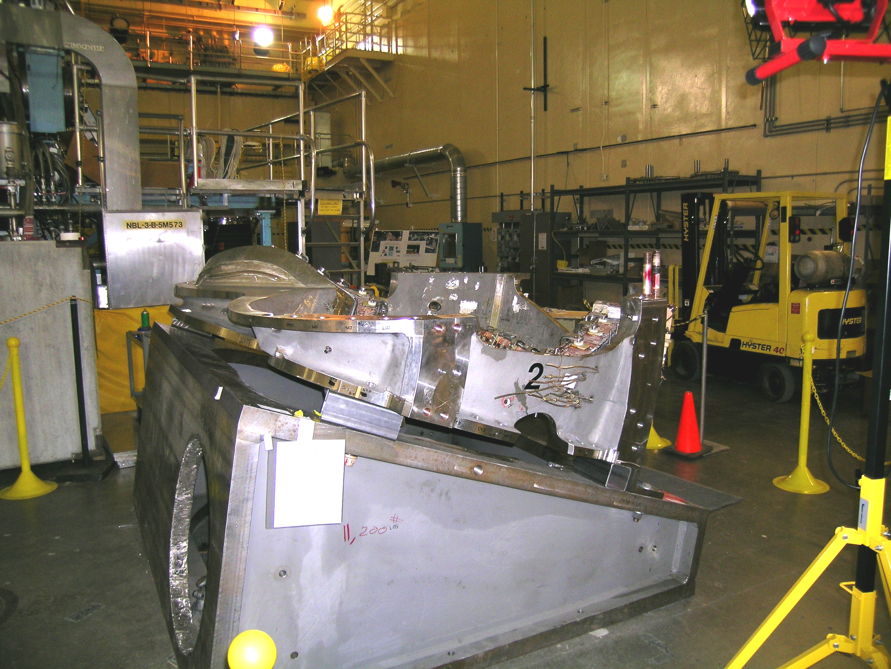

Figure 2.4-1 Type “A” to Type “B” Setup

Rack the “A” coil into its proper shape, following the process of section 2.2, using tooling balls rather than conical seats. At the end of this step, a successful alignment to the part geometry will have been completed,, with a RMS deviation of .003” or better, and a set of global fiducial monuments will have been established. Subsequent alignments of the laser tracker will be to the global monuments, and the criterion of .002” RMS deviation will apply

After the nose shim and puck locations have been marked, install an initial set of 4-8 alumina coated shims and lower the mating “B” coil into position. See
:
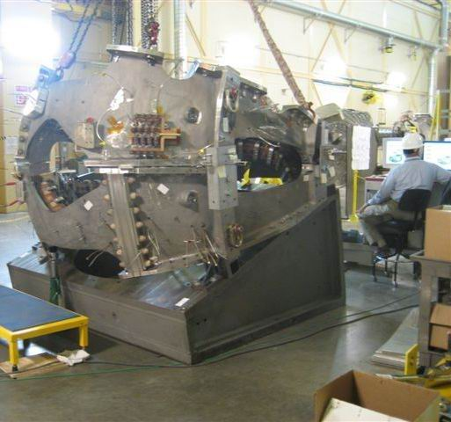
Figure 2.4-2 Mating “B” Coil into Position

Install the jack screws and dial indicators for horizontal positioning. See

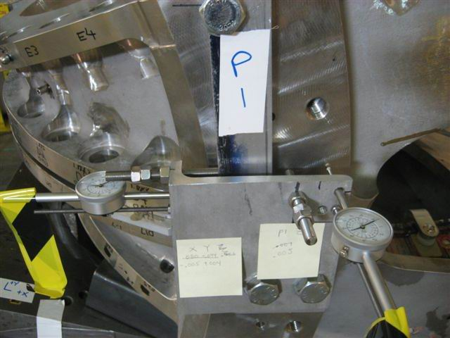

Figure 2.4-3 Jack Screws and Dial Indicator Installation

Using three selected monuments on the “B” coil, position the coil horizontally. An accuracy of ±.002” or better normal to the mating flanges, and ±.06” in the horizontal directions [parallel to flange face] is expected and required for this step.

Perform an alignment to the “B” coil tooling balls to verify that it has not changed shape. Do not accept the alignment. If the alignment fails to meet the .003”RMS criterion, add additional shims to the initial set, or adjust shim thicknesses as necessary, until the “B” coil meets the alignment criterion.

Install monuments for monitoring septum movement during half period assembly on “A” and “B” coils.

Install remaining shims and torque the bolts to 50% of final value, and measure the positions of all of the monuments on both coils. This measurement will require repositioning the laser tracker at least once, with an alignment to global monuments required at each repositioning. The process of steps 2.3.3 through 2.4.4 shall be followed. All monuments on the “A” coil shall be within .007”of their theoretical position. The component of the deviations of monuments on the “B” coil that is normal to the flange faces shall be less than .007”.

Measure the shim puck height at each nose shim location, at multiple points for each puck.

Unfasten bolts and remove the “B” coil. Place it on a separate fixture, datum “D” up.

Perform an alignment on the “A” coil to verify that it still meets the .003” RMS criterion. Do not accept alignment. If the .003” criterion is not met, re-rack the “A” coil.

Weld the “A” coil flex shims in place.

Perform an alignment on the “A” coil to verify that it still meets the .003”RMS criterion.

Measure the “B” coil fiducials to establish a reference shape prior to welding of flex shims.

Weld the “B” coil flex shims in place.

Align the laser tracker to the set of nominals measured in 2.4.13. The acceptance criterion on the RMS deviation is .004”. Consult Dimensional Control if this criterion is not met.

With 4-8 of the alumina coated shims in place, lower the “B” coil back onto the “A” coil.

Perform an alignment to the “B” coil, but do not accept it. If the “B” coil does not meet the .003” RMS criterion, adjust shims as needed. A new scan of the “A” coil flange may be required.

Using three selected monuments on the “B” coil, position the coil horizontally. An accuracy of ±.002” or better in each direction is expected and required for this step.

After installation of final set of shims, bushings, and final tightening of bolts, measure the positions of all monuments per the process in steps 2.3.3 through 2.3.7. All deviations should be less than .009” from nominal positions. Repeat shim and position adjustments until this tolerance is met.

Weld the nose shims.

After welding, measure the positions of all monuments per the process in steps 2.3.3 through 2.3.7. The maximum deviation should be less than .012”

Identify, if possible, a set of monuments that have moved less than .005” from their original positions. The alignment that will be necessary for mating to the “C” coil will use monuments from among this set .

Scan the top, or datum “E” flange of the “B” coil, for the purpose of shim thickness calculations for the mating to the “C” coil.

Save the measurement data file and back it up.

(A+B) to C Assembly
After the “A” and “B” coils are joined, they must be placed on a fixture tilted at 40 degrees from horizontal, so that the top flange of the “B” coil is horizontal. This will enable the “C” coil to be properly positioned. This new fixturing will be achieved by lifting the “A” and “B” coils, along with their fixture, onto another wedge with its top surface tilted at 20 degrees from horizontal. It will be necessary to bolt the “A” coil to its fixture prior to lifting.

Select the set of monuments, from the set chosen in 2.4.22, that will be used for the initial alignment in the next phase of half period assembly.

Lift the fixture/A/B assembly onto the wedge designated for A-B-C assembly. Bolt the fixtures together.

Align to the set of monuments selected in 2.5.1. Acceptance criterion is .005” rms deviation

Establish a set of global monuments, including two positions on the fixture and at least five on the building.

After the nose shim and puck locations have been marked, install an initial set of 4-8 alumina coated shims and lower the mating “C” coil into position.

Perform, but do not accept, an alignment to the “C” coil to verify its shape. If it fails to meet the .003” criterion, add or adjust shims as necessary.

Using three selected monuments on the “C” coil, position the coil horizontally. An accuracy of ±.002” or better normal to the mating flanges, and ±.06” in the horizontal directions [parallel to flange face] is expected and required for this step.

Install remaining shims and torque the bolts to 50% of final value, and measure the positions of all of the monuments on both coils. This measurement will require repositioning the laser tracker at least once, with an alignment to global monuments required at each repositioning. The process of steps 2.3.3 through 2.4.4 shall be followed. All monuments on the “A” and “B” coils shall be within .015”of their desired posision. The component of the deviations of monuments on the “C” coil that is normal to the flange faces shall be less than .010”.

Measure the shim puck height at each nose shim location, at multiple points for each puck.

Unfasten bolts and remove the “C” coil. Place it on a separate fixture, datum “D” up.

Perform an alignment on the “A/B” coil assembly to verify that it still meets the .005” RMS criterion. Do not accept the alignment; this is merely a check.

Weld the “B” coil flex shims in place.

Perform an alignment on the “A/B” coil assembly to verify that it still meets the .005”RMS criterion.

Measure the “C” coil fiducials to establish a reference shape prior to welding of flex shims.

Weld the “C” coil flex shims in place.

Align the laser tracker to the set of nominals measured in 2.5.14. The acceptance criterion on the RMS deviation is .004”. Consult Dimensional Control if this criterion is not met.

With 4-8 of the alumina coated shims in place, lower the “C” coil back onto the “B” coil.

Perform, but do not accept, an alignment to the “C” coil to verify its shape. If it fails to meet the .003” criterion, add or adjust shims as necessary. A new scan of the datum “E” flange of the “B” coil may be required.

Using three selected monuments on the “C” coil, position the coil horizontally. An accuracy of ±.002” or better in each direction is expected and required for this step.

After installation of final set of shims, bushings, and final tightening of bolts, measure the positions of all monuments per the process in steps 2.3.3 through 2.3.7. All deviations should be less than .015” from nominal positions. Repeat shim and position adjustments until this tolerance is met.

Weld the nose shims.

After welding, measure the positions of all monuments per the process in steps 2.3.3 through 2.3.7. The maximum deviation should be less than .020”.

Scan the datum “E” flange of the “C” coil, and all base support feet.

Save the data file and back it up. Print reports of all alignments used, and nonconformance reports, and keep with run copies of the assembly procedure.

Appendix 1 – Derivation of Racking Calculations
The first step in the process is to calculate the offsets of a set of as-wound monuments [“nominals”] from the Datum “E” surface of each coil. The coordinate system established for measuring each coil is a Cartesian system, with the y-axis through the vertical centerline of NCSX, and the x-axis at midplane between the A-A joint. The z-axis is normal to datum “D” of the “A” coil, pointing away from the “B” coil.
The unit normal vector to Datum “E” of a given coil is obtained as
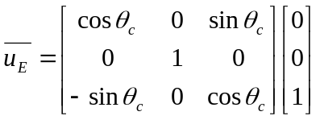,
Where 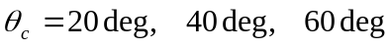 for type “A”, “B”, and “C” respectively. The distance along the normal to datum “E” to a point
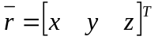
is simply the dot product 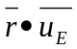, because datum “E” passes through the origin. This distance is computed for each as-wound monument.
When the coil is placed on the measurement fixture, the distance between each monument and an arbitrary reference plane is computed. Three points are measured to define the arbitrary plane “G”. The vector equation defining a plane is
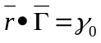,
Where 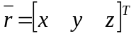 is any point in the plane, and is the unit normal vector to that plane. Having three points in the plane, we can solve the equation
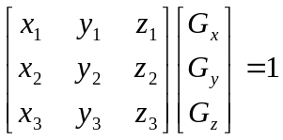,
and obtain and 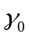 by normalizing the vector .
The distance between any point and our plane “G” is determined by drawing a line through that point and perpendicular to the plane [or parallel to ],

determining its intersection with the plane, and measuring the distance between the intersection and the original point.
The equation of a line in 3-dimensional space is represented as
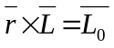,
Where is a point on the line, is a unit vector in the direction of the line, and 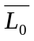 is the cross product of the two vectors. The intersection of a plane 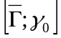 and a line 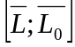 is computed using the relation
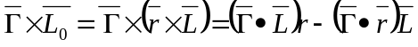.
Because our line is normal to the plane “G”, we have 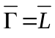, and therefore the intersection point is
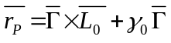.
The distance from the point to the plane, normal to the plane, is simply
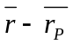.
We can now, for the measured as-wound nominal points, subtract the smallest distance to datum “E” from the distance to datum “E” of each point, resulting in a set of distances from datum “E” relative to the distance of the closest point. We refer to this set of distances as “deltas”. The same can be done for the distances between conical seats and the plane “G”. Subtracting the latter set of “deltas” from the former, we obtain a set of height adjustments to be made at each jack. By subtracting the minimum of these values from each adjustment, we obtain a set of adjustments that are upward in all locations, with a zero adjustment at one point. This logic is incorporated into the “racking spreadsheet.”

Attachment 1 – Sample Alignment Report

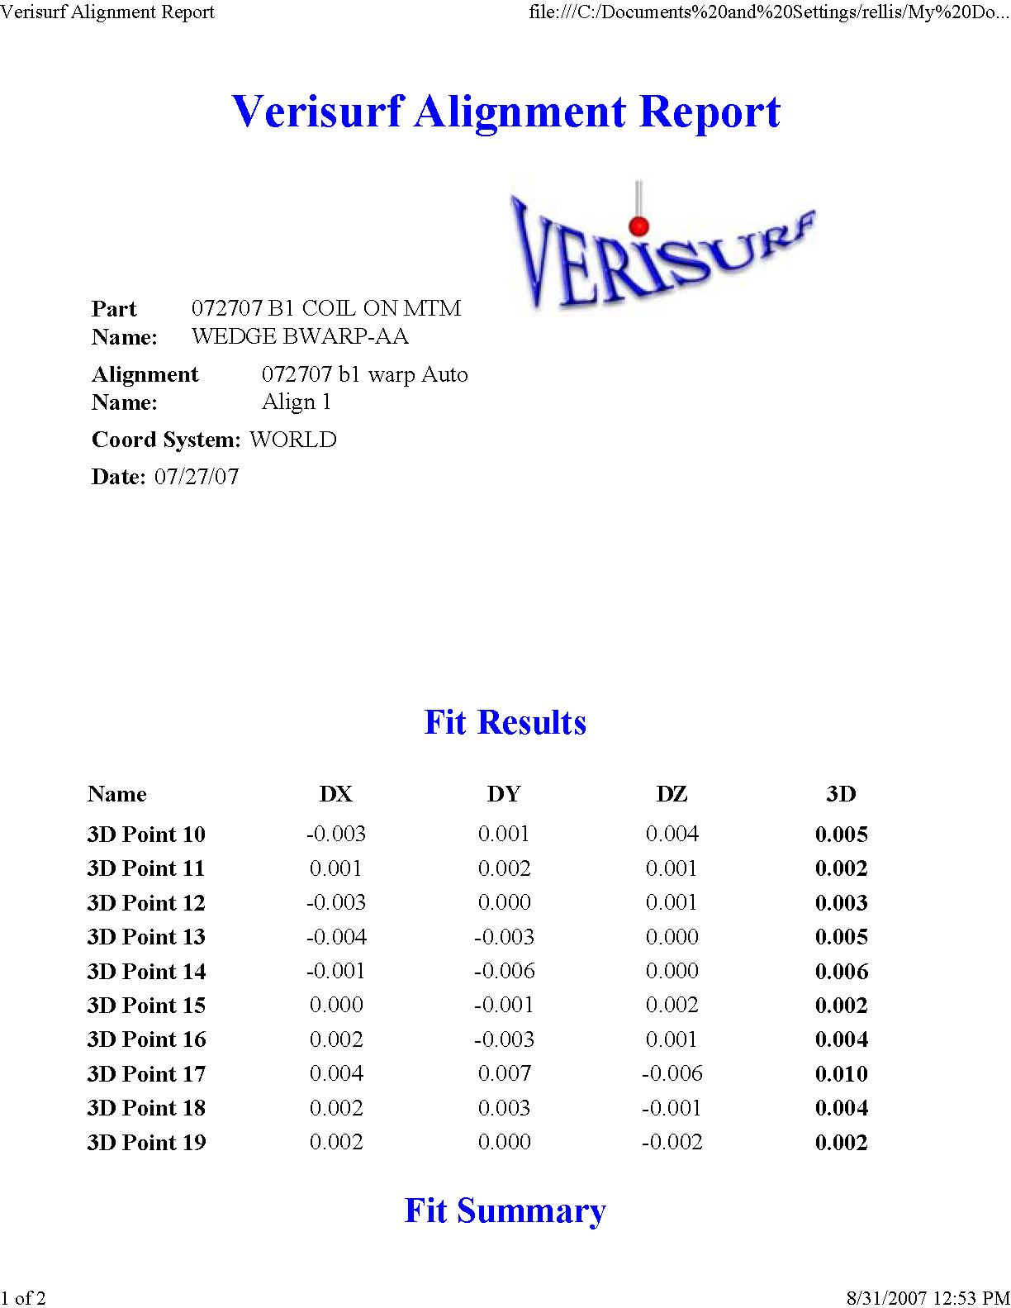

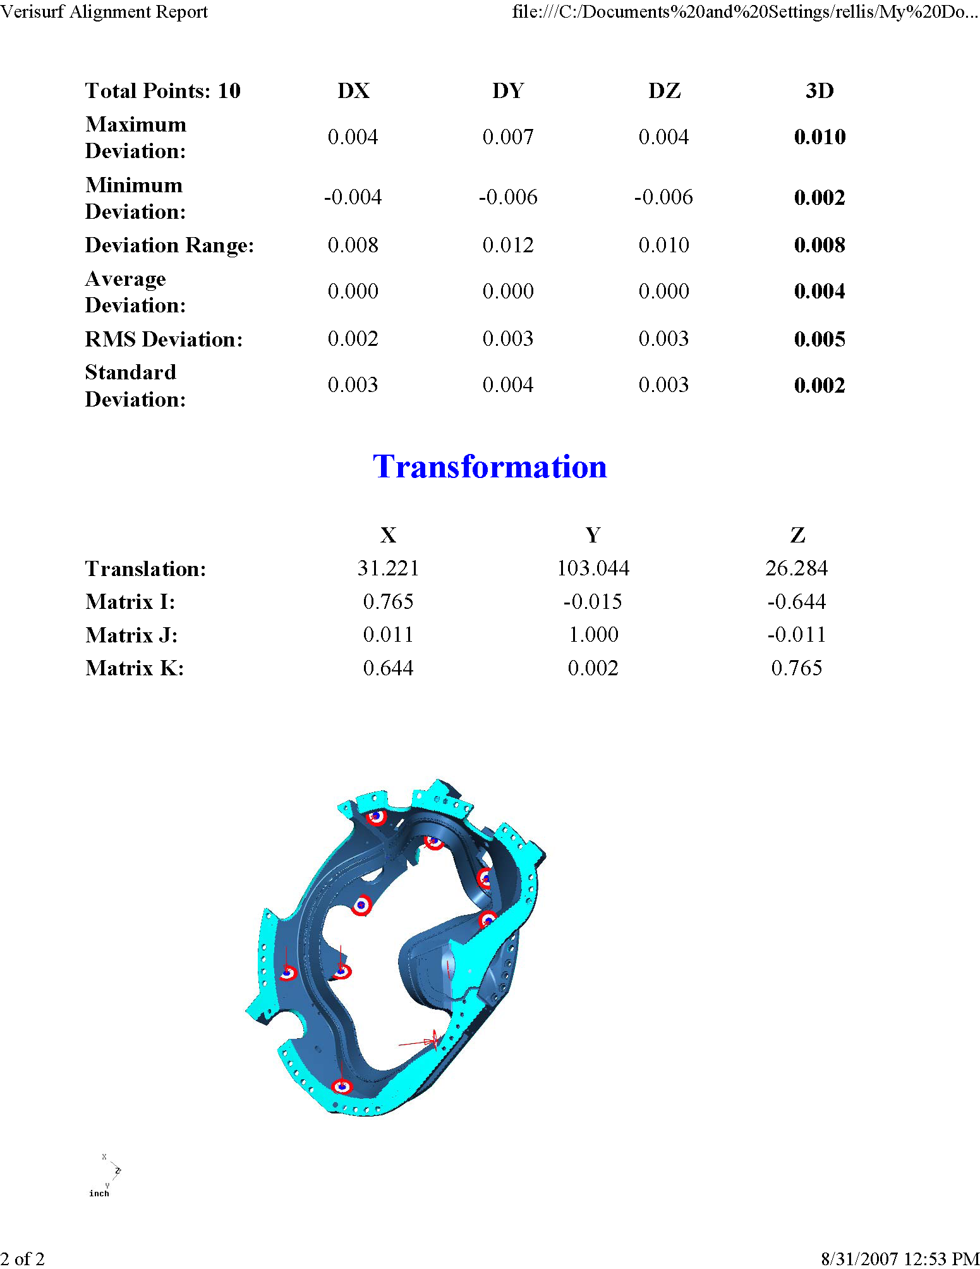

Attachment 2 – Type “A” Modular Coil

Attachment 3 – Type “B” Modular Coil

Attachment 4 – Type “C” Modular Coil

