NCSX Field Period Assembly (Station 3) Dimensional Control Plan
NCSX-PLAN-FPA3DC-00
June 16, 2008

Author: __________________________________________________
Robert Ellis, Dimensional Control Coordinator

Reviewed By:_____________________________________________
Craig Priniski, Metrology Engineer

Reviewed By:_____________________________________________
Tiana Dodson, Metrology Engineer

Reviewed By:_____________________________________________
M. Viola, Field Period Assembly Manager

Reviewed By:_____________________________________________
Larry Dudek, NCSX Construction Manager

Approved By:_____________________________________________
Phil Heitzenroeder, NCSX Design & Procurement RLM
Record of Changes
Revision | Date | Description
0 | 6/16/08 | Initial Issue
Table of Contents

1 Introduction 1
1.1 Scope 1
1.2 Relevant Documents 3
1.3 Overview 3
2 FPA and Dimensional Control Steps 4
2.1 Assembly Area Preparation 5
2.2 Pre-Install the Modular Coil Half Periods 6
2.3 Pre-Assemble LH and RH Modular Coil Half Periods 7
2.4 Weld Nose Shims to Each MCHP 8
2.5 Install Vacuum Vessel 9
2.6 Install Right MCHP Over Vacuum Vessel 9
2.7 Install Left MCHP Over Vacuum Vessel 10
2.8 Weld Nose Shims 11
3 Addendum 11
Attachment 1 – Sample Alignment Report 1
Table of Figures
Figure 1.3-1Half Period Assembly 4
Figure 2.1-1FPA Assembly Fixture 5
Figure 2.2-1Left HPA On Assembly Fixture 6
Figure 2.2-2 Field Period On Assembly Fixture 8
Figure 2.5-1Vacuum Vessel On Assembly Fixture 9
Figure 2.7-1 Left and Right Half Periods Over Vacuum Vessel 10

Introduction

Scope
This plan describes the dimensional control steps that will be taken to ensure adequate dimensional control of the Modular Coil Field Period (MCFP) assembly of the National Compact Stellarator Experiment (NCSX) at the Princeton Plasma Physics Laboratory. This activity shall occur at Station 3. Each field period assembly consists of two modular half period assemblies (MCHP) and a vacuum vessel segment. The MCHPs are joined together in stellarator symmetry with bolts and shims at the interface between the “A” coils. Adequate dimensional control will ensure that the coil current centers are within the specified tolerance.

This document is not an assembly procedure. It is meant to provide an overview of the dimensional control strategy for half period assembly, and to provide input into the assembly procedures. Certain major steps in the assembly procedure have been repeated in this document in order to define the points where measurements are required.

Relevant Documents

NCSX Plans
- Modular Coil Winding Dimensional Control Plan (NCSX-PLAN-MCWDC) – latest version
- Half Period Assembly Dimensional Control Plan (NCSX-PLAN-FPA2DC-00)

Overview
The dimensional control steps outlined in this document are the result of experience gained during half period assembly.
A modular coil half period assembly (MCHP) consists of three modular coils: one each of type A, B, and C. Each coil subtends a 20deg toroidal angle. The coils are joined by bolts and shims at the hole locations in the flanges, and welded together in the nose region. The gap between flanges is nominally .500”. Two datum planes, defining the toroidal angular extent of the coils, are nominally .250” offset from the plane of each flange, and pass through the vertical centerline of NCSX. The datum planes are defined as datums “D” and “E”. Datum “D” corresponds to side “A” or flange “A” of the coil; datum “E” corresponds to flange “B”. See attachments 2, 3, and 4.
A modular coil field period assembly (MCFP) consists of two MCHPs, joined together at the “A” coils in stellarator symmetry with a bolted and welded joint.
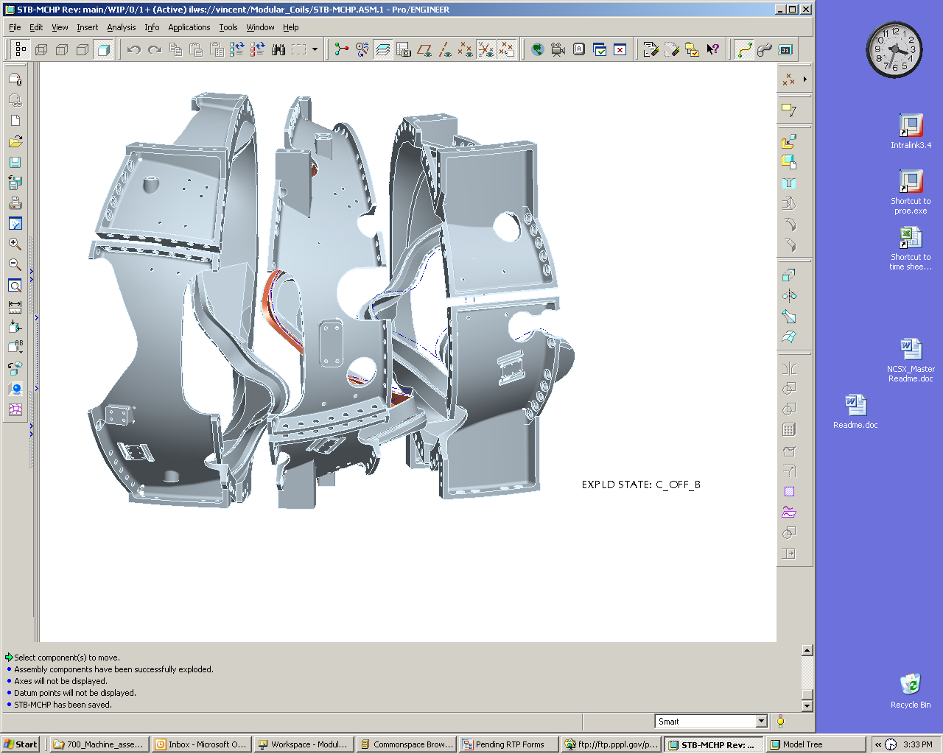
Type-A
Type-B
Type-C
Figure 1.3-1Half Period Assembly
During assembly, the position of the coil current centers is not measured directly, as the winding surfaces are not accessible. Their position is inferred from the position of external monuments, or tooling balls, located on the outside of the flanges and bodies of the modular coils. The positions of these monuments are related to the special “conical seat” monuments that were used for coil winding through the coil pre-measurement process
Measurements during the modular coil field period assembly process are performed with a laser tracker and photogrammetry. The measurement philosophy, generally, is to establish a global coordinate system in the assembly area, and position all components relative to that coordinate system. Once the coordinate system is established, a set of global monuments are established for the purpose of repositioning the tracker, and for periodic checks of the accuracy of the process. Metrology equipment must be aligned to the global coordinate system, unless otherwise specified, in order to make measurements. As a general rule, any alignment to the global coordinate system shall have an RMS deviation of .002” or less. Multiple alignments will be required for many laser tracker measurements, and each alignment must satisfy the criterion above.

FPA and Dimensional Control Steps

Assembly Area Preparation
The preparation of the assembly area involves establishing a set of global monuments and a global coordinate system, establishing monuments on the assembly fixture, installing the fixture and measuring its position, and installing the laser projection screens used for tracking a MCHP as it passes over the vacuum vessel.
Establish a set of global monuments for both laser metrology and photogrammetry that will be suitable for measurement of the entire field period assembly. To establish this coordinate system, the laser tracker is first positioned at approximately the x-y origin of the NCSX global coordinate system. The z-axis of the global system will be the default vertical axis of the laser tracker. The y-axis will be parallel to the direction of the fixture rails. A set of monument receptacles [welded on pucks, drilled and reamed holes, or other mounting techniques as required] will be installed on the building walls, and additional concrete columns placed on the floor as needed, in such quantity and location that will permit the laser tracker to be aligned to the global system at all measurement positions, and to provide an appropriate set of photogrammetry monuments. The set of monuments will be determined by the metrology engineers, and approved by the Dimensional Control Coordinator.
A set of monuments shall also be established on the assembly fixture, in particular on the rails and on the vacuum vessel base support weldment. A set of holes, for mounting tooling balls, shall be drilled and reamed in the rails at roughly two foot intervals. Six holes for tooling balls shall be drilled and reamed in the vacuum vessel base support. These holes should be positioned to an accuracy of .005”. After drilling the holes in all of the parts, their locations shall be measured with metrology equipment. A best-fit alignment to the part geometries can be used to relate the coordinate system of the metrology equipment to the part geometry, and then the positions of the tooling balls can be measured. The tooling balls can then be added to the CAD models of the fixture components and assemblies.
The fixture is now ready to be installed in the assembly area. The strategy is to position it approximately, measure its location exactly, and then incorporate the monuments on the fixture into the global system.
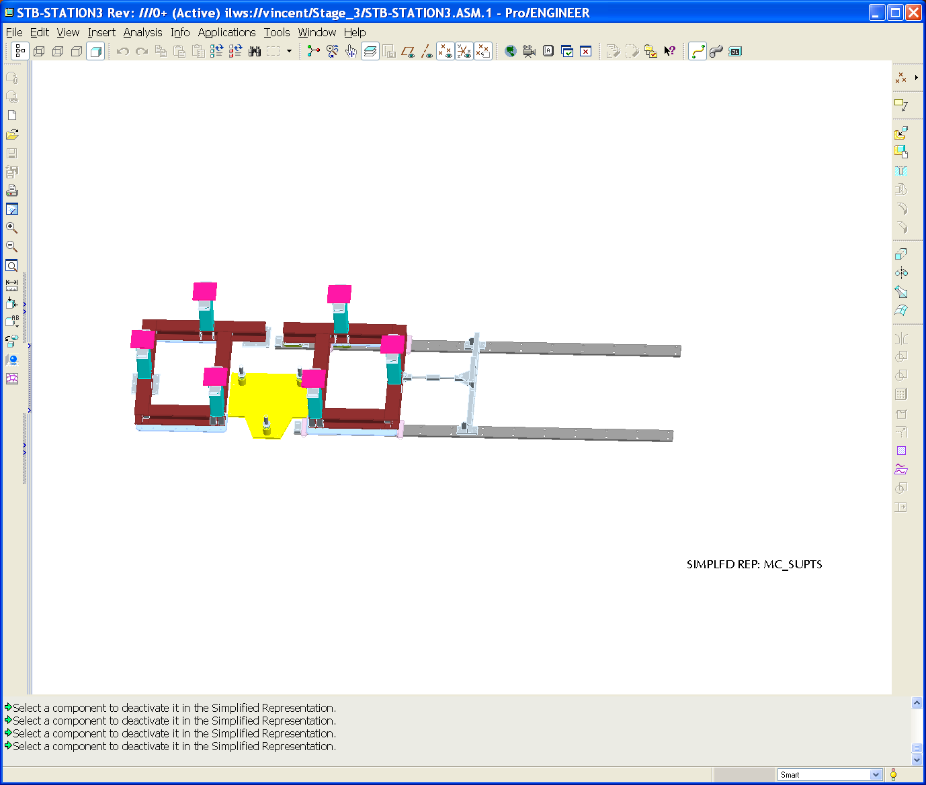
MCHP track
VV base support
Anti tip weldment (below right support)
Left MCHP support bolted to floor
Figure 2.1-2FPA Assembly Fixture
Align the laser tracker to the global coordinate system. An accuracy of .002”RMS is required. Lay the support rails and the vacuum vessel base support weldment on the floor in their approximate positions. Use the laser tracker and at two monuments on each component as an aid in positioning. A maximum deviation of .030” from the theoretical position of the monuments is desired at this step. Anchor the rails and base support to the floor. Check the alignment of the laser to the global system, and measure the position of all of the monuments on the fixture components. They should be within .050” of their theoretical position. Record and save these points as “fixture fiducials”. They can be incorporated into the network of global monuments, but it must be remembered that they may be less stable than the building fiducials.
The laser projection screens will each have at least four locations for tooling balls or equivalent metrology monuments. They are to be positioned by hand so that the monuments are within .060” of their desired position, then anchored to the floor. The installation and use of these screens is not specifically part of the dimensional control process; the installation of the screens is included here because it will utilize the metrology equipment.

Pre-Install the Modular Coil Half Periods

Each MCHP must be pre-installed in its position on the assembly fixture – the left MCHP on its stand and the right on its cart – in order that the end flanges may be scanned for the purpose of calculating shim thicknesses, and for analyzing any changes in coil shape that may occur as a result of the change in orientation from station 2 to station 3. The left MCHP is installed first.
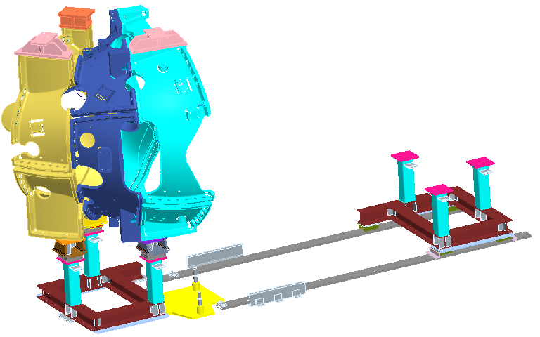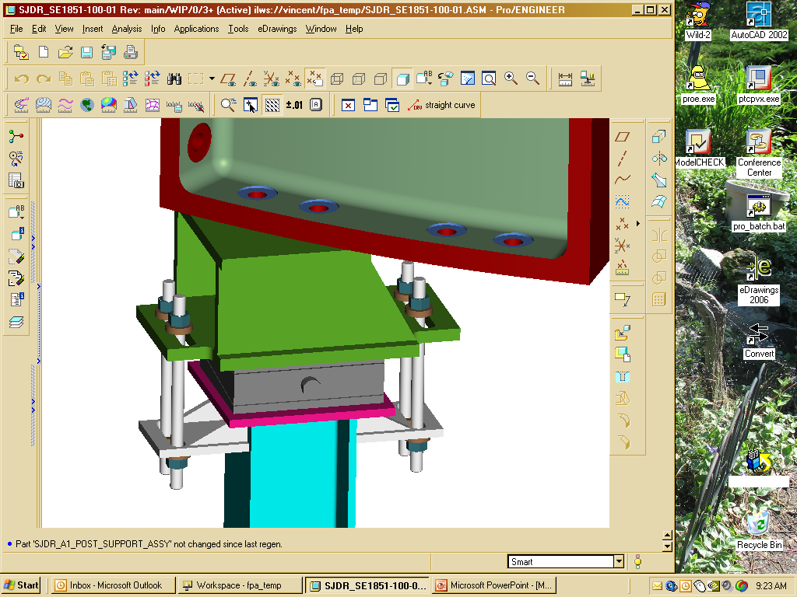
MCHP support cart assembly
MCHP Left side
AirLoc Wedgemount bolt on spherical seat precision leveler
Figure 2.2-3Left HPA On Assembly Fixture
Position the left MCHP over the left support using the SISSCO rigging, the base support lateral adjustment system, and the alignment calculator similar to that from station 2. Use six target monuments in the alignment calculator. Adjust position until the monuments are within .010” of their positions as measured in station 2. Compare the positions of these target monuments to their nominal positions. The positions should be within .030” of their nominal values. Consult Dimensional Control for guidance if this criterion is not met.
Align to the part geometry. The acceptance criterion for this alignment is .005” or less RMS deviation. Consult Dimensional Control for guidance if this criterion is not met.
Scan the end flange on the A coil.
Mark the nose shim and puck locations.
Lock the left MCHP in position.
Save the measurement data file and back it up.
Slide the cart for the right MCHP to its extreme position away from the coil interface.
Position the right MCHP over its support using the SISSCO rigging and the base support lateral adjustment system. Use six target monuments in the alignment calculator. guidance if this criterion is not met.
Align to the part geometry. The acceptance criterion for this alignment is .005” or less RMS deviation. Consult Dimensional Control for guidance if this criterion is not met.
Scan the end flange on the A coil.
Save the measurement data file and back it up.
Mark the nose shim and puck locations.
Lock the right MCHP in position.

  - Pre-Assemble LH and RH Modular Coil Half Periods
The next major step is to pre-assemble the left and right MCHPs. The coils are brought together, without the vacuum vessel present, and with the pre-calculated shims installed. Studs and supernuts are installed and partially tightened, puck heights in the inboard region are measured, and the monuments on the both half periods are measured to verify that dimensional tolerances have been successfully maintained during pre-assembly.
Install all shims on the left MCHP, including one temporary shim in the nose, and secure temporarily.
Using the alignment calculator and six target monuments, verify that the MCHP is positioned correctly relative to the global coordinate system. All targets should be within .010” of their desired position, using the monument locations as measured in station 2.
Move the cart to the “coil mating” position.
Using the SISSCO crane, alignment calculator and base support lateral adjustment system, position the right MCHP using six target monuments. Adjust until the monuments are all within .010” of their desired position. Contact Dimensional Control for guidance if this criterion is not met.
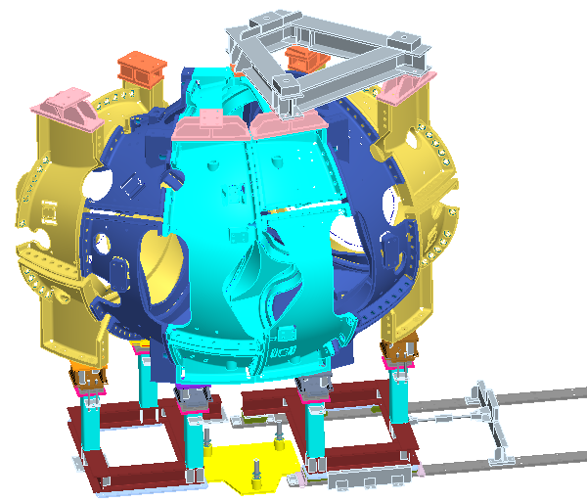
Figure 2.2-4 Field Period On Assembly Fixture
Move the AirLoc Wedgemount leveler to take up the load. Re-check the targets with the alignment calculator. All targets should be within .010” of their desired position. Contact Dimensional Control if this criterion is not met.
Install all studs and supernuts, and torque to 50%.
Perform a hand “wiggle test” and replace loose shims.
Measure the puck heights.
Measure the position of all monuments on both MCHPs. When compared to the original fiducials that were defined prior to station 2, all monuments should be within .030” of their ideal position. Contact Dimensional Control for guidance if this criterion is not met.
Save the measurement data file and back it up.
Remove the studs and separate the MCHPs.

Weld Nose Shims to Each MCHP
Weld the nose shims to each MCHP.
After welding of shims, perform an alignment of metrology to each MCHP, using the monument coordinates as measured in station 2 as nominals. Do not accept the alignments; they are used to verify that the MCHPs have not changed shape. Each alignment should have an RMS deviation of .005” or better. If this criterion is not met, contact Dimensional Control for guidance.
At this point in the procedure, time must be allocated for the back office to process measurement data.

Install Vacuum Vessel
Install the vacuum vessel on its supports.
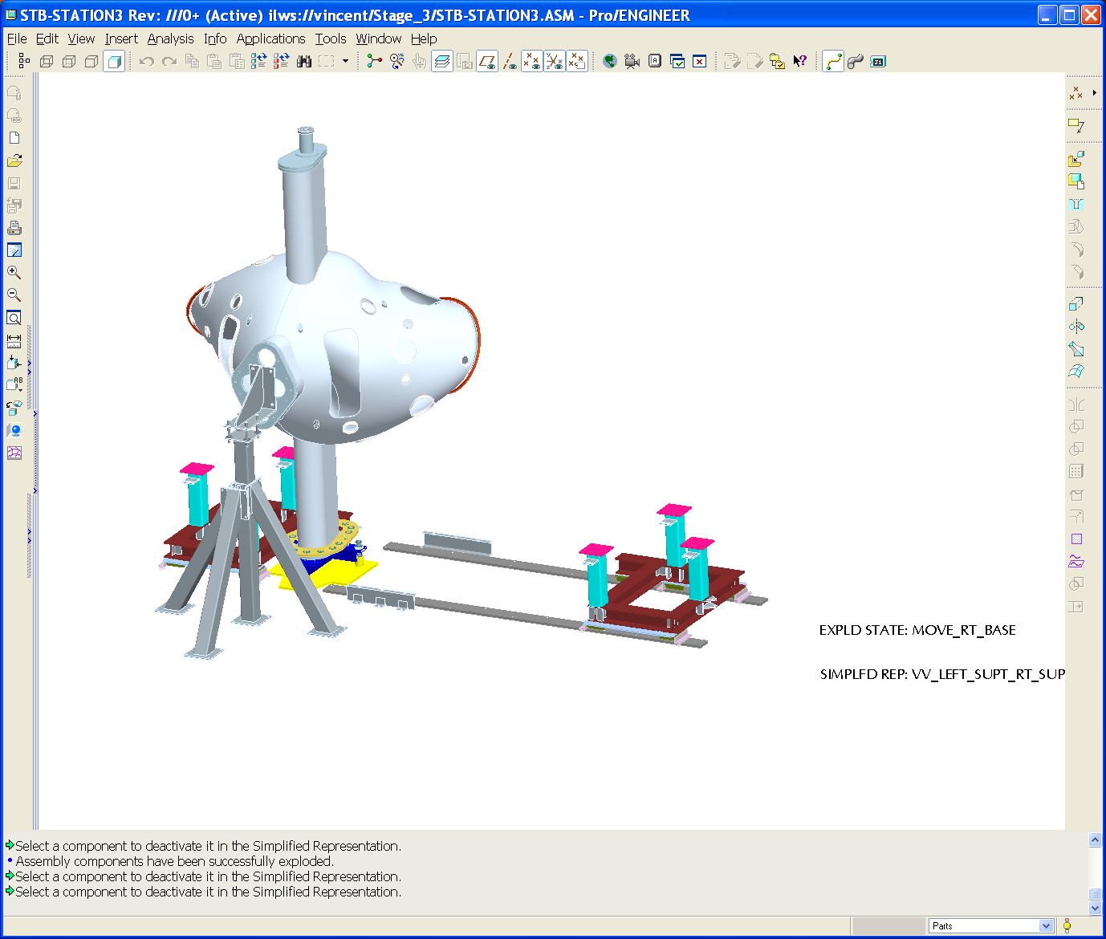
MCHP support cart assembly
MCHP fixed support assembly
VV lateral support
Figure 2.5-5Vacuum Vessel On Assembly Fixture
Using the alignment calculator and six target monuments, position the vacuum vessel to within .060” of its desired position.
Align the laser tracker to the global coordinate system, with a RMS deviation better than .002”, and scan the vacuum vessel surface.
The back office will now compare the scanned surface with the station 1 data, in order to verify that clearances for installing the MCHPs over the vacuum vessel will be adequate.
Save the data file and back it up.

Install Right MCHP Over Vacuum Vessel
The right MCHP is installed over the vacuum vessel using the laser guidance system. Following this step, it is placed in position.
Using the SISSCO crane, the base support lateral adjustment system and the alignment calculator, position the right MCHP to within .005” of its desired position using six target monuments as measured in station 2. Contact Dimensional Control for guidance if this criterion is not met.
While the MCHP is supported with the SISSCO rigging, use the AirLoc Wedgemount leveler to take the load. Secure the MCHP to its support base.
Re-check the target monuments on the right MCHP. The same .005” criterion applies. Contact Dimensional control if it is not met.
Save the data file and back it up.
Using the adjuster bar, move the MCHP 0.5” away from its final position.

Install Left MCHP Over Vacuum Vessel
The left MCHP is installed over the vacuum vessel using the laser guidance system. Following this step, it is placed in position.
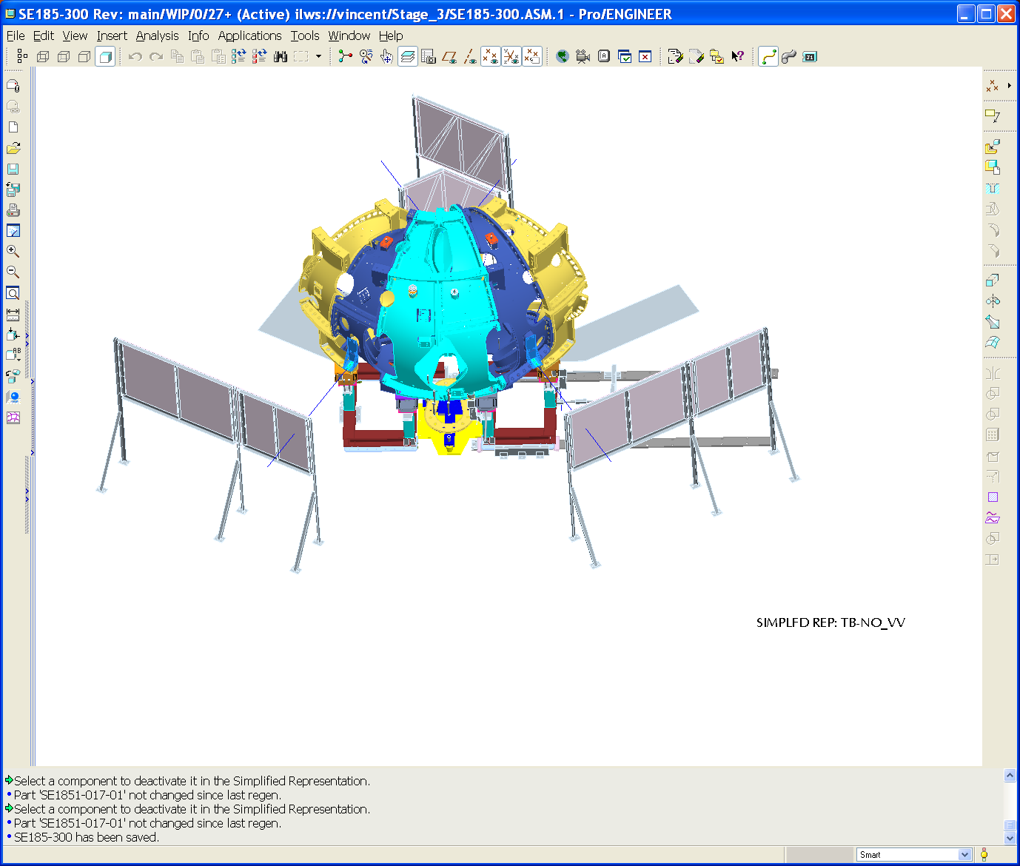
Floor mounted screen
Left screen
Right screen
Inboard screens
Floor mounted screen
Figure 2.7-6 Left and Right Half Periods Over Vacuum Vessel
Using the SISSCO crane, the base support lateral adjustment system and the alignment calculator, position the left MCHP to within .010” of its desired position using six target monuments as measured in station 2. Contact Dimensional Control for guidance if this criterion is not met.
While the MCHP is supported with the SISSCO rigging, use the AirLoc Wedgemount leveler to take the load. Secure the MCHP to its support base.
Re-check the target monuments on the right MCHP. The same .010” criterion applies. Contact Dimensional control if it is not met.
Install all shims and pucks and tighten supernuts to 50%.
Perform a hand “wiggle test” and replace loose shims.
Measure all coil monuments. At this point, the measurements are to be compared to the “compiled realigned fiducials” that were defined before Station 2. All monuments should be less than .030” (true distance) from their nominal position. Contact Dimensional Control for guidance if this criterion is not met.
Install all bushings and tighten supernuts to 100%.
Measure all coil monuments. Relative to the original “compiled realigned fiducials, defined before station 2, they should be within .035” (true distance) of their nominal position. Contact Dimensional Control for guidance if this criterion is not met.
Save the data file and back it up.

Weld Nose Shims
Weld the inboard shims.
Measure all of the coil monuments on the field period. All monuments should be within .040” (true distance) of their nominal position as defined in the “compiled realigned fiducials”. Contact Dimensional Control for guidance if this criterion is not met.
Measure the monuments on the vacuum vessel that are accessible.
Scan the surfaces of the “feet” on the coils to which the PF and TF coil supports will mount, where accessible.
Save the data file and back it up.

Addendum
There are two key aspects of the logic in this dimensional control plan. The first is the establishment of a global coordinate system into which the components are positioned, rather than fitting a coordinate system to one or the other of the field period assemblies. Our experience in half period assembly has shown that magnitude of the deformation of modular coils due to gravity can be on the order of the tolerance goals of the assembly step. In half period assembly, this deformation was managed by referencing everything to a global coordinate system, against which we could obtain absolute position measurements of coil monuments. These measurements allowed us to correct unwanted deformations. Whether the global coordinate system is arbitrarily fixed to the building, or perhaps obtained by fitting to the vacuum vessel, is an issue that would be resolved during area preparation. But because the accurate positioning of the modular coils is of paramount importance, they must be installed into a global reference system against which they can be measured in an absolute sense.
The other important component of the dimensional control plan is the choice of monument coordinates. Prior to assembling half periods, a set of “realigned” coordinates for the monuments on each coil was established. The goal at the end of full period assembly is to have all of the monuments on all six coils be within .040” of their “realigned” positions. However, the monuments will move up to .020” from their theoretical positions during half period assembly. If the original “realigned” coordinates were used for this dimensional control plan, it would be necessary to do the initial positioning to an accuracy of .030”. Therefore, in this plan, a more stringent criterion on the positioning of the coils is obtained by using the coordinates of the monuments as measured at the end of half period assembly in positioning operations using the alignment calculator, but using the original “realigned” coordinates as the acceptance criteria ahead of critical steps such as bushing installation and welding.

Attachment 1 – Sample Alignment Report



