NCSX Half Period Assembly Dimensional Control Plan
NCSX-PLAN-HPADC-00-dB
September 7, 2007

Author: __________________________________________________
Robert Ellis, Dimensional Control Coordinator
Reviewed By:_____________________________________________
Steve Raftopoulos, Metrology Engineer
Reviewed By:_____________________________________________
Michael Zarnstorff, NCSX Project Physics Manager
Reviewed By:_____________________________________________
M. Viola, Field Period Assembly Manager
Approved By:_____________________________________________
Phil Heitzenroeder, NCSX Engineering Manager
Record of Changes
Revision | Date | Description
0-dB | 9/7/2007 | Initial Issue (Draft B)
Table of Contents
1 Introduction 1
1.1 Overview 1
1.2 Relevant Documents 1
1.3 Overview and Assumptions 1
2 HPA and Dimensional Control Steps 3
2.1 Monuments and Alignments 3
2.2 Racking of the Modular Coils 4
2.3 Pre-Measurement of Modular Coils 6
2.4 Type “A” to Type “B” Assembly 7
2.5 Transfer to A-B-C Fixture 10
Appendix 1 – Derivation of Racking Calculations 1
Attachment 1 – Sample Alignment Report 1
Attachment 2 – Type “A” Modular Coil 1
Attachment 3 – Type “B” Modular Coil 1
Attachment 4 – Type “C” Modular Coil 1
Table of Figures
Figure 2.4-1 Type “A” to Type “B” Setup 7
Figure 2.4-2 Mating “B” Coil into Position 8
Figure 2.4-3 Jack Screws and Dial Indicator Installation 9
Figure 2.4-4 Fuji Paper Showing Loads 9

Introduction

Overview
This plan describes the dimensional control steps that will be taken to ensure adequate dimensional control of the half period assembly (HPA) of the National Compact Stellarator Experiment (NCSX) at the Princeton Plasma Physics Laboratory. Each half period assembly consists of three modular coils, one each of type A, B, and C. The three coils are joined together with bolts and shims. Two half periods are joined, in stellarator symmetry, to form a full period.
In order to minimize field errors in the NCSX plasma, the current centroid of each coil is required to be within .060” of the design location in the completed NCSX device. An uncertainty of .020” is assigned to full period assembly, with half assigned to half period assembly. A recent design change from fully bolted coil-to-coil interfaces to a configuration with the shims in the inboard region welded will increase this uncertainty.
The welding process and design is currently under development, and the additional uncertainty will be known when this development work is complete. It is expected that the uncertainty in half period assembly will become .025” for the welded configuration.
This document is not an assembly procedure. It is meant to provide an overview of the dimensional control strategy for half period assembly, and to provide input into the assembly procedures.

Relevant Documents

NCSX Plans
- Modular Coil Winding Dimensional Control Plan (NCSX-PLAN-MCWDC) – latest version

NCSX Drawings
- Modular Coil Winding Form Assembly Type A (SE141-101) – latest version
- Modular Coil Winding Form Assembly Type B (SE141-102) – latest version
- Modular Coil Winding Form Assembly Type C (SE141-103) – latest version

NCSX Assembly Procedures
- Half Period Assembly Sequence Procedure (What is procedure ##?) – or is this a plan???
- Modular Coil Nose Welding Procedure (What is procedure ##?)

Overview and Assumptions
The dimensional control steps outlined in this document are the result of experience gained during coil-to-coil fitup trials, the modular coil weld tests, and development of the coil racking procedure. The welding tests are still underway, and it is expected that some revision of this plan will be required as test results become available.
A half period assembly consists of three modular coils: one each of type A, B, and C. Each coil subtends a 20deg toroidal angle. The coils are joined by bolts and shims at the hole locations in the flanges, and welded together in the nose region. The gap between flanges is nominally .500”. Two datum planes, defining the toroidal angular extent of the coils, are nominally .250” offset from the plane of each flange, and pass through the vertical centerline of NCSX. The datum planes are defined as datums “D” and “E”. Datum “D” corresponds to side “A” or flange “A” of the coil; datum “E” corresponds to flange “B”. See attachments 2, 3, and 4.
During assembly, the position of the coil current centers is not measured directly, as the winding surfaces are not accessible. Their position is inferred from the position of external monuments, or tooling balls, located on the outside of the flanges and bodies of the modular coils. The positions of these monuments are related to the special “conical seat” monuments that were used for coil winding through the coil pre-measurement process. Because of the flexibility of the coils, and the need to represent the positions of the current centers as accurately as possible, the coil is twisted slightly, or “racked” into its as-wound shape prior to pre-measurement. This step is a necessary precursor to the pre-measurement process.
Measurements during the half period assembly process are performed with a laser tracker, used in conjunction with Verisurf© measurement software. The measurement philosophy, generally, is to align the tracker to the part geometry in order to relate the measurements to the CAD model of the part. Once an alignment is successfully completed, a set of global monuments are established for the purpose of repositioning the tracker, and for periodic checks of the accuracy of the process. Before aligning to the part geometry, it is necessary for the part to be twisted into the proper shape; the racking process therefore must be a predecessor to the measurement process.
In the pre-measurement process, the laser tracker is aligned to the coordinate system of the CAD model of the coil with the coil in its as-wound configuration. All of the external monuments are measured, as well as the “A”, or datum “D” flange of the coil. The monument locations are used to position and track the coil during all subsequent assembly operations, and the measurements of the flange surface are used to predetermine shim thicknesses at all locations for the initial assembly. It is not possible to measure the full set of coil monuments from one laser position. Monuments are measured from two or three vantage points, as required. Each time the laser tracker is repositioned, an alignment using the global monuments is performed. Where possible, monuments that are accessible from both vantage points are measured from each location, as a check on the accuracy of the process.
The steps used for the pre-measurement process are the building blocks of the dimensional control steps for half period assembly. The first step of half period assembly is to set the first coil [type “A”] on a wedge fixture that is oriented so that the top, or datum “E” flange, of the coil, is pointing up. The racking procedure is used to twist the coil into the proper shape, and the laser tracker is aligned to the coil. A network of global monuments is immediately established. The surface of the datum “E” flange is scanned in order to calculate the required shim thicknesses. The shims, along with pressure sensitive “Fuji paper”, are placed on the top flange, and the mating coil [“B”] is lowered into position. Using jack screws, and measurements of three designated monuments, the top coil is positioned in the plane of the flanges. The bolts are partially torqued, and all of the monuments, on both coils, are measured. The top coil is raised, and the Fuji paper is inspected to verify proper load distribution among the shims. Monument positions are analyzed by the dimensional control team to verify proper coil placement. If necessary, some shim thicknesses are changed in order to achieve dimensional accuracy and adequate load sharing. The coils are brought back together with fresh Fuji paper installed, the bolts are partially torqued, and the monuments are measured. As before, the coils are separated, the results are checked, and if acceptable, the shims, without Fuji paper, are installed, along with the proper bushings, and the coils are brought together for the final time. At this point, the gap along the nose region is measured, the initial shims in that region are removed, and the special weld shims are final machined to the appropriate dimensions and installed. After welding the nose region and final tightening of the bolts, the full set of monuments is measured and the datum “E” flange of the top, or “B”, coil is scanned. Because the nose region is welded, there is no easy remedy if the deviations of the monuments from their nominal positions are not acceptable.
After this step, the coils, still attached to the fixture, are mounted on another wedge that has its top surface tilted at 20 degrees from horizontal, so that the top flange of the “B” coil is approximately horizontal. It is assumed that, when the monuments were measured after welding, that a suitable set of monuments, within an acceptable deviation from nominal position, were found, and the laser tracker can be aligned to them. A set of global monuments is immediately measured, and the same basic coil-to-coil joining sequence is performed between the “B” and “C” coils.

HPA and Dimensional Control Steps

Monuments and Alignments
The laser tracker measures point locations in a 3-dimensional Cartesian coordinate system that has its z-axis parallel to the vertical axis of the tracker. The purpose of an alignment is to relate this coordinate system to the coordinate system in which a part, or a set of monuments, is defined. Two types of monuments are used in the half period assembly: part monuments and global monuments. The fundamental difference between the two is that part monuments are physical points on the part that are defined in the CAD model of the part, while global monuments are physical locations, on a fixture or in the assembly area, that are measured by the laser tracker in order to establish their position, and thereafter used as references. Alignment is a means of defining the position of the laser tracker in terms of a set of monuments, and as such is less sensitive to small variations in the positions of monuments when a set of well chosen, reasonably distant monuments, covering a large range of the azimuth of the tracker, are used. An ideal set of monuments for alignment would be a placed on a sphere of about 20ft – 30ft radius with its center at the head of the tracker. Practical considerations prevent this, but a wise choice of monuments for alignment will minimize errors that are incurred during repositioning of the laser tracker. It is clear from the above that alignment to the part geometry, while necessary at some point in the procedure, should only be used as a first step towards establishing a global network of monuments for a given step of the assembly sequence.
If the part is deformed from the state in which the part monuments were defined, the accuracy of the alignment will suffer. A process for correcting this deformation prior to initial alignment to the part geometry has been developed, and is the first step in the pre-measurement process and the assembly process.
A useful criterion for measuring the quality of an alignment is the rms deviation of the alignment. This quantity appears in the alignment report provided by Verisurf©. A sample report is shown in attachment 1. Our criterion for alignments to part geometry is that the rms deviation be not greater than 0.005”. For alignments to global monuments, the rms deviation shall not be greater than 0.002”. Nonconformance reports shall be generated for each alignment that exceeds its relevant criterion, and must be resolved prior to use of that alignment. Additional requirements on selection of monuments appear in later sections of this document. Alignment reports for all alignments used in the process are to be saved and recorded with the run copy of the assembly procedure.
The positions of the monuments are measured by measuring a 10-point sphere around the spherical monument. The external monuments are tooling balls which already have a spherical shape. To measure conical seats, a 15mm diameter ball bearing is placed in the seat, and a sphere is measured around it. The sphericity measurement returned by Verisurf© is a useful and necessary check on the quality of the measurement. Our goal is a sphericity of 0.001” or better, but .002” on 25% or less of the monuments can be accepted.

Racking of the Modular Coils

The following general steps are provided to rack the modular coils:

Set up a wedge fixture, with the top surface approximately level, with the appropriate top plate for the type of coil to be measured. Support the narrow edge at its corners and approximately midway along its length. The top plate shall have precisely drilled holes for monuments at its corners, or pucks to receive the 1.5” diameter reflecting ball shall be glued to the corners.

Place a set of wedge jacks, one roughly under the position where each conical seat will be, on the top surface.

Place the laser tracker in a position relative to the wedge, and at a height, where it will be able to measure at least 75% of the conical seats on the coil, and three of the corner monuments on the wedge. Note: this position, for each type of coil, is to be determined during pre-measurement of the first coil of each type.

Measure a plane [“measure plane” in Verisurf©] by measuring three arbitrary points on the top surface of the fixture. One point should be near each corner at the thick end of the wedge, and the third point should be approximately midway along the narrow edge. This plane will be referred to as plane “G”.

Measure the four corner monuments on the wedge, and a set of five or more global monuments attached to the building. These will be the global monuments used for subsequent global alignments. The set of monuments must be approved by the Dimensional Control Coordinator.

Using the laser tracker and the “Build to Surface” feature of Verisurf©, set the jacks to a constant height relative to plane “G”.

Lower the coil onto the jacks, datum “E” facing down.

Re-check the measurements of global monuments on the fixture. If they have moved more than .002”, re-measure the full set of global monuments.

Measure the locations of all of the conical seats that are accessible, in sequence from lowest to highest number.

In Microsoft Excel, open the racking spreadsheet for the particular coil that has been prepared by Dimensional Control. In Verisurf©, select only the level in which plane “G” has been defined, do a point report on the three points, and transfer the results to the spreadsheet in the cells assigned to those points. This enables the spreadsheet to compute the unit normal vector and the scalar that define the plane in 3dimensional Cartesian space.

In Verisurf©, select only the level on which the conical seats are defined. Do a point report, transfer the results to the racking spreadsheet in the cells that are assigned to the conical seats. The “nominal”, or as-wound, positions of the conical seats, will have already been entered into the spreadsheet by Dimensional Control. The coordinates of each conical seat are pasted into sheet 2 of the spreadsheet, in the assigned location, to calculate the offsets of the conical seats from plane “G”. These offsets are entered in the assigned cells on sheet 1, and after this has been done for each conical seat, the spreadsheet will display the amount that each conical seat must be raised in order to twist the coil as close as possible to its as-wound condition.

Clamp a dial indicator to the fixture surface near each jack location so that it reads the vertical motion of the flange closest to the fixture surface. Take care that each indicator reads of an adequately smooth surface. Check each indicator to verify its proper operation.

Watching the dial indicators, jack at each location by the amount specified on the racking spreadsheet. Jack alternately at points roughly across the diameter, rather than working around circumferentially.

Save the racking spreadsheet, and save it as a new copy.

Repeat steps 2.2.9 through 2.2.14. When the racking spreadsheet indicates that the required jacking at each location is 0.002” or less, the coil has been adjusted to the best of our ability. It is now permissible to do an alignment.

Align to the set of conical seats that are accessible. The acceptance criterion is .005” rms deviation. If this is not met, a nonconformance report must be generated. The nonconformance must be resolved by the Dimensional Control office and project management before proceeding further.

After alignment and resolution of any nonconformances, the alignment report is saved, and the alignment is accepted.

Measure the global monuments. Note that, because of the presence of the coil, one or two of the monuments on the fixture will no longer be accessible. This set of global monuments will be used for subsequent alignments of the laser tracker. All alignments to the global monuments will include the full set of building monuments, and at least two of the monuments on the fixture. The acceptance criterion for global alignments is .002” rms deviation. A failure to meet this criterion is a nonconformance that must be resolved by the Dimensional Control office.

Pre-Measurement of Modular Coils
The following general steps are provided to pre-measure the modular coils:

Verisurf© Build, check the location of two monuments on the fixture. If they are less than .003” from their original position, proceed to 3.3.2. If they are more than .003” from their original position, it may indicate that the laser has been bumped, or the fixture moved slightly. Re-align to the global monuments. If the acceptance criterion is not met, it may mean that the fixture and the building have moved relative to each other. Do not accept the alignment, but re-align to the conical seats. If this alignment is not acceptable, do not accept it. Contact the Dimensional Control Office and work out a resolution to the problem before proceeding.

Scan the top flange of the coil. This information will be used in the pre-calculation of shim thicknesses.

Measure the positions of all of the tooling balls accessible to the laser. Use the “measure sphere” technique with 10 point spheres. Accuracy criteria are laid out in Section 2.1.

Move the laser tracker to a new vantage point from which the remaing monuments on the part are visible. [note – a third position may be required]

Align to the global monuments, using the full set of building monuments and at least two monuments on the fixture. If the alignment does not meet the acceptance criterion, generate a nonconformance report and resolve it with Dimensional Control and project management before proceeding.

Measure the positions of all of the tooling balls accessible to the laser. Use the “measure sphere” technique with 10 point spheres. Accuracy criteria are laid out in Section 2.1.

Repeat steps 2.3.4 through 2.3.6 until all of the monuments have been measured.

At this point, the pre-measurement of the modular coil is complete. The external tooling balls are now related to the position of the coil current center in the as-sound condition of the coil. The external tooling balls, with the appropriate rigid body realignments as needed, will be the reference points for positioning and tracking the modular coil during subsequent assembly steps. The conical seats that interfere with coil-to-coil fitup can be removed at this point, but should not be removed unless it is necessary. This will ensure that we retain redundant dimensional information as far as possible into the assembly sequence. It is anticipated that, prior to full period assembly, all remaining conical seats will be removed.

Type “A” to Type “B” Assembly
A wedge fixture with its top surface tilted at 20 degrees from horizontal is the starting point for this step. See Figure 2.4-1 below:

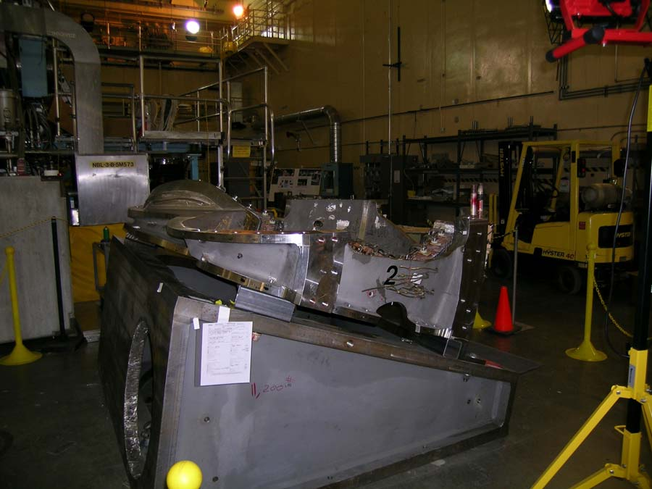

Figure 2.4-1 Type “A” to Type “B” Setup

Place a set of jacks, one at the position of each tooling ball on the datum “D” flange of the “A” coil, on the top surface. Use magnets to keep the jacks from sliding.

The coil must be racked into its as-wound shape, this time using tooling ball nominal positions. All tooling balls on the top flange of the “A” coil shall be used for racking. The racking procedure, because it based on an arbitrary plane related to the fixture surface, is applicable to the wedge with a tilted top surface. Perform the racking procedure as described in 2.2 The result will be a coil in its as-wound shape, and a set of global monuments that can be used for the rest of the A-B assembly.

Measure the top, or datum “E” flange, of the “A” coil. The “back office” will use this information, along with the pre-measurement of the mating “B” coil, to calculate the shim thicknesses.

Place the pre-calculated shims and Fuji paper at the bolt locations and in the nose region.

Lower the mating “B” coil into position. See Figure 2.4-2:
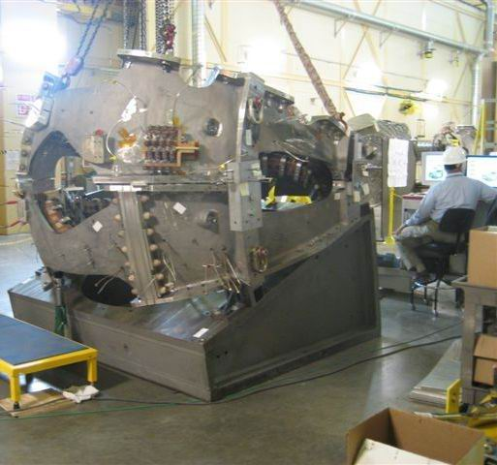
Figure 2.4-2 Mating “B” Coil into Position

Install the jack screws and dial indicators for horizontal positioning. See Figure 2.4-3 :

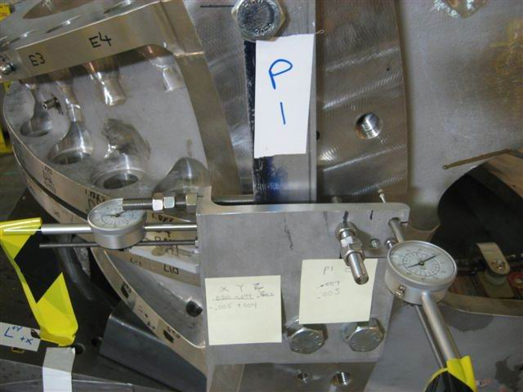
Figure 2.4-3 Jack Screws and Dial Indicator Installation

Using three selected monuments on the “B” coil, position the coil horizontally. An accuracy of .002” or better is expected and required for this step.

Torque the bolts to 50% of final value, and measure the positions of all of the monuments on both coils. This measurement will require repositioning the laser tracker at least once, with an alignment to global monuments required at each repositioning. The process of steps 2.4.3 through 2.4.7 shall be followed.

Unfasten the bolts, lift the “B” coil enough to remove the Fuji paper, and examine the load sharing. At the same time, the “back office” will analyze the measurements of the monument positions. A revised set of shim thicknesses, to provide adequate load sharing and dimensional accuracy, will be generated. See Figure 2.4-4:
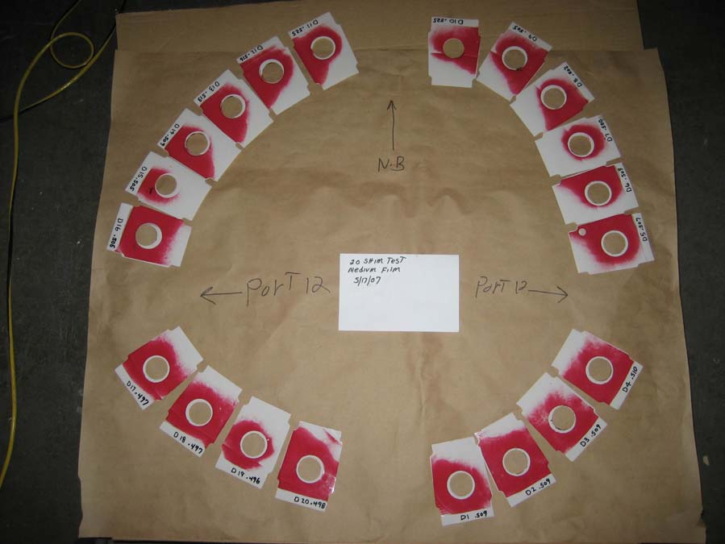

Figure 2.4-4 Fuji Paper Showing Loads

Install the new shims and Fuji paper. Lower and reposition, if necessary, the “B” coil. Repeat steps 2.4.8 and 2.4.9.

After the proper load sharing and dimensional accuracy is verified, install the shims without Fuji paper, lower and position the “B” coil, install all bushings and other parts of the bolt kits, and tighten the bolts to their pre-weld torque. Note: do not install nose shims here.

Measure the gaps in the nose region with gauge blocks, and use these measurements to determine the final dimensions of the weld shims.

Install the weld shims.

Weld the nose region.

Tighten all bolts to their final torque.

Measure the positions of all monuments per the process in steps 2.3.3 through 2.3.7.

Identify, if possible, a set of monuments that have moved less than .005” from their original positions. The alignment that will be necessary for mating to the “C” coil will use monuments from among this set. Note: results of the weld tests may require revision of this step.

Scan the top, or datum “E” flange of the “B” coil, for the purpose of shim thickness for the mating to the “C” coil.

Save the measurement file and back it up.

Transfer to A-B-C Fixture
After the “A” and “B” coils are joined, they must be placed on a fixture tilted at 40 degrees from horizontal, so that the top flange of the “B” coil is horizontal. This will enable the “C” coil to be properly positioned. This new fixturing will be achieved by lifting the “A” and “B” coils, along with their fixture, onto another wedge with its top surface tilted at 20 degrees from horizontal. It will be necessary to bolt the “A” coil to its fixture prior to lifting. The following steps provide guidance for transferring to an A-B-C fixture:

Select the set of monuments that will be used for the initial alignment in the next phase of half period assembly.

Lift the fixture/A/B assembly onto the wedge designated for A-B-C assembly. Bolt the fixtures together.

Align to the set of monuments selected in 3.5.1. Acceptance criterion is .005” rms deviation. This may change as a result of weld test results.

Establish a set of global monuments, including three positions on the fixture and five on the building.

The rest of this assembly sequence is identical to 3.4.4 through 3.4.18. The free flange of the “C” coil does not need to be scanned until after full period assembly.

Save the data file and back it up. Print reports of all alignments used, and nonconformance reports, and keep with run copies of the assembly procedure.

Appendix 1 – Derivation of Racking Calculations
The first step in the process is to calculate the offsets of a set of as-wound monuments [“nominals”] from the Datum “E” surface of each coil. The coordinate system established for measuring each coil is a Cartesian system, with the y-axis through the vertical centerline of NCSX, and the x-axis at midplane between the A-A joint. The z-axis is normal to datum “D” of the “A” coil, pointing away from the “B” coil.
The unit normal vector to Datum “E” of a given coil is obtained as
$\overline{u_{E}}=\left[\begin{matrix}\text{cos}θ_{c} & 0 & \text{sin}θ_{c} \\ 0 & 1 & 0 \\ −\text{sin}θ_{c} & 0 & \text{cos}θ_{c}\end{matrix}\right]\left[\begin{matrix}0 \\ 0 \\ 1\end{matrix}\right]$,
Where $θ_{c}=\text{20}\text{deg,} \text{40}\text{deg,} \text{60}\text{deg}$ for type “A”, “B”, and “C” respectively. The distance along the normal to datum “E” to a point
$$\overline{r}={\left[\begin{matrix}x & y & z\end{matrix}\right]}^{T}$$
is simply the dot product $\overline{r} ⋅ \overline{u_{E}}$, because datum “E” passes through the origin. This distance is computed for each as-wound monument.
When the coil is placed on the measurement fixture, the distance between each monument and an arbitrary reference plane is computed. Three points are measured to define the arbitrary plane “G”. The vector equation defining a plane is
$\overline{r} ⋅ \overline{Γ} =γ_{0}$,
Where $\overline{r} = {\left[\begin{matrix}x & y & z\end{matrix}\right]}^{T}$ is any point in the plane, and $\overline{Γ}$ is the unit normal vector to that plane. Having three points in the plane, we can solve the equation
$\left[\begin{matrix}x_{1} & y_{1} & z_{1} \\ x_{2} & y_{2} & z_{2} \\ x_{3} & y_{3} & z_{3}\end{matrix}\right]\left[\begin{matrix}G_{x} \\ G_{y} \\ G_{z}\end{matrix}\right]=1$,
and obtain $\overline{Γ}$ and $γ_{0}$ by normalizing the vector $G$.
The distance between any point $\overline{r} = {\left[\begin{matrix}x & y & z\end{matrix}\right]}^{T}$ and our plane “G” is determined by drawing a line through that point and perpendicular to the plane [or parallel to $\overline{Γ}$], determining its intersection with the plane, and measuring the distance between the intersection and the original point.
The equation of a line in 3-dimensional space is represented as
$\overline{r} × \overline{L} = \overline{L_{0}}$,
Where $\overline{r} = {\left[\begin{matrix}x & y & z\end{matrix}\right]}^{T}$ is a point on the line, $\overline{L}$ is a unit vector in the direction of the line, and $\overline{L_{0}}$ is the cross product of the two vectors. The intersection of a plane $\left[\overline{Γ};γ_{0}\right]$ and a line $\left[\overline{L};\overline{L_{0}}\right]$ is computed using the relation
$\overline{Γ} × \overline{L_{0}} =\overline{ Γ} × \left(\overline{r} × \overline{L}\right) = \left(\overline{Γ} ⋅ \overline{L}\right)r − \left(\overline{Γ} ⋅ \overline{r}\right)\overline{L}$.
Because our line is normal to the plane “G”, we have $\overline{Γ} = \overline{L}$, and therefore the intersection point is
$\overline{r_{P}} = \overline{Γ} × \overline{L_{0 }} + γ_{0}\overline{Γ}$.
The distance from the point to the plane, normal to the plane, is simply
$\overline{r}−\overline{r_{P}}$.
We can now, for the measured as-wound nominal points, subtract the smallest distance to datum “E” from the distance to datum “E” of each point, resulting in a set of distances from datum “E” relative to the distance of the closest point. We refer to this set of distances as “deltas”. The same can be done for the distances between conical seats and the plane “G”. Subtracting the latter set of “deltas” from the former, we obtain a set of height adjustments to be made at each jack. By subtracting the minimum of these values from each adjustment, we obtain a set of adjustments that are upward in all locations, with a zero adjustment at one point. This logic is incorporated into the “racking spreadsheet.”

Attachment 1 – Sample Alignment Report

Attachment 2 – Type “A” Modular Coil

Attachment 3 – Type “B” Modular Coil

Attachment 4 – Type “C” Modular Coil

