NCSX

Field Period Assembly (FPA) Manufacturing/Assembly, Inspection, Test and Quality Assurance Plan
NCSX-MIT/QA-185-01-00
May 1, 2006

Author: ________________________________________________________________
Mike Viola - Field Period Assembly (FPA) Facility Manager

Reviewed by:

Jerry Levine Judy Malsbury
PPPL Safety Representative NCSX QA Representative

Tom Brown Brent Stratton
WBS 186 Manager Dimensional Control Coordinator

Steve Raftopoulos John Edwards
Lead Metrology Engineer FPA Field Supervisor

Brad Nelson Wayne Reiersen
Stellarator Core Design RLM NCSX Engineering Manager

Approved By: ___________________________________________________________
Larry Dudek
RLM for the NCSX Manufacturing Facility
Controlled Document
THIS IS AN UNCONTROLLED DOCUMENT ONCE PRINTED.
- Check the NCSX Engineering Web prior to use to assure that Final Prep for Transport
  - Perform Final Measurements
  - Install transportation supports
  - Load on truck
  - Locate cooling tubes
  - Install tube clamp studs
  - Perform measurements
  - nsion

document is current.
Record of Revisions

Revision | Date | Description of Change
0 | 5/1/2006 | Initial Issue.

Table of Contents

1 Introduction and Scope 1
1.1 Introduction 1
1.2 Scope 1
2 Applicable Documents 1
2.1 NCSX Project Documents for FPA 2
2.2 Field Period Assembly Manufacturing Procedures 2
2.3 Drawings 2
3 Training Requirements 3
3.1 General Training Requirements 3
3.2 Specialized Training Requirements 3
3.3 Training Matrix 3
4 Field Period Assembly Processes 4
4.1 Overall Field Period Assembly Process Outline 4
4.2 Summary of Field Period Assembly Stations and Procedures 6
4.2.1 VVSA Preparation (Station 1) 6
4.2.2 Modular Coil Half Period Assembly (Station 2) 8
4.2.3 Install Modular Coil Half Period over VV (Station 3) 11
4.2.4 TF Half Period Assembly (Station 4) 13
4.2.5 Final Field Period Assembly (Station 5) 14
5 Documentation Requirements 19
5.1 Document Control 19
5.2 Field Assembly Station Field Packages 19
5.3 Assembly/Installation Procedures 19
5.4 Assembly/Installation Procedure Sign-Off’s 19
5.5 Procedure Completion 19
5.6 Authorized Signoff’s for Manufacturing Completions 20
5.7 Final Document Storage 20
6 Quality assurance/quality control requirements 20
6.1 Inspection/Surveillance and Audit: 20
6.2 Inspection and Test Procedures: 21
6.3 Equipment/Material Identification and Status 21
6.4 Non-conformance & Corrective Actions: 21
6.5 Release for Station Transfer: 21
6.6 Process History: 21
6.6.1 Material Certifications: 21
6.6.2 Completed Procedures: 22
6.6.3 Inspection Reports: 22
6.6.4 Test Reports: 22

List of Figures
Figure 4-1 FPA Area Layout 4
Figure 4-2 Field Period Assembly Process Outline 5
Figure 4-3 Vacuum Vessel Support 6
Figure 4-4 Vacuum Vessel Support 7
Figure 4-5 Cooling / Heating Line Tracing Installed on Vacuum Vessel 8
Figure 4-6 Modular Coil Subassembly with Fixture 9
Figure4-7 Spherical Seat Positions 9
Figure 4-8 Construction of Mating MCHP 10
Figure 4-9 MCHP Assembly Simulation 11
Figure 4-10 MCHP Assembly Simulation 12
Figure 4-11 Vacuum Vessel Support Hardware 13
Figure 4-12 TF Half Period Assembly 14
Figure 4-13 Steps for Final Period Assembly 15
Figure 4-14 Typical Vacuum Vessel Port Extension ready for welding 16
Figure 4-15 External Trim Coils 16
Figure 4-16 Field Period Assemblies with Trim Coils 17
Figure 4-17 TFTR Loading Station 18

List of Tables
Table 4-1 Field Period Component Weights 18

Introduction and Scope

Introduction
The National Compact Stellarator Experiment (NCSX) will be assembled and built at Princeton Plasma Physics Laboratory. The stellarator core will be preassembled into three 120° field period assemblies in the TFTR Test Cell. There will be five (5) stations to accomplish this task. Once completed, the Field Period Assemblies (FPA) will be moved into the NCSX test cell.

Scope
This document addresses the manufacturing, inspection, test and Quality Assurance (QA) plan to complete and deliver three (3) Field Period Assemblies for the NCSX Project to the NCSX test cell.

Applicable Documents
Four plans have been prepared to date which cover the Field Period Assembly (FPA) activities. These are the NCSX Manufacturing Facility Operations Plan (NCSX-PLAN-MFOP-01), the Field Period Assembly Sequence Plan (NCSX-PLAN-SEQ-FPA1), the NCSX Field Period Assembly Station 1 Dimensional Control Plan (NCSX-PLAN-FPA1DC-00), and this document, the NCSX Field Period Assembly Manufacturing, Inspection, Test, and Quality Assurance Plan (NCSX-PLAN-MIT/QA-185-01). Additional dimensional control plans will be prepared for other FPA stations to facilitate procedure development appropriate for meeting our dimensional control objectives. The dimensional control plans are not intended to be used directly in field activities. The Manufacturing Facility Operations Plan describes how the activities within the NCSX Manufacturing Facility will meet PPPL Integrated Safety Management (ISM) requirements specified in laboratory policies, programs, and procedures. It also provides an overview of the general processes that occur in the facility, including general facility operating guidelines, safety controls, and reviews. The Field Period Assembly Sequence Plan provides guidance to convey the designer’s intentions as to how the Field Period Assembly is to be performed. Field period assembly procedures will be developed from the sequence plan, in combination with this MIT/QA plan, which explains how to perform the tasks at each of the 5 assembly stations. The Field Period Assembly sequence plan should be used only to facilitate the development of the MIT/QA Plan and supporting procedures. It is not intended to be used directly in field activities. This document specifically addresses FPA activities, providing:
- A description of the field period assembly sequence including a process outline;
- A description of each station including tooling and fixtures;
- A listing of specifications (which identify applicable drawings and models, define requirements, and verifications) for each station; and
- A listing of procedures for each station.
Identified below are the primary documents that that will be needed to complete the FPA.

NCSX Project Documents for FPA
Document No. | Title
NCSX-CSPEC-141-03 | VVSA Specification
NEPA No. 1261 | Construction and operation of NCSX
WP-1224 | Field Period Assembly work Plan
NCSX-PLAN-MFOP-01 | NCSX Manufacturing Facility Operations Plan
NCSX-PLAN-FPA1DC-00 | NCSX Field Period Assembly Station 1 Dimensional Control Plan
NCSX-PLAN-SEQ-FPA1 | Sequence Plan
NCSX-PLAN-QAP | NCSX QA Plan

Field Period Assembly Manufacturing Procedures
Document No. | Title
D-NCSX- FPA -QA1 | Material receipt and verification
D-NCSX- FPA -001 | FPA Assembly – Install diagnostic loops, cooling tubes, and I&C
D-NCSX- FPA -002 | FPA Assembly – Assembly and align modular coils
D-NCSX- FPA -003 | FPA Assembly – Install MC Assemblies
D-NCSX- FPA -004 | FPA Assembly – Assemble and align TF coils
D-NCSX- FPA -005 | FPA Assembly – Install TF Assemblies
D-NCSX- FPA -006 | FPA Assembly – Install port extensions and trim coils.  Final verification and prep for transport to NCSX test cell

Drawings
Drawings for each field period assembly and station will be provided by the NCSX project. Only signed and “Approved for Fabrication” stamped drawings may be used. A complete list of filed period drawings are listed in the field period assembly specification. Procedures will identify applicable drawings.

Training Requirements
Training of personnel working on the FPA is critical to successfully completing the assembly of the FPA. There are two categories of training requirements, general and specialized. A Training Matrix has been provided for FPA personnel.

General Training Requirements
General training includes all laboratory-training requirements that are required to enter or work in the Manufacturing Facility. Examples of this training include:
- General Employee Training [GET]
- Integrated Safety Management [ISM]
- Radiation Safety Training

Specialized Training Requirements
Specialized training includes specific training or certification required to complete tasks during the assembly of the FPA. Examples include:
- Crane operations and rigging
- Weld and braze certifications
- Confined space
- NCSX Manufacturing Facility Operations Plan [MFOP]
In addition, training will be provided for all Job Hazard Analyses and procedures that apply to Field Period Assembly activities.

Training Matrix
A training matrix which establishes training and qualification requirements for technicians working on FPA activities is posted on the NCSX Engineering Web. A link to the training matrix is provided on the Training page at:
http://ncsx.pppl.gov/SystemsEngineering/Training/NCSX_Training_index.htm
The training matrix also identifies training and qualification requirements for riggers and crane operators, field supervisors, and quality control representatives. Training and qualification records for personnel working on FPA activities are maintained by PPPL Human Resources.

Field Period Assembly Processes

Overall Field Period Assembly Process Outline
This section outlines the processes that are to be performed and procedures required to complete field period assembly. Figure 4-1 provides a pictorial of the general layout with the NCSX manufacturing facility. The FPA activities will take place along the North wall and in the South West corner. The Modular Coil activities take place along the East wall and on the center 102 foot elevation.
Figure 4-1 FPA Area Layout
Figure 4-2 provides an outline of the overall field period assembly process and provides a layout of the Field Period Assembly layout within the NCSX Manufacturing Facility.
Send to NCSX Test Cell
- Final Field Period Assembly
  - Align and Weld Ports
  - Install TF 3 Coil Assemblies
  - Install Trim Coils
  - Perform Final Measurements
  - Install transportation supports
  - Load on truck
Material Receipt
  - VVSA receipt & inspection
  - Cooling Tubes receipt & inspection
  - Misc. hardware inspection guidelines
- MC Assembly
  - Align and assembly 3 MC sets
  - Magnetically align 3 coil sets.

- VVSA Preparation
  - Locate diagnostic loops
  - Install templates
  - Install Diagnostic Loops
  - Locate cooling tubes
  - Install tube clamp studs
  - Perform measurements
Procedure No.
D-NCSX-FPA-005

Procedure No.
D-NCSX-FPA-QA1
Procedure No.
D-NCSX-FPA-003

Procedure No.
D-NCSX-FPA-001
Procedure No.
D-NCSX-FPA-002

- Install MC Assembly over VV
  - Align and Install VVSA
  - Install first 3 MC sets
  - Install Second 3 MC sets
  - Align and bolt together
- TF HP Assembly
  - Assemble two 3 TF coil sets

Procedure No.
D-NCSX-FPA-004

Material Receipt

Station No. 1
VVSA loops and tubes

Station No. 2 MC Assembly

Station No. 3
Install MC over VV

Station No. 4
TF HP Assembly

Station No. 5
Final Field Period Assembly

Figure 4-2 Field Period Assembly Process Outline

Summary of Field Period Assembly Stations and Procedures
Three Field Period Assemblies (FPAs) make up the full NCSX stellarator device. The Field Period Assembly area will make use of the crane primarily for picking up major components such as the Vacuum Vessel, Modular Coil, TF Coil and the completed Field Period Assembly. When components arrive from the vendor they will be inspected for damage, lifted off the truck and placed in an area designated for receiving inspection. All necessary documentation will be reviewed and any additional inspection will be performed. When the component has passed the receiving inspection test it will be lifted to the appropriate fixture in the assembly area. Each Field Period procedure will be generated from the approved sequence plan generated to convey the assembly and installation steps envisioned by the designer.

VVSA Preparation (Station 1)
The Field Period Assembly will begin with the installation of magnetic loops, coolant lines, heating elements and thermocouples on the vacuum vessel. To perform this task the vacuum vessel will be mounted to a vacuum vessel support fixture, shown in Figure 4-3 and Figure 4-4. The vertical port flanges with interfacing hardware are bolted to a support fixture that allows rotation of the vessel in enhance the installation of surface components. The following two sections summarize two of the major components installed on the outside surface of the vacuum vessel.

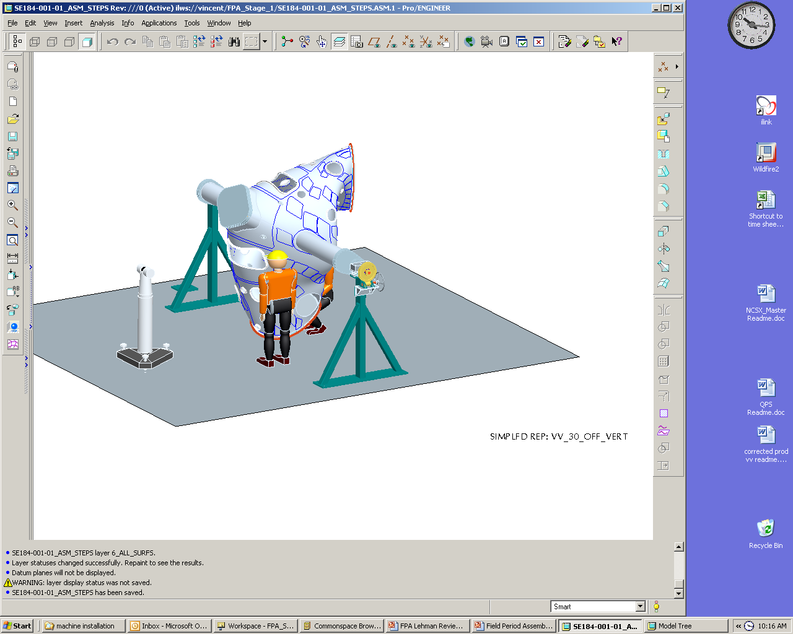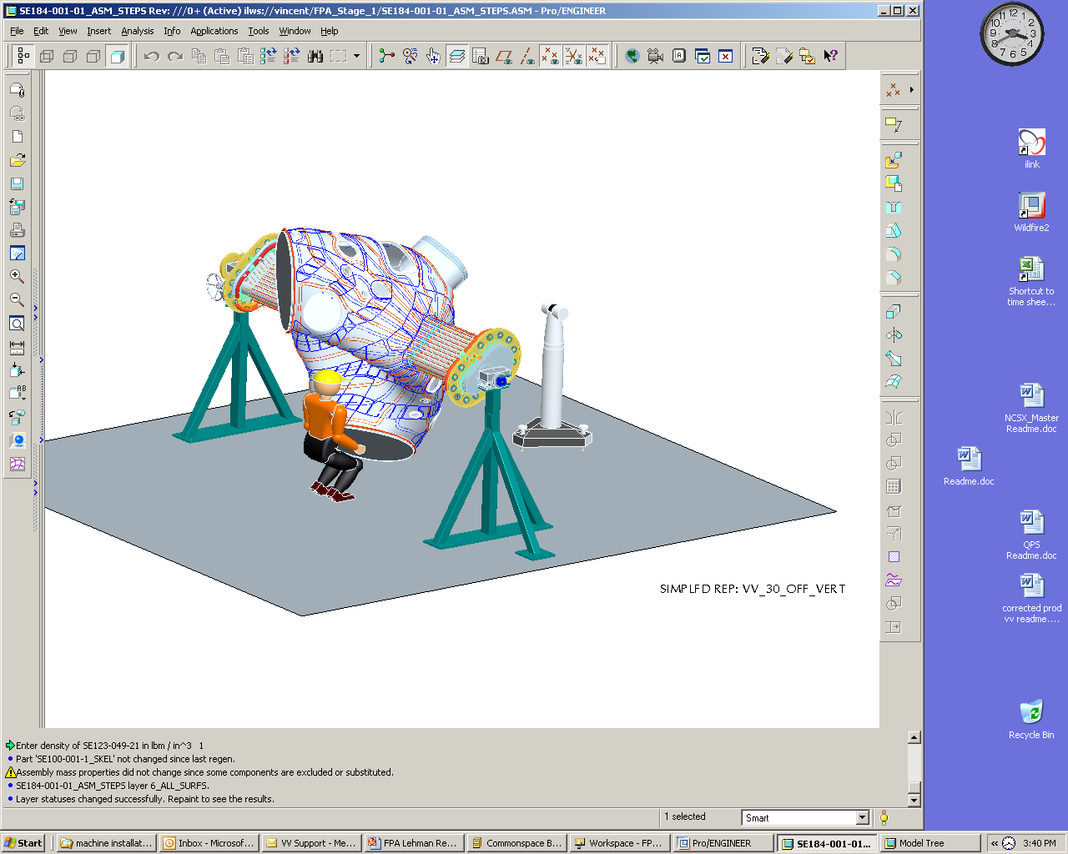

Figure 4-3 Vacuum Vessel Support

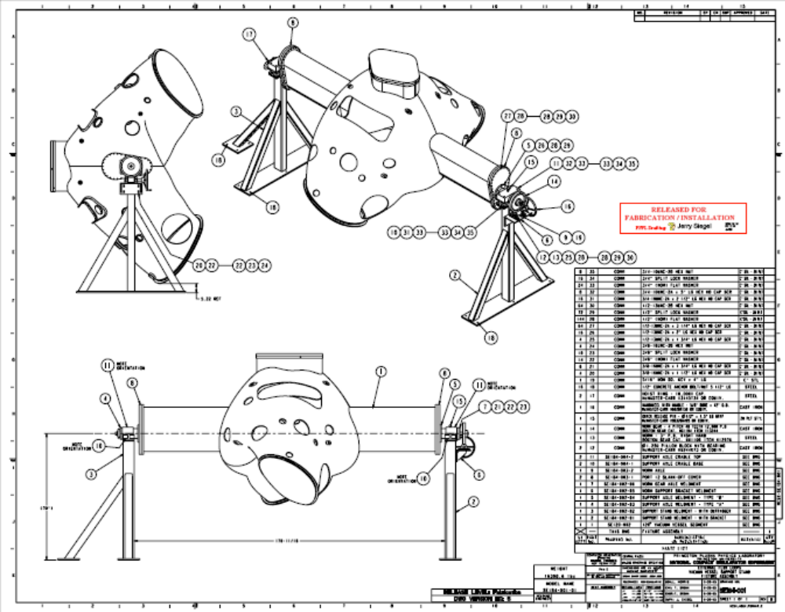
Figure 4-4 Vacuum Vessel Support

Magnetic loops / saddle coils
FPA 1 will have 65 flux loops, FPA 2 - 80 flux loops, and FPA 3 - 67 flux loops. There will also be four toroidal voltage loops mounted on the surface of the vessel, 16 flux loops on one of the three vacuum vessel spool pieces, and two flux loops on each of the other two vacuum vessel spool pieces at the symmetry points. Saddle loops will be installed on all three vacuum vessel Field Periods with varying numbers on each. The technique for installing the flux loops is to place a thin copper template that mimics the size and shape of a particular flux loop over the surface of the vacuum vessel. The template will have a number of edge marks that will be used to match up with pre-inscribed marks placed on the surface of the vessel by the Romer or Leica metrology measurement system. Each copper loop will be pressed down against the vessel to conform to the vessel surface and centered between locating marks with temporary tabs spot welded to the vessel surface to hold the loop in place. Mineral insulated (MI) cable for the sensors will be wrapped around the edge of the template. Leads from the coils will be routed to the vertical ports and terminated in a junction box on the ports. The MI cable will be held in place by wrapping the cable with thin tabs and spot welded to the vessel. Measurements of the coils will be made using a Faro arm or laser tracker and recorded for future information. The flux loops will be located to within +/-4 mm (0.160") of the design locations, except the loops at the symmetry points, which will be located with +/-0.5 mm (0.020").

Cooling / heating trace lines
A total of 64 cooling/heating flexible trace lines made of SS braided hose (1/4” ID x 48” OD) will be attached to the body of each vacuum vessel Field Period with 712 studs located at approximately 5” spacing, shown in Figure 4-5. The braided hoses will be attached to the vessel by stud welding saddle clamps with Grafoil used to improve thermal conductance. The braided hoses from the body are connected to a 5/16” OD SS tubing weir with “J” clamps located on each vertical port and collected in a manifold at the top of each port. Prior to installing the SS tubing on each of the vertical ports ½” heat tape retention foil will be installed.
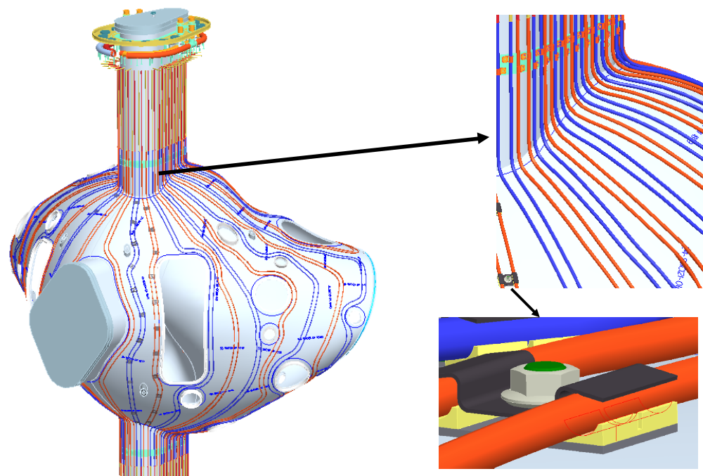

Figure 4-5 Cooling / Heating Line Tracing Installed on Vacuum Vessel

Modular Coil Half Period Assembly (Station 2)
An adjustable support stand, shown in Figure 4-6, is used to support and construct the modular coil half periods, made up from modular coils Type A, B and C. The Type-A modular coil segment will be placed first on the support stand fixture and the stand adjusted to provide a horizontal surface for the Type-B modular coil. Metrology measurements will then be taken to set tree spherical seats (shown in Figure4-7) that are used to initially support the Type-B modular coil. The spherical seat positions on all modular coils are pre-adjusted for every Modular Coil winding based on metrology measurements of the winding and manipulation of a field period assembly CAD model prior to the modular coil half period assembly. Inspection data from each coil will be collected, including the relationship between the winding geometry, flange geometry, and tooling ball monuments. The location of these features relative to the global machine assembly will be calculated based on the optimum position of each coil in the assembly. This information must be processed to determine the best fit of the coils in the final assembly, and to size the shims needed for the next step.

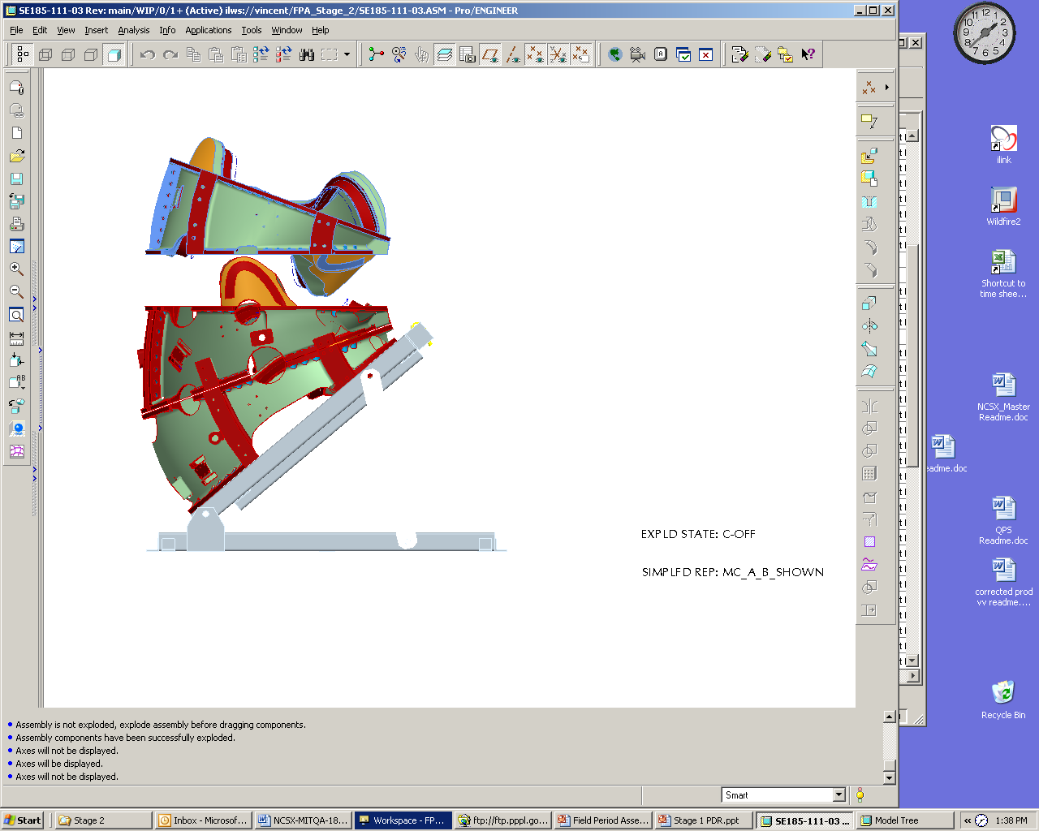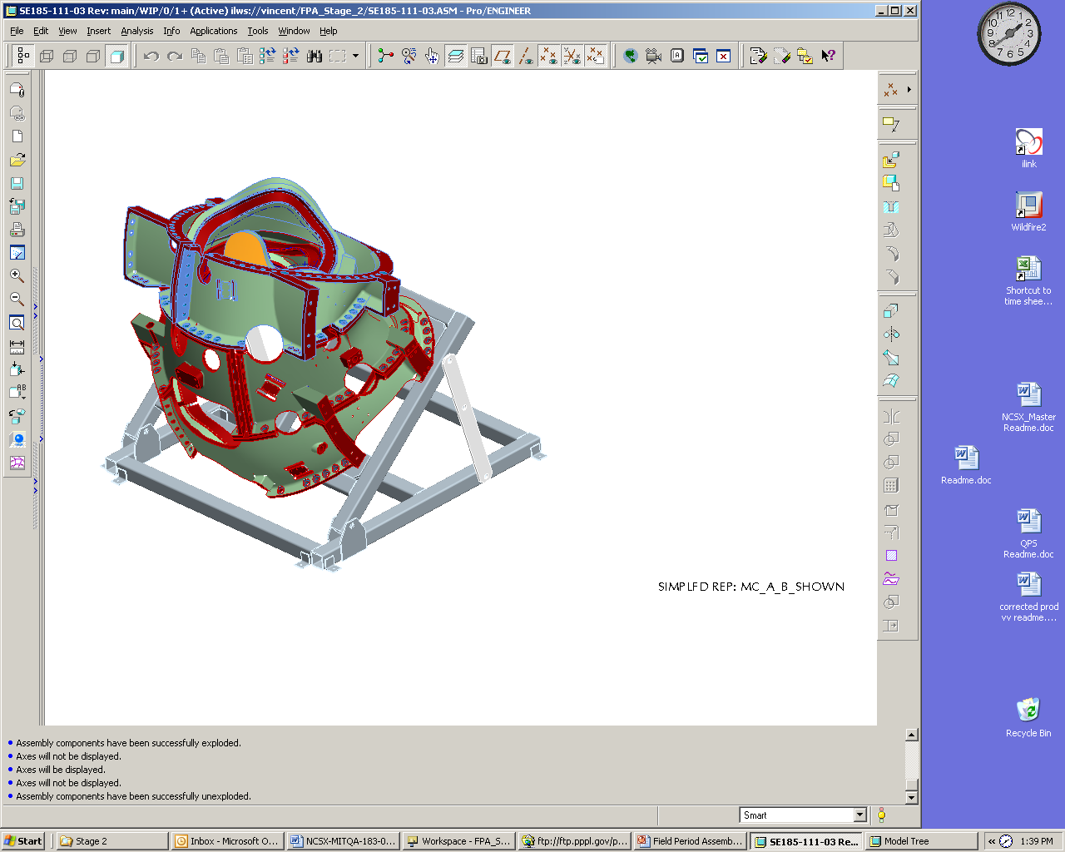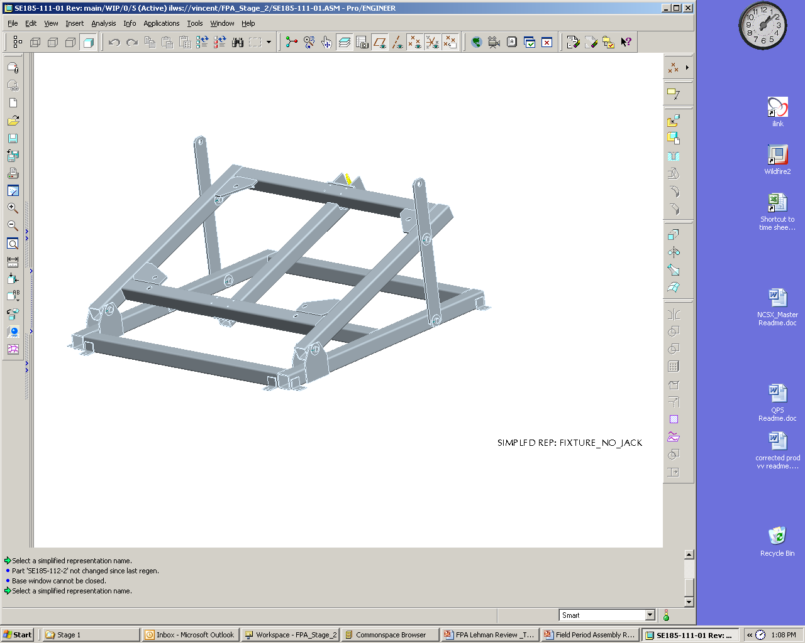
Adjustable support stand
Completed MCHP
Type-C assembly being lowed in place

Figure 4-6 Modular Coil Subassembly with Fixture
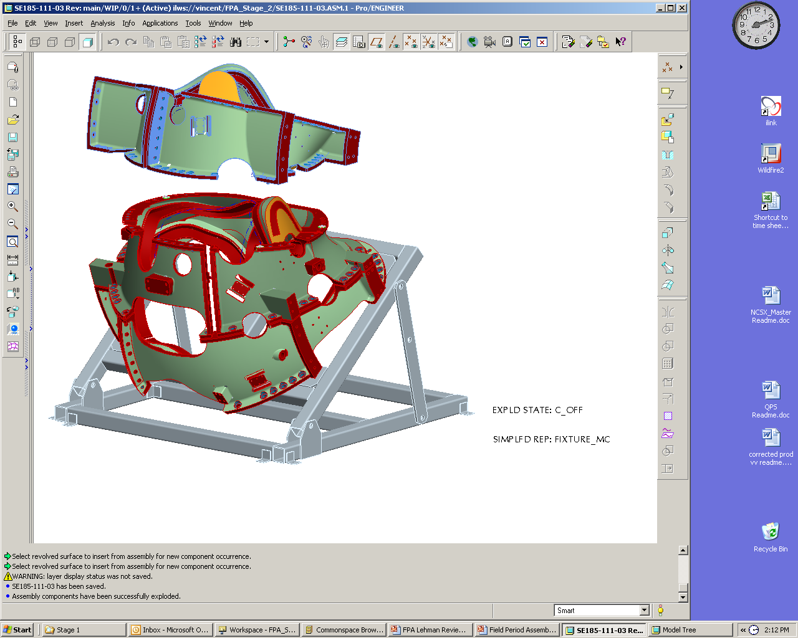
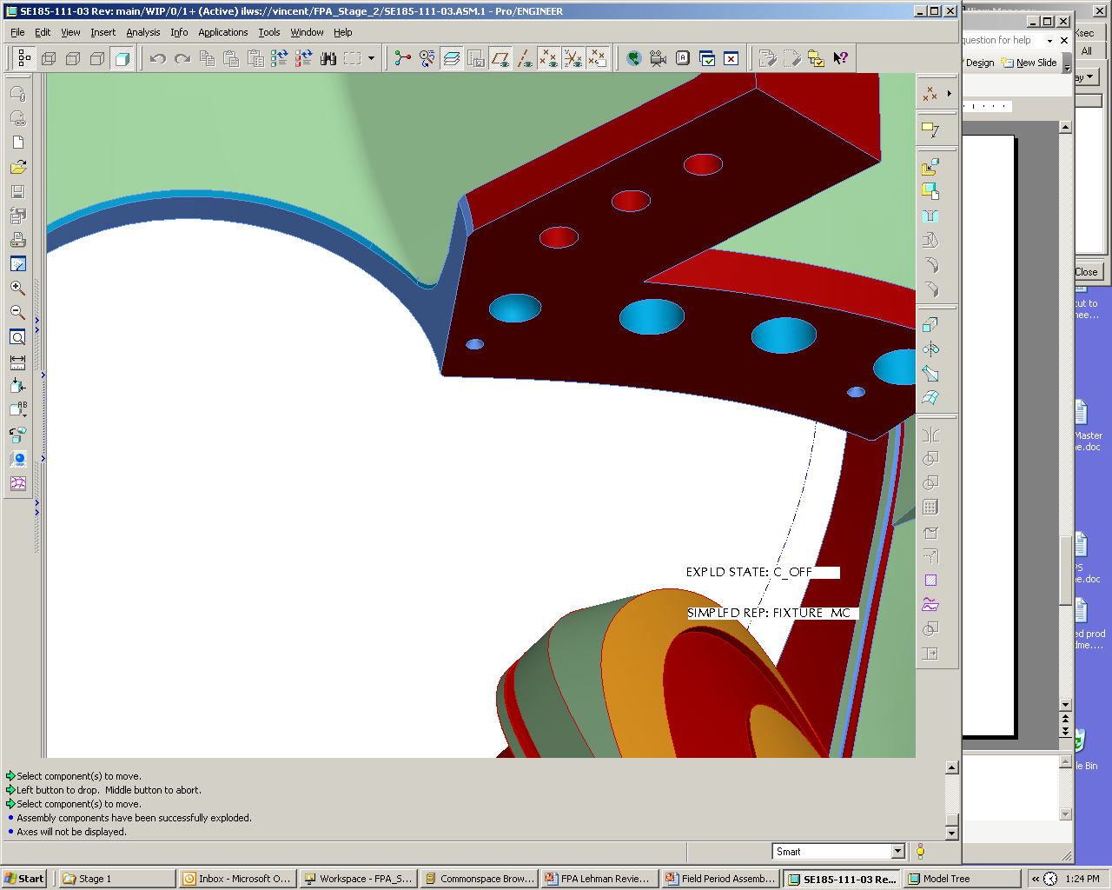
Female side spherical seat.

+.002
-.000
Machine Tol

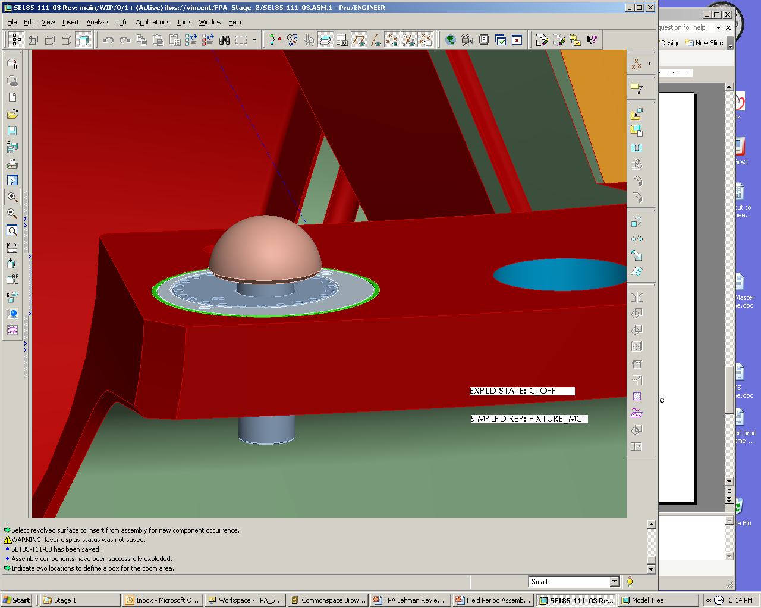
Adjustable male spherical seat

Figure4-7 Spherical Seat Positions

After the Type-B coil is placed metrology measurements will be made to verify that an accurate position was indeed achieved. Shim stock which has been sized, based on dimensional data taken during the fabrication of the A and B coils and output form the CAD assembly model, will be placed between the flanges and checked for its accuracy. Once the part accuracy is assured the Type-B coil will be secured with insulated bolts that will be matched reamed with the flange holes and bolt and nut assemblies torqued to specifications. The Type-C modular coil will be installed using the same procedure and dimensional inspection data will be taken to verify the location of all coils.

After one modular coil half period has been assembled it will be lifted from the support stand and rotated into a vertical position and secured to a second support fixture that will allow the assembly of its interfacing half period using a magnetic alignment method, illustrated in Figure 4-8. Each magnetically aligned module coil will adjusted with six degrees of freedom to allow it to magnetically match its sister coil in the adjacent modular coil half period, that is coil A will match coil A, B will match B and C will magnetically match C.
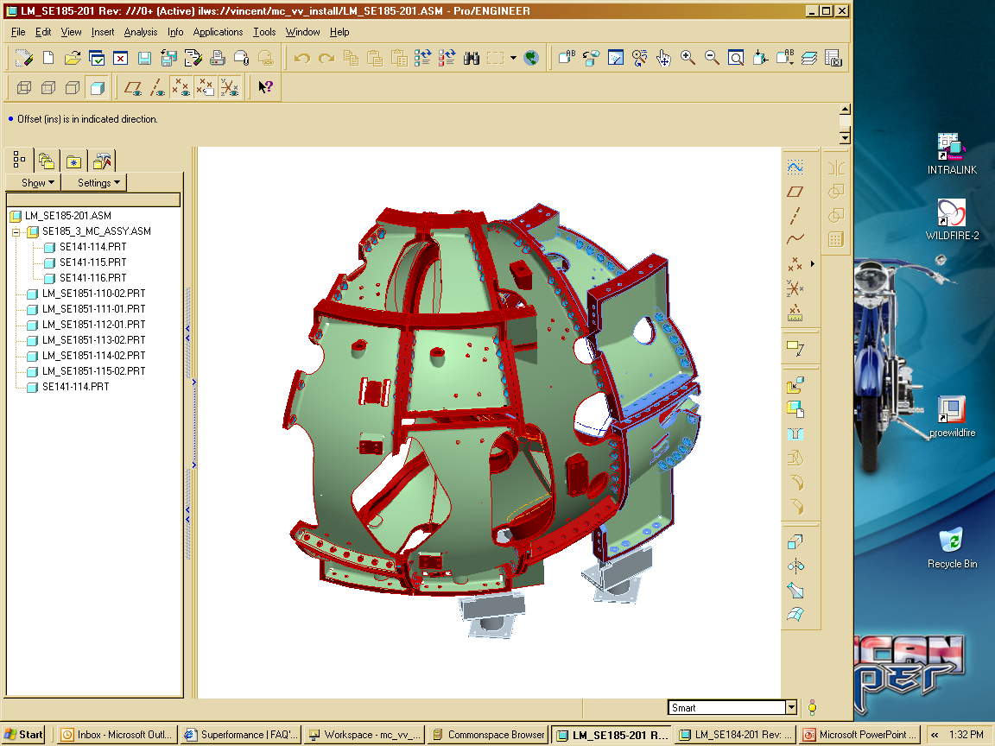
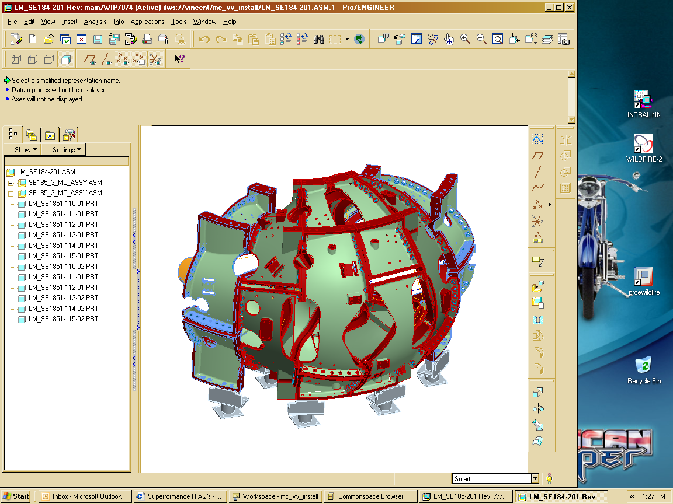
Support Stand Assembled MCHP
Magnetically aligned Type-A module coil
Support Stand Assembled MCHP
Magnetically aligned MCHP
b) Completed magnetic alignment mating MCHP
Type-A Coil

a) Type-A modular coil magnetic alignment

Figure 4-8 Construction of Mating MCHP

In a similar manner to the first modular coil half period the magnetically assembled MCHP will have shim stock placed between flanges and secured with insulated nut and bolt assemblies that are matched reamed with the flange holes. Once completed the two MCHP’s will be separated at the Type-A interfacing flanges and the assemblies stored for used in Station 3.

Install Modular Coil Half Period over VV (Station 3)
This station is comprised of a support that will hold the vacuum vessel vertical and allow the modular coils to be rotated (screwed) onto each end of the VVSA, one at a time. From this point forward, the Assembly will be called the Field Period Assembly. The installation activity of Station 3 involves manipulating two 24,000 lb MCHP’s over a vacuum vessel field period within a prescribed assembly path. The motion of the MCHP will be controlled by using a combination of the D-site crane, three chain-fall supports mounted to the crane hook and hand manipulation for rotation control. To improve on motion control a motor driven mechanical screw system with in-line encoders is being evaluated to replace the chain-fall supports. Three lasers will be mounted on the MCHP and the path traveled by each laser will be plotted on sheets of velum, mounted on screens that are pre-aligned. To evaluate the accuracy of the Crane Supported – hand assisted assembly approach a small demonstration effort was undertaken using a 25,000 lb concrete block with three lasers mounted to it (see Figure 4-9). The simulation was run and the block was manipulated to follow the sequential points with an occasional maximum deviation of about ¾” to 1”, all within our allowed assembly tolerances.
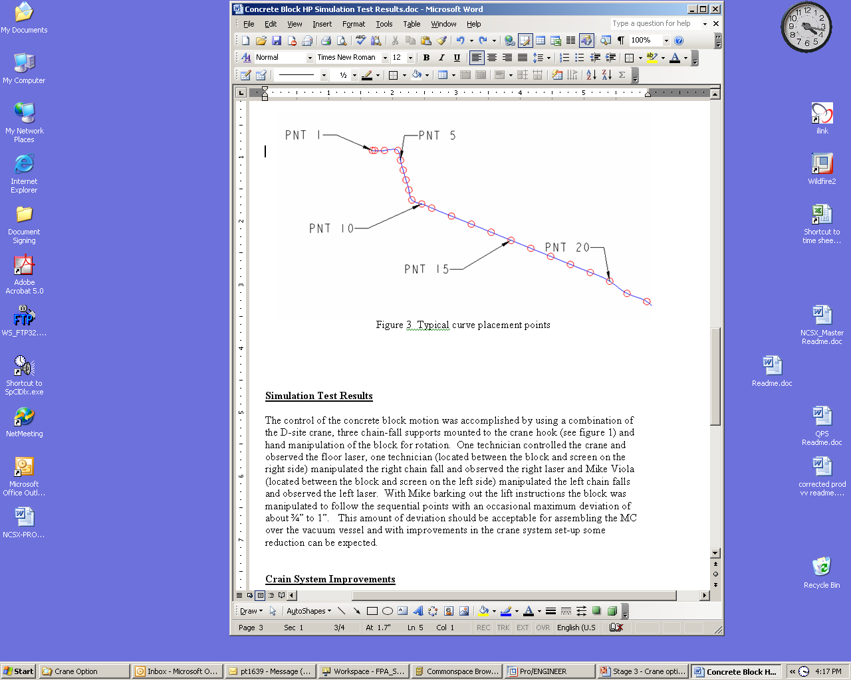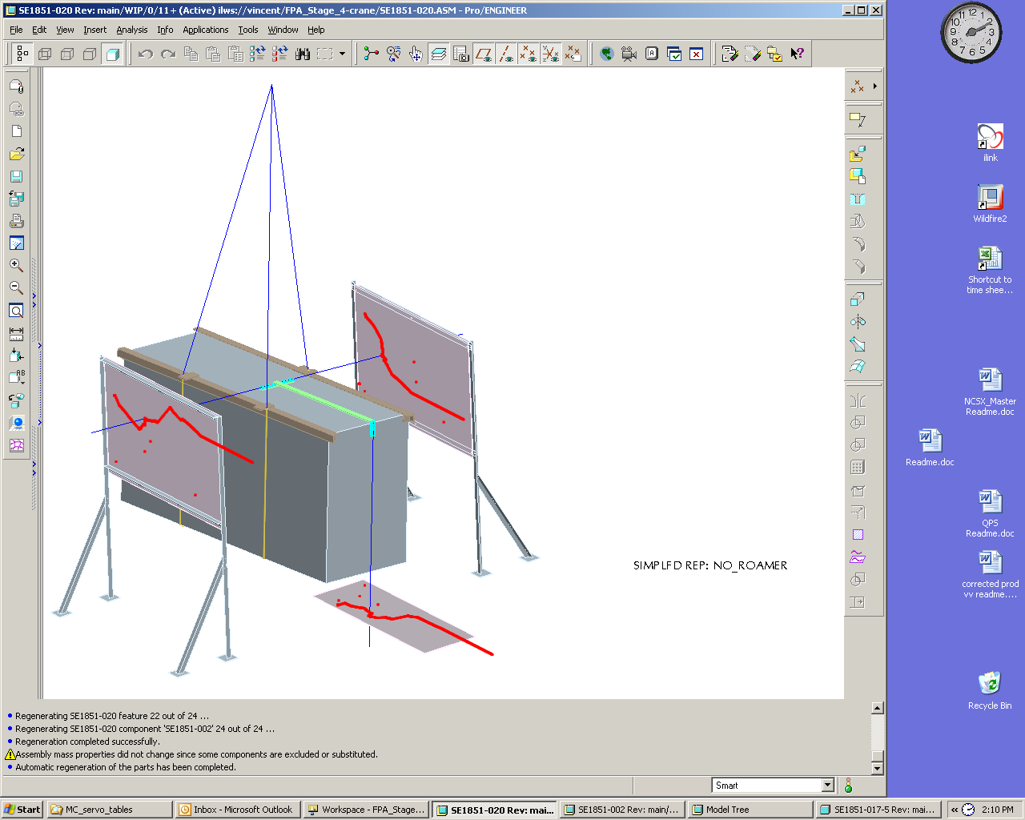
One-quarter inch circles were used to define the required laser positions along the curve path.
Figure 4-9 MCHP Assembly Simulation

The design details of the Station 3 assembly fixtures are in progress but the installation approach can be illustrated in Figure 4-10b. The first step is to set up and properly align the vacuum vessel (Figure 4-10a below). Using the overhead crane and chain-fall supports the left side module coil half period is rotated about the vacuum vessel to within ½”of its final position. While supported from the overhead crane a ground support system is rolled beneath the MCHP, interfacing surfaces are elevated to support the load of the modular coil and the unit is then locked in place. The crane is removed from the left MCHP and then used to rotate the right MCHP over the right side of the vacuum vessel (Figure 4-9b below), also moving it to within ½” of its final position. At this point left side MCHP is moved to its final position using the ground based roller system. The reason for holding the MCHP off their final position is to eliminate the Type-A wing interference that would occur at the end of the MCHP rotation process. Once the left side is set the crane will move the right side into its final position, making any positional alignment adjustments. Once positioned the right side ground support will be rolled beneath the assembly and it will be secured in place. The interfacing Type-A flanges are then shimmed and bolted together. The completed Station 2 installation is shown in Figure 4-10c below.

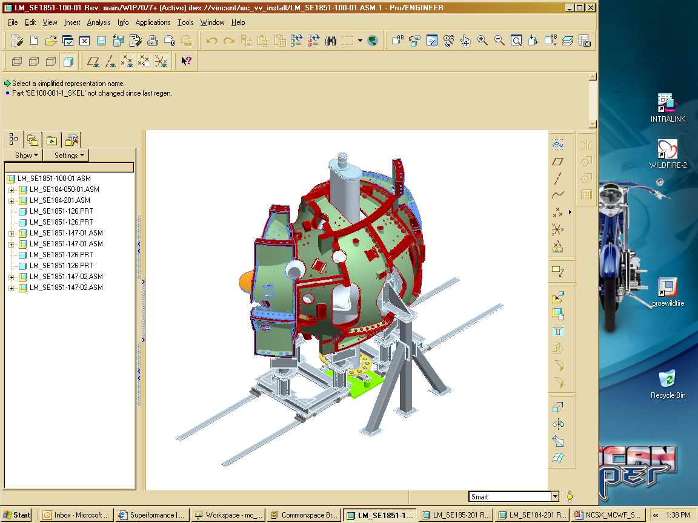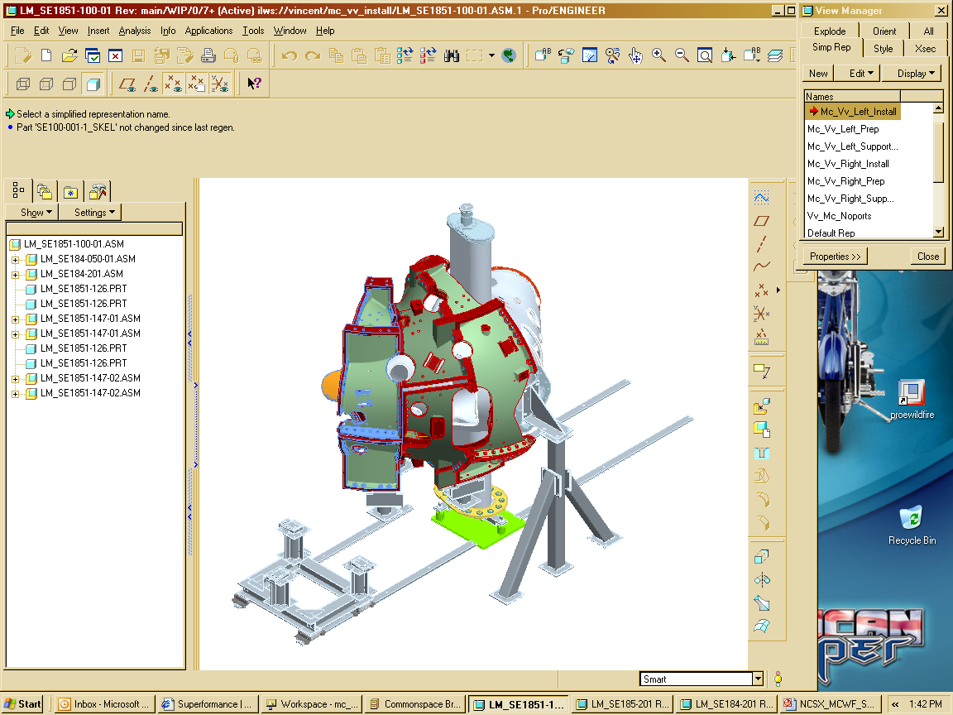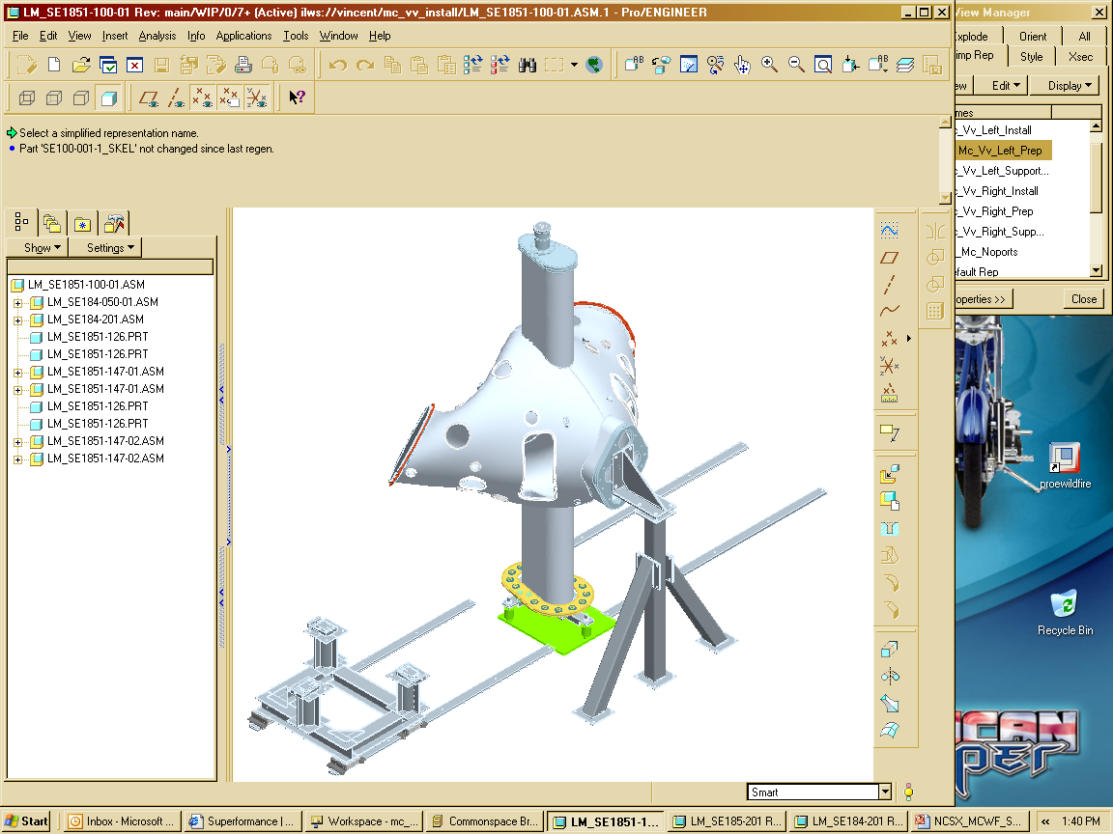
a) VV Set-up
b) MCHP rotated over VV
c) Completed Station 3 Installation
Figure 4-10 MCHP Assembly Simulation

The vacuum vessel support hardware (Figure 4-11) will then be installed between the vacuum vessel and the shell. A clevis subassembly will be fitted thru access ports in the shell and screwed into bosses that are in the vessel. Threaded rods can be inserted into the clevis from the outside of the shell. Belleville washers and a nut will be attached to the threaded rod and tightened against the shell until the vacuum vessel is snug. The vessel will not be fully supported by this hardware until the ports have been installed and welded to the vessel.

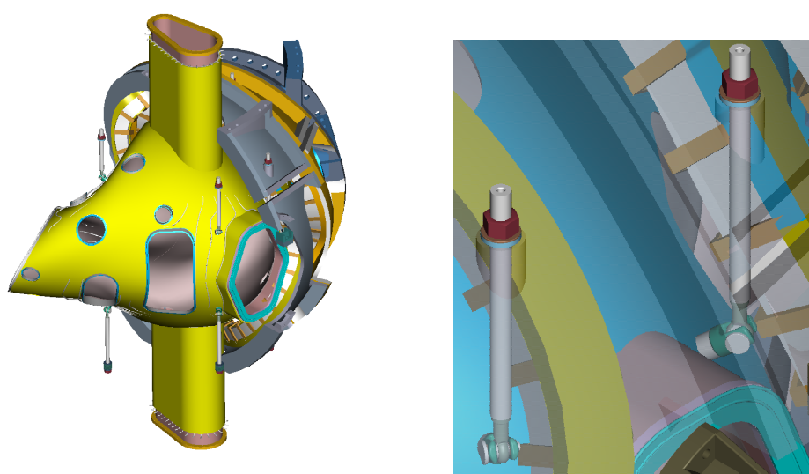
Figure 4-11 Vacuum Vessel Support Hardware

TF Half Period Assembly (Station 4)
Station 4 involves assembling three TF coils and structure into a three coil half periods with the assembly process summarized in the three sub-figures of Figure 4-12. The subassembly consists of 3 TF coils with cast top and bottom support structures. This subassembly step is required prior to assembling the TF coils over the modular coil shell. The TF coils will be positioned slightly offset in the radial direction (~1/4 in) from their final position. This provides clearance during the final machine assembly, when the three Field Periods are installed on the base structure. However to assure that the TF coils will wedge together at final assembly the coils will be matched positioned and adjusted in the wedged position in Station 4 to match an accurately machined fixture. The support structure is made form a number of cast pieces that provide toroidal support but allow the coil windings to slide within the plane of the coils. The TF upper and lower structures are eventually supported form the modular coils so temporary structures are needed for the construction process of the TF half period assembly.
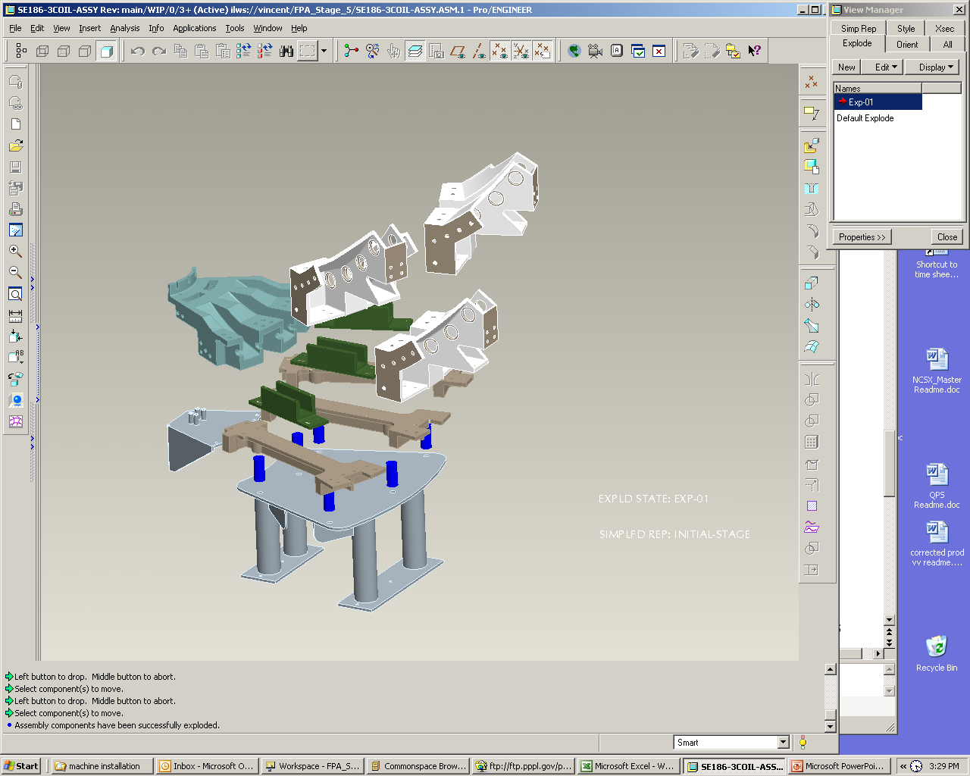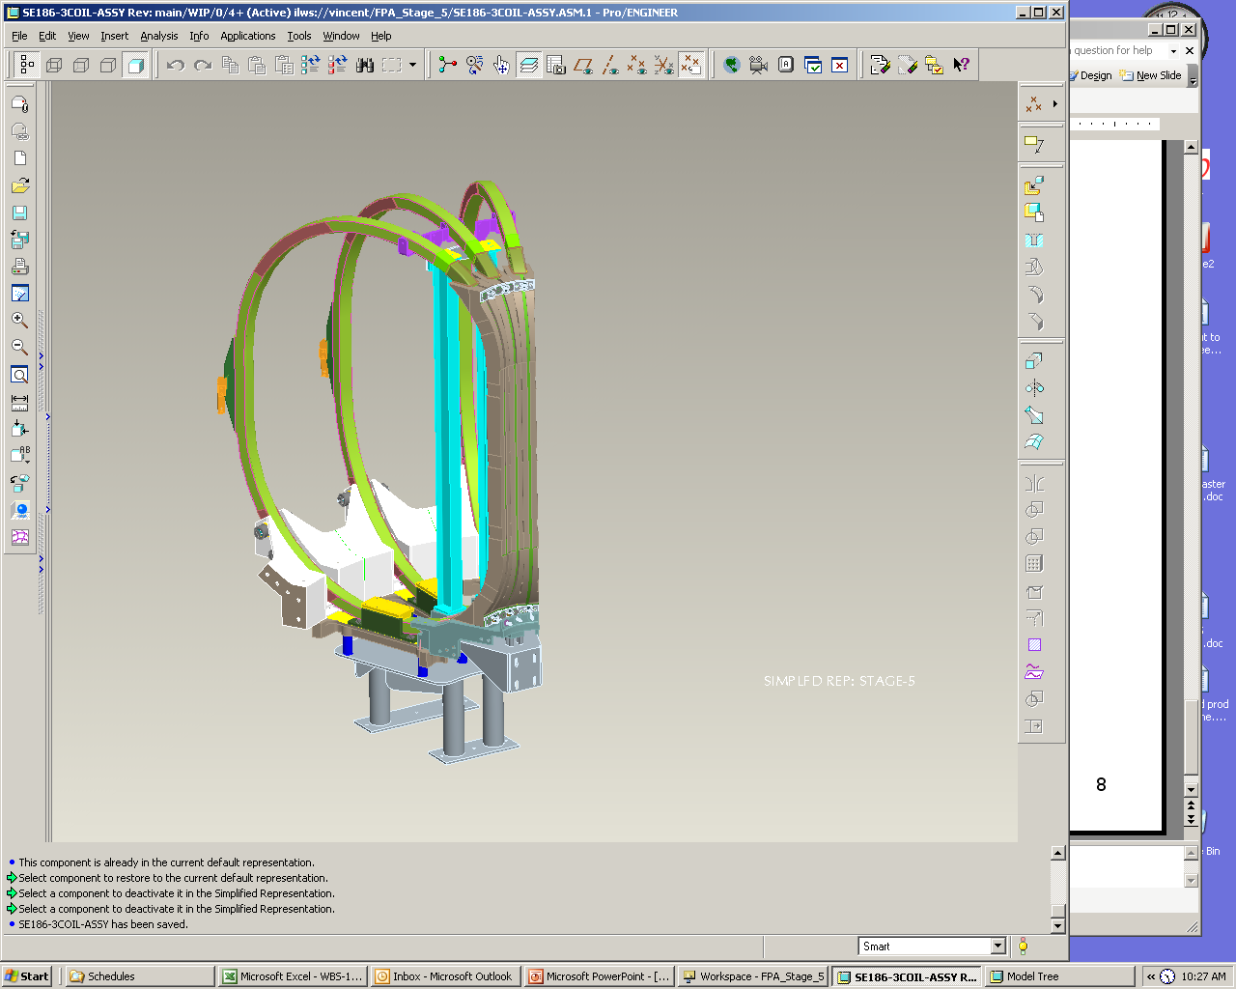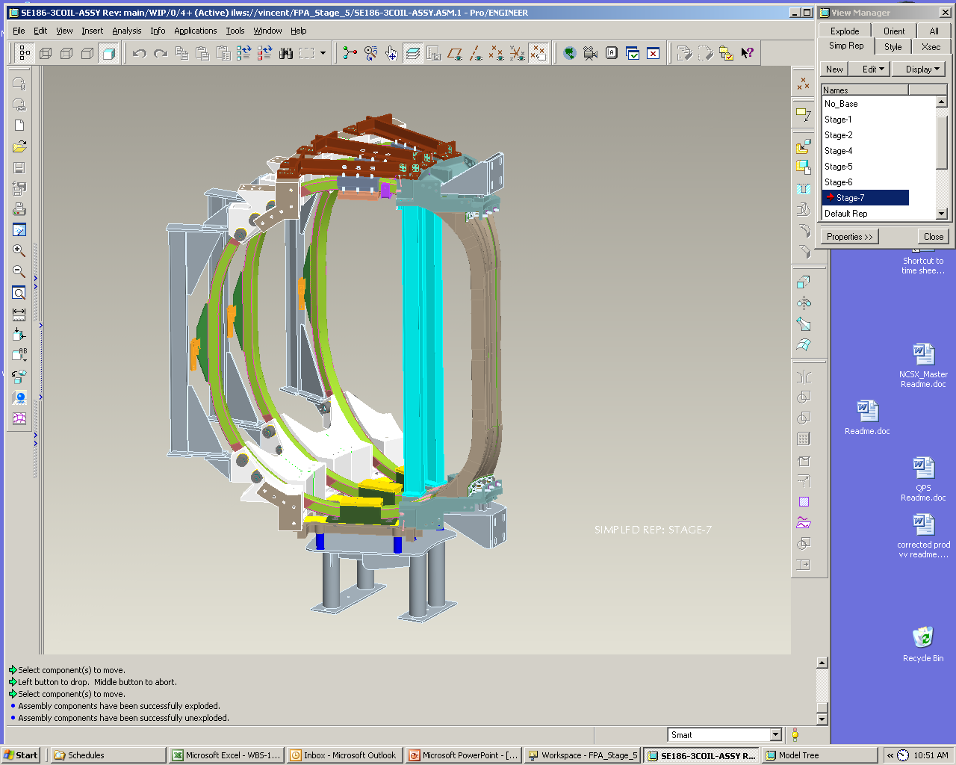
a) TF support structure assembly
b) TF winding installation
c) TF upper structure assembly

Figure 4-12 TF Half Period Assembly

Final Field Period Assembly (Station 5)
Station 5 completes the FPA assembly process bringing together the VV/MCHP assembly, TFHP and attaching VV ports, external trim coils and services. Since the TF coils will be rotated in a circular arc over the VV/MC assembly greater floor space is needed. Because of the space available under the TF coils all vacuum ports, except for the three large horizontal ports, can be welded to the vessel shell prior to rotating the TF half period over the VV/MCHP assembly. After the assembly of the TF coils, the External Trim Coils will be attached to the Field Period Assembly. Some of the External Trim Coils are shown in Figure 4-15. They consist of three upper, three lower, and two outer coils. The upper and lower coils are attached to the frame of the TF coil support structure. The outer trim coil is mounted on the outside of the TF coil. At the machine assembly level an additional outer trim coil will be added between each Field Period Assembly. Before completing the Field Period Assembly, the support hardware that was installed in Station 3 is now tightened until the vessel is barely lifted off the support fixture. The vessel is now free and can move inside the shell assembly. Temporary blocking will be installed between the shell and the vessel during transport from the assembly area to the NCSX test cell. The completed field period assembly is shown in Figure 4-13c. Final metrology measurements will be made to assure that tracked surfaces and fiducials have not changed during the final installation process.
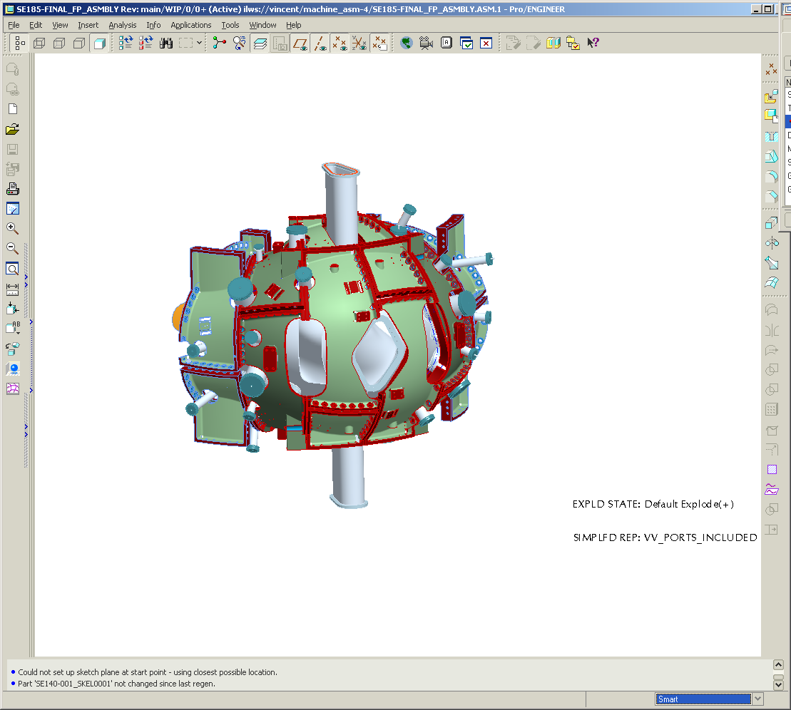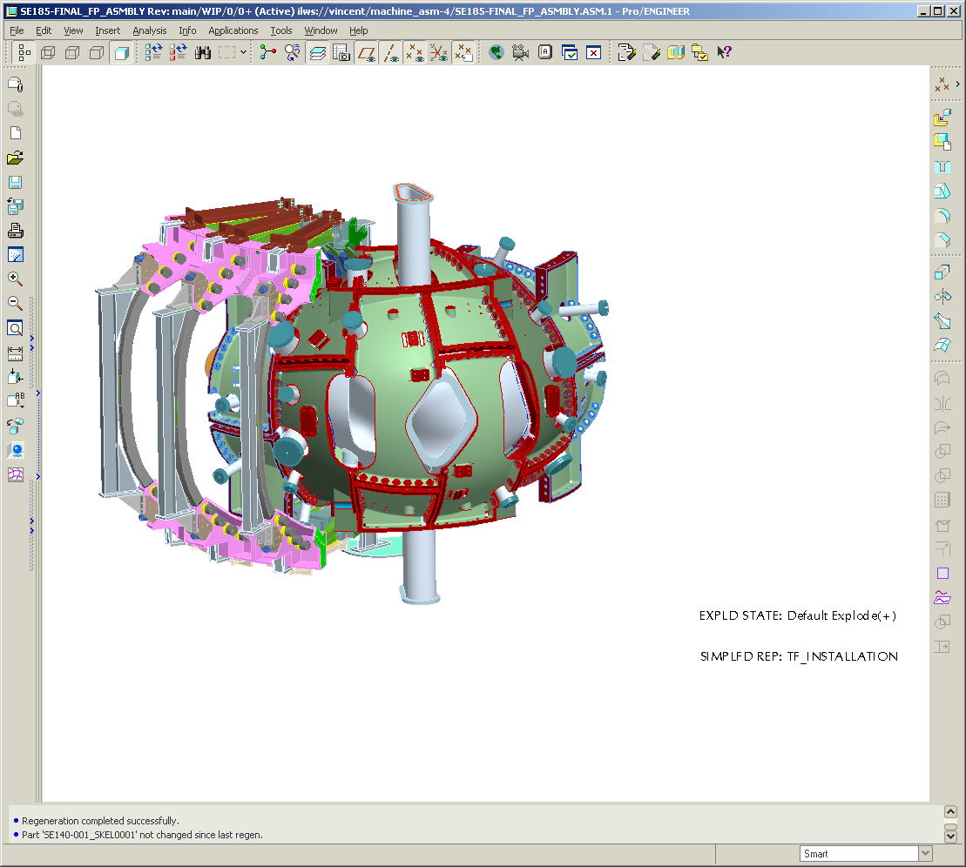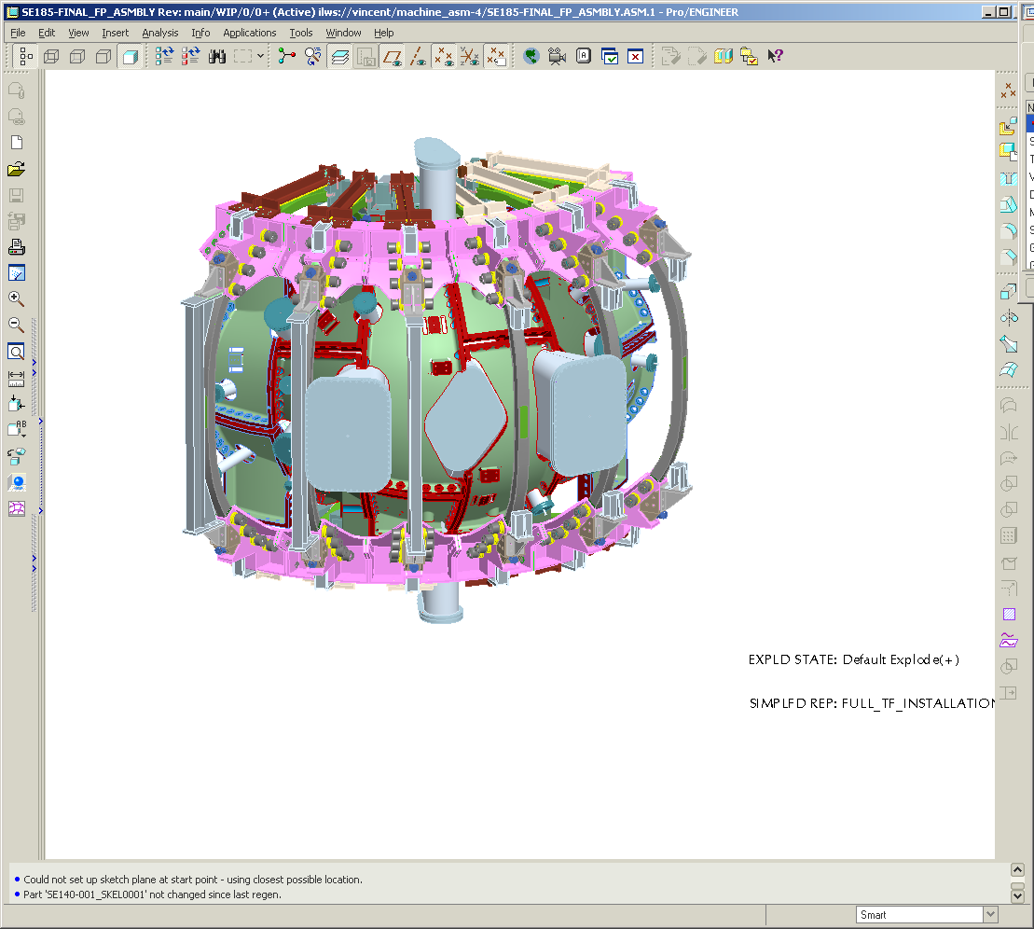
b) TF rotated over MC
a) Ports welded to VV
c) Completed TF assembly
VV Ports
Figure 4-13 Steps for Final Period Assembly

Assembly of the Ports
The vacuum vessel ports are the last major items to be assembled to the Field Period Assembly. Before installing the ports the Field Period Assembly will have the components assembled as shown in Figure 4-13. A typical port configuration is shown in Figure 4-14. A backing ring is shown welded to the port. The backing ring will help position the port over the stub in the vacuum vessel. An assembly fixture will be used to maintain alignment of the ports relative to the global reference frame. All of the ports will be positioned on the vessel and aligned using the alignment fixture. As each port is positioned a tack weld will hold the port stable. After all ports have been assembled each joint will be finished with a full penetration weld. Blank off flanges will be installed on the ports and on the open ends of the vacuum vessel. The vacuum vessel will be baked above the normal bake out temperature (150°C) to 165°C and cycled several times. A vacuum leak test will be performed to verify all the welds are leak tight. In addition to the vacuum leak test, a dimensional verification of the port locations will be performed. All fixtures shall be removed and the inspection shall be made with the ports in a “free condition”.

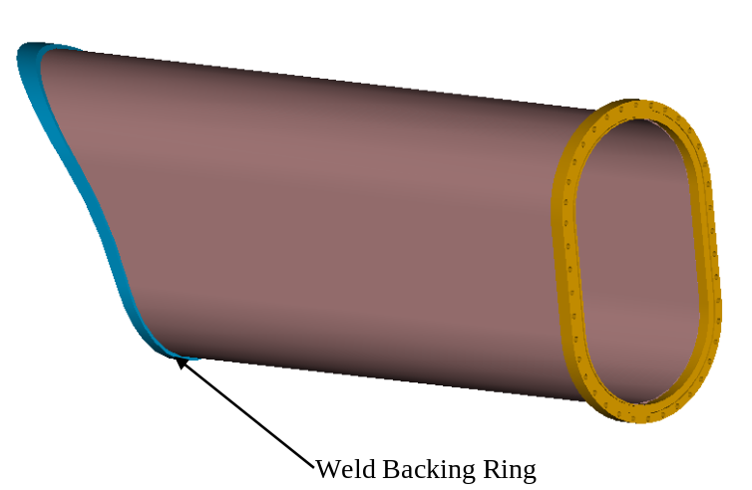
Figure 4-14 Typical Vacuum Vessel Port Extension ready for welding

Assembly of External Trim Coils
After the assembly of the TF coils, the External Trim Coils will be attached to the Field Period Assembly. The External Trim Coils are shown in Figure 4-15. The external trim coils consist of three upper, three lower, and two outer coils. The upper and lower coils are attached to the frame of the TF coil support structure. The outer trim coil is mounted on the outside of the TF coil. At the machine assembly level an additional outer trim coil will be added between each Field Period Assembly. The complete assembly of all the external trim coils is shown in Figure 4-16.

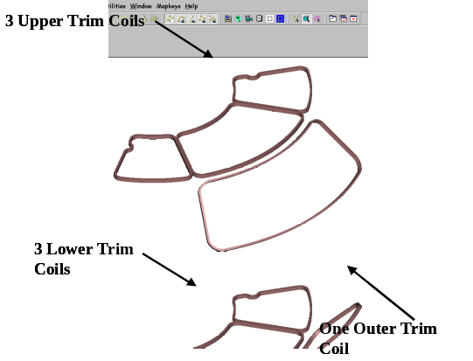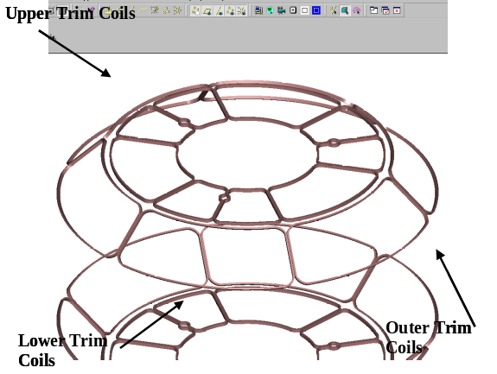
Figure 4-15 External Trim Coils
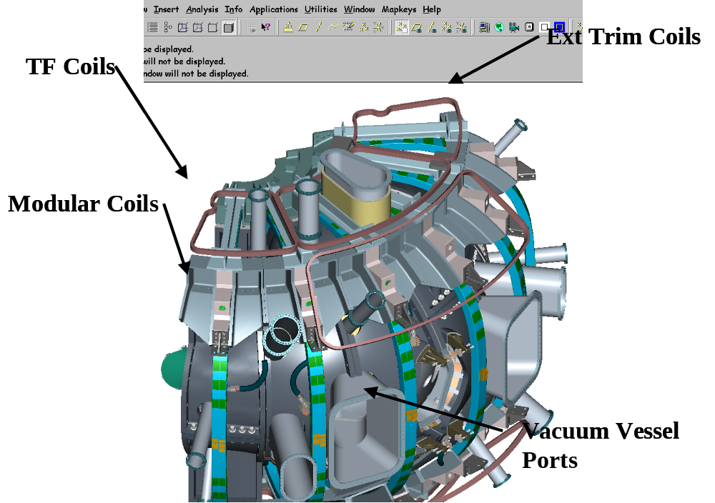
Figure 4-16 Field Period Assemblies with Trim Coils

Vacuum Vessel Final Support Adjustment.
Before completing the Field Period Assembly, the vacuum vessel has to be supported from the shell. The support hardware that was installed after the modular coils is now tightened until the vessel is barely lifted off the support fixture. The vessel is now free and can move inside the shell assembly. Temporary blocking will be installed between the shell and the vessel during transport from the assembly area to the NCSX test cell. The completed field period assembly is shown in Error: Reference source not found.

Field Period Transportation to NCSX Test Cell
When a Field Period Assembly is completed it will be lifted from the fixture in the assembly area and set on a truck for shipment as shown in Figure 4-17. The Field Period Assembly will be driven a short distance on site to the NCSX test cell. A summary of the field period component weights is shown in Table 4-1.
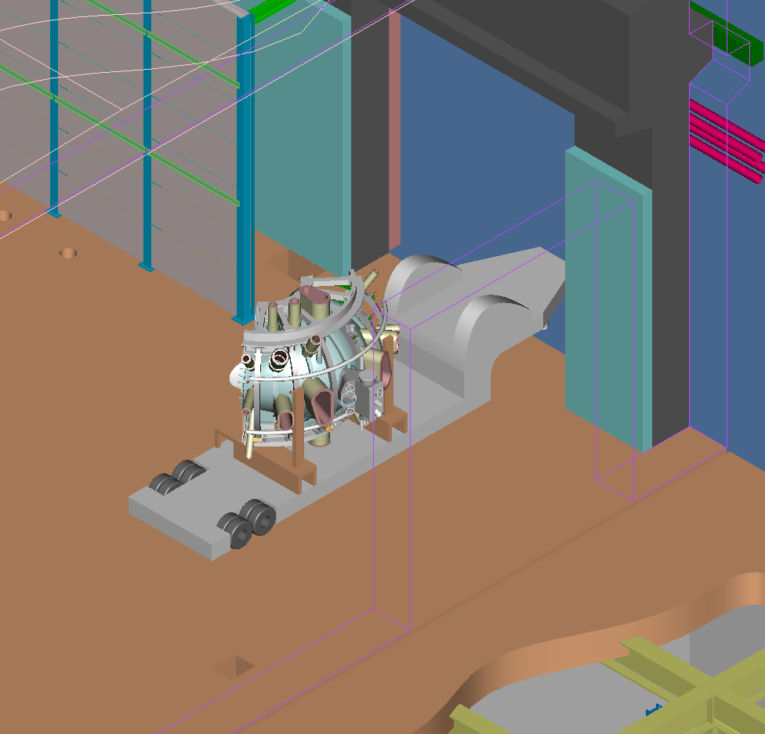
Figure 4-17 TFTR Loading Station

Description | Weight
Vacuum Vessel | 7,200 lbs
Modular Coils (6) | 45,600 lbs
TF Coils (6) | 26,200 lbs
Field Period Assembly | 79,400 lbs

Table 4-1 Field Period Component Weights

Documentation Requirements

Document Control
All NCSX associated documents providing instruction for assembling the field period assembly (e.g. plans and procedures) will be maintained under NCSX Project document control. Bob Simmonds to provide reference or further guidance

Field Assembly Station Field Packages
Each field period assembly station shall have a “Station Field Package” that shall be maintained by the field period assembly team. This package shall include all process procedures, inspection reports, photographs, test results, and measurements used to document completion of major activities associated with the activities in each station to assembly the filed period assembly. It shall also include ECNs, non-conformance reports (NCR), or other exceptions to or changes in requirements. All documents shall be complete, legible and validated by responsible personnel.

Assembly/Installation Procedures
Field Period Procedures shall include:
- The critical steps and criteria established by the sequence plan.
- Reference the specification applicable to the procedure
- The list of drawings applicable to the procedure
- Procedure sign-offs for critical steps in the procedure
- The verification list of criteria to determine the successful completion of the procedure.

Assembly/Installation Procedure Sign-Off’s
Assembly/Installation procedures will be used as a signoff/approval document noting that critical manufacturing steps have been completed. Authorized personnel associated with the manufacturing, inspection and test processes will perform the signoff’s. In addition, it will provide witness points as well as reference for test results, and measurements.

Procedure Completion
The Lead Technician or Field Supervisor will document all critical completions on the procedure. This will be completed using the signer’s initials or full signature.
The procedures will be filled out in a timely fashion once a particular activity has been completed.

Authorized Signoff’s for Manufacturing Completions
The manufacturing procedures will identify what level of signoff is required for a particular step. The following disciplines are the authorized signatures for the in-process procedures.
- Station Lead Technicians
- Field Supervisors
- Dimensional Control Representative
- Quality Control Representative
- Manufacturing Facility Manager
The Lead Tech and Field Supervisor are signing that the procedural aspects of the assembly stage are completed. The FPA Manager is signing that the Documentation package is complete and ready for verification. The QA representative is signing that he has reviewed the documentation package, verified that it is complete and verified that all steps and test have been documented to be complete.

Final Document Storage
All documents (hard copy) associated with the manufacturing will be stored in the PPPL Operations center, electronic documents will be stored on the NCSX Web site for the lifetime of the NCSX MIE Project, after which the files will be turned over to the Operations Center.

Quality assurance/quality control requirements
General quality requirements for all work performed for NCSX are specified in the NCSX Q Plan, NCSX-PLAN_QAP. Additional specific quality requirements are:

Inspection/Surveillance and Audit:
Field Supervisors; lead technician and Quality Control (QC) representatives will perform FPA inspection and surveillances as required by FPA procedures.
Independent Audits may be performed by the Quality Assurance Division to ensure that approved manufacturing processes and quality of product is being observed.

Inspection and Test Procedures:
Inspections, measurement and tests will be performed by the field crews and engineering. Where required by procedure, a QC representative shall be present during inspections, measurements, or tests.
Inspection and tests shall be performed:
- In accordance with written/approved procedures referencing criteria for acceptance or rejection.
- Using properly calibrated measuring and test equipment in accordance with PPPL procedure ENG-002 “Control of Measurement Test Equipment & Calibration.
Adequate records to reproduce the inspection shall be maintained and available for NCSX Project review.

Equipment/Material Identification and Status
Material and equipment identification shall be maintained throughout the program and be traceable to the records. Status of acceptability shall be readily discernible through the use of tags, stamps, travelers, serial numbers or other positive means.

Non-conformance & Corrective Actions:
Nonconforming items shall be positively identified and, where possible, segregated to prevent use. The Manufacturing Team shall document each non-conformance in accordance with PPPL procedure QA-005 “Control of Non-Conformances”.

Release for Station Transfer:
Prior to releasing a VVSA or FPA from one station to the next, the Station Lead Technician, Field Supervisor, FPA Manager and the QC representative will review and approve the release on the procedure for that station indicating that all processes at the station have been satisfactorily completed.

Process History:
The FPA team shall provide a Process History for the VVSA or FPA that includes a compilation of documents, detailing the objective evidence of the acceptability of the work performed. Process History shall be stored in the Operation Center after assembly is completed. The Process History shall include as a minimum, but not be limited to the following:

6.6.1 Material Certifications:
The FPA Team shall compile inspection reports, test data, and/or certifications from vendors, showing relevant chemical, mechanical and electrical properties of materials used, where applicable, as detailed in applicable procedures, as well as documents showing adherence to in-process requirements. Material certifications from sub-tier suppliers shall also be submitted.

Completed Procedures:
Original or copies of filled in and completed process planning and control documents (procedures, etc.), which verify controlled execution of the required work. Each FPA will have its own set of process planning and control documents.

Inspection Reports:
Copies of the original reports from all required inspections and examinations, that are properly validated by authorized personnel.

Test Reports:
Copies of the original test data sheets or reports of all required tests, both in-process and acceptance, that are properly validated by authorized personnel.

