NCSX

Field Period Assembly (FPA) Manufacturing/Assembly, Inspection, Test and Quality Assurance Plan
NCSX-MIT/QA-185-01-02
November 14, 2007

Author: ________________________________________________________________
Mike Viola - Field Period Assembly (FPA) Facility Manager

Reviewed by:

Tom Brown Judy Malsbury
Design Integration Manager r NCSX QA Representative

Jerry Levine Bob Ellis
PPPL Safety Representative Dimensional Control Coordinator

Steve Raftopoulos John Edwards
Lead Metrology Engineer FPA Field Supervisor

Phil Heitzenroeder
Stellarator Core Design RLM

Approved By: ___________________________________________________________
Larry Dudek
RLM for the NCSX Manufacturing Facility
Controlled Document
THIS IS AN UNCONTROLLED DOCUMENT ONCE PRINTED.
Check the NCSX Engineering Web prior to use to assure that Final Prep for Transport
  - Perform Final Measurements
  - Install transportation supports
  - Load on truck
  - Locate cooling tubes
  - Install tube clamp studs
  - Perform measurements
  - nsion

document is current.
Record of Revisions

Revision | Date | Description of Change
0 | 4/28/2006 | Initial Issue.
1 | 11/14/2007 | Updated Sections 4.1, 4.2.2, 4.2.4, and 4.2.5 to reflect Sequence Plan 9.4. Added new Section 6.3 to address Metrology Systems.
2

Table of Contents
1 Introduction and Scope 1
1.1 Introduction 1
1.2 Scope 1
2 Applicable Documents 1
2.1 NCSX Project Documents for FPA 2
2.2 Field Period Assembly Manufacturing Procedures 2
2.3 Drawings 2
3 Training Requirements 2
3.1 General Training Requirements 2
3.2 Specialized Training Requirements 3
3.3 Training Matrix 3
4 Field Period Assembly Processes 3
4.1 Overall Field Period Assembly Process Outline 3
4.2 Summary of Field Period Assembly Stations and Procedures 5
4.2.1 VVSA Preparation (Station 1) 5
4.2.1.1 Magnetic Loops / Saddle Coils 6
4.2.1.2 Cooling /Heating Trace Lines 7
4.2.2 Modular Coil Half Period Assembly (Station 2) 7
4.2.2.1 Overview of Station 2 Activities 7
4.2.2.2 Monuments and Alignments 12
4.2.2.3 Verification of Type B Position 13
4.2.2.4 Rotation of MCHP to Vertical Position 13
4.2.3 Install Modular Coil Half Period over VV (Station 3) 14
4.2.3.1 Station 3 Installation Approach 15
4.2.3.2 Installation of Vacuum Vessel Support Hardware 16
4.2.3.3 Completion of MCHP Assembly and Transfer to NCSX Test Cell 17
4.2.4 TF Half Period Assembly (Station 4) 17
4.2.5 Final Field Period Assembly (Station 5) 17
4.2.5.1 Component Preparations and Set-Up 17
4.2.5.2 Assembly of the Ports 18
4.2.5.3 Assembly of External Trim Coils 20
4.2.5.4 Modular Coil Lead and Coolant Connections 21
4.2.5.5 TF Coil Installation 21
4.2.5.6 Installation of Porft 4, PF Structural Members, and Routing of MC Services and Diagnostics 24
4.2.5.7 Final Measurements and Transfer to Station 6 25
5 Documentation Requirements 25
5.1 Document Control 25
5.2 Field Assembly Station Field Packages 25
5.3 Assembly/Installation Procedures 26
5.4 Assembly/Installation Procedure Sign-Off’s 26
5.5 Procedure Completion 26
5.6 Authorized Signoff’s for Manufacturing Completions 26
5.7 Final Document Storage 27
6 Quality assurance/quality control requirements 27
6.1 Inspection/Surveillance and Audit: 27
6.2 Inspection and Test Procedures: 27
6.3 Metrology Systems 27
6.4 Equipment/Material Identification and Status 28
6.5 Non-conformance & Corrective Actions: 28
6.6 Release for Station Transfer: 28
6.7 Process History: 28
6.6.1 Material Certifications: 28
6.7.2 Completed Procedures: 28
6.7.3 Inspection Reports: 28
6.7.4 Test Reports: 29

List of Figures
Figure 4-1 Field Period Assembly Process Outline 4
Figure 4-2 Vacuum Vessel Support 5
Figure 4-3 Vacuum Vessel Support 6
Figure 4-4 Cooling / Heating Line Tracing Installed on Vacuum Vessel 7
Figure 4-5 Modular Coil Subassembly with Fixture 8
Figure 4-6 Typical coil to Coil Setup 8
Figure 4-7 MCHP Component Winding Forms 9
Figure 4-8 MC Arrangement for the Full Machine Assembly 10
Figure 4-9 Construction of Mating MCHP 14
Figure 4-10 MCHP Assembly Simulation 15
Figure 4-11 MCHP Assembly Simulation 16
Figure 4-12 Vacuum Vessel Support Hardware 17
Figure 4-13 FPA Component Weights 17
Figure 4-14 Pre-Installation Set-Up 18
Figure 4-15 Typical Vacuum Vessel Port Extension ready for welding 19
Figure 4-16 VV Port Installation 19
Figure 4-17 Boot Seal Assemblies 20
Figure 4-18 Typical Circular Port Boot Assembly 20
Figure 4-19 External Trim Coils 21
Figure 4-20 TF Coil Support Scheme 22
Figure 4-21 Initial TF Coil Support Scheme 23
Figure 4-22 Additional TF Support Details 23
Figure 4-23 PF Structure Installation 24
Figure 4-24 Routing of Coolant Lines, Leads, and Diagnostics 25
List of Tables
Table 4-1 Field Period Component Weights 17

Introduction and Scope

Introduction
The National Compact Stellarator Experiment (NCSX) will be assembled and built at Princeton Plasma Physics Laboratory. The stellarator core will be preassembled into three 120° field period assemblies in the TFTR Test Cell. There will be five (5) stations to accomplish this task. Once completed, the Field Period Assemblies (FPA) will be moved into the NCSX test cell.

Scope
This document addresses the manufacturing, inspection, test and Quality Assurance (QA) plan to complete and deliver three (3) Field Period Assemblies for the NCSX Project to the NCSX test cell.

Applicable Documents
Four plans have been prepared to date which cover the Field Period Assembly (FPA) activities. These are the NCSX Manufacturing Facility Operations Plan (NCSX-PLAN-MFOP-01), the Field Period Assembly Sequence Plan (NCSX-PLAN-SEQ-FPA1), the NCSX Field Period Assembly Station 1 Dimensional Control Plan (NCSX-PLAN-FPA1DC-00), and this document, the NCSX Field Period Assembly Manufacturing, Inspection, Test, and Quality Assurance Plan (NCSX-PLAN-MIT/QA-185-01). Additional dimensional control plans will be prepared for other FPA stations to facilitate procedure development appropriate for meeting our dimensional control objectives. The dimensional control plans are not intended to be used directly in field activities. The Manufacturing Facility Operations Plan describes how the activities within the NCSX Manufacturing Facility will meet PPPL Integrated Safety Management (ISM) requirements specified in laboratory policies, programs, and procedures. It also provides an overview of the general processes that occur in the facility, including general facility operating guidelines, safety controls, and reviews. The Field Period Assembly Sequence Plan provides guidance to convey the designer’s intentions as to how the Field Period Assembly is to be performed. Field period assembly procedures will be developed from the sequence plan, in combination with this MIT/QA plan, which explains how to perform the tasks at each of the 5 assembly stations. The Field Period Assembly sequence plan should be used only to facilitate the development of the MIT/QA Plan and supporting procedures. It is not intended to be used directly in field activities. This document specifically addresses FPA activities, providing:
- A description of the field period assembly sequence including a process outline;
- A description of each station including tooling and fixtures;
- A listing of specifications (which identify applicable drawings and models, define requirements, and verifications) for each station; and
- A listing of procedures for each station.
Identified below are the primary documents that that will be needed to complete the FPA.

NCSX Project Documents for FPA
Document No. | Title
NCSX-CSPEC-141-03 | VVSA Specification
NEPA No. 1261 | Construction and operation of NCSX
WP-1224 | Field Period Assembly work Plan
NCSX-PLAN-MFOP-01 | NCSX Manufacturing Facility Operations Plan
NCSX-PLAN-FPA1DC-00 | NCSX Field Period Assembly Station 1 Dimensional Control Plan
NCSX-PLAN-SEQ-FPA1 | Assembly Sequence Plan
NCSX-PLAN-QAP | NCSX QA Plan

Field Period Assembly Manufacturing Procedures
Document No. | Title
D-NCSX- FPA -QA1 | Material receipt and verification
D-NCSX- FPA -001 | FPA Assembly – Install diagnostic loops, cooling tubes, and I&C
D-NCSX- FPA -002 | FPA Assembly – Assembly and align modular coils
D-NCSX- FPA -003 | FPA Assembly – Install MC Assemblies
D-NCSX- FPA -004 | FPA Assembly – Assemble and align TF coils
D-NCSX- FPA -005 | FPA Assembly – Install TF Assemblies
D-NCSX- FPA -006 | FPA Assembly – Install port extensions and trim coils.  Final verification and prep for transport to NCSX test cell

Drawings
Drawings for each field period assembly and station will be provided by the NCSX project. Only signed and “Approved for Fabrication” stamped drawings may be used. A complete list of filed period drawings are listed in the field period assembly specification. Procedures will identify applicable drawings.

Training Requirements
Training of personnel working on the FPA is critical to successfully completing the assembly of the FPA. There are two categories of training requirements, general and specialized. A Training Matrix has been provided for FPA personnel.

General Training Requirements
General training includes all laboratory-training requirements that are required to enter or work in the Manufacturing Facility. Examples of this training include:
- General Employee Training [GET]
- Integrated Safety Management [ISM]
- Radiation Safety Training

Specialized Training Requirements
Specialized training includes specific training or certification required to complete tasks during the assembly of the FPA. Examples include:
- Crane operations and rigging
- Weld and braze certifications
- Confined space
- NCSX Manufacturing Facility Operations Plan [MFOP]
In addition, training will be provided for all Job Hazard Analyses and procedures that apply to Field Period Assembly activities.

Training Matrix
A training matrix which establishes training and qualification requirements for technicians working on FPA activities is posted on the NCSX Engineering Web. A link to the training matrix is provided on the Training page at
http://ncsx.pppl.gov/SystemsEngineering/Training/NCSX_Training_index.htm
The training matrix also identifies training and qualification requirements for riggers and crane operators, field supervisors, and quality control representatives. Training and qualification records for personnel working on FPA activities are maintained by PPPL Human Resources.

Field Period Assembly Processes

Overall Field Period Assembly Process Outline
This section outlines the processes that are to be performed and procedures required to complete field period assembly. Station 1 (VVSA Assembly, Station 2 (Modular Coil Half Period Assembly), and Station 3 (Modular Coil Period Assembly) will take place in the NCSX Manufacturing Facility. Station 4 (TF Assembly) has been combined with Station 5 Final Period Assembly (Assembly of VV Ports, TF Coils, and Services) in the NCSX Test Cell. In the NCSX Manufacturing Facility, the FPA activities will take place along the North wall and in the South West corner. The Modular Coil activities take place along the East wall and on the center 102 foot elevation. The Station 5 activities will take place in the NCSX Test Cell. The exact location for the Station 5 activities within the NCSX Test Cell are TDB pending finalization of the Station 6 and Station 5 space requirements.

t
Table4-1 provides an outline of the overall field period assembly process and provides a layout of the Field Period Assembly layout within the NCSX Manufacturing Facility.
- Final Field Period Assembly
  - Align and Weld Ports
  - Install TF Coil Assemblies except End Coils
  - Install Trim Coils
  - Perform Final Measurements
  - Install transportation supports
  - Load on truck
Material Receipt
  - VVSA receipt & inspection
  - Cooling Tubes receipt & inspection
  - Misc. hardware inspection guidelines
- MC Assembly
  - Align and assembly 3 MC sets
  - Magnetically align 3 coil sets.

- VVSA Preparation
  - Locate diagnostic loops
  - Install templates
  - Install Diagnostic Loops
  - Locate cooling tubes
  - Install tube clamp studs
  - Perform measurements
Procedure No.
D-NCSX-FPA-005

Procedure No.
D-NCSX-FPA-QA1
Procedure No.
D-NCSX-FPA-003

Procedure No.
D-NCSX-FPA-001
Procedure No.
D-NCSX-FPA-002

- Install MC Assembly over VV
  - Align and Install VVSA
  - Install first 3 MC sets
  - Install Second 3 MC sets
  - Align and bolt together

Material Receipt

Station No. 1
VVSA loops and tubes

Station No. 2 MC Assembly

Station No. 3
Install MC over VV

Send to NCSX Test Cell

Station No. 5
Final Field Period Assembly

Table4-1 Field Period Assembly Process Outline

Summary of Field Period Assembly Stations and Procedures
Three Field Period Assemblies (FPAs) make up the full NCSX stellarator device. The Field Period Assembly area will make use of the crane primarily for picking up major components such as the Vacuum Vessel, Modular Coil, TF Coil and the completed Field Period Assembly. When components arrive from the vendor they will be inspected for damage, lifted off the truck and placed in an area designated for receiving inspection. All necessary documentation will be reviewed and any additional inspection will be performed. When the component has passed the receiving inspection test it will be lifted to the appropriate fixture in the assembly area. Each Field Period procedure will be generated from the approved sequence plan generated to convey the assembly and installation steps envisioned by the designer.

VVSA Preparation (Station 1)
The Field Period Assembly will begin with the installation of magnetic loops, coolant lines, heating elements and thermocouples on the vacuum vessel. To perform this task the vacuum vessel will be mounted to a vacuum vessel support fixture, shown in Table4-2 and Table4-3. The vertical port flanges with interfacing hardware are bolted to a support fixture that allows rotation of the vessel in enhance the installation of surface components. The following two sections summarize two of the major components installed on the outside surface of the vacuum vessel.

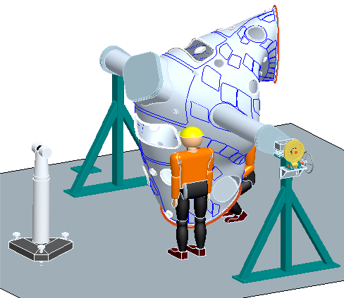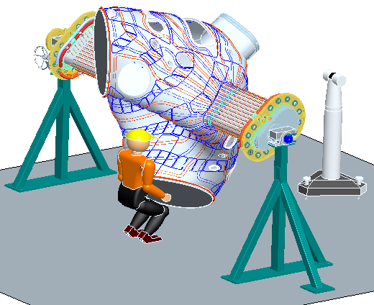

Table4-2 Vacuum Vessel Support

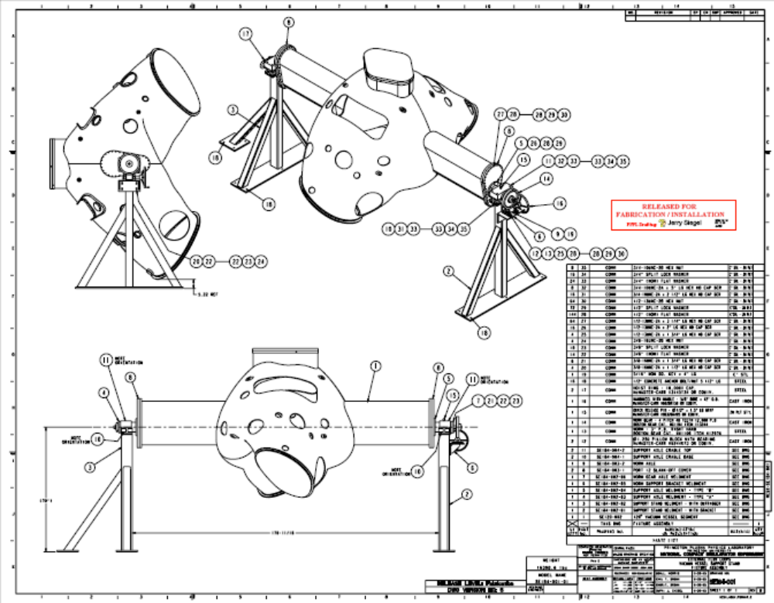

Table4-3 Vacuum Vessel Support

Magnetic Loops / Saddle Coils
FPA 1 will have 65 flux loops, FPA 2 - 80 flux loops, and FPA 3 - 67 flux loops. There will also be four toroidal voltage loops mounted on the surface of the vessel, 16 flux loops on one of the three vacuum vessel spool pieces, and two flux loops on each of the other two vacuum vessel spool pieces at the symmetry points. Saddle loops will be installed on all three vacuum vessel Field Periods with varying numbers on each. The technique for installing the flux loops is to place a thin copper template that mimics the size and shape of a particular flux loop over the surface of the vacuum vessel. The template will have a number of edge marks that will be used to match up with pre-inscribed marks placed on the surface of the vessel by the Romer or Leica metrology measurement system. Each copper loop will be pressed down against the vessel to conform to the vessel surface and centered between locating marks with temporary tabs spot welded to the vessel surface to hold the loop in place. Mineral insulated (MI) cable for the sensors will be wrapped around the edge of the template. Leads from the coils will be routed to the vertical ports and terminated in a junction box on the ports. The MI cable will be held in place by wrapping the cable with thin tabs and spot welded to the vessel. Measurements of the coils will be made using a Faro arm or laser tracker and recorded for future information. The flux loops will be located to within +/-4 mm (0.160") of the design locations, except the loops at the symmetry points, which will be located with +/-0.5 mm (0.020").

Cooling /Heating Trace Lines
A total of 64 cooling/heating flexible trace lines made of SS braided hose (1/4” ID x 48” OD) will be attached to the body of each vacuum vessel Field Period with 712 studs located at approximately 5” spacing, shown in Table4-4. The braided hoses will be attached to the vessel by stud welding saddle clamps with Grafoil used to improve thermal conductance. The braided hoses from the body are connected to a 5/16” OD SS tubing weir with “J” clamps located on each vertical port and collected in a manifold at the top of each port. Prior to installing the SS tubing on each of the vertical ports ½” heat tape retention foil will be installed.
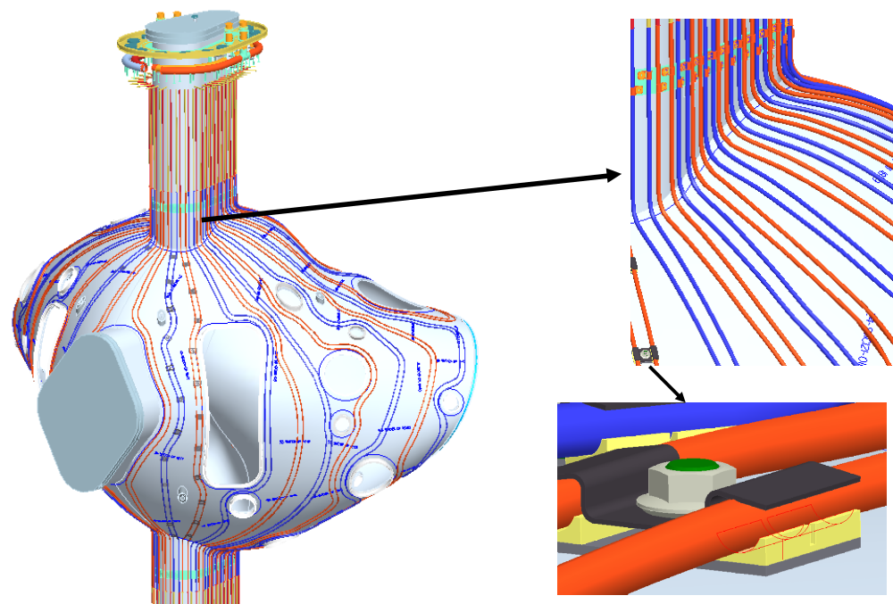

Table4-4 Cooling / Heating Line Tracing Installed on Vacuum Vessel

Modular Coil Half Period Assembly (Station 2)

Overview of Station 2 Activities
A support stand, shown in Table4-5 , is used to support and construct the modular coil half periods, made up from modular coils Type A, B and C. The Type-A modular coil segment will be placed first on the support stand fixture. Metrology measurements will then be taken to set shims (shown in Table4-6) that are used to initially support the Type-B modular coil. The shims are pre-determined for every Modular Coil winding based on metrology measurements of the winding and manipulation of a field period assembly CAD model prior to the modular coil half period assembly. Inspection data from each coil will be collected, including the relationship between the winding geometry, flange geometry, and tooling ball monuments. The location of these features relative to the global machine assembly will be calculated based on the optimum position of each coil in the assembly. This information must be processed to determine the best fit of the coils in the final assembly, and to size the shims needed for the next step.
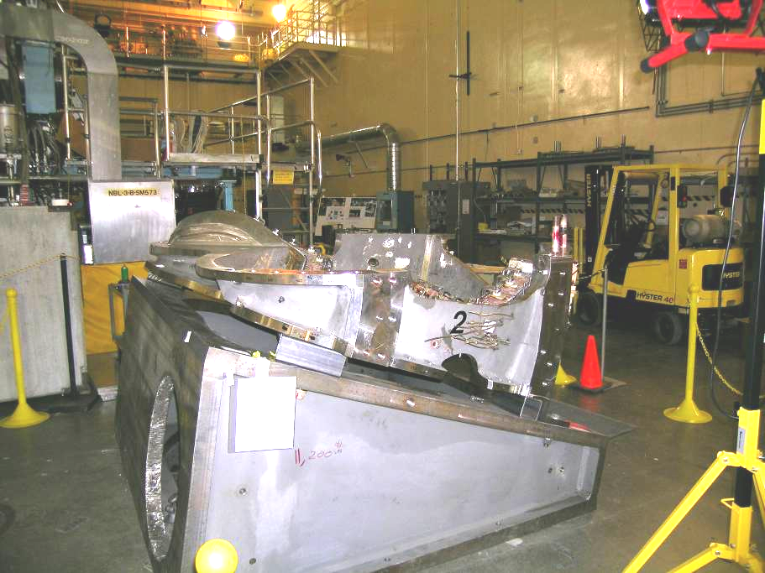
Table4-5 Modular Coil Subassembly with Fixture
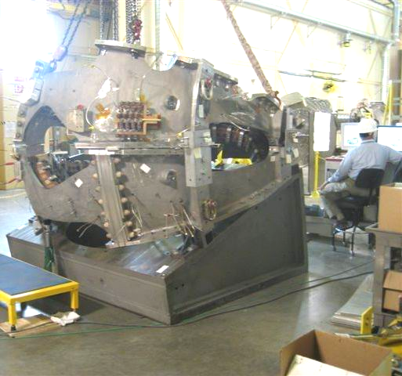
Table4-6 Typical coil to Coil Setup

The dimensional control steps outlined in this document are the result of experience gained during coil-to-coil fit-up trials, the modular coil weld tests, and development of the coil racking procedure.
A modular coil half period assembly consists of three modular coils: one each of type A, B, and C. Each coil subtends a 20° toroidal angle.. The coils are joined by bolts and shims at the hole locations in the flanges, and welded together in the nose region. The gap between flanges is nominally .500”. Two datum planes, defining the toroidal angular extent of the coils, are nominally .250” offset from the plane of each flange, and pass through the vertical centerline of NCSX. The datum planes are defined as datums “D” and “E”. Datum “D” corresponds to side “A” or flange “A” of the coil; datum “E” corresponds to flange “B”. See Table4-7 and Table4-8.
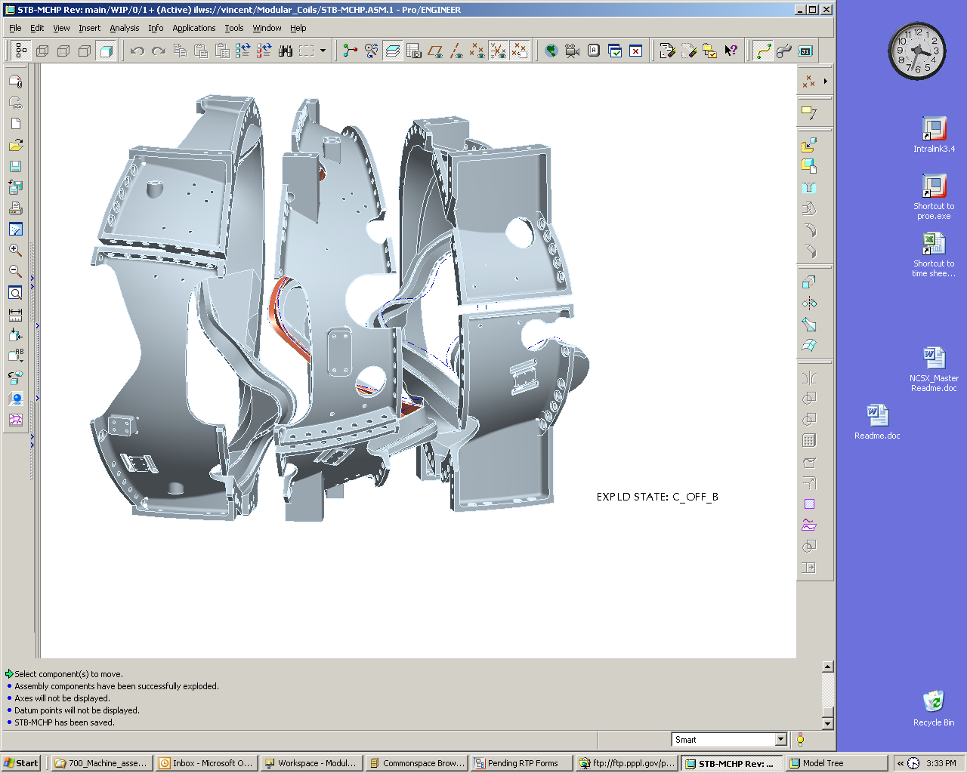
Type-A
Type-B
Type-C
Side-A (datum D)
Side-B (datum E)
Side-B (datum E)
Side-A (datum D)
Type-A
Type-B
Type-C
Side-A (datum D)
Side-B (datum E)
Side-B (datum E)
Side-A (datum D)
Table4-7 MCHP Component Winding Forms
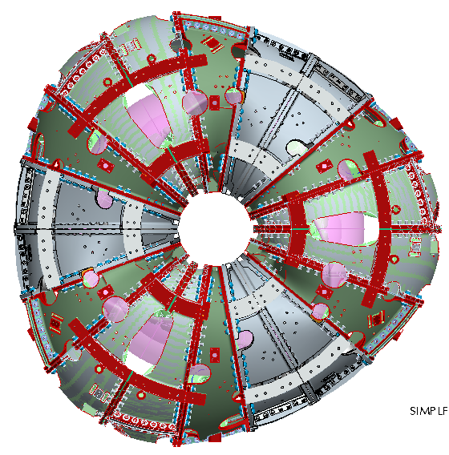
1st Period
2nd Period
3rd Period
C2
C1
B1
A1
A2
B2
C3
B3
A3
B4
A4
C4
C6
B5
A5
A6
B6
C5
Y
X
X
Y
Z
CS0
MCHP – Right Side
Table4-8 MC Arrangement for the Full Machine Assembly

During assembly, the position of the coil current centers is not measured directly, as the winding surfaces are not accessible. Their position is inferred from the position of external monuments, or tooling balls, located on the outside of the flanges and bodies of the modular coils. The positions of these monuments are related to the special “conical seat” monuments that were used for coil winding through the coil pre-measurement process. Because of the flexibility of the coils, and the need to represent the positions of the current centers as accurately as possible, the coil is twisted slightly, or “racked” into its as-wound shape prior to pre-measurement. This step is a necessary precursor to the pre-measurement process.
Measurements during the modular coil half period assembly process are performed with a laser tracker, used in conjunction with Verisurf© measurement software. The measurement philosophy, generally, is to align the tracker to the part geometry in order to relate the measurements to the CAD model of the part. Once an alignment is successfully completed, a set of global monuments are established for the purpose of repositioning the tracker, and for periodic checks of the accuracy of the process. Before aligning to the part geometry, it is necessary for the part to be twisted into the proper shape; the racking process therefore must be a predecessor to the measurement process.
In the pre-measurement process, the laser tracker is aligned to the coordinate system of the CAD model of the coil with the coil in its as-wound configuration. All of the external monuments are measured, as well as the “A”, or datum “D” flange of the coil. The monument locations are used to position and track the coil during all subsequent assembly operations, and the measurements of the flange surface are used to predetermine shim thicknesses at all locations for the initial assembly. It is not possible to measure the full set of coil monuments from one laser position. Monuments are measured from two or three vantage points, as required. Each time the laser tracker is repositioned, an alignment using the global monuments is performed. Where possible, monuments that are accessible from both vantage points are measured from each location, as a check on the accuracy of the process.
The steps used for the pre-measurement process are the building blocks of the dimensional control steps for modular coil half period assembly. The first series of steps involves measurement of the A, B, and C coils. The A coil is lowered individually on the wedge and racked into its proper shape. The top of each coil (datum “E” is then measured. The coil is then removed and placed in a holding area.. The B coil is then lowered onto the wedge and measured in a similar fashion to the A coil, removed to a holding area, and its top flange (datum “E”) is measured. Finally the C coil is measured in a similar fashion. These measurements will provide the data to define the required alumina shim thicknesses needed for assembly.
The A-B modular coil assemblies shall be the first two coils. The first step is to set the first coil [type “A”] on a wedge fixture that is oriented so that the top, or datum “E” flange, of the coil, is pointing . The racking procedure is used to twist the coil into the proper shape, and the laser tracker is aligned to the coil. A network of global monuments is immediately established. The surface of the datum “E” flange is scanned in order to calculate the required shim thicknesses. The shims, along with pressure sensitive “Fuji paper”, are placed on the top flange, and the mating coil [“B”] is lowered into position. [note: the steps involving the “Fuji paper” apply only to the first modular coil half period] Using jack screws, and measurements of three designated monuments, the top coil is positioned in the plane of the flanges. The bolts are partially torqued, and all of the monuments, on both coils, are measured. The top coil is raised, and the Fuji paper is inspected to verify proper load distribution among the shims. Monument positions are analyzed by the dimensional control team to verify proper coil placement. If necessary, some shim thicknesses are changed in order to achieve dimensional accuracy and adequate load sharing. The coils are brought back together with fresh Fuji paper installed, the bolts are partially torqued, and the monuments are measured. As before, the coils are separated, the results are checked, and if acceptable, the shims, without Fuji paper, are installed, along with the proper bushings, and the coils are brought together for the final time. At this point, the gap along the nose region is measured, the initial shims in that region are removed, and the special weld shims are final machined to the appropriate dimensions and installed. After welding the nose region and final tightening of the bolts, the full set of monuments is measured and the datum “E” flange of the top, or “B”, coil is scanned. Because the nose region is welded, there is no easy remedy if the deviations of the monuments from their nominal positions are not acceptable.

The A coil is lowered into position on the wedge and racked into shape. Inboard shim nose shim and puck locations are marked and an initial set of alumina shims are placed at the designated locations for the initial alignment of the mating B coil. Unfilled shim bags are then placed in the wing areas and the mating B coil is lowered into position and measured. The B coil position is adjusted by adding additional shims and/oir adjusting the shim thicknesses until proper alignment is obtained. When that is achieved, the remaining shims will be installed, studs and supernuits installed, and partially torqued to
After this step, the coils, still attached to the fixture, are mounted on another wedge that has its top surface tilted at 20° from horizontal, so that the top flange of the “B” coil is approximately horizontal. It is assumed that, when the monuments were measured after welding, that a suitable set of monuments, within an acceptable deviation from nominal position, were found, and the laser tracker can be aligned to them. A set of global monuments is immediately measured, and the same basic coil-to-coil joining sequence is performed between the “B” and “C” coils.

Monuments and Alignments
The laser tracker measures point locations in a 3-dimensional Cartesian coordinate system that has its z-axis parallel to the vertical axis of the tracker. The purpose of an alignment is to relate this coordinate system to the coordinate system in which a part, or a set of monuments, is defined. Two types of monuments are used in the modular coil half period assembly: part monuments and global monuments. The fundamental difference between the two is that part monuments are physical points on the part that are defined in the CAD model of the part, while global monuments are physical locations, on a fixture or in the assembly area, that are measured by the laser tracker in order to establish their position, and thereafter used as references. Alignment is a means of defining the position of the laser tracker in terms of a set of monuments, and as such is less sensitive to small variations in the positions of monuments when a set of well chosen monuments, covering a large range of the azimuth of the tracker, are used. Alignment to the part geometry, while necessary at some point in the procedure, should only be used as a first step towards establishing a global network of monuments for a given step of the assembly sequence.
If the part is deformed from the state in which the part monuments were defined, the accuracy of the alignment will suffer. A process for correcting this deformation prior to initial alignment to the part geometry has been developed, and is the first step in the pre-measurement process and the assembly process.
A useful criterion for measuring the quality of an alignment is the rms deviation of the alignment. This quantity appears in the alignment report provided by Verisurf©. A sample report is shown in attachment 1. Our criterion for alignments to part geometry is that the rms deviation be not greater than 0.005”. For alignments to global monuments, the rms deviation shall not be greater than 0.002”. Nonconformance reports shall be generated for each alignment that exceeds its relevant criterion, and must be resolved prior to use of that alignment. Additional requirements on selection of monuments appear in later sections of this document. Alignment reports for all alignments used in the process are to be saved and recorded with the run copy of the assembly procedure.
A variety of techniques can be used to measure the positions of monuments. During coil racking, the conical seats are measured by measuring a 10-point sphere around a 15mm ball placed in the seat. The sphericity measurement returned by Verisurf© is a useful and necessary check on the quality of the measurement. Our goal is a sphericity of 0.001” or better, but .002” on 25% or less of the monuments can be accepted.
Tooling balls can be measured directly by use of an angle reflector, or by placing a magnetic nest and 0.5” diameter ball reflector (corner cube) in the tooling ball holder. This will yield a more accurate result than the 10-point sphere. The 10-point sphere is required during the racking process because it enables a greater number of conical seats to be measured from a single laser tracker position. With the angle reflector or the corner cube method, averaging of repeated measurements can be used to increase the certainty of the measurement.
Accuracy, and certainty, of measurements is a function of several factors, including measurement technique, choice of reflector, layout of monuments, and position of laser tracker. An accuracy standard for measurement of tooling balls, and global monuments, is required for dimensional control and is defined as follows:
The measured position of a monument, relative to the laser tracker, shall be within a sphere of .003” of the actual position of that monument, relative to the tracker, with a confidence of 98%. This statement defines a 98% confidence interval about the measured position of the monument. It is the role of the metrology engineer to develop procedures, and specify techniques, that meet this requirement.

Verification of Type B Position
After the Type-B coil is placed metrology measurements will be made to verify that an accurate position was indeed achieved. Shim stock which has been sized, based on dimensional data taken during the fabrication of the A and B coils and output form the CAD assembly model, will be placed between the flanges and checked for its accuracy. Once the part accuracy is assured the Type-B coil will be secured with insulated bolts that will be matched reamed with the flange holes and bolt and nut assemblies torqued to specifications. The Type-C modular coil will be installed using the same procedure and dimensional inspection data will be taken to verify the location of all coils.

Rotation of MCHP to Vertical Position
After one modular coil half period has been assembled it will be lifted from the support stand and rotated into a vertical position and secured to a second support fixture that will allow the assembly of its interfacing half period using a magnetic alignment method, illustrated in Table4-9. Each magnetically aligned module coil will adjusted with six degrees of freedom to allow it to magnetically match its sister coil in the adjacent modular coil half period, that is coil A will match coil A, B will match B and C will magnetically match C.

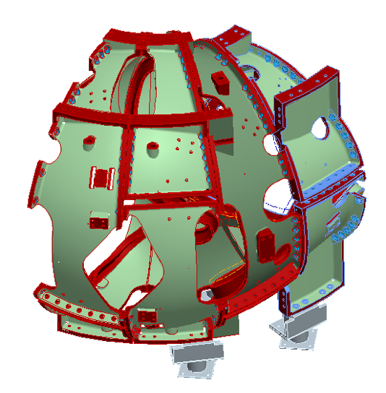
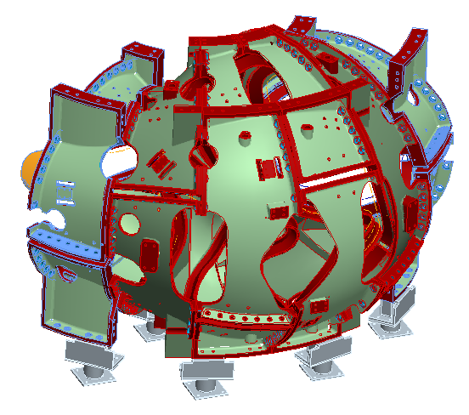
Support Stand Assembled MCHP
Magnetically aligned Type-A module coil
Support Stand Assembled MCHP
Magnetically aligned MCHP
b) Completed magnetic alignment mating MCHP
Type-A Coil

a) Type-A modular coil magnetic alignment

Table4-9 Construction of Mating MCHP

Install Modular Coil Half Period over VV (Station 3)
This station is comprised of a support that will hold the vacuum vessel vertical and allow the modular coils to be rotated (screwed) onto each end of the VVSA, one at a time. From this point forward, the Assembly will be called the Field Period Assembly. The installation activity of Station 3 involves manipulating two 24,000 lb MCHP’s over a vacuum vessel field period within a prescribed assembly path. The motion of the MCHP will be controlled by using a combination of the D-site crane, three chain-fall supports mounted to the crane hook and hand manipulation for rotation control. To improve on motion control a motor driven mechanical screw system with in-line encoders is being evaluated to replace the chain-fall supports. Three lasers will be mounted on the MCHP and the path traveled by each laser will be plotted on sheets of velum, mounted on screens that are pre-aligned. To evaluate the accuracy of the Crane Supported – hand assisted assembly approach a small demonstration effort was undertaken using a 25,000 lb concrete block with three lasers mounted to it (see Table4-10). The simulation was run and the block was manipulated to follow the sequential points with an occasional maximum deviation of about ¾” to 1”, all within our allowed assembly tolerances.
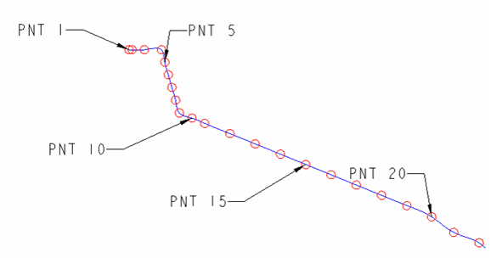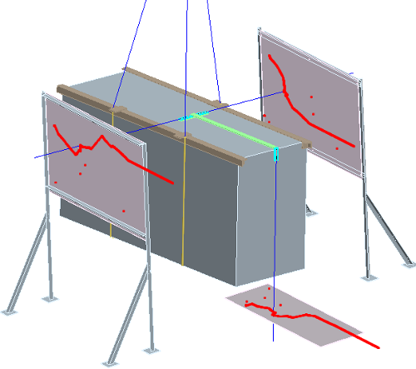
One-quarter inch circles were used to define the required laser positions along the curve path.
Table4-10 MCHP Assembly Simulation

Station 3 Installation Approach
The design details of the Station 3 assembly fixtures are in progress but the installation approach can be illustrated in Table4-11. The first step is to set up and properly align the vacuum vessel (Table4-11a below). Using the overhead crane and chain-fall supports the left side module coil half period is rotated about the vacuum vessel to within ½”of its final position. While supported from the overhead crane a ground support system is rolled beneath the MCHP, interfacing surfaces are elevated to support the load of the modular coil and the unit is then locked in place. The crane is removed from the left MCHP and then used to rotate the right MCHP over the right side of the vacuum vessel (Table4-11b below), also moving it to within ½” of its final position. At this point left side MCHP is moved to its final position using the ground based roller system. The reason for holding the MCHP off their final position is to eliminate the Type-A wing interference that would occur at the end of the MCHP rotation process. Once the left side is set the crane will move the right side into its final position, making any positional alignment adjustments. Once positioned the right side ground support will be rolled beneath the assembly and it will be secured in place. The interfacing Type-A flanges are then shimmed and bolted together. The completed Station 2 installation is shown in Table4-11c below.

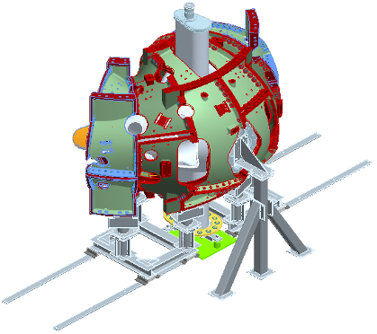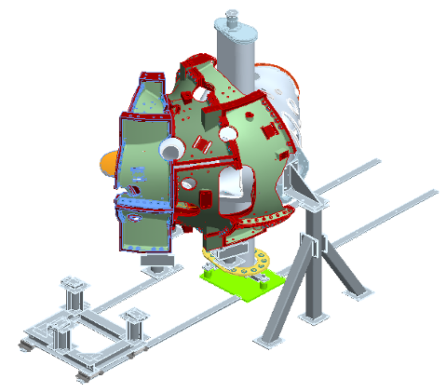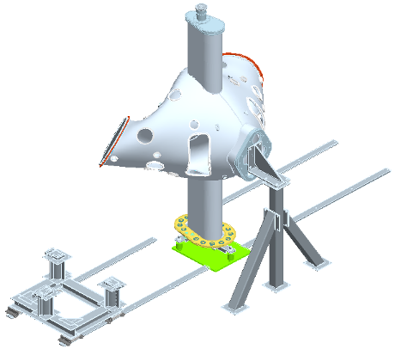
a) VV Set-up
b) MCHP rotated over VV
c) Completed Station 3 Installation
Table4-11 MCHP Assembly Simulation

Installation of Vacuum Vessel Support Hardware
The vacuum vessel support hardware Table4-12) will then be installed between the vacuum vessel and the shell. A clevis subassembly will be fitted thru access ports in the shell and screwed into bosses that are in the vessel. Threaded rods can be inserted into the clevis from the outside of the shell. Belleville washers and a nut will be attached to the threaded rod and tightened against the shell until the vacuum vessel is snug. The vessel will not be fully supported by this hardware until the ports have been installed and welded to the vessel.
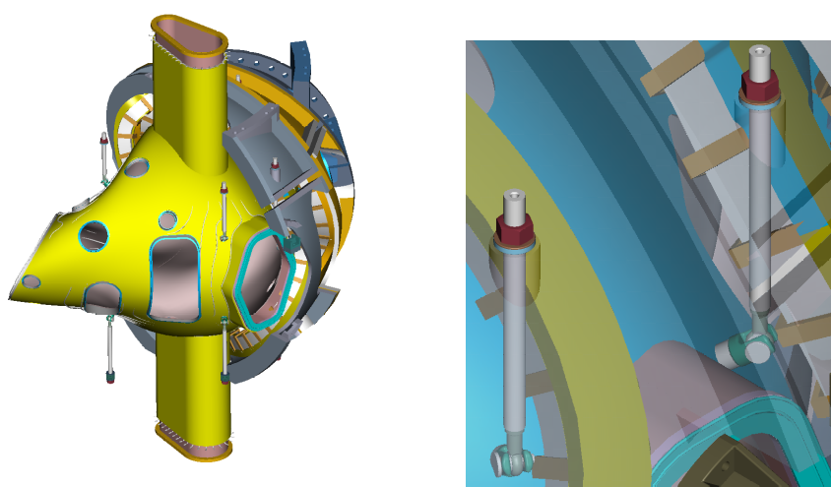
Table4-12 Vacuum Vessel Support Hardware

Completion of MCHP Assembly and Transfer to NCSX Test Cell
When a Field Period Assembly is completed it will be lifted from the fixture in the assembly area and set on a truck for shipment to the NCSX test cell. Table 4-1 FPA Component Weights provides the weights of the FPA components leaving Station 3.

Description | Weight
Vacuum Vessel | 7,200 lbs
Modular Coils (6) | 45,600 lbs
Field Period Assembly | 52,800 lbs
Table 4-1 FPA Component Weights

TF Half Period Assembly (Station 4)
Station 4 activities have now been combined into Station 5.

Final Field Period Assembly (Station 5)
TableStation 5 is locatged within the NCSX Test Cell and completes the FPA assembly process bringing together the a period consisting of the VVSA and two MCHP and attaching VV ports, the external trim coils, modular coil lead and coolant connections, and 4 of the 6 TF coils per period.

Component Preparations and Set-Up
Once the Period is received in Station 5, the short dome port must be cut off to provide adequate space and insulation, heater tape and thermocouples will be installed in the port areas. In preparation of final period assembly, the FPA support stanbd will be installed and the lower trim coils will be positioned on the FPA support stand. The FPA will then be installed on the FPA support stand (Table 4-13). Leveler pads will be use to engage the base of the Modular Coils.
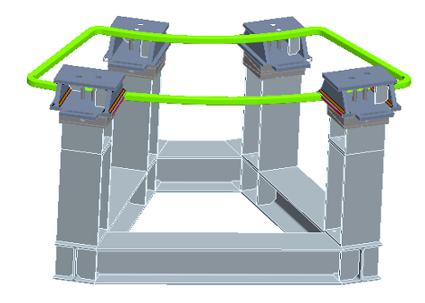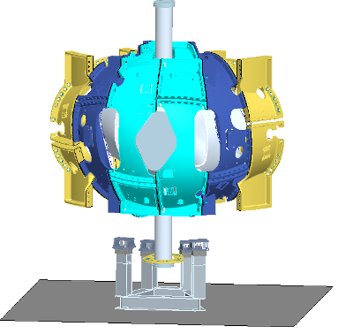
FPA support stand with lower trim coil
FPA lowered onto support stand
Table 4-13 Pre-Installation Set-Up

TableAssembly of the Ports
A typical port configuration is shown in Table4-14. A backing ring is shown welded to the port. The backing ring will help position the port over the stub in the vacuum vessel. An assembly fixture will be used to maintain alignment of the ports relative to the global reference frame. All of the ports will be positioned on the vessel and aligned using the alignment fixture. As each port is positioned a tack weld will hold the port stable. After all ports have been assembled each joint will be finished with a full penetration weld. Blank off flanges will be installed on the ports and on the open ends of the vacuum vessel. A vacuum leak test will be performed to verify all the welds are leak tight. In addition to the vacuum leak test, a dimensional verification of the port locations will be performed. All fixtures shall be removed and the inspection shall be made with the ports in a “free condition”. Table 4-15 shows the dome and ports installation.
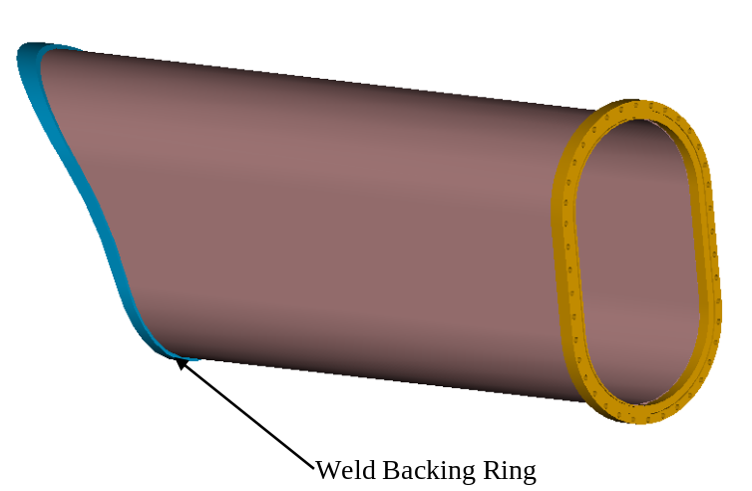

Table4-14 Typical Vacuum Vessel Port Extension ready for welding
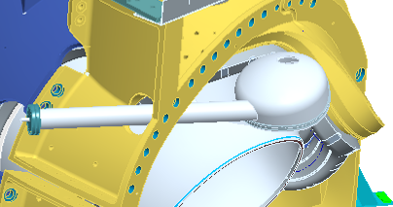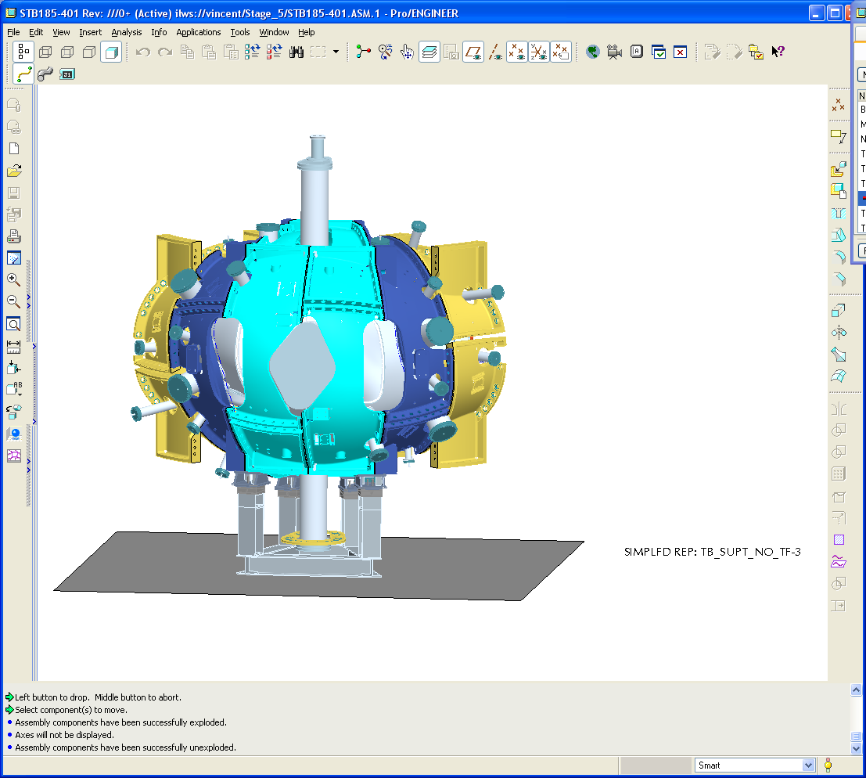
Dome installation
VV ports installation
Table 4-15 VV Port Installation
Following installation of the vacuum vessel ports, the port boot seal assembly will be installed on all the ports except the two port 4’s. Table 4-16 and Table 4-17 show the port boot assemblies.

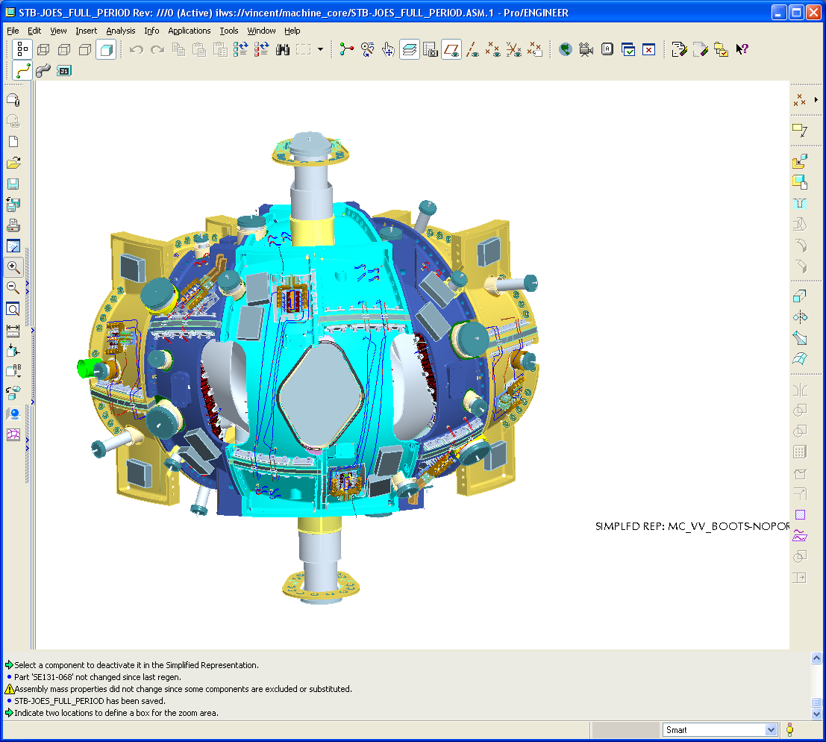
Boot seals on port 4 installed later
Boot seal for spool port at Type-C parting joint installed at final machine assembly.
Table 4-16 Boot Seal Assemblies

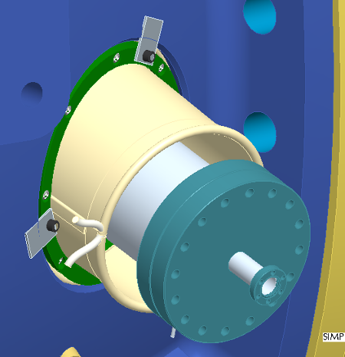
local port insulation is not shown..
Table 4-17 Typical Circular Port Boot Assembly

Assembly of External Trim Coils
After the assembly of the TF coils, the External Trim Coils will be attached to the Field Period Assembly. The External Trim Coils are shown in Table4-18. The external trim coils consist of 36 coils in four sizes that are3 configured as 24 coils.. The upper and lower coils are attached to the frame of the modular coil support structure. Metrology measurements will be tgaken to ensure that the placement of the trim coils are in alignment.
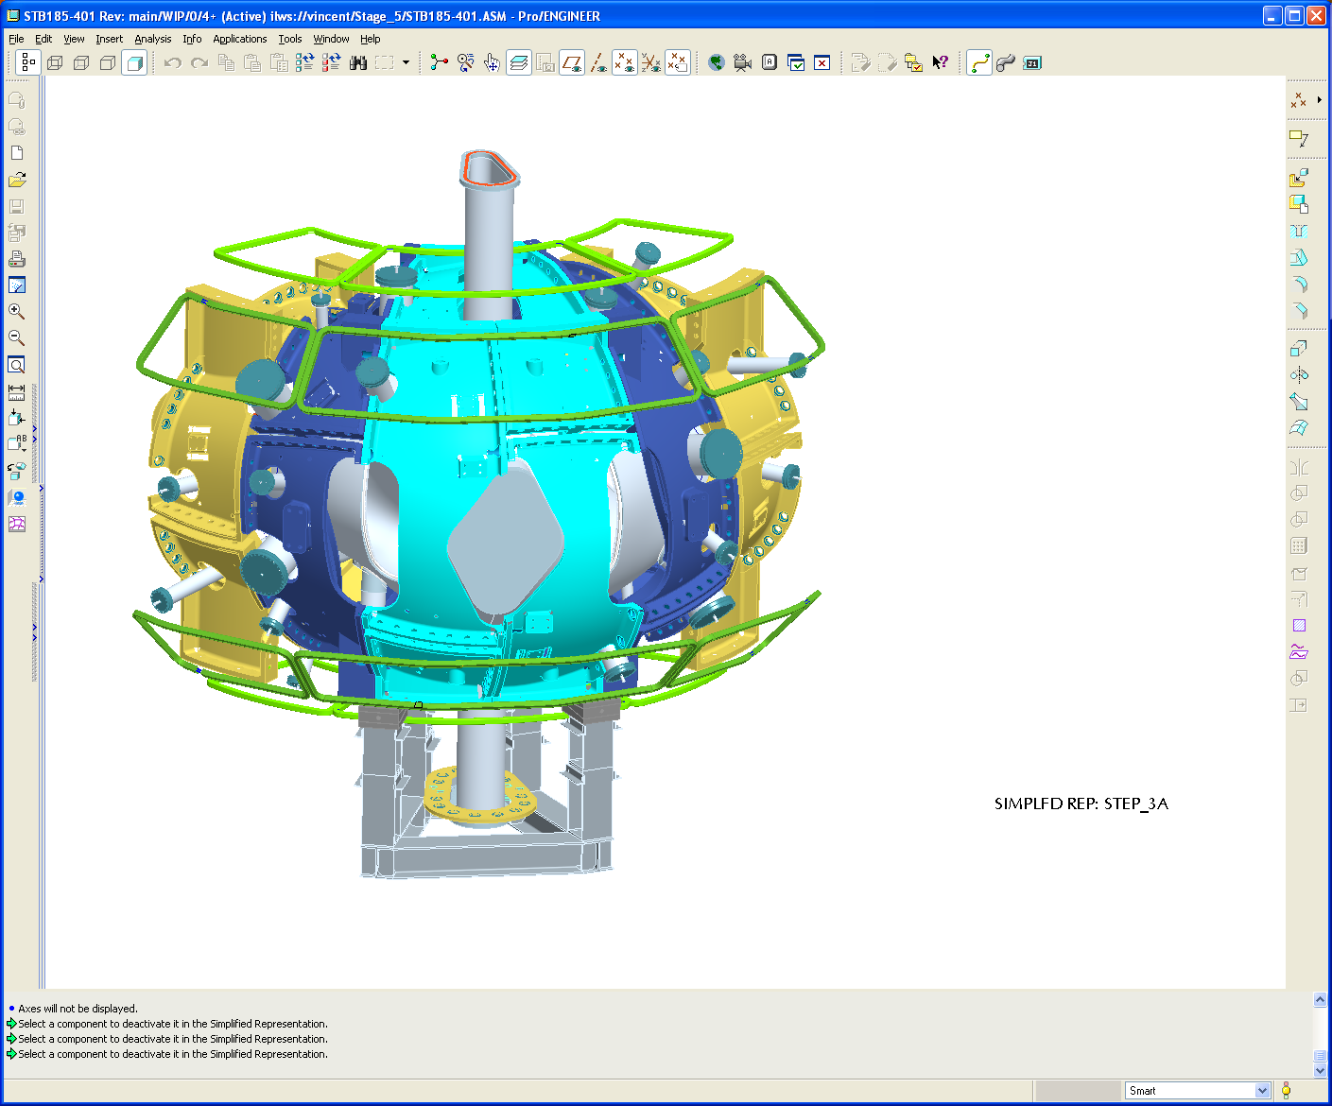Table4-18 External Trim Coils
There are four different trim coil sizes at this time.

TableModular Coil Lead and Coolant Connections
The modular coil lead and coolant connections on each of the MC’s are installed in temporary positions that will not interfere with the TF coil installation and for routing through the PF structure.

TF Coil Installation
At Station 5, only four of the six TF coils will be installed in Station 5, two on both the right and left sides of the FPA..The TF coils will be temporarily supported of the Type B and C modular coils as shown in Table 4-19.

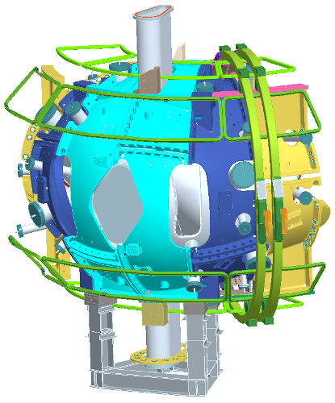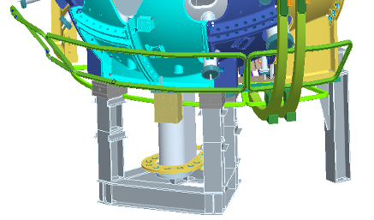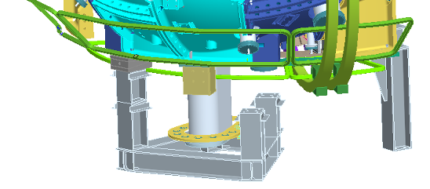
Two TF coils temporarily supported off the MCs.
Temporary end support simplified with two TF coils)
Right side leveler pad and intermediate support removed..
Table 4-19 TF Coil Support Scheme
Once the top and bottom support brackets are installed to the port 12 side of the Type A modular coil, the first TF assembly can be rotated on to the right side of the FPA and then secured. For the second second TF assembly, support brackets will installed to the port 12 side of the Type B modular coil to enable the TF assembly to be rotated into place (Table 4-20). Permanent inboard and outboard machine support plates will then be installed (Table 4-21). The final step will be to install the TF support brackets on the Type B coil for the final TF assembly installation that will occur at Station 6.
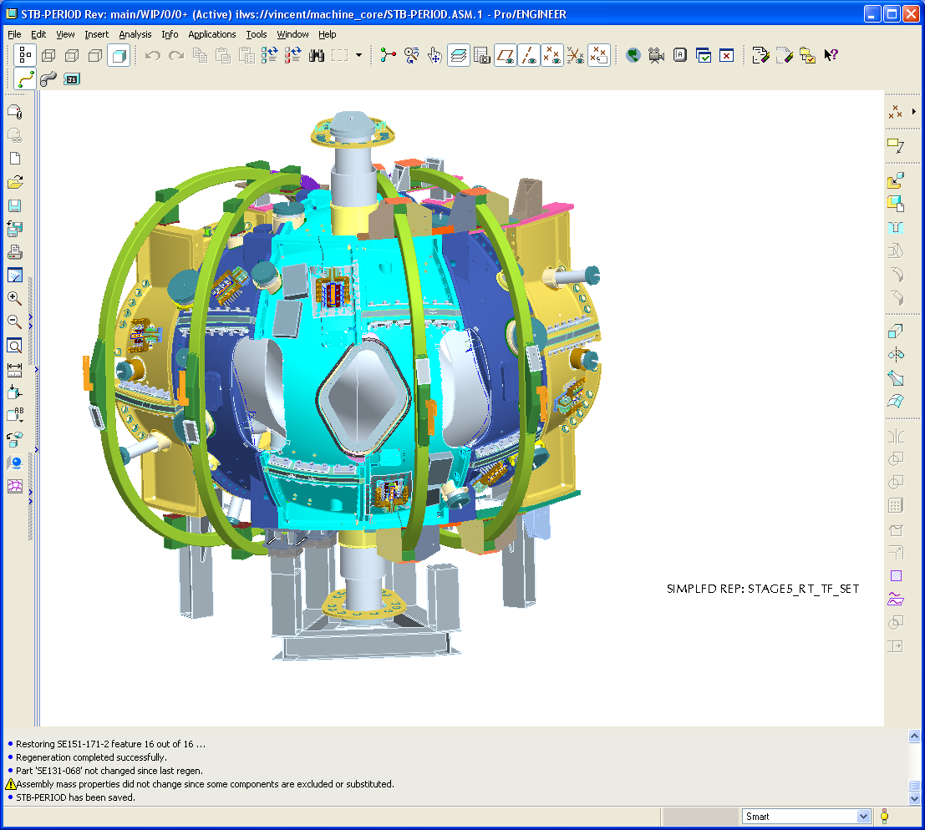
Install TF support brackets on the sides of the coils, both on the top of the MC and on the bottom.
Table 4-20 Initial TF Coil Support Scheme
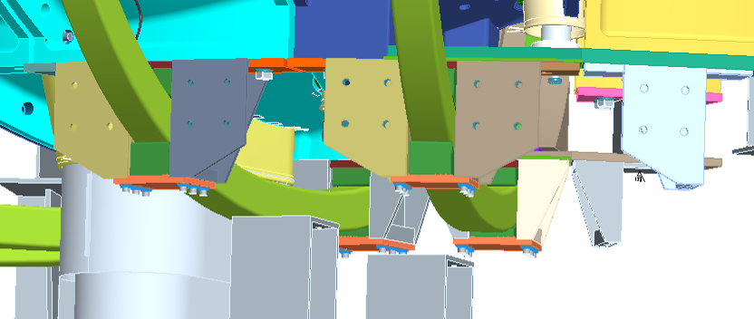
Lower TF support brackets attached to the MC's are shown, inboard and outboard.
The lower supports will be modified to allow machine support plates to be attached from which the machine will be supported from the period support fixture.
Period support fixture posts
One side TF brackets attached on Type-C MC's are shown, inboard and outboard.
Table 4-21 Additional TF Support Details
A similar sequence will be utilized to install the two TF assemblies to the left side of the FPA. A final fit-up check of the 4 installed TF assemblies to determine if then can be positioned within tolerances.

Installation of Porft 4, PF Structural Members, and Routing of MC Services and Diagnostics
Following installation of the 4 TF assemblies, port 4 (with insulation, heater tapes, and thermocouples already installed) will be tack welded. Metrology will be utilized to ensure proper installation. The PF coils support structure that surrounds the TF coils will be installed, ensuring that there will sufficient clearances to permit roputing of the modular coil leads and coolant lines can be routed to the outside of the PF structure (Table 4-22). It should be noted that the PF structure will only be partially installed at the Type C modular coils to permit installation of the final TF assemblies in Station 6 . The modular coil coolant manifold will then be installed outside of the PF structure in the area of PF6 and all the coolant lines will then be connected.

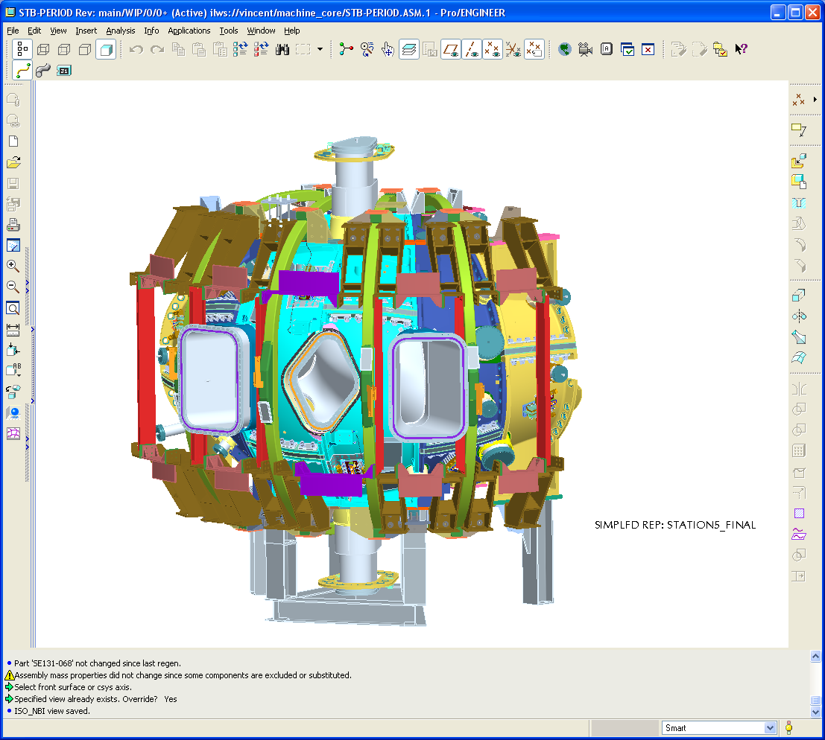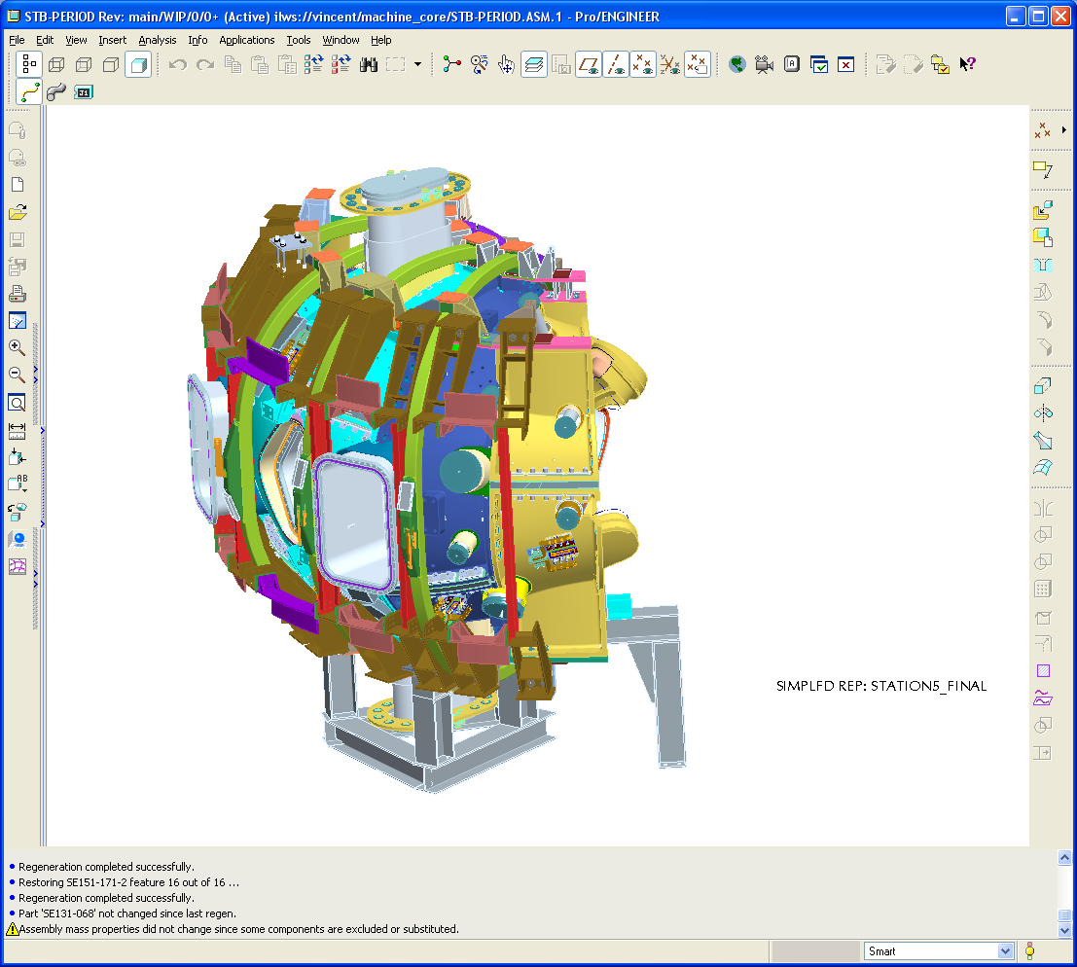
Port 4
PF coil support structure
PF coil structure partially left off on the Type-C.
Table 4-22 PF Structure Installation

Diagnostics (Rogowski Loops) are then installed on the end of the left side of the vacuum vessel. The leads are routed through the space between port 8 and the spool port opening and coil onto the shell of the modular coil for future routing (Table 4-23).
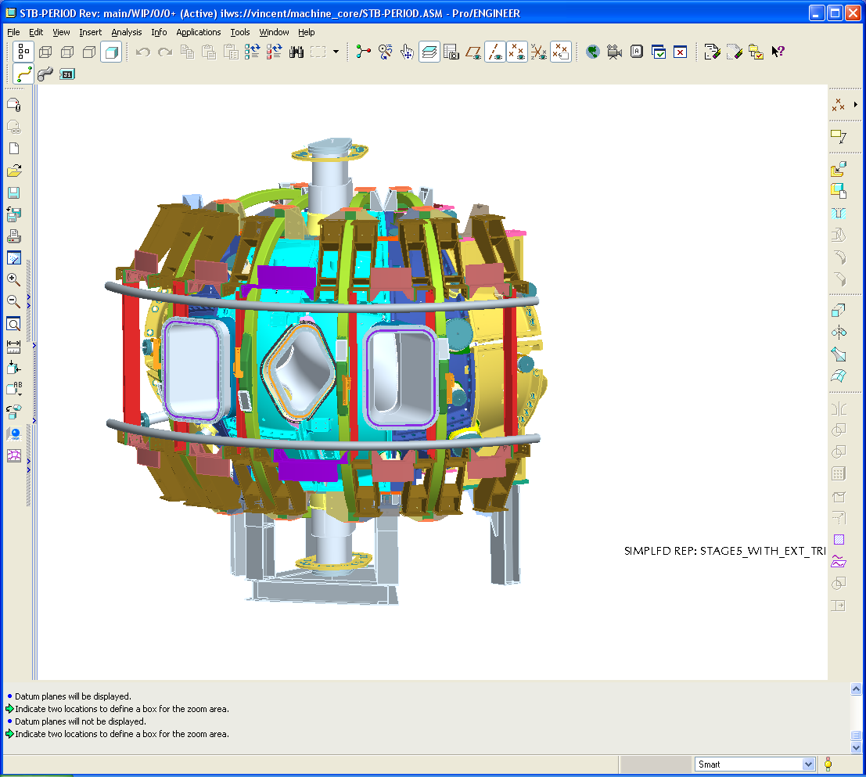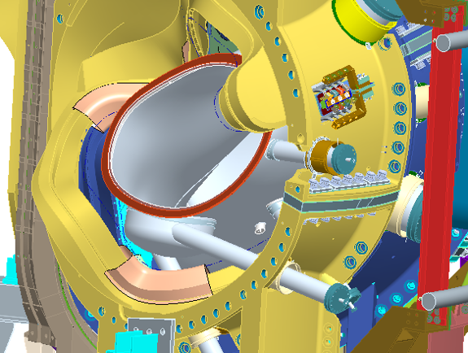
MC coolant manifold
Rogowski coil install around VV shell .
Lead routed to outside.
Table 4-23 Routing of Coolant Lines, Leads, and Diagnostics

Final Measurements and Transfer to Station 6
As the final sequences in Station 5, metrology measurements of the Period 1 alignment fidcucial positions are obtained as well as the alignment of the tooling balls to each MCHP. Uding this data,the vacuum vessel position is adjusted to within alignment tolerances – final adjustments are made to secure the vacuum vessel in place. Finally, a set of three primary fiducials that will be used in Station 6 are identified or installed.
Just prior to transfer of FPA to Station 6, one final rounjd of checks of assembly (bolts, etc.), diagnostics (loops and thermocouples), manifolds (pressure, flow, etc.), modular coils (voltage, etc.) trim coils (voltage, etc.), and TF coils (voltages, etc.) are made. When these are completed, the FPA is transferred to Station 6 (Final Machine Assembl.y).

Documentation Requirements

Document Control
All NCSX associated documents providing instruction for assembling the field period assembly (e.g. plans and procedures) will be maintained under NCSX Project document control. Bob Simmonds to provide reference or further guidance

Field Assembly Station Field Packages
Each field period assembly station shall have a “Station Field Package” that shall be maintained by the field period assembly team. This package shall include all process procedures, inspection reports, photographs, test results, and measurements used to document completion of major activities associated with the activities in each station to assembly the filed period assembly. It shall also include ECNs, non-conformance reports (NCR), or other exceptions to or changes in requirements. All documents shall be complete, legible and validated by responsible personnel.

Assembly/Installation Procedures
Field Period Procedures shall include:
- The critical steps and criteria established by the sequence plan.
- Reference the specification applicable to the procedure
- The list of drawings applicable to the procedure
- Procedure sign-offs for critical steps in the procedure
- The verification list of criteria to determine the successful completion of the procedure.

Assembly/Installation Procedure Sign-Off’s
Assembly/Installation procedures will be used as a signoff/approval document noting that critical manufacturing steps have been completed. Authorized personnel associated with the manufacturing, inspection and test processes will perform the signoff’s. In addition, it will provide witness points as well as reference for test results, and measurements.

Procedure Completion
The Lead Technician or Field Supervisor will document all critical completions on the procedure. This will be completed using the signer’s initials or full signature.
The procedures will be filled out in a timely fashion once a particular activity has been completed.

Authorized Signoff’s for Manufacturing Completions
The manufacturing procedures will identify what level of signoff is required for a particular step. The following disciplines are the authorized signatures for the in-process procedures.
- Station Lead Technicians
- Field Supervisors
- Dimensional Control Representative
- Quality Control Representative
- Manufacturing Facility Manager
The Lead Tech and Field Supervisor are signing that the procedural aspects of the assembly stage are completed. The FPA Manager is signing that the Documentation package is complete and ready for verification. The QA representative is signing that he has reviewed the documentation package, verified that it is complete and verified that all steps and test have been documented to be complete.

Final Document Storage
All documents (hard copy) associated with the manufacturing will be stored in the PPPL Operations center, electronic documents will be stored on the NCSX Web site for the lifetime of the NCSX MIE Project, after which the files will be turned over to the Operations Center.

Quality assurance/quality control requirements
General quality requirements for all work performed for NCSX are specified in the NCSX Q Plan, NCSX-PLAN_QAP. Additional specific quality requirements are:

Inspection/Surveillance and Audit:
Field Supervisors; lead technician and Quality Control (QC) representatives will perform FPA inspection and surveillances as required by FPA procedures.
Independent Audits may be performed by the Quality Assurance Division to ensure that approved manufacturing processes and quality of product is being observed.

Inspection and Test Procedures:
Inspections, measurement and tests will be performed by the field crews and engineering. Where required by procedure, a QC representative shall be present during inspections, measurements, or tests.
Inspection and tests shall be performed:
- In accordance with written/approved procedures referencing criteria for acceptance or rejection.
- Using properly calibrated measuring and test equipment in accordance with PPPL procedure ENG-002 “Control of Measurement Test Equipment & Calibration.
Adequate records to reproduce the inspection shall be maintained and available for NCSX Project review.

Metrology Systems
Measurement Hardware - Measurement/Metrology systems used for FPA shall be periodically checked to ensure that the accuracy and precision of the measurements is within the manufacturer’s specifications and/or within the requirements set forth by the Dimensional Control Plan (for each assembly station). This is typically (but not necessarily the only method) of accomplishing this is by the use of N.I.S.T. traceable length standards and by the execution of manufacturer specified field checks.
Measurement Process – Alignment to the component is a prerequisite to measurements. Verifying that the alignment was maintained during the duration of the measurement is of paramount importance. Periodic verification during a prolonged measurement will minimize loss of time in case of loss of alignment. Alignment verification at the conclusion of measurements will be a mandatory step required for the acceptance of the measurement data.

Equipment/Material Identification and Status
Material and equipment identification shall be maintained throughout the program and be traceable to the records. Status of acceptability shall be readily discernible through the use of tags, stamps, travelers, serial numbers or other positive means.

Non-conformance & Corrective Actions:
Nonconforming items shall be positively identified and, where possible, segregated to prevent use. The Manufacturing Team shall document each non-conformance in accordance with PPPL procedure QA-005 “Control of Non-Conformances”.

Release for Station Transfer:
Prior to releasing a VVSA or FPA from one station to the next, the Station Lead Technician, Field Supervisor, FPA Manager and the QC representative will review and approve the release on the procedure for that station indicating that all processes at the station have been satisfactorily completed.

Process History:
The FPA team shall provide a Process History for the VVSA or FPA that includes a compilation of documents, detailing the objective evidence of the acceptability of the work performed. Process History shall be stored in the Operation Center after assembly is completed. The Process History shall include as a minimum, but not be limited to the following:

6.6.1 Material Certifications:
The FPA Team shall compile inspection reports, test data, and/or certifications from vendors, showing relevant chemical, mechanical and electrical properties of materials used, where applicable, as detailed in applicable procedures, as well as documents showing adherence to in-process requirements. Material certifications from sub-tier suppliers shall also be submitted.

Completed Procedures:
Original or copies of filled in and completed process planning and control documents (procedures, etc.), which verify controlled execution of the required work. Each FPA will have its own set of process planning and control documents.

Inspection Reports:
Copies of the original reports from all required inspections and examinations, that are properly validated by authorized personnel.

Test Reports:
Copies of the original test data sheets or reports of all required tests, both in-process and acceptance, that are properly validated by authorized personnel.

