Princeton Plasma Physics Laboratory
Procedure
‘
Procedure Title: Modular Coil Fabrication-Post VPI Activities

Number:  D-NCSX-MCF-004 |  | Revision:  00 |  |  | Effective Date:  Expiration Date:  (2 yrs. unless otherwise stipulated)
Procedure Approvals
Author: James H. Chrzanowski |  |  |  |  |  | Date:
ATI: James H. Chrzanowski |  |  |  |  |  | Date:
RLM: Larry Dudek |  |  |  |  |  | Date:
Responsible Division: NCSX Project
Procedure Requirements
Designated by RLM
LABWIDE:
X | Work Planning Form # WP-1188 & 1138 (ENG-032) |  |  | Lockout/Tagout (ESH-016)
 | Confined Space Permit (5008,SEC.8 Chap 5) |  |  | Lift Procedure (ENG-021)
 | Master Equip. List Mod (GEN-005) |  | X | ES&H Review (NEPA, IH, etc.) NEPA 1283
 | RWP (HP-OP-20) |  |  | Independent Review
 | ATI Walkdown |  | X | Pre-Job Brief
X | Post-job Brief *
D-SITE SPECIFIC:
X | D-Site Work Permit (OP-AD-09) |  |  | Door Permit (OP-G-93)
 | Tritium Work Permit (OP-AD-49) |  |  | USQD (OP-AD-63)
X | Pre-Job Brief (OP-AD-79) |  |  | T-Mod (OP-AD-03)
 | ** DCA/DCN (OP-AD-104) #

* Required for installations involving internal vacuum installations, critical lifts, and for the initial installation of repetitive work.
** OP-AD-104 was voided by procedure ENG-032. However, DCA’s that were open at the time of adoption of ENG-032 are still considered valid for work approval purposes.

REVIEWERS (designated by RLM)
Accountable Technical Individual. …………………………. J. Chrzanowski
Test Director Geoff Gettelfinger
Independent Reviewer
D-Site Shift Supervisor
Independent
NCSX Steve Raftopoulos Tom Meighan
Vacuum
Project Engineer for Stellerator Systems (WBS 1) Manager…….. Brad Nelson (ORNL)
WBS Manager for Modular Coils (WBS14).. ………………Dave Williamson (ORNL)
Quality Assurance/Quality Control. …………………………Judy Malsbury
Maintenance and Operations Division
Energy Conversion System/Motor Control Division
Engineering ……………………………………..
Environmental Restoration & Waste Management Division
Environmental, Safety & Health………………………………Jerry Levine
Industrial Hygiene…………………………………………… Bill Slavin
Health Physics…………………
RLM ………………………………………………………………..Larry Dudek

TRAINING (designated by RLM)
No training required ______________ | Instructor Jim Chrzanowski
Personnel (group, job title or individual name) |  | Read Only | Instruction  Pre-job  Briefing | Hands On
Lead Tech. |  |  | X
Technicians performing task |  |  | X
Field Supervisors |  |  | X
Quality Control Representative |  |  | X
Training Rep.
RLM Larry Dudek

RECORD OF CHANGE

Revision | Date | Description of Change
00 |  | Initial release

TABLE OF CONTENTS

1 Scope 1
1.1 Introduction 1
1.2 Scope 1
1.3 Identification of winding form being prepared: 1
2 Applicable Documents 1
2.1 NCSX-MIT/QA-142-01: 1
2.2 NCSX-PLAN-MCWFOP-00: 1
3 Safety Requirements: 1
3.1 Job Hazard Analysis: 2
4 Prerequisites 2
4.1 Pre-Job Briefing: 2
5 Materials and Parts for this station 2
6 Fabrication Process 2
6.1 Install MC or TRC in Turning Fixture: 2
6.2 Sprue Removal 3
6.3 Coil Clamp Installation 4
6.4 Electrical Testing of Coil Prior to Transport 6
6.5 Remove the MC or TRC from the Turning Fixture: 9
6.6 Disassembly of coil/casting from Support Ring Assembly: 9
7 Completion of Activities at Post VPI Station: 10
7.1 Document Verification: 10
7.2 Field Package: 10
7.3 Approval: 10

List of Figures

Figure 1- G-11 Pad Location 4
Figure 2- Coil Clamp Assembly 5
Figure 3- Clamp Torque Locations 5
Figure 4- Casting Assy. Fixture- Vertical Position 9
Figure 5- Casting Assy. Fixture in Horizontal Position 9
Figure 6- Assy. Fixture without Lift/Support Beam 10
Figure 7- Coil without Support Ring 10

Scope

Introduction

The Modular Coil Manufacturing Facility is divided into 6 workstations. Each workstation has a specific set of tasks that will be performed as part of the overall fabrication process. This procedure addresses the manufacturing, inspection, test and QC inspection points for a specific workstation.

- Station No. 1… Winding Form Preparation
- Station No. 2… Winding Station A/ Molding and VPI Preparation
- Station No. 3… Winding Station B/ Molding and VPI Preparation
- Station No. 4… Vacant
- Station No. 5… VPI and Autoclave Activities
- Station No. 1… Post VPI Activities
- Station No. 6… Coil Testing Facility

Scope

This procedure identifies the post VPI activities for each Modular Coil (MC) or Twisted Racetrack Coil (TRC). It includes:
- Cleanup of the coil following VPI
- Preparation of coil for final coil clamps
- Installation of the coil clamps
- Room temperature electrical testing of coil
- Disassembly of coil/winding form from support ring
- Transport of coil to the basement coil test facility

Identification of winding form being prepared:

Station Number: ________ (Location where work will be performed)

Winding Form Type: _______________ [Type A, B, C or Twisted Racetrack Coil (TRC)]

MC Winding Form ID No: _________________

Modular Coil Identification Number: ___________

Applicable Documents

NCSX-MIT/QA-142-01:
All applicable documents associated with this procedure, are identified in the MIT/QA Plan, document number NCSX-MIT/QA-142-01.

NCSX-PLAN-MCWFOP-00:
All Modular Coil work processes are governed by the “Winding Facility Operations Plan”, document number NCSX-PLAN-MCWFOP-00.

Safety Requirements:

All work will be performed in a safe manner in accordance with PPPL safety policies ES&H 5008 and “Integrated Safety Management” (ISM) policy.

Job Hazard Analysis:

JHA’s will be generated for each workstation, identifying existing or potential workplace hazards and to evaluate the risk of worker injury or illness associated with job tasks. (Reference document ESH-004 “Job Hazard Analysis”) The IH representative will review the JHA’s for accuracy as well as completeness. It will be reviewed with all activity participants at the Pre-Job briefings.

Prerequisites

Pre-Job Briefing:
A pre-job briefing will be held, describing the processes and safety issues prior to starting any part of this procedure. Attendance shall be documented via training sign-in sheet.

Pre job Briefing complete: ________________________________ _________________
MC Field Supervisor Date

Materials and Parts for this station
The following materials and/or equipment will be used with this procedure. MSDS’s for chemicals will be located in a notebook in the winding facility.

General Description | Material | Reference Document/Product No.
Solvent | Acetone | MSDS# 00561
Coil clamps | 316L stainless steel | SE1405-250P
MC Turning Fixture | Equipment | Drawing no. SE144-008
Rolled Ring Assembly | Fixture | Drawing no. SE144-007
Casting to Ring Assy. Fixture | Fixture | Drawing no. SE144-050
Megger Electrical Tester | Equipment
Mobile Cryo-test Facility Transport Cart | Equipment

Fabrication Process
This fabrication procedure is to be used as guide to complete Post VPI activities. Deviation from this procedure can be made during process with the concurrence of the MC Field Supervisor. All deviations shall be documented in the procedure and initialed by the MC Field Supervisor prior to implementing the deviations. Procedure changes need to be incorporated into document via “Minor Procedure Changes” or “Revisions”.

Install MC or TRC in Turning Fixture:

Ensure that the Station No. 1 is ready to receive a coil/winding form.

Verified by: _________________________ Date: __________________
Lead Technician

All rigging and preparation work in the autoclave requires a confined space permit.

Transport the VPI’d coil from the Autoclave to the Station No. 1 turning fixture using lift procedure D-L-NCSX-983. Secure the coil and ring assembly to the turning fixture.

Verified by: _________________________ Date: __________________
Field Supervisor

Install the upper guide rollers, and align all guide rollers to the support ring.

Verify that the support ring gear rack is engaged with the drive unit.

Verified by: _________________________ Date: __________________
Lead Technician

Verify that the upper support/lift beam is in proper position and secured with appropriate hardware that is torqued to the proper value.

Verified by: _________________________ Date: __________________
Lead Technician

Remove the upper support plates between the support ring and lift beam. This operation must be verified prior to operating turning fixture.

Verified by: _________________________ Date: __________________
Lead Technician

To ensure proper alignment and operation of the turning fixture, rotate the coil/ring assembly a full revolution using the foot-pedal control. Re-adjust the alignment rollers as required. Alignment of coil/ring assembly to the turning fixture is complete.

Verified by: _________________________ Date: __________________
Lead Technician

Sprue Removal

Using a pre-approved cut-off saw, cut off each of the G-11 sprues from the coil bundle. The sprues shall be cut flush with the outer “French Toast” covering.

Once cut, sand the remaining sprue removing any sharp edges or ledges.

All epoxy sprues have been removed, and the coil is ready for installation of final clamps.

Verified by: _________________________ Date: __________________
Lead Technician

Coil Clamp Installation

Completely remove a VPI clamp assembly from one location.

Carefully cutaway the vulcanized rubber bag mold in the area directly under the VPI clamp exposing the G-11 push pad. See Figure 1- G-11 Pad Location.

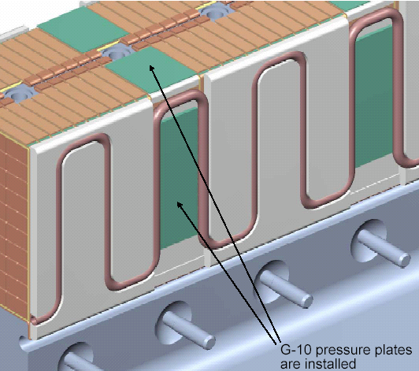

G-11 Pad Locations

Figure 1- G-11 Pad Location

Remove any excess epoxy that may be on the G-11 pad.

Use drawing SE1405-250P [Clamp Assembly] and install a final winding clamp assembly. See Figure 2- Coil Clamp Assembly.

Use “Loctite” to secure threaded components.

Torque all clamp hardware to TBD ft-lbs. See Figure 3- Clamp Torque Locations for identification numbers of joints. Record all torque verifications in Table 1 - Coil Clamp Torque Verification. .

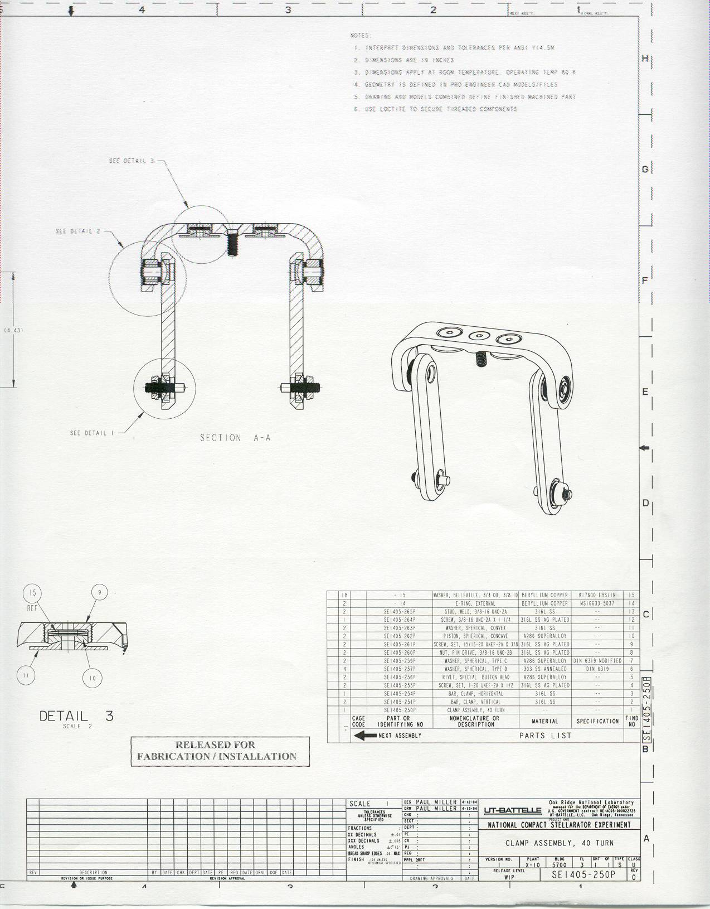
Figure 2- Coil Clamp Assembly

Torque #7
Torque 6
Torque #5
Torque #4
Torque #3
Torque #2
Torque #1

Figure 3- Clamp Torque Locations

Table 1 - Coil Clamp Torque Verification
Torque verified | Torque  #1 | Torque  #2 | Torque  #3 | Torque  #4 | Torque  #5 | Torque  #6 | Torque  #7
Clamp No.
1
2
3
4
5
6
7
8
9
10
11
12
13
14
15
16
17
18
19
20
21
22
23
24
25
26
27
28
29

Electrical Testing of Coil Prior to Transport
This series of electrical tests will be performed at room temperature to verify the integrity of the coil insulation prior to transporting to the Cold Coil Test Facility.

Test Director:
Test Director for this test series is: _______________________

Safety Requirements & Conditions

The following safety and prerequisites shall be used for performing tests on the Twisted Racetrack and Modular Coils.

Technicians and engineers performing these tests shall be familiar with the hazards and work procedure to minimize accidents that may occur.

There shall be present a second person, “safety watch” monitoring the operator, and capable of removing the power in case of an accident. This person shall be CPR qualified.

Qualified CPR Member: _____________________ Recertification Date: ___________

During the test, the “Test Area” shall be roped-off and suitable “danger high voltage” signs and flashing lights displayed.

Test Director Verify: ___________________________

The test operator shall stand on an electrical safety mat during the test operation.

Approved rubber electrical safety gloves shall be worn by test members during grounding operations which occur once the test has been completed, and the test equipment turned off.

Upon completion of test and before the components are declared safe to touch, (dielectric joint) being tested shall be properly discharged using a “Ground Hook”. After a minimum period of 10 seconds, while the ground hook is still in place, attach a ground cable to the casting and poloidal mid-plane. The ground hook may be removed once the ground cable is in place.

Resistance Measurement

The test equipment used for this test will be a “Biddle” digital low resistance ohmmeter (DLRO).

Equipment ID No. ___________________ Calibration Date: __________________

Using the bridge probe, make pressure contact on the ends of the system bus being tested.

Record the resistance readings on the test sheet.

Place temperature sensor on the surface of the bus leads and record the temperature of the copper after the reading stabilizes.
R20 = 254.5 x Rc
234.5 + Tc
where: Rc = measured resistance of the conductor (milliohms)
Tc = temperature of coil when resistance measurement is made (degrees C)

Table 2- Coil Resistance
Measured System Resistance (Rc)  m-ohms at Tc | System Resistance corrected to 20 deg. C (R20) | Calculated System Resistance @ 20 deg.C
Rc:
Tc:

Resistance Results: Acceptable: _______________ Unacceptable: ____________

Test Director Signoff: _____________________________ Date: ______________

Insulation Megger Test:
Test Criteria
- Test Voltage: volts

- Acceptance criteria for this test: > k-ohms

Test director shall verify that all safety and prerequisites have been performed prior to starting the test.

Verify that the turning fixture is well grounded to building steel.

Place the megger test set on a firm, stable surface.

Securely connect a ground cable between building steel and the test unit.

Connect the megger ground lead to the coil casting.

Connect the megger power lead to the coil leads.

Measure the insulation resistance to ground. The test results shall be in compliance with the requirements noted in Section 6.4.4.

Table 3-Megger Test Results
Test Voltage | Insulation Resistance Minimum 1000Ω | Observations
1000
2000
3000
2500
5000
7500
10000
12000

Equipment ID Number:__________________________ Calibration Date: _____________

Megger Results: Acceptable: _______________ Unacceptable: ____________

Test Director Signoff: _____________________________ Date: ______________

Quality Control Witness: __________________________ Date: ______________

Remarks:

Remove the MC or TRC from the Turning Fixture:

Install the upper support plates that secure the support ring to the support/lift beam. This operation must be verified prior to proceeding.

Verified by: _________________________ Date: __________________
Lead Technician

Using lift procedure D-L-NCSX-983 rig the upper support/lift beam to the overhead crane.

Once a slight load has been taken, remove the hardware that secures the upper support/lift beam to the turning fixture frame.

Disengage and remove the upper guide rollers.

Using lift procedure D-L-NCSX-983 carefully raise the Coil/winding form from the turning fixture and transport/position directly over the casting assembly fixture.

Verified by: _________________________ Date: __________________
Field Supervisor

Disassembly of coil/casting from Support Ring Assembly:

Secure the coil support ring to the casting assembly fixture. Figure 4- Casting Assy. Fixture- Vertical Position

Using the overhead crane, carefully lower the coil/support ring assembly until the coil is in the horizontal position and resting on the support stands. Figure 5- Casting Assy. Fixture in Horizontal Position

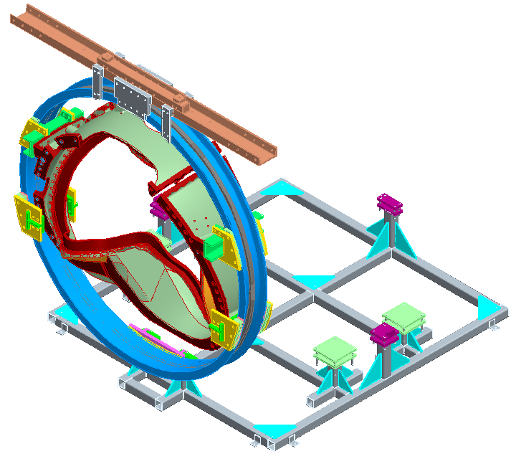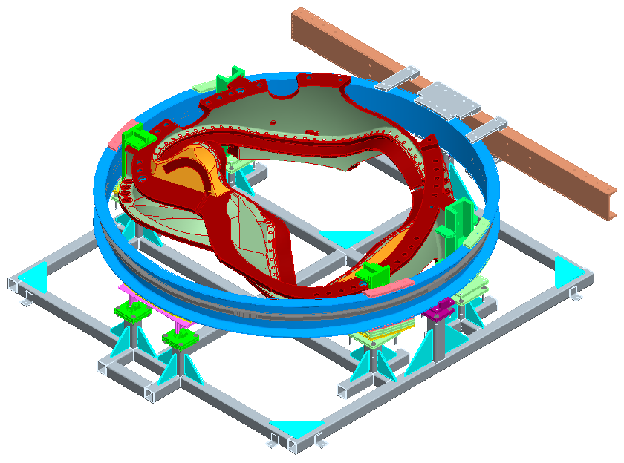
Secure support ring to assy. fixture

Figure 4- Casting Assy. Fixture- Vertical Position
Figure 5- Casting Assy. Fixture in Horizontal Position

Disassemble the support/lifting beam and support brackets between the support ring and casting.

Lift the support ring from the assembly fixture and transport to storage area. Figure 6- Assy. Fixture without Lift/Support Beam and Figure 7- Coil without Support Ring

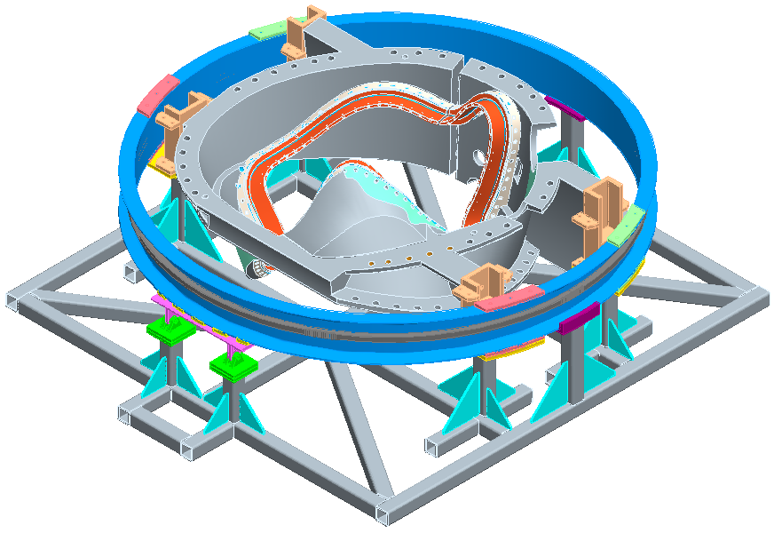
Figure 6- Assy. Fixture without Lift/Support Beam

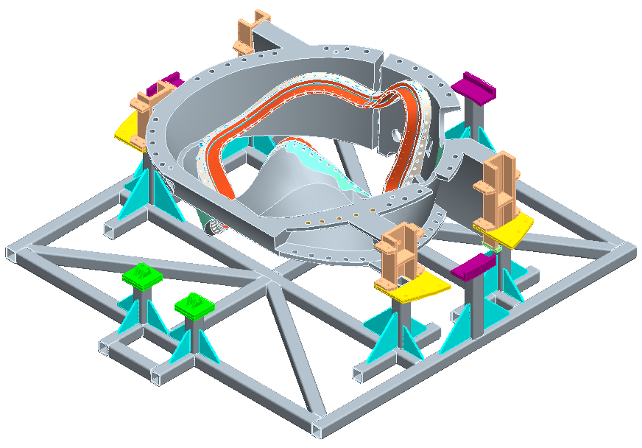
Figure 7- Coil without Support Ring

Position the completed coil onto the mobile cryo-test test facility transport cart.

Verified:

Lead Technician: ____________________________ Date: ____________________

Field Supervisor: ____________________________ Date: ____________________

Completion of Activities at Post VPI Station:

Document Verification:
Verify that all pertinent data in the procedure and data sheets have been completed.

Field Package:
Ensure that all data sheets, photographs, QC inspection sheets, etc are included in the “Coil Field Package”.

Approval:
Prior to releasing a modular coil to the Test Facility, it is required that the all-responsible individuals sign the release indicating that all processes at the Post VPI station have been satisfactorily completed. The release will include signatures from the Station Lead Technician, VPI Director and the QC representative.

All Post VPI activities have been satisfactorily completed.

Lead Technician: ____________________________ Date: ____________________

Field Supervisor: ____________________________ Date: ____________________

QC shall verify completion of documentation:

Quality Control Representative: _________________________ Date: ________

The completed coil is ready for transfer down the elevator to the basement Coil Test Facility.

Signature by Test Facility Manager (TFM) indicates that the completed coil has been satisfactorily transported to the coil test facility and that the TFM has assumed responsibility for the coil.

Test Facility Manager: _______________________ Date: _____________________

Comments:

