Princeton Plasma Physics Laboratory
Procedure
Procedure Title: Dimensional Control and Metrology for NCSX Modular Coils
Number:  D-NCSX-MCF-005 |  | Revision:  1 |  |  | Effective Date: August 24, 2005  Expiration Date:  (2 yrs. unless otherwise stipulated)
Procedure Approvals
Author: Steve Raftopoulos
ATI: Steve Raftopoulos
RLM: Larry Dudek
Responsible Division: NCSX
Procedure Requirements
Designated by RLM
LABWIDE:
X | Work Planning Form # WP-1138 & WP-1188 (ENG-032) |  |  | Lockout/Tagout (ESH-016)
 | Confined Space Permit  (5008,SEC.8 Chap5) |  |  | Lift Procedure (ENG-021)
 | Master Equip. List Mod (GEN-005) |  |  | ES&H Review (NEPA, IH, etc.) NEPA 1283
 | RWP (HP-OP-20) |  |  | Independent Review
 | ATI Walkdown |  |  | Pre-Job Brief
 | Post-job Brief * |  |  | Hazard analysis
D-SITE SPECIFIC:
X | D-Site Work Permit (OP-AD-09) |  |  | Door Permit (OP-G-93)
 | Tritium Work Permit (OP-AD-49) |  |  | USQD (OP-AD-63)
 | Pre-Job Brief (OP-AD-79) |  |  | T-Mod (OP-AD-03)
 | ** DCA/DCN (OP-AD-104) #
** OP-AD-104 was voided by procedure ENG-032. However, DCAs that were open at the time of adoption of ENG-032 are still considered valid for work approval purposes.

- Purpose

  - The purpose of this procedure is to provide guidance for achieving the desired placement of the current centroid of the NCSX Modular Coils. The procedure describes the steps required to measure, control and adjust the location of the Modular Coil conductor so that the net resultant current is within the tolerance specified.

- Scope

  - This procedure details the steps to use the Romer pCMM arm for the winding and positioning of conductor onto the NCSX Modular Coil Winding Forms.

    - Measuring the Modular Coil Winding Forms as delivered.
    - Installing and measuring location of additional fiducial monuments.
    - Establishing a baseline surface after Cladding and Ground Wrap installation.
    - Setting clamp positions prior to winding activities.
    - Verifying conductor placement during the winding process.
    - Adjustment of coil pack by adjustment of clamp position.
    - Re-measuring the coil pack after the lacing is installed.

  - This procedure provides a mechanism for ensuring and documenting the following:

    - pCMM arm is calibrated, per manufacturer’s instruction, prior to measurement.
    - Unique measurement instructions, specific to the modular coils, are identified.
    - Information gathered during the measurement/inspection process is collected, labeled, and saved in a manner that it is readily available for further use.

  - Measurements shall be made by individuals that are trained in the operation of the pCMM arm and the use of the PowerINSPECT software. This procedure DOES NOT provide instruction on the use of the pCMM arm.

  - When measuring or inspecting a component against its CAD model, a measurement routine is typically used. The routine, which is run from the PowerINSPECT software, defines the measurement steps required to inspect the part. For the NCSX Modular Coils the basis for the measurement routine will be defined in this procedure.

- Definitions

  - “Best Fit” alignment Alignment option using a minimum of three, but typically performed with more than three points.
  - “Best Fit” optimization Optimization of the alignment using data obtained from the part.
  - CAD Computer Aided Design Drafting.
  - pCMM Portable Coordinate Measurement Machine.
  - “Free Form” alignment Alignment method used when there are no fiducial points.
  - Fiducial Points Reference features used for alignments.
  - “Length Check” procedure Process for calibrating the pCMM to a NIST length standard.
  - “Point Check” procedure Process for establishing or verifying the calibration of a probe.
  - “Surface Inspection” mode Taking data and comparing it to the CADD model
  - Three Point” alignment An alignment using only three points.
  - TRC Twisted Racetrack Coil
  - Metrology Engineer Individual responsible for the metrology program. Oversees the measurement process.
  - Metrology Technician Individual trained to operate the metrology equipment for taking measurements.
  - Dimensional Control Individual Responsible for the definition of
Representative dimensional requirements.

- References

  - PowerINSPECT 2.2 operating manual.

  - PowerINSPECT 3.0/3.050 operating manual.

  - PowerINSPECT Training manuals.

  - D-NCSX-MCF-001, “Modular Coil Fabrication – Winding Form Preparation Activities”

  - D-NCSX-MCF-002, “Modular Coil Fabrication – Winding Station Activities”

  - NCSX-MIT/QA-142-01 “Manufacture, Inspect and Test/Quality Assurance Plan”

  - NCSX-PLAN-CMFOP-00 “NCSX Coil Manufacturing Facility Operations Plan”

  - D-NCSX-PLAN-MCWDC “Modular Coil Dimensional Control Plan”

  - SE780-011 “Weld-On Metrology Target Holders” drawing

  - NCSX-PLAN-MCWDC-00 “Modular Coil Winding Dimensional Control Plan”

- Tools and Special Equipment

  - Romer pCMM Arm
  - Sheet metal templates for setting winding clamp side legs.
  - Sheet metal templates for establishing spacing for “Standard Pattern” measurement

- Precautions and Limitations

  - The ROMER pCMM arm is a delicate instrument. The precision encoders at every joint will be damaged if the pCMM is bumped or dropped.

  - The Probe tips are susceptible to damage. If the operator suspects that the probe has been damaged, a different probe shall be used until the damaged probe has been recalibrated and/or repaired. Altered and/or replacement probes shall be calibrated to the particular pCMM arm prior to use.

  - The accuracy and precision of measurements is greatly affected (or rendered invalid) if either the pCMM or the measured component moves during the measurement. Ensure that both the pCMM base and the measured component are secure and will not move relative to each other during the measurement process.

  - The pCMM must remain at a constant, stable temperature (preferably the same as the part) during calibration and subsequent measurements.

  - Within the Romer pCMM operating software, predetermined measurement routine for each coil type will be generated, reviewed and approved by the Metrology Engineer and the Dimensional Control Representative. The metrology technicians should complete all the steps that are defined in the measurement routine. Deviations from the routine shall require the approval of the Metrology Engineer or the Dimensional Control Representative. At a minimum, the typical measurement routine shall contain the following sequences:

    - Align to Coil (Aligns the pCMM coordinate system to the CADD coordinate system)

    - Measure desired features (Measurements of surfaces and part features)

    - Re-measure the fiducials (verifies that pCMM and/or the Coil have not moved during measurement).

- Prerequisites

  - At least once per day [during measurements] and/or prior to the start of a critical measurement, the pCMM shall undergo the “Length Check” procedure.

  - The Modular Coil shall be mounted into the turning fixture in Station 1, 2 or 4 and the coil shall be clean of oils and debris prior to the measurements.

  - A CAD model of the fiducial points and surfaces to be measured is to be loaded into the PowerINSPECT measurement routine. The required surfaces are a subset of the approved, latest revision of the Pro/Engineer models and include:

    - Bare Winding Form casting (with fiducial locations)

    - Casting with Cladding

    - Casting with Cladding and Ground Wrap

    - Surfaces of layers that are to be measured. This includes top and side of conductor surface. At a minimum the first, fourth, seventh and last (10 or 11) layer models should be available.

    - Establish a new PowerINSPECT file for the measurement. The file should be named in the following format:

(Date)_(Coil Identifier)_(Side Identifier)_(Surface identifier), where:

      - Date: mm_dd_yy
      - Coil Identifier: A1 to A6, B1 to B6, C1 to C6
      - Side Identifier: SideA or SideB
      - Surface Identifier: Casting, Cladding, Inner Ground Wrap, Layer 1 to 11, Outer Ground Wrap, Chill Plate, Bag Mold

- Procedure for Measuring Modular Coils

  - Station 1: Measuring the machined winding form:

    - In the table below, enter the coordinates of any known fiducial points. Typically, these fiducial points are installed by the fabricating vendor and are identified and located during the QC/inspection process. Note that the coordinates may change if a “Best Fit” transformation is performed later.

Point ID | Target Type | X-coordinate | Y-Coordinate | Z-Coordinate | Comments

    - With the pCMM arm set up in the measuring stand, and with the 15mm ball probe (Probe 1) installed, rotate the coil to various positions and survey the winding form to determine the locations for “Conical Seat” type fiducial pucks. Ensure that the Romer arm can reach at least 8 fiducial points at any coil rotation angle. Mark these locations so that the Conical Seat, Weld-On Pucks can be readily located for welding. The weld-on fiducial points are identified in drawing SE780-011 part 1.

Metrology Engineer: Date: _________________

    - Weld additional fiducial points onto the casting.

Note: If there are no “vendor supplied” fiducials then skip this step and perform steps 7.1.5 to 7.1.8. If there are “vendor supplied” fiducials then perform 7.1.4 and skip 7.1.5 to 7.1.8.

    - After the pucks are welded onto the coil, perform a “Best Fit” alignment (using as many fiducials as can be reached) to “vendor supplied” fiducials, and then measure the location of the Conical Seat fiducials. Record below. The coil may have to be rotated to several positions and realigned to the Romer to complete this task.

Point ID | Target Type | X-coordinate | Y-Coordinate | Z-Coordinate | Comments

Metrology Engineer: Date: _________________

    - If there are none, or an inadequate number of fiducial points to perform an alignment, then perform a “Free Form” alignment to the part.

    - Using “Surface Inspection” mode, take inspection data along the winding surface with the 6mm ruby ball probe (probe 2). Break up the data into 4 separate inspection groups, one group for each sidewall and for each base of the winding surface. Start at clamp 1 and take data at consecutive clamps until all measurements are complete for both sides. The points should be taken in a pattern as shown in figure 2, which is referred to as the “standard pattern”. The “standard pattern” involves taking six rows of points (three horizontal and three vertical) in the spaces between the clamps. The rows are adjacent to the clamp pad and midway between clamp pads. Use the sheet-metal templates to obtain the proper spacing for the points taken on the base and sidewall. The template(s) have the proper number of correctly spaced notches for each particular type of coil (A, B or C).

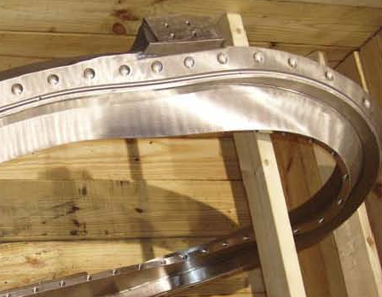
Coil “Base”

Coil “Sidewall”

Figure 1: Bare Casting. This is the TRC; the Full-sized Modular Coils are similar

Coil “Sidewall”

Coil “Base”

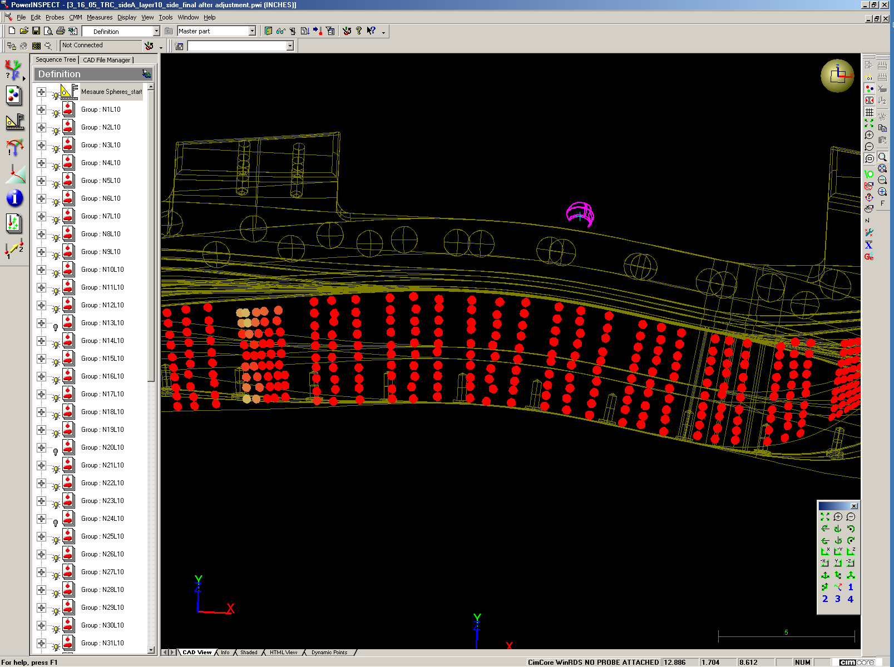
Side Pattern: 3 rows of 10 points or 3 rows of 11 points, depending on coil type

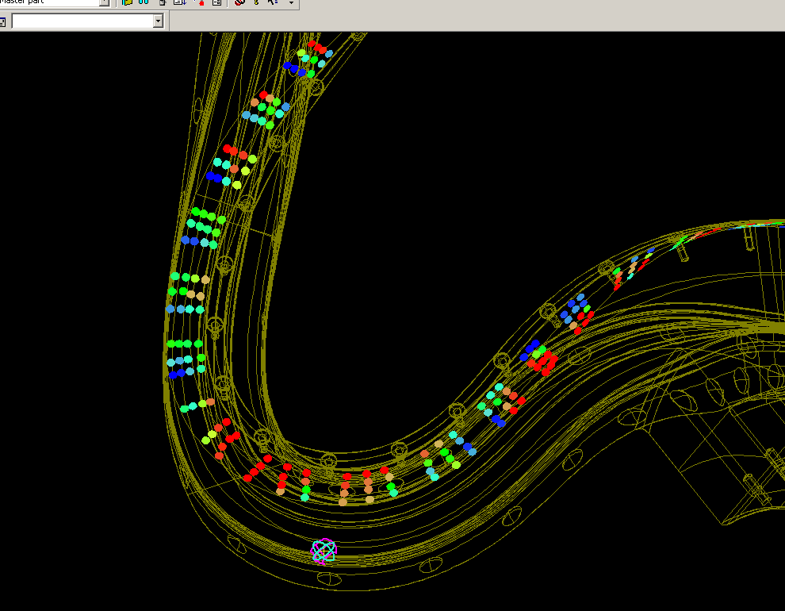
Top Pattern: 3 rows of 4 points for all coil types

Figure 2: Inspection pattern for “Surface Inspection” of coil.

    - Refine the alignment with a “Best Fit” optimization using the inspection data from the winding surface. DO NOT rotate the coil or move the Romer pCMM at this point.

    - After the “Best Fit”, measure the location all the Conical Seat fiducials that can be reached.

    - If all conical seats cannot be reached, then rotate the coil and realign the Romer pCMM using the coordinates of the conical seats measured in the previous step. When all the conical seat fiducials are located record coordinates below:

Point ID | Target Type | X-coordinate | Y-Coordinate | Z-Coordinate | Comments

    - Using “Surface Inspection” mode, take inspection data along the winding surface with the 6mm ruby ball probe (probe 2). Break up the data into 4 separate inspection groups, one group for each sidewall and for each base of the winding surface. The points should be taken in a pattern as shown in figure 2, which is referred to as the “standard pattern”. The “standard pattern” involves taking six rows of points (three horizontal and three vertical) in the spaces between the clamps. The rows are adjacent to the clamp pad and midway between clamp pads. Use the sheet-metal templates to obtain the proper spacing for the points taken on the base and sidewall. The template(s) have the proper number of correctly spaced notches for each particular type of coil (A, B or C).

    - Inspect the remaining areas of the Coil (Flanges, bolt holes, new fiducial points and “As-Cast” surfaces).

    - This completes the initial inspection of the bare Modular Coil winding form/casting. Installation of studs and cladding can commence.

Metrology Engineer: Date: _________________

Dimensional Control Representative: Date: _______________

  - Stations 2 & 4: Measuring the conductor during/after winding activities:

Note: The modular coil has two sides that are wound independent of each other. One side is completed and measured and the coil is repositioned for winding of the second side. After completion of the second side, the measured data is analyzed and the two sides are adjusted (my means of clamp repositioning) to bring the net current centroid within tolerance.

    - After the installation of the Ground Wrap, measure the winding surface by:

      - Aligning to coil.
      - Measure the surface of the ground wrap using the “Standard Pattern”.
      - Re-measure the fiducial points.

    - Prior to the start of conductor installation, at a point after the whisker detector but before the conductor reaches the coil, use a set of calipers to measure the height and width of the conductor. Record below:

 | Spool 1 | Spool 2 | Spool 3 | Spool 4 | nominal
Tall dimension |  |  |  |  | 0.415”
Short dimension |  |  |  |  | 0.384

Measurements during the winding process:

Per direction of the Dimensional Control Representative and/or the Metrology Engineer, measurements of a layer of conductor, after it is installed, are to be taken. The measurements are made against the CADD model of the particular layer.

    - After the installation of a layer, measure the coil pack surface by:
      - Aligning to coil.
      - Measure the surface of the conductor pack (approximate center of each individual conductor) using the6mm probe in the “Standard Pattern”.
      - Re-measure the fiducial points.

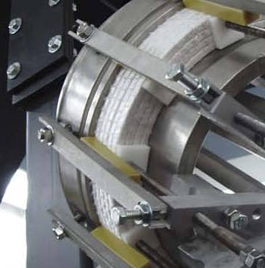

Figure 3: Locations for measuring the winding pack.
Measure winding pack next to clamp and midway between clamps.

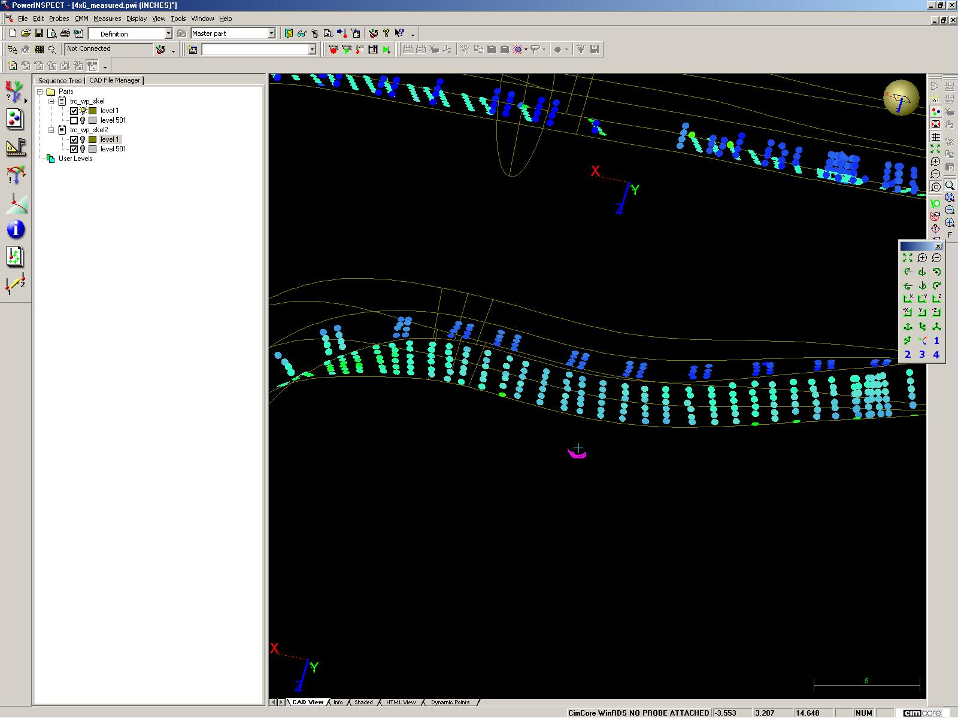
Figure 4: Winding Pack measurement data in PowerINSPECT

    - When all layers are installed and prior to completion of the outer ground wrap insulation, take a comprehensive set of measurements of the winding pack by:
      - Aligning to coil.
      - Measure the winding pack using the “Standard Pattern”.
      - Measure the “groove” between layers of conductor to establish layer-to-layer and pie-to-pie spacing of the winding pack.
      - Re-measure the fiducial points.

  - Adjusting the Winding Pack to position the current center.

Adjust height and width of both winding packs starting with Side “A”. This adjustment attempts to keep the current center of the coil within tolerance (0.020”) of the design position in places where setting of the top clamps to the calculated values can not be achieved. Work systematically in regions of 3-5 clamps. Start in regions of high torsion/curvature. Measurements should be taken with a 6mm probe.

    - Set top and side clamps to values provided by the Dimensional Control Representative. Use Romer arm to set top clamps and adjust shims to set side clamps.

    - Measure top and side of Side “A” winding pack.

    - Readjust side A winding pack to put height and width within ±0.010” of predicted values where possible.

    - Measure top and side of Side “A” winding pack.

Measurements of adjusted Side “A” winding pack (from step 7.3.4) will be used to calculate adjustments to Side “B” winding pack required to put overall current center of coil at design location.

    - Adjust Side “B” top and side clamps to calculated values provided by the Dimensional Control Representative.

    - Measure top and side of Side “B” winding pack

    - Readjust side B winding pack to put height and width within ±0.010” of predicted values where possible.

    - Measure top and side of Side “B” winding pack

    - Perform final analysis to make sure design position of current center of coil is achieved. Use final measurements of both sides as input.

    - If current center position is not satisfactory, repeat adjustment of both sides (steps 7.3.1 to 7.3.10)

    - Perform final measurement of height and width of winding packs after adjustment is complete.

Dimensional Control Representative: Date:

  - Maintaining Conductor Position After Installation of Lacing Bands

    - After the installation of the lacing bands, measure the winding surface by:

      - Aligning to coil.
      - Measure the top and side surfaces of the winding pack using the “Standard Pattern”.
      - Re-measure the fiducial points.

- Post Measurements

  - Once measurements have been completed perform the following steps:

  - Save data

  - Create PowerINSPECT report.

  - Shut down the system; carefully remove the pCMM Arm from its stand and store in its storage compartment.

  - Provide copy of PowerINSPECT file and Inspection report to the Metrology Engineer or the Dimensional Control Representative.
Appendix A

Procedures and Acceptance Criteria for Various Measurement Techniques:

- Length check Procedure:

This procedure verifies the calibration of the arm by making 5 measurements of a known standard length. The Accuracy is determined by the average of the measurements and the precision is determined by the standard deviation (Range/2) of the measurements.

  - Measure the N.I.S.T. length standard per instructions in the Romer training manual.
  - The calculated “Average Length” should be within the range of the length standard value (printed on the label on the bar) +/-0.1mm. If it does not fall within this range then repeat measurement.
  - The measured “Range/2” should be less than 0.1mm [the length tolerance (LthTol)].
  - If the arm cannot measure the length standard within the specified tolerance, then remove this arm from service.

- Point Check Procedure:

This process checks the calibration of the probes. The 15mm steel ball probe is considered a “standard” and cannot be re-calibrated. If the probe fails its calibration check then it should be taken out of service and return to Romer. Other probes can be re-calibrated (the lookup file that contains the probe parameters can be re-written) if there is any suspicion that they have been bent or damaged. Note that the acceptance criteria is for the 15mm probe. Other probes (especially longer probes) typically have greater “Range/2” values.

15mm Probe (Probe 1)
  - Perform the Point Checkout per the instructions in the Romer training manual.
  - The measured “Range/2” value for X, Y, and Z, should each be less than the Point Tolerance (PtTol).
  - If the “Range/2” is greater than the PtTol then take probe out of service.

Other Probes
  - Perform the Point Checkout per the instructions in the Romer training manual. Make note of the “Range/2”.
  - Accept the calibration of the point and repeat the Point Checkout procedure. The “Range/2” should be equal to or less than the value in step “d”. If not, repeat the process.

- Best Fit Alignment:

This process is used to align the arm to the part being measured. A CAD model of the part is loaded into the PowerINSPECT software. A set of geometric elements with known coordinates is part of the model. The geometric elements are measured and the software performs a coordinate transformation (translation/rotation) of the measured pattern to the pattern defined by the CAD coordinates to align the Arm’s coordinate system to the CAD coordinate system.

  - Define a set of “Geometric Elements” that corresponds to the fiducials. For tooling balls define the elements as “Spheres”; for conical seats define the elements as “Points”. Enter the coordinates of know Fiducial points into the “nominal value” box.
  - Measure the locations of the fiducials in the same order that they are defined in the “Best Fit Alignment”
  - Select “Best Fit (points) Alignment” option. Define the alignment points as the elements measured in step “a”.
  - “Play” the “Best Fit”. If you have not already done so, you will be directed to measure the points that were defined. The coordinate system will undergo a translation/rotation to align the measured pattern to the defined (nominal values) pattern.
  - Check the error of the alignment.

    - If the “error” for more than one point is greater that 0.008” out, then reset and repeat the alignment process.
    - If only one point is out by more than 0.008”, discard that point from the alignment process. If the resultant alignment still contains points that are more than 0.008”, then “reset” the “Geometric Element” measurement and the “Best Fit” and repeat from the start.
    - If measuring spheres, the diameter of the measured sphere must be within 0.003” (of the nominal diameter) for that measurement to be accepted.

REVIEWERS (designated by RLM) Rec’d/
Incorp.
Comments
Accountable Technical Individual/Metrology Engineer …………Steve Raftopoulos
Test Director
Independent Reviewer
D-Site Shift Supervisor
Independent
NCSX Dimensional Control Representative ……………………….Brent Stratton
Vacuum
NCSX Field Supervisors… Jim Chrzanowski,
Project Engineer for Stellerator Systems (WBS 1) Manager.. Brad Nelson (ORNL)
WBS Manager for Modular Coils (WBS14).. …………………
Quality Assurance/Quality Control. ………………………… Judy Malsbury
Maintenance and Operations Division
Energy Conversion System/Motor Control Division
Engineering ……………………………………..
Environmental Restoration & Waste Management Division
Environmental, Safety & Health……………………………………
Industrial Hygiene………………………………………………...
Health Physics…………………
RLM ………………………………………………………………..Larry Dudek

TRAINING (designated by RLM)
No training required ______________ | Instructor Steve Raftopoulos
Personnel (group, job title or individual name) | Read Only | Instruction-job  Briefing | Hands On
Lead Tech. |  | X
Technicians performing task |  | X
Field Supervisors |  | X
Quality Control Representative |  | X
Training Rep.
RLM Larry Dudek
RECORD OF CHANGE

Revision | Date | Description of Change
00 |  | Initial release
01 | 8/24/05 | Make specific to Modular Coils

