Princeton Plasma Physics Laboratory
Procedure
Procedure Title: Dimensional Control and Metrology for NCSX Modular Coils
Number:  D-NCSX-MCF-005 |  | Revision:  1 |  |  | Effective Date:  Expiration Date:  (2 yrs. unless otherwise stipulated)
Procedure Approvals
Author: Steve Raftopoulos |  |  |  |  |  | Date
ATI: Steve Raftopoulos |  |  |  |  |  | Date
RLM: Larry Dudek |  |  |  |  |  | Date
Responsible Division: NCSX
Procedure Requirements
Designated by RLM
LABWIDE:
X | Work Planning Form # WP-1138 & WP-1188 (ENG-032) |  |  | Lockout/Tagout (ESH-016)
 | Confined Space Permit  (5008,SEC.8 Chap5) |  |  | Lift Procedure (ENG-021)
 | Master Equip. List Mod (GEN-005) |  |  | ES&H Review (NEPA, IH, etc.)
 | RWP (HP-OP-20) |  |  | Independent Review
 | ATI Walkdown |  |  | Pre-Job Brief
 | Post-job Brief * |  |  | Hazard analysis
D-SITE SPECIFIC:
X | D-Site Work Permit (OP-AD-09) |  |  | Door Permit (OP-G-93)
 | Tritium Work Permit (OP-AD-49) |  |  | USQD (OP-AD-63)
 | Pre-Job Brief (OP-AD-79) |  |  | T-Mod (OP-AD-03)
 | ** DCA/DCN (OP-AD-104) #
** OP-AD-104 was voided by procedure ENG-032. However, DCAs that were open at the time of adoption of ENG-032 are still considered valid for work approval purposes.

- Purpose

  - The purpose of this procedure is to provide guidance for achieving the desired placement of the current centroid of the NCSX Modular Coils. The procedure describes the steps required to measure, control and adjust the location of the Modular Coil conductor so that the net resultant current is within the tolerance specified.

- Scope

  - This procedure details the steps to use the Romer CMM arm for the winding and positioning of conductor onto the NCSX Modular Coil Winding Forms.

    - Measuring the Modular Coil Winding Forms as delivered.
    - Installing and measuring location of additional fiducial monuments.
    - Establishing a baseline surface after Cladding and Ground Wrap installation.
    - Setting clamp positions prior to winding activities.
    - Verifying conductor placement during the winding process.
    - Adjustment of coil pack by adjustment of clamp position.
    - Maintaining coil pack position during chill plate, ground wrap and bag mold installation.

  - This procedure provides a mechanism for ensuring and documenting the following:

    - CMM arm is calibrated, per manufacturer’s instruction, prior to measurement.
    - Unique measurement instructions, specific to the modular coils, are identified.
    - Information gathered during the measurement/inspection process is collected, labeled, and saved in a manner that it is readily available for further use.

  - Measurements shall be made by individuals that are trained in the operation of the CMM arm and the use of the PowerINSPECT software. This procedure DOES NOT provide instruction on the use of the CMM arm.

  - When measuring or inspecting a component against its CADD model, a measurement routine is typically used. The routine, which is run from the PowerINSPECT software, defines the measurement steps required to inspect the part. For the NCSX Modular Coils the basis for the measurement routine will be defined in this procedure.

- Definitions

  - “Best Fit” alignment Alignment option using a minimum of three, but typically performed with more than three points.
  - “Best Fit” optimization Optimization of the alignment using data obtained from the part.
  - CADD Computer Aided Design Drafting.
  - CMM Coordinate Measurement Machine.
  - “Free Form” alignment Alignment method used when there are no fiducial points.
  - Fiducial Points Reference features used for alignments.
  - “Length Check” procedure Process for calibrating the CMM to a NIST length standard.
  - “Point Check” procedure Process for establishing or verifying the calibration of a probe.
  - “Surface Inspection” mode Taking data and comparing it to the CADD model
  - Three Point” alignment An alignment using only three points.
  - TRC Twisted Racetrack Coil

- References

  - PowerINSPECT 2.2 operating manual.
  - PowerINSPECT 3.0/3.050 operating manual.
  - PowerINSPECT Training manuals.
  - D-NCSX-MCF-001, “Modular Coil Fabrication – Winding Form Preparation Activities”
  - D-NCSX-MCF-002, “Modular Coil Fabrication – Winding Station Activities”
  - NCSX-MIT/QA-142-01 “Manufacture, Inspect and Test/Quality Assurance Plan”
  - NCSX-PLAN-MCWFOP-00 “Modular Coil Manufacturing Facility Operations Plan”

- Precautions and Limitations

  - The ROMER CMM arm is a delicate instrument. The precision encoders at every joint will be damaged if the CMM is bumped or dropped.
  - The Probe tips are susceptible to damage. If the operator suspects that the probe has been damaged, a different probe shall be used until the damaged probe has been recalibrated and/or repaired. Altered and/or replacement probes shall be calibrated to the particular CMM arm prior to use.
  - The accuracy and precision of measurements is greatly affected (or rendered invalid) if either the CMM or the measured component moves during the measurement. Ensure that both the CMM base and the measured component are secure and will not move relative to each other during the measurement process.
  - The CMM must remain at a constant, stable temperature (preferably the same as the part) during calibration and subsequent measurements.
  - Within the Romer CMM operating software, predetermined measurement routine for each coil type will be generated, reviewed and approved by the Metrology Engineer and the Dimensional Control Representative. The metrology technicians should complete all the steps that are defined in the measurement routine. Deviations from the routine shall require the approval of the Metrology Engineer or the Dimensional Control Representative. At a minimum, the typical measurement routine shall contain the following sequences:
    - Align to Coil (Aligns the CMM coordinate system to the CADD coordinate system)
    - Measure desired features (Measurements of surfaces and part features)
    - Re-measure the fiducials (verifies that CMM and/or the Coil have not moved during measurement).

- Prerequisites

  - At least once per day and/or prior to the start a critical measurement, the CMM shall undergo the “Length Check” procedure.
  - The Modular Coil shall be mounted into the turning fixture in Station 1, 2 or 4 and the coil shall be clean of oils and debris prior to the measurements.
  - A CADD model of surfaces to be measured is to be loaded into the PowerINSPECT measurement routine. The required surface models include:
    - Bare Winding Form casting (with fiducial locations)
    - Casting with Cladding
    - Casting with Cladding and Ground Wrap
    - Surfaces of layers that are to be measured. This includes top and side of conductor surface. At a minimum the first, fourth, seventh and last (10 or 11) layer models should be available.
    - Establish a new PowerINSPECT file for the measurement. The file should be named in the following format:

(Date)_(Coil Identifier)_(Side Identifier)_(Surface identifier), where:

      - Date: mm/dd/yy
      - Coil Identifier: A1 to A6, B1 to B6, C1 to C6
      - Side Identifier: A or B
      - Surface Identifier: Casting, Chill plate, Inner Ground Wrap, Layer 1 to 11, Outer Ground Wrap, Chill Plate, Bag Mold

- Procedure for Measuring Modular Coils

  - Station 1: Measuring the machined winding form:

    - With the CMM arm set up in the measuring stand, survey the winding form to determine whether or not the number of existing fiducial points is adequate to allow measurement of the entire coil.
    - In the table below, enter the coordinates of any known fiducial points. Note that the coordinates may change if a “Best Fit” transformation is performed later.

Point ID | X-coordinate | Y-Coordinate | Z-Coordinate | Comments

    - If the number of fiducial points is not adequate, then weld additional fiducial points onto the casting. The type, number and location of the additional fiducial points shall be approved by the Metrology Engineer.

    - If there are an adequate number of fiducial points with established coordinates, perform either a “three-point”, or a “Best-Fit” alignment (if more than 3 fiducial points are within reach of the CMM).
    - If there are none, or an inadequate number of fiducial points to perform an alignment, then perform a “Free Form” alignment to the part.
    - Using “Surface Inspection” mode, take inspection data along the winding surface with the 6mm ruby ball probe (probe 2). Break up the data into 4 separate inspection groups, one group for each sidewall and for each base of the winding surface. The points should be taken in a pattern as shown in figure 2, which is referred to as the “Standard Pattern”. Use the sheet-metal templates to obtain the proper spacing for the points taken on the base and sidewall.

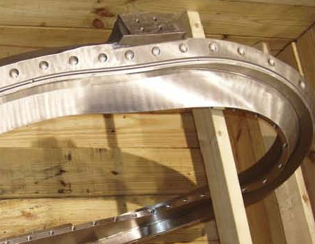
Coil “Base”

Coil “Sidewall”

Figure 1: Bare Casting. This is the TRC; the Full-sized Modular Coils are similar

Coil “Sidewall”

Coil “Base”

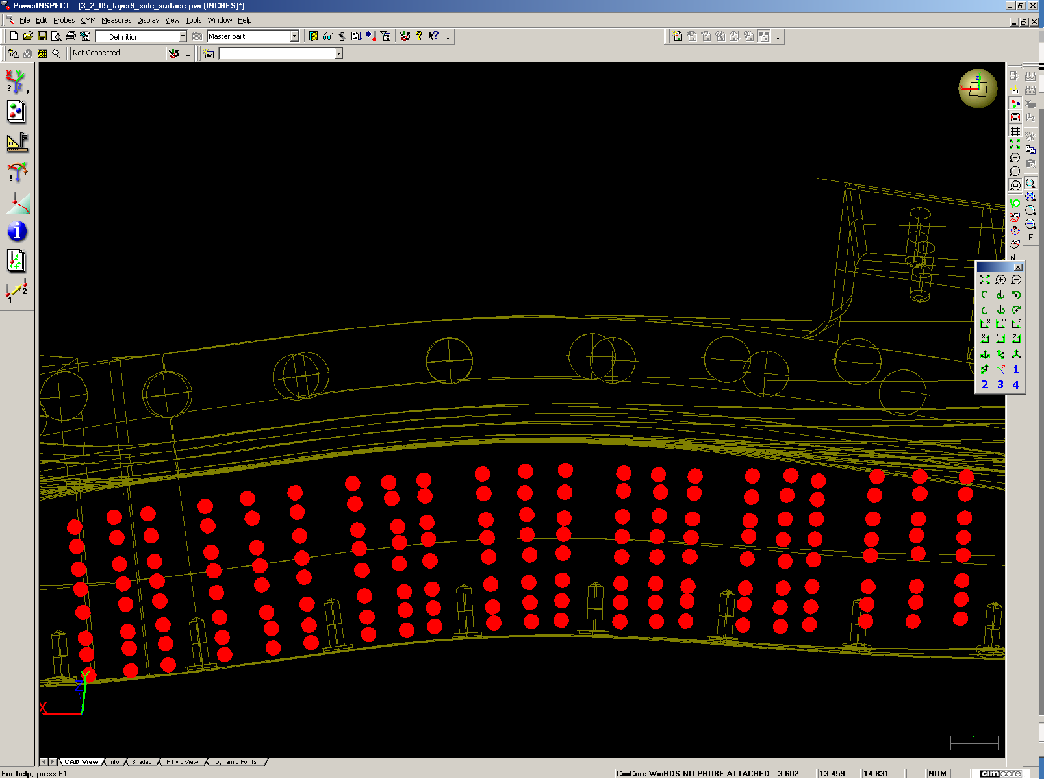

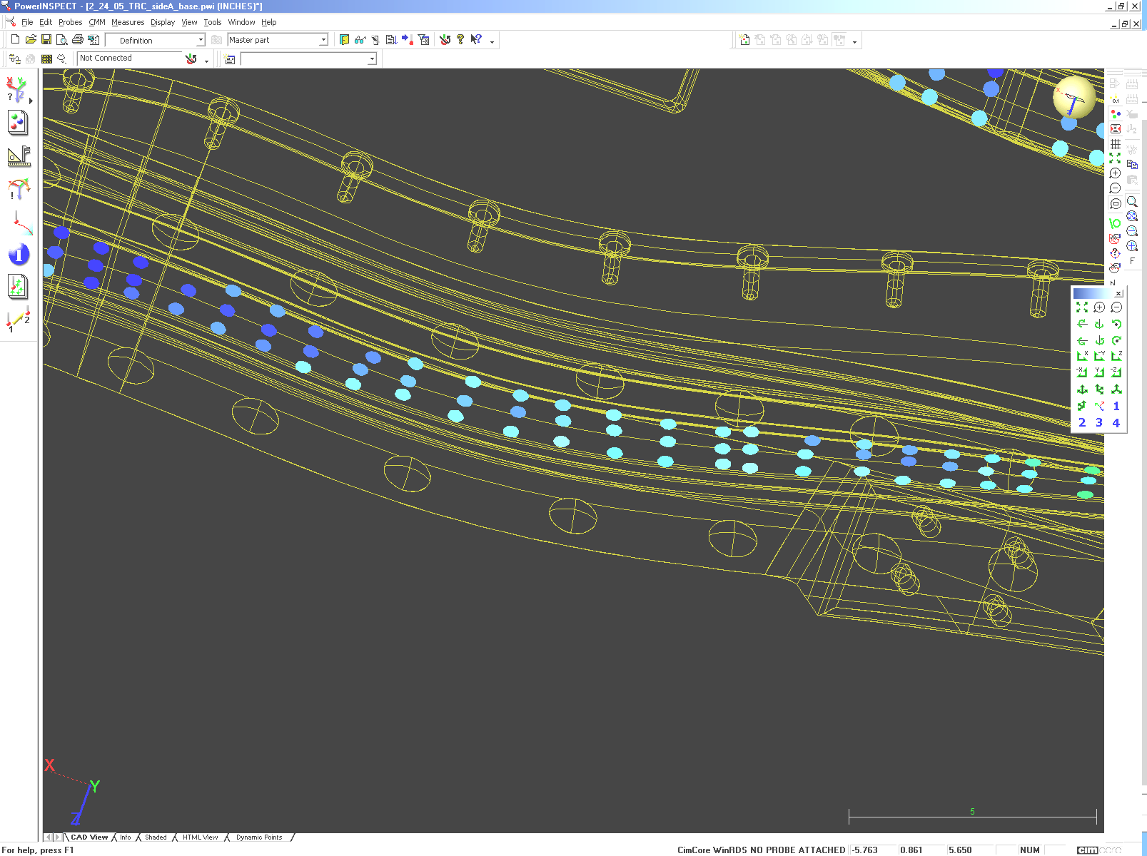

Figure 2: Inspection pattern for “Surface Inspection” of coil.

    - Refine the alignment with a “Best Fit” optimization using the inspection data from the winding surface.
    - After the “Best Fit”, re-measure the location of all fiducials and record below:

Point ID | X-coordinate | Y-Coordinate | Z-Coordinate | Comments

    - Compare “vendor supplied” coordinates of fiducials to the values of those elements as measured after the “Best Fit”. The Metrology Engineer and Dimensional Control Representative shall determine which set of coordinates will be used as the reference values for all subsequent re-alignments.
    - Using “Surface Inspection” mode, take inspection data along the winding surface with the 6mm ruby ball probe (probe 2). Break up the data into 4 separate inspection groups, one group for each sidewall and for each base of the winding surface. The points should be taken in a pattern as shown in figure 2. Use the sheet-metal templates to obtain the proper spacing for the points taken on the base and sidewall.

    - Inspect the remaining areas of the Coil (Flanges, new Fiducial points, close fitting areas)
    - After the installation of the copper cladding, measure the winding surface by:
      - Aligning to coil.
      - Measure the surface of the cladding using the “Standard Pattern”.
      - Re-measure the fiducial points.

    - This completes the initial inspection of the bare Modular Coil winding form/casting. Installation of studs and cladding can commence.

Metrology Engineer:

Dimensional Control Representative:

  - Stations 2 & 4: Measuring the conductor during/after winding activities:

Note: the coil has two sides that are wound independent of each other. One side is completed and measured and the coil is repositioned for winding of the second side. After completion of the second side, the measured data is analyzed and the two sides are adjusted (my means of clamp repositioning) to bring the net current centroid within tolerance.

    - After the installation of the Ground Wrap, measure the winding surface by:
      - Aligning to coil.
      - Measure the surface of the ground wrap using the “Standard Pattern”.
      - Re-measure the fiducial points.

    - Prior to the start of conductor installation, measure the height and width of the conductor. Record below:

 | Spool 1 | Spool 2 | Spool 3 | Spool 4 | nominal
Tall dimension |  |  |  |  | 0.415”
Short dimension |  |  |  |  | 0.384

Measurements during the winding process:

Per direction of the Dimensional Control Representative and/or the Metrology Engineer, measurements of a layer of conductor after it is installed are to be taken. The measurements are made against the CADD model of the particular layer.

    - After the installation of a layer, measure the coil pack surface by:
      - Aligning to coil.
      - Measure the surface of the conductor pack using the “Standard Pattern”.
      - Re-measure the fiducial points.

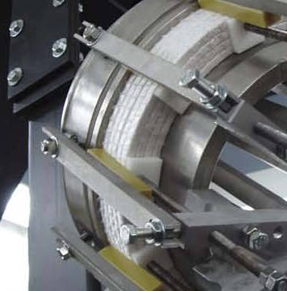

Figure 3: Locations for measuring the winding pack.
Measure winding pack next to clamp and midway between clamps.

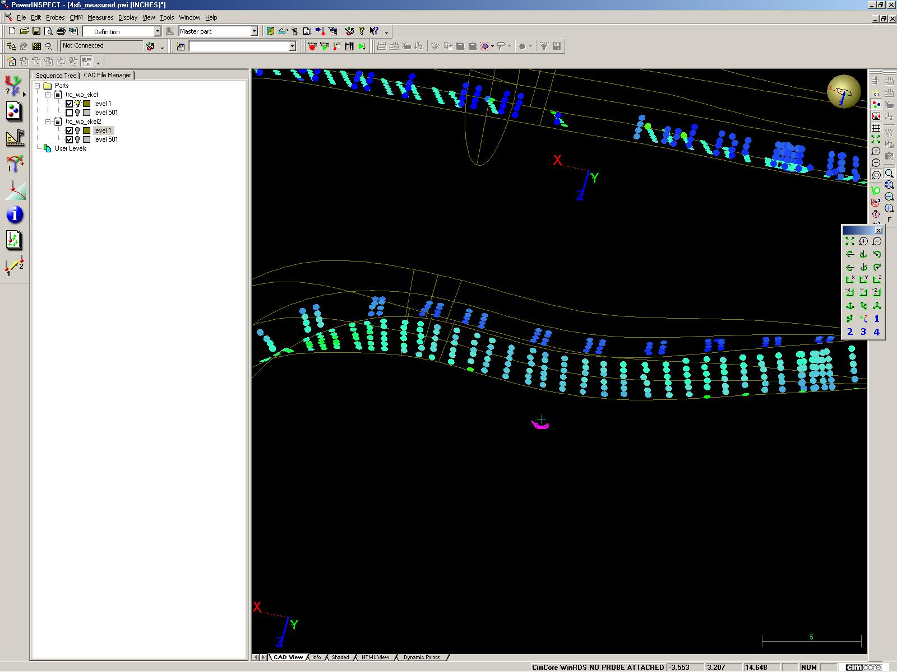

Figure 4: Winding Pack measurement data in PowerINSPECT

    - When all layers are installed, take a comprehensive set of measurements of the winding pack by:
      - Aligning to coil.
      - Measure the winding pack using the “Standard Pattern”.
      - Re-measure the fiducial points.

  - Adjusting the Winding Pack to position the current center.

Adjust height and width of both winding packs starting with Side “A”. This adjustment attempts to keep the current center of the coil within tolerance (0.020”) of the design position in places where setting of the top clamps to the calculated values can not be achieved. Work systematically in regions of 3-5 clamps. Start in regions of high torsion/curvature.

    - Set top and side clamps to values provided by the Dimensional Control Representative. Use Romer arm to set top clamps and adjust shims to set side clamps.
    - Measure top and side of Side “A” winding pack.
    - Readjust side A winding pack to put height and width within ±0.010” of predicted values where possible.
    - Measure top and side of Side “A” winding pack.

Measurements of adjusted Side “A” winding pack (from step 7.3.4) will be used to calculate adjustments to Side “B” winding pack required to put overall current center of coil at design location.

    - Adjust Side “B” top and side clamps to calculated values provided by the Dimensional Control Representative.
    - Measure top and side of Side “B” winding pack
    - Readjust side B winding pack to put height and width within ±0.010” of predicted values where possible.
    - Measure top and side of Side “B” winding pack
    - Perform final analysis to make sure design position of current center of coil is achieved. Use final measurements of both sides as input.
    - If current center position is not satisfactory, repeat adjustment of both sides (steps 7.3.1 to 7.3.10)
    - Perform final measurement of height and width of winding packs after adjustment is complete.

  - Maintaining Conductor Position during Ground Wrap and Chill Plate Installation

    - Use Romer arm to measure positions of top and side. (Need to define measurement points on clamps)
    - Go around coil, completing ground wrap and installing chill plates in sections of 3-5 clamps each. In each section:
      - Remove minimum number of top and side clamps needed to complete ground wrap and install chill plates on both sides in one section of the coil.
      - Complete ground wrap on both sides of coil, keeping thickness as uniform as possible at top and side clamp locations. Thickness variation elsewhere is OK.
      - Install chill plates, ensuring that they are in good contact with the winding pack, especially in clamp locations.
      - Re-install top and side clamps to positions measured in step 33 minus compressed ground wrap thickness plus chill plate thickness. Use Romer arm to set top clamps. Use shims to set side clamps.
    - Measure top and sides of chill plates in standard measurement pattern. Check that dimensions are consistent with final measurements of winding packs in step 32 plus thicknesses of compressed ground wrap and chill plates. What tolerance to set on this measurement?
    - Install cooling tubes and solder them in place, removing minimum number of clamps required to work in a given area. Re-install top and side clamps to positions used in step 7.4.2.4.

- Post Measurements

  - Once measurements have been completed perform the following steps:
  - Save data
  - Create PowerINSPECT report.
  - Shut down the system; carefully remove the CMM Arm from its stand and store in its storage compartment.
  - Provide copy of PowerINSPECT file and Inspection report to the Metrology Engineer or the Dimensional Control Representative.
Appendix A

Procedures and Acceptance Criteria for Various Measurement Techniques:

- Length check Procedure:

This procedure verifies the calibration of the arm by making 5 measurements of a known standard length. The Accuracy is determined by the average of the measurements and the precision is determined by the standard deviation (Range/2) of the measurements.

  - Measure the N.I.S.T. length standard per instructions in the Romer training manual.
  - The calculated “Average Length” should be within the range of the length standard value (printed on the label on the bar) +/-0.1mm. If it does not fall within this range then repeat measurement.
  - The measured “Range/2” should be less than 0.1mm [the length tolerance (LthTol)].
  - If the arm cannot measure the length standard within the specified tolerance, then remove this arm from service.

- Point Check Procedure:

This process is checks the calibration of the probes. The 15mm steel ball probe is considered a “standard” and cannot be re-calibrated. If the probe fails its calibration check then it should be taken out of service and return to Romer. Other probes can be re-calibrated (the lookup file that contains the probe parameters can be re-written) if there is any suspicion that they have been bent or damaged. Note that the acceptance criteria for the 15mm probe. Other probes (especially longer probes) typically have greater “Range/2” values.

15mm Probe (Probe 1)
  - Perform the Point Checkout per the instructions in the Romer training manual.
  - The measured “Range/2” value for X, Y, and Z, should each be less than the Point Tolerance (PtTol).
  - If the “Range/2” is greater than the PtTol then take probe out of service.
Other Probes
  - Perform the Point Checkout per the instructions in the Romer training manual. Make note of the “Range/2”.
  - Accept the calibration of the point and repeat the Point Checkout procedure. The “Range/2” should be equal to or less than the value in step “d”. If not, repeat the process.

- Best Fit Alignment:

This process is used to align the arm to the part being measured. A CADD model of the part is loaded into the PowerINSPECT software. A set of geometric elements with known coordinates is part of the model. The geometric elements are measured and the software performs a coordinate transformation (translation/rotation) of the measured pattern to the pattern defined by the CADD coordinates to align the Arm’s coordinate system to the CADD coordinate system.

  - Define a set of “Geometric Elements” that corresponds to the fiducials. For tooling balls define the elements as “Spheres”; for conical seats define the elements as “Points”. Enter the coordinates of know Fiducial points into the “nominal value” box.
  - Measure the locations of the fiducials in the same order that they are defined in the “Best Fit Alignment”
  - Select “Best Fit (points) Alignment” option. Define the alignment points as the elements measured in step “a”.
  - “Play” the “Best Fit”. If you have not already done so, you will be directed to measure the points that were defined. The coordinate system will undergo a translation/rotation to align the measured pattern to the defined (nominal values) pattern.
  - Check the error of the alignment.

    - If the “error” for more than one point is greater that 0.008” out, then reset and repeat the alignment process.
    - If only one point is out by more than 0.008”, discard that point from the alignment process. If the resultant alignment still contains points that are more than 0.008”, then “reset” the “Geometric Element” measurement and the “Best Fit” and repeat from the start.
    - If measuring spheres, the diameter of the measured sphere must be within 0.003” (of the nominal diameter) for that measurement to be accepted.

REVIEWERS (designated by RLM)
Accountable Technical Individual… S. Raftopoulos
Test Director…………………………
Independent Reviewer
D-Site Shift Supervisor…………….
NCSX……………………………J. Chrzanowski, Brad Nelson, L. Dudek, B. Stratton
Vacuum……………………………….
Diagnostics
Quality Assurance/Quality Control……….J. Malsbury
Maintenance and Operations Division
Energy Conversion System/Motor Control System
D&D HP/Rad Waste Coordinator
Environmental Restoration & Waste Management Division
NCSX Mechanical/Vacuum…………….
Environmental, Safety, & Health ……
Industrial Hygiene……………………...
Health Physics…………………………..
NCSX Electrical…………………………

TRAINING (designated by RLM)
No training required ______________ | Instructor _________________________
Personnel (group, job title or individual name) |  | Read Only | Instruction Pre-job Briefing | Hands On
Lead Tech. |  | X
QC |  | X
Technicians performing task |  | X
NSTX Field Supervisors |  | X
NSTX Construction Manager |  | X
Training Rep.

RLM L. Dudek

