Princeton Plasma Physics Laboratory
Procedure
Procedure Title: Modular Coil Autoclave Operating Procedure
Number:  D-NCSX-OP-G-162 |  | Revision:  1 |  |  | Effective Date: May 12, 2006  Expiration Date:  (2 yrs. unless otherwise stipulated)
Procedure Approvals
Author: Steve Raftopoulos
ATI: Steve Raftopoulos
RLM: Larry Dudek
Responsible Division: NCSX
Procedure Requirements
Designated by RLM
LABWIDE:
X | Work Planning Form # WP-1138 & 1188 (ENG-032) |  |  | Lockout/Tagout (ESH-016)
X | Confined Space Permit  (5008,SEC.8 Chap5) |  |  | Lift Procedure (ENG-021)
 | Master Equip. List Mod (GEN-005) |  | X | ES&H Review (NEPA, IH, etc.)
 | RWP (HP-OP-20) |  |  | Independent Review
 | ATI Walkdown |  |  | Pre-Job Brief
 | Post-job Brief * |  |  | Hazard analysis
D-SITE SPECIFIC:
X | D-Site Work Permit (OP-AD-09) |  |  | Door Permit (OP-G-93)
 | Tritium Work Permit (OP-AD-49) |  |  | USQD (OP-AD-63)
 | Pre-Job Brief (OP-AD-79) |  |  | T-Mod (OP-AD-03)
 | ** DCA/DCN (OP-AD-104) #
** OP-AD-104 was voided by procedure ENG-032. However, DCAs that were open at the time of adoption of ENG-032 are still considered valid for work approval purposes.

1.0 Purpose

The purpose of this procedure is to provide the guidance for operating the NCSX Modular Coil Autoclave.

- Scope

The scope of this procedure covers the following:

- Pumpdown, heating, pressurization and air circulating modes of operation.

The scope does not cover the following

- Installation of coil(s), VPI process.

- References

  - ENG-021, "Hoisting and Rigging Program" Rev.3
  - SC144-400 “Modular Coil Autoclave Vacuum P&ID” drawing
  - ESH-016 "Control of Hazardous/Energy Sources-Safing/Lockout/Tagout"
  - D-NCSX-MCF-001, “Modular Coil Fabrication – Winding Form Preparation Activities”
  - D-NCSX-MCF-002, “Modular Coil Fabrication – Winding Station Activities”
  - D-NCSX-MCF-003, “Modular Coil Fabrication”- VPI/Autoclave Activities
  - NCSX-MIT/QA-142-01 “Manufacture, Inspect and Test/Quality Assurance Plan”
  - NCSX-PLAN-MFOP-01 “NCSX Manufacturing Facility Operations Plan”
  - D-NCSX-OP-EO-41 “Modular Coil Manufacturing Facility-Emergency Response Procedure”
  - OP-AD-09 “D-Site Work Permit”
  - ESH-008 “Access to RCAs”
  - IH-OP-08 “Fume Hood Velocity Measurement & Performance Evaluation”

- Precautions and Limitations

  - The Autoclave will operate at elevated temperatures (up to 300 degrees Fahrenheit). In addition to proper PPE (determined by IH), the workers should exercise caution in the proximity of heated surfaces.
  - The autoclave chamber will operate under vacuum. Proper vacuum safety protocols should be followed by workers.
  - The autoclave chamber will operate at positive pressures. Proper compressed gas safety protocols should be followed by workers.
  - When the Autoclave lid is removed, access to the upper walkway is restricted to the ladder landing area. Workers ARE NOT permitted to go beyond the chains with the lid off. Access to the upper walkway IS permitted only when the lid is within 12” of the chamber.
  - If the autoclave chamber is to be moved, the lid must be installed and the lifting lugs on the cylinder walls must be used. The lifting lugs located on the lid are rated for the weight of the lid only.
  - The main system circuit breaker (480V) should never be thrown unless all loads are switched off.
  - Before the chamber is evacuated, the circulating air heating system valves (A-VV-3 and A-VV-4) must be closed.
  - Before the chamber is pressurized, the circulating air heating system valves (A-VV-3 and A-VV-4) must be closed.
  - Whenever individuals enter the autoclave the following must be done:
  - Confined Space entry permit must be obtained;
  - Blower, heaters and vacuum pumps should be de-energized and safed per ESH-016, "Control of Hazardous/Energy Sources-Safing/Lockout/Tagout".

Prerequisites

  - Perform an inspection of the Autoclave. Verify that the following conditions are met:

    - Lexan guards are installed on the viewports.
    - Insulation is intact and that none of the chamber and heating duct surfaces are uncovered.
    - All valves are labeled.
    - If the lid is off, inspect the O-ring for damage.
    - Interior lighting is functioning.
    - Vacuum & pressure readouts are operational.
    - Temperature readouts are operational.
    - Remove unnecessary items from the walkways.
    - Bottled gas supply is adequate to support VPI run.
    - A clean exhaust oil trap filter is installed (not saturated with oil).
    - Vacuum pump exhausts are configured to Stack 8 elephant trunk station and RF-113/114 and Booster Fan system are in operation.
    - Elephant trunk station has been tested by IH.

Procedure

  - Removing/Installing the Autoclave Lid

CAUTION: Before attempting to remove the lid, ENSURE that all the nuts for the lid bolts have been removed.

    - Use the three lifting eyes and the test cell overhead crane to remove or install the lid. Rigging to be determined by Qualified Riggers.
    - While the lid is off, INSPECT the O-ring seal for damage. Minor damage can be repaired using silicone RTV. If the O-ring appears unserviceable, then REPLACE with a new one.

  - Pumping out the air in the Chamber

General precautions regarding the vacuum system:
- The circulating duct isolation valves must be closed before the initiation of pumpdown.
- When a pump is running its exhaust valve must be open.
- When a pump is stopped it should be vented to atmosphere.
- Do not open gate valves when there is pressure differential > 20 Torr across the gate.
- Unless specified, venting gas is room air.

    - PLACE pump disconnect switch and starter to “ON” positions
    - ENSURE that vacuum pump exhaust is directed to elephant trunk system.
    - If the autoclave is pressurized above ambient (0 psig) then VENT to room pressure by opening A-SV-5
    - CLOSE the Air Heating Circuit isolation valves (A-VV3 and A-VV-4).
    - VERIFY valve position indication at control panel.
    - If only one pump is operating, CLOSE the non-running Pump’s isolation and exhaust valves.
    - VERIFY that all other service valves for the autoclave are shut.
    - OPEN the vacuum pump isolation valve(s) (A-VV1 and/or A-VV-2), exhaust valve(s) (EV1 and/or EV-2) and the autoclave tank isolation valve (A-VV-5).
    - If desired, FILL the cryo-trap with LN2.
    - From the main control panel, START Pump(s). VERIFY indication at control panel.
    - PUMP on tank until desired pressure is achieved.

  - Pressurizing the Chamber

General precautions regarding this system:

- The circulating duct isolation valves (A-VV3 and A-VV-4) must be CLOSED before any pressurization above ambient room pressure (0 psig).
- Pressurization gas is nitrogen, unless otherwise specified by the cog engineer.
- If bottled gas is used, each standard type-K bottle (full @ 2000 psi) will increase the chamber pressure by approximately 1.6 psi

    - If the autoclave is evacuated (under any vacuum) then VENT to room pressure.
    - CLOSE the Air Heating Circuit isolation valves (A-VV3 and A-VV-4).
    - CLOSE both Pump 1 & 2 isolation valves (A-VV-1 & A-VV-2).
    - CLOSE the autoclave tank isolation valve (A-VV5)
    - Using bottled gas (or LN2 blow-off gas), PRESSURIZE the autoclave to the desired pressure via the line connected to A-SV-4.
    - ISOLATE the bottle by closing A-SV-4.
    - When pressurization is no longer desired, EVACUATE the chamber using the vacuum system and VENT to 0psig with room air.

  - Heating System

General precautions regarding this system:

- The heating system should be operated in “AUTO” mode. If “MANUAL” mode is selected, be aware that the thermocouple feedback control of the heaters is disabled.

    - Heated air circulating system operation

      - Ensure that the chamber is at 0 psig (ambient room pressure)
      - OPEN the heated air circulating valves (A-VV-3 & A-VV-4).
      - PLACE blower and heater starter/disconnect switches to the “ON” positions.
      - SET the heater air temperature dial to the desired setting.
      - PLACE the Manual blower bypass switch to the “OFF” position.
      - PLACE the Autoclave heater system switch to the “AUTO” position. The blower should start.
      - Monitor temperatures, adjust the set points as required to achieve desired final temperature.
      - If desired LOG temperature data with the Omega “DP472-C2 series Viewer Software”

Chamber strip heater operation

General precautions regarding this system:

- When the chamber strip heaters are de-energized, set the temperature controllers to the room temperature (~68º F).
- The heater strips operate at approximately 1500º Fahrenheit. They reside under the raised bumps in the insulation. Use caution when working in the vicinity of these heaters.

PLACE the Autoclave heater system switch to the “AUTO” position.

SET the temperature controllers to the desired target temperature. The heaters should energize and the temperature readouts should respond.

If desired, LOG temperature data with the Omega “DP472-C2 series Viewer Software”

Continue to heat the chamber and monitor until the desired temperature is achieved.

  - Emergency Response/Shutdown

This section covers the steps required to rapidly shut down the autoclave in the event of an emergency or alarm.

    - Emergency Response #1– In the situation where all energized electrical sources must be de-energized immediately:

      - PLACE the following circuit breakers to the “OFF” position and immediately evacuate the area:
On Cart #1, circuit breakers PCB-66 and PCB-67.
On Cart #2, circuit breakers PCB-68.

    - Emergency Response #2– Response to alarm where there is not an immediate risk of injury and there is sufficient time for an orderly shutdown of equipment:

      - At the Main Control Panel (B-ACLV-02), TURN OFF the vacuum pumps and PLACE the Autoclave heater system switch to the “OFF” position.
      - At the Vacuum pump station, CLOSE both pump isolation valves (A-VV-1 and A-VV-2) and VENT the pump(s) at valves (A-SV1 and/or A-SV-2).

- Figures
Figure 1: VPI Control/Information Panel (On VPI Platform)

Chamber air temperature readout

Chamber air temperature readout

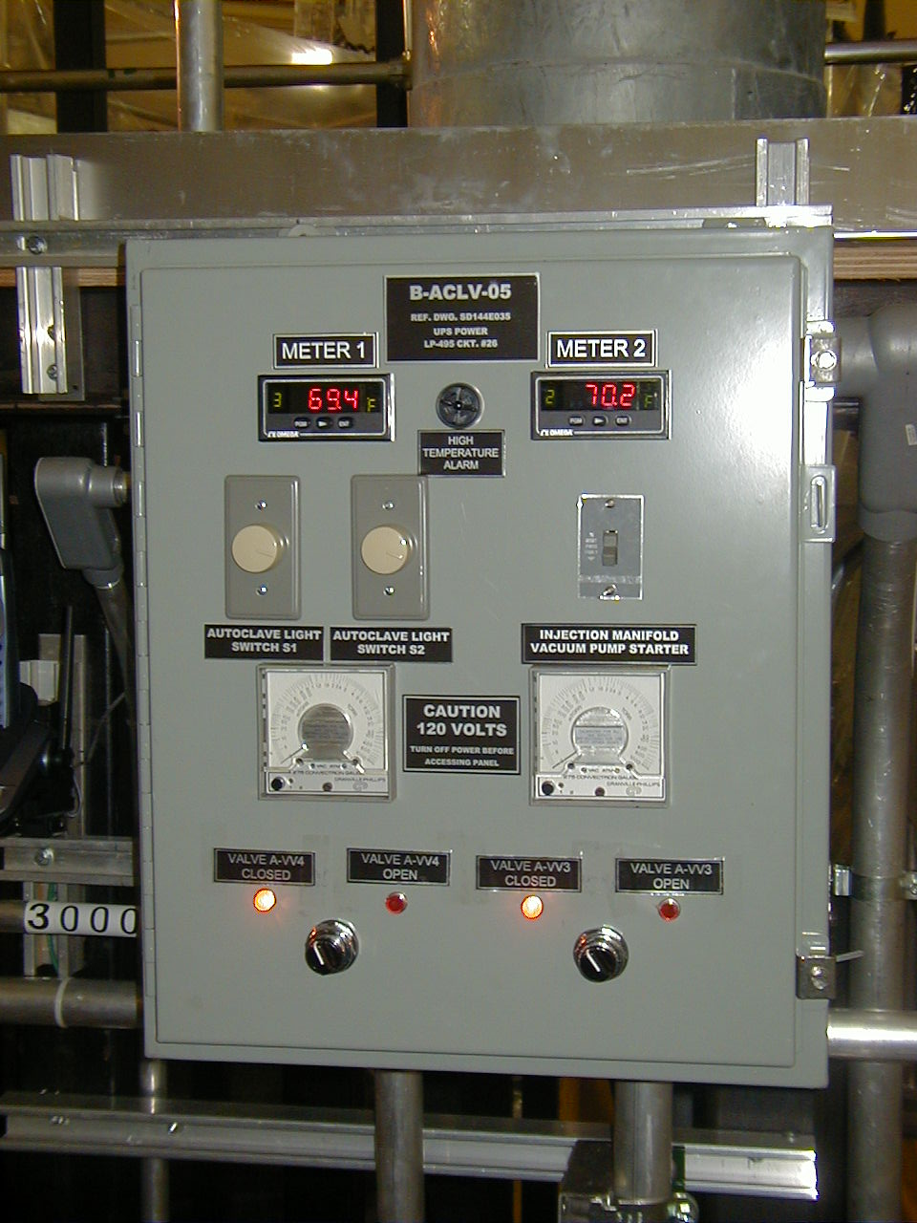
Secondary lights switch. On/off & dimmer.

Valve position indicator lights

Valve A-VV-4 position switch

Valve A-VV-3 position switch

Primary lights switch. On/off & dimmer.

Figure 2: Vacuum pump Starters and Disconnect Switches
(Located along the south wall of the test cell, next to the vacuum pumps)

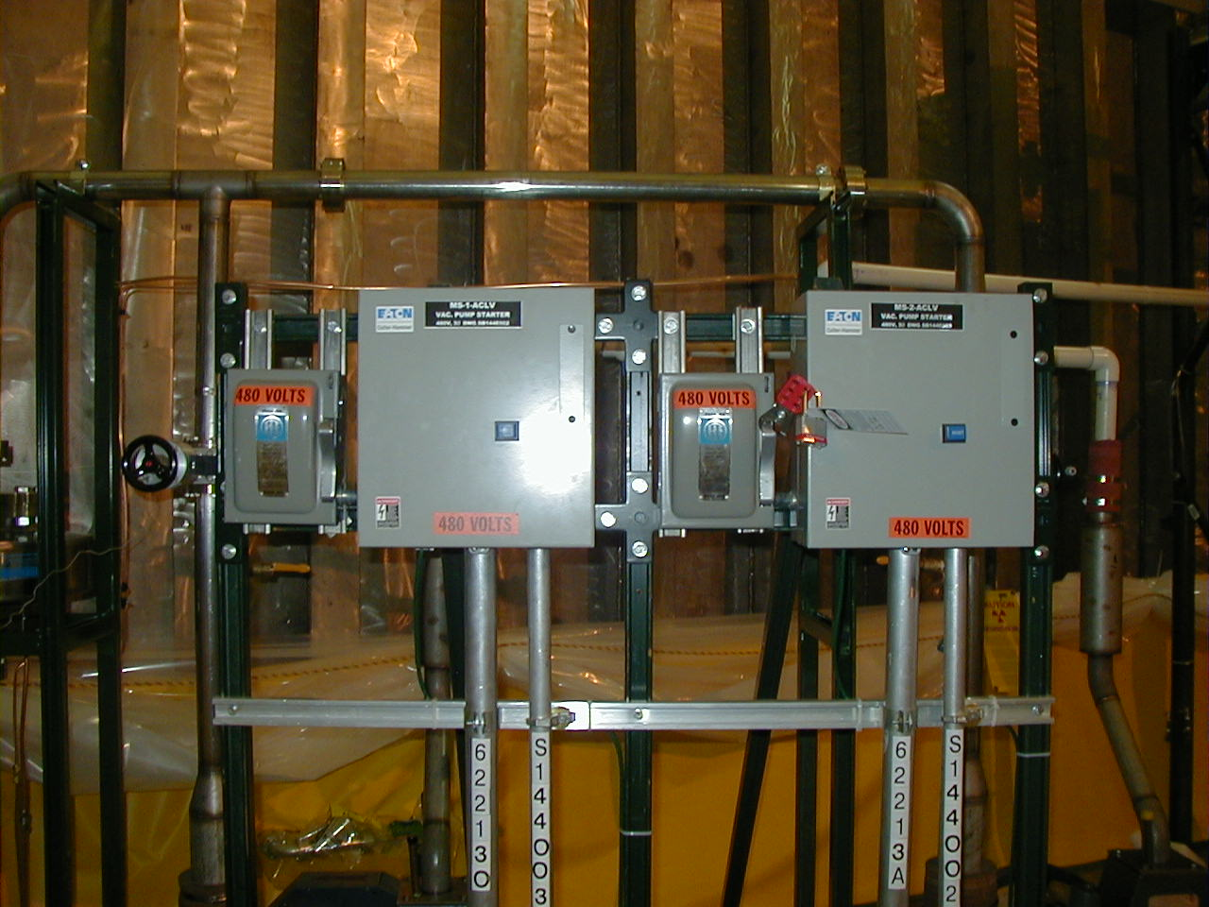

Pump A-VP-2 starter

Pump A-VP-1 starter

Pump A-VP-2 disconnect switch

Pump A-VP-1 disconnect switch

Figure 3: Circulating Air Heating System Starters/Disconnect Switches
(Located at the northwest corner of the autoclave on 102’ level)

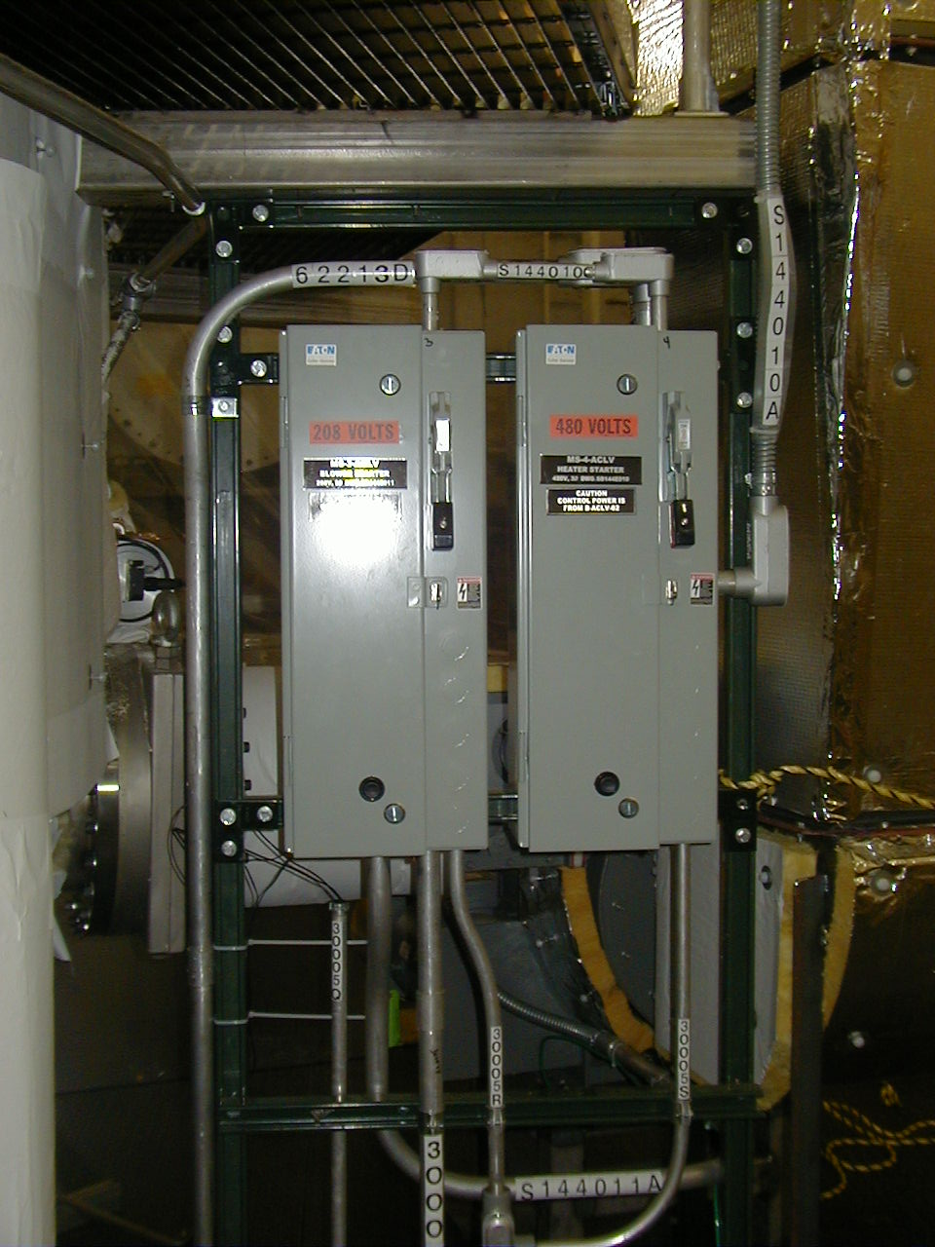

Air heating system – circulating blower starter/circuit breaker

Air heating system – 24Kw heater starter/circuit breaker

Figure 4: Main 480V switch
(Located on the south wall)

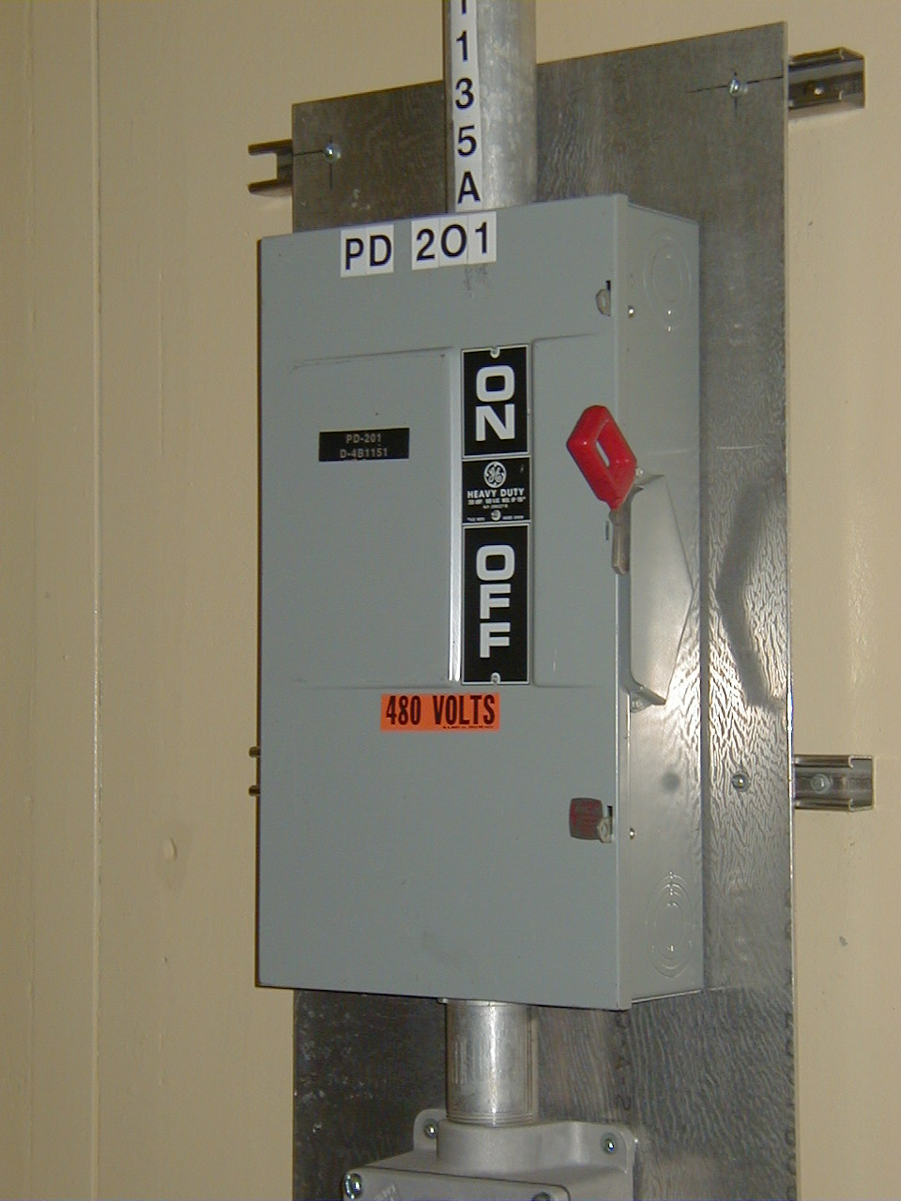
System main power (480V) breaker. Should be under “no load” condition before operating switch.

Figure 5: Chamber strip heater circuit breakers
(Located near the south wall, on the power cart(s))

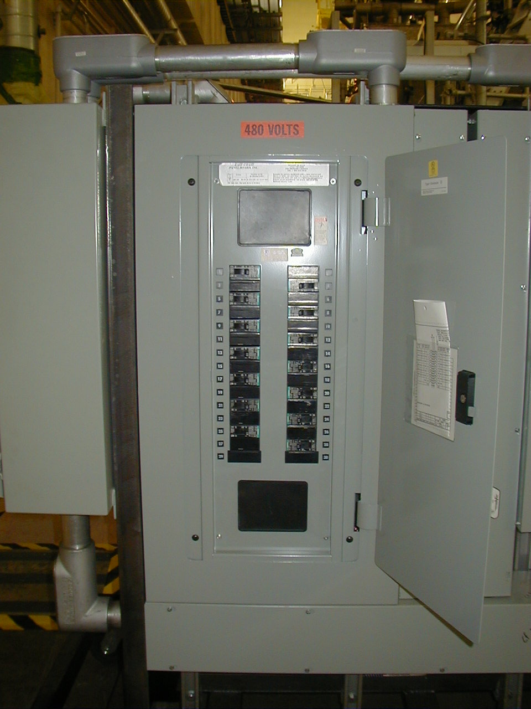
Primary heater circuit breakers

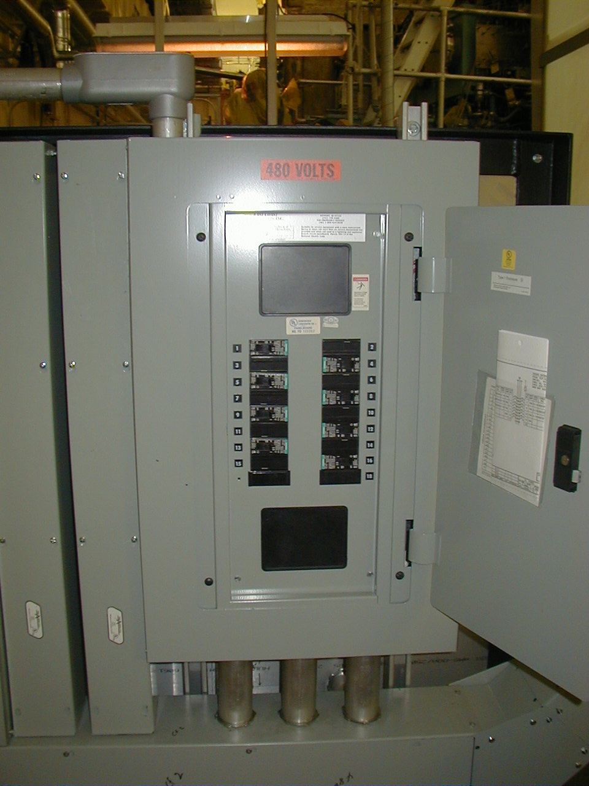
Secondary heater circuit breakers

Figure 6: Vacuum system components
(Located on the south side of the autoclave)

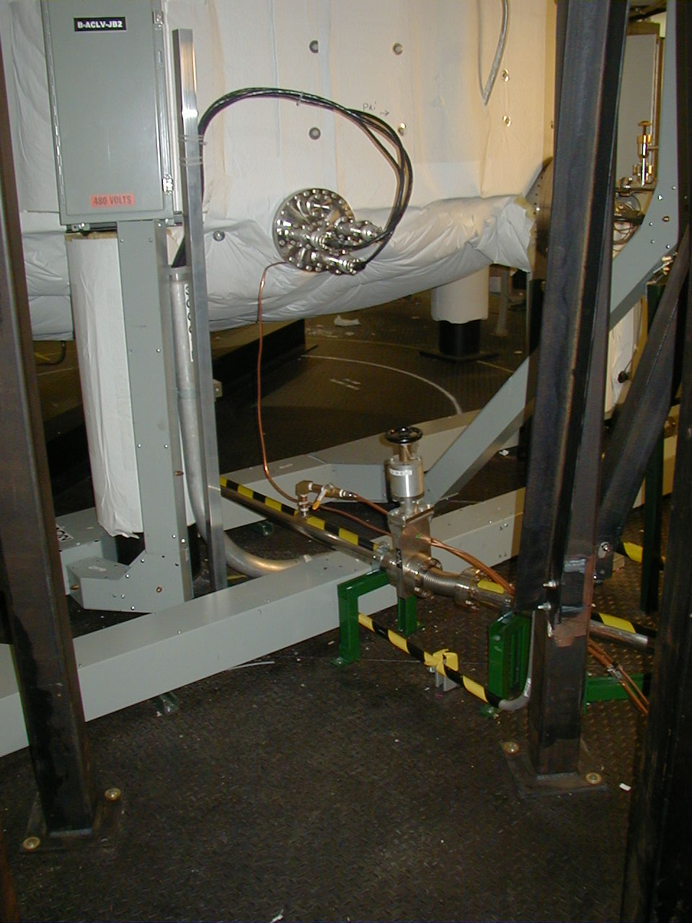
A-VV-5
Vacuum system fore-line isolation valve

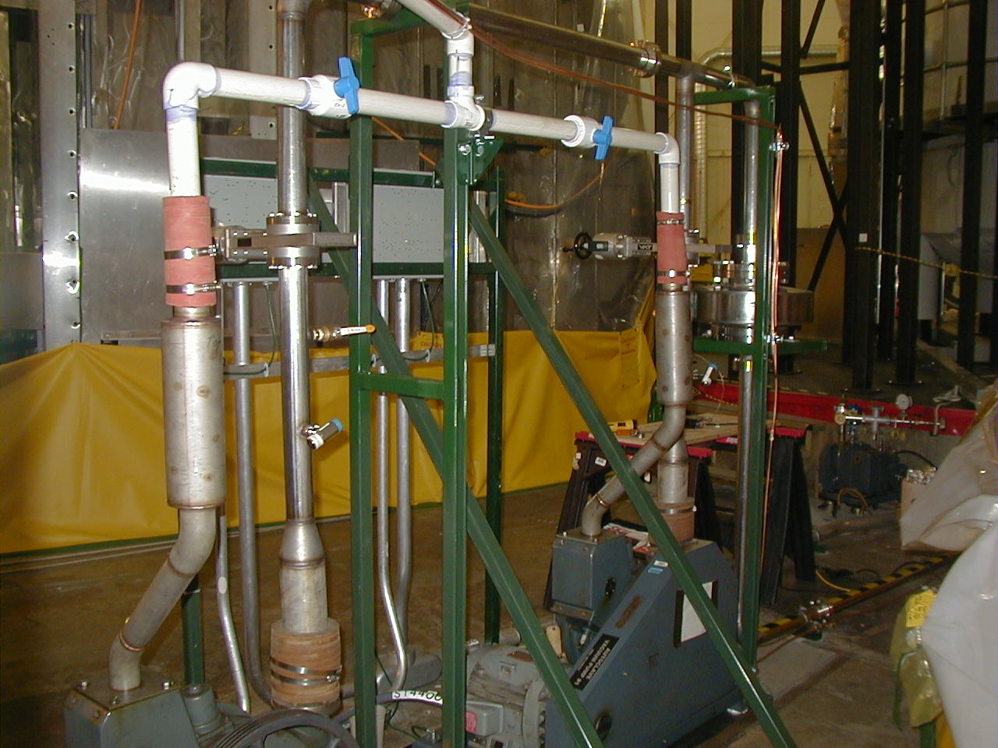
Pump 2 exhaust isolation valve EV-2

Pump 1 exhaust isolation valve EV-1

Figure 7: Vacuum system components
(Located on the south side of the autoclave)

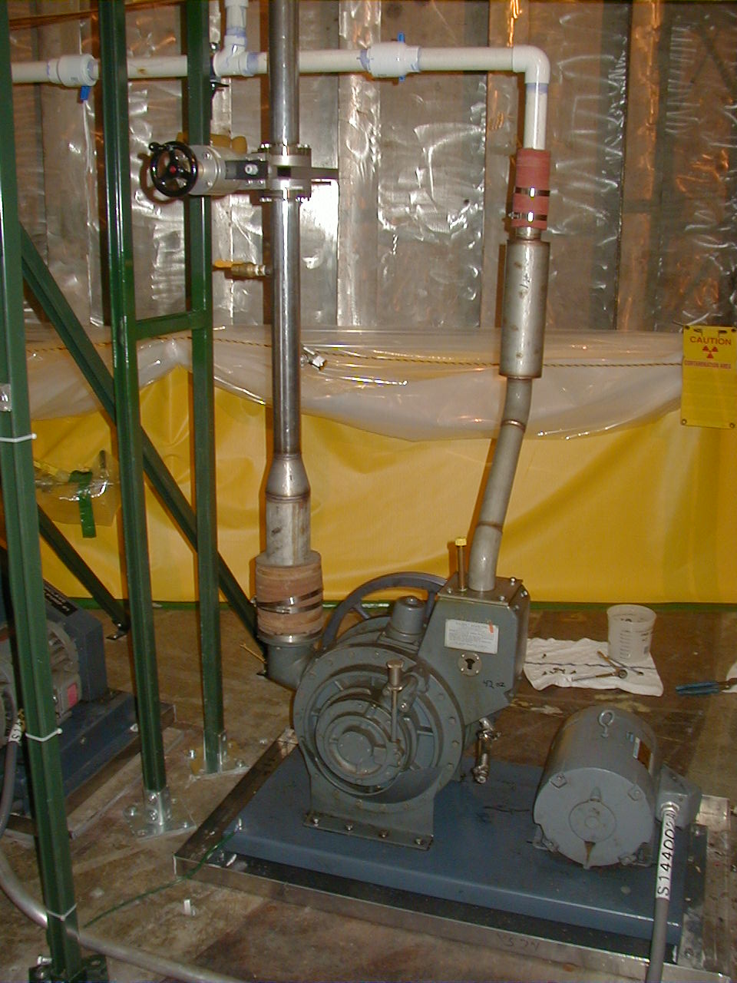
Pump A-VP-2
Pump 2 isolation valve A-VV-2
Pump 2 exhaust isolation valve EV-2

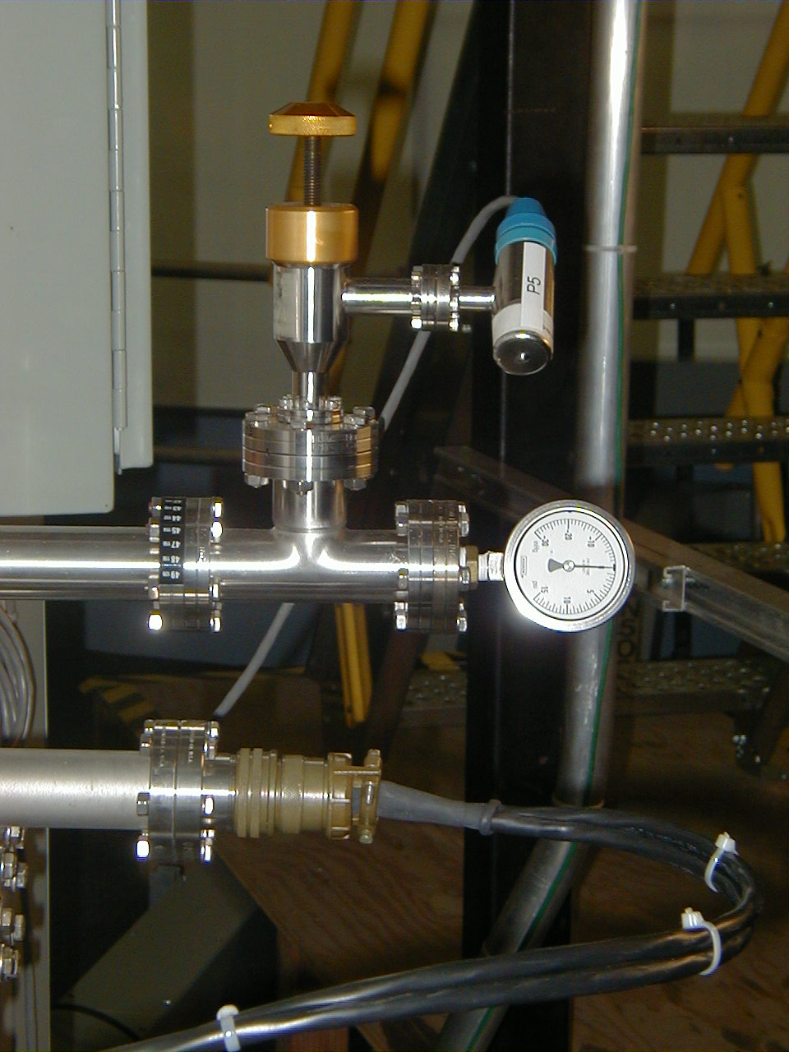
Manual vacuum/pressure gauge
“P5” Pressure transducer

Figure 8: Main Control Panel
(Located along the south wall of the test cell)

Secondary TC temperature readout(s)

Blower air temperature readout(s)
Vacuum pump “start” & “stop”
switches

Primary TC temperature readout(s)

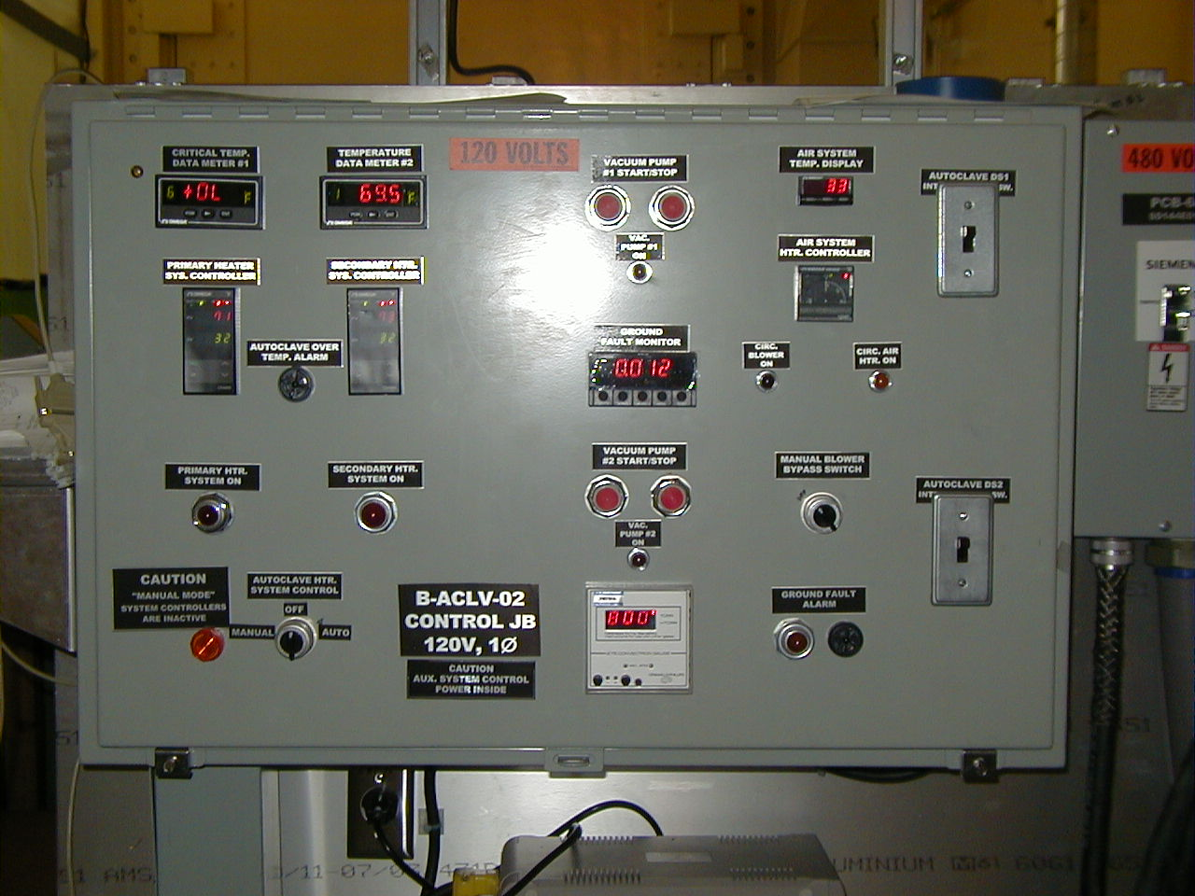
Blower air temperature setting
Air circulating blower fan manual over-ride switch.
Chamber vacuum reading
Heating system “manual/auto” switch. No feedback control on “manual”.
Secondary TC temperature controller
Primary TC temperature controller
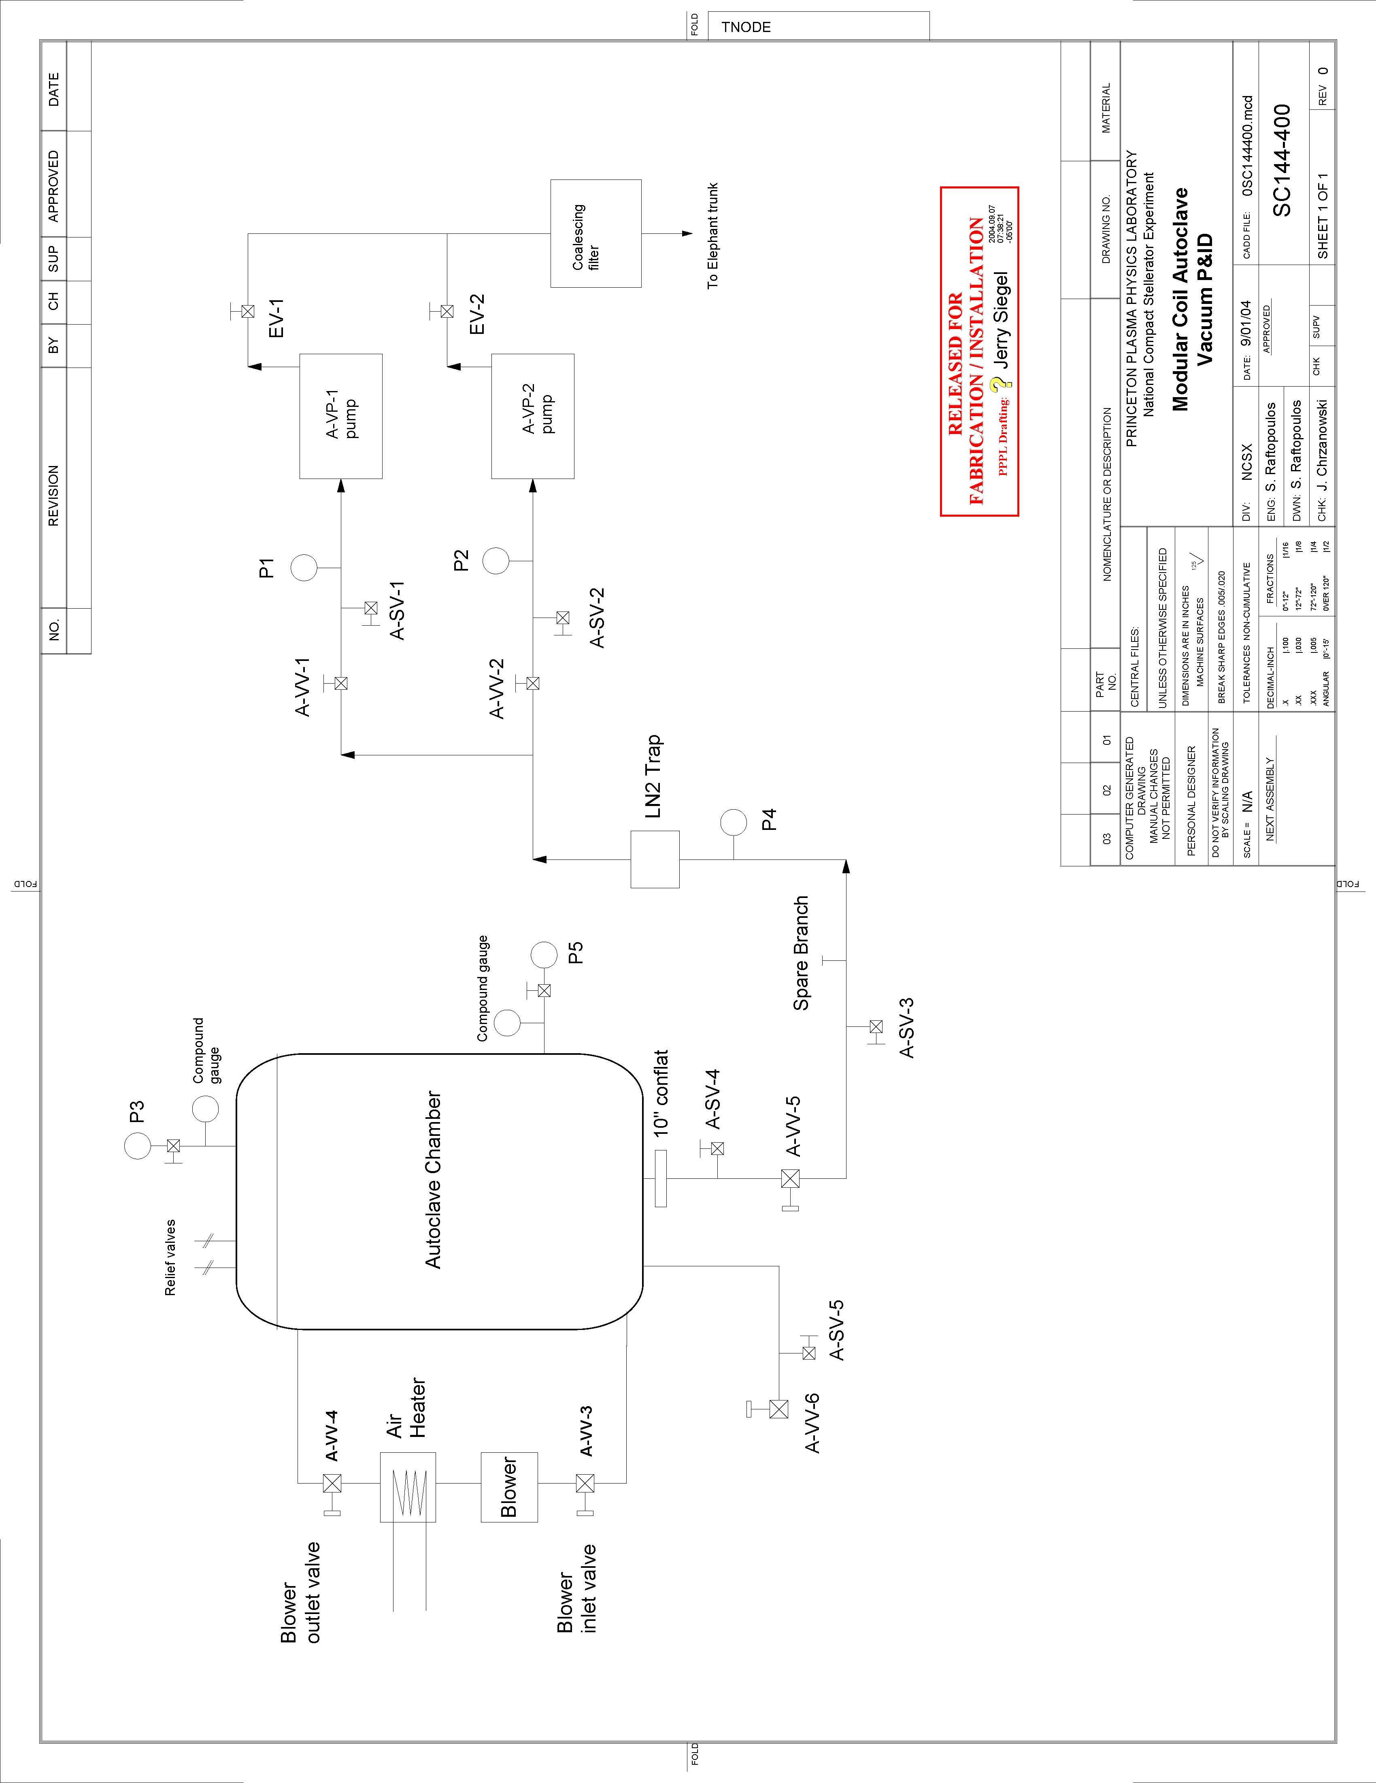

REVIEWERS (designated by RLM)
Accountable Technical Individual… S. Raftopoulos
Test Director…………………………
Independent Reviewer
D-Site Shift Supervisor…………….
NCSX……………………………J. Chrzanowski, T. Meighan, L. Dudek
Vacuum……………………………….
Diagnostics
Quality Assurance/Quality Control……….
Maintenance and Operations Division
Energy Conversion System/Motor Control System
D&D HP/Rad Waste Coordinator
Environmental Restoration & Waste Management Division
NCSX Mechanical/Vacuum…………….Eugene Kearns
Environmental, Safety, & Health ……
Industrial Hygiene……………………...W. Slavin
Health Physics…………………………..
NCSX Electrical…………………………F. Jones

TRAINING (designated by RLM)
No training required ______________ | Instructor _________________________
Personnel (group, job title or individual name) |  | Read Only | Instruction Pre-job Briefing | Hands On
Lead Tech. |  |  | X
QC |  |  | X
Technicians performing task |  |  | X
NSTX Field Supervisors |  |  | X
NSTX Construction Manager |  |  | X
Training Rep.

RLM L. Dudek

