Princeton Plasma Physics Laboratory
Procedure
Procedure Title: Modular Coil Lead Repair-Part 2 Repair

Number:  D-NCSX-RP-STEL-058 |  | Revision:  00 |  |  | Effective Date: July 28, 2006  Expiration Date:  (2 yrs. unless otherwise stipulated)
Procedure Approvals
Author: Tom Meighan:
ATI: Jim Chrzanowski:
RLM: Larry Dudek:
Responsible Division: NCSX Project
Procedure Requirements
Designated by RLM
LABWIDE:
 | Work Planning Form # WP-1138 (ENG-032) |  |  | Lockout/Tagout (ESH-016)
 | Confined Space Permit (5008,SEC.8 Chap 5) |  | X | Lift Procedure (ENG-021)
 | Master Equip. List Mod (GEN-005) |  | X | ES&H Review (NEPA, IH, etc.) NEPA 1224
 | RWP (HP-OP-20) |  |  | Independent Review
 | ATI Walkdown |  | X | Pre-Job Brief
X | Post-job Brief *
D-SITE SPECIFIC:
X | D-Site Work Permit (OP-AD-09) |  |  | Door Permit (OP-G-93)
 | Tritium Work Permit (OP-AD-49) |  |  | USQD (OP-AD-63)
X | Pre-Job Brief (OP-AD-79) |  |  | T-Mod (OP-AD-03)
 | ** DCA/DCN (OP-AD-104) #

- Required for installations involving internal vacuum installations, critical lifts, and for the initial installation of repetitive work.
** OP-AD-104 was voided by procedure ENG-032. However, DCAs that were open at the time of adoption of ENG-032 are still considered valid for work approval purposes.

REVIEWERS (designated by RLM)
Accountable Technical Individual ………………… Steve Raftopoulos
Test Director
Independent Reviewer ……………………………………………Hutch Neilson, Mike Williams XX
D-Site Shift Supervisor …………………………
NSTX ……………………………..
Electrical …………………………….. Raki Ramakrishnan, Bob Marsala X
Vacuum
Computer
Field Supervisor /Test Director Tom Meighan X
Quality Assurance/Quality Control ……………………………Colin Phelps X
AC Power
Maintenance and Operations Division
Energy Conversion System/Motor Control Division
D & D Rad Waste / H.P Coordinator…………………………………
Environmental Restoration & Waste Management Division
Water
Neutral Beam (Heating Systems Branch of Electrical Engineering)
Radiofrequency (Heating Systems Branch of Electrical Engineering)
Diagnostics
Environmental, Safety & Health ……………………
Industrial Hygience…………………………….. Neil Gerrish
Health Physics……………………………………
RLM……………………….. Larry Dudek X

TRAINING (designated by RLM)
No training required ______________ | Instructor _Jim Chrzanowski
Personnel (group, job title or individual name) |  | Read Only | Instruction  Pre-job  Briefing | Hands On
Technicians performing task |  |  | x
Training Rep.
RLM Larry Dudek

1.0 PURPOSE

This procedure will describe the precautions and steps required to repair and seal the Type “C” modular coil lead block area after diagnosis has been completed.

- SCOPE

This procedure will include:
  - Prerequisites prior to starting work
  - Steps for moving the coil so that the lead block is positioned optimally for the repair.
  - Steps for repairing the defects in the lead block region.
  - Steps for testing/validating the repair prior to seal.
  - Steps for sealing the lead block area.
  - Steps for testing/validating the repair after the lead block is sealed.

- REFERENCE DOCUMENTS

  - ESHD-5008, Environmental, Safety and Health Manual
  - D-NCSX-931 Lift Procedure

- PREREQUISITIES & ES&H ISSUES

  - The ATI or his designee will hold a pre-job briefing. This meeting will include a discussion of the hazards associated with this repair via the Job Hazard Analysis (JHA) sheet. The meeting shall be documented with attendance sheets forwarded to the Training Office.

Pre-job Briefing complete: ______________________ Date: ________
ATI/Designee

  - Use appropriate Personnel Protective Equipment as outlined in the JHA and procedure.

  - Using lift procedure D-L-NCSX-983, orient coil so that lead block is facing up.

- Repair procedure

  - This repair will be performed under the supervision of the Repair Director. The Repair Director, upon notifying the ATI and/or the RLM, has the authority to re-arrange the order of the steps if his observations during the repair warrant such re-arrangement.

Repair Director for this procedure:

RLM Acceptance:

  - ENSURE that all chill plate/cladding tubes, flux loops and strain gage wires are shorted together and grounded to the casing. ENSURE that the casing is shorted to building ground.

Verified: _______________________________ Date: ___________________
Repair Director

  - During repair work, COVER any exposed flux loop with blue vinyl tape in order to protect the diagnostic flux loops that exit the lead box on both sides of the coil.

Verified: _______________________________ Date: ___________________
Repair Director

  - REMOVAL OF CHILL PLATES

- SAFETY NOTE: Safety glasses MUST be worn when performing the steps that involve cutting, removing and bending of copper plates.

    - PERFORM initial Megger test by:

- SAFETY NOTE: High voltage gloves and an insulating mat MUST be used when performing the steps that involve the Megger test.

      - SHORT the terminals with section of welding cable or heavy duty clip leads.
      - APPLY voltage in gradual steps (1000 volt steps). HOLD at 5kV for one minute.
      - MEASURE and RECORD the resistance to ground.

Voltage Applied (KV) | Insulation Resistance (ΜΩ) | Comments
500V
1kV
2kV
3kV
4kV
5kV

Instrument model number:

Instrument serial number:

Calibration date:

Coil/Ambient temperature (degrees Centigrade):

Ambient Humidity:

    - MASK off the surrounding area around the chill plate fingers with duct tape and plastic. See figure 1.

    - Straighten the cladding fingers in location A that lock the cladding and chill plates.

    - Using tin snips and clippers CUT the Cladding plate fingers back so that once the fingers are re-bent the tabs on opposite sides of the septum DO NOT touch. [Location A]

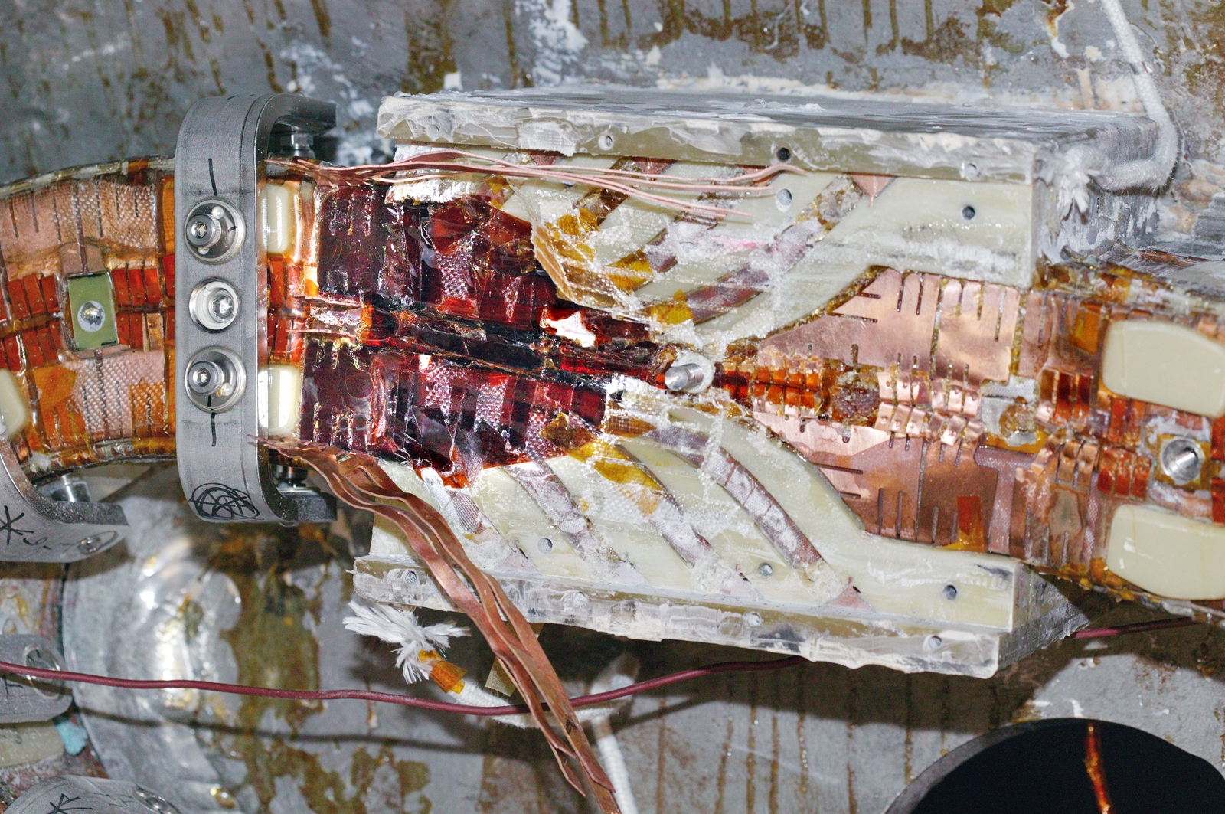
C
A
B
Figure 1- Lead Repair Area

    - At location B, flatten the chill plate that is bowed. EXTREME care should be taken not to damage the coil turns.

    - At location A, CUT the Chill Plate fingers so that approximately ¾” extends above the coil pack.

    - DRESS edges of the newly cut copper tabs with a file so that edges are smooth. USE a vacuum cleaner to capture filings.

    - At location C BEND the inner tabs inward toward the center of the septum wall. USE adhesive backed Kapton to ensure that tabs remain electrically isolated from the septum.

    - At location A, FOLD and rejoin the cladding and chill plates. Ensure that the cladding does not touch the cladding on the opposite side of the septum.

    - To ensure that the insulation resistance hasn’t changed after bending the tabs, MEGGER the coil to 500VDC for 1 minute using the Fluke mega-ohm meter and record the resistance.

- SAFETY NOTE: High voltage gloves and an insulating mat MUST be used when performing the steps that involve the Megger test.

      - SHORT the terminals with section of welding cable or heavy duty clip leads.
      - MEASURE and RECORD the resistance to ground.

Voltage Applied (KV) | Insulation Resistance (ΜΩ) | Comments

Instrument model number:

Instrument serial number:

Calibration date:

Coil/Ambient temperature (degrees Centigrade):

Ambient Humidity:

    - Megger tests acceptable - PROCEED to repair section 5.5.

Verified: _______________________________ Date: ___________________
Repair Director

  - REPAIR/SEALING OF DRY AREAS

- SAFETY NOTE: Chemical goggles and heavy nitrile gloves MUST be worn when performing the steps that involve the use of epoxy.

    - Using the original lid, PERFORM a trial fit. This should include the glass/kapton and the lid. DETERMINE how much (if any) of the material from the bottom side of the lid should be removed so that the insulating materials WILL NOT be compressed more that 10 percent when the lid is installed.

    - APPLY adhesive backed Kapton tape and mold release spray to the bottom side of the lid EXCEPT to the edges of the lid that seal against the sides of the lead block box.

    - DAM off surrounding the repair area so that epoxy will not run off when it is applied to the coil surface.

    - APPLY a thin coating of CTD-540 epoxy to all dry locations.

    - Using short strips of glass cloth COVER all cut tabs and SEAL with CTD-540 epoxy (room temperature cure).

  - WET LAYUP OF LEAD BLOCK

    - Using a combination glass cloth strips and glass/kapton strips soaked in CTD-540, SEAL the lead block area.

    - Using a brush, (if necessary) APPLY a thin coat of CTD-540 epoxy to glass cloth.

    - INSTALL the lid being careful not to compress the wet lay-up more than 10 percent by height. If it appears to be over compressed REMOVE appropriate layer(s) of glass cloth. Do not remove the glass/kapton layer.

    - ALLOW 24 hours to dry.

- FINAL TESTING OF MODULAR COIL

  - DC Resistance

    - REMOVE (if in place) the welding cable that shorts the terminals of the coil.

    - Using a Digital Low Resistance Ohm Meter (DLRO), MEASURE the resistance across the terminals of the coil. RECORD value below.

Instrument model number:

Instrument serial number:

Calibration date:

Coil temperature (degrees Centigrade):

Resistance (mOhms):

  - Inductance test

    - REMOVE (if in place) the welding cable that shorts the terminals of the coil.

    - SET meter to measure inductance and RECORD the following:

      - The inductance across the terminals of the coil.
      - The inductance across each individual leg from its crossover connector to both “A” and “B” side terminals.

Measurements | Inductance | Comments
Terminal “A” to terminal “B”
Leg “1” to terminal “A”
Leg “2” to terminal “A”
Leg “3” to terminal “A”
Leg “4” to terminal “A”
Leg “1” to terminal “B”
Leg “2” to terminal “B”
Leg “3” to terminal “B”
Leg “4” to terminal “B”

    - SET meter to measure capacitance and record the following:

      - The capacitance from the conductor terminals “A” and “B” to the coil winding form. (The values for these two measurements should be identical)

Measurements | Capacitance | Comments
Terminal “A” to Winding Form
Terminal “B” to Winding Form
Leg “2” to terminal “A”

Instrument model number:

Instrument serial number:

Calibration date:

Inductance (H):

  - Megger test

- SAFETY NOTE: High voltage gloves and an insulating mat MUST be used when performing the steps that involve the Megger test.

    - USE the same instrument to perform this test that was used in step 5.4.1

    - SHORT the terminals with section of welding cable or heavy duty clip leads.

    - APPLY voltage in gradual steps (~500 to 1000 volt steps). HOLD at 5kV for one minute and at 7.5kV for one minute.

    - MEASURE and RECORD the resistance to ground.

Voltage Applied (KV) | Insulation Resistance (ΜΩ) | Comments
500V
1kV
2kV
3kV
4kV
5kV
6kV
7.5kV

Instrument model number:

Instrument serial number:

Calibration date:

Coil/Ambient temperature (degrees Centigrade):

Ambient Humidity:

  - Polarization Index test

- SAFETY NOTE: High voltage gloves and an insulating mat MUST be used when performing the steps that involve the Megger test.

    - SHORT the terminals with section of welding cable or heavy duty clip leads.

    - APPLY voltage in gradual steps (~500 to 1000 volt steps). HOLD at 5kV (max voltage allowed for this test).

    - RECORD the leakage current after one minute and after ten minutes.

Voltage Applied (KV) | Leakage Current | Comments
5kV for 1 minute
5kV for 10 minute

Instrument model number:

Instrument serial number:

Calibration date:

Coil/Ambient temperature (degrees Centigrade):

Ambient Humidity:

- PROCEDURE COMPLETION
  - All work has been performed in accordance with this procedure.
  - All notes, observations and data sheets will be appended to this procedure document as permanent record. This procedure will be placed in the coil field package of the coil being repaired.

All work has been performed in accordance with this procedure.

Repair Director Signoff: _____________________________ Date: ______________

Quality Control Verify: __________________________ Date: ______________

Field Supervisor: __________________________ Date: ______________

