INTERFACE CONTROL DOCUMENT TITLE AND APPROVAL PAGE
(Page 1)
ICD Number: ICD-14-310-0003 | Primary Author: B. Stratton
Impacted WBS Elements: WBS-3 to WBS-14 |  | Type of Interface: Mechanical/Envelope Interface
Description of Interface:

Diagnostic magnetic field sensor loops shall be co-wound with the modular field coils. Two sensor loops are required for each modular coil. They shall be located on top of the modular coil winding pack (facing plasma), with one sensor loop on each side of the center leg of the winding form tee.
Record of Revisions

Revision Number | Description | Date
0 | Initial Issue | April 14, 2003

Approvals

WBS Manager: | WBS Manager:
Project Engineer: | Project Engineer:
Systems Engineering Support Manager:

ICD DETAIL SHEET
ICD-14-310-0003
(Page 2)
(Use Continuation Sheets as Necessary to Include the Following Applicable Information)
Scope of Interface:

This interface impacts the design and fabrication of the modular coils (WBS14) and magnetics diagnostics (WBS3).

Equipment and Responsibility List:

Modular Coils (WBS 14): Williamson
Magnetics Diagnostics (WBS 3): Johnson

Related ICDs:

Notes and Abbreviations:

Interface Block Diagrams:

Cross section of modular coil showing co-wound sensor loops:
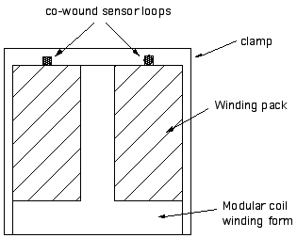

Installation Information:

The co-wound sensor loops shall be installed during winding of the modular coils.

Other Pertinent Information:
The sensor loops shall be laid on top of the winding pack before epoxy impregnation and held in place by the winding clamps (grooves on the inside of each clamp are required). The epoxy will hold the sensor loops in place after impregnation. The sensor loops shall be made of suitable thin cable such as mineral insulated cable (diameter: 0.061” or less). The two leads for each loop shall be brought out through holes in the center leg of the winding form tee. The reliability of the sensor loops shall be at the same level as the reliability of the modular coils.

