NCSX
Data Management Plan

NCSX-PLAN-DMP

DRAFT H

December 3, 2002

Prepared by: _______________________________________
R. Simmons, NCSX Systems Engineering Support Manager

Concurrences:

_____________________________ _____________________________
T Brown, NCSX Design Integration P. Heitzenroeder, Deputy Project
Manager Manager for Engineering

_____________________________ _____________________________
B. Nelson, Stellarator Core Systems L. Dudek, Ancillary Systems
Project Engineer Project Engineer

_____________________________ _____________________________
E. Perry, Assembly Operations J. Malsbury, QA Manager
Project Engineer

Approved by: ______________________________________
W. Reiersen, Engineering Manager

Record of Revisions

Revision | Date | Description of Changes
DRAFT G1 (formerly Rev0V2) | 9/13/02 | Incorporates QA initial comments and comments from others
DRAFT H | 12/03/02 | Incorporated WTR & QA second round of comments

Table of Contents
1 Introduction 1
1.1 Purpose 1
Storage Location 1
1.2 Applicable Documents 3
2 managing the technical documentation 3
2.1 Definition of Technical Documentation 3
2.2 Control and Management of Model and Drawing Records 4
2.2.1 Overview 4
2.2.2 CAD Drawing Systems 7
2.3 Drawing Control Process 8
2.4 Model and Drawing Storage 14
2.5 Changing Models and Drawings 14
2.6 Other Technical Documents 14
2.6.1 General 14
2.6.2 Specifications 14
2.6.3 Interface Control Documents (ICDs) 15
2.6.4 Non Conformance Reports (NCRs) 15
2.6.5 Supporting Design Documentation 15
3 MANAGING OTHER PROJECT DOCUMENTATION 16
3.1 Cost and Schedule Documentation 16
3.2 Plans and Procedures 16
3.3 Miscellaneous Documents 16

List of Figures
Figure 2.2-1Pro/INTRALINK Communications 5
Figure 2.2-2 NCSX Commonspace Folders 6
Figure 2.2-3 NCSX Data Management Process 7
Figure 2.3-1 NCSX Drawing Release Flow Chart 10
Figure 2.3-2 Drawing Promotion Process 11

List of Tables
Table 1.1-1 Sites for Data Storage and Retrieval 1
Table 2.3-1 NCSX Drawing/Model Release Levels 9

Introduction

Purpose
The purpose of this Data Management Plan (DMP) is to describe the process by which documents for the National Compact Stellarator Experiment (NCSX) Project will be stored and managed. All project documents will be created, stored, and be accessible electronically. Data will be stored in six sites – three Web sites accessible through the Internet, two sites on the PPPL File Transfer Protocol (FTP) server, and an Oracle database that can be accessed using Pro/INTRALINK software from Parametric Technologies Corporation (PTC), the maker of Pro/Engineer software. A listing of the six sites and their customers, custodians, document types, and access restrictions is provided in Table 1.1-1. The custodians are the personnel solely responsible for the content and maintenance of the data storage site (web or FTP server) and there is only one custodian (plus the single “back-up” person identified as the designee in case of absence of the custodian) per storage site. In instances where there are controlled documents involved (e.g., the Engineering Web, the Pro/INTRALINK database, etc.), the custodian also becomes the electronic document manager.

Table 1.1-1 Sites for Data Storage and Retrieval

Storage Location | Documents | Custodian  (Write Access) | Customer  (Read Only Access)
Project Web | General project information, external design review data, physics meetings, advisory committee meeting, publications, and project directory | Project Manager (or his designee) | Global - General public and project
Procurement Web | All procurement-related documentation required for potential suppliers to develop proposals and for suppliers to execute their scope of work | Procurement Manager (or his designee) | Global – but primarily suppliers
Pro/INTRALINK Database | Electronic Drawings and Models | Design Integration Manager (or his designee) | Project (INTRALINK software required)
Project FTP Server | Large Data Files primarily used in physics analyses | Engineering Manager (or his designee) | Global, but primarily Physics & Engineering Analysts
Vendor FTP Server | Procurement-related electronic drawings and models | Engineering Manager (or his designee) | Global – but primarily suppliers
Engineering Web | All other project documentation, including cost and schedule information, design criteria, internal design review data, engineering & project meeting minutes/presentations, memoranda, analysis reports, draft and controlled copies of controlled documents (not including drawings and models or procurement-related documents), and work plans/WAFs. Also contains sub-webs dedicated to configuration management and interface control and management. | Engineering Manager (or his designee) | Project

Not included in this list are several databases or files that are not readily available for general public or project access. These include:
- The cost and schedule database. All source cost and schedule data is maintained in the Primavera Project Planner (P3) database. This is a restricted site that reflects all input data from the project relative to the cost and schedule baselines. The P3 database is controlled and maintained by the NCSX Project Control Manager. The output data from this database is forwarded to and posted on the NCSX Engineering Web.
- The Non-Conformance Report (NCR) database. NCRs are the responsibility of QA. QA has a database that is used to generate and track these NCRs. The signed copies, maintained by QA in paper format, are the official records of the NCR system. The QA RAP/NCR database provides for tracking and a less formal backup of the paper records. Copies of approved NCRs are available in pdf format from QA., however, the output files are also available to project personnel upon request.
- As indicated in the Systems Engineering Management Plan (NCSX-PLAN-SEMP), the PPPL Work Planning (WP) form is not directly applicable to the NCSX design and fabrication phase. However, at the discretion of the responsible Project Engineers and WBS Managers, the WP may be utilized as a guide to planning work. If the WP is utilized, the Work Planning (WP) files are kept in the PPPL Operations Center. While electronic WP forms are available from the PPPL Engineering Department Web page, completed and approved WPs are maintained in hard copy in the Operations Center where copies are available to project personnel upon request.
- The Job Hazard Analysis (JHA) forms are maintained and filed by the PPPL Industrial Safety Office. Copies are available to project personnel upon request.

As a general rule, approved and controlled documents will only appear on one storage site and links will be established to gain access to that document from other storage sites. The one major exception to this rule involves documents intended for vendor use. With respect to vendors, the “approved” documents are those specifically referenced in the contracts with them. The Procurement and Vendor FTP storage sites are the sole source of access and information by vendors. However, it should be noted that duplicate files are also maintained as part of the project files on both the Engineering and Pro/INTRALINK storage sites. It is also conceivable, that a later version of the particular document and/or drawing or model will be available on the project-only access sites than on the vendor-access sites until such time that the respective contracts are modified to reflect the latest information. The project-only access sites (e.g., Engineering Web, Pro/INTRALINK database, Project FTP server, etc.) will always contain the latest master versions of the respective documents.

From a project management perspective, there are three NCSX project baselines – technical, cost, and schedule. These three baselines are fully integrated since they are derived from the same configuration. The combination of technical, cost, and schedule baselines forms the basis for project work authorization and management. While this DMP will primarily focus on the management and retrieval of documentation that describes the physical and functional configuration of the Project’s technical baseline, it will also addressed the storage and retrieval of non-technical, but controlled documentation such as project plans and procedures.

Applicable Documents
This Data Management Plan (DMP) draws on the documents listed below. Documents referenced are the latest issues of the:

NCSX Documents
- Project Execution Plan (NCSX-PLAN-PEP)
- Systems Engineering Management Plan (NCSX-PLAN-SEMP)
- Work Breakdown Structure (WBS) Dictionary (NCSX-WBS)
- Quality Assurance Plan (NCSX-PLAN-QAP)
- Document and Records Plan (NCSX-PLAN-DOC)
- Configuration Management Plan (NCSX-PLAN-CMP)
- Interface Control Management Plan (NCSX-PLAN-ICMP)
PPPL Documents
- PPPL Pro/INTRALLINK Users Guide
- PPPL P-010 Design Reviews
- PPPL ENG-006 Review and Approval of Specifications and Statements of Work
- PPPL ENG-010 Control of Drawings, Software, and Firmware
- PPPL ENG 019 PPPL Engineering Standards
- PPPL ENG 029 Technical Definitions and Acronyms
- PPPL ENG-030 PPPL Technical Procedures for Experimental Facilities
- PPPL ENG-032 Work Planning Procedure
- PPPL ENG-033 Design Verification
- PPPL QA-005 Control of Nonconformances

managing the technical documentation

Definition of Technical Documentation
The NCSX technical documentation describes the physical and functional configuration of the Project’s technical baseline. This includes models and drawings, whether created in Pro/Engineer or in other project-approved drawing software packages, technical specifications, statements of work, Interface Control Documents (ICDs), Non Conformance Reports (NCRs), etc. In addition, there are other technical supporting documentation, such as memoranda and analyses that are not under configuration control, but nonetheless describe the basis for the controlled technical documentation.

NCSX will primarily utilize two sites for managing controlled technical information. These are the Pro/INTRALINK database and the Engineering Web. The Pro/INTRALINK database is the repository for the storage and retrieval of the all NCSX models and drawings, whether approved and controlled or in a “work-in-progress” status. All other technical documentation (e.g., specifications, analyses, technical memoranda, etc.) is contained on the Engineering Web. However, as indicated in Section 1.1 above, other specific PPPL technical documentation pertaining to NCSX such as Non-Conformance Reports (NCRs), Work Planning (WP) forms, and Job Hazard Analysis (JHA) forms may or may not be stored in an electronic format and are controlled and maintained by separate PPPL entities. There are other specific sites (e.g., Manufacturing Web, PPPL FTP Server, Vendor FTP Server, and the Procurement Web) that may include duplicate copies of the controlled documentation for specific use and purpose, but the Pro/INTALINK database and the Engineering Web are the primary sites for technical information. As necessary, links to the other supporting sites may be established to facilitate use and access.

Control and Management of Model and Drawing Records

Overview
All models and drawings will exist in electronic form. The project’s drawing software package standards are Pro/Engineer (2D or 3D) for mechanical systems and AutoCAD drawings for electrical systems. Mechanical models and drawings of the test cell, ancillary equipment and services will be generated using Pro/Engineer as the first choice system in order to facilitate the building of assemblies and to establish a single, unified database defining the NCSX facility. Electrical drawings (2D) will be generated using AutoCAD or Pro/Engineer (if appropriate) or other Project-approved software package. The Engineering Manager may, on an exception basis, approve the use of other drawing software packages, but the project’s Pro/Engineer model will then have to be modified to accurately define the component envelope and placed in the full Pro/Engineer assembly model. Models and drawings will be managed using the Pro/INTRALINK software from PTC. The central core of the Pro/INTRALINK data management system is a central database called the Commonspace (or server). The Commonspace is the collection point for all design activities and is accessible to all users. Non-ProE models and drawings will be treated as individual objects (like Word or other software-generated documents) by INTRALINK and cannot be automatically updated as can models and drawings generated in ProE.

The Pro/INTRALINK system summarized in this DMP, and described in greater detail in the Pro/INTRALINK Users Guide, achieves two critical objectives. First, the Pro/INTRALINK system serves as the NCSX Project’s primary electronic file system for controlled and in process models and drawings. As necessary, appropriate links to supporting technical documentation that is stored on other web sites will be made. All approved and controlled models and drawings will be maintained in this database such that the Pro/INTRALINK database will be the repository for project personnel to access the latest controlled and approved models and drawings. However, to maintain the integrity of these files, only a limited number of personnel will be provided “write” access to modify these controlled files. The Pro/INTRALINK Users Guide provides greater detail on the specific “write” and “read-only”

Secondly, the Pro/INTRALINK database of CAD models and drawings represents the physical attributes of the NCSX technical baseline. The NCSX Project’s design configuration is progressively described in greater detail as it proceeds through the design process. As such, so-called “developmental baselines” will evolve as the design progresses. Drawings and models developed using either Pro/Engineer or AUTOCAD are maintained in a separate developmental area of the Pro/INTRALINK database to permit ready access and interaction during the design evolution process. A great deal of flexibility exists when models and drawings are in this developmental state.

Figure 2.2-1 illustrates the communication between the Pro/INTRALINK Commonspace (or server) and Workspace databases contained on individual user computers.

Figure 2.2-1Pro/INTRALINK Communications

CAD models and drawings (both those in a developmental stage as well as those under configuration control) and - will be stored in a folder structure within the Commonspace. The NCSX Common Space folder format follows the project defined Work Breakdown Structure (WBS) and is illustrated in Figure 2.2-2. Each folder will have subfolders that expand the WBS to the second and third level WBS level.

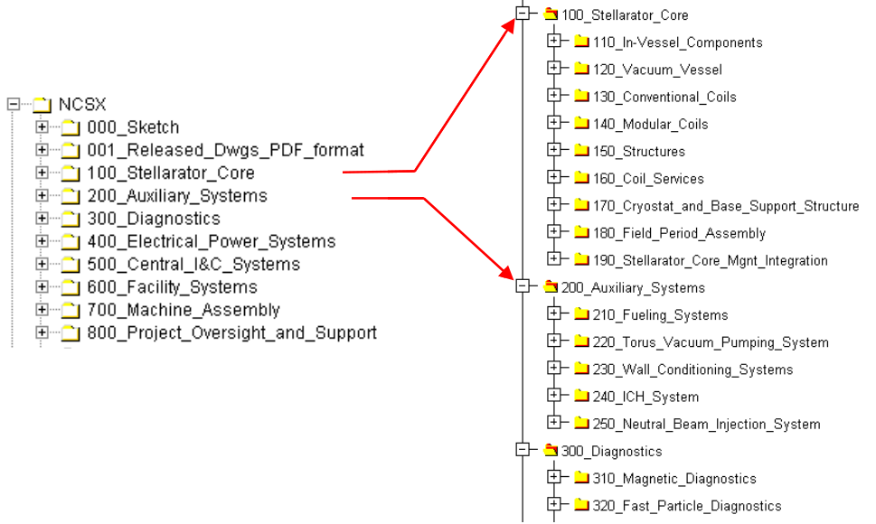

Figure 2.2-2 NCSX Commonspace Folders

The Pro/INTRALINK Data Management System is closely linked to the NCSX Configuration Management Program. In the developmental stage of the design, Pro/INTRALINK provides a flexible environment to iterate the drawings and models that represent the evolving nature of the technical baseline. A broader discussion of the drawing release process is contained in the Pro/INTRALINK Users Manual. Once a drawing or model is placed under configuration control, the process for changing drawings and models that define the physical and functional configuration of the technical baseline is then controlled by the configuration control processes outlined in the NCSX Configuration Management Plan (CMP). The relationship between the Pro/INTRALINK data management system and Configuration Management (CM) is illustrated in Figure 2.2-3.

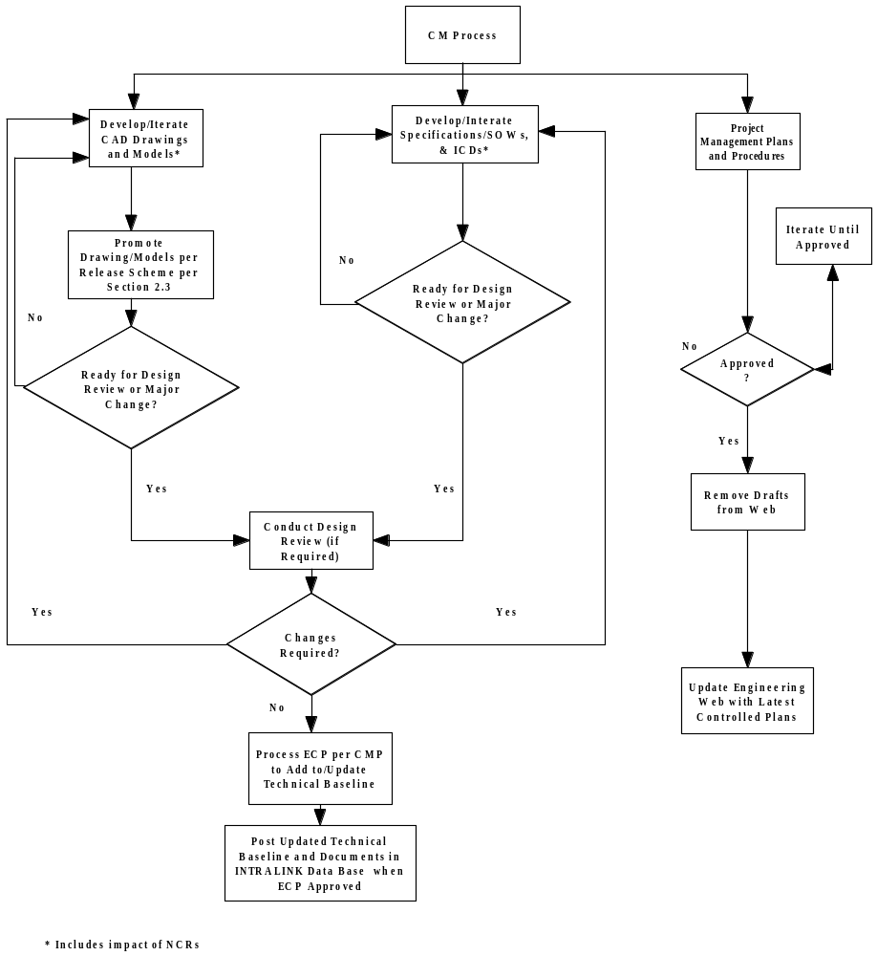

Figure 2.2-3 NCSX Data Management Process

CAD Drawing Systems
The NCSX configuration management provides for a precise identification of technical, cost, and schedule baselines to establish the bases for performance measurement as well as tracking changes to those baselines. The Pro/INTRALINK database establishes the framework to document the technical baseline attributes described and documented in CAD models and drawings, specifications, and other controlled technical documentation.

NCSX drawing numbers will take a form that follows the NCSX WBS structure. A typical number during conceptual design might be S17E112-011; where S is the NCSX project designation, 17 defines the concept number, E the sheet size, a three level WBS breakdown (112) follows, then the drawing number (001). The concept number (17 in this example) is only used during the developmental or conceptual design phase. After leaving the conceptual design phase of the project, the concept number designation (17 in this example) will be dropped, so that going forward the drawing number will be shortened to, SE112-011 in this example.

Assigning drawing numbers will be the responsibility of the WBS manager in charge of a WBS design activity. The design process established in using Pro/INTRALINK requires the engineer or designer working in a design area to “lock” the models and drawings being worked on so that other users cannot inadvertently make changes to the design as it is being developed. Using the WBS drawing tree structure and Pro/INTRALINK, an engineer or designer can go into the database “Commonspace” and take the next available number within the NCSX folder he is working in when a drawing is started (saving the part to Commonspace as the design progresses), or a temporary name can be used while developing the drawing on the Workspace. However, when the drawing is saved and returned to the Commonspace, the next available version will be assigned in the Commonspace. Reserving a block of numbers is discouraged since the only way that a block could be taken is by assigning “dummy” part or component numbers. Pro/INTRALINK allows one and only one name within the database so there can be no duplications.

As a rule, in developing mechanical drawings, drawing numbers –000 through –010 are saved for top-level assemblies. Drawing numbers –011 through –999 will be used for parts, assemblies or drawings with no preference to order (the next number is taken).

The Pro/INTRALINK Users Guide contains specific drawing numbering scheme formats. Generally, there will be several categories:
- Sketch Numbers – used in the very early developmental stage before a concept evolves
- Concept Numbers – once a concept evolves, this marks the conceptual design stage of development
- Regular Drawing Numbers – assigned once the concept leaves the conceptual design phase and culminates in the fabrication release
- Prototype Numbers – used only if the prototype is anticipated to differ from the first production unit. This denotes that the prototype is not expected to represent the final production units.
- As-Built Numbers – only used if a physical change to the overall model is necessitated by a physical change to a component is approved by a NCR. Use of the “AB” symbol maintains a clear pedigree/connection to the original model.

Drawing Control Process
At any time in the design evolution process, there may exist a series of developmental baselines representing various design studies and evolution. Within the Pro/INTRALINK environment, a defined set of “release” levels are available for a drawing or model to progress through from development to fabrication. For the NCSX Project, six release levels have been defined and are illustrated in Table 2.3-2. The NCSX“ release” scheme provides a great deal of flexibility in dealing with design assessments and “release” promotions during the design review process. As with those models and drawings that represent the established technical baseline, a unique name and numbering scheme must be utilized for each of these developmental baselines. When a model or drawing is in this developmental status, a number of operations can be performed: create, view, modify, move to a different folder location, rename, check out objects to workspace and interrogate. Baseline parameters can be set as: read only; read and add; read, add and delete.

Work in Progress
Conceptual Design (CD)
Preliminary Design (PD)
Prototype (P)
Final Design (FD)
Fabrication

Table 2.3-2 NCSX Drawing/Model Release Levels

It is not necessary that an object pass though each release level. As a general rule, each of the “standard” release levels supporting the design process and evolution (e.g., Conceptual Design, Preliminary Design, and Final Design) is accomplished in preparation for a design review. Once a drawing has successfully completed a Conceptual Design Review and all comments have been incorporated, it will be promoted to the Conceptual Design level and this level of promotion will form part of the frozen Conceptual Design technical baseline that will not be changed. As the drawing is modified in preparation for the next design review, it will be demoted back to a “Work in Progress” status until such time it has undergone a Preliminary Design Review and all the comments have been incorporated - it will then be promoted to the Preliminary Design release level and form part of the frozen Preliminary Design technical baseline that will not be changed. The same process applies to promotion to higher-level release levels such as Final Design and Fabrication. provides flow chart of the drawing release process.

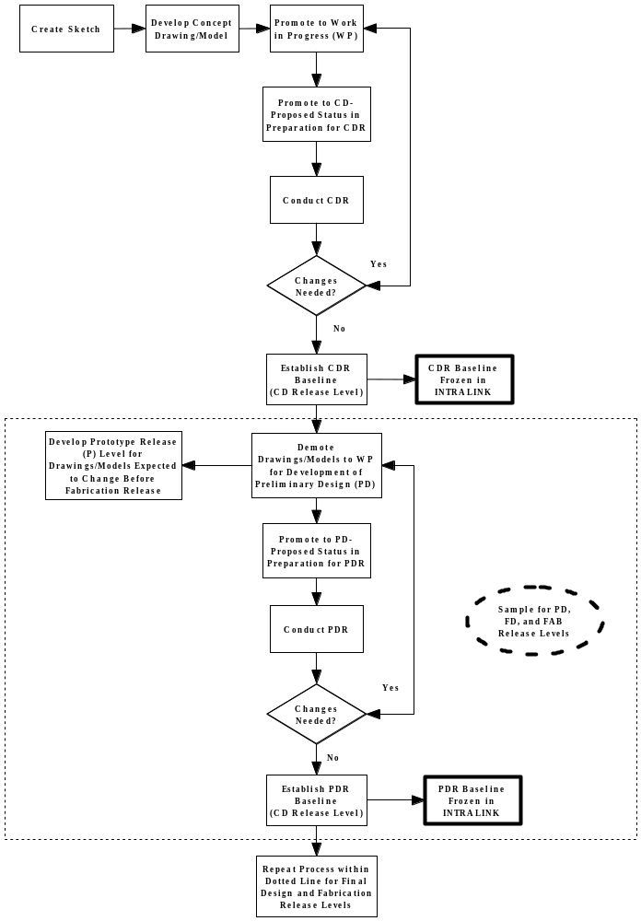
Figure 2.3-4 NCSX Drawing Release Flow Chart

When a drawing or model is proposed for promotion, this will trigger a review process that will eventually culminate in the processing of an Engineering Change Proposal (ECP) that will eventually result in the updating of the technical, cost, and schedule baselines. Promotion of a drawing or model from Final Design Release to Release for Fabrication will invoke a new rigor of checking and design. Figure 2.3-5 displays the promotion sequence.

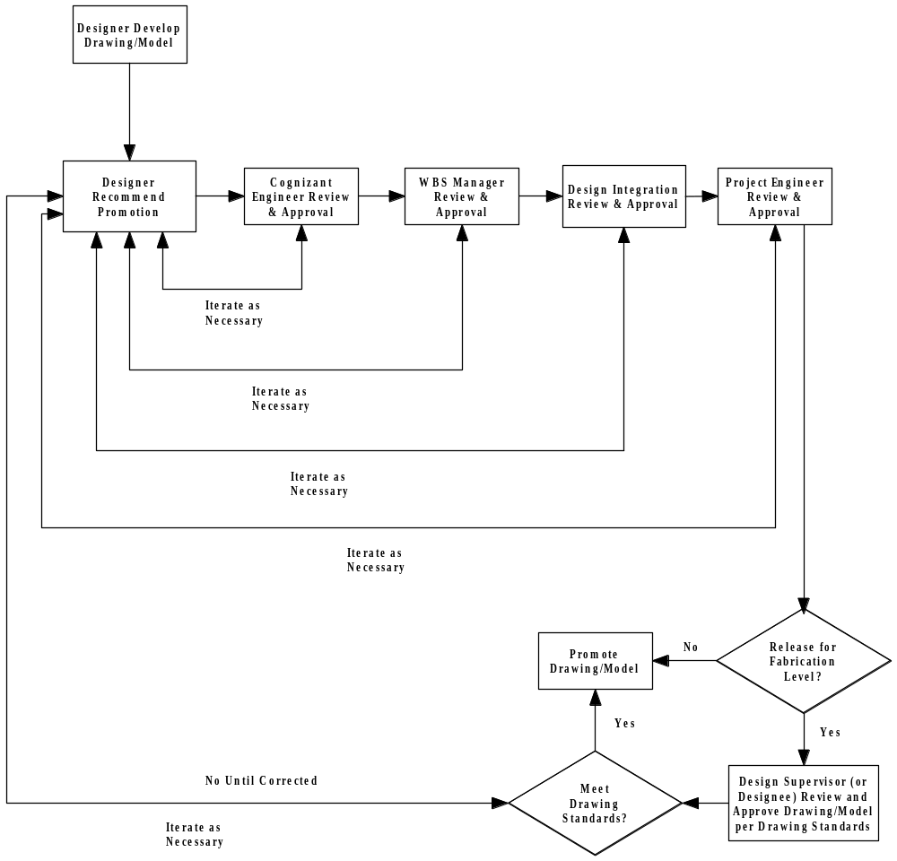

Figure 2.3-5 Drawing Promotion Process

The exception to this “standard” sequence addresses those drawings that are used for the development of prototypes. Prototype drawings are only used whenever it is anticipated that the design concept is not close to final and that changes are likely. If, however, the prototype is anticipated to represent the first production unit, then prototypes will also follow this sequence.

Each Pro/INTRALINK folder will have a predefined set of release procedures that identifies who can approve an object to allow it to pass to the next release level. The WBS Manager or Cognizant Engineer directly involved with the component design process will determine when a model or drawing should be proposed for promotion and whether the full release scheme should be followed or if a subgroup for the WBS section under his/her responsibility will suffice. The NCSX project release procedure starts with the designer (or drafter) promoting the object followed by sequential approvals made by the Cognizant Engineer, the responsible WBS manager, Design Integration manager and finally the responsible Project Engineer.

For Pro/Engineer drawings, the Pro/INTRALINK database automatically records the revision number (only for Fabrication Release level drawings and models), the release level (e.g., CD, PD, FD, etc.), and version number (for each release level, each subsequent update version is sequenced up one number, starting with 1). Adobe Acrobat electronic signature procedures that provide secure password protected signatures will be used to document at the Fabrication Release level. Until a drawing or model reaches the Fabrication Release level, approvals/concurrences in proposed promotion of the releases level are obtained using the Request to Promote (RTP) forms outlined in the Pro/INTRALINK Users Guide.

Promoting a model or drawing to the next higher release level does not, by itself, result in a change to the technical baseline; only an ECP can do that. Release promotion will coincide closely with the preparations for a design review (e.g., preliminary design review/PDR or final design review/FDR). Changes to a model or drawing may be proposed at any time deemed appropriate by the Cognizant WBS Manager, but the release level will not normally be changed (as a proposed release level) until a design review is scheduled. The “baseline” release level is not frozen until such time that the results from the design review are fully incorporated.

The purpose of design reviews is to assess key aspects of the NCSX design at appropriate times in the design. Configuration Items (CIs) represent the lowest level of control under configuration management and may be a single physical or functional item or collection of items that will satisfy a final end point or deliverable. CIs will come under configuration control at different stages in the life of NCSX as some designs proceed at a faster pace than do others. The design review package will include at a minimum the following:
- Updated models and drawings that have been proposed for promotion to release level consistent with the level of the design review.
- Other updated technical documentation represented by specifications and ICDs.
- Updated technical documentation, at the level appropriate for the systems/CIs being reviewed and the level of the design review. The primary purpose of this documentation is to address the current level of design and its basis at the particular snapshot in time. A secondary purpose of this technical documentation is to provide an historical record of the project’s baseline design at established stages (e.g., preliminary design, final design, etc.) in the project life cycle.
- Updated cost and schedule documentation that is consistent with the updated technical documentation.
- An ECP that summarizes all the proposed changes to the technical, cost, and schedule baseline documentation. This ECP will assist the reviewers in understanding all the impacts of the proposed changes, but the ECP will not be approved until after the design review and the incorporation of comments/recommendations impacting the current level of technical, cost, and schedule documentation.
At the completion of the design review, it is likely that additional iterations will be needed to the released models and drawings. Only when the recommended modifications from the design review are incorporated and the models and drawings re-promoted to the appropriate release level and the cost and schedule documentation updated will the ECP be updated, processed, and be ready for approval. Only when the ECP is approved in accordance with the CMP, will the technical, cost, and schedule baselines be updated and the released model and drawings stored as an approved update to the project baselines.

As production procurement packages are assembled, models and drawings will be released to the Fabrication level and assigned a Revision 0 status. Only at this level will revisions be tracked. Pro/INTRALINK version numbers will be used to track early stages in the release process. They will identify baselines, design milestones and the status of the object. As such version numbers need to be maintained for documentation purposes. The Pro/INTRALINK system administrator will not purge version numbers in any of the NCSX folders without consent of the NCSX Project Design Integration group.

When a drawing (or model) is ready to be released for fabrication the responsible designer/drafter/engineer shall make an Adobe PDF file for obtaining signatures. The Adobe PDF file will be routed for signatures following the sign-off procedure for the WBS group for which the drawing was released. At a minimum, a drawing release sign-off procedure will call for signatures by the drawing originator, a drawing checker and the WBS manager(s). The approved drawing signatures will be electronically added to the PDF file using the Adobe signing process. After the WBS manager signs he will send the Adobe PDF file to the PPPL Drafting supervisor. The Drafting supervisor will add his signature to the PDF drawing (indicating that PPPL drawing standards are met), add the stamp “Released for Fabrication/Installation”, and enter the drawing in the Released Drawing folder in Pro/INTRALINK (001_Released_Dwgs_PDF_Format). Write access to this area will be restricted to the Drafting Supervisor and his designees. Release drawings developed at ORNL will be sent to the PPPL Drafting supervisor for placement in the NCSX released drawing folder.

The electronic CAD version of the release drawing will be stored in Pro/INTRALINK in the appropriate subfolder based on the WBS level where it originated. The electronic CAD version will have a unique numbering scheme consisting of the revision number (only when issued as an approved Fabrication Release level), the release level, and the version number.

Model and Drawing Storage
All CAD models and drawings, and the native CAD data files, will be stored in Commonspace within the governing WBS folder under which the data was developed. All models and drawings that describe the approved technical baseline will be stored in the approved technical baseline folder in a PDF format. Models and drawings in a developmental baseline status will also be stored in a PDF format as each release level is achieved. The released drawing folder will have restricted write access with an unrestricted read access.

Changing Models and Drawings
Until a drawing or model is approved and released for fabrication, the revision level (e.g., Revision 0) will not be advanced. Rather, in accordance with Section 2.3 above, only the version number will be advanced. The same degree of discipline will be applied when promoting and/or demoting drawings and models to ensure that the latest released version is available on the Pro/INTRALINK Commonspace database. Changes to approved and released fabrication drawings will be made in a manner that follows the NCSX Configuration Management Plan (CMP).

Other Technical Documents

General
Technical project documents identified as controlled documents (e.g., specifications, ICDs, etc.) will reside in a web-based environment as they are being developed, existing as drafts for project review and mark-up. Once the documents are approved both a PDF file format will be stored on the Engineering Web page <http://www.pppl.gov/me/NCSX_Engineering/>. Note that NCRs will be maintained in the QA/NCR database and are only available in a pdf format. WBS-specific procurement and process specifications, including statements of work, assembly procedures and testing procedures, will be stored in the parent WBS folder. Other technical documents that support the controlled technical documents will be maintained on the appropriate web page and links established to the Engineering Web page <http://www.pppl.gov/me/NCSX_Engineering/>.

Specifications
Specifications are requirements documents. As described in the Systems Engineering Management Plan (NCSX-PLAN-SEMP), specifications may fall into two categories; “design-to” or “build-to” specifications. The SEMP also defines 5 types of specifications with different purposes. If the specification is specific to a single WBS element (e.g., procurement or process specification), the specification will be stored in the parent WBS folder on the Engineering Web page <http://www.pppl.gov/me/NCSX_Engineering/>. However, if the specification is non-WBS-specific, then it is stored in the Project Oversight and Support folder. Samples of some specifications that will be developed for the NCSX Project include the following:
- NCSX General Requirement Document (NCSX-ASPEC-GRD)
- NCSX Vacuum Materials List
- NCSX Structural and Cryogenic Design Criteria Document
- NCSX Grounding Specification for Personnel and Equipment Safety
- NCSX Development Specifications
- NCSX Product/Procurement Specifications
- NCSX Process Specifications (Assembly and Testing Procedures)

Interface Control Documents (ICDs)
Interface definitions between two WBS system components will be defined in an Interface Control Document (ICD). The Interface Control Management Plan (NCSX-PLAN-ICMP) provides the process details for identifying, numbering, and managing interfaces between separate WBS elements with separate WBS Managers (primary interfaces) and those interfaces entirely within a single WBS element or between two WBS elements, but with the same WBS Manager (secondary interface).

An interface may define a written agreement between WBS systems or define a physical boundary, mating surface geometry or attachment details that exist between two adjoining WBS components. An Interface Control Document folder will be set up in Pro/INTRALINK that will contain two subfolders. One subfolder will contain PDF files of ICD’s and the other will contain CAD drawing files (if a drawing format exists). For Pro/Engineer users, the ICD parts and/or assemblies whether described in models or drawings or by simple written agreement will remain in their respective WBS folders. One WBS system manager will take the responsibility of generating the ICD. The number placed on the ICD will be a number generated by the generating WBS group. No special number is assigned if the ICD is defined with a drawing. The originating WBS group takes the next available number in its drawing number sequence. After the ICD is completed, a PDF file will be generated and routed to both interfacing WBS managers and the cognizant Project Engineer(s) for approval. Once an ICD represented by a model or drawing is approved, a Pro/INTRALINK version will be created in order to save the release level and version number. The drawing or model that is created will clearly identify the ICD number. The Pro/INTRALINK database will reflect a description of the ICD in the name description.

Non Conformance Reports (NCRs)
Should a part and/or component be received that is out of the specification guidelines, the NCSX Project will process a Non Conformance Report (NCR) in accordance with PPPL QA-005. Each NCR file will be assigned a unique number that relates it to the impacted project and component/drawing (and eventually the WBS) and will be stored in subfolder to the same folder as the impacted drawing or model. It should be noted that NCRs, in themselves, are not under configuration control, rather the resulting impacts of the NCR on drawings, hardware, cost, and schedule are what is controlled by the Configuration Control processes outlined in the CMP.

Supporting Design Documentation
Memoranda and analyses will be stored on the appropriate web site (e.g., the Engineering Web Page <http://www.pppl.gov/me/NCSX_Engineering/> for memoranda and the FTP server for large data analyses files). These documents will placed in these servers by the initiating author. Where appropriate, links will be established to the Pro/INTRALINK database to ensure traceability and applicability to the controlled technical documents.

MANAGING OTHER PROJECT DOCUMENTATION

Cost and Schedule Documentation
The cost and schedule baselines will reside on the Primavera Project Planner (P3) database maintained by the NCSX Project Control Manager. PDF files of the most recent cost and schedule baselines will be posted on the Engineering Web Page <http://www.pppl.gov/me/NCSX_Engineering/> when the technical, cost, and schedule baselines are updated. As indicated in this DMP and the Configuration Management Plan (CMP), the technical, cost, and schedule baselines can only be changed by an ECP once the initial set of baselines is established at the start of preliminary design.

Plans and Procedures
The NCSX Project Execution Plan ((NCSX-PLAN-PEP) identifies the list of project-specific plans to be developed and controlled under configuration control. These will be prepared and approved in accordance with the review and approval hierarchy specified in the NCSX Document and Records Plan (NCSX-PLAN-DOC). Proposed changes or drafts to new plans will be maintained on the NCSX Engineering Web Page <http://www.pppl.gov/me/NCSX_Engineering/> until such time that they are approved and placed under configuration control. Once that happens, they will be placed in the Engineering Web as part of the controlled project files. Since the project plans cut across all WBS elements, these are stored in the Project Oversight and Support folder.

Miscellaneous Documents
The NCSX Work Breakdown Structure (WBS) Dictionary (NCSX-WBS) is also a controlled document that is under configuration control. The WBS Dictionary is stored on the Engineering Web page <http://www.pppl.gov/me/NCSX_Engineering/>.

