NCSX

Data Management Plan

NCSX-PLAN-DMP

Revision 0 - Draft F

September 4, 2002

Prepared by: _______________________________________
T Brown, NCSX Design Integration

Concurrences:

_____________________________ _____________________________
R. Simmons, Systems Engineering P. Heitzenroeder, Deputy Project
Support Manager Manager for Engineering

_____________________________
W. Reiersen, Engineering Manager

Approved by: ______________________________________
G.H. Neilson, NCSX Project Manager

Controlled Document
This is a controlled document. Check the NCSX Pro/INTRALINK database prior to use to assure that this document is current.

Record of Revisions

Revision | Date | Description of Changes
Rev. 0 Draft A | 7/25/02 | Initial draft
Rev. 0 Draft B | 8/5/02 | Incorporated comments. Revised order to some sections and added additional sections. Changed to an “All Electronic” drawing system using Acrobat PDF sign-off.
Rev. 0 Draft C | 8/21/02 | Incorporated comments. Added documentation storage section.
Rev. 0 Draft D | 8/22/02 | Incorporated comments.
Rev 0 Draft D1 | 8/23/02 | Revised format and incorporated comments
Rev 0 Draft D2 | 8/28/02 | Revised to incorporate comments and added Annex I
Rev 0 Draft E | 9/3/02 | Clarified relationships between CM program and drawing release program and added additional guidance on accessing Pro/INTRALINK
Rev 0 Draft F | 9/4/02 | Incorporated WTR comments

Table of Contents
1 Introduction 1
1.1 Purpose 1
1.2 Applicable Docments 3
1.3 Overview of the Pro/INTRALINK Data Management System 3
2 MANAGING CAD MODELS AND DRAWINGS 5
2.1 CAD Drawing Systems 5
2.2 Drawing Numbers 6
2.2.1 Standard Numbers 6
2.2.2 Sketch Numbers 6
2.2.3 Prototype Numbers 7
2.2.4 As Built Numbers 7
2.3 Drawing Control Process 7
2.3.1 Developmental Baseline Documentation 7
2.3.2 Drawing Release Scheme 8
2.4 Model and Drawing Storage 11
2.5 Changing Models and Drawings 11
3 MANAGING OTHER PROJECT DOCUMENTATION 12
3.1 General Approach 12
3.2 Interface Control Documents 12
3.3 Specifications, Plans and Procedures, and Other Controlled Documents 13
3.3.1 Plans 13
3.3.2 Specifications 13
3.3.3 Miscellaneous Documents 13

List of Figures
Figure 1.3-1 Pro/INTRALINK Communications 4
Figure 1.3-2 NCSX Common Space Folders 4
Figure 1.3-3 NCSX Data Management Process 5

List of Tables
Table 1.1-1 Sites for Data Storage and Retrieval 1
Table 2.3-1 Pro/INTRALINK Roles 8
Table 2.3-2 Model and Drawing Release Levels 9

Introduction

Purpose
The purpose of this Data Management Plan (DMP) is to describe the process by which documents for the National Compact Stellarator Experiment (NCSX) Project will be stored and managed. Project documents will be accessible electronically. Data will be stored in six sites – four Web sites accessible through the Internet, a site on the PPPL File Transfer Protocol (FTP) server, and an Oracle database that can be accessed using Pro/INTRALINK software from Parametric Technologies Corporation (PTC), the maker of Pro/Engineer software. A listing of the six sites and their customers, custodians, document types, and access restrictions is provided in Table 1.1-1.

NCSX will feature a single electronic database for the storage and retrieval of models and drawings. All models and drawings will exist in electronic form. Mechanical models (3D) and drawings (2D) will be generated in Pro/Engineer to facilitate the building of assemblies and to establish a single, unified database defining the NCSX facility. Electrical drawings (2D) will be generated in Pro/Engineer, AutoCAD, or other Project-approved software. Models and drawings will be managed using the Pro/INTRALINK software from PTC. All controlled documents, e.g. approved plans and specifications, will also be stored in the Pro/INTRALINK database. This DMP will focus on the management of controlled data in the Pro/INTRALINK database.

Table 1.1-1 Sites for Data Storage and Retrieval

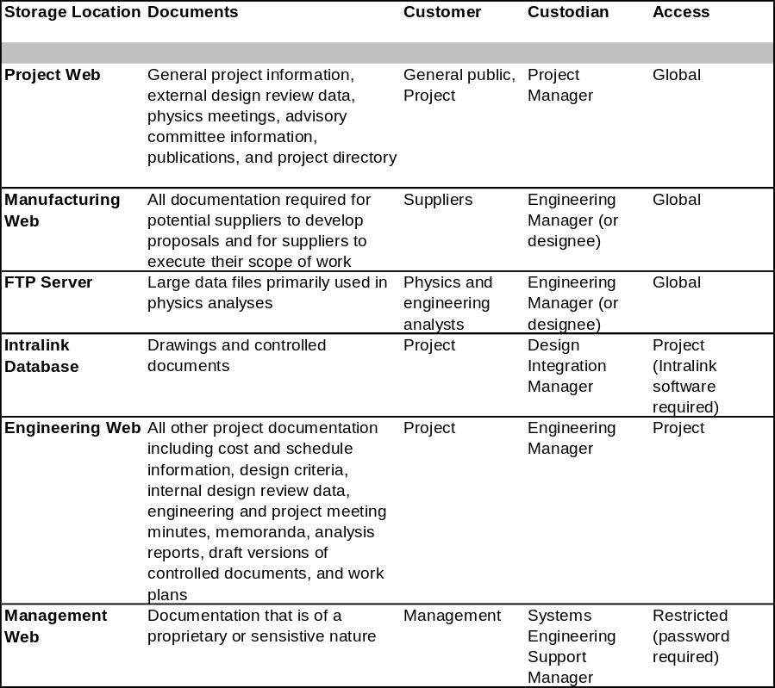

The Pro/INTRALINK system described in this DMP achieves two critical objectives. First, the Pro/INTRALINK system serves as the NCSX Project’s primary electronic file system for controlled documents. All approved and controlled documents will be maintained in this database such that the Pro/INTRALINK database will be the repository for project personnel to access the latest controlled and approved documents. However, to maintain the integrity of these files, only a limited number of personnel will be provided “write” access to modify these controlled files. These documents will include the following and are described in greater detail in the Documents and Records Plan (NCSX-PLAN-DOC):
- Computer Aided Design (CAD) models and drawings developed using either the Pro/Engineer 2D or 3D capabilities or the AUTOCAD drawings developed for electrical systems.
- Design specifications (e.g., the General Requirements Document)
- Interface Control Documents (ICDs), if not in drawing format.
- Project controlled plans and project-specific procedures as described in the Section 4.0 of this DMP.
In general, no documents will be placed in this controlled area until the document is approved and placed under configuration control.

Secondly, the Pro/INTRALINK database of CAD models and drawings represents the physical attributes of the NCSX technical baseline. As indicated in the NCSX Configuration Management Plan (NCSX-PLAN-CMP), the initial technical baseline in the form of the General Requirements Document (NCSX-ASPEC-GRD) and the Pro/Engineer model will be established at the start of Preliminary Design. The associated cost and schedule database that is consistent with this initial technical baseline are established as the initial cost and schedule baselines. At this time the technical baseline will be placed under change control.

The NCSX Project and details of its design configuration is progressively described in greater detail as it proceeds through the design process. As such, so-called “developmental baselines” will evolve as the design progresses. Drawings and models developed using either Pro/Engineer or AutoCAD are maintained in a separate developmental area of the Pro/INTRALINK database to permit ready access and interaction during the design evolution process. A great deal of flexibility exists when models and drawings are in this developmental state.

For other controlled documents such as plans, specifications/procedures, or interface control documents (ICDs) not in drawing/model format, developmental/drafts and/or draft updates will be maintained on the NCSX Engineering Web Page < http://www.pppl.gov/me/NCSX_Engineering/ > until such time that they are approved and placed under configuration control. Once a document is approved and placed under configuration control, the document is then transferred to the controlled project file area of Pro/INTRALINK.

Applicable Docments
This Data Management Plan (DMP) draws on the documents listed below. Documents referenced are the latest issues of the:

NCSX Documents
- Project Execution Plan (NCSX-PLAN-PEP)
- Work Breakdown Structure (WBS) Dictionary (NCSX-WBS)
- Quality Assurance Plan (NCSX-PLAN-QAP)
- Document and Records Plan (NCSX-PLAN-DOC)
- Configuration Management Plan (NCSX-PLAN-CMP)
- Interface Control Management Plan (NCSX-PLAN-ICMP)
PPPL Documents
- PPPL P-010 Design Reviews
- PPPL ENG-006 Review and Approval of Specifications and Statements of Work
- PPPL ENG-010 Control of Drawings, Software, and Firmware
- PPPL ENG 019 PPPL Engineering Standards
- PPPL ENG 029 Technical Definitions and Acronyms
- PPPL ENG-030 PPPL Technical Procedures for Experimental Facilities
- PPPL ENG-032 Work Planning Procedure
- PPPL ENG-033 Design Verification

Overview of the Pro/INTRALINK Data Management System
As indicated above, Pro/INTRALINK will be used for the storage of data contained in drawings and model and controlled approved documents. The central core of the Pro/INTRALINK data management system is a central database called the Common Space (or server). The Common Space is the collection point for all design activities and is accessible to all users. Error: Reference source not found illustrates the communication between the Pro/INTRALINK Common Space (or server) and the Work Space databases contained on individual users computers.

Figure 1.3-1 Pro/INTRALINK Communications

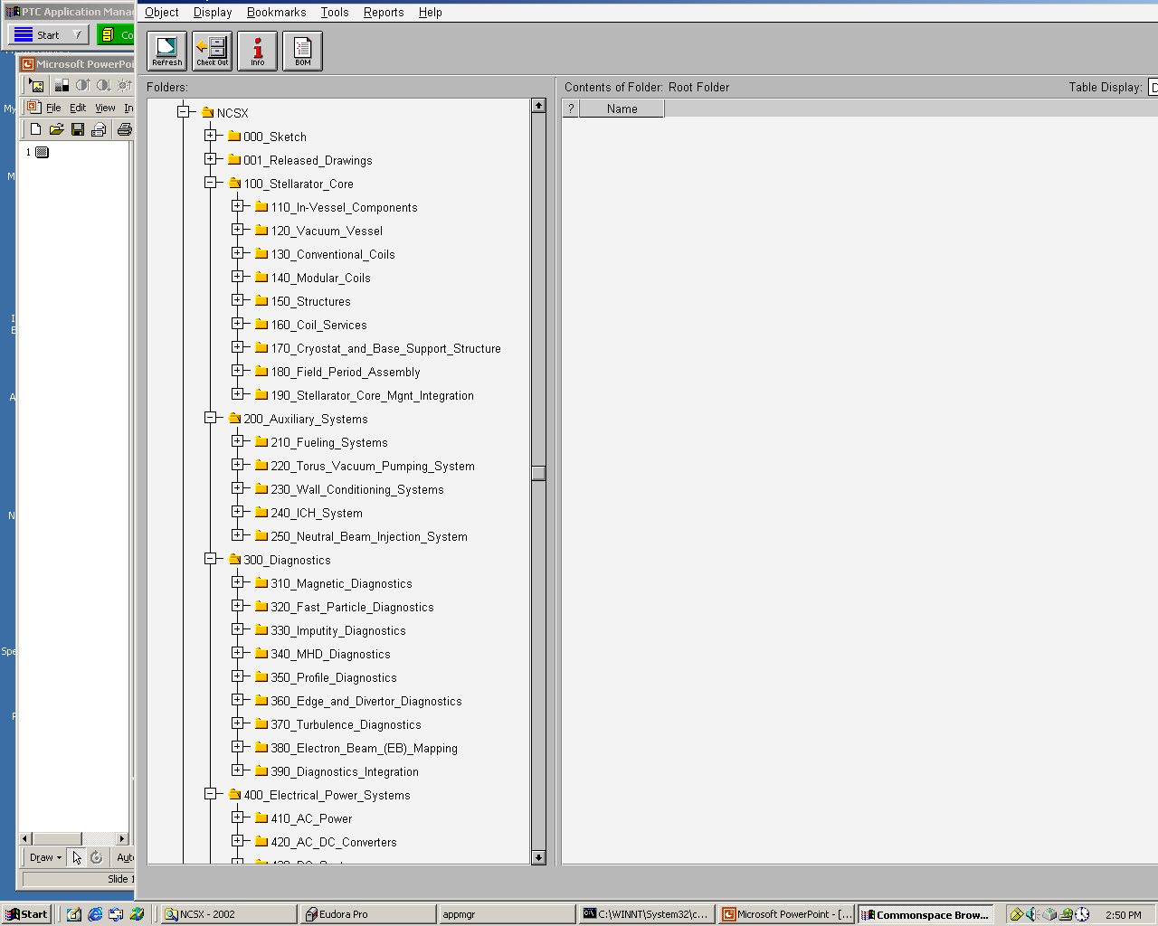
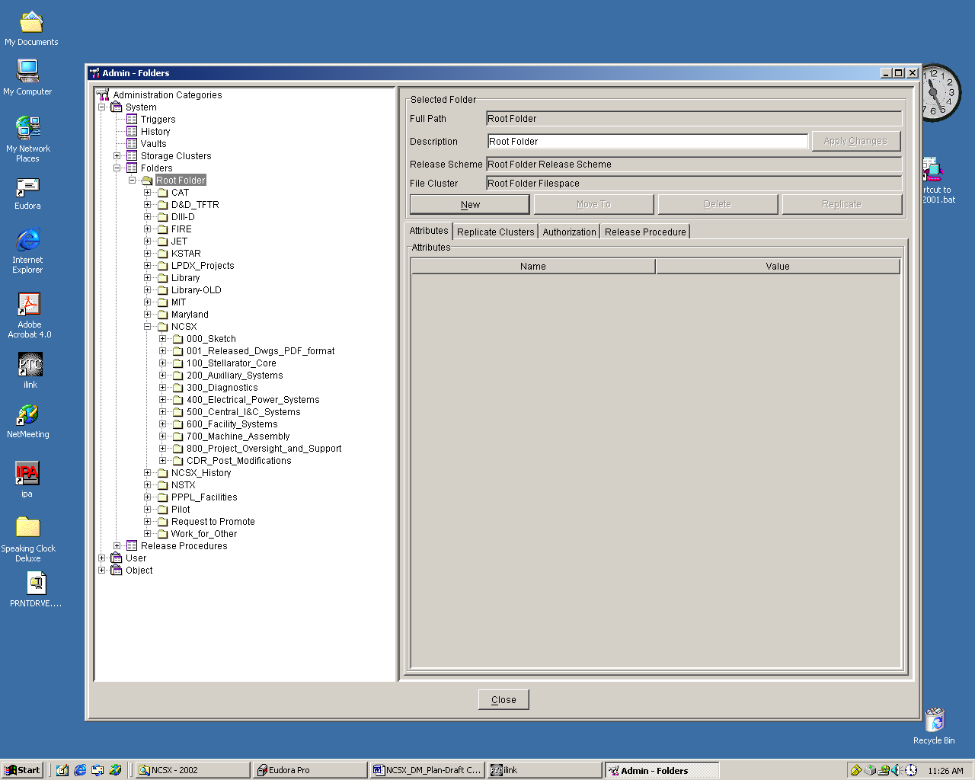
All CAD models and drawings (both those in a developmental stage as well as those under configuration control) and all approved and controlled project documents under configuration control will be stored in a folder structure within the Common Space. The NCSX Common Space folder format follows the project defined Work Breakdown Structure (WBS) and is illustrated in . Each folder will have subfolders that expand the WBS to the second and third level WBS level.

Figure 1.3-2 NCSX Common Space Folders

The Pro/INTRALINK Data Management System is closely linked to the NCSX Configuration Management Program. In the developmental stage of the design, Pro/INTRALINK provides a flexible environment to iterate the drawings and models that represent the evolving nature of the technical baseline. While this process is outside the formal configuration control processes outline in the CMP, a disciplined review and release process. A broader discussion of the drawing release process in contained in Section 2.3.2 of this DMP and in the Pro/INTRALINK Users Manual. Once a drawing or model is placed under configuration control, the process for changing drawings and models that define the physical and functional configuration of the technical baseline is then controlled by the configuration control processes outlined in the NCSX Configuration Management Plan (CMP). The relationship between the Pro/INTRALINK data management system and Configuration Management (CM) is illustrated in Figure 1.3-3

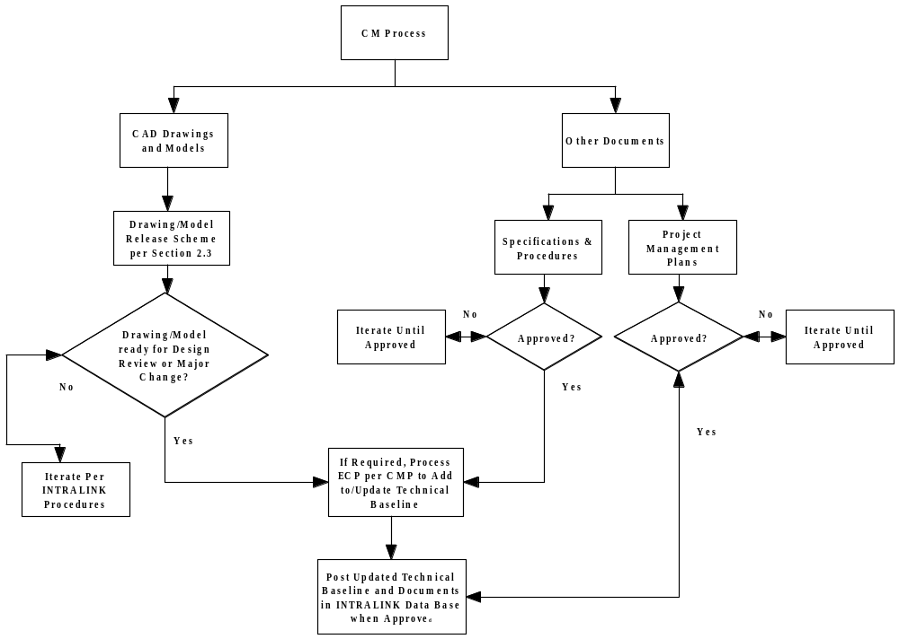

Figure 1.3-3 NCSX Data Management Process

MANAGING CAD MODELS AND DRAWINGS

CAD Drawing Systems
The NCSX configuration management provides for a precise identification of technical, cost, and schedule baselines to establish the bases for performance measurement as well as tracking changes to those baselines. Pro/INTRALINK establishes the framework to document the technical baseline attributes described and documented in CAD models and drawings. All models and drawings will exist in electronic form. All mechanical 3D models and 2D drawings of the device core or interfacing components will be generated in Pro/Engineer to facilitate the building of a unified assembly. If a variance to this rule is required to develop a component as a 2D drawing in another CAD package then there will be a Pro/Engineer model that accurately defines the component envelope and placed in the full Pro/Engineer assembly model. Mechanical models and drawings of the test cell, ancillary equipment and services will be generated using Pro/Engineer as the first choice system, again to maintain uniformity of the overall NCSX database. Electrical drawings (2D) will be generated using AutoCAD or Pro/Engineer (if appropriate) or other Project-approved software package.

Drawing Numbers

Standard Numbers
NCSX drawing numbers will take a form that follows the NCSX WBS structure. A typical number might be S17E112-011; where S is the NCSX project designation, 17 defines the concept number (the CDR in this example), E the sheet size, a three level WBS breakdown (112) follows, then the drawing number (001). After leaving the conceptual design phase of the project, the concept number designation (17 in this example) will be dropped, so that going forward the drawing number will be shortened to, SE112-011 in this example.

Assigning drawing numbers will be the responsibility of the WBS manager in charge of a WBS design activity. Using the WBS drawing tree structure and Pro/INTRALINK, an engineer or designer can go into the database “Commonspace” and take the next available number within the NCSX folder he is working in when a drawing is started (saving the part to Commonspace as the design progresses); or a temporary name can be used while developing a drawing and then changing it to the next available number before saving to Commonspace. Pro/INTRALINK allows one and only one name within the database so there can be no duplications.

As a rule, in developing mechanical drawings, drawing numbers –000 thru –010 are saved for top-level assemblies. Drawing numbers –011 thru –999 will be used for parts, assemblies or drawings with no preference to order (the next number is taken).

Sketch Numbers
Preliminary sketch numbers that are assigned to a model or drawing shall be based on the NCSX WBS structure and take the following form: S B 112- XXXXXX. Where the first letter (S) designates the NCSX project; the letter “B” is the last initial of the user name (first and second initials can also be used); 112 define the first three WBS levels and –XXXXX can be a number or alphanumeric description of the object. A sketch file directory (000_sketch) has been established to allow all engineers/designers/drafters participating in the NCSX project to store sketch files.

Prototype Numbers
Prototype models and drawings will have a special designation in the drawing number with the letter “P” added at the end of the standard number. This will allow the models and drawing of components that are to be fabricated as prototypes to take the same number as the baseline model except for the added letter “P” at the end.

As Built Numbers
When fabricated parts arrive on site and there is a variance on one of the parts that make it different from the standard part set, a new drawing number will be assigned once the variance is approved. The letters “AB” will be placed at the end of the part model/drawing number to identify those parts and/or models that revised as-built parts. Top-level assembly models developed using Pro/Engineer will also be revised by replacing the standard part with the revised part that matched the features of the as-built part.

Drawing Control Process

Developmental Baseline Documentation
At any time in the design evolution process, there may exist a series of developmental baselines representing various design studies and evolution. The “release” scheme described in the Section 2.3.2 that follows provides a great deal of flexibility in dealing with design assessments and “release” promotions during the design review process. As with those models and drawings that represent the established technical baseline, a unique name and numbering scheme must be utilized for each of these developmental baselines. When a model or drawing is in this developmental status, a number of operations can be performed: create, view, modify, move to a different folder location, rename, check out objects to workspace and interrogate. Baseline parameters can be set as: read only; read and add; read, add and delete.

In Pro/INTRALINK, three groups of personnel have been identified with various access capabilities within Pro/INTRALINK. These are:
- ADMIN – selected personnel authorized to perform administrative functions that alter the functions of Pro/INTRALINK. This is limited to PPPL Computer Division personnel.
- CADD – NCSX project personnel authorized to develop and modify Pro/Engineer or AUTOCAD models and drawings. This is limited to personnel trained in the operation of Pro/Engineer and/or AUTOCAD and includes NCSX Project Design Integration personnel, Project Engineers, WBS Managers, cognizant engineers, and designers.
- VIEWER – All other NCSX personnel not in either the ADMIN or CADD groups. Personnel in this category only have view only access with no ability to modify and/or create models and drawings.

Within the CADD Group, a further subdivision of user “roles” or levels of drawing and model access capabilities is established to define what a user is able to do with a specific folder and the models and/or drawings stored within a folder. Actions can include: view only, object check out, deleting an object, creating folders, etc. Five “roles” have been established for the NCSX project listed here in descending order of capabilities:
- Manager;
- WBS Manager;
- Designer;
- View Only, and
- No Access.

The established Roles for these users are detailed in Table 2.3-2. General and illustrated instructions for accessing and running Pro/INTRALINK is contained in ANNEX I to this DMP.

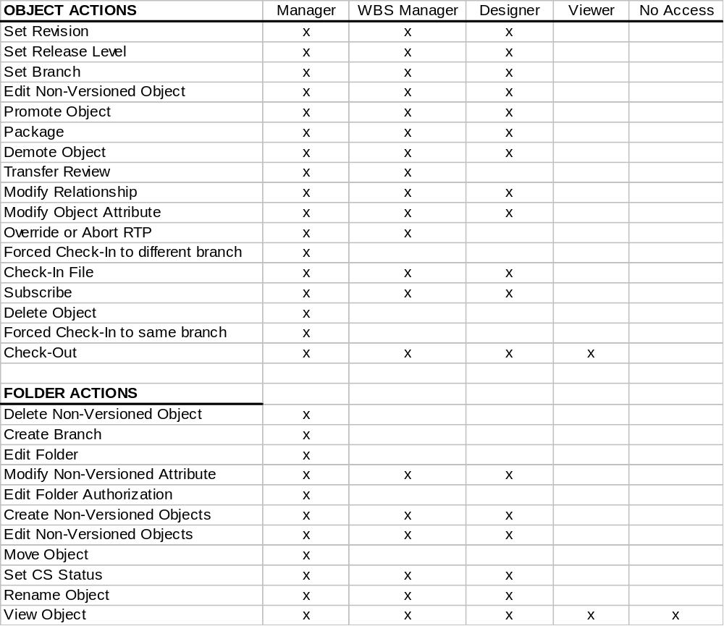

Table 2.3-2 Pro/INTRALINK Roles

Drawing Release Scheme
Within the Pro/INTRALINK environment, a defined set of “release” levels has been defined that a drawing or model will progress through. Six release levels have been established and are illustrated in Table 2.3-3. It is not necessary that an object pass though each release level. Each Pro/INTRALINK folder will have a predefined set of release procedures that identifies who can approve an object to allow it to pass to the next release level. The WBS Manager or Cognizant Engineer directly involved with the component design process will determine when a model or drawing should be proposed for promotion and whether the full release scheme should be followed or if a subgroup for the WBS section under his/her responsibility will suffice. The NCSX project release procedure starts with the designer (or drafter) promoting the object followed by sequential approvals made by the Cognizant Engineer, the WBS manager, Design Integration manager and finally the section Project Engineer.

Work in Progress
Conceptual Design
Preliminary Design
Prototype
Final Design
Fabrication

Table 2.3-3 Model and Drawing Release Levels

Pro/INTRALINK automatically records that revision number and the release level and version number on the drawing and model format to indicate the release level. Approvals are recorded using Adobe Acrobat electronic signature procedures that provides secure password protected signatures.

Promoting a model or drawing to the next higher release level does not, by itself, result in a change to the technical baseline. Only an ECP can do that. Release promotion will coincide closely with the preparations for a design review (e.g., preliminary design review/PDR or final design review/FDR). Changes to a model or drawing may be proposed at any time deemed appropriate by the cognizant WBS Manager, but the release level will not be changed until a design review is scheduled.

The design review package will include at a minimum the following:
- Updated models and drawings that have been promoted to the next appropriate release level consistent with the level of the design review.
- Other updated technical documentation represented by specifications and ICDs.
- Updated System Design Descriptions (SDDs) that document the current level of design and its basis. The purpose of SDDs is to provide an historical record of the project’s baseline design at established stages (e.g., preliminary design, final design, etc.) in the project life cycle.
- Updated cost and schedule documentation that is consistent with the updated technical documentation.
- An ECP that summarizes all the proposed changes to the technical, cost, and schedule baseline documentation. This ECP will assist the reviewers in understanding all the impacts of the proposed changes, but the ECP will not be approved until following the design review and the incorporation of comments/recommendations impacting the current level of technical, cost, and schedule documentation.
At the completion of the design review, it is likely that additional iterations will be needed to the released models and drawings. Only when the recommended modifications from the design review are incorporated and the models and drawings re-promoted to the appropriate release level and the cost and schedule documentation updated will the ECP be updated, processed, and be ready for approval. Only when the ECP is approved in accordance with the CMP, will the technical, cost, and schedule baselines be updated and the released model and drawings stored as an approved update to the project baselines.

Typical Drawing Release Procedure
Release procedures specify an approval process that occurs when an object is promoted or demoted to a designated release level. As work progresses and a designated milestone is reached, an authorized user can move a drawing, model, or other object from one release level of Pro/INTRALINK to higher level by promoting it. Likewise an object can be moved back to a lower level by demoting it. When a user tries to move an object, the associated release procedure is initiated. A release procedure request is sent to those users who have been designated as reviewers for the procedure. For the NCSX project the promotion process can be completed with approvals made by the cognizant Project Engineer and Engineering Manager, based on a predefined set of release procedures established for each WBS area. A detailed set of instructions that defines the promotion process is described in the Pro/INTRALINK User Manual for the NCSX project.

A typical release sequence is as follows:

- All new models and drawings will start in the Work in Progress release level from which they can be promoted to a higher level. It is not necessary that the progression be to the next release level. The standard sequence is Preliminary Design release to Final Design Release to Fabrication Release. However, this can be changed with the approval of the Engineering Manager. Also if a change is needed to be made in a model or drawing previously released (say for Preliminary Design) it must be “demoted” and placed in the Work in Progress Release level where modifications are made and then again promoted to a higher Release level.
- Models and drawings used for the Conceptual Design Review (CDR) are all frozen at the Conceptual Design Release level. These constitute the NCSX CDR Baseline, which is NOT allowed to change. Copies of these models can be demoted to Work in Progress Release level in order to modify them or promote them to a higher release level.
- Upon successful completion of the Preliminary Design Review, all models will be promoted to the Preliminary Design Release level. Again if changes are to be made in some of the Preliminary Design modes/drawings, those needing modifications will be demoted to the Work in Progress Release level.
- If prototype components are to be fabricated, copies of the detailed design models and drawings will be certified for construction as prototypes and released to the Prototype Release level. A prototype number will be placed on these objects per Sec. 3.1.3. Prototype drawings are a branch of the design process and do not necessarily represent the final design, but since they may be included in procurement packages, they must have revision capability. Once a prototype model or drawing is approved they will be moved into the Fabrication Release level (skipping Final Design) where revisions are tracked.
- For standard objects (not becoming a prototype) after the successful completion of the Final Design Review the models and drawings will be promoted to the Final Design Release level.

As procurement packages are assembled, models and drawings will be released to the Fabrication level. Only at this level will revisions be tracked. Pro/INTRALINK version numbers will be used to track early stages in the release process. They will identify baselines, design milestones and the status of the object. As such version numbers need to be maintained for documentation purposes. The Pro/INTRALINK system administrator will not purge version numbers in any of the NCSX folders without consent of the NCSX Project Design Integration group.

Released Fabrication Drawing
When a drawing (or model) is ready to be released for fabrication the responsible designer/drafter/engineer shall make an Adobe PDF file for obtaining signatures. The Adobe PDF file will be routed for signatures following the sign-off procedure for the WBS group that the drawing was released in. Typically a drawing release sign-off procedure will call for signatures by the drawing originator, a drawing checker and the WBS manager(s). The approved drawing signatures will be electronically added to the PDF file using the Adobe signing process. After the WBS manager signs he will send the Adobe PDF file to the PPPL Drafting supervisor. The Drafting supervisor will add his signature to the PDF drawing (indicating that PPPL drawing standards are met) and add the stamp “Released for Fabrication/Installation”. He will then enter the drawing in the Released Drawing folder in Pro/INTRALINK (001_Released_Dwgs_PDF_Format). Write access to this area will be restricted. Release drawings developed at ORNL will be sent to the PPPL Drafting supervisor for placement in the NCSX released drawing folder.

The electronic CAD version of the release drawing will be stored in Pro/INTRALINK in the appropriate subfolder based on the WBS level where it originated.

Model and Drawing Storage
All CAD models and drawings, and the native CAD data files, will be stored in Common Space within the governing WBS folder under which the data was developed. All models and drawings that describe the approved technical baseline will be stored in the approved technical baseline folder in a PDF format. Models and drawings in a developmental baseline status will also be stored in a PDF format as each release level is achieved. The released drawing folder will have restricted write access with an unrestricted read access.

Changing Models and Drawings
Until such time that a drawing or model is approved and released for fabrication, the revision level (e.g., Revision 0) will not be advanced. Rather, in accordance with subsection 2.3.2.1, only the version number will be advanced. However, the same degree of discipline will be applied when promoting and/or demoting drawings and models to ensure that the latest released version is available on the Pro/INTRALINK Common Space database.

Changes to approved and released fabrication drawings will be made in a manner that follows the PPPL Engineering Procedure ENG-010, “Control of Drawings, Software, and Firmware” with one alteration. When an ECN is pending on a particular drawing the Drafting supervisor will extract the affected drawing from the NCSX Pro/INTRALINK drawing released folder and add an Acrobat stamp that states “ECN Pending” along with the ECN number and any summary description added to the drop-down note. Once the Acrobat stamp is added, the Drafting supervisor will place the drawing back into the released drawing folder. This process allows all viewers of drawings in the Released Drawing folder to be made aware that an ECN is pending on a particular drawing. After the ECN changes have been completed a PDF file will be made of the revised drawing and placed in the Release Drawing folder and the drawing with the ECN Acrobat stamp removed.

MANAGING OTHER PROJECT DOCUMENTATION

General Approach
Project documents other than CAD models and drawings will reside in a Web base environment as they are being developed, existing as drafts for project review and mark-up. Once the documents are approved both a PDF file format and the native Word file will be stored in the Pro/INTRALINK database. WBS-specific procurement and process specifications, including assembly procedures and testing procedures, will be stored in the parent WBS folder. NCSX Plans and non-specific WBS project documents will be stored in the Project Oversight and Support folder.

Interface Control Documents
Interface definitions between two WBS system components will be defined in an Interface Control Document (ICD). The Interface Control Management Plan (NCSX-PLAN-ICMP) provides the process details for identifying and managing interfaces between separate WBS elements with separate WBS Managers (primary interfaces) and those interfaces entirely within a single WBS element or between two WBS elements, but with the same WBS Manager (secondary interface).

An interface may define a written agreement between WBS systems or define a physical boundary, mating surface geometry or attachment details that exist between two adjoining WBS components. An Interface Control Document folder will be set up in Pro/INTRALINK that will contain two subfolders. One subfolder will contain PDF files of ICD’s and the other will contain CAD drawing files (if a drawing format exists). For Pro/Engineer users, the ICD parts and/or assemblies whether described in models or drawings or by simple written agreement will remain in their respective WBS folders. One WBS system manager will take the responsibility of generating the ICD. The number placed on the ICD will be a number generated by the generating WBS group. No special number is assigned if the ICD is defined with a drawing. The originating WBS group takes the next available number in its drawing number sequence. After the ICD is completed, a PDF file will be generated and routed to both interfacing WBS managers and the cognizant Project Engineer(s) for approval. Once an ICD represented by a model or drawing is approved, a Pro/INTRALINK version will be created in order to save the release level and version number. The Pro/INTRALINK database will reflect a description of the ICD in the name description.

Specifications, Plans and Procedures, and Other Controlled Documents

Plans
The NCSX Project Execution Plan ((NCSX-PLAN-PEP) identifies the list of project-specific plans to be developed and controlled under configuration control. These will be prepared and approved in accordance with the review and approval hierarchy specified in the NCSX Document and Records Plan (NCSX-PLAN-DOC). Proposed changes or drafts to new plans will be maintained on the NCSX Engineering Web Page < http://www.pppl.gov/me/NCSX_Engineering/ > until such time that they are approved and placed under configuration control. Once that happens, they will be placed in the Pro/INTRALINK database as part of the controlled project files. Since the project plans cut across all WBS elements, these are stored in the Project Oversight and Support folder.

Specifications
Specifications are requirements documents. As described in the Systems Engineering Management Plan (NCSX-PLAN-SEMP), specifications may fall into two categories; “design-to” or “build-to” specifications. The SEMP also defines 5 types of specifications with different purposes. If the specification is specific to a single WBS element (e.g., procurement or process specification), the specification will be stored in the parent WBS folder in the Pro/INTRALINK database. However, if the specification is non-WBS-specific, then it is stored in the Project Oversight and Support folder. Samples of some specifications that will be developed for the NCSX Project include the following:
- NCSX General Requirement Document (NCSX-ASPEC-GRD)
- NCSX Vacuum Materials List
- NCSX Structural and Cryogenic Design Criteria Document
- NCSX Grounding Specification for Personnel and Equipment Safety
- NCSX Development Specifications
- NCSX Product/Procurement Specifications
- NCSX Process Specifications (Assembly and Testing Procedures)

Miscellaneous Documents
The NCSX Work Breakdown Structure (WBS) Dictionary (NCSX-WBS) is also a controlled document that is under configuration control. Each WBS Dictionary for a specific WBS element will be stored in the parent WBS folder.

Annex I

Pro/INTRALINK General Access Instructions

General Access Instructions
To access the Pro/INTRALINK database within PPPL the Pro/INTRALINK client software must be loaded on a users computer. The Pro/INTRALINK client is composed of software as well as defined workspace for each user. The software enables the user to communicate with the central Commonspace that is accessible to all users. When Pro/INTRALINK is started a floating toolbar is shown which defines the starting point for accessing most Pro/INTRALINK features.

Most Pro/INTRALINK activities involves using the workspace, Commonspace and Locate as described in the following list:

- Workspace – The location of one’s personal work area(s) that is separate form other users. More than one workspace can be identified.
- Commonspace – All information is stored in the Commonspace
- Locate – Locate is used to search for information in the Commonspace.

For offsite users the Pro/INTRALINK client will need to be configured to connect to the PPPL Pro/INTRALINK server through the PPPL firewall. Access through the PPPL firewall can be obtained by contacting the PPPL computer account administrator who will supply the necessary form to be completed and submitted to obtain authorization for access through the PPPL firewall. Full Instructions for Authenticating at the PPPL Firewall will be provided upon approval. Configuration of the local Pro/INTRALINK client also requires coordination with the Pro/INTRALINK administration group at PPPL.

The Pro/INTRALINK Users Manual contains a broader discussions and instructions for accessing and operating Pro/INTRALINK.

