NCSX Engineering Design Document

Final Assembly Plan

NCSX PDR

October 7-9, 2003

Lead Author: Erik Perry

Table of Contents
1 Test Cell Assembly Operations 1
2 Construction Safety 6
3 Cost and Schedule 7
4 Risk Management 8

Table of Figures
Figure 1 NCSX Test Cell 1
Figure 2 Base support structure with lower PF coils in place 2
Figure 3 First field period being installed 3
Figure 4 Second field period being installed 3
Figure 5 Third field period being installed 4
Figure 6 Field periods assembled together 4
Figure 7 PF and external trim coils installed 5
Figure 8 Cryostat installed (after initial operations) 5
Figure 9 Installation in Test Cell complete 6

Tables
Table 1 Work Breakdown Structure (Level 3) for WBS 7 7
Table 2 Cost summary by expense class (WBS Level 3) 7
Table 3 Cost summary by year of expenditure (WBS Level 2) 8

Test Cell Assembly Operations
The NCSX machine will be located in the NCSX Test Cell at C-site. The footprint of the stellarator core in the experimental area of the Test Cell is shown in Figure 1. The present plan is to pre-assemble and test as many components as possible, such as the field periods, outside of the NCSX Test Cell. This will help to minimize congestion in the Test Cell and streamline the assembly schedule. This method was used quite successfully during the construction of the NSTX device. The machine components will be delivered to the NCSX Test Cell and assembled together using the overhead crane’s 30-ton main hook and the 5-ton auxiliary hook.
Before the assembly phase, the shield walls will be reconfigured and seismically supported. Shield walls in front of the roll-up door to the outside will be left out until the main assembly has been completed. Leaving this area open will allow larger components, such as the field periods, to be brought into the Test Cell and lifted with greater ease. Following installation of the shield walls, convenience outlets and welding outlets will be installed around the walls.

Figure 1 NCSX Test Cell

The first step in assembling the stellarator core is to position, level, and mount the base support structure on the on the Test Cell floor. The base support structure is the element on which all three field periods will be installed. The base support structure is shown in Figure 2.
Once the base support structure has been installed, the installation of the platform around the machine will begin. When completed, the platform will extend from the machine perimeter all the way to the shield walls, as shown in Figure 1. There will be access from the control room area to the platform through a doorway at the northwest corner of the test cell. Three stairways are provided for access to the Test Cell floor. Three-quarters of the platform will be installed to serve as the scaffolding for machine assembly. Only the northeast section of platform will not be installed. This will facilitate installation of the field periods on the base support structure. The early installation of the platform will allow the other WBS elements, such as Electrical Power Systems (WBS 4), Neutral Beam Injection Systems (WBS 25), Torus Vacuum Pumping System (WBS 22), Helium Bakeout System (WBS 64), Water Cooling Systems (WBS 61), and Cryogenic Systems (WBS 62), to begin installation of their equipment. In addition, lighting, fire detection, and fire suppression systems under the platform can also be installed.
Prior to the delivery of the field periods, it is necessary to pre-position the lower poloidal field (PF) coils on the base support structure. The field periods enter the Test Cell from the northeast corner overhead door via a lowboy trailer and will be raised into position using the 30-ton overhead crane. Each of the three field periods will be delivered and mounted on the base support structure. When the last field period has been delivered to the Test Cell, the remaining sections of the machine platform will be installed to make access easier and to support auxiliary lines that will interface with the machine. The last sections of the shield wall in front of the receiving area could also be completed at that point.
The three field periods will be simultaneously moved radially on rail assemblies in the base support structure. The vacuum vessel and TF coils will be slightly retracted to ensure that the mating surfaces on the modular coil and the coil support structures come together before the vacuum vessel and TF coils do.
Once the field period assemblies are properly positioned in their final location, the modular coil and coil support structures are partially bolted together. The vacuum vessel segments are then positioned for welding to the spool pieces. The weld joints will be helium leak checked. The vacuum pumping duct and pumps will then be connected to the vacuum vessel so that a Pre-Operational Test Procedure (PTP) can be performed to verify the integrity of the vacuum vessel. As part of the PTP, the vacuum vessel will be pumped down to as low a vacuum as is achievable and a vacuum leak check will be performed.
Once these tests have been completed, the vacuum vessel will be vented and final assembly operations resumed. Bolting of the modular coil and coil support structures will be completed. The TF coils, which were installed in a retracted position, will be slid radially so that the eighteen coils wedge together in the nose region. This is critical for the reaction of centering forces on the TF coils. Proper wedging will be checked visually prior to installation of the central solenoid (CS) assembly.
Once the TF coils are installed, the PF coils are installed. The lower ring coils (PF4L-6L) are lifted from the base support into their final positions on the coil support structure. The upper ring coils (PF4U-PF6U) and central solenoid (CS) assembly are installed from overhead. The initial phases of operation, First Plasma and Initial Field Line Mapping, will be performed with the coils at room temperature. The cryostat will be only partially installed to allow access for inspections and adjustment of coils positions, if necessary.
The remaining WBS elements will then be completed, including the installation of coil bus and cable runs, helium gas bakeout lines, water-cooling lines, and liquid nitrogen lines. The installation of diagnostics required for First Plasma could also be completed. The last activity is to perform hi-pots. The machine will then be ready for Integrated Systems Testing.

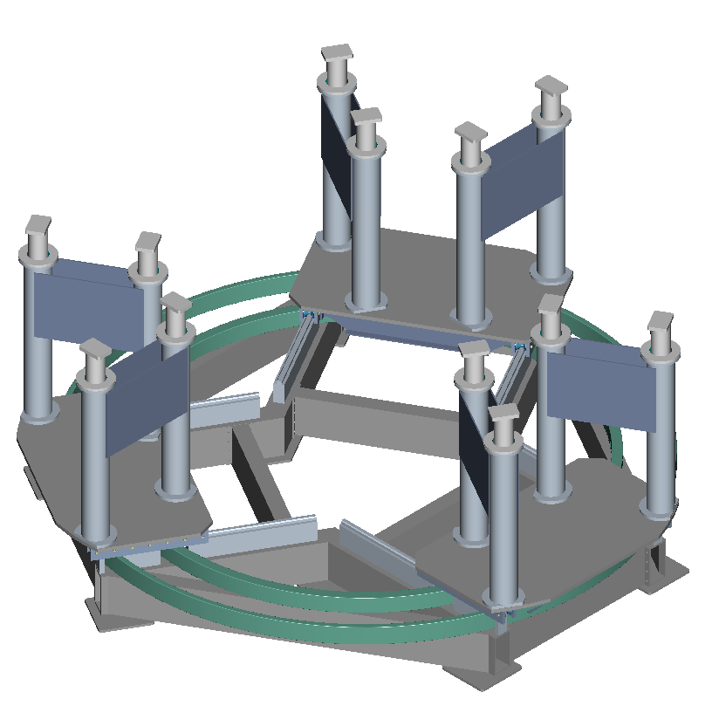
Figure 2 Base support structure with lower PF coils in place
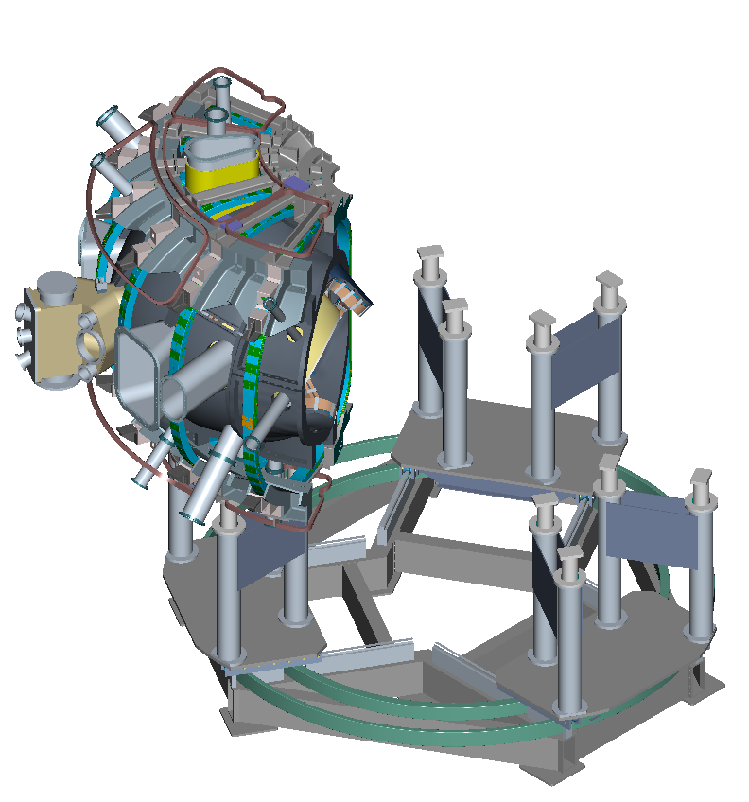
Figure 3 First field period being installed

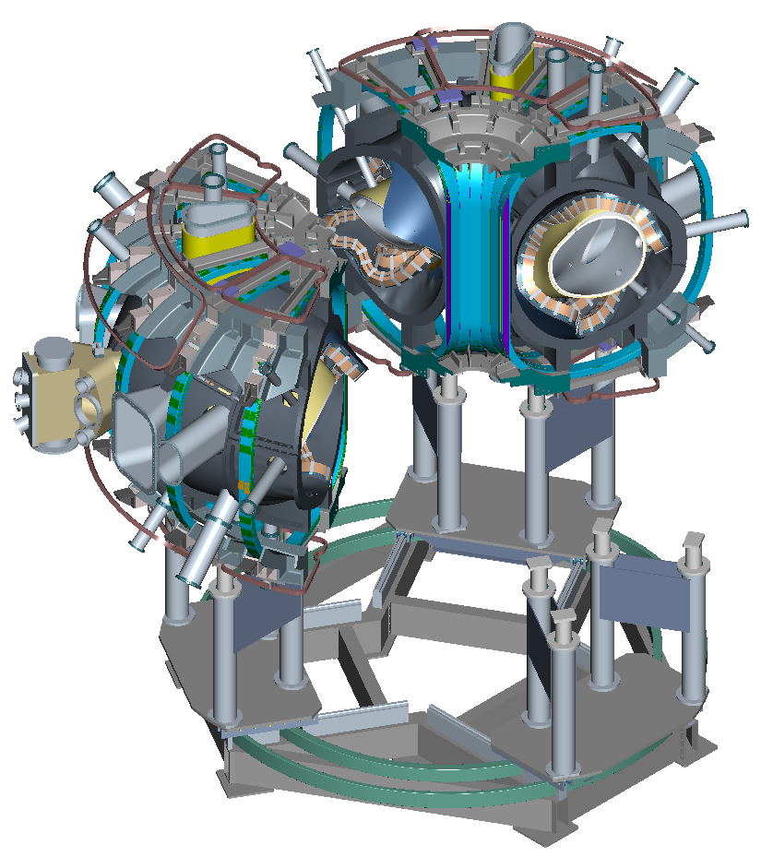
Figure 4 Second field period being installed

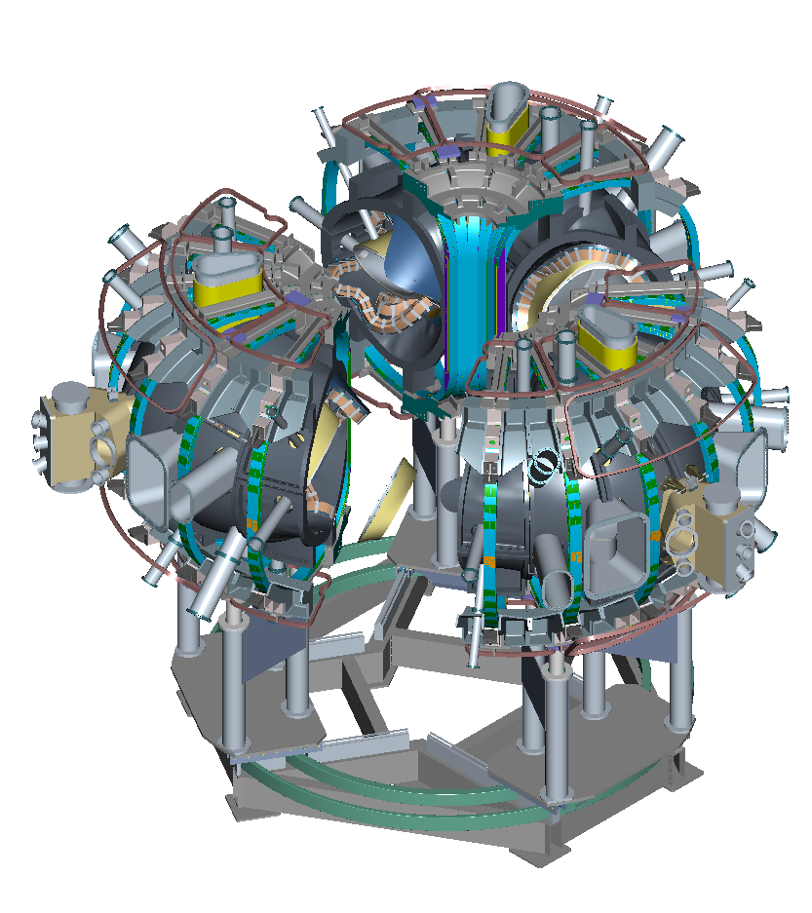
Figure 5 Third field period being installed

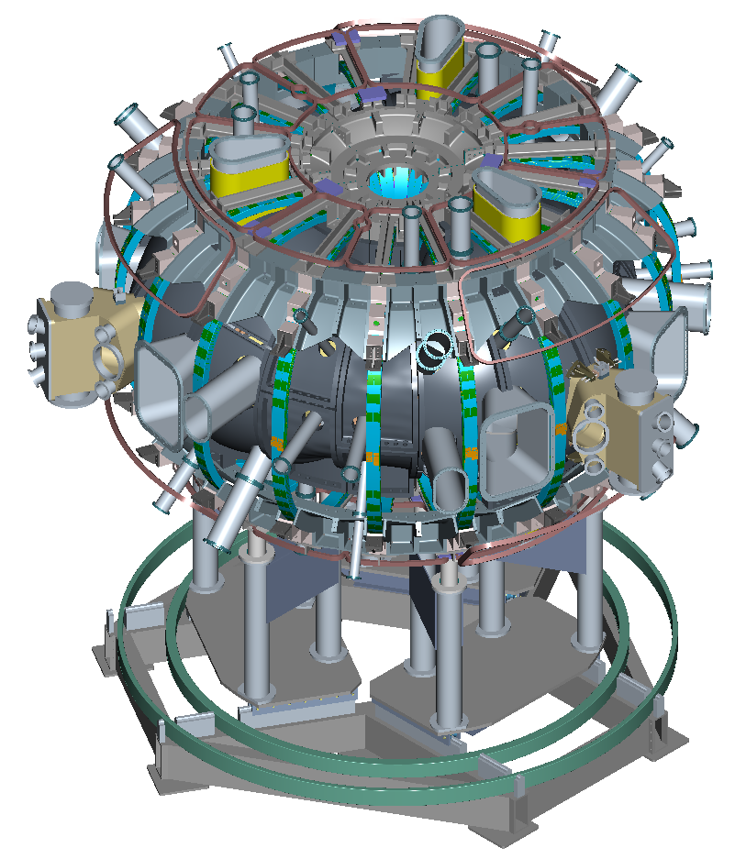
Figure 6 Field periods assembled together

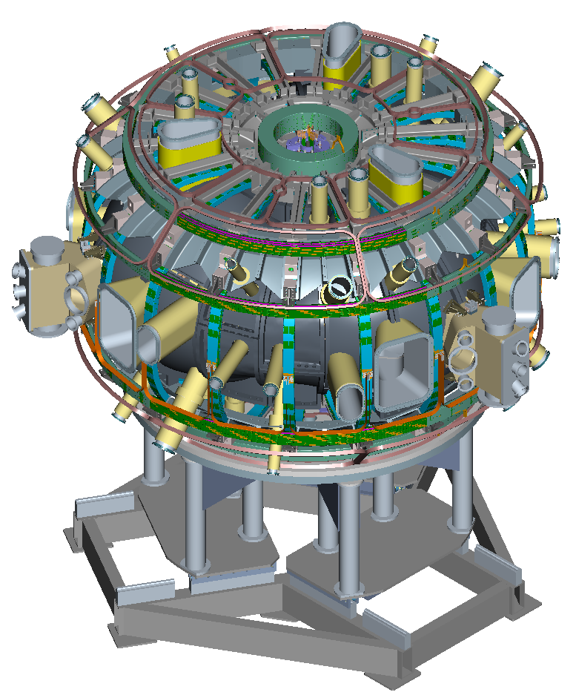
Figure 7 PF and external trim coils installed

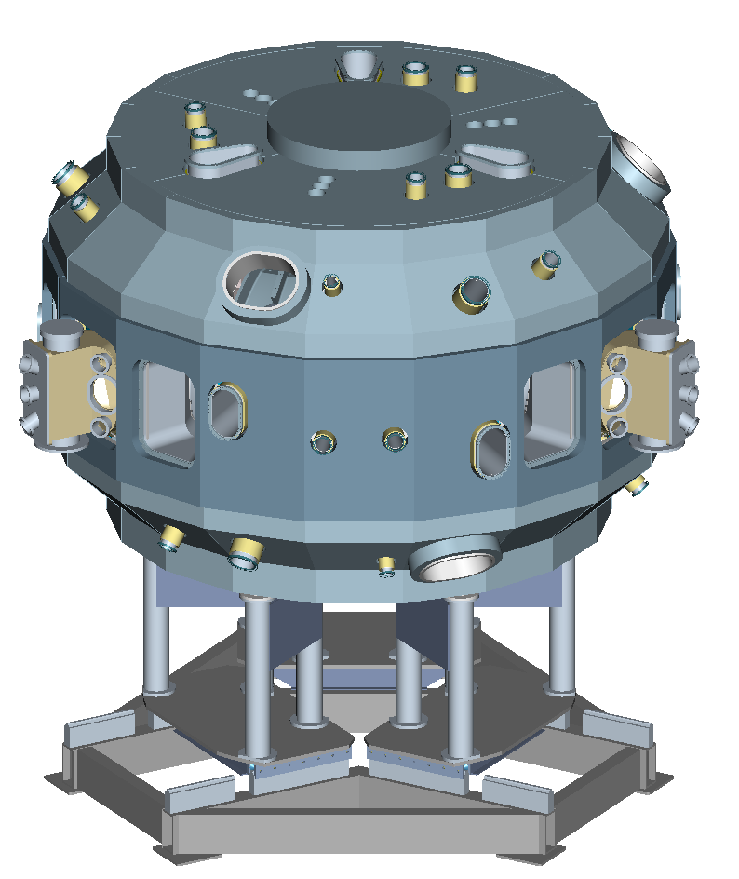
Figure 8 Cryostat installed (after initial operations)

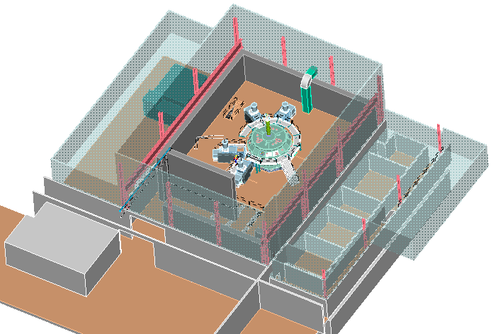
Figure 9 Installation in Test Cell complete

Construction Safety
All work activities associated with the NCSX Project will be performed in accordance with Princeton Plasma Physics Laboratory (PPPL) Engineering and ES&H Procedures and Directives. A summary of these is provided below:
- Integrated Safety Management (ISM). All work activities will be completed using the guiding principles of ISM. . All personnel involved will be trained to use this approach.
- Job Hazard Analysis (JHA). Line managers and workers will generate JHAs to identify existing or potential workplace hazards and to establish how the hazards will be mitigated for each task. A JHA will be generated for all work activities associated with the preparation, fabrication and assembly of the NCSX device. (Reference document ESH-014 “Job Hazard Analysis”)
- Engineering Work Package (EWP). Engineering Work Packages (EWP) will be utilized for consolidation of documentation and accountability for tasks being performed in the field. An EWP is a package, which contains all pertinent documentation necessary to complete an activity. The package will contain approved RUN copies of the procedures, Job Hazard Analysis, permits, drawings etc.
- Installation Procedures. Procedures will be generated for the installation / removal of all components and systems. These procedures will be generated, reviewed and approved in accordance with Engineering procedure ENG-030 “PPPL Technical Procedures for Experimental Facilities”.
- Safety. All work will performed in accordance with PPPL ES&H Directives and Procedures.
- Pre-Job Briefings. A pre-job briefing will be held prior to the start of any new work activity. The purpose of the briefing will be to discuss specific work activities, responsibilities of the participants, review of the JHA/safety issues, and to respond to all questions and concerns. The participants at these briefings must include all individuals who will be involved with the activity including lead technician, field crews, and supervisors. Representatives from Construction Safety, Industrial Hygiene, and Quality Control will be included as required.
- Post-Job Briefings. A post-job briefing will be held at the conclusion of a work activity. The purpose of the briefing will be to discuss the completed work activities and the lessons learned, including technique problems and improvements as well as safety related issues. The participants at these briefings should include all individuals involved with the procedure.
- Training. Training of personnel is an important part of completing the NSCX assembly safely. Courses will be required for all personnel, instructing them in the proper use of tools and equipment; personal protective equipment (PPE); and general laboratory policy and safety requirements.
To ensure that all field activities are conducted safely, a full time Construction Safety Representative will be utilized throughout the construction phase. Representatives from Industrial Hygiene, and Quality Control will provide support as required.

Cost and Schedule

Table 1 Work Breakdown Structure (Level 3) for WBS 7
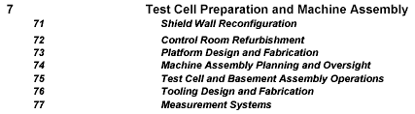

Table 2 Cost summary by expense class (WBS Level 3)

Table 3 Cost summary by year of expenditure (WBS Level 2)

Risk Management

Appendix – WBS 7 Schedule

