National Compact Stellarator Experiment

NCSX

PROJECT EXPECTATIONS SUMMARY
and
STATEMENT OF WORK

(NCSX-PLAN-PES/SOW)

Revision 0, Draft C

January 25, 2002

Approvals:

Project Laboratory

______________________________
J.F. Lyon J. A. Schmidt
NCSX Deputy Project Manager Advanced Projects Department Head

______________________________
G. H. Neilson R.J. Goldston
NCSX Project Manager PPPL Director

S. Milora
ORNL Fusion Energy Division Director

DOE

______________________________ ______________________________
G. Pitonak Warren Marton
DOE NCSX Project Manager DOE OFES Program Manager

Revision | Date | Description of Changes
Draft A | 1/8/02 | Initial draft
Draft B | 1/11/02 | Incorporated RJH comments
Draft C | 1/25/02 | Incorporated WTR & GP comments

Table of Contents

1.0 INTRODUCTION AND SCOPE OF THIS DOCUMENT 1
2.0 PROJECT EXPECTATIONS SUMMARY 1
2.1 Mission 1
2.2 Technical Objectives and Project Scope 3
2.3 Cost Objectives 5
2.4 Schedule Objectives 5
2.5 Project Completion Schedule 7
3.0 STATEMENT OF WORK 8

Tables and Figures

Table 2.3-1 NCSX DOE Level 0 and 1 Milestones…………..……………...……4
Table 2.5-1 Project Completion Schedule…………………..……………...……7
Figure 3-1 Stellarator Core……………………………………………………...8

1.0 INTRODUCTION AND SCOPE OF THIS DOCUMENT
The National Compact Stellarator Experiment (NCSX) is an experimental research facility that is to be designed and constructed at the Department of Energy’s Princeton Plasma Physics Laboratory (PPPL). Its purpose is to develop the physics of compact stellarators, an innovative fusion confinement concept. The facility will include the stellarator device and ancillary support systems. The design and fabrication project will be led by PPPL, in partnership with the Oak Ridge National Laboratory (ORNL).

This document constitutes the highest-level agreement between the performing organizations (PPPL and ORNL) and the Department of Energy as to NCSX project goals and overall approach. The Project Expectations Summary (PES) covers the NCSX mission, technical objectives, milestones, and cost objectives. The Statement of Work describes how these objectives will be accomplished.

2.0 PROJECT EXPECTATIONS SUMMARY

2.1 Mission
The National Compact Stellarator Experiment (NCSX) is an integral part of the Department’s Office of Fusion Energy Sciences program. The mission of the NCSX supports two of the program’s goals (Report of the Integrated Program Planning Activity, Dec., 2000), namely:
Goal 2: Resolve outstanding scientific issues and establish reduced-cost paths to more attractive fusion energy systems by investigating a broad range of innovative magnetic confinement configurations.
Goal 1: Advance understanding of plasma, the fourth state of matter, and enhance predictive capabilities through comparison of well-diagnosed experiments, theory, and simulation.

NCSX Mission in Support of Program Goal 2
The compact stellarator (CS) is one of the innovative magnetic confinement configurations being investigated by the Fusion Energy Sciences Program. Within Goal 2, there is a ten-year objective for the CS, namely “Determine the attractiveness of a compact stellarator by assessing resistance to disruption at high beta without instability feedback control or significant current drive, assessing confinement at high temperature, and investigating 3-D divertor operation.” The potential of the compact stellarator as an attractive concept lies in its possibility to eliminate disruptions and operate steady-state with minimal recirculating power. In order to assess it quantitatively, however, the physics of compact stellarators must be further developed. A stellarator proof-of-principle (PoP) program consisting of theory, experiment, international collaboration, and design has been established for this purpose. The NCSX, as the PoP program’s lead element, has the primary responsibility to test the physics understanding and develop the physics knowledge base needed to determine the concept’s attractiveness. Accordingly, the NCSX mission in support of Goal 2 is to:
- Demonstrate conditions for high-beta disruption-free operation, compatible with bootstrap current and external transform in a compact stellarator configuration.
- Understand beta limits and limiting mechanisms in a low-aspect-ratio current-carrying stellarator.
- Understand reduction of neoclassical transport by quasi-axisymmetric (QA) design.
- Understand confinement scaling and reduction of anomalous transport by flow-shear control.
- Understand equilibrium islands and stabilization of neoclassical tearing-modes by choice of magnetic shear.
- Understand compatibility between power and particle exhaust methods and good core performance in a compact stellarator.

NCSX Mission in Support of Program Goal 1
Within Goal 1, the Fusion Energy Science program aims to advance understanding and predictive capability in fusion plasma physics, including turbulence and transport, macroscopic stability, wave-particle interactions, plasma-wall interactions, and general plasma science. The NCSX mission in support of Goal 1 is to understand three-dimensional plasma effects important to toroidal magnetic configurations generally. Critical questions to be answered using the NCSX facility include:
- Can pulse-length-limiting instabilities, such as external kinks and neoclassical tearing modes, be stabilized by external transform and 3D shaping?
- How do externally-generated transform and 3D shaping affect disruptions and their occurrence?
- Can the collisionless orbit losses typically associated with 3D fields be reduced by designing the magnetic field to be quasi-axisymmetric? Is flow damping reduced?
- Do anomalous transport control and reduction mechanisms that work in tokamaks transfer to quasi-axisymmetric stellarators? How does the transport scale in a compact stellarator?
- How do stellarator field characteristics such as islands and stochasticity affect the boundary plasma and plasma-material interactions? Are 3D methods for controlling particle and power exhaust compatible with good core confinement?

The NCSX mission will be carried out in the Operations phase. The goal of the NCSX design and fabrication project is to provide an operational facility which meets the requirements of the NCSX physics mission.

2.2 Technical Objectives and Project Scope
The key technical objective of the NCSX project is the fabrication and assembly of the NCSX experimental facility. The facility will be capable of producing magnetized plasmas with a well defined set of configuration properties, such as size, shape, magnetic field strength, and pressure, which in turn determine its physics properties. The NCSX will provide the flexibility to vary the configuration parameters over a range of flexibility. The plasmas to be studied are three-dimensional toroids, that is, doughnut-shaped plasmas whose cross sectional shape varies depending on where it is sliced. The magnetic field coils, which control the plasma shape, must be accurately constructed to precise shape specifications. The NCSX will provide plasma control, heating, diagnostic, and power and particle handling systems sufficient for first few phases of experimental operation and will be able to accommodate later upgrades, depending on research needs. The specific parameter objectives are as follows:
- Major radius R = 1.4 m;
- Toroidal field strength B0 = 1.7 T for 0.2 second flattop;
- Neutral beam heating power PNB = 3 MW

The scope of the NCSX Project is to provide the equipment needed for the initial phases of NCSX operation. The first four phases of NCSX operation are expected to be:
- Initial Operation;
- Field Line Mapping;
- Initial Ohmic Heating; and
- Initial Auxiliary Heating;

The NCSX Project scope includes all the equipment required through the Initial Ohmic Heating phase of operation (i.e., Phases 1, 2, and 3) and re-commissioning, installation, and testing of 3MW of neutral beams. Equipment required through the Initial Ohmic Heating phase of operation (Phase 3) will be installed prior to first plasma, with the exception of diagnostics which will be installed as needed for each phase (e.g., Phase 1, Phase 2, and Phase 3). Re-commissioning, installation, and testing of 3MW of neutral beams will be done prior to the start of Phase 4. These activities, which includes Title I through Title III engineering, physics requirements definition and analyses in support of this design, supporting manufacturing development, fabrication/assembly and installation activities, and commissioning and integrated systems tests for in-scope equipment define the TEC.

The NCSX Project scope includes design work needed to ensure that certain equipment upgrades (namely: an additional 3 MW of neutral beam power, 6 MW of ICRF heating power, a pellet injector, additional trim coils, power supplies for higher B-field or faster startup, additional plasma facing components and internal pumps for divertor operation, and wall conditioning upgrades) can be accommodated. The NCSX Project scope does not include the actual implementation of these upgrades, would be funded of the research program, depending on program needs.

Activities to support NCSX research planning and preparation that will proceed in parallel with the NCSX Project, are not included in the NCSX Project scope.

2.3 Cost Objectives
The NCSX Project cost objective (TEC) is $69M in year-of-expenditure dollars, assuming project execution on the schedule given in Section 2.3. The project cost objective will be fully defined at the completion of the Title I phase.

2.4 Schedule Objectives
The schedule objectives for the NCSX project are summarized by the sequence of milestones tabulated as follows:

NCSX DOE Level 0 and 1 Milestones

Table 2.3-1
Milestone | Schedule | DOE Level 0 or 1 Milestone
Physics Validation Review Completed | March 2001A | 1
CD-0 Milestone Completed | May 2001A | 0
Conceptual Design Review Completed | May 2002 | 1
CD-1 Milestone Completed | May 2002 | 0
Start Preliminary Design (Title I) | October 2002 | 1
Award Prototype Contact(s) for Vacuum Vessel | TBD | 1
Award Prototype Contract (s) for Modular Coils | TBD | 1
CD-2 Milestone Completed | TBD | 0
Award Production Contract for Vacuum Vessel | TBD | 1
Award Production Contract for Modular Coils | TBD | 1
CD-3 Milestone Completed | TBD | 0
Award Production Contract for PF Coils | TBD | 1
Start Fabrication Activities: | TBD | 1
Vacuum Vessel Delivered | TBD | 1
First Modular Coil Delivered | TBD | 1
PF Coils Delivered | TBD | 1
Last Modular Coil Delivered | TBD | 1
Procurement and Construction Completed: | TBD | 1
Start Pre-Ops Testing | TBD | 1
CD-4 Milestone Completed | TBD | 0
First Plasma | March 2007 | 0

2.5 Project Completion Schedule
The major milestone marking the transition from a fabrication project to an operating facility is the First Plasma milestone. First plasma is defined as an heated discharge in a magnetic field of ≥ 0.5 T and a plasma current of ≥ 50 kA. While the Operations phase will begin upon completion of the first plasma milestone, a small portion of fabrication project scope will be completed after first plasma. At first plasma, all components of the stellarator core that are within the scope of the project will be complete. However, certain ancillary systems, which are in scope but not needed for First Plasma, will be completed during the initial phases of operation. In-scope equipment will be completed according to the following schedule:
Table 2.5-1
Project Completion Schedule (TEC)
WBS | Description  (WBS Level 2) | First Plasma | Start of Phase 2. | Start of Phase 3. | Start of Phase 4.
1 | Stellarator Core Systems | X
2 | Plasma Heating, Fueling, and Vacuum Systems
 | WBS 25. Neutral Beams |  |  |  | X
 | All other WBS 2 | X
3 | Diagnostic Systems
 | Needed for 1st Plasma | X
 | Needed for F.L. Mapping |  | X
 | All other WBS 3 |  |  | X
4 | Power Systems | X
5 | Central I&C Systems | X
6 | Site and Facilities | X
7 | Machine Assembly | X
8 | Project Oversight and Support | X
9 | Preparations for Operations | X

3.0 STATEMENT OF WORK
The NCSX facility will be designed, fabricated, installed, and made ready for operation. At the heart of the facility is the plasma confinement device, or stellarator core, an assembly of several magnet systems and structures that surround a highly shaped plasma. Coils will be provided to produce a magnetic field for plasma shape control, inductive current drive, and field error correction. A vacuum vessel and plasma facing components will produce a high vacuum plasma environment with access for heating, pumping, diagnostics, and maintenance. The core will be enclosed in a cryostat to permit cooling of the magnets at cryogenic temperature. The figure which follows shows a cutaway view of the stellarator core assembly.
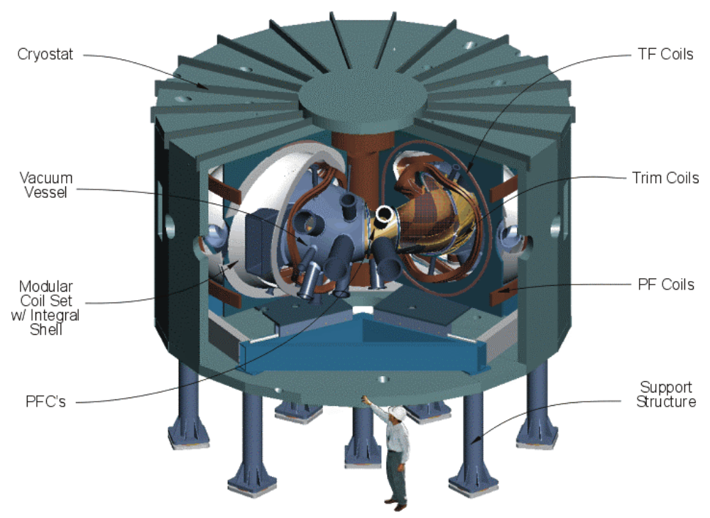
NCSX Stellarator Core
Figure 3-1

The NCSX core will be installed in the C-site test cell (formerly occupied by the Princeton Large Torus and Princeton Beta Experiment facilities) at the Princeton Plasma Physics Laboratory. It will be equipped with neutral-beam heating systems, pumps, fueling systems, diagnostics, control systems, and data acquisition systems. Site infrastructure such as cryogenic systems and utility services will be used. The PBX/PLT computer and control rooms, which are contiguous to the test cell, will be refurbished and utilized. Power supplies located at D-site will be used.

The design of the NCSX facility will be done by Laboratory (PPPL and ORNL) researchers and engineers (including subcontractors). Development and manufacture of the major stellarator core components, that is, the coils and vacuum vessel, will be done in industry under contract to PPPL, or in some cases by a combination of industry and Laboratory efforts. The device will be assembled by Laboratory personnel. Ancillary systems will be provided using a combination of new and existing equipment. Major site credits to be used are the PBX-M neutral beams, D-site magnet power supplies originally used on TFTR, some C-site power supplies, the PBX-M vacuum pumping and gas injection systems, the test cell and associated infrastructure, and the adjacent control and computer rooms. As part of the project, the facilities and equipment to be re-used will be reconfigured or refurbished as needed to meet NCSX requirements. In the final stage of the project, an integrated testing program will be carried out and a plasma (“first plasma”) will be produced in the device to make it ready for experimental operations.

