Applicability

This procedure is applicable to the entire NCSX Project.

Introduction

With few exceptions, all NCSX Project documents will be stored electronically. Drawings and models will be stored on the Pro/INTRALINK database and other documentation (e.g., project Plans and procedures, specifications, analyses, memorandum, etc.) will be stored on the NCSX Engineering Web Page http://www.pppl.gov/me/NCSX_Engineering/ . These documents will be posted in pdf format to facilitate easy access. Since NCSX Project files will be electronic in nature, it is appropriate to utilize an electronic review and signature process. In order to access pdf documents, a user need not have an established electronic signature profile. However, with the exception of DOE-level project plans, all documents will be signed electronically.

The NCSX Project has adopted the Digital Signature Process and Security embodied in Adobe Acrobat. In order to ensure consistency across the NCSX Project, Adobe Acrobat 5.0 (or later) version is required. In Adobe Acrobat, this is called the “Acrobat Self-Sign Security.’ The Adobe Acrobat system permits personnel required to sign documents to create their own secure electronic signature (via password protection), permit authentication of the electronic signatures, and permit casual users to also view completed documents with the full signatures visible. Inherent in all these tasks is the requirement that all users (whether personnel signing documents or casual viewers) establish their own User Attribute profile. This profile will permit personnel to set up their own protected electronic signature or permit the casual user to verify all the signatures. Without the unique User Attribute, the electronic signature process will not work correctly.

Once electronically signed, the document (be it drawing or other project document) is frozen and additional changes precluded without changing the file name. The signed document will then be posted in the appropriate electronic project files. Changes to approved documents are then processed in accordance with the NCSX Configuration Management Plan.

Referenced Documents

NCSX-PLAN-PEP | NCSX Project Execution Plan
NCSX-PLAN-SEMP | NCSX Systems Engineering Plan
NCTX-PLAN-CMP | NCSX Configuration Management Plan
PPPL ES-DRFT-002 | PPPL Pro/INTRALINK Users Guide

Procedure
There are two distinct, albeit similar, tracks for signing drawings and models and for signing other project documents. This procedure consists of five sections:

- Establishing a User Attribute and Electronic User Signature Profile
- Verifying Signatures
- Setting up the signature blocks for a document and/or drawing
- Signing drawings and models
- Signing other project documents
- Obtaining copies of approved documents

It should be noted that these directions were generated assuming a PC. It is recognized that the interfaces may appear slightly different on a MAC, however, the processes are the same.

- Establishing a User Attribute and Electronic User Signature Profile
The key element for electronic signature is for each user/person signing documents establish his or her own unique password-protected User Attribute and signature file (if the person is required to sign documents) or certificate that can only be accessed by the user. This need only be accomplished once. Once the User Attribute (and electronic signature if needed) is accomplished, the processes of signing a document or verifying other signatures are reasonably straightforward.

It may be desirable to create at least two electronic “signatures”. The first electronic “signature” should be a full name (full name “signature” for signing most documents or drawings) and an initials “signature” (for signing documents with only limited space availability). Note: Due to Identity Theft concerns, only electronic “text” signatures will be established => NO script signatures.

Attachment 1 to this procedure provides a visual step-by-step representation of this process.

Responsibility | Action
User | 1. Open Adobe Acrobat 5.0 (or later version) and select Tool Menu => Self-Sign Security => Log In
 | - When Self-Sign Security – Log In dialogue box opens, select New User Profile

- When Create New User Profile dialogue box opens, fill in the User Attributes:
- Name (Required)
- Organization Name (Optional)
- Organization Unit (Optional)
- Profile File => select unique password and confirm that password)
- Close Create New User dialogue box by clicking “OK”. If only created to view and verify electronically signed documents/drawings, this completes the necessary steps. If need to also create an electronic signature, continue to Step A5 below.
- After User Attribute file established, select Tool Menu again => Self-Sign Security => User Settings
- When Self-Sign Security – User Settings for XXXX (name of user) appears, select “Signature Appearance” and “New” button.
- When “Configure Signature Appearance” dialogue box appears, name the title of the signature (e.g., Full Name Text Signature, Initials Text Signature, etc.) in the Title section and then in the “Configure Graphic” section, select “NAME”. DO NOT SELECT IMPORT “IMPORTED GRAPHIC.”
- In the “Configure Text” section, select the appropriate “show” options. It is recommended that only the “Date” block be selected to preclude too much detail on the electronic signature.
- Select “OK” to close the “Configure Signature Appearance” dialogue box. Your electronic signature is now established.
- If other specific signature appearances are required (e.g., initials), repeat steps A3 through A10 until all desired electronic signature options are determined.
- When completed setting up your signature profiles, the final process is to e-mail your certificates to a central repository so that any other users may download validated certificates when verifying signatures. There are slightly different processes depending on the E-mail program in use.
- Under the Tool Menu, select “Self-Sign Security” and then “User Settings”.
- When the “Self-Sign Security - User Settings for XXXX”, select “User Information”. Outlook users should then proceed to step A14 and Eudora and Entourage users should proceed to step A18.
- Outlook users should select “E-Mail”.

- When the “E-Mail Certificate” dialogue box appears, complete the information as follows”
- In “Message to” section, fill-in the e-mail address of the Systems Engineering Support Manager ( bsimmons@pppl.gov ). The Systems Engineering Support Manager will maintain the complete folder of validated certificates on the Systems Engineering Web Page < >
- Fill-in your contact information (usually a phone number)
- Select “E-Mail” option
 | - When the “Acrobat Certificate Exchange File from XXXX” dialogue box appears, select “Send” option to send e-mail. Note: You may also e-mail your certificate directly to other users if so desired. However, ensure that a certificate is e-mailed to the Systems Engineering Support Manager.
Systems Engineering Support Manager | - Receives e-mailed certificate and posts in “Validated Certificates” folder accessible via links from the NCSX Engineering Web page http://www.pppl.gov/me/NCSX_Engineering/ .
User | - Eudora and Entourage users should select “Export to File…”
 | - Place the Certificate File (.fdf) on your desktop or in a folder. DO NOT change the Object name.
 | - Using Eudora or Entourage, send the an e-mail with the Certificate File (.fdf) to the Systems Engineering Support Manager ( bsimmons@pppl.gov ). The Systems Engineering Support Manager will maintain the complete folder of validated certificates on the Systems Engineering Web Page < >. Note: You may also e-mail your certificate directly to other users if so desired. However, ensure that a certificate is e-mailed to the Systems Engineering Support Manager.
Systems Engineering Support Manager | - Receives e-mailed certificate and posts in “Validated Certificates” folder accessible via links from the NCSX Engineering Web page http://www.pppl.gov/me/NCSX_Engineering/

- Verifying Signatures
When a document is forwarded for signature and that person wants to verify the signatures before signing, or a casual user desires to verify signatures in order to remove the electronic question mark (?), the person must first ensure that they have an electronic User Attribute established in accordance with the procedure outlined in Section A previously. It should be noted here that the “verification” process is linked to the Adobe Acrobat Digital Signature Verification process and is not necessarily a physical verification process. However, as indicated in this procedure, the user may call the previous signatures to confirm that they did indeed electronically sign the document and to match the number of their certificate.

The Systems Engineering Support Manager is responsible for maintaining an up-to-date list of validated signatures. This list can be found in tabular format in via links from the NCSX Engineering Web page http://www.pppl.gov/me/NCSX_Engineering/ .

The person approving the document is required to verify all the previous signatures before signing. Other users have the option to either accept that this verification occurred before the document was approved or, at their option, may also verify the signatures.

Each time the document is opened once posted, all the electronic signatures will appear, albeit with a question mark (?) that indicates that the signatures on the opened document have not been re-verified. Since the person approving the document is required to verify all the previous signatures before signing, anyone opening the document can assume that the approving official has verified the signatures before approving the document. Nonetheless, at their option, users may also verify the signatures, although it is not required. This section outlines the process for verifying signatures.

Attachment 2 to this procedure provides a visual step-by-step representation of this process.

Responsibility | Action
Approving Official or User | 1. Open the document using Adobe Acrobat 5.0 (or later version) and Log In using the procedures in Section A. When document is open, all signatures will have a question mark (?) appearing. The Approving Official must first verify all signatures before signing. Other users have the option to verify signatures or to accept that all signatures were verified before the document was approved.
 | - Open the NCSX Engineering Web page http://www.pppl.gov/me/NCSX_Engineering/ and select the link to the Validated Signatures web page. Once at the Validated Signatures Web page, select the link to the table of validated signatures. This table provides the validated certificate numbers for each user with an electronic signature.
 | - To verify a signature for the first time, right click the signature field that is to be verified. Right-clicking signature field will automatically open another dialogue box. Select “Verify Signature”. If the all the signatures had been previously verified and added to “Your Trusted Certificates” section in the Users Profile, proceed to step B8.
 | - Selecting the “Verify Signature” will result in the “Self Sign Security – Validation Status” dialogue box appearing with the message, “Signature validity is UNKNOWN”. Select “Verify Identity.” option.
- When the “Verify Identity” dialogue box appears, confirm the MD5 and SHA1 Fingerprint numbers with those on the Validated Signature Web list.
- If they are the same, select “Add to List”.
- If they are not the same, call the contact information for the certificate owner and notify the Systems Engineering Support Manager of the discrepancy.
 | - When convinced of the certificate validity, check the “Add to List” box to add the list to your “Trusted Certificate” list. The “Self-Sign Security – Alert” dialogue box will appear indicating that this signature has been added to your “Trusted Certificate” list and the question mark (?) will change to a check (√) indicating that the signature has been verified.
 | - Repeat steps B2 through B6 until all the desired validated certificates are transferred to the user’s “Trusted Certificate” folder, all signatures are verified, and all question marks (?) are changed to a checks (√) indicating that the signatures have been verified.
 | - If the signatures have all been previously verified and are in your “Trusted Certificates” list, you need only select Tool Menu => “Digital Signatures”. When the adjacent dialogue box opens, select “Verify All Signatures”.
 | - When the “Digital Signature – Alert” dialogue box appears, select ”OK”. This will change the question marks (?) to checks (√) once the signatures are verified.
 | - The ”Digital Signature –Alert” dialogue box will then change to show “Verification Complete” – check “OK” to complete the verification process.

- Setting Up and Modifying The Signature Blocks For Documents And/Or Drawings
The person that who originates the document (either drawing or other document) is responsible for providing the source document to the responsible official (either the NCSX Systems Engineering Support Manager or NCSX Engineering Manager for controlled documents other than drawings and to the Design Integration Manager for drawings). The responsible official will then convert the source document to pdf format, establish the initial document security for that document, and establish the signature field for each required signature. The responsible official will then distribute the pdf document for signature.

Attachment 3 to this procedure provides a visual step-by-step representation of this process.

Responsibility | Action
Originator of the Document | 1. Saves the source document in the original format and forwards the document electronically to the responsible official (either the Systems Engineering Support Manager or Engineering Manager for controlled documents other than drawings and to the Design Integration Manager for drawings).
Responsible Official | - Converts the source document to a pdf format.
 | - Under the File Menu, select “Document Security.”
 | - When the “Document Security” dialogue box appears, select ”Acrobat Standard Security”.

- When the “Standard Security” dialogue box appears:
- Check the “Password Required to Change Permissions and Passwords” in the “Specify Password” section and enter whatever password desired as the password. Ensure that the password is remembered, as it will be needed to modify the signature fields.
- In the “Permissions” section, select 128-bit RC4 (Acrobat 5.0) Encryption Level and check both blocks:
  - “Enable content Access for the visually Impaired”
  - “Allow Content Copying and Extraction”
- In the “Changes Allowed” section, select:
  - For a drawing, “Comment Authoring, Form Field Fill-In or Signing
  - For all other documents, “Only Form Field Fill-In or Signing”
- In the “Printing” section, ensure that “Fully Allowed” appears
- Check “OK” when completed with the above
- When “Password dialogue box appears, retype in the password selected in C4 above.
- Click the Form Tool icon to activate it
- Drag the cross hair over the area where the signature will be placed
- When the “Field Properties” dialogue box appears:
- Type in the Name of the person to sign the document
- In the “Type” block, ensure that “Signature” is selected (vs. the “Text” default)
- In the “Short Description” section, enter “Prepared by, Reviewed by, or Approved by” or other appropriate descriptor of the action indicated by the signature
- Unless otherwise desired, leave “Border” section at the default settings
- In the “Text” section, select the desired font color and type
- Unless otherwise desired, leave “Common Properties” section at the default setting
- Select “OK” when the above settings are selected.
- Repeat step C8 as many times as necessary for the number of signatures desired.
- Save the document and distribute to the personnel required to sign the document in accordance with the procedures in Section D.
- Should a signature field need to be modified or corrected, follow steps C12 through C20 below.
- Under File Menu, select “Document Security’.
- When the “Document Security” dialogue box appears, select “Change Settings”.
- When the “Password: dialogue box replaces the “Document Security” dialogue box, type in the password previously selected by the originator in step C4 above.

- When the “Standard Security” dialogue box appears, select “Cancel”. Selecting “OK” will preclude changing the signature field blocks.
- When the “Document Security” reappears, select “Close”.
- Right click the signature field block to be changed and a dialogue box will appear with several options.
- Select “Delete Signature Field”.
- When the “Digital Signature –Alert” dialogue box appears asking if you want to delete the selected field, select “OK” to delete the signature field.
- Reapply the corrected/modified signature field block in accordance with steps C2 through C10.
- When all fields have been corrected as necessary, save the document and distribute to the personnel required to sign the document in accordance with the procedures in Section D.

- Signing Drawings And Models
Drawings and models prepared electronically have a slightly more different sign-off process than other NCSX documents in that the final signature will be by the PPPL Drafting Supervisor who then signs and places a “Released for Fabrication”, “Pending ECN XXXX”, or “NCR-XXX” stamp on the drawing. The originator of the document will be the first person to sign the document.

Attachment 4 to this procedure provides a visual step-by-step representation of this process.

Responsibility | Action
Originator of the Document | 1. Log-In in accordance with the procedures of Section A of this procedure.
 | - Opens document in PDF format.
 | - If not already done, establishes the document security and signature blocks in accordance with the procedures of Section C of this procedure.
 | - To sign the document, activate the “Hand” icon by clicking it and then right click on his signature area field.
- When the “Self-Sign Security – Sign Document” dialogue box appears:
- Type in the user’s password in the “Confirm Password” section
- Select or edit reason for signing in the “Reason for Signing Document” section
- At the option of the user, fill in the “Location” and “Contact Information”
- Select the name of the signature determined in procedure step A7 in the “Signature Appearance” section or edit the signature appearance per procedure step A7
- Check “Save” when completed with the above and the signature will appear with a check mark (√).
 | - The “Self-Sign Security – Validation Status” will appear indicating that the “Signature is Valid”
 | - Save document and forwards document electronically in PDF format

Subsequent Signers | - Open document and verify previous signatures (if desired) in accordance with Section B of this procedure.
 | - Repeat steps D1 though D6
 | - Repeat step D7 until the PPPL Drafting Supervisor is next signer. When the PPPL Drafting Supervisor is the next signer, proceed to step D11.
PPPL Drafting Supervisor | - Open document and verify previous signatures (REQUIRED) in accordance with Section B of this procedure.
 | - If document is satisfactory, sign document in accordance with steps D1 through D6.
 | - Activate the “Stamp” icon and move icon of stamp to the desired location. Left click mouse (three button mouse) to set the stamp location.
 | - Size the stamp top the proper size by dragging the stamp corners.
 | - Move the stamp icon over the stamp and right click the mouse button.
 | - When the “Stamp Properties” dialogue box appears, select the proper stamp message. Note: After the stamp is placed a “Document was Modified” warning is set in the Signature Area.” warning is set in the Signature Area.
 | - Save fully signed drawing and place in the appropriate NCSX Pro/INTRALINK database “001_Released_Drawing_PDF_Format” folder in accordance with PPPL ES-DRFT-002.

- Signing Other Project Documents
Signing other project documents (e.g., Plans, Procedures, etc.) is very similar to the steps outlined in Section D above.

Attachment 5 to this procedure provides a visual step-by-step representation of this process.

Responsibility | Action
Originator of the Document | 1. Log-In in accordance with the procedures of Section A of this procedure.
 | - Opens document in PDF format.
 | - If not already done, establishes the document security and signature blocks in accordance with the procedures of Section C of this procedure.
 | - To sign the document, activate the “Hand” icon by clicking it and then right click on his signature area field.

- When the “Self-Sign Security – Sign Document” dialogue box appears:
- Type in the user’s password in the “Confirm Password” section
- Select or edit reason for signing in the “Reason for Signing Document” section
- At the option of the user, fill in the “Location” and “Contact Information”
- Select the name of the signature determined in procedure step A7 in the “Signature Appearance” section or edit the signature appearance per procedure step A7
- Check “Save” when completed with the above and the signature will appear with a check mark (√).
 | - The “Self-Sign Security – Validation Status” will appear indicating that the “Signature is Valid”
 | - Save document and forwards document electronically in PDF format
Subsequent Signers | - Open document and verify previous signatures (if desired) in accordance with Section B of this procedure.
 | - Repeat steps E1 though E6
 | - Repeat step E7 until the Approving Official is next signer. When the Approving Official is the next signer, proceed to step E11.
Approving Official | - Open document and verify previous signatures (REQUIRED) in accordance with Section B of this procedure.
 | - If document is satisfactory, sign document in accordance with steps E1 through E6.
 | - Forward approved document to the NCSX Engineering Project Web custodian for filing.
NCSX Project Engineering Web Custodian | - File the Approved document in PDF format on the NCSX Engineering Web page http://www.pppl.gov/me/NCSX_Engineering/ in the format indicated in the NCSX Data Management Plan (NCSX-PLAN-DMP).
 | - Obtain original media version (Word, etc.) from the originator and files this copy in the NCSX Engineering Web page folder in this format as indicated in the NCSX Data Management Plan (NCSX-PLAN-DMP).

- Obtaining Copies Of Approved Documents
Approved documents will be posted on either the Pro/INTRALINK database for electronic drawings and models or on the NCSX Engineering Web Page http://www.pppl.gov/me/NCSX_Engineering/ for all other project documents. Accessing these project files is relatively straightforward and will not be covered here. However, it is an anomaly of the Adobe Acrobat Digital Signature Process and Security System that the signatures of all approved documents will contain a question mark (?). Section B of this procedure outlines the steps to validate the signatures if so desired. However, it the responsibility of the approving official to verify the signatures before signing the document.

Attachments
Attachment 1: Establishing A User Attribute And Electronic User Signature Profile
Attachment 2: Verifying Signatures
Attachment 3: Setting Up and Modifying The Signature Blocks For Documents And/Or Drawings
Attachment 4: Signing Drawings And Models
Attachment 5: Signing Other Project Documents

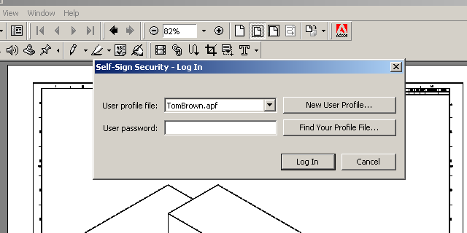

1
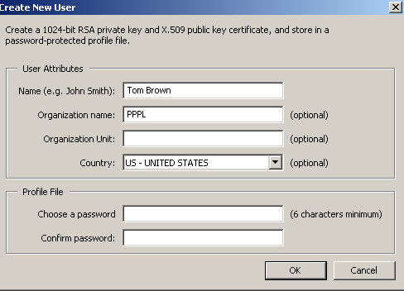

2

- Choose Tools => Self-Sign Security => Login
- New User Profile => Then fill in the User Attributes.

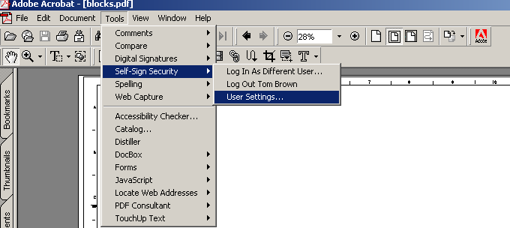

1

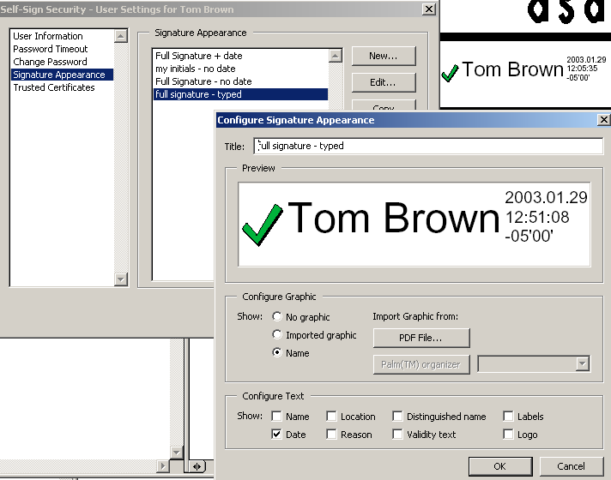
2

- Choose Tools => “Self-Sign Security” => “User Settings”
- Then => “Edit” to modify appearance.
- Select “Name”

3

Drawing Title Block Details

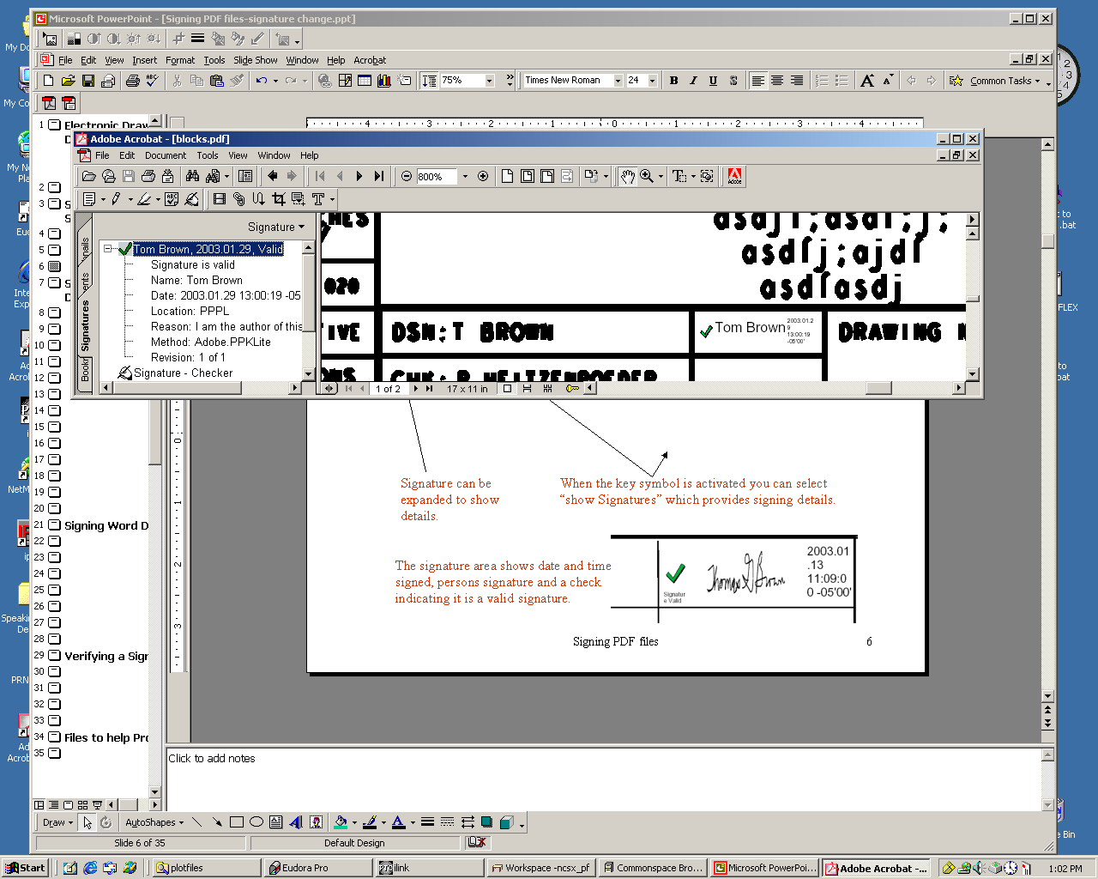

When the key symbol is activated you can select “show Signatures” which provides signing details.

Signature can be expanded to show details.

The signature area shows date and time signed, the person’s signature and a check indicating it is a valid signature.

Other Documents
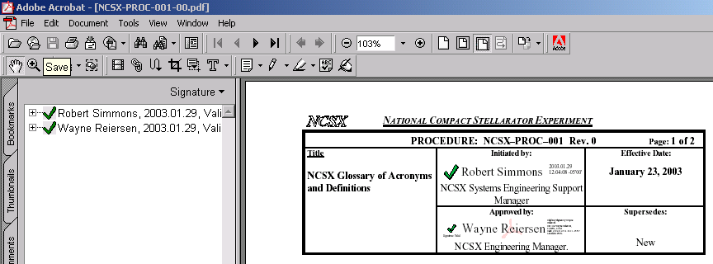

Signature can be expanded to show details.

The signature area shows date and time signed, the person’s signature and a check indicating it is a valid signature.

E-mailing Certificates

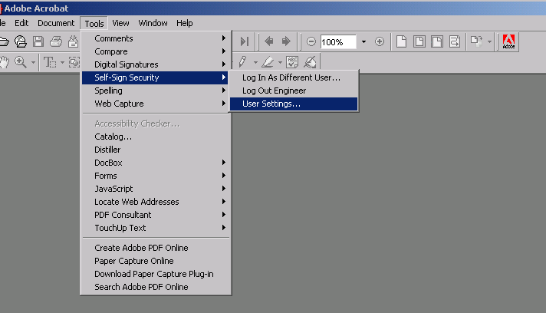

1
2

- Under Tool Menu, select “Self-Sign Security”
- Select “User Settings…”

E-mailing Certificates
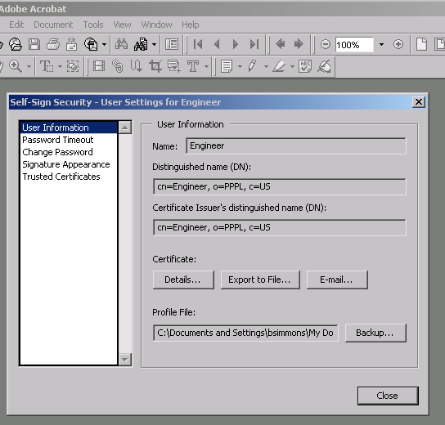

- When dialogue box appears, select “User Information”

E-mailing Certificates Using Outlook
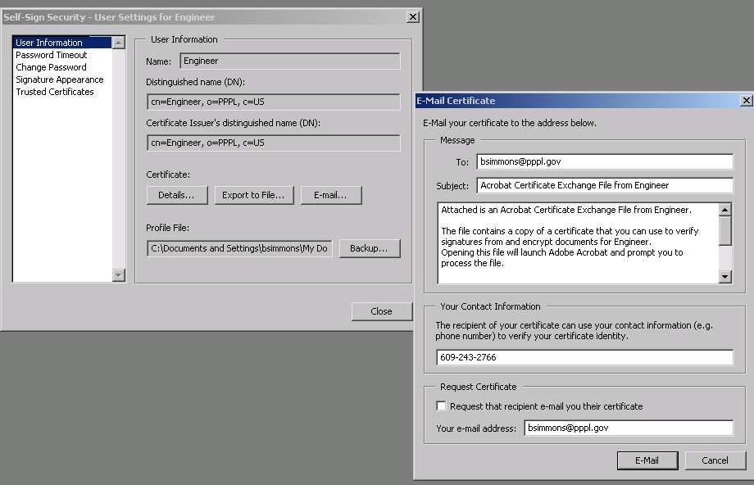

1
2

- Select “E-Mail”
- When the “E-Mail Certificate” dialogue box appears:
- Fill-in e-mail address of the Systems Engineering Support Manager ( bsimmons@pppl.gov )
- Fill-in your contact information
- Select “E-Mail” option

E-mailing Certificates Using Outlook

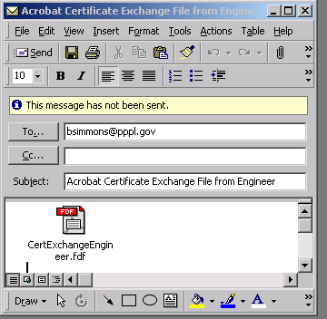

- When the “Acrobat Certificate Exchange File for XXXX” appears, select “Send”. NOTE: You may also directly e-mail certificate to another user if desired.
- Upon receipt of e-mail, Systems Engineering Support Manager will post on the “Validated Signatures” folder which is accessible via the NCSX Engineering Web page http://www.pppl.gov/me/NCSX_Engineering/

E-mailing Certificates Using Eudora or Entourage
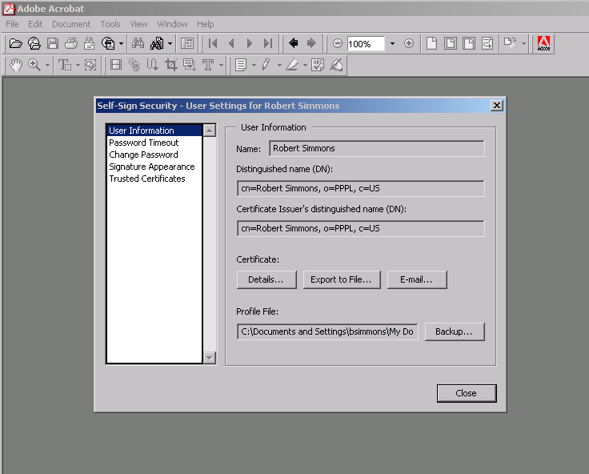

- Select “Export to File”

E-mailing Certificates Using Eudora or Entourage
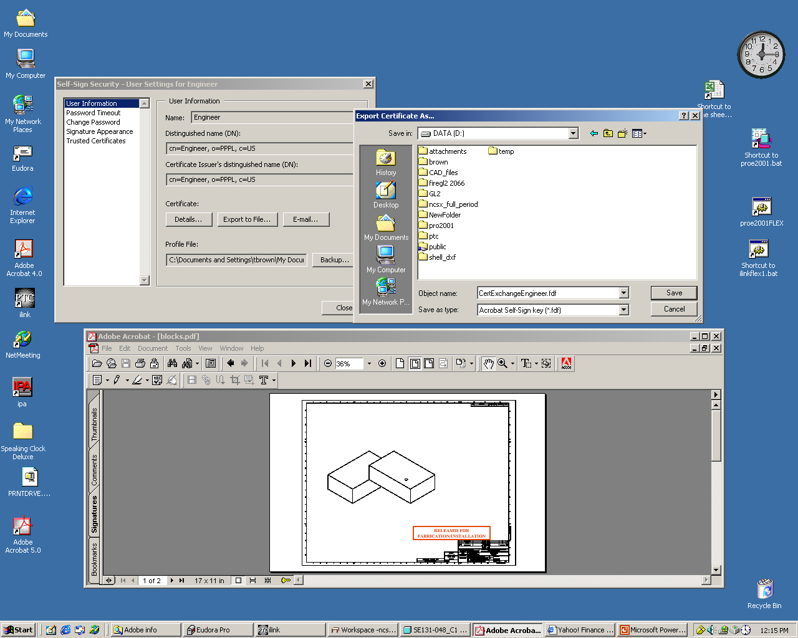
1

- Place the Certificate File (.fdf) on desktop or in a folder.
- Using Eudora, e-mail the Certificate file to the Systems Engineering Support Manager <bsimmons@pppl.gov> . NOTE: You may also directly e-mail certificate to another user if desired.
- Upon receipt of e-mail, Systems Engineering Support Manager will post in the “Validated Signatures” folder which is accessible via the NCSX Engineering Web page http://www.pppl.gov/me/NCSX_Engineering/.

DO NOT CHANGE THE OBJECT NAME.

First Time Verification

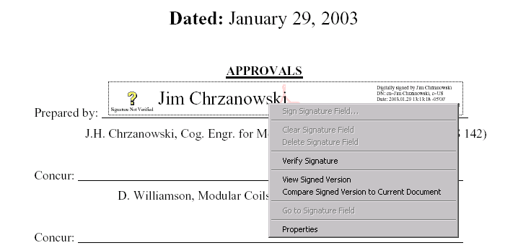

1

2

- Right click signature block
- Select “Verify Signature”

First Time Verification
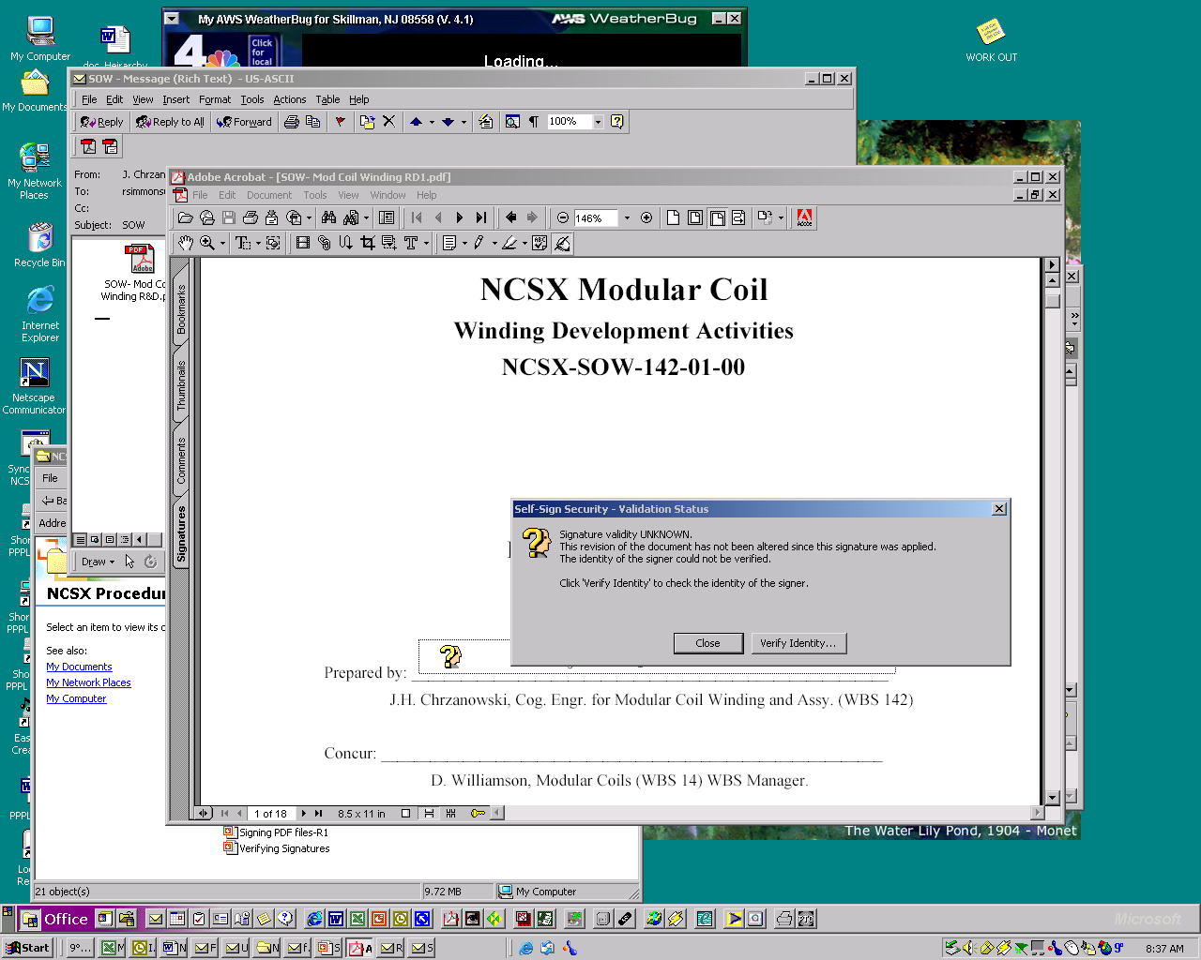

1

- Select “Verify Identity”

First Time Verification
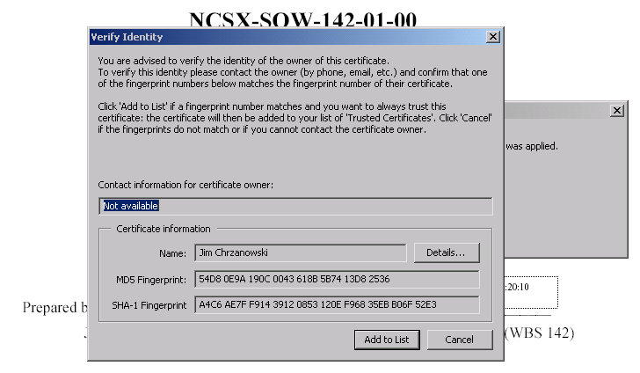

1

- To verify the identity of the owner of the certificate, check the Validated Signature list that can be accessed via a link on the NCSX Engineering Web page http://www.pppl.gov/me/NCSX_Engineering/ to confirm that the fingerprint numbers matches that on the users computer screen.
- Select “Add to List” once the user is satisfied that the certificate is valid

2

First Time Verification

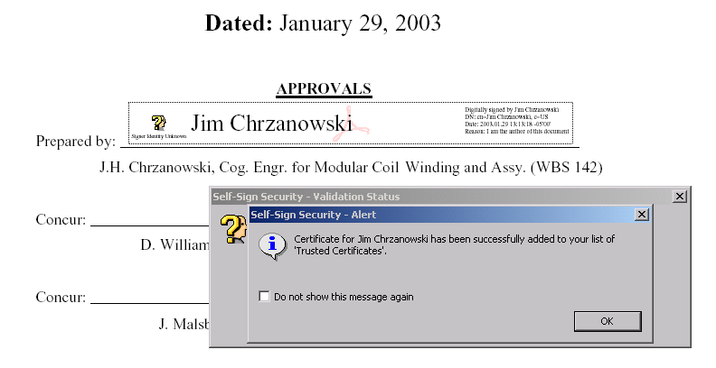

1

- Check “OK”

First Time Verification

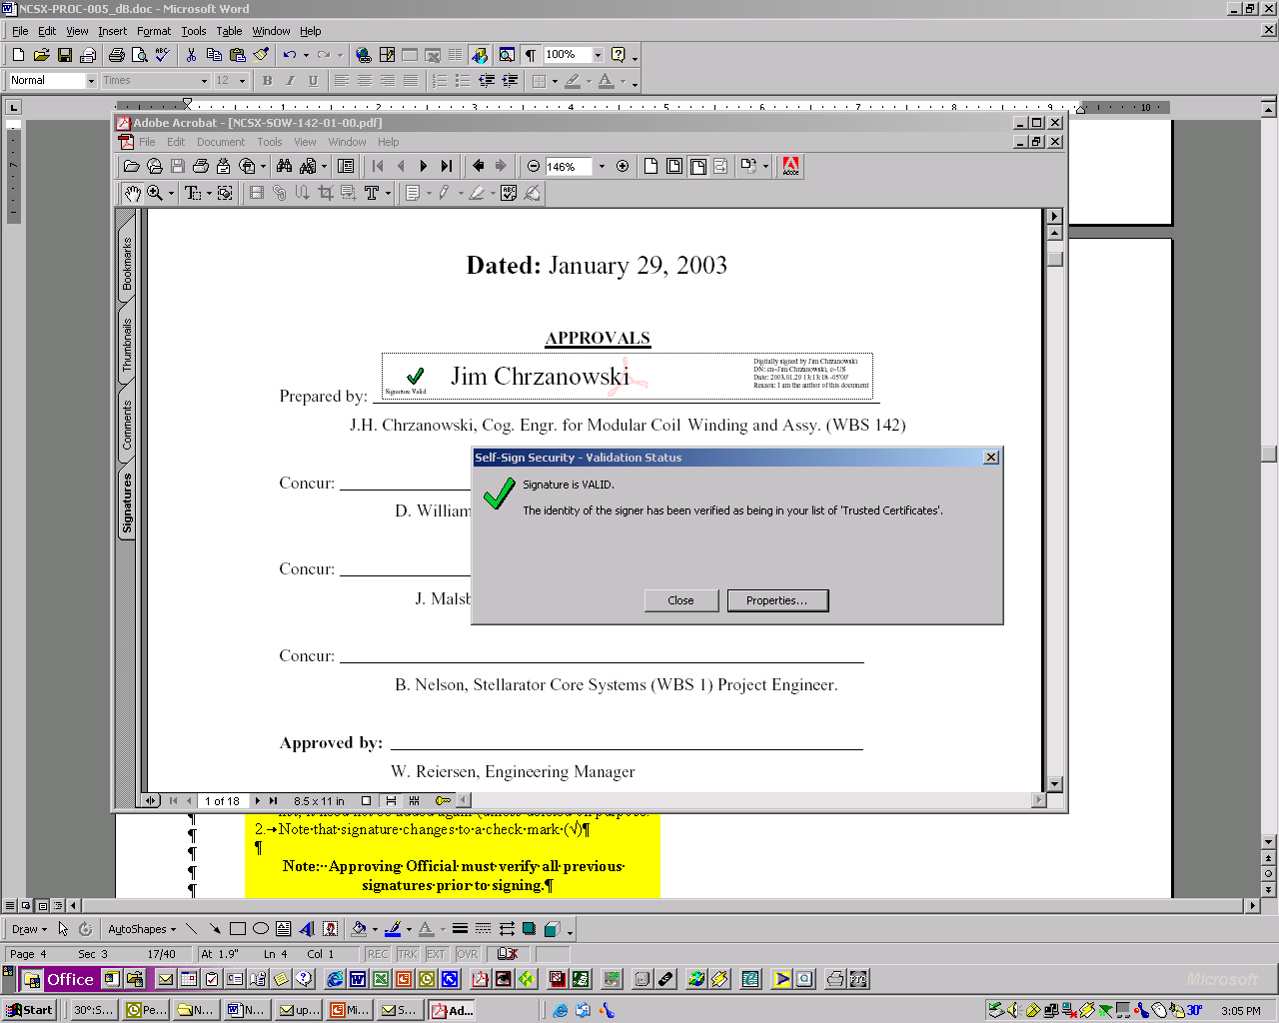

1

- Once the signature is added to the ‘Trusted Certificate’ list, the question mark (?) will change to a check mark (√) in both the “Self-Sign Security – Validation Status” and in the signature block field. Once on the ‘Trusted Certificate’ list, it need not be added again (unless deleted on purpose.
Note: Approving Official must verify all previous signatures prior to signing.

Subsequent Verification when all Signatures in ‘Trusted Certificate’ File

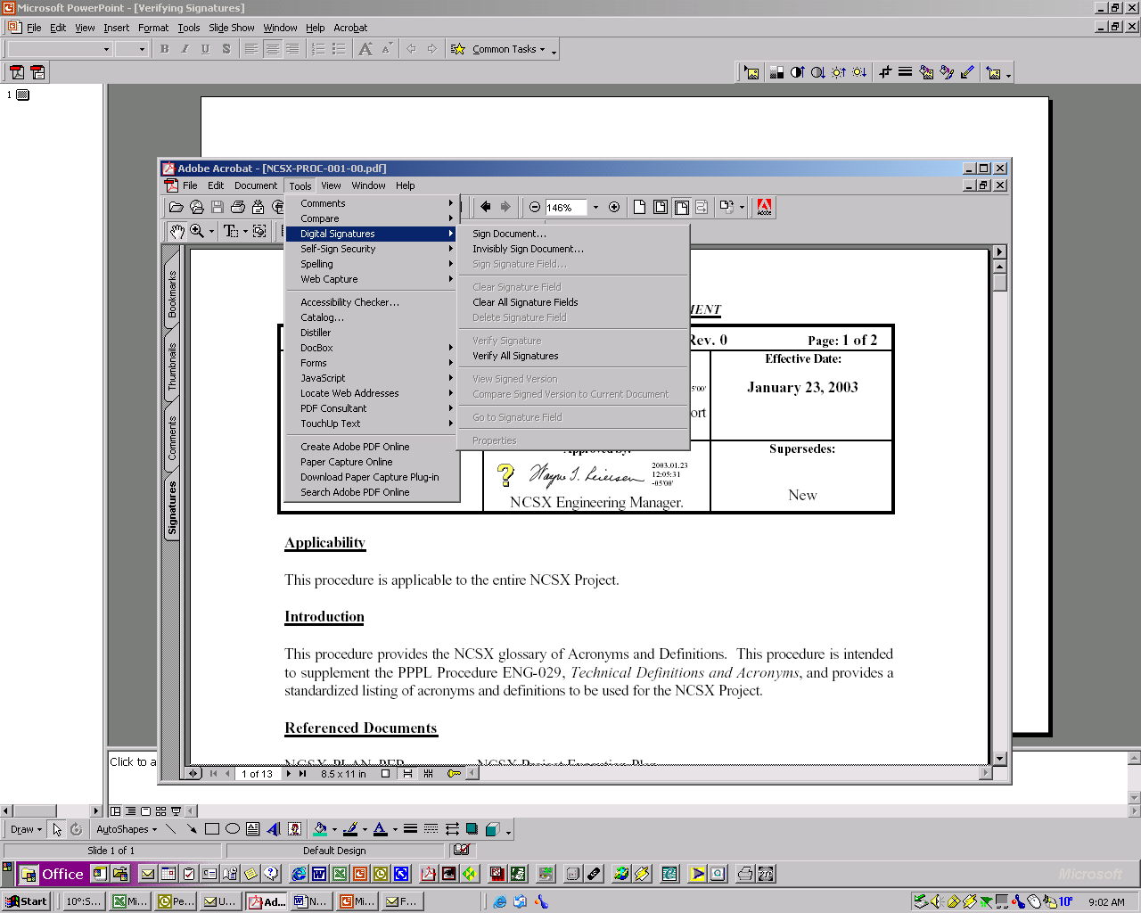
- When a document is selected, Signature Blocks will Contain Question Marks (“?”)
- Under Tools Menu, select “Digit Signatures”
- When another dialogue box appears, select “Verify All Signatures”

- Select “Verify All Signatures”

2
3

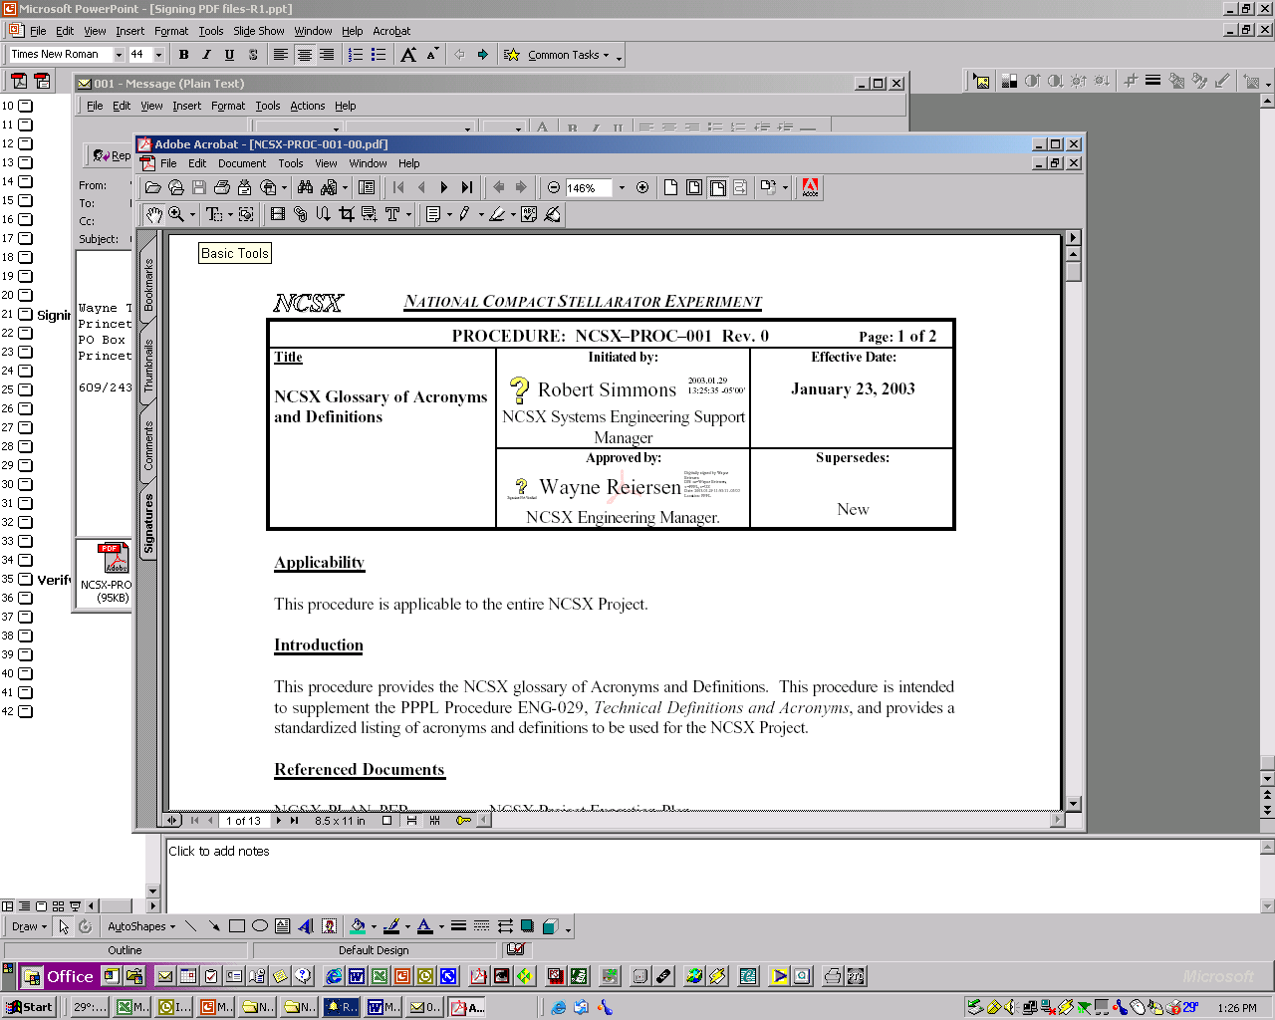

1

Subsequent Verification when all Signatures in ‘Trusted Certificate’ File
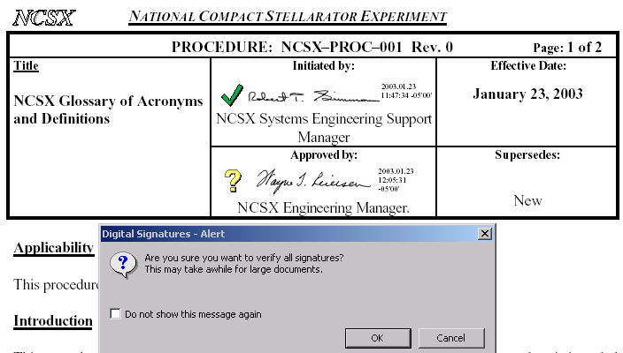

1

- Each time the document is subsequently opened, question marks (?) will appear
- When Digital Signature – Alert dialogue box appears, select OK to start verification process

2

Subsequent Verification when all Signatures in ‘Trusted Certificate’ File
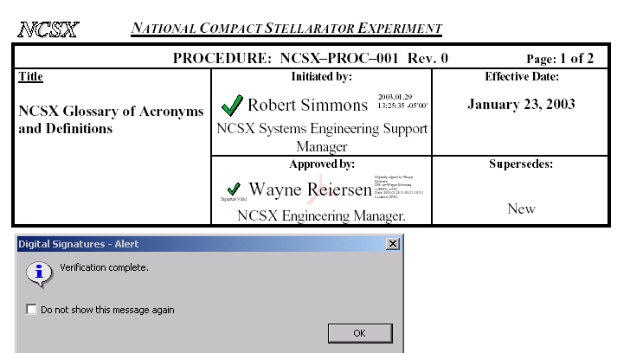

1

- When all signatures verified, question marks (?) will change to check marks (√) and the “Verification Complete” notice will appear
- Check “OK” to complete verification process.

2

To View “Trusted Certificates’ Folder

- Under Tools Menu, select “Self-Sign Security” and then select “Users Settings”
- Then select “Trusted Certificates” to view whose signatures have been previously verified.

2

The creator of the document or drawing sets the documents password and signature blocks

- Under the File Menu, select “Document Security”
- When the “Document Security” dialogue box appears, select “Acrobat Standard Security”
- When the “Standard Security” dialogue box appears, select
    - Check “Password Required…” and enter password selected by the originator
    - Select “128-bit RC4 (Acrobat 5.0)” encryption
    - Select both “Enable Content Access…” and “Allow Content Copying…”
- In Changes section, select “Only Form Field Fill-In or Signing” for documents or “Comment Authoring, Form Field Fill-In or Signing” for drawings
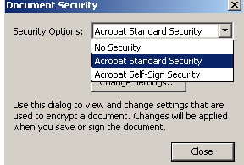

2

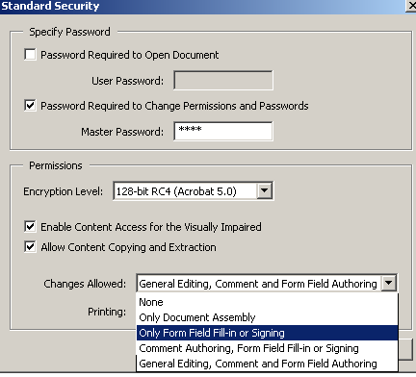
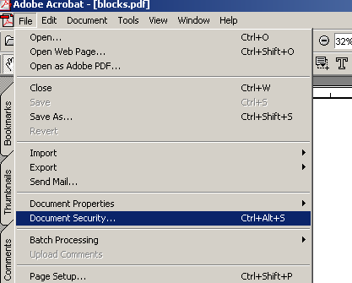
1

3

4

Establishing Signature Blocks for a Document
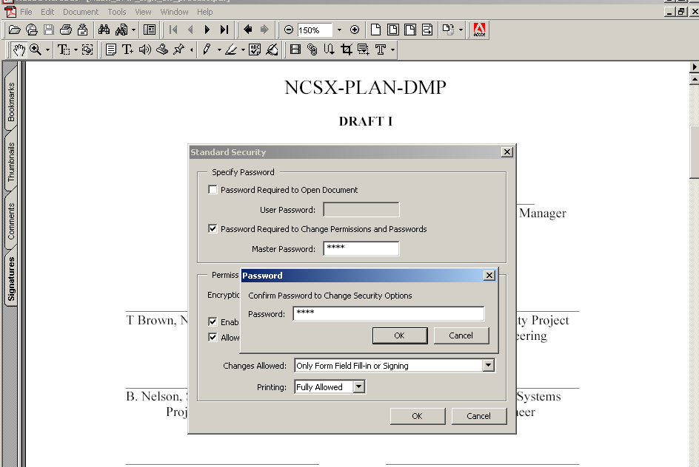

- Under “Tools Menu” select “Acrobat Standard Security” and then “Standard Security” and Master Password selected by the originator.
- When “Password” dialogue box appears, type in password selected by the originator to confirm the password

1

2

Establishing Signature Blocks for a Document
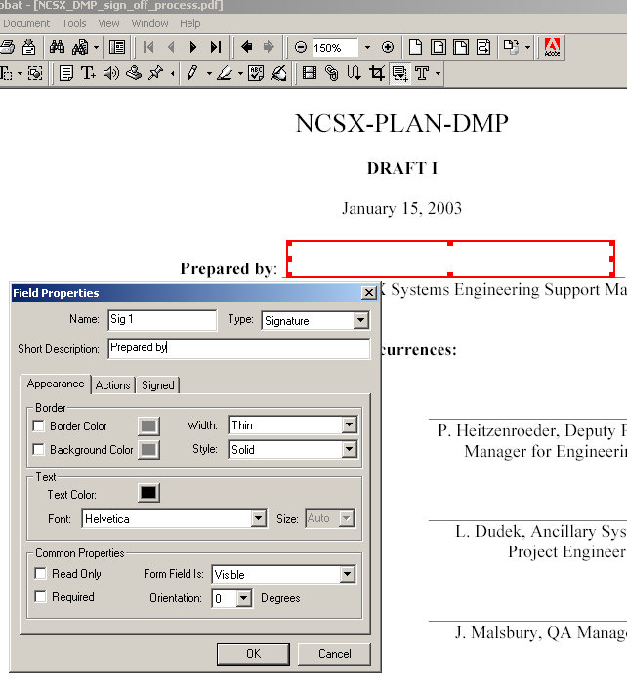

1

- Click the Form Tool to activate it => a cross hair will appear
- Drag the cross hair over the area where the signature will be placed
- In the field properties box that appears inter the Name (e.g. Sig 1in this example). Make sure that the “Type” is set to “Signature” (default is Text). Borders, etc can be added if desired.

2

3

Establishing Signature Blocks for a Document

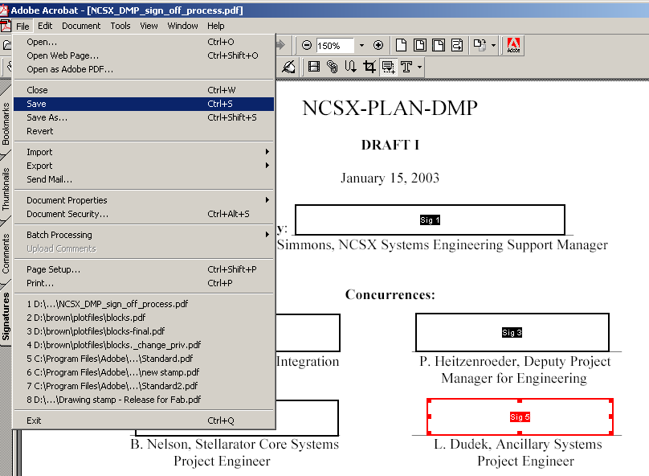

- After all signature blocks or fields are established, the creator should save the document
Note: The creator could sign the document before the document is saved.
1

Establishing Signature Blocks for a Drawing

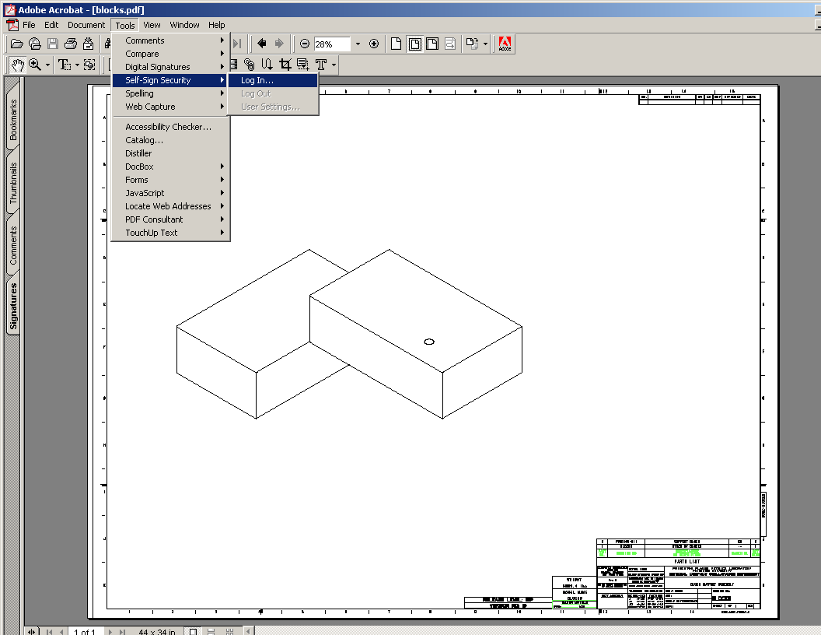

- From the “Tools” Menu, select “Self-Sign Security” and “Log In”
- When “Self-Sign Security – Log In” dialogue box appears, input your User password and select “Log In”.
- Repeat steps to set drawing password as outlined earlier.
1

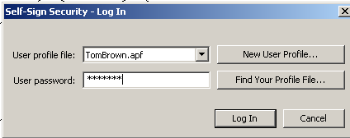

2

Establishing Signature Blocks for a Drawing

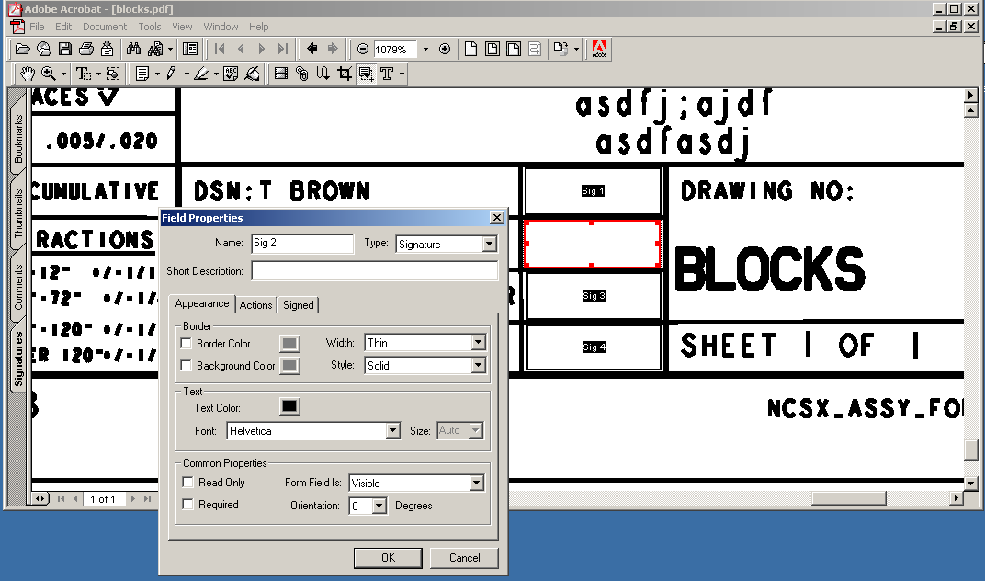
Cog Engineer
- Click the form tool icon to activate it => a cross hair will appear
- Drag the cross hair over the area where the signature will be placed
- In the Field Properties box that appears inter the Name (e.g. Sig 2). Make sure that there is no check on Border or Background (when used in a drawing title block). Also make sure that the Type A Short Description such as Cog Engineer, Designer, etc., can also be added. Make sure that the “Type” is set to “Signature” (default is Text).
- Repeat this process for every signature area. For drawings there will be several signatures (Sig 1, Sig 2, Sig 3, Sig 4)
- Save the drawing once the signature field blocks are established.

1

2

3

Modifying Signature Block Fields
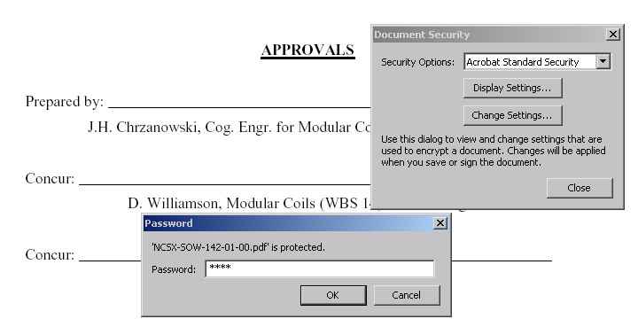

1

2

- Under File Menu select “Document Security”. When “Document Security” dialogue box appears, select “Change Settings”.
- When “Password” dialogue box appears, retype in password selected by the originator and then select “OK”.

Modifying Signature Block Fields

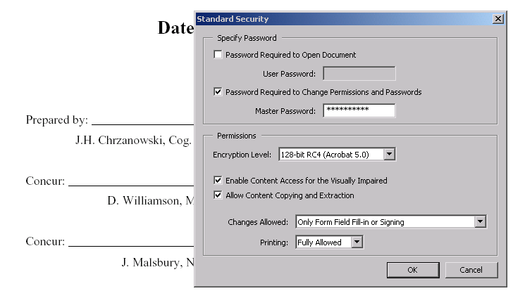

- When “Standard Security” dialogue box appears, select “Cancel” (selecting “OK” will preclude any modifications).

Modifying Signature Block Fields

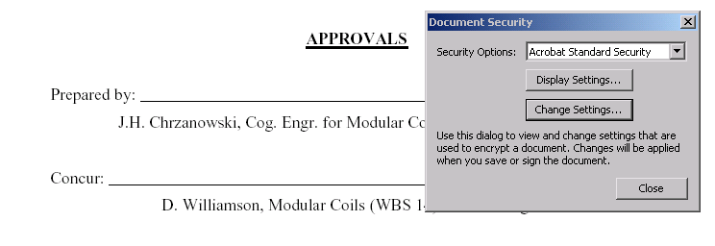

- The “Document Security” dialogue box will then reappear. Check “Close”.

Modifying Signature Block Fields
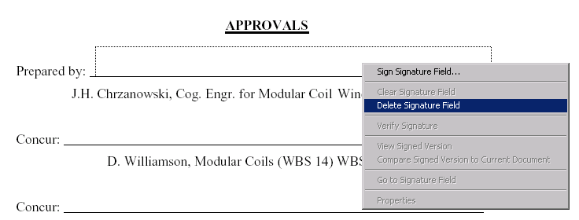

1

2

- Right click on the signature block to be modified
- When the dialogue box appears, select “Delete Signature Field”

Modifying Signature Block Fields
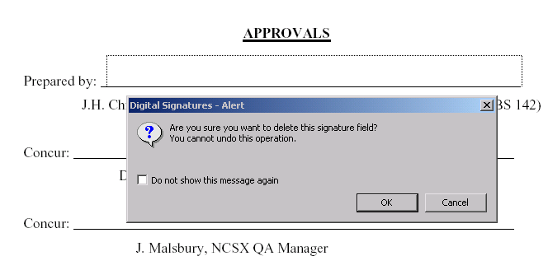

1

- When “Digital Signatures – Alert” dialogue box appears, select “OK” to delete the signature field.
- Reapply corrected signature field block in accordance with the procedures described earlier in this Attachment

1
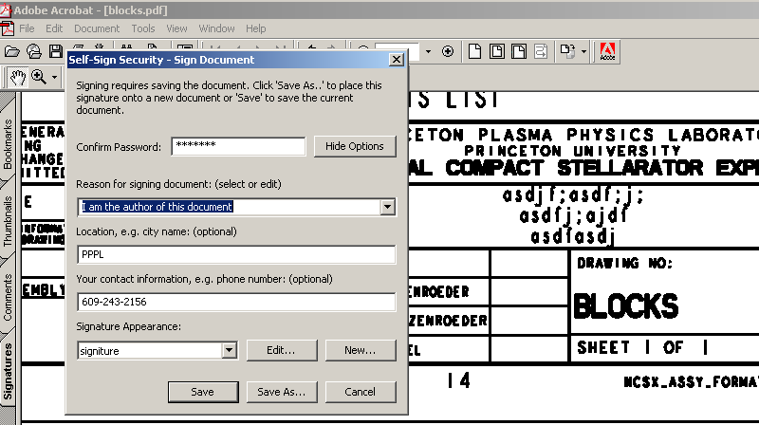

3
The originator will be the first to sign a drawing

- Activate the “Hand” icon to activate it.
- Right click on the signature area. A Sign Signature Field will appear. Select Sign Signature Field and the Self-Sign Security dialog will come up.
- Fill in your password and the reason for signing the document (use pull down window).
2

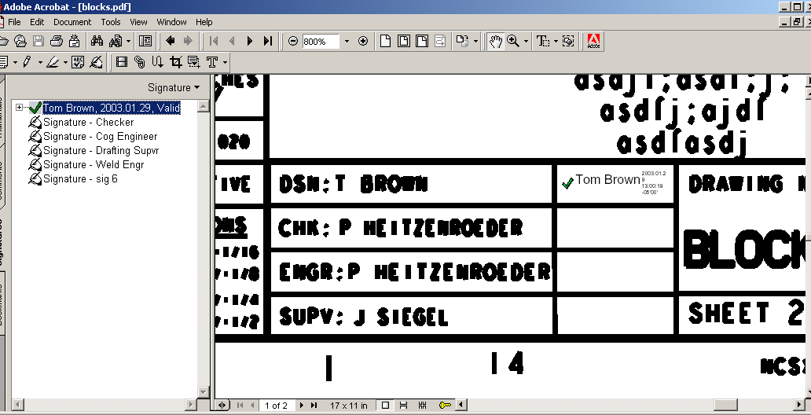

\

1

2

- After the first signature, the Title Block will appear
- Activate the document key and “show signature” to view signatures
- Repeat process until Drafting Supervisor’ signature is the next signature

Drafting Supervisor Must First Validate all Previous Signatures
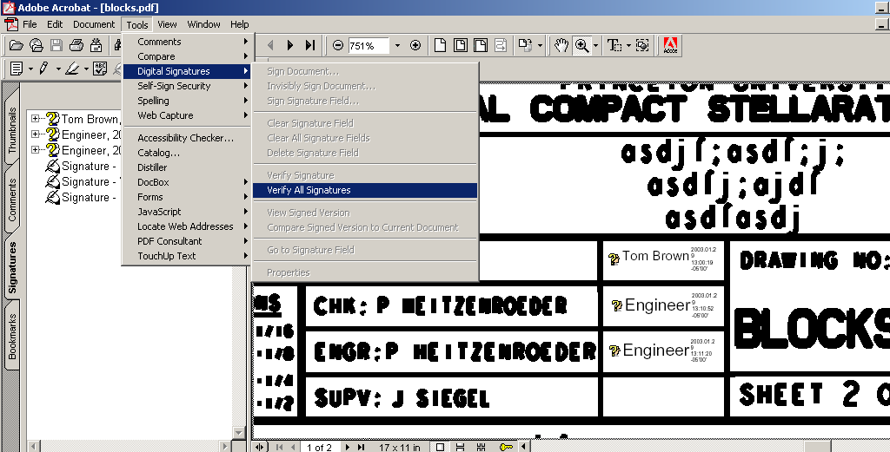

1

2

- After Logging In, from Tools Menu, the Drafting Supervisor selects “Digital Signatures” and then “Verify Signatures”
- Drafting supervisor should validate signatures in accordance with procedures outlined in Section B (Attachment 2). Once validated the question marks (?) changes to a check mark (√)

- To sign the document, the Drafting Supervisor activates the “Hand” icon
- Right click on the signature area. A Sign Signature Field will appear. Select Sign Signature Field and the Self-Sign Security dialog will come up.
- Fill in your password and the reason for signing the document (use pull down window)
- Click “Save”

1
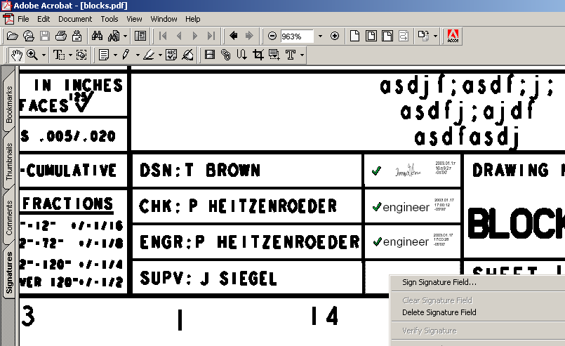

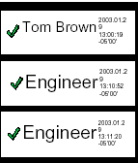
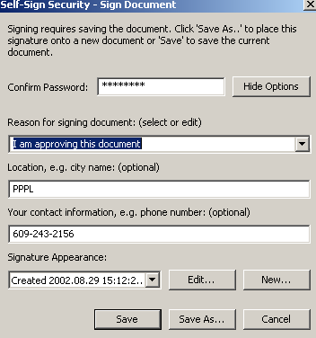

2
3

4

Drafting Supervisor Places Stamp
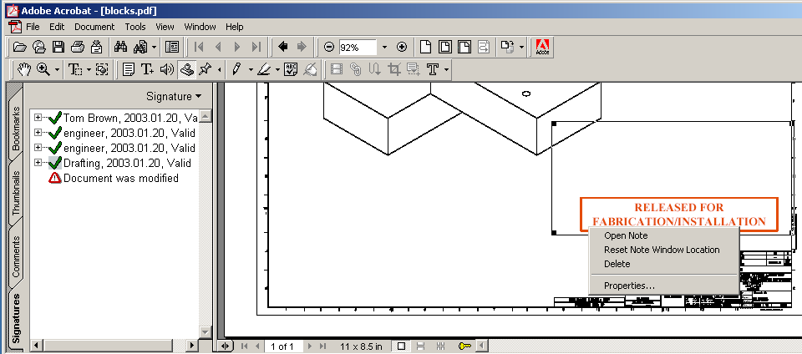
- Activates the “Stamp” icon.
- An icon of a stamp will appear. Move the stamp to the desired location and left click mouse (three button mouse) to set stamp. Drag stamp corners to set it to the desired size.
- Move the icon over the stamp and right click mouse button and open Properties to change stamp message.
1

2
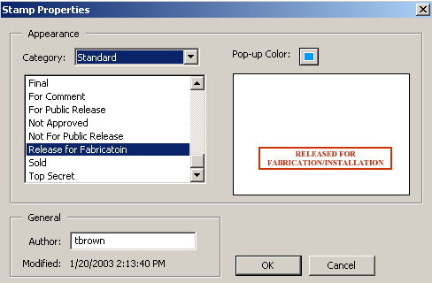
3

Note: After the stamp is placed a “Document was modified” warning is set in the Signature area.

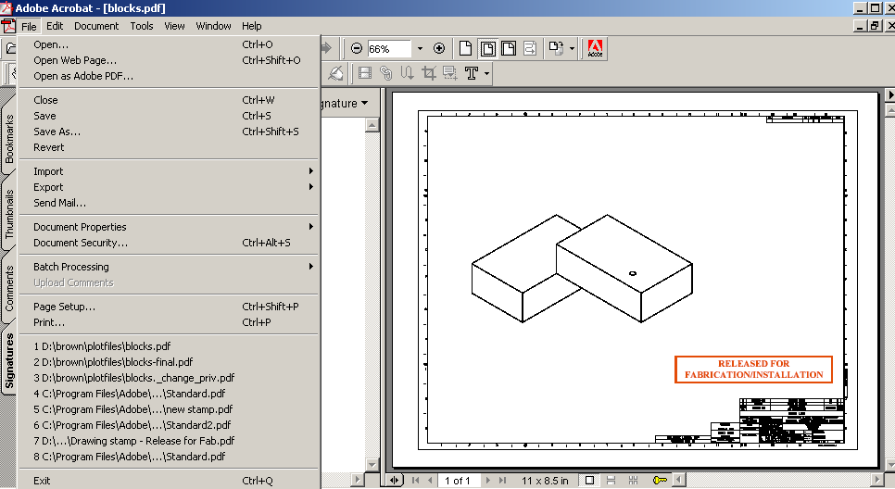

- Drafting Supervisor saves drawing

1

The drawing is complete and now ready to be placed in the released area of the Pro/INTRALINK database

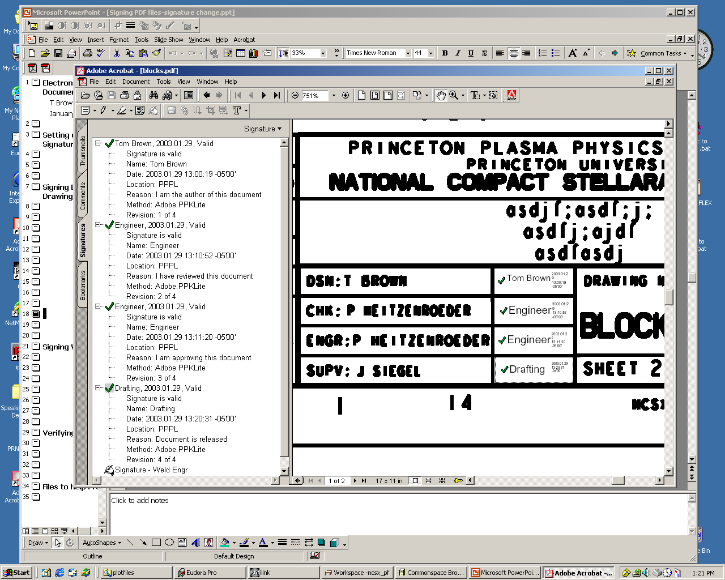

To Compare Signed Version to Earlier Unsigned Version
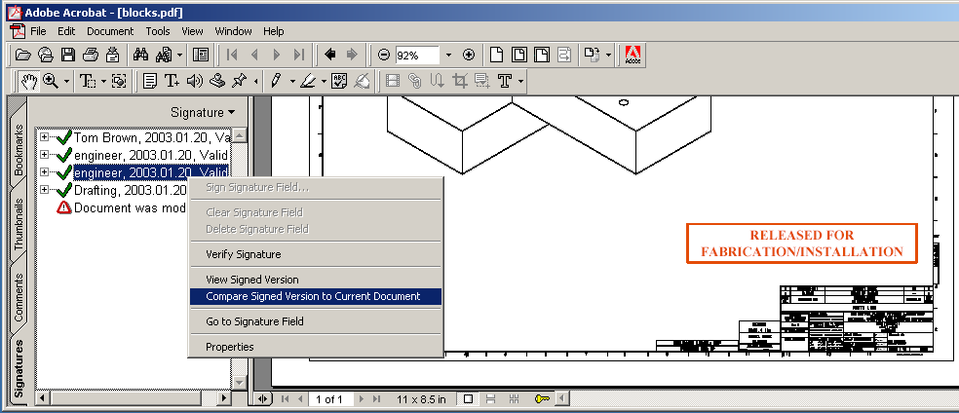
- Right click on signatures and activate Compare Signed Version to Current Version.

1

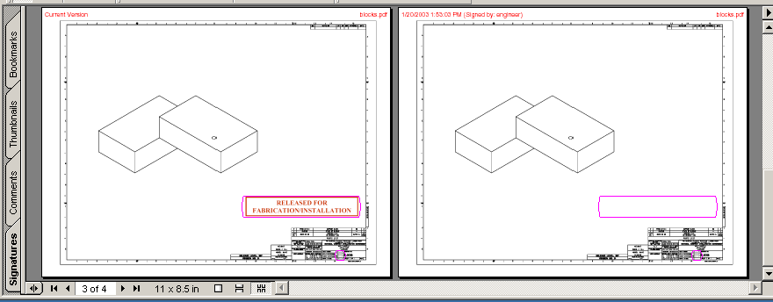

Version Signed by Engineer
Current Version
Changes Made

When a drawing is reopened, question marks (?) will appear until the signatures are re-verified. A user can only verify signatures => the signatures cannot be deleted by anyone

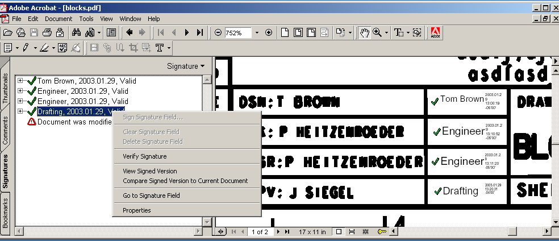

The originator of the document must first set up the signature block fields in accordance with Section C (Attachment 3)

- User Logs In and confirms password

1

1

- After setting up the signature block fields, the originator saves the document.

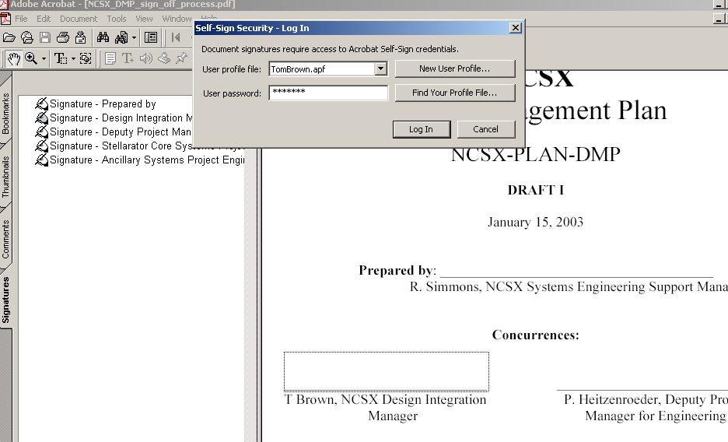

1

- User Logs In and activates the “Hand” Icon
- Right click on the signature area. A Sign Signature Field will appear. Select Sign Signature Field and the Self-Sign Security dialog will come up.
- User fills in their password and the reason for signing the document (use pull down window).
- Each User repeats process until all Approving Official signature
- Approving Official must first verify all previous signatures prior to signing in accordance with Section B (Attachment 2)
- Approving Official then sends approved document to the NCSX Engineering Web page for posting.

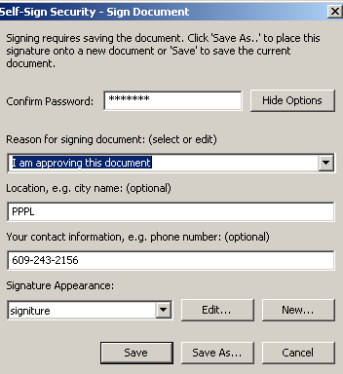

2

3

