Record of Revisions

Revision | Date | Description of Changes
0-dA | 5/2/2005 | Initial Draft

Applicability

This procedure is applicable to the entire NCSX Project.

Introduction

The NCSX ProE/INTRALINK Users Guide (NCSX-GUID-PRO/INTR) and the NCSX Procedure NCSX-PROC-007 (NCSX Electronic Model and Drawing/INTRALINK Processes) describe the operation of the Pro/INTRALINK database. FroTools is a browser based program that enables personnel not having direct access to Pro/Engineer (Pro/E) or do not have in-depth familiarity with how to navigate the Pro/INTRALINK database to relatively easily access and copy CAD files to their desktop. If used correctly, Fro/Tools will provide easy web access to the Pro/INTRALINK database. While FroTools has the capability to access other formats such as native ProE, DXF, IGES, etc. files, the NCSX Project’s use of FroTools is limited to accessing electronically signed pdf drawings.

In order to utilize FroTools, three prerequisites must be met:
- A potential user must have FroTools installed on their computer – the CADD Administrator in the Computer Division is the contact person to obtain a copy of Fro/Tools;
- A potential user must have an INTRALINK Account – the CADD Administrator in the Computer Division is the contact person to obtain this account; and
- A potential user must be trained in the use of Fro/Tools – the Design Integration Manager or his designee will provide this training (either one-on-one or in group session).

This procedure will cover the basics of using Fro/Tools. The FroTools program is available through the Princeton Intralink Data Access (PIDA) web at: http://www/pida.pppl.gov

Referenced Documents

Document Number | Document Title
NCSX-GUID-PRO/INTR | Pro/INTRALINK Users Guide
NCSX-PROC-007 | NCSX Electronic Model and Drawing/INTRALINK Processes

Procedure

- Use of FroTools
User of FroTools opens a convenient web browser and types in the following URL: http://www/pida.pppl.gov

User logs into FroTools using their individual Pro/INTRALINK Username and Password.
Note: User obtains this from the PPPL CADD Administrator.
1
When FroTools page opens, the User selects the in the NCSX Folder under the sub directory: 001_Released Dwgs_PDF_Format

User edits/customizes the level of detail to be displayed by using teh Edit Menu. FroTools offers a wide range of options. After selecting the options desired, User selects Customize to save the options. See Attachment 1 to this procedure for illustrations.

For Stellartor Core drawings, (WBS 100 Level), the User selects 100_Stellarator_Core. A FroTools menu provides the option to select a limited number or all (e.g., 20, 50, 100, or 200) of objects (drawings) to be listed. User can also use the Web Browser to do a specific word or number search.

1
User selects the file desired and, under the Application Menu, selects “Add to Export List.” A FroTools Export Center Dialogue box appears and selects “Export Now.”
Note: If an error message appears (CADD Administrator working to solve this issue, merely right click and select “refresh” and then “retry” -- this should solve the problem.
Once the transfer/export is completed, User double clicks on the filename icon to display the selected pdf drawing. Drawing may be resized and printed on any printer selected or can be plotted.
END
When finished, User select File Menu, selects EXIT, and then OK when the pop up dialogue box appears

Attachment

1- FroTools Illustration

The following screen shots are intended to provide the User of FroTools an illustrative example on how the FroTools program will work.

Open a Web Browser and Type in this address
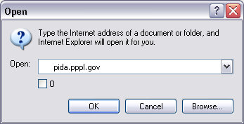
For future use bookmark this address.

Enter INTRALINK Username and Password
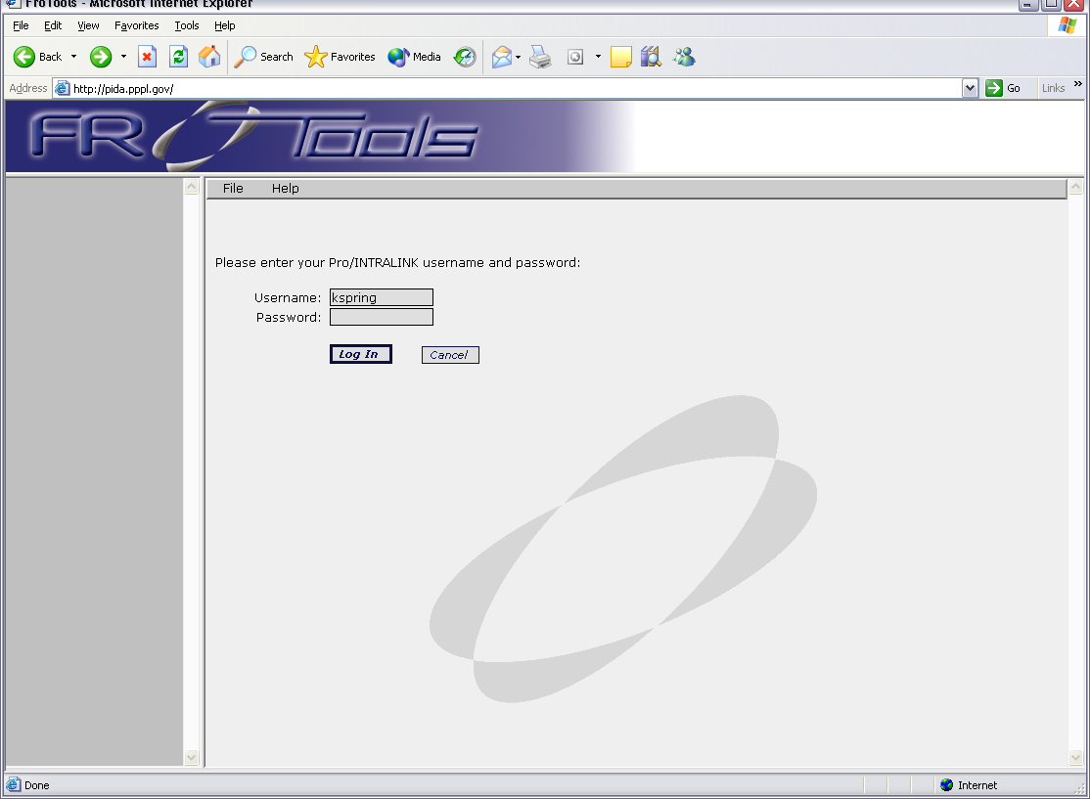
Note: To obtain an INTRALINK account call CADD Administrator

Click on Log In
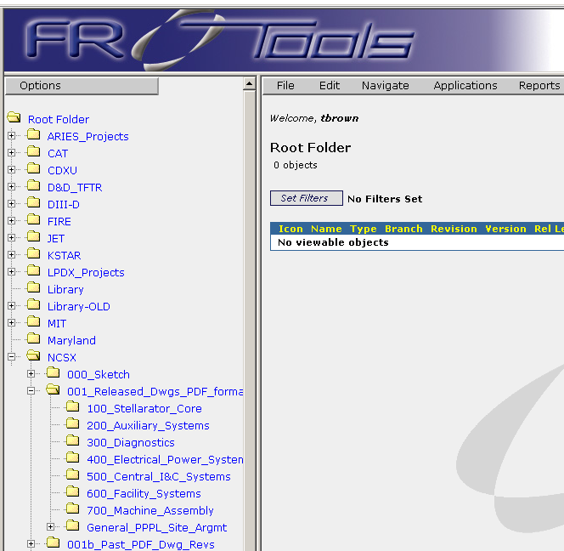
FroTools opens with a page showing the INTRALINK folders.
NCSX pdf files are located in the sub directory: 001_Released Dwgs_PDF_format
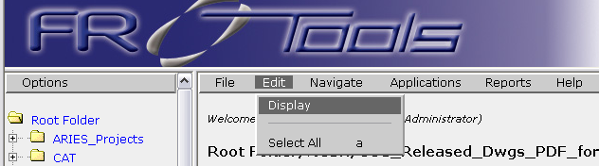
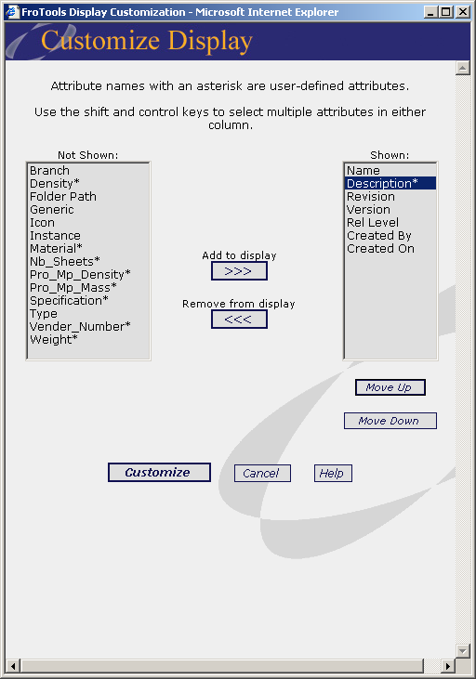
Select Edit / Display

To format the Listing

Add to Display
Remove from Display
Move Up/Move Down
Customize
1
2
3
4

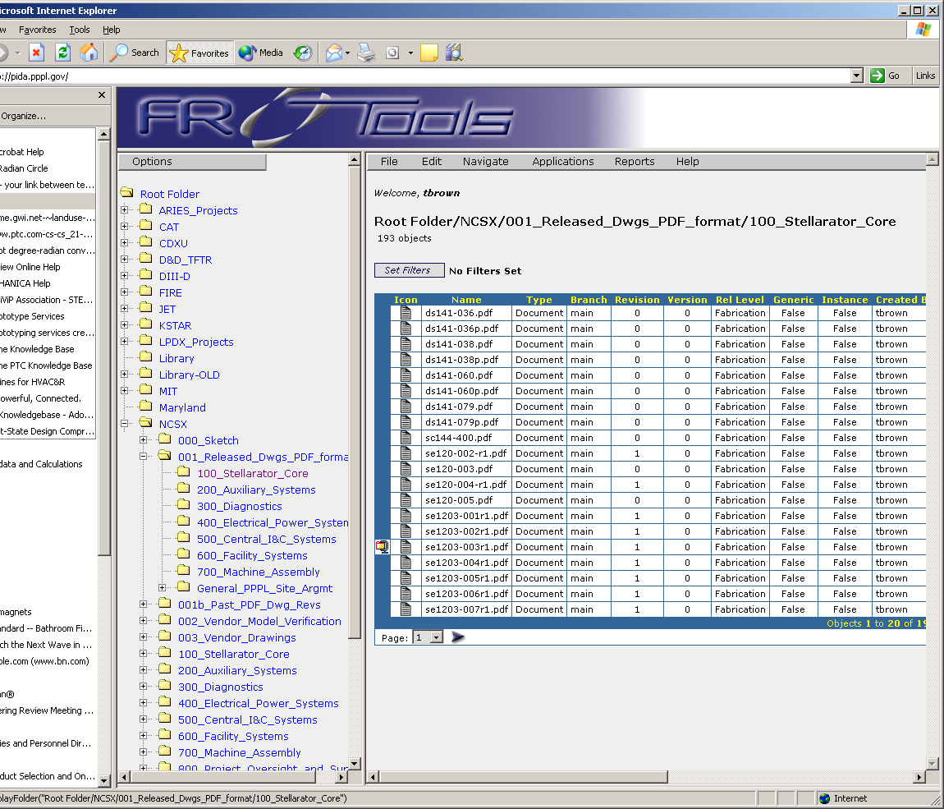
All NCSX Core drawings (WBS 100 level) can be found under 100_Stellarator_Core. A Left click of the mouse button will list the drawings as shown above.
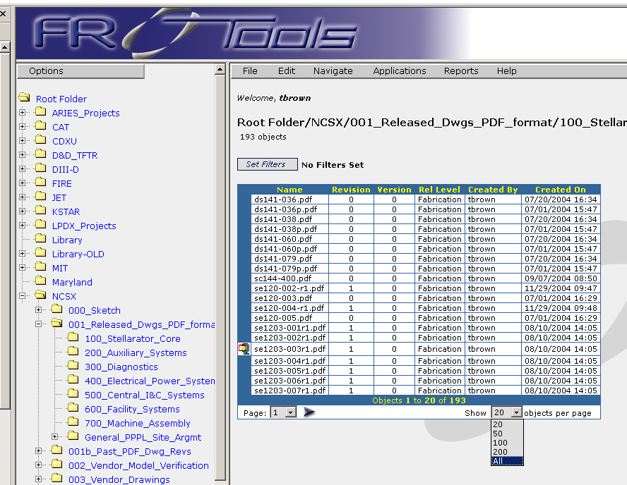
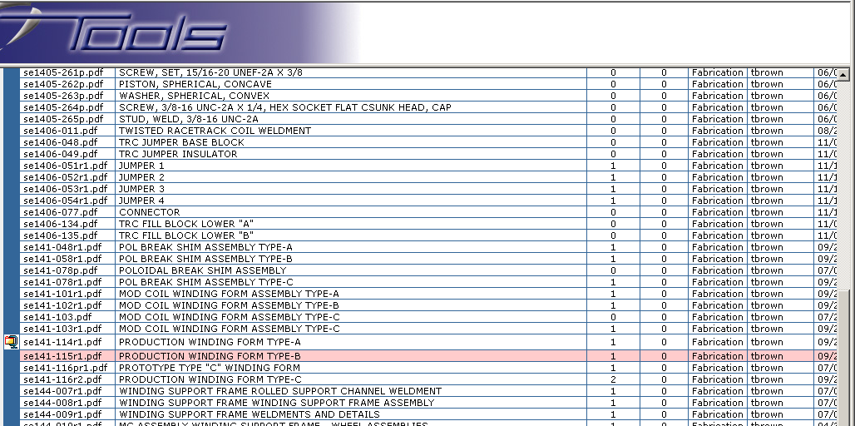
To list all files select All from pull down window
Select the file that you want, and under the
Applications Menu
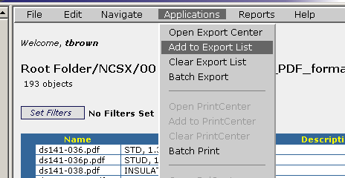
Select “Add to Export List”

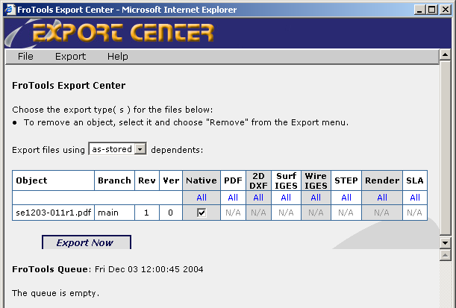
Select “Export Now”
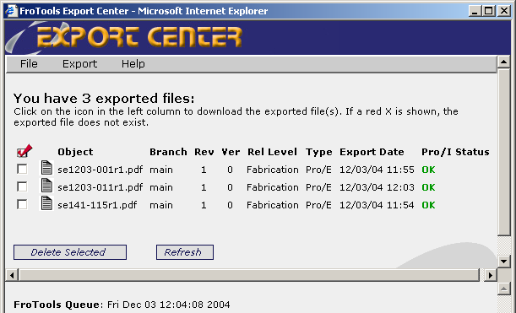
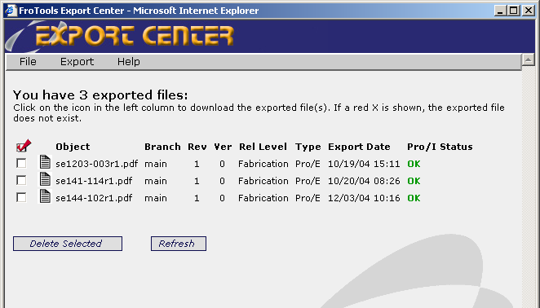
If error message appears:
- Right click and select “refresh”
- When second dialogue box appears, select “retry”
Once it finishes double click on the filename icon

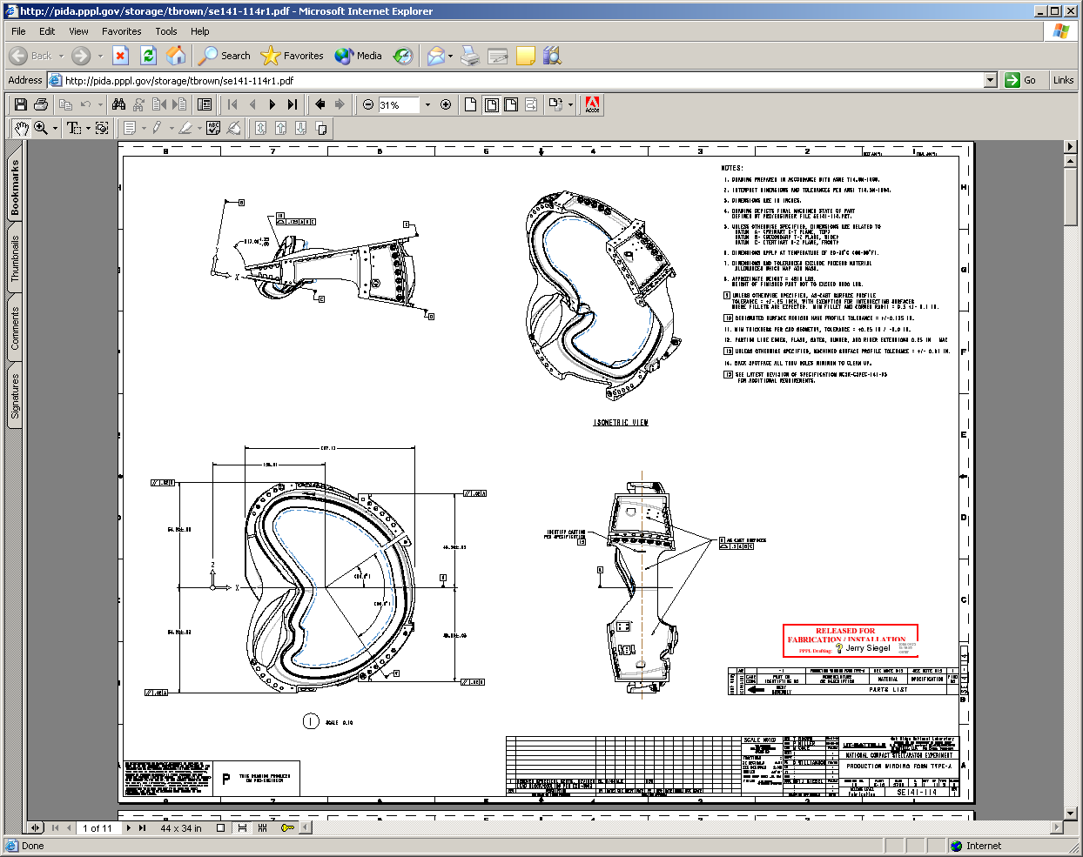
After clicking the filename icon the Acrobat drawing file will appear. The drawing can be re-sized and printed to any installed printer or it can be sent to plotters.

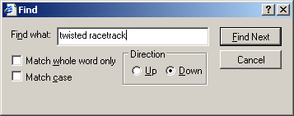
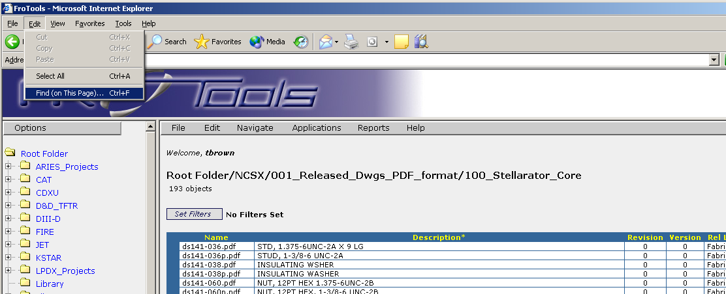
The Web Browser can do a word or number search

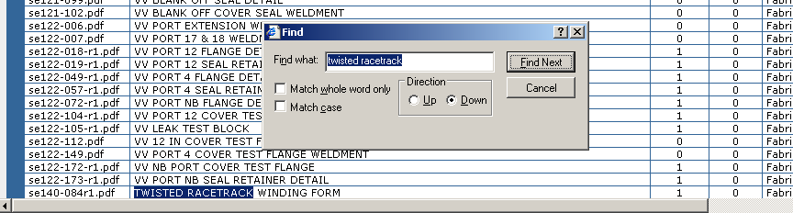
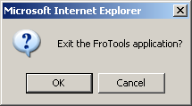
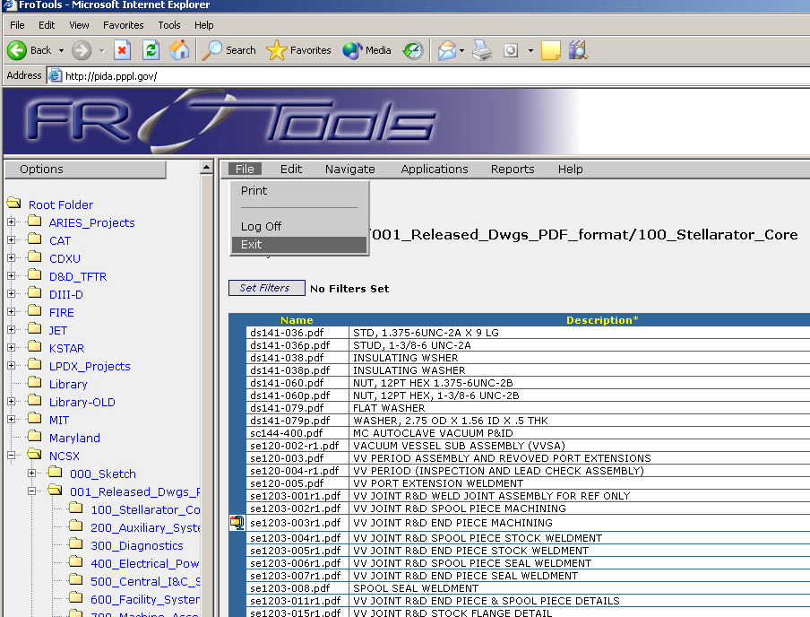
When finished go to File and select Exit then OK in the pop up window.

